CODE:

package com.selenium.cse;

import org.openqa.selenium.By;

import org.openqa.selenium.WebDriver;

import org.openqa.selenium.WebElement;

import org.openqa.selenium.edge.EdgeDriver;

import org.testng.annotations.AfterTest;

import org.testng.annotations.BeforeTest;

import org.testng.annotations.Test;

import io.github.bonigarcia.wdm.WebDriverManager;

import junit.framework.Assert;

public class CC1Q01 {

WebDriver driver;

@Test

public void f() throws Exception {

WebElement username = driver.findElement(By.name("user-name"));

username.sendKeys("standard_user");

WebElement password = driver.findElement(By.name("password"));

password.sendKeys("secret_sauce");

WebElement login = driver.findElement(By.name("login-button"));

login.click();

Thread.sleep(3000);

WebElement addcart = driver.findElement(By.name("add-to-cart-sauce-labs-backpack"));

addcart.click();

WebElement cart = driver.findElement(By.className("shopping_cart_link"));

cart.click();

String t1 = driver.getCurrentUrl();

Assert.assertEquals(t1, "https://www.saucedemo.com/cart.html");

Thread.sleep(3000);

WebElement checkout = driver.findElement(By.name("checkout"));

checkout.click();

Thread.sleep(3000);

String t2 = driver.getCurrentUrl();

Assert.assertEquals(t2, "https://www.saucedemo.com/checkout-step-one.html");

WebElement fn = driver.findElement(By.name("firstName"));

fn.sendKeys("Nithya");

WebElement ln = driver.findElement(By.name("lastName"));

ln.sendKeys("S");

WebElement postalcode = driver.findElement(By.name("postalCode"));

postalcode.sendKeys("123456");

WebElement conti = driver.findElement(By.name("continue"));

conti.click();

String t3 = driver.getCurrentUrl();

Assert.assertEquals(t3, "https://www.saucedemo.com/checkout-step-two.html");

// String name = "Sauce Labs Backpack";

// System.out.println(name);

//

// String price = "$29.99";

// System.out.println(price);

WebElement name = driver.findElement(By.xpath("//*[@id=\"item_4_title_link\"]/div"));

System.out.println(name.getText());

WebElement amt = driver.findElement(By.xpath("//*[@id=\"checkout_summary_container\"]/div/div[1]/div[3]/div[2]/div[2]/div"));

System.out.println(amt.getText());

String title=driver.getTitle();

System.out.println(title);

Assert.assertEquals(t1, "https://www.saucedemo.com/cart.html");

String url2=driver.getCurrentUrl();

System.out.println(url2);

String url3 = "https://www.saucedemo.com/checkout-step-two.html";

Assert.assertEquals(url2,url3);

}

@BeforeTest

public void beforeTest() throws Exception {

WebDriverManager.edgedriver().setup();

driver = new EdgeDriver();

driver.manage().window().maximize();

String URL = "https://www.saucedemo.com/";

driver.get(URL);

Thread.sleep(3000);

}

@AfterTest

public void afterTest() {

driver.quit();

}

} }

}

CONSOLE OUTPUT:

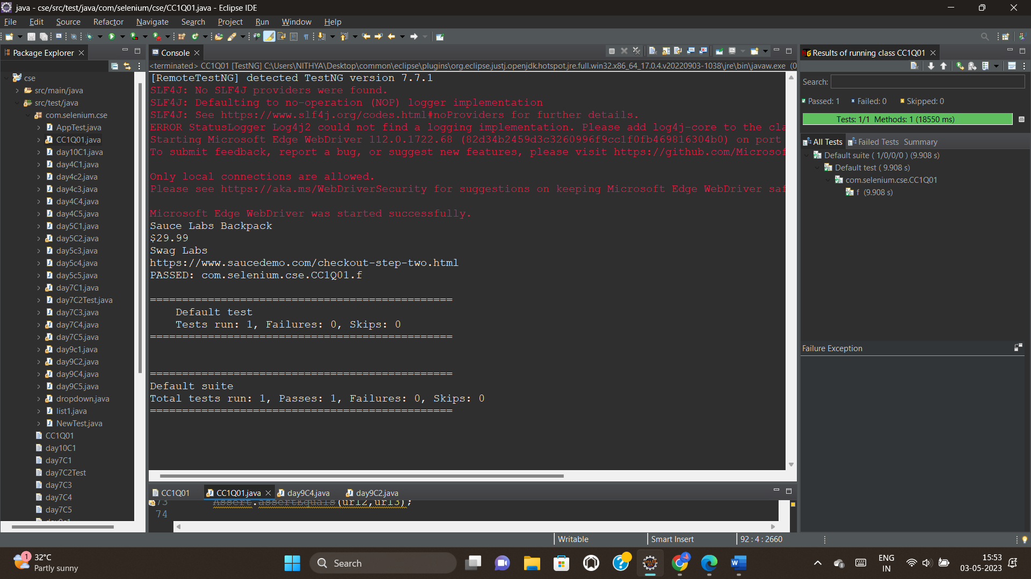

EDGE OUTPUT:

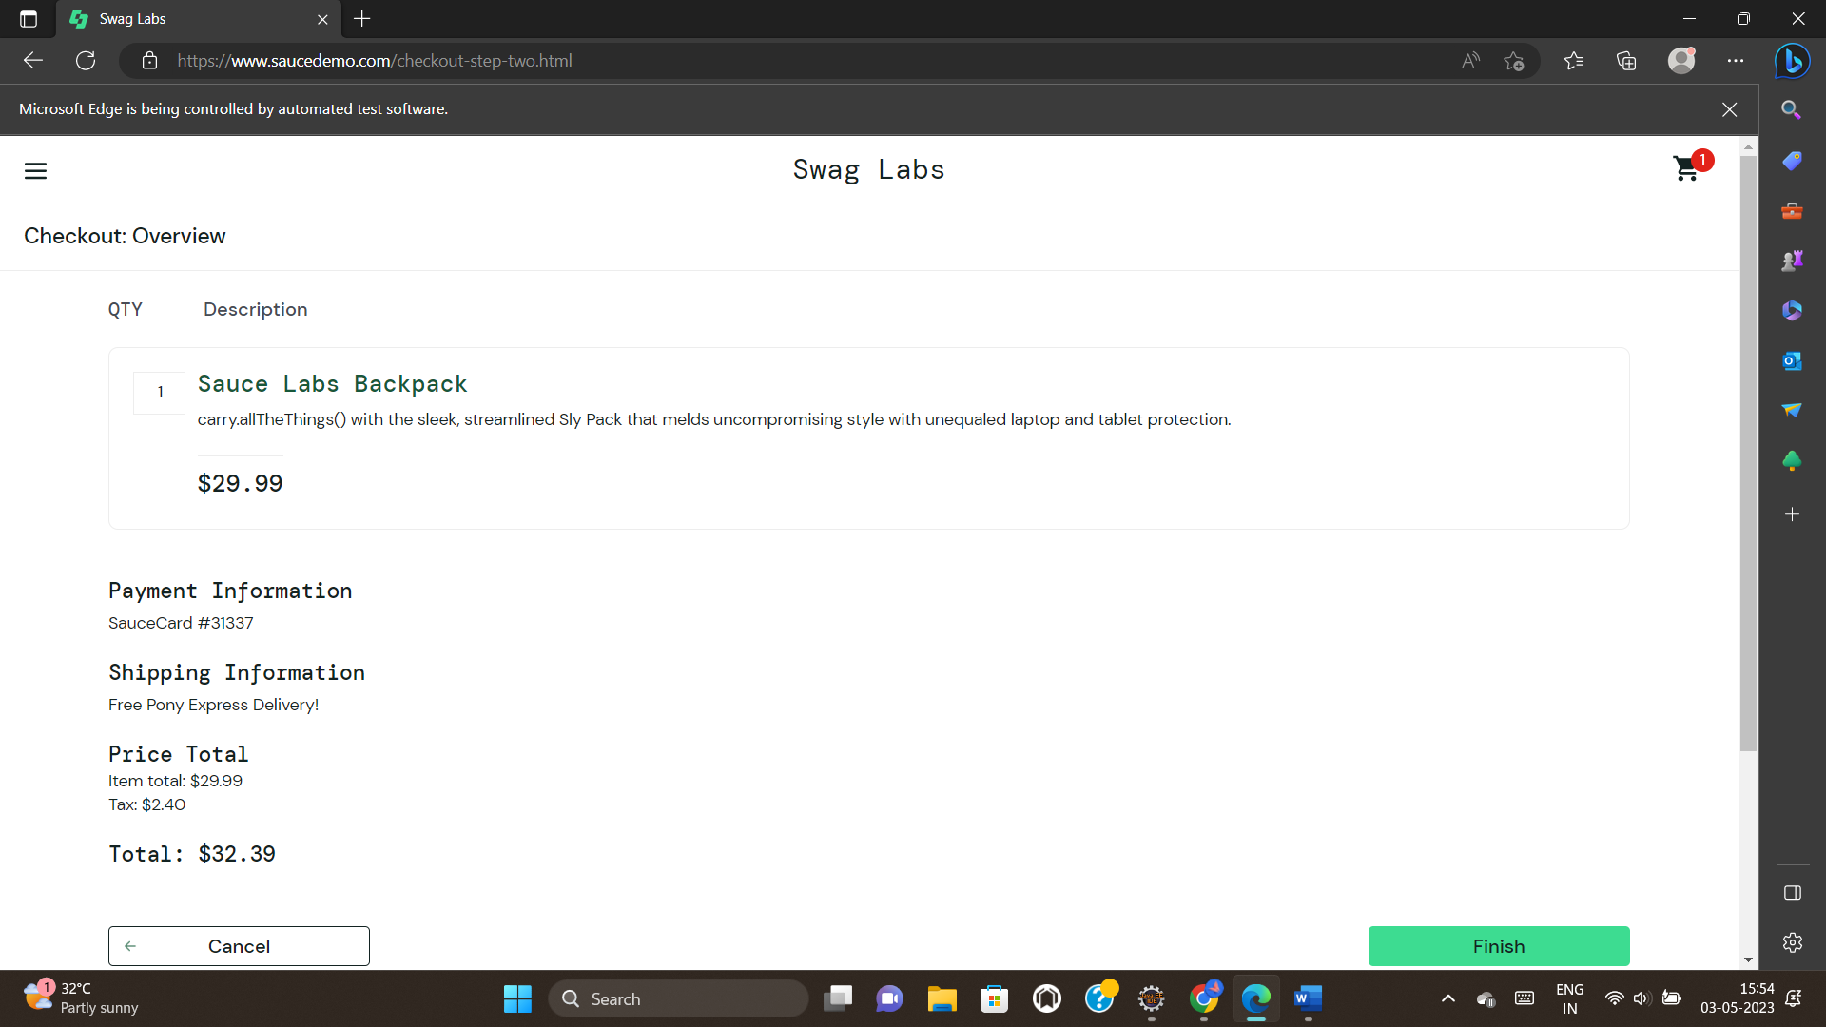



CODE:

package com.selenium.cse;

import org.openqa.selenium.By;

import org.openqa.selenium.WebDriver;

import org.openqa.selenium.WebElement;

import org.openqa.selenium.edge.EdgeDriver;

import org.openqa.selenium.support.ui.Select;

import org.testng.annotations.AfterTest;

import org.testng.annotations.BeforeTest;

import org.testng.annotations.Test;

import io.github.bonigarcia.wdm.WebDriverManager;

public class CC2Q02 {

WebDriver driver;

@Test

public void f() throws Exception {

WebElement username = driver.findElement(By.name("user-name"));

username.sendKeys("standard_user");

WebElement password = driver.findElement(By.name("password"));

password.sendKeys("secret_sauce");

WebElement login = driver.findElement(By.name("login-button"));

login.click();

Thread.sleep(3000);

WebElement t1 = driver.findElement(By.xpath("//*[@id=\"item_4_title_link\"]/div"));

System.out.println(t1.getText());

WebElement filter1 = driver.findElement(By.className("product_sort_container"));

filter1.click();

Select s1=new Select(filter1);

s1.selectByIndex(1);

WebElement t2 = driver.findElement(By.xpath("//*[@id=\"item_3_title_link\"]/div"));

System.out.println(t2.getText());

WebElement filter2 = driver.findElement(By.className("product_sort_container"));

filter2.click();

Select s2=new Select(filter2);

s2.selectByIndex(2);

WebElement t3 = driver.findElement(By.xpath("//*[@id=\"item_2_title_link\"]/div"));

System.out.println(t3.getText());

WebElement filter3 = driver.findElement(By.className("product_sort_container"));

filter3.click();

Select s3=new Select(filter3);

s3.selectByIndex(3);

WebElement t4 = driver.findElement(By.xpath("//*[@id=\"item_5_title_link\"]/div"));

System.out.println(t4.getText());

}

@BeforeTest

public void beforeTest() throws Exception {

WebDriverManager.edgedriver().setup();

driver = new EdgeDriver();

driver.manage().window().maximize();

String URL = "https://www.saucedemo.com/";

driver.get(URL);

Thread.sleep(3000);

}

@AfterTest

public void afterTest() {

}

}

CONSOLE OUTPUT:

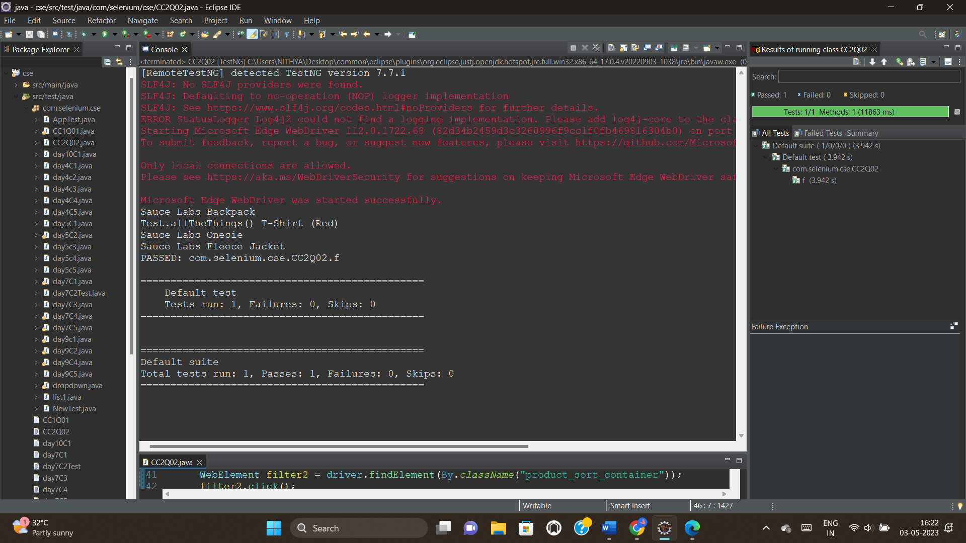

EDGE OUTPUT:

