package com.selenium.cse;

import org.testng.annotations.Test;

import io.github.bonigarcia.wdm.WebDriverManager;

// import junit.framework.Assert;

import org.testng.annotations.BeforeTest;

import org.openqa.selenium.By;

import org.openqa.selenium.Keys;

import org.openqa.selenium.WebDriver;

import org.openqa.selenium.WebElement;

import org.openqa.selenium.edge.EdgeDriver;

import org.testng.Assert;

import org.testng.annotations.AfterTest;

public class day7C1 {

WebDriver driver;

*@Test*

public void f() {

// WebElement fb = driver.findElement(By.id("APjFqb"));

// fb.sendKeys("Apple");

// driver.findElement(By.id("APjFqb")).sendKeys(Keys.ENTER);

String t1 = driver.getTitle();

System.***out***.println(t1);

String t2 = "Guest Registration Form – User Registration";

Assert.*assertEquals*(t1,t2);

}

*@BeforeTest*

public void beforeTest() {

WebDriverManager.*edgedriver*().setup();

driver = new EdgeDriver();

driver.manage().window().maximize();

driver.get("https://demo.wpeverest.com/user-registration/guest-registration-form/");

}

*@AfterTest*

public void afterTest() {

// driver.quit();

}

}

OUTPUT:

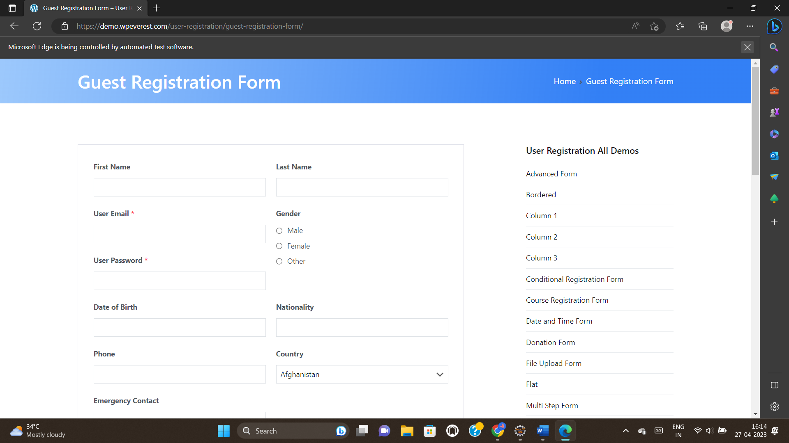



package com.selenium.cse;

import org.testng.annotations.Test;

//import junit.framework.Assert;

//import org.testng.annotations.BeforeTest;

import org.testng.Assert;

//import org.testng.annotations.AfterTest;

public class day7C2Test {

int a = 7,b=2,c;

@Test(priority = 4)

public void add() {

c = a+b;

Assert.assertEquals(c,9);

}

@Test(priority = 3)

public void sub() {

c = a-b;

Assert.assertEquals(c,5);

}

@Test(priority = 2)

public void multi() {

c = a*b;

Assert.assertEquals(c,14);

}

@Test(priority = 1)

public void div() {

c = a/b;

Assert.assertEquals(c,3);

}

}

OUTPUT:

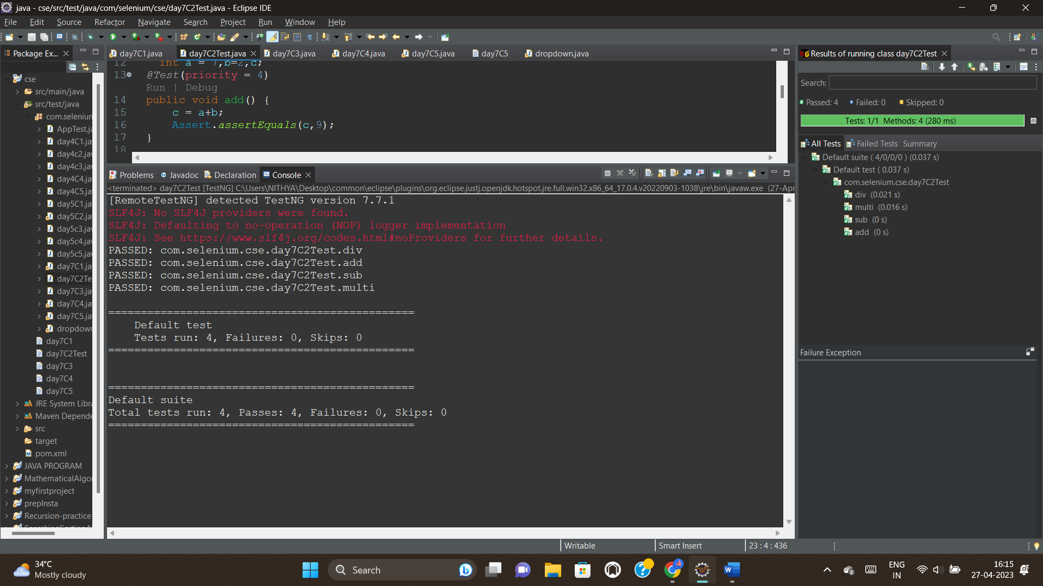



package com.selenium.cse;

import org.openqa.selenium.By;

import org.openqa.selenium.WebDriver;

import org.openqa.selenium.WebElement;

import org.openqa.selenium.edge.EdgeDriver;

import org.testng.Assert;

import org.testng.annotations.AfterTest;

import org.testng.annotations.BeforeTest;

import org.testng.annotations.Test;

import io.github.bonigarcia.wdm.WebDriverManager;

public class day7C3 {

WebDriver driver;

*@Test*

public void f() {

WebElement username = driver.findElement(By.*name*("username"));

username.sendKeys("Admin");

WebElement password = driver.findElement(By.*name*("password"));

password.sendKeys("admin123");

WebElement login = driver.findElement(By.*xpath*("//*[@id=\"app\"]/div[1]/div/div[1]/div/div[2]/div[2]/form/div[3]/button"));

login.submit();

String t1 = driver.getCurrentUrl() ;

System.***out***.println(t1);

String t2 = "https://opensource-demo.orangehrmlive.com/web/index.php/dashboard/index";

Assert.*assertEquals*(t1,t2);

}

*@BeforeTest*

public void beforeTest() throws Exception {

WebDriverManager.*edgedriver*().setup();

driver = new EdgeDriver();

driver.manage().window().maximize();

driver.get("https://opensource-demo.orangehrmlive.com/web/index.php/auth/login");

Thread.*sleep*(3000);

}

*@AfterTest*

public void afterTest() {

driver.quit();

}

}

OUTPUT:

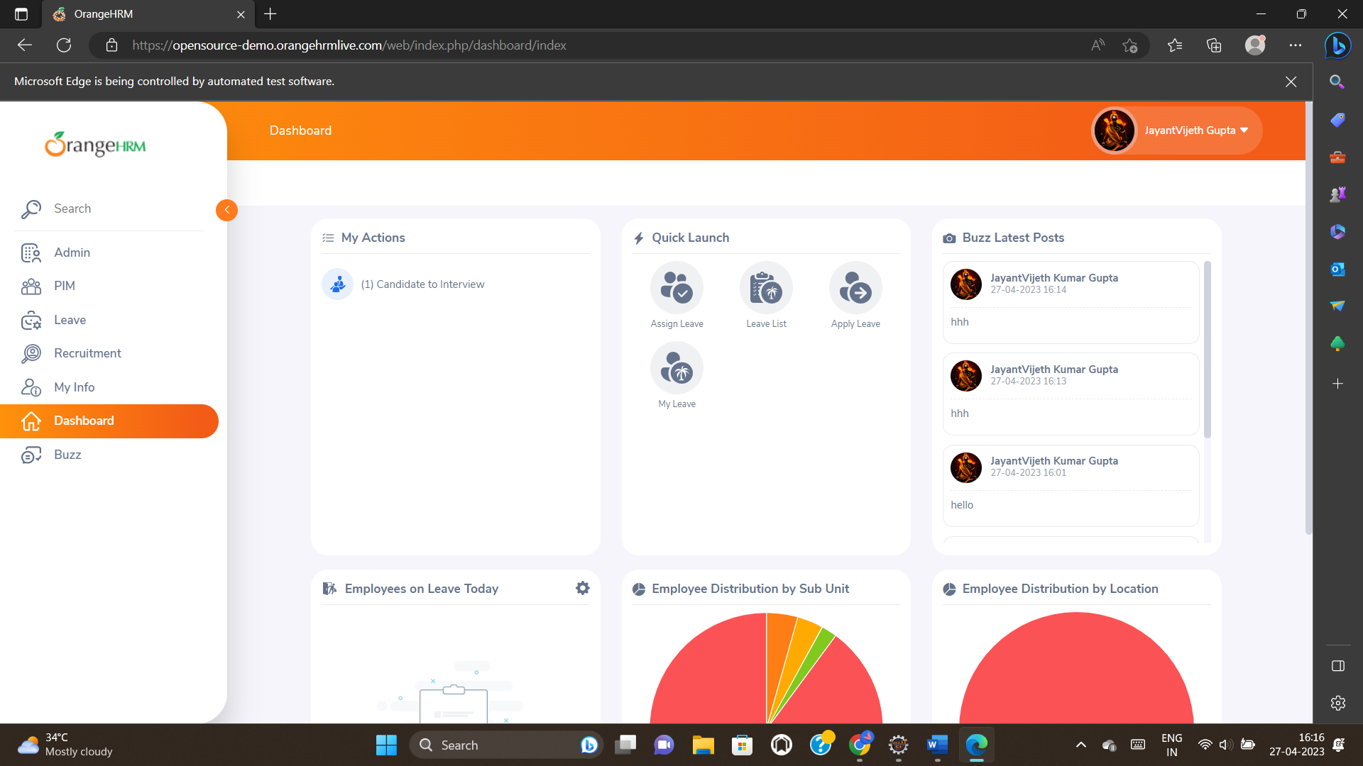

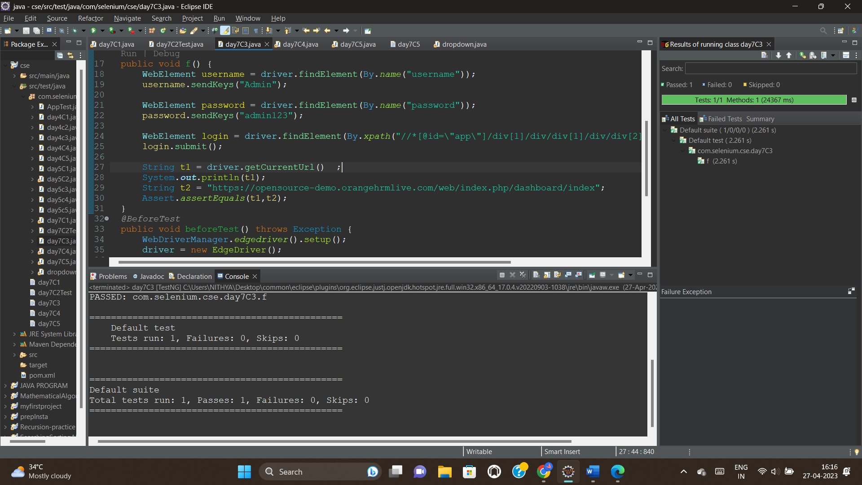



package com.selenium.cse;

import org.openqa.selenium.By;

import org.openqa.selenium.Keys;

import org.openqa.selenium.WebDriver;

import org.openqa.selenium.WebElement;

import org.openqa.selenium.edge.EdgeDriver;

import org.testng.Assert;

import org.testng.annotations.AfterTest;

import org.testng.annotations.BeforeTest;

import org.testng.annotations.Test;

import io.github.bonigarcia.wdm.WebDriverManager;

public class day7C4 {

WebDriver driver;

*@Test*

public void test1() throws Exception {

Thread.*sleep*(3000);

driver.findElement(By.*name*("username")).sendKeys("Admin");

driver.findElement(By.*name*("password")).sendKeys("admin123");

WebElement login = driver.findElement(By.*xpath*("//*[@id=\"app\"]/div[1]/div/div[1]/div/div[2]/div[2]/form/div[3]/button"));

login.submit();

String t1 = driver.getCurrentUrl() ;

System.***out***.println(t1);

String t2 = "https://opensource-demo.orangehrmlive.com/web/index.php/dashboard/index";

Assert.*assertEquals*(t1,t2);

}

*@Test* (dependsOnMethods="test1")

public void test2() throws Exception {

Thread.*sleep*(3000);

driver.findElement(By.*xpath*("//*[@id=\"app\"]/div[1]/div[1]/header/div[1]/div[2]")).click();

driver.findElement(By.*xpath*("//*[@id=\"app\"]/div[1]/div[1]/header/div[1]/div[2]/ul/li/ul/li[4]/a")).click();

String t3 = driver.getCurrentUrl();

System.***out***.println(t3);

String t4 = "https://opensource-demo.orangehrmlive.com/web/index.php/auth/login";

Assert.*assertEquals*(t3, t4);

}

*@BeforeTest*

public void beforeTest() {

WebDriverManager.*edgedriver*().setup();

driver = new EdgeDriver();

driver.get("https://opensource-demo.orangehrmlive.com/web/index.php/auth/login");

driver.manage().window().maximize();

}

*@AfterTest*

public void afterTest() {

driver.quit();

}

}

OUTPUT:

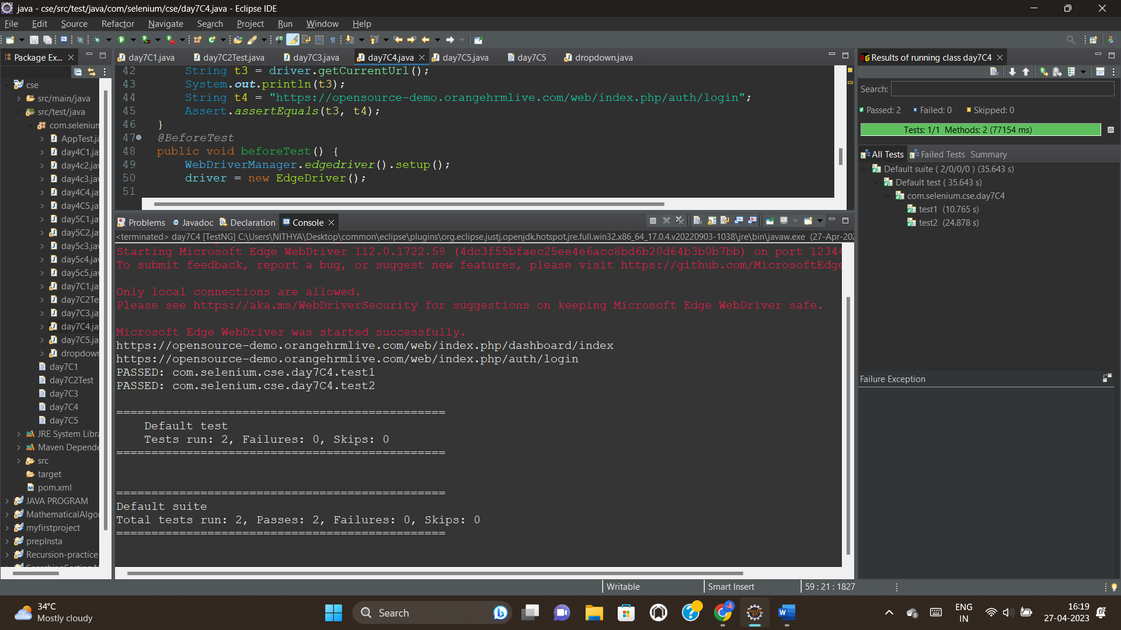

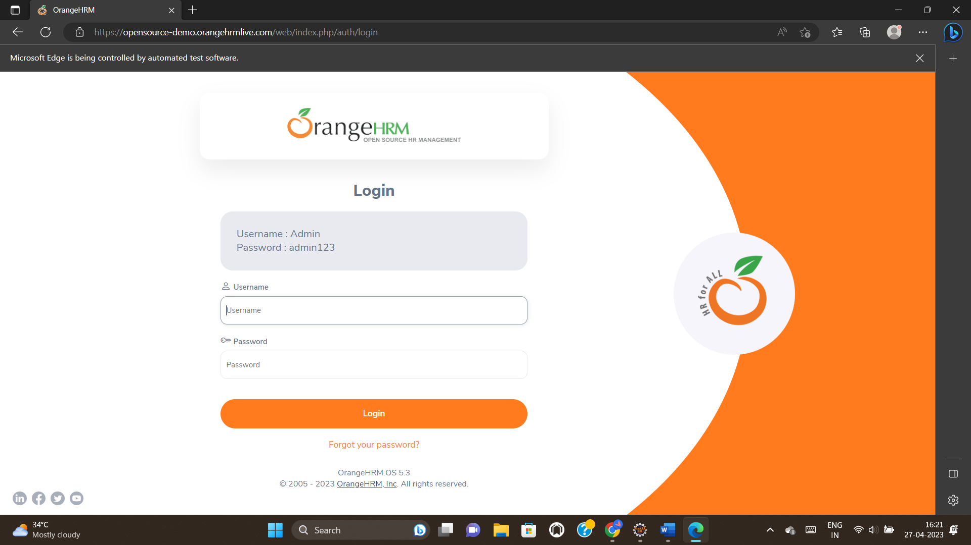



package com.selenium.cse;

import java.util.concurrent.TimeUnit;

import org.openqa.selenium.By;

import org.openqa.selenium.WebDriver;

import org.openqa.selenium.chrome.ChromeDriver;

import org.openqa.selenium.chrome.ChromeOptions;

import org.testng.annotations.Test;

import io.github.bonigarcia.wdm.WebDriverManager;

import junit.framework.~~Assert~~;

public class day7C5 {

*@Test*(groups= {"SmokeTest"})

public void Test1() throws Exception {

WebDriverManager.*chromedriver*().setup();

WebDriver driver;

ChromeOptions co = new ChromeOptions();

co.addArguments("--remote-allow-origins=*");

driver=new ChromeDriver(co);

driver.get("https://www.godaddy.com/en-in");

driver.manage().window().maximize();

Thread.*sleep*(3000);

String t1=driver.getTitle();

System.***out***.println(t1);

~~Assert~~.~~assertEquals~~(t1, "Domain Names, Websites, Hosting & Online Marketing Tools - GoDaddy IN");

String u1=driver.getCurrentUrl();

~~Assert~~.~~assertEquals~~(u1,"https://www.godaddy.com/en-in");

driver.quit();

}

*@Test*(groups= {"RegressionTest"})

public void Test2() throws Exception {

WebDriverManager.*chromedriver*().setup();

WebDriver driver;

ChromeOptions co = new ChromeOptions();

co.addArguments("--remote-allow-origins=*");

driver=new ChromeDriver(co);

driver.get("https://www.godaddy.com/en-in");

driver.manage().window().maximize();

//Thread.sleep(3000);

driver.manage().timeouts().~~implicitlyWait~~(10,*TimeUnit*.***SECONDS***);

driver.findElement(By.*xpath*("//*[@id=\"id-631b049a-e9c0-4d24-8710-c504745206dd\"]/div[2]/div[1]/ul/li[1]/button")).click();

driver.findElement(By.*linkText*("Domain Name Search")).click();

}

*@Test*(groups= {"SmokeTest"})

public void Test3() throws Exception {

System.***out***.println("in smoke test");

}

*@Test*(groups= {"RegressionTest"})

public void Test4() throws Exception {

System.***out***.println("in RegressionTest");

}

}

XML:

<?xml version="1.0" encoding="UTF-8"?>

<suite parallel="false" name="Suite">

<groups>

<run>

<include name="RegressionTest"/>

</run>

</groups>

<test name="Test">

<classes>

<class name="com.selenium.Cse1.D7C5"/>

</classes>

</test> <!-- Test -->

</suite> <!-- Suite -->

OUTPUT:

