package com.selenium.cse;

import org.openqa.selenium.By;

import org.openqa.selenium.JavascriptExecutor;

import org.openqa.selenium.WebDriver;

import org.openqa.selenium.WebElement;

import org.openqa.selenium.edge.EdgeDriver;

import io.github.bonigarcia.wdm.WebDriverManager;

public class day4C1 {

public static void main(String[] args) throws Exception {

// TODO Auto-generated method stub

// Driver setup start

// WebDriverManager.chromedriver().setup();

//// These lines are only for chrome browsers...

// ChromeOptions co = new ChromeOptions();

// co.addArguments("--remote-allow-orgins=*");

//// Lines end...................................

// WebDriver driver = new ChromeDriver(co);

WebDriverManager.edgedriver().setup();

WebDriver driver = new EdgeDriver();

driver.get("https://demo.opencart.com/index.php?route=account/register&language=en-gb");

driver.manage().window().maximize();

Thread.sleep(3000);

JavascriptExecutor js = (JavascriptExecutor) driver;

js.executeScript("window.scrollBy(0,1000)","");

WebElement fn = driver.findElement(By.id("input-firstname"));

fn.sendKeys("Nithya");

WebElement ln = driver.findElement(By.id("input-lastname"));

ln.sendKeys("Sivan");

WebElement em = driver.findElement(By.id("input-email"));

em.sendKeys("nithya@gmail.com");

WebElement pwd = driver.findElement(By.id("input-password"));

pwd.sendKeys("{890}");

WebElement sub = driver.findElement(By.id("input-newsletter-yes"));

sub.click();

driver.quit();

}

}

OUTPUT:

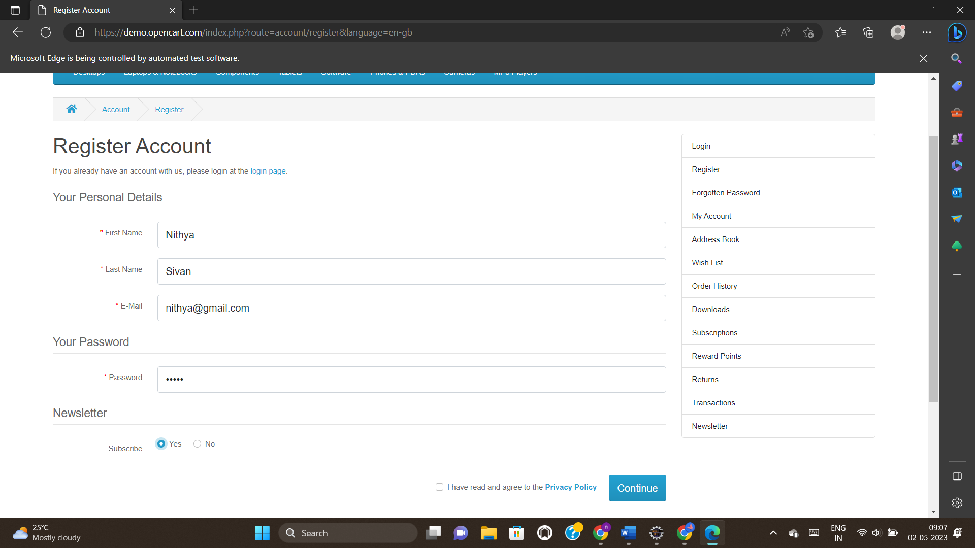



package com.selenium.cse;

import org.openqa.selenium.By;

import org.openqa.selenium.JavascriptExecutor;

import org.openqa.selenium.WebDriver;

import org.openqa.selenium.WebElement;

import org.openqa.selenium.edge.EdgeDriver;

import io.github.bonigarcia.wdm.WebDriverManager;

public class day4c2 {

public static void main(String[] args) throws Exception {

// TODO Auto-generated method stub

WebDriverManager.edgedriver().setup();

WebDriver driver = new EdgeDriver();

driver.get("https://demo.opencart.com/index.php?route=account/register&language=en-gb");

driver.manage().window().maximize();

Thread.sleep(3000);

JavascriptExecutor js = (JavascriptExecutor) driver;

js.executeScript("window.scrollBy(0,1000)","");

WebElement fn = driver.findElement(By.xpath("//*[@id=\"input-firstname\"]"));

fn.sendKeys("Nithya");

WebElement ln = driver.findElement(By.xpath("//*[@id=\"input-lastname\"]"));

ln.sendKeys("Sivan");

WebElement em = driver.findElement(By.xpath("//*[@id=\"input-email\"]"));

em.sendKeys("nithya@gmail.com");

WebElement pwd = driver.findElement(By.xpath("//*[@id=\"input-password\"]"));

pwd.sendKeys("{jhgj;");

WebElement sub = driver.findElement(By.xpath("//*[@id=\"input-newsletter-yes\"]"));

sub.click();

driver.quit();

}

}

OUTPUT:

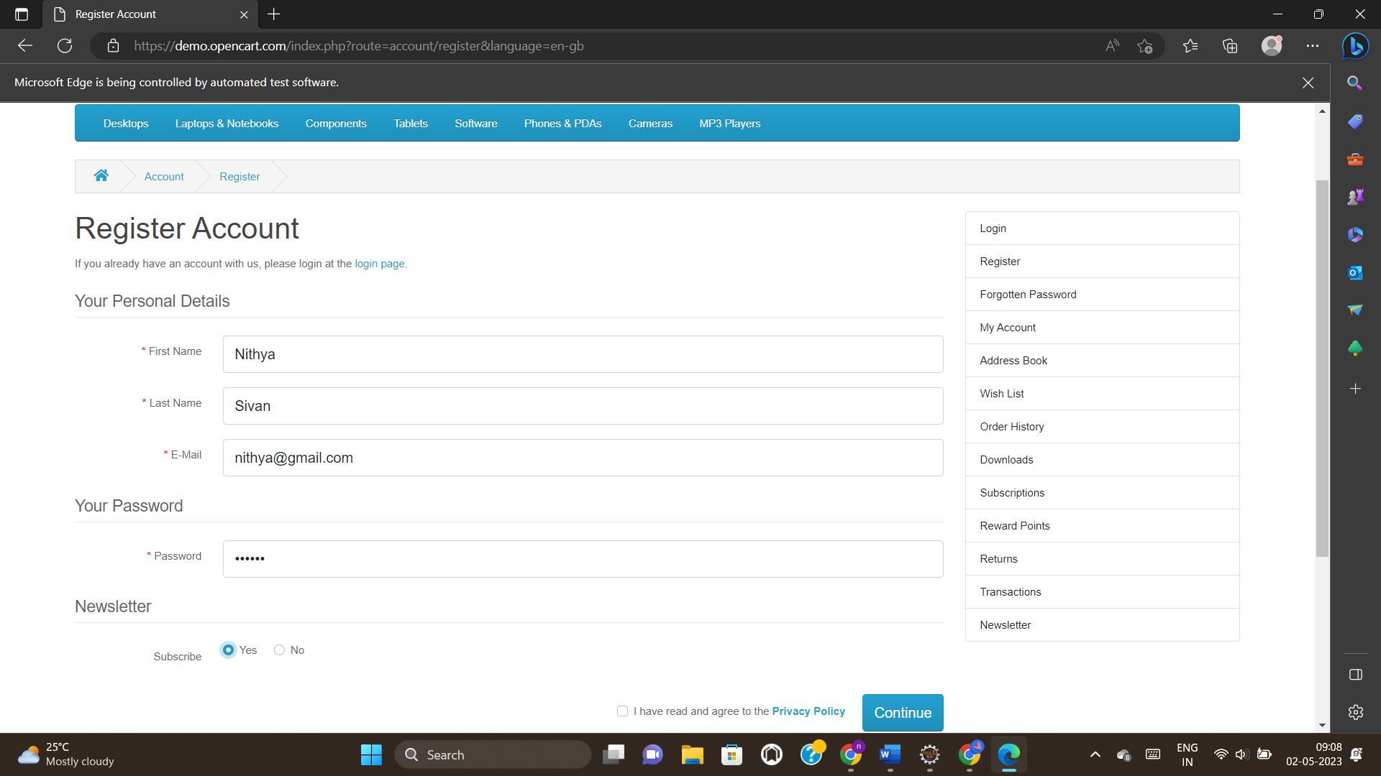



package com.selenium.cse;

import org.openqa.selenium.By;

import org.openqa.selenium.JavascriptExecutor;

import org.openqa.selenium.WebDriver;

import org.openqa.selenium.edge.EdgeDriver;

import io.github.bonigarcia.wdm.WebDriverManager;

public class day4c3 {

public static void main(String[] args) throws Exception {

WebDriverManager.edgedriver().setup();

WebDriver driver = new EdgeDriver();

driver.get("https://j2store.net/free/");

driver.manage().window().maximize();

Thread.sleep(3000);

JavascriptExecutor js = (JavascriptExecutor) driver;

js.executeScript("window.scrollBy(0,1000)","");

driver.findElement(By.linkText("Clothing (5)")).click();

driver.navigate().back();

Thread.sleep(3000);

driver.navigate().forward();

Thread.sleep(3000);

driver.navigate().refresh();

driver.quit();

}

}

OUTPUT:

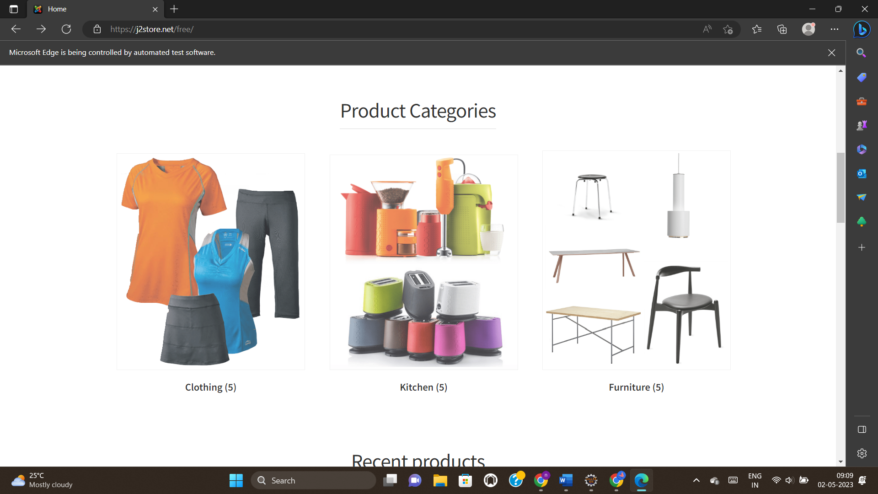

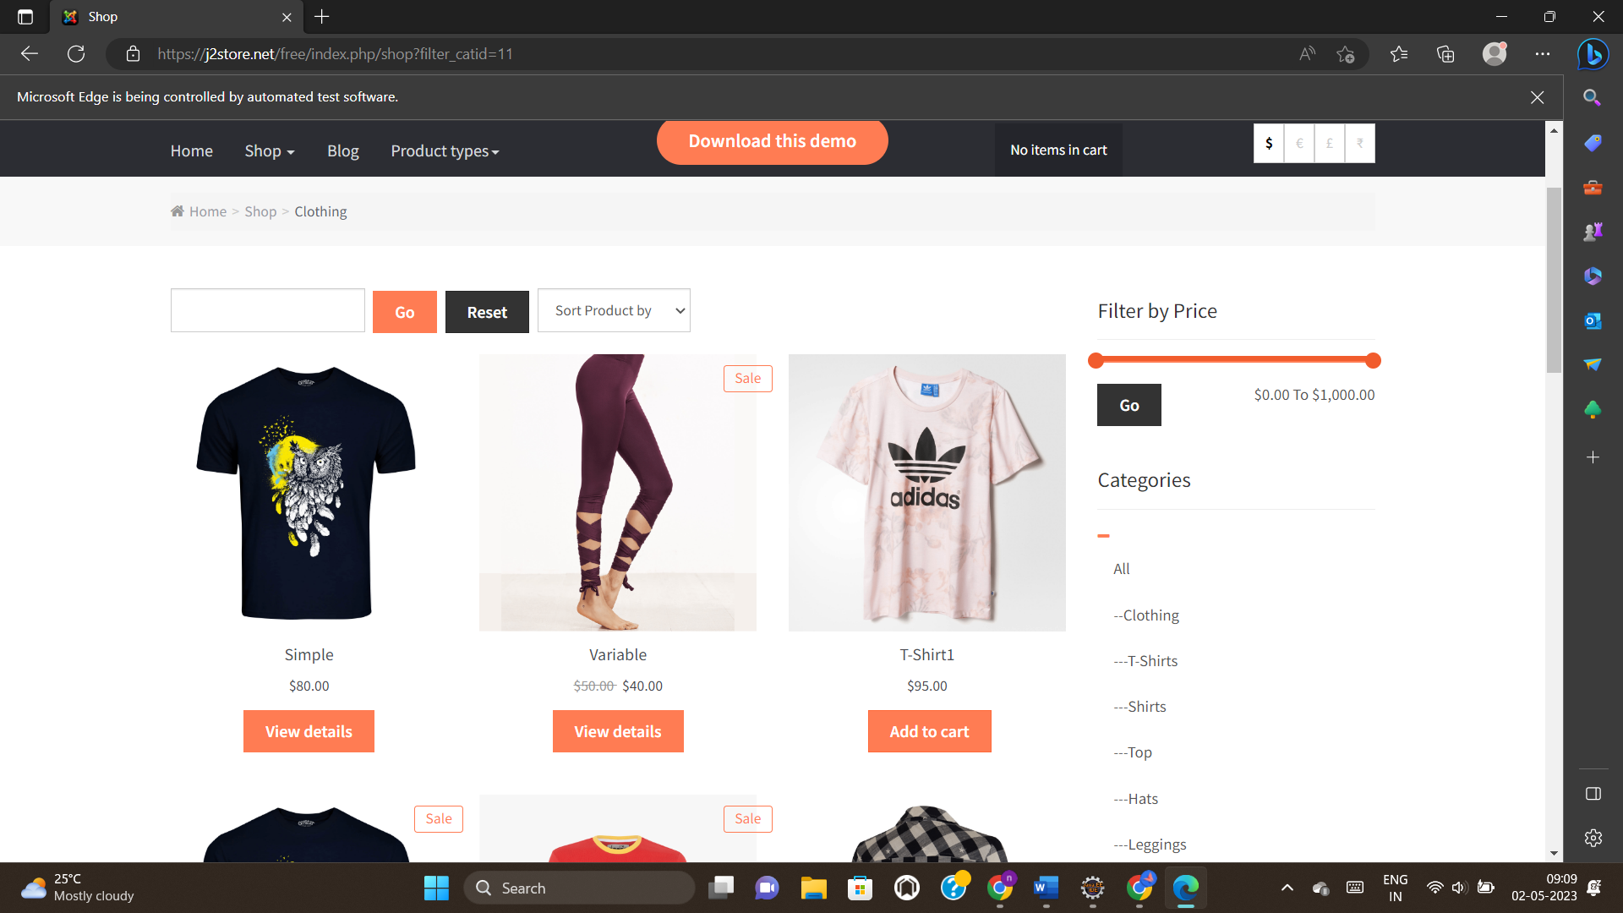



package com.selenium.cse;

import org.openqa.selenium.By;

import org.openqa.selenium.JavascriptExecutor;

import org.openqa.selenium.WebDriver;

import org.openqa.selenium.edge.EdgeDriver;

import io.github.bonigarcia.wdm.WebDriverManager;

public class day4C4 {

public static void main(String[] args) throws Exception {

WebDriverManager.edgedriver().setup();

WebDriver driver = new EdgeDriver();

driver.get("https://j2store.net/free/");

driver.manage().window().maximize();

Thread.sleep(3000);

JavascriptExecutor js = (JavascriptExecutor) driver;

js.executeScript("window.scrollBy(0,1000)","");

String t1 = driver.getCurrentUrl();

String t2 = "https://j2store.net/free/";

System.out.println(t1);

if(t1.equals(t2)) {

System.out.println("Correct URL");

}

else {

System.out.println("Incorrect URL");

}

driver.findElement(By.linkText("Clothing (5)")).click();

String t3 = driver.getCurrentUrl();

String t4 = "https://j2store.net/free/index.php/shop?filter_catid=11";

System.out.println(t3);

if(t3.equals(t4)) {

System.out.println("Right URL");

}

else {

System.out.println("Wrong URL");

}

}

}

OUTPUT:

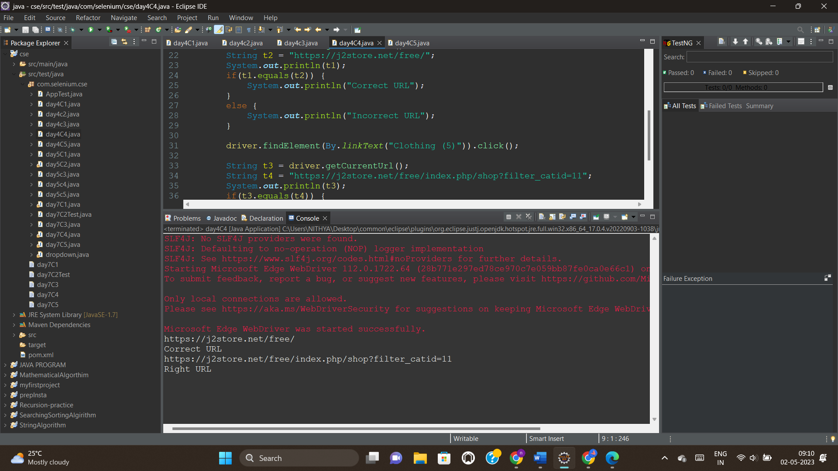



package com.selenium.cse;

import java.util.List;

import org.openqa.selenium.By;

import org.openqa.selenium.JavascriptExecutor;

import org.openqa.selenium.WebDriver;

import org.openqa.selenium.WebElement;

import org.openqa.selenium.edge.EdgeDriver;

import io.github.bonigarcia.wdm.WebDriverManager;

public class day4C5 {

public static void main(String[] args) throws Exception {

// TODO Auto-generated method stub

WebDriverManager.edgedriver().setup();

WebDriver driver = new EdgeDriver();

driver.get("https://j2store.net/free/");

driver.manage().window().maximize();

Thread.sleep(3000);

JavascriptExecutor js = (JavascriptExecutor) driver;

js.executeScript("window.scrollBy(0,1000)","");

driver.findElement(By.linkText("Clothing (5)")).click();

List<WebElement> l1 = driver.findElements(By.xpath("//h2[@class=\"product-title\"]"));

for(WebElement link:l1) {

System.out.println(link.getText());

}

}

}

OUTPUT:

