package com.selenium.cse;

import org.testng.annotations.Test;

import junit.framework.Assert;

import org.testng.annotations.DataProvider;

public class day9c1 {

@Test(dataProvider = "dp")

public void add(Integer n, Integer s) {

System.out.println(n+s);

// Assert.assertEquals(12,n+s );

}

@Test(dataProvider = "dp")

public void sub(Integer n, Integer s) {

System.out.println(n-s);

}

@Test(dataProvider = "dp")

public void multi(Integer n, Integer s) {

System.out.println(n\*s);

}

@Test(dataProvider = "dp")

public void div(Integer n, Integer s) {

System.out.println(n/s);

}

@Test(dataProvider = "dp")

public void mod(Integer n, Integer s) {

System.out.println(n%s);

}

@DataProvider

public Object[][] dp() {

return new Object[][] {

new Object[] { 10, 2 },

new Object[] { 9, 3},

};

}

}

OUTPUT:

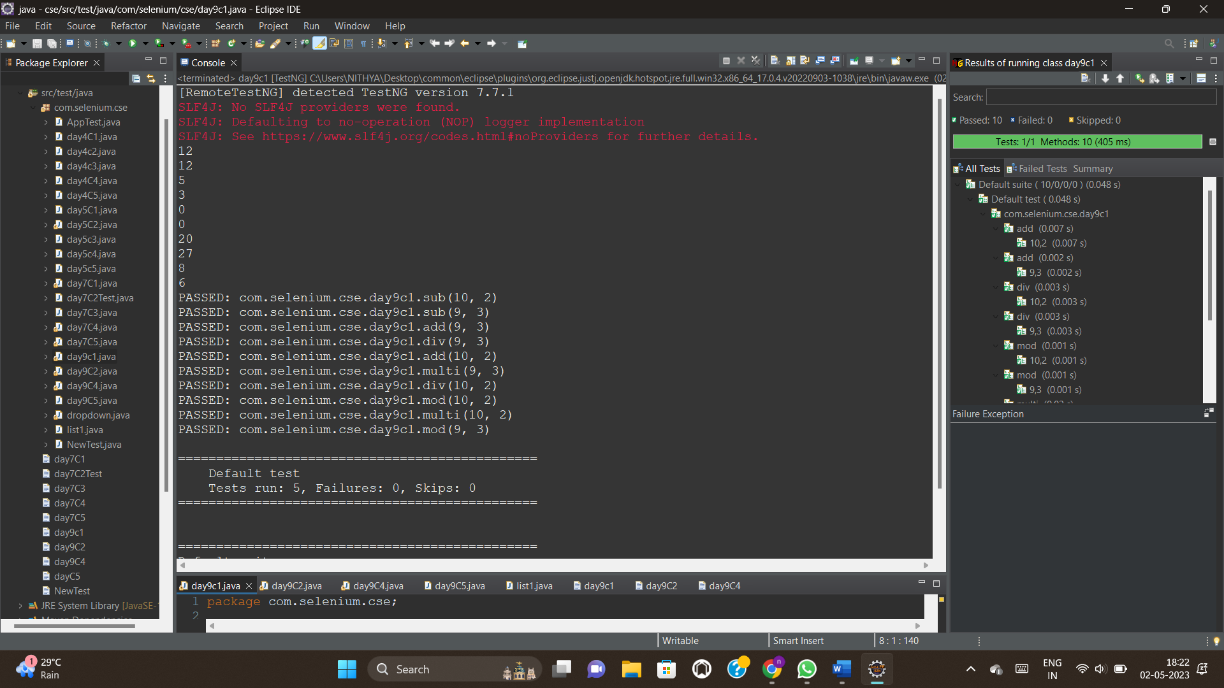

1. & (3)

package com.selenium.cse;

import java.util.concurrent.TimeUnit;

import org.openqa.selenium.By;

import org.openqa.selenium.WebDriver;

import org.openqa.selenium.chrome.ChromeDriver;

import org.openqa.selenium.chrome.ChromeOptions;

import org.testng.annotations.Test;

import io.github.bonigarcia.wdm.WebDriverManager;

import junit.framework.Assert;

public class day9C2 {

@Test

public void Test1() throws Exception {

WebDriverManager.chromedriver().setup();

WebDriver driver;

ChromeOptions co = new ChromeOptions();

co.addArguments("--remote-allow-origins=\*");

driver=new ChromeDriver(co);

driver.get("https://www.godaddy.com/en-in");

driver.manage().window().maximize();

Thread.sleep(3000);

String t1=driver.getTitle();

System.out.println(t1);

Assert.assertEquals(t1, "Domain Names, Websites, Hosting & Online Marketing Tools - GoDaddy IN");

String u1=driver.getCurrentUrl();

Assert.assertEquals(u1,"https://www.godaddy.com/en-in");

// driver.quit();

}

@Test

public void Test2() throws Exception {

WebDriverManager.chromedriver().setup();

WebDriver driver;

ChromeOptions co = new ChromeOptions();

co.addArguments("--remote-allow-origins=\*");

driver=new ChromeDriver(co);

driver.get("https://www.godaddy.com/en-in");

driver.manage().window().maximize();

//Thread.sleep(3000);

driver.manage().timeouts().implicitlyWait(10,TimeUnit.SECONDS);

driver.findElement(By.xpath("//\*[@id=\"id-631b049a-e9c0-4d24-8710-c504745206dd\"]/div[2]/div[1]/ul/li[1]/button")).click();

driver.findElement(By.linkText("Domain Name Search")).click();

}

@Test

public void Test3() throws Exception {

System.out.println("in smoke test");

}

@Test

public void Test4() throws Exception {

System.out.println("in RegressionTest");

}

}

OUTPUT:

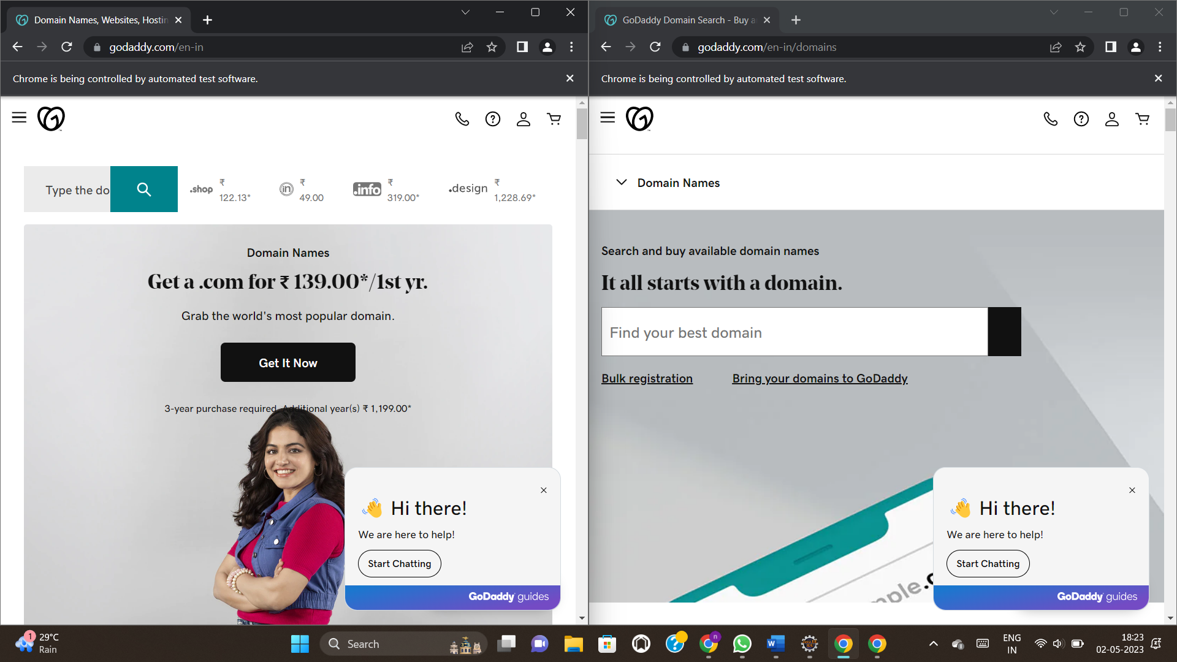



package com.selenium.cse;

//import org.junit.runners.Parameterized.Parameters;

import org.openqa.selenium.By;

import org.openqa.selenium.WebDriver;

import org.openqa.selenium.WebElement;

import org.openqa.selenium.chrome.ChromeDriver;

import org.openqa.selenium.chrome.ChromeOptions;

import org.openqa.selenium.edge.EdgeDriver;

import org.testng.AssertJUnit;

import org.testng.annotations.AfterMethod;

import org.testng.annotations.AfterTest;

import org.testng.annotations.BeforeMethod;

//import org.testng.annotations.Test;

import org.testng.annotations.Parameters;

import org.testng.annotations.Test;

import io.github.bonigarcia.wdm.WebDriverManager;

public class day9C4 {

WebDriver driver;

@Test

public void f() throws Exception {

Thread.sleep(3000);

WebElement username = driver.findElement(By.name("username"));

username.sendKeys("Admin");

WebElement password = driver.findElement(By.name("password"));

password.sendKeys("admin123");

WebElement login = driver.findElement(By.xpath("//\*[@id=\"app\"]/div[1]/div/div[1]/div/div[2]/div[2]/form/div[3]/button"));

login.submit();

Thread.sleep(3000);

AssertJUnit.assertEquals(driver.getCurrentUrl(),"https://opensource-demo.orangehrmlive.com/web/index.php/dashboard/index");

}

@Parameters("browser")

@BeforeMethod

public void beforeMethod(String b1) {

if(b1.equals("chrome")) {

WebDriverManager.chromedriver().setup();

ChromeOptions co = new ChromeOptions();

co.addArguments("--remote-allow-origins=\*");

driver = new ChromeDriver();

driver.manage().window().maximize();

String url="https://opensource-demo.orangehrmlive.com/web/index.php/auth/login";

driver.get(url);

driver.manage().window().maximize();

}

else if(b1.equals("edge")) {

WebDriverManager.edgedriver().setup();

driver = new EdgeDriver();

driver.manage().window().maximize();

driver.get("https://opensource-demo.orangehrmlive.com/web/index.php/auth/login");

}

}

@AfterTest

public void afterMethod() {

driver.quit();

}

}

XML:

<?xml version="1.0" encoding="UTF-8"?>

<suite parallel="false" name="Suite">

<parameter name="browser" value="chrome"/>

<test name="Test">

<classes>

<class name="com.selenium.cse.day9C4"/>

</classes>

</test> <!-- Test -->

</suite> <!-- Suite -->

LISTENER:

package com.selenium.cse;

import org.testng.ITestContext;

import org.testng.ITestListener;

import org.testng.ITestResult;

public class list1 implements ITestListener {

@Override

public void onTestStart(ITestResult result) {

// TODO Auto-generated method stub

System.out.println("Test Started...");

}

@Override

public void onTestSuccess(ITestResult result) {

// TODO Auto-generated method stub

System.out.println("Test Success...");

}

@Override

public void onTestFailure(ITestResult result) {

// TODO Auto-generated method stub

System.out.println("Test Failed...");

}

@Override

public void onTestSkipped(ITestResult result) {

// TODO Auto-generated method stub

System.out.println("Test skipped...");

}

@Override

public void onStart(ITestContext context) {

// TODO Auto-generated method stub

System.out.println("Test Finished....");

}

}



package com.selenium.cse;

import org.openqa.selenium.By;

import org.openqa.selenium.WebDriver;

import org.openqa.selenium.WebElement;

import org.openqa.selenium.edge.EdgeDriver;

import org.testng.AssertJUnit;

import org.testng.annotations.AfterTest;

import org.testng.annotations.BeforeTest;

import org.testng.annotations.Test;

import io.github.bonigarcia.wdm.WebDriverManager;

public class day9C5 {package com.selenium.Cse1;

import org.openqa.selenium.By;

import org.openqa.selenium.WebDriver;

import org.openqa.selenium.WebElement;

import org.openqa.selenium.chrome.ChromeDriver;

import org.openqa.selenium.chrome.ChromeOptions;

import org.testng.annotations.AfterMethod;

import org.testng.annotations.BeforeMethod;

import org.testng.annotations.Test;

import io.github.bonigarcia.wdm.WebDriverManager;

public class D9C5 {

WebDriver driver;

@Test

public void f() throws Exception {

String url="https://opensource-demo.orangehrmlive.com/web/index.php/auth/login";

driver.get(url);

Thread.sleep(3000);

WebElement uname=driver.findElement(By.name("username"));

WebElement pwd=driver.findElement(By.name("password"));

WebElement submit=driver.findElement(By.xpath("//\*[@class='oxd-button oxd-button--medium oxd-button--main orangehrm-login-button']"));

uname.sendKeys("Suvitha");

pwd.sendKeys("12345");

submit.click();

String url1="https://opensource-demo.orangehrmlive.com/web/index.php/dashboard/index";

}

@BeforeMethod

public void beforeMethod() {

WebDriverManager.chromedriver().setup();

ChromeOptions co = new ChromeOptions();

co.addArguments("--remote-allow-origins=\*");

driver=new ChromeDriver(co);

}

@AfterMethod

public void afterMethod() {

driver.close();

}

}

}

XML:

<?xml version="1.0" encoding="UTF-8"?>

<suite parallel="false" name="Suite">

<listeners>

<listener class-name="com.selenium.Cse1.list1">

</listener>

</listeners>

<test name="Test">

<classes>

<class name="com.selenium.Cse1.D9C5"/>

</classes>

</test> <!-- Test -->

</suite> <!-- Suite -->