package com.selenium.cse;

import org.openqa.selenium.By;

import org.openqa.selenium.JavascriptExecutor;

import org.openqa.selenium.WebDriver;

import org.openqa.selenium.WebElement;

import org.openqa.selenium.edge.EdgeDriver;

import org.openqa.selenium.interactions.Actions;

import io.github.bonigarcia.wdm.WebDriverManager;

public class day5C1 {

public static void main(String[] args) throws Exception {

// TODO Auto-generated method stub

WebDriverManager.edgedriver().setup();

WebDriver driver = new EdgeDriver();

driver.get("https://demoqa.com/droppable/");

driver.manage().window().maximize();

Thread.sleep(3000);

JavascriptExecutor js = (JavascriptExecutor) driver;

js.executeScript("window.scrollBy(0,1000)","");

Actions a = new Actions(driver);

WebElement drag = driver.findElement(By.id("draggable"));

WebElement drop = driver.findElement(By.id("droppable"));

a.clickAndHold(drag).release(drop).build().perform();

}

}

OUTPUT:

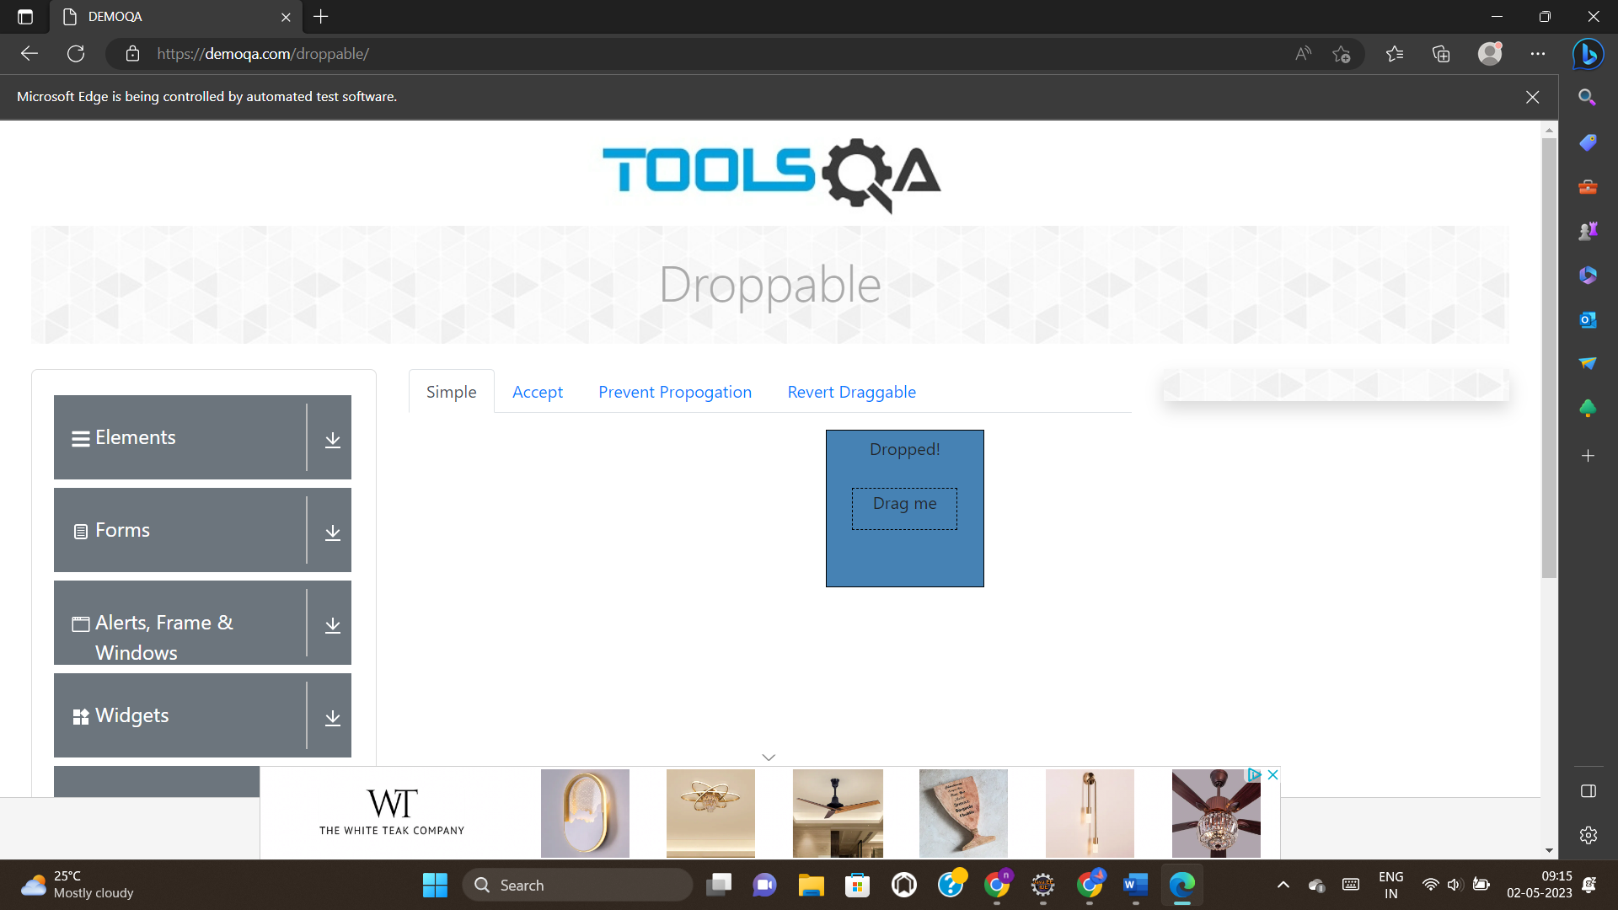



package com.selenium.cse;

import org.openqa.selenium.By;

import org.openqa.selenium.JavascriptExecutor;

import org.openqa.selenium.WebDriver;

import org.openqa.selenium.WebElement;

import org.openqa.selenium.edge.EdgeDriver;

import org.openqa.selenium.interactions.Actions;

import io.github.bonigarcia.wdm.WebDriverManager;

public class day5C2 {

public static void main(String[] args) throws Exception {

// TODO Auto-generated method stub

WebDriverManager.edgedriver().setup();

WebDriver driver = new EdgeDriver();

driver.get("https://jqueryui.com/droppable/");

driver.manage().window().maximize();

Thread.sleep(3000);

// JavascriptExecutor js = (JavascriptExecutor) driver;

// js.executeScript("window.scrollBy(0,1000)","");

driver.switchTo().frame(0);

Actions a = new Actions(driver);

WebElement drag = driver.findElement(By.id("draggable"));

WebElement drop = driver.findElement(By.id("droppable"));

a.clickAndHold(drag).release(drop).build().perform();

}

}

OUTPUT:

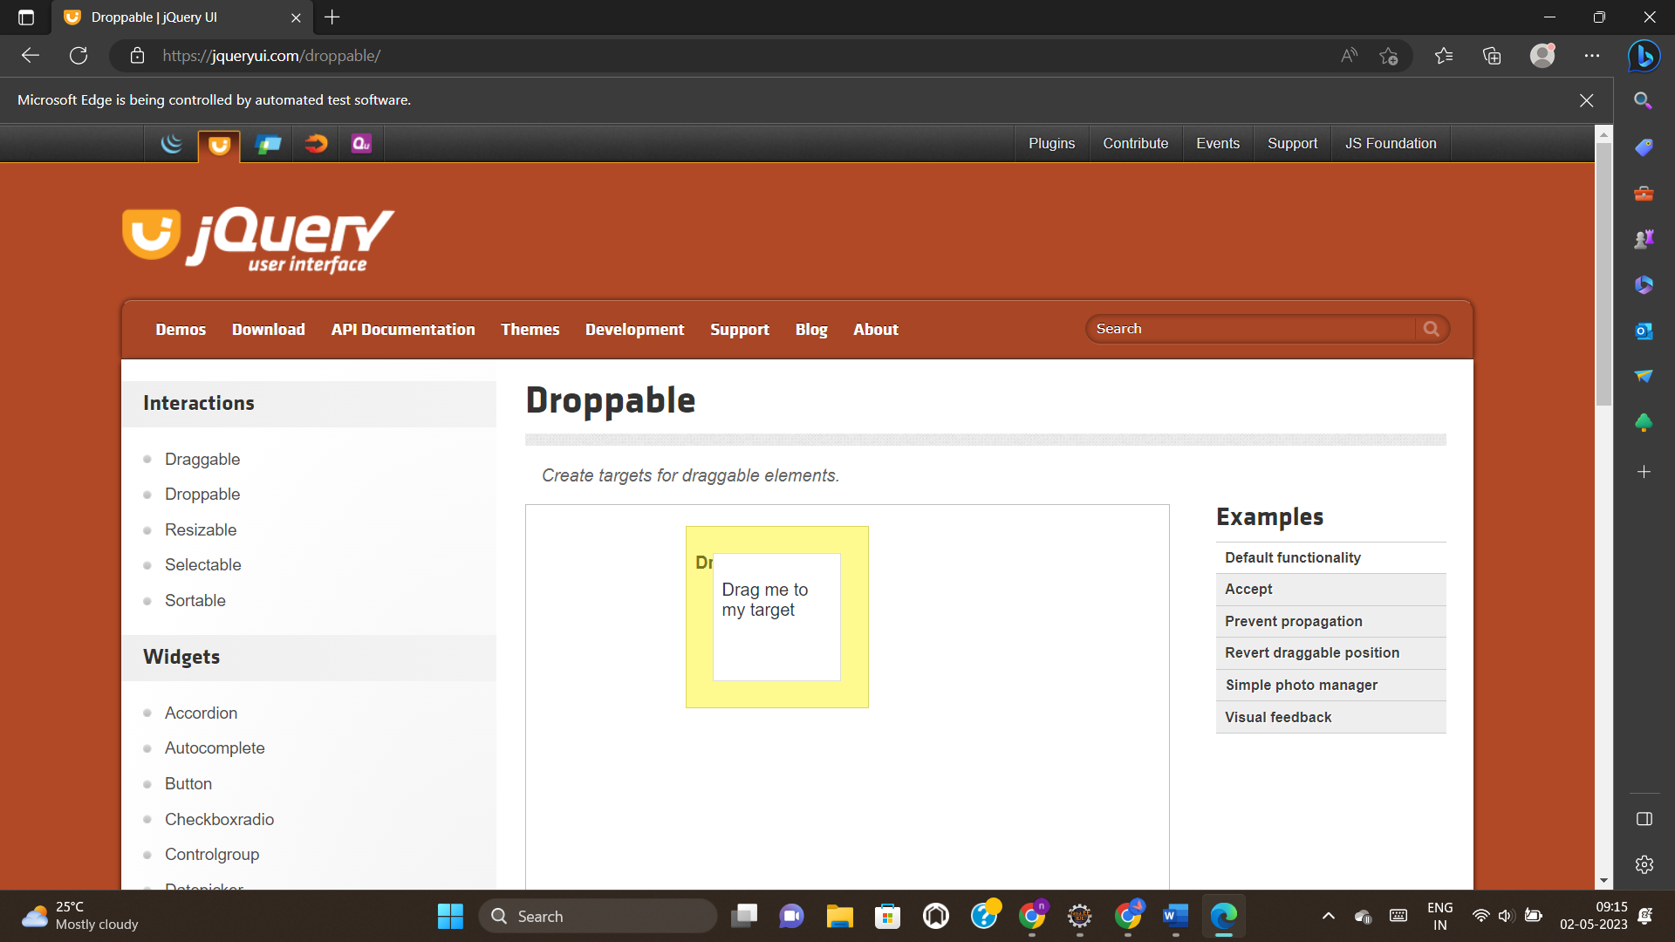



package com.selenium.cse;

import org.openqa.selenium.Alert;

import org.openqa.selenium.By;

import org.openqa.selenium.WebDriver;

import org.openqa.selenium.WebElement;

import org.openqa.selenium.edge.EdgeDriver;

import io.github.bonigarcia.wdm.WebDriverManager;

public class day5c3 {

public static void main(String[] args) throws Exception {

// TODO Auto-generated method stub

WebDriverManager.edgedriver().setup();

WebDriver driver = new EdgeDriver();

driver.get("https://demo.guru99.com/test/delete_customer.php");

driver.manage().window().maximize();

// Thread.sleep(3000);

WebElement text1 = driver.findElement(By.name("cusid"));

text1.sendKeys("401");

WebElement sub = driver.findElement(By.name("submit"));

sub.submit();

Alert alert1 = driver.switchTo().alert();

alert1.dismiss();

text1.clear();

text1.sendKeys("402");

sub.submit();

Alert alert2 = driver.switchTo().alert();

alert2.accept();

Alert alert3 = driver.switchTo().alert();

String text = alert3.getText();

alert3.accept();

System.out.println(text);

}

}

OUTPUT:

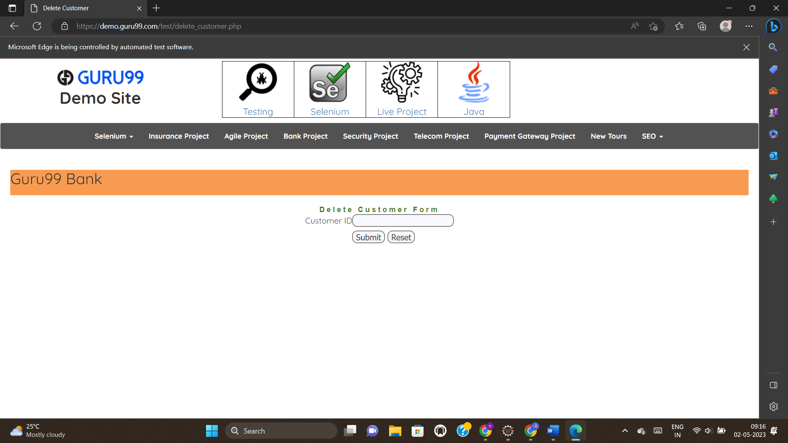



package com.selenium.cse;

import org.openqa.selenium.By;

import org.openqa.selenium.JavascriptExecutor;

import org.openqa.selenium.WebDriver;

import org.openqa.selenium.WebElement;

import org.openqa.selenium.edge.EdgeDriver;

import io.github.bonigarcia.wdm.WebDriverManager;

public class day5c4 {

public static void main(String[] args) throws Exception {

// TODO Auto-generated method stub

// TODO Auto-generated method stub

WebDriverManager.edgedriver().setup();

WebDriver driver = new EdgeDriver();

driver.get("https://www.abhibus.com/bus-ticket-booking");

driver.manage().window().maximize();

Thread.sleep(3000);

// JavascriptExecutor js = (JavascriptExecutor) driver;

// js.executeScript("window.scrollBy(0,1000)","");

WebElement lf = driver.findElement(By.id("source"));

lf.sendKeys("Coimbatore");

WebElement gt = driver.findElement(By.id("destination"));

gt.sendKeys("Hosur");

WebElement dp = driver.findElement(By.xpath("//*[@id=\"datepicker1\"]"));

JavascriptExecutor js = (JavascriptExecutor) driver;

js.executeScript("arguments[0].setAttribute('value','26/04/2023')",dp);

}

}

OUTPUT:

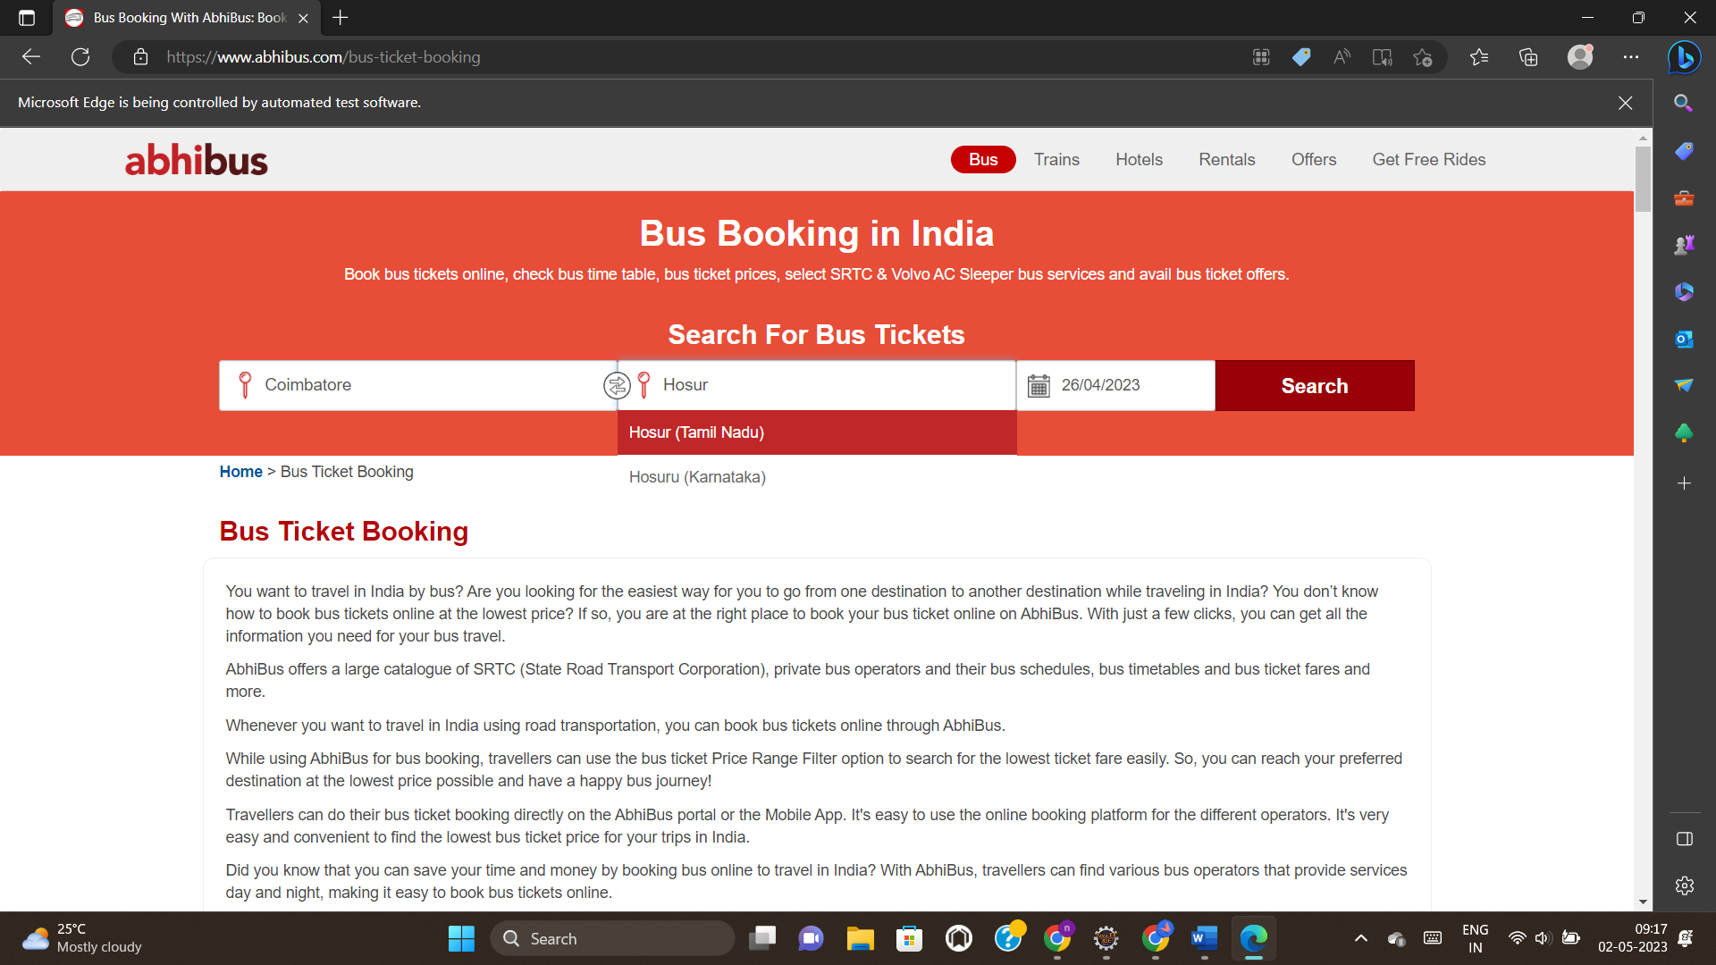



package com.selenium.cse;

import java.util.Set;

import org.openqa.selenium.By;

import org.openqa.selenium.Keys;

import org.openqa.selenium.WebDriver;

import org.openqa.selenium.WebElement;

import org.openqa.selenium.WindowType;

import org.openqa.selenium.edge.EdgeDriver;

import io.github.bonigarcia.wdm.WebDriverManager;

public class day5c5 {

public static void main(String[] args) throws Exception {

// TODO Auto-generated method stub

WebDriverManager.edgedriver().setup();

WebDriver driver = new EdgeDriver();

driver.get("https://www.google.com/");

driver.manage().window().maximize();

WebElement fb = driver.findElement(By.id("APjFqb"));

fb.sendKeys("Apple");

driver.findElement(By.id("APjFqb")).sendKeys(Keys.ENTER);

Thread.sleep(3000);

String t1 = driver.getTitle();

System.out.println(t1);

String i1 = driver.getWindowHandle();

System.out.println(i1);

driver.switchTo().newWindow(WindowType.TAB);

driver.get("https://www.google.com/");

driver.manage().window().maximize();

WebElement sb = driver.findElement(By.id("APjFqb"));

sb.sendKeys("Selenium");

driver.findElement(By.id("APjFqb")).sendKeys(Keys.ENTER);

Thread.sleep(3000);

String t2 = driver.getTitle();

System.out.println(t2);

String i2 = driver.getWindowHandle();

System.out.println(i2);

driver.switchTo().newWindow(WindowType.TAB);

driver.get("https://www.google.com/");

driver.manage().window().maximize();

WebElement tb = driver.findElement(By.id("APjFqb"));

tb.sendKeys("Cucumber");

driver.findElement(By.id("APjFqb")).sendKeys(Keys.ENTER);

Thread.sleep(3000);

String t3 = driver.getTitle();

System.out.println(t3);

String i3 = driver.getWindowHandle();

System.out.println(i3);

Set<String> s = driver.getWindowHandles();

System.out.println("Number of tabs opened: "+s.size());

}

}

OUTPUT:

