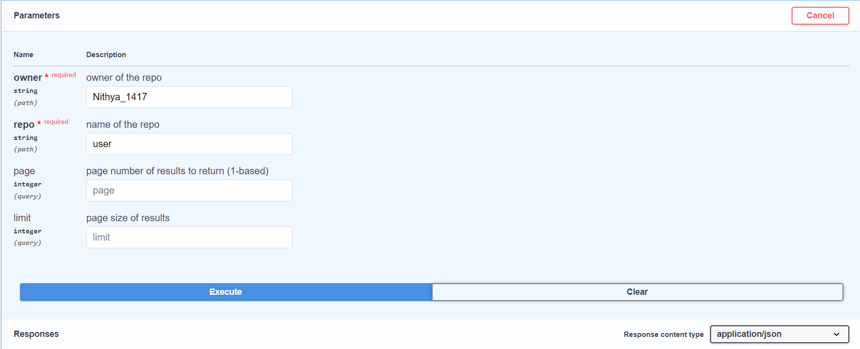

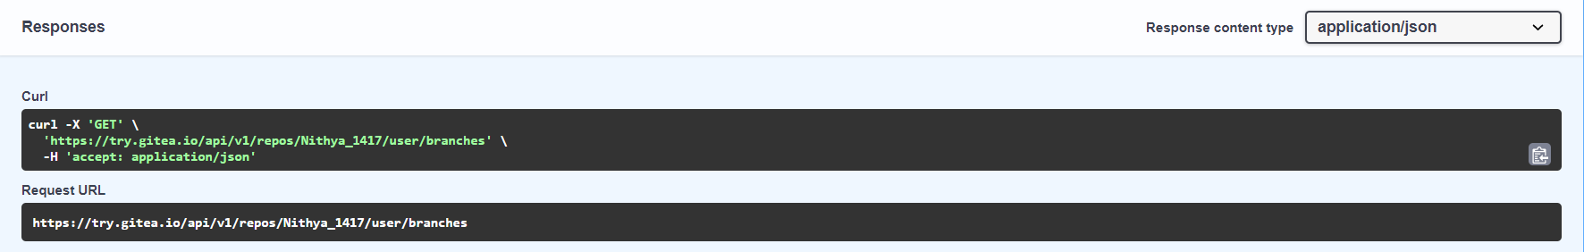

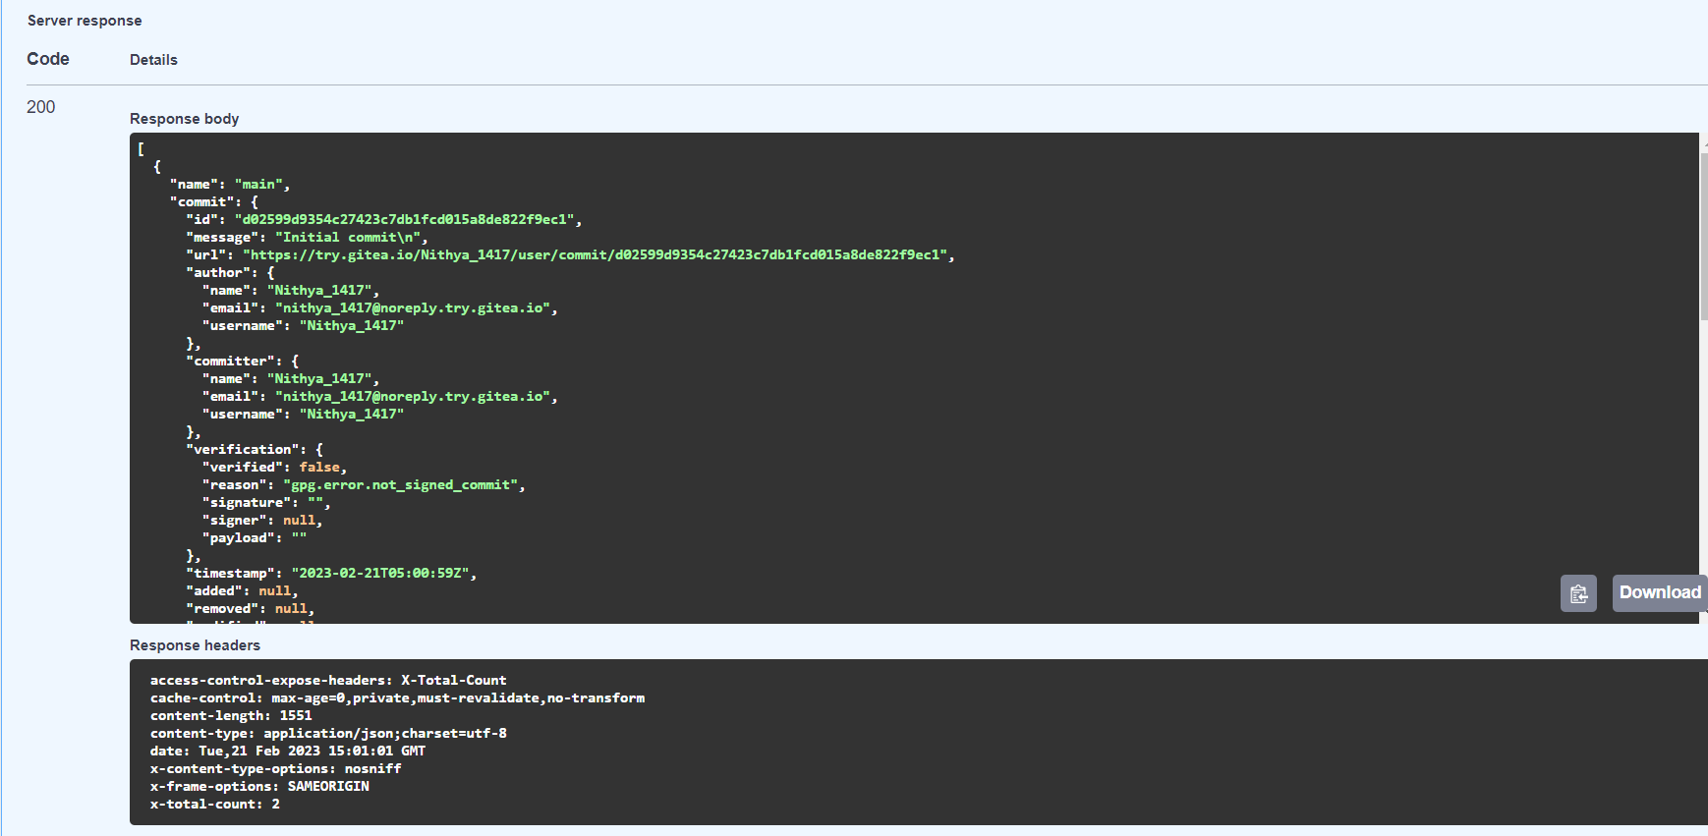

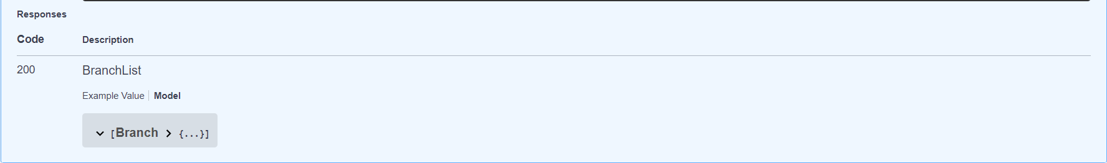

Response Body:

[

{

"name": "main",

"commit": {

"id": "d02599d9354c27423c7db1fcd015a8de822f9ec1",

"message": "Initial commit\n",

"url": "https://try.gitea.io/Nithya_1417/user/commit/d02599d9354c27423c7db1fcd015a8de822f9ec1",

"author": {

"name": "Nithya_1417",

"email": "nithya_1417@noreply.try.gitea.io",

"username": "Nithya_1417"

},

"committer": {

"name": "Nithya_1417",

"email": "nithya_1417@noreply.try.gitea.io",

"username": "Nithya_1417"

},

"verification": {

"verified": false,

"reason": "gpg.error.not_signed_commit",

"signature": "",

"signer": null,

"payload": ""

},

"timestamp": "2023-02-21T05:00:59Z",

"added": null,

"removed": null,

"modified": null

},

"protected": false,

"required_approvals": 0,

"enable_status_check": false,

"status_check_contexts": [],

"user_can_push": false,

"user_can_merge": false,

"effective_branch_protection_name": ""

},

{

"name": "user2",

"commit": {

"id": "d02599d9354c27423c7db1fcd015a8de822f9ec1",

"message": "Initial commit\n",

"url": "https://try.gitea.io/Nithya_1417/user/commit/d02599d9354c27423c7db1fcd015a8de822f9ec1",

"author": {

"name": "Nithya_1417",

"email": "nithya_1417@noreply.try.gitea.io",

"username": "Nithya_1417"

},

"committer": {

"name": "Nithya_1417",

"email": "nithya_1417@noreply.try.gitea.io",

"username": "Nithya_1417"

},

"verification": {

"verified": false,

"reason": "gpg.error.not_signed_commit",

"signature": "",

"signer": null,

"payload": ""

},

"timestamp": "2023-02-21T05:00:59Z",

"added": null,

"removed": null,

"modified": null

},

"protected": false,

"required_approvals": 0,

"enable_status_check": false,

"status_check_contexts": [],

"user_can_push": false,

"user_can_merge": false,

"effective_branch_protection_name": ""

}

]