Work on each task should be presented in the designated section for that task.

## Task 1 i) – Perform appropriate checks on the claims data that have been provided. If necessary, make any changes to the data. Show your result (6 points)

* Fix the #Record 44 and 61 from -1110 and 618500000 to 1110 and 6185 respectively.

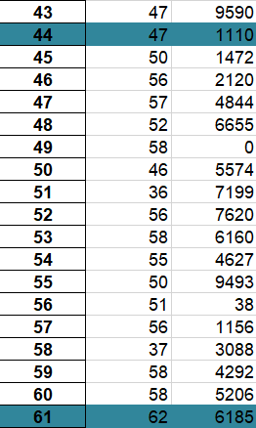

## Task 1 ii) – Calculate the ratio of actual claim amounts against expected claim amounts (A/E) for each age band (using the average age at each age band) and also at the total portfolio level. Show your result (12 points)

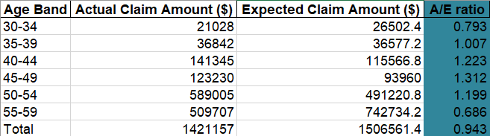

## Task 1 iii) – Use the calculated A/E ratio at the total portfolio level to adjust the mortality table as required and hence determine the assurance factors and annuity factors that are required to calculate the premium rates for each age band. Show your result (24 points)

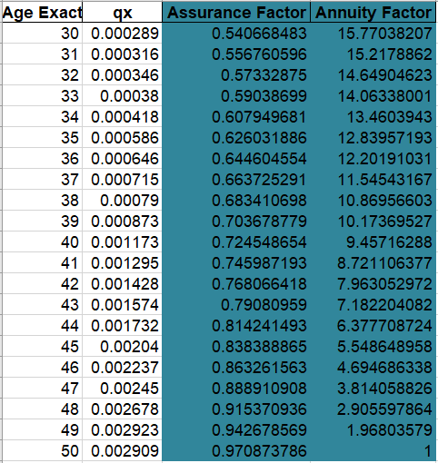

## Task 1 iv) – According to your choice in (iv), determine the net premium rate & gross premium rate for each age band, using these factors. Which of the above type of premium should be used as customer actual pay? Justify your choice (12 points)

* The Gross Premium should be used as customer actual pay because it is the amount expected to be received by the insurer over the life of the policy term. On the other hand, the Net Premium has been reduced because the insurer has to pay for other costs.

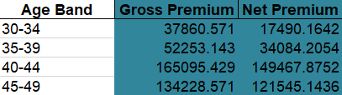

## Task 1 v) – Determine the overall weighted average premium rate and the total new business premium expected in 2022. Show your result (6 points)

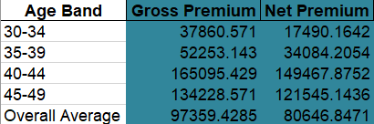

## Task 2 Write a memo to your manager to describe the model including: purpose, data and assumptions used, methodology, i.e. description of how each calculation stage in the model has been produced, explanation of any checks performed. (30 points)

* **Purpose:** PVA is a growing life insurance company that writes various types of business, including term assurance policies. Term assurance policies are life insurance policies which pay out a lump sum, known as the sum assured, if the policyholder dies during the term of the policy. All term assurance policies that have been issued by PVA have a term of 10 years and so are referred to as T-10 policies. PVA is currently considering its business plan for 2022 and wants to determine the level annual premium rates which should be charged for T-10 policies in 2022.
* **Data input:** Include 4 worksheet:
  + Exposure: Provides details of the amounts exposed to risk during the investigation period. This is grouped in five year age bands, where age *x* denotes the exposed to risk period from age *x* exact to age *x*+1 exact.
  + Claims: Provides details of each of the claims that occurred during the investigation period. This includes the age at the time of the claim and the claim amount. Age *x* at the time of the claim is equivalent to age *x* exactly at the start of the policy year in which the claim was made.
  + New Business: Provided details of the T-10 business that it expects to write during 2022. The expected new business has been split by age band (which denotes age exact at entry). The expected new business refers to percentage of the total sum assured expected to be written in each age band. The Sales department has indicated that it expects to write new business in 2022 for a total sum assured of $220m.
  + Mortality Table: Provides initial rates of mortality split by age exact.
* **Data solution:** Include 4 worksheet:
  + New Claims: Correct some typos or error data from “Claims” worksheet above.
  + AE Ratio: Calculate the ratio of actual claim amounts against expected claim amounts (A/E) for each age band (using the average age at each age band) and also at the total portfolio level.
  + Adj qx - Assurance – Annuity: This worksheet includes the adjusted mortality table based on A/E ratio, assurance factors and annuity factors that are required to calculate the premium rates for each age band.
  + Premium 2022: Include level Gross Premium and Net Premium for each age band and also at the total portfolio level.
* **Methodology:** 
  + For convenience in data processing, I used Python programming to clean and wrangle data for this problem. For more details visit my source code [].
  + When performing appropriate checks on the claims data that have been provided, I found that there are two records that seem very strange, a record is negative (-1110) and a record is very large (618500000), this may be a typos or error data , so I fixed them as 1110 and 6185 respectively.
  + To calculate the ratio of actual claim amounts against expected claim amounts (A/E) for each age band, first I build a function to convert age exactly to age band from the “Claims” worksheet, then I groupby total claim amount by each age band, and I called it “actual_claim”. I also apply the function above to the mortality table to groupby qx by age band and then multiply them to the Exposure to find “expected_claim”. When I have to table of actual_claim and expected_claim, I merge them into a table and take the actual_claim divide expected_claim to find the A/E ratio.
  + To adjust the mortality table, I take each value of A/E ratio of each age band then multiple with the px of mortality table, after that I shortcut the mortality table for age limit from 30 to 50 inclusive for calculate assurance factors and annuity factors. With these factors, I build two function using recursion to calculate.
  + To determine the gross premium rate for each age band, I take the expected claim amount then apply 30% margin. To determine the net premium, first I calculate expected PV of claim outgo by taking assurance factor multiply the maximum sum assured of the T-10 policies, then I calculate expected PV for a $1 which is payable at the beginning of the year by taking annuity factor multiply the amount of level annual premium required to purchase, finally I take the gross premium subtract these two expect PV to find the net premium of each age band and also find the overall average of gross premium and net premium.