ATR (Average True Range) is a technical indicator used in trading to measure market volatility—how much the price of an asset typically moves during a given period.
ATR was developed by J. Welles Wilder Jr. and is commonly used for stocks, forex, cryptocurrencies, and futures.
The key distinction is that ATR measures volatility, not price direction. It tells you how much the market moves, but not whether it will go up or down.
1. How does ATR work?
ATR measures the average True Range over a specified number of candles, typically 14 periods.
Illustrative example: ATR increasing as price swings widen
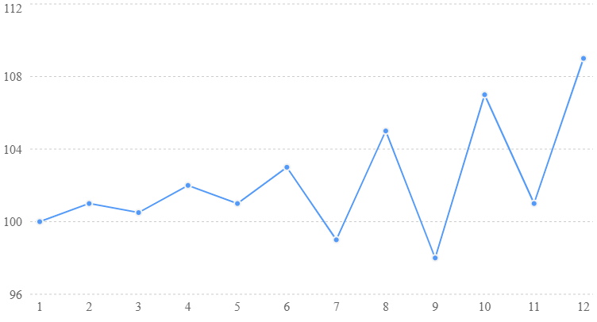
Illustrative data, not actual market prices
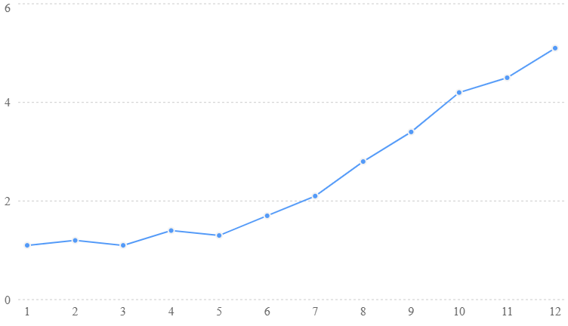
- High ATR: Large price movements and higher volatility.
- Low ATR: Smaller price movements and lower volatility.
- Rising ATR: Volatility is increasing.
- Falling ATR: Volatility is decreasing.
For example, if a stock trades at $100 and has an ATR of $2.50 on the daily chart, its recent average true range is approximately $2.50 per day.
This does not mean the price will necessarily move $2.50 tomorrow.
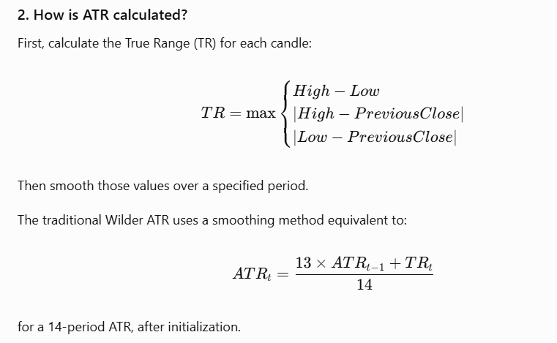

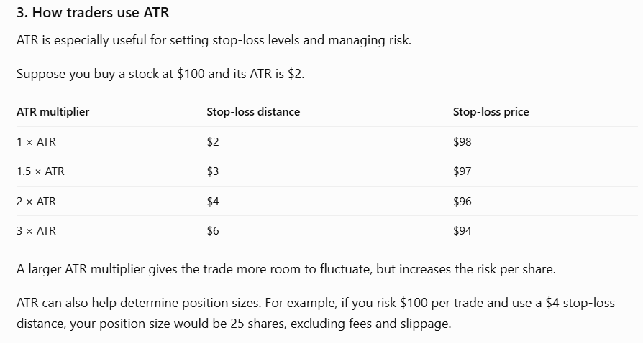
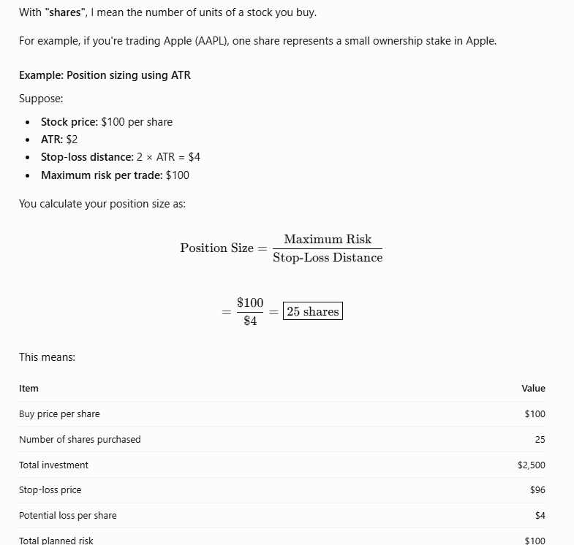

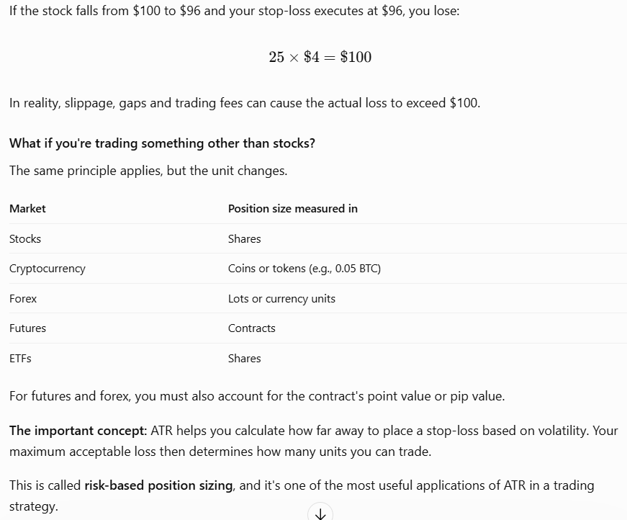

4. ATR in Python
Since you're developing trading indicators in Python, you can calculate ATR using pandas:
import pandas as pd

def calculate_atr(df, period=14):
high = df["High"]
low = df["Low"]
previous_close = df["Close"].shift(1)

tr = pd.concat([
high - low,
(high - previous_close).abs(),
(low - previous_close).abs()
], axis=1).max(axis=1)

atr = tr.ewm(
alpha=1 / period,
adjust=False
).mean()

return atr
This uses Wilder-style exponential smoothing, although its initial values can differ from a traditionally initialized Wilder ATR.
5. ATR versus other indicators
Indicator | Measures | Primary use
ATR | Volatility | Stop-losses, position sizing
RSI | Price momentum | Overbought/oversold conditions
MACD | Trend and momentum | Trend changes
Bollinger Bands | Price dispersion | Volatility and relative price levels
ADX | Trend strength | Identifying strong or weak trends
One particularly useful application for your trading indicator project: Combine ATR with your buy/sell signals.
For example, you could use RSI or MACD to generate a trading signal, ATR to determine an appropriate stop-loss distance, and your account risk limit to calculate position size.
This creates a more volatility-aware trading system than using a fixed percentage stop-loss for every trade.

