CRAVE-OFF
Native Ads Copy Set — Amazon Açaí Discovery Angle
20 creatives · US market · Taboola / Outbrain / MGID / Facebook

BRIEFING — FOR TRAFFIC MANAGER
Product: Crave-Off — Brazilian açaí-based supplement (appetite control + metabolism + cravings)
Audience: US women 35–55, failed diets, cravings, belly fat, post-pregnancy, perimenopause
Angle: Amazon açaí discovery — indigenous Brazilian tradition, tribal knowledge, berry the U.S. doesn’t have
Format: Native: 1200x628 image + headline ≤90 chars · FB: primary text 111–138 chars
Platforms: Taboola/Outbrain premium · MGID/RevContent lower-tier · FB: only #3, #10, #11, #12, #15, #17, #19
Compliance: No 'cure', 'guaranteed', 'Ozempic replacement'. Tone: editorial journalism + discovery story.
Launch priority: #7, #10, #16 first (strongest CTR projection). #8, #1, #2 second.
Frameworks: Schwartz Lvl 1–2 · Kennedy PAS · Caples testimonial/secret · Sugarman curiosity gap · Hopkins specificity (200 years, 27 days, 14 lbs)
Known issue: Creative #20: original image includes Coca-Cola branded bottles — TRADEMARK RISK. Regenerate without branded products before upload.

CREATIVE #01

TITLE (ANGLE) The Amazon Berry That Flattened Her Belly in 60 Days
HEADLINE (NATIVE ≤90) Her belly came back after 2 kids. An Amazon berry changed that. (63 chars)
DESCRIPTION (FACEBOOK/NATIVE) She avoided belly shots for 4 years. Then a Brazilian midwife told her the fruit Amazon women eat to stay flat. (111 chars)

CREATIVE #02
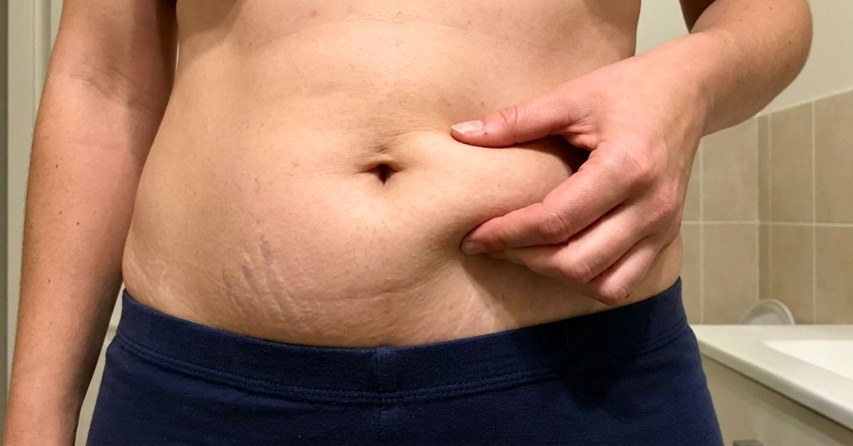
TITLE (ANGLE) She Pinched Her Belly in Shame. Then She Learned What Brazilian Women Do.
HEADLINE (NATIVE ≤90) She pinched her belly in shame. An Amazon berry ended the habit. (64 chars)
DESCRIPTION (FACEBOOK/NATIVE) U.S. women pinch. Brazilian women don't — they use one plant from the Amazon rainforest passed down for 3 generations. (118 chars)

CREATIVE #03
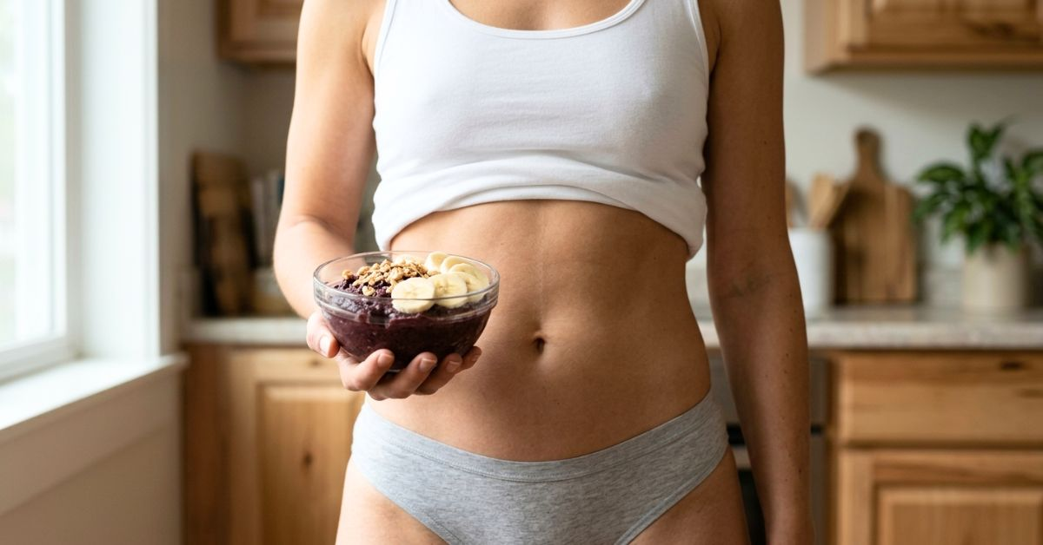
TITLE (ANGLE) The Kitchen Ritual Brazilian Women Over 40 Never Skip
HEADLINE (NATIVE ≤90) She added this to her breakfast. 27 days later she lost 14 pounds. (66 chars)
DESCRIPTION (FACEBOOK/NATIVE) An Amazon berry bowl is the simple routine behind firm Brazilian bellies. Thousands of U.S. women just started copying it. (122 chars)

CREATIVE #04
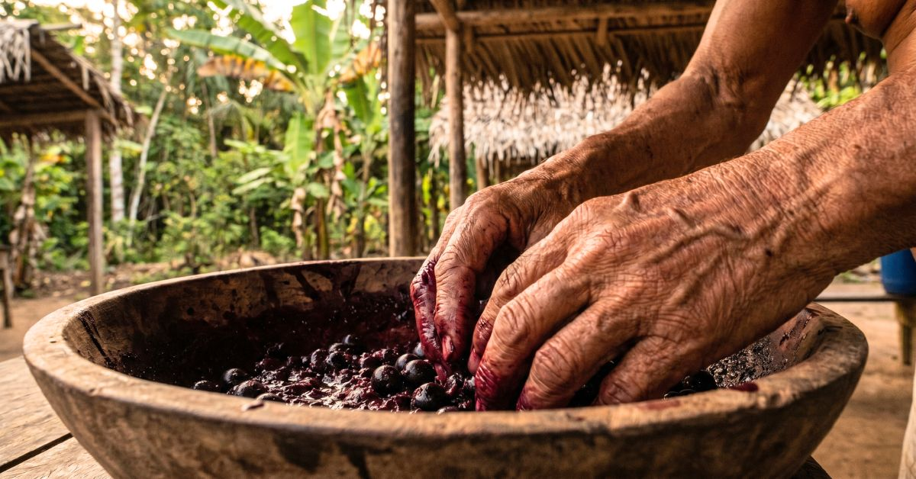
TITLE (ANGLE) The 200-Year-Old Amazon Ritual Finally Reaching the U.S.
HEADLINE (NATIVE ≤90) Hands that macerated this berry for 200 years. Finally in the U.S. (66 chars)
DESCRIPTION (FACEBOOK/NATIVE) The Brazilian Amazon practice of crushing açaí fresh is behind one of the fastest-growing discoveries in natural appetite control. (130 chars)

CREATIVE #05
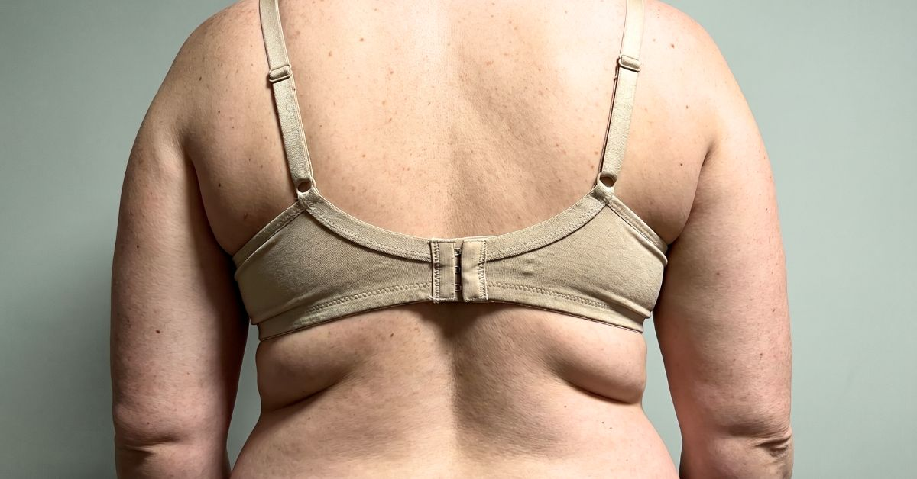
TITLE (ANGLE) The Back Fat That Made Her Hide — Until an Amazon Berry
HEADLINE (NATIVE ≤90) 3 years hiding her back fat. An Amazon berry changed the mirror. (64 chars)
DESCRIPTION (FACEBOOK/NATIVE) She stopped wearing tank tops for years. Her Brazilian friend showed her what Amazon women do — no diet, no gym, no surgery. (124 chars)

CREATIVE #06
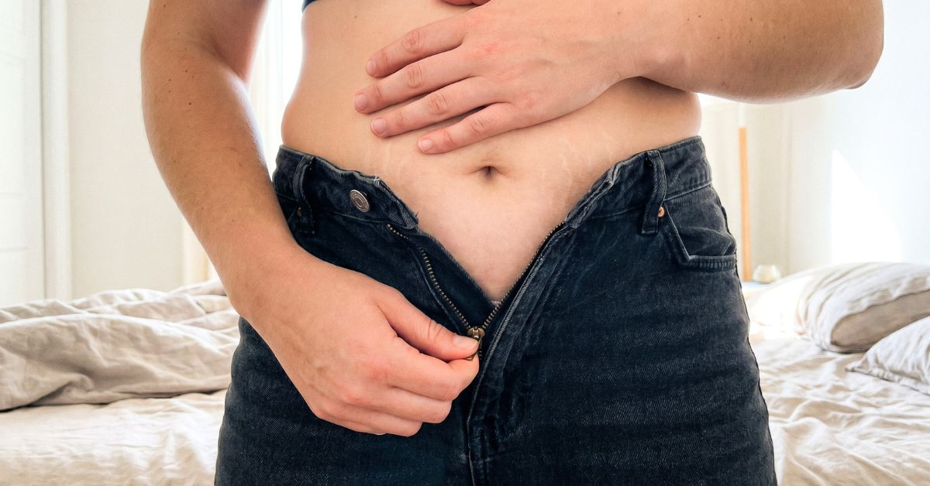
TITLE (ANGLE) The Morning She Couldn’t Zip Her Jeans — And the Amazon Berry She Found
HEADLINE (NATIVE ≤90) The day her jeans stopped zipping. An Amazon berry fixed it. (60 chars)
DESCRIPTION (FACEBOOK/NATIVE) Nothing she tried worked. A Brazilian nanny showed her the berry Amazon women use before every meal. 6 weeks later — different jeans. (133 chars)

CREATIVE #07

TITLE (ANGLE) He Stopped Rolling Over — Then She Discovered an Amazon Berry
HEADLINE (NATIVE ≤90) Her husband stopped touching her. An Amazon berry ended that. (61 chars)
DESCRIPTION (FACEBOOK/NATIVE) 3 years of him turning away. A Brazilian friend showed her the berry indigenous women use — the distance disappeared in 4 weeks. (128 chars)

CREATIVE #08

TITLE (ANGLE) Her Wedding Dress Didn’t Fit — Until She Tried an Amazon Berry
HEADLINE (NATIVE ≤90) She tried to zip her wedding dress. An Amazon berry made it fit. (64 chars)
DESCRIPTION (FACEBOOK/NATIVE) 7 years since her wedding. 22 lbs later. A Brazilian berry used in Amazon communities for centuries closed the dress in 54 days. (128 chars)

CREATIVE #09
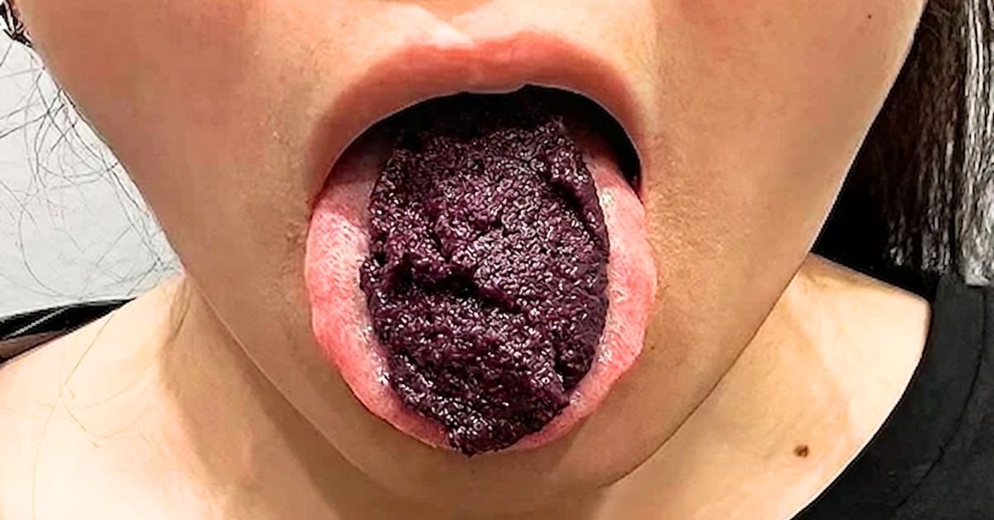
TITLE (ANGLE) The Dark Amazon Fruit She Was Told to Eat First Thing in the Morning
HEADLINE (NATIVE ≤90) She put this Amazon fruit in her mouth. Cravings vanished for 8 hours. (70 chars)
DESCRIPTION (FACEBOOK/NATIVE) Indigenous women in Brazil take it raw. U.S. women are just discovering what it does to afternoon snack cravings. (113 chars)

CREATIVE #10

TITLE (ANGLE) Breaking: Researchers Stunned by Amazon Berry’s Appetite Effects
HEADLINE (NATIVE ≤90) Researchers stunned: Amazon berry controls appetite in women 40+. (65 chars)
DESCRIPTION (FACEBOOK/NATIVE) Brazilian scientists tested it. U.S. dermatologists are now ordering bulk from the Amazon basin. Limited supplies reaching the U.S. (131 chars)

CREATIVE #11
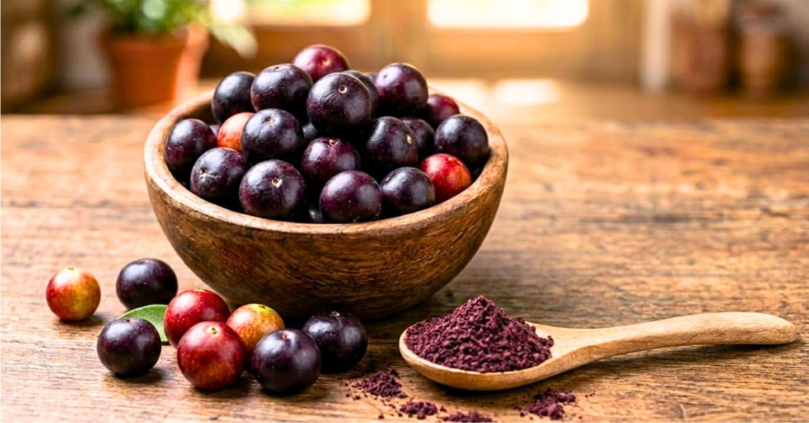
TITLE (ANGLE) Why Americans Can’t Buy This Amazon Berry at the Store
HEADLINE (NATIVE ≤90) The Amazon berry U.S. stores don't sell. Brazilian women live on it. (68 chars)
DESCRIPTION (FACEBOOK/NATIVE) Only one company got FDA clearance to import it as a supplement. Women 35+ are ordering it faster than the Amazon can harvest. (126 chars)

CREATIVE #12
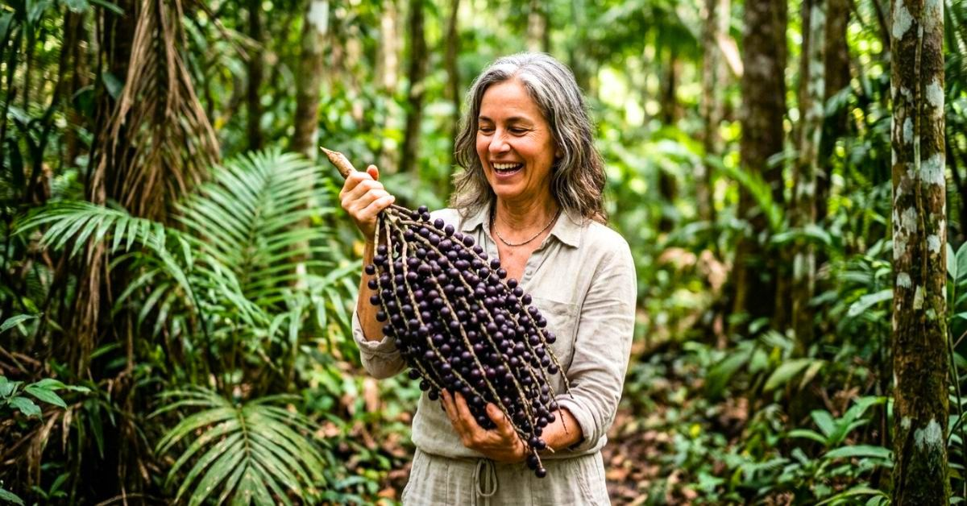
TITLE (ANGLE) What She Brought Back From the Amazon Replaced Her Entire Diet
HEADLINE (NATIVE ≤90) She went to the Amazon for 2 weeks. Came back 15 pounds lighter. (64 chars)
DESCRIPTION (FACEBOOK/NATIVE) A travel writer visited a remote Brazilian village. She returned with a berry routine that made her Ozempic prescription feel unnecessary. (138 chars)

CREATIVE #13
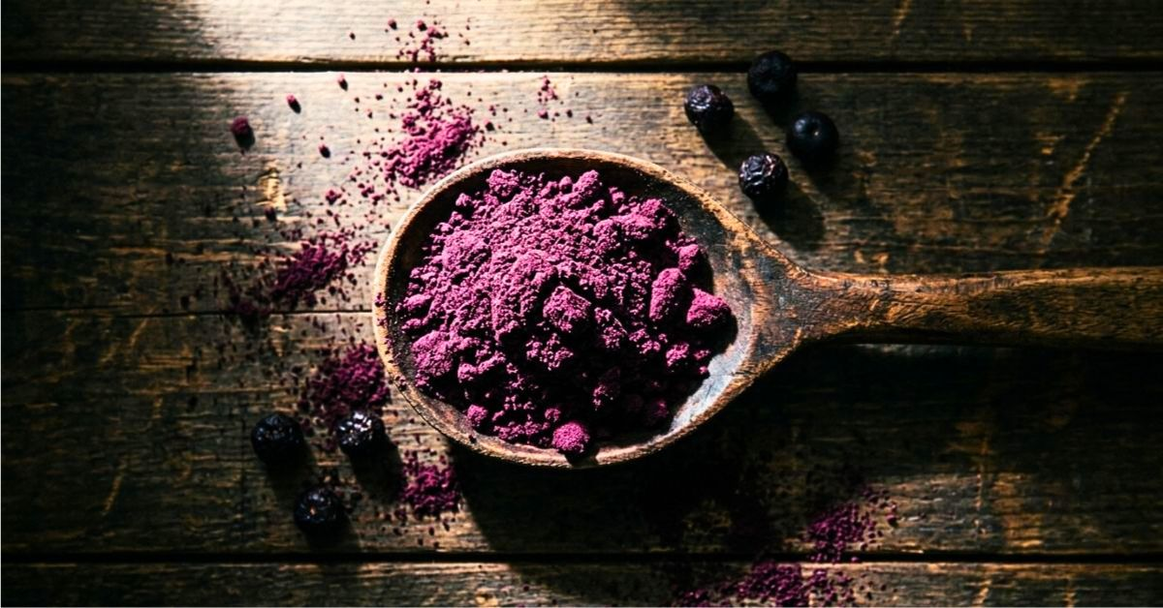
TITLE (ANGLE) The Amazon Powder Brazilian Women Mix Into Coffee Every Morning
HEADLINE (NATIVE ≤90) Brazilian women mix this Amazon powder into coffee. Hunger drops. (65 chars)
DESCRIPTION (FACEBOOK/NATIVE) One spoon in the morning. Cravings stop by noon. It's the oldest trick in the Amazon — and the newest habit of U.S. women over 40. (130 chars)

CREATIVE #14
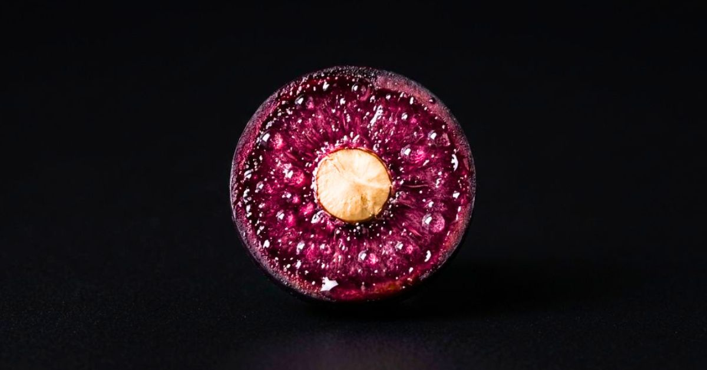
TITLE (ANGLE) What’s Inside an Amazon Berry — And Why Your Pharmacy Doesn’t Want You to Know
HEADLINE (NATIVE ≤90) Inside the Amazon berry your pharmacy doesn't want you to know. (63 chars)
DESCRIPTION (FACEBOOK/NATIVE) One compound inside this tiny fruit does what Ozempic does — without the injections, the cost, or the side effects women 45+ report. (132 chars)

CREATIVE #15
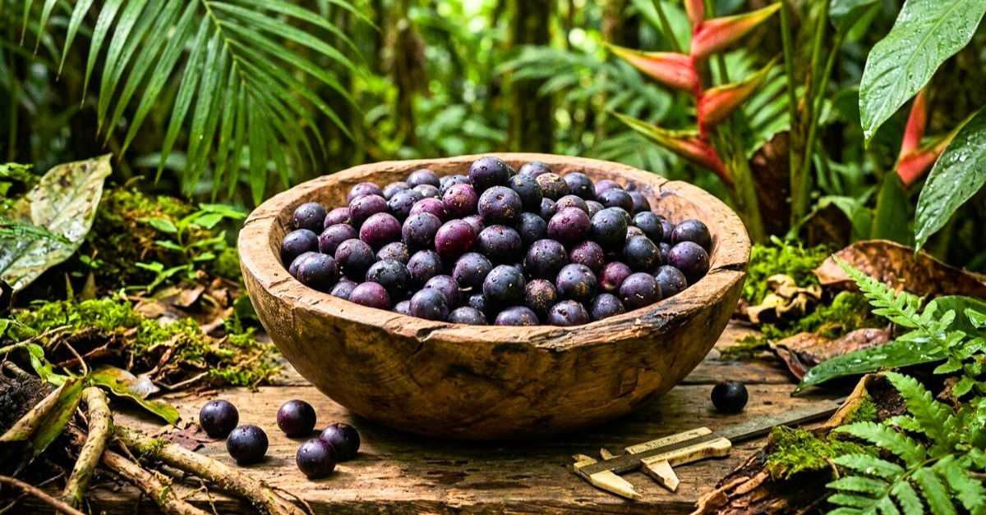
TITLE (ANGLE) The Brazilian Village That Exports America’s Fastest-Selling Berry
HEADLINE (NATIVE ≤90) The Brazilian village that harvests it. The berry reaching the U.S. (67 chars)
DESCRIPTION (FACEBOOK/NATIVE) Deep in the Amazon, one community supplies what’s become the U.S. breakthrough in natural appetite control for women over 35. (125 chars)

CREATIVE #16
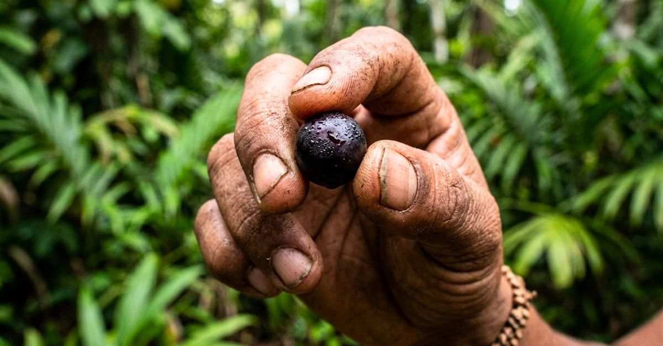
TITLE (ANGLE) The Amazon Berry Held by Hands That Knew It for Generations
HEADLINE (NATIVE ≤90) The berry Amazon communities held for generations. Now in the U.S. (66 chars)
DESCRIPTION (FACEBOOK/NATIVE) A fruit passed through 300 years of Brazilian indigenous knowledge. The reason U.S. women over 40 are replacing their diet pills with it. (137 chars)

CREATIVE #17
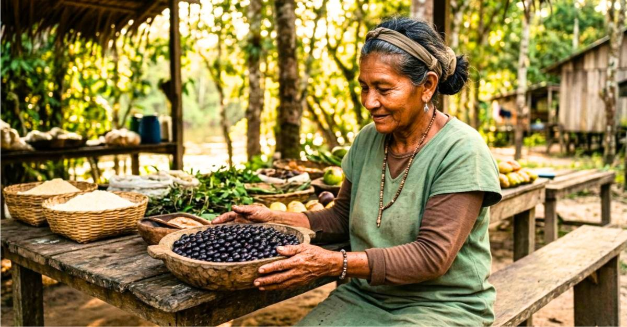
TITLE (ANGLE) The Brazilian Grandmother Who Never Saw a Single Diet Book
HEADLINE (NATIVE ≤90) Amazon women never diet. They eat this berry. U.S. women caught on. (67 chars)
DESCRIPTION (FACEBOOK/NATIVE) She’s 68 and has never been overweight. The Amazon berry she grew up on is the reason — and it’s finally available in American stores. (134 chars)

CREATIVE #18
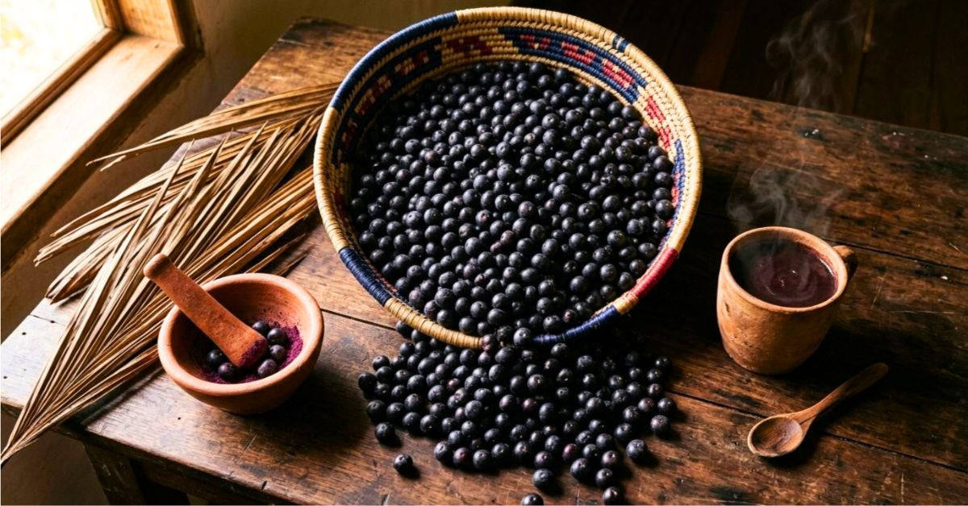
TITLE (ANGLE) The 300-Year-Old Amazon Recipe Becoming America’s Latest Trend
HEADLINE (NATIVE ≤90) An Amazon kitchen ritual from 1720. U.S. women copying it in 2026. (66 chars)
DESCRIPTION (FACEBOOK/NATIVE) Indigenous Brazilian women used açaí before European explorers arrived. The preparation method is finally reaching U.S. kitchens. (129 chars)

CREATIVE #19
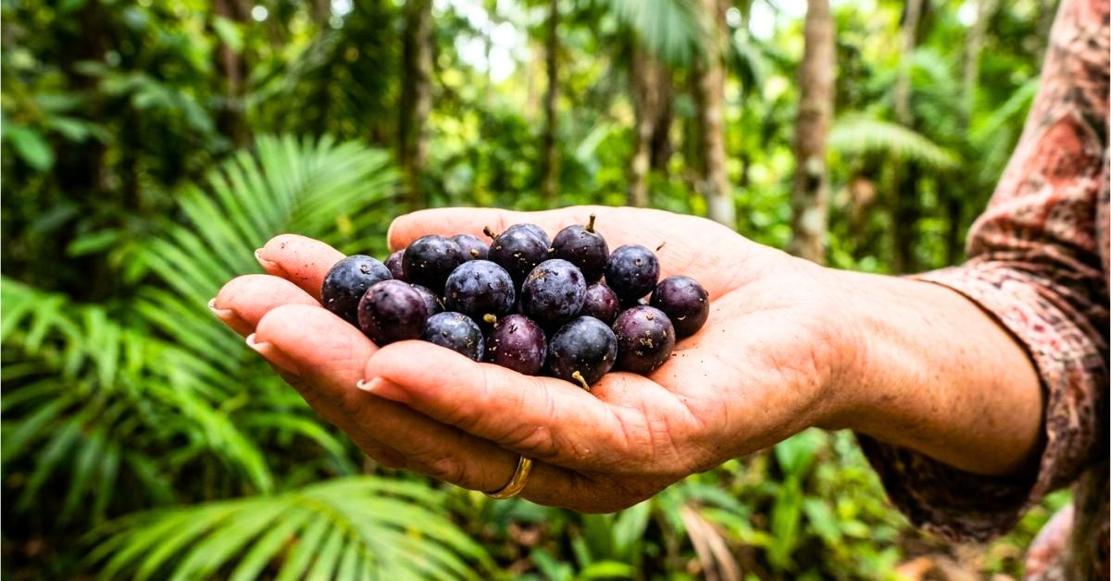
TITLE (ANGLE) The Berry Amazon Grandmothers Pass to Their Daughters
HEADLINE (NATIVE ≤90) The berry passed from Amazon grandmother to granddaughter. (58 chars)
DESCRIPTION (FACEBOOK/NATIVE) 4 generations of Brazilian women have used it to stay lean. The first U.S. company to import it is shipping 1,000 bottles a day. (128 chars)

CREATIVE #20
⚠ TRADEMARK RISK: original image shows Coca-Cola branded bottles. Regenerate without branded products before using.
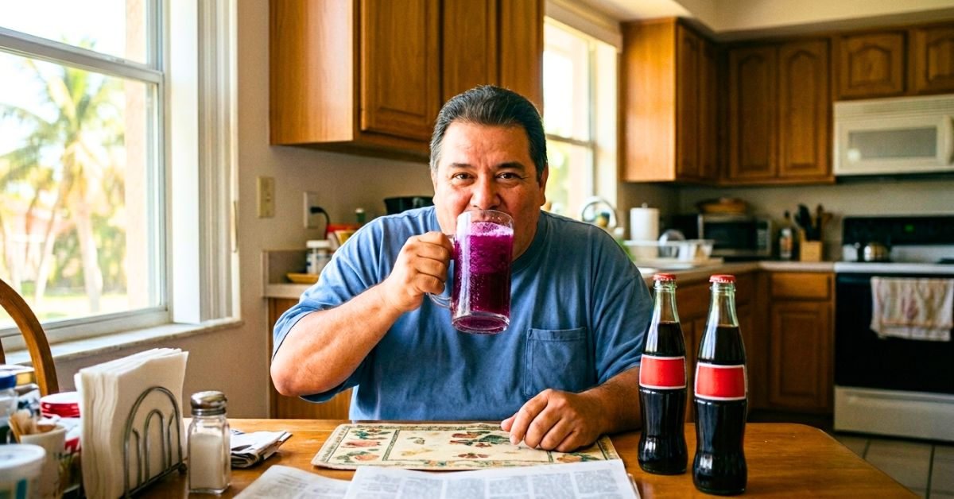
TITLE (ANGLE) The Soda Replacement Brazilian Families Serve at Every Meal
HEADLINE (NATIVE ≤90) He replaced soda with one Amazon drink. Lost 18 lbs in 6 weeks. (63 chars)
DESCRIPTION (FACEBOOK/NATIVE) Brazilian working-class families drink açaí pulp mixed with water instead of soda. The quiet reason behind Brazil’s lower obesity rates. (136 chars)

HANDOFF CHECKLIST
- Launch first (Taboola/Outbrain premium): #7, #10, #16, #1, #8, #2 — strongest CTR projection for cold US traffic.
- Budget $50–$75 per creative for 48h test. Kill anything below 0.4% CTR on Taboola desktop placements.
- Facebook/Instagram: only #3, #10, #11, #12, #15, #17, #19 pass review. Softer açaí lifestyle angle needed — avoid body-focused copy.
- Google Ads/YouTube: only #10, #11, #12, #15, #17 may pass. Avoid weight-loss explicit language.
- MGID/RevContent/Adnow lower-tier: all 19 usable (skip #20 until regenerated). Expect CTR 0.8–1.4%.
- Presell advertorial MANDATORY — direct-to-checkout from these creatives burns budget in 4–6 hours.
- Creative #20: regenerate WITHOUT Coca-Cola bottles OR replace branded products with unbranded cans/bottles. Also consider changing persona from Hispanic male to US woman 45+ (matches primary audience).
- Missing from set — consider regenerating: scale shock image (shows 187–213 lbs), measuring tape at waist (41–44 inches), midnight fridge raid scene. Craving/food-shame imagery is ABSENT despite being the core of Crave-Off’s positioning.
- Rotate every 7 days on premium placements. Every 5 days on MGID/RevContent (fatigue hits faster on cheaper traffic).
- Top 3 winners after 72h: generate 5 variations each (skin tone variation, time of day, slight angle change) for scale without fatigue.
Prepared for traffic manager · Crave-Off native ads campaign · Amazon açaí discovery angle

