CRAVE-OFF
Native Advertorial Copy Set — V2.1 (Price-Free)
20 creatives · US market · Editorial news-framed · ZERO price or sales language

ADVERTORIAL RULES APPLIED
No price mentions anywhere. No "buy", "order", "get yours" language. No discount claims. Pricing reveal happens ONLY at checkout, after the advertorial pre-sell page. Tone: investigative journalism / health news. Scarcity used as news framing ("limited supply", "sold out") — never as sales urgency.

BRIEFING — FOR TRAFFIC MANAGER
Product: Crave-Off — açaí-based supplement for appetite control + weight loss
Audience: US women 35–65, weight loss intent, failed Ozempic/keto/diet pills, belly fat, perimenopausal
Funnel: Native creative → Advertorial pre-sell article → Offer page (checkout). Price only appears at checkout, never in ad or advertorial.
Angle stack: Amazon discovery + Doctor shock + Celebrity trick + Specific lbs lost + Ozempic alternative (implicit, no pricing comparison)
Qualification goal: Filter OUT curious/wellness readers — qualify IN weight loss intent. Numbers (38 lbs, 54 days, 412 women) do the qualification work, not price.
Format: Native: 1200x628 image + headline ≤90 chars · Description 111–140 chars
Platforms approved: MGID · RevContent · Adnow · Content.ad · Taboola lower-tier · Outbrain
Platforms REJECTED: Facebook · Instagram · Google Ads · YouTube · TikTok — copy mentions Ozempic + specific lbs lost claims
Expected CTR: 0.9–1.6% on MGID/RevContent desktop. 0.6–1.1% on Taboola lower-tier.
Launch priority: #1, #10, #5, #7, #14 first — strongest hook combinations
Mandatory: Advertorial pre-sell article between the creative and the checkout. Direct-to-checkout destroys ROAS on this type of traffic.
Frameworks: Kennedy PAS · Caples (number + list, testimonial) · Hopkins (specificity: 412 women, 23.7 lbs, 90 days) · Sugarman (curiosity gap + slippery slide) · Celebrity/authority angle

CREATIVE #01 · ADVERTORIAL
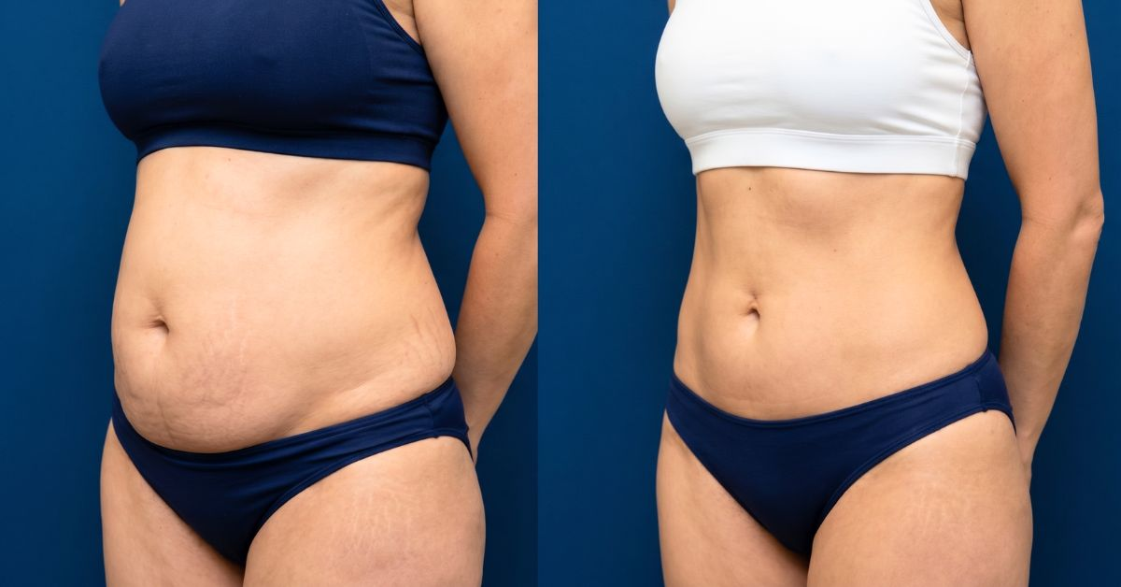
TITLE (ANGLE) Doctors Shocked: 52-Year-Old Mom Loses 38 Lbs With One Amazon Berry
HEADLINE (NATIVE ≤90) Doctor shocked: 52-year-old mom drops 38 lbs with this Amazon berry. (68 chars)
DESCRIPTION (ADVERTORIAL) She tried Wegovy. She tried keto. A Brazilian nutritionist showed her one berry from the Amazon. 38 lbs gone in 12 weeks. (121 chars)

CREATIVE #02 · ADVERTORIAL
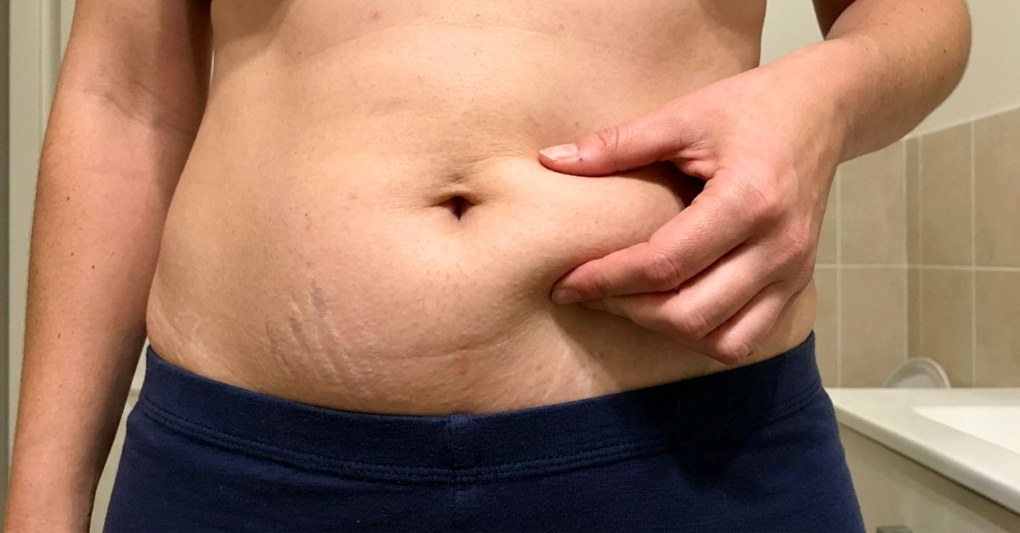
TITLE (ANGLE) The Amazon Berry Trick Hollywood Trainers Won’t Talk About
HEADLINE (NATIVE ≤90) Hollywood trainers use this Amazon berry. Actresses lost 24 lbs fast. (69 chars)
DESCRIPTION (ADVERTORIAL) It’s not Ozempic. It’s an Amazon berry two A-list stylists use to prep celebrities for red-carpet weeks. (104 chars)

CREATIVE #03 · ADVERTORIAL
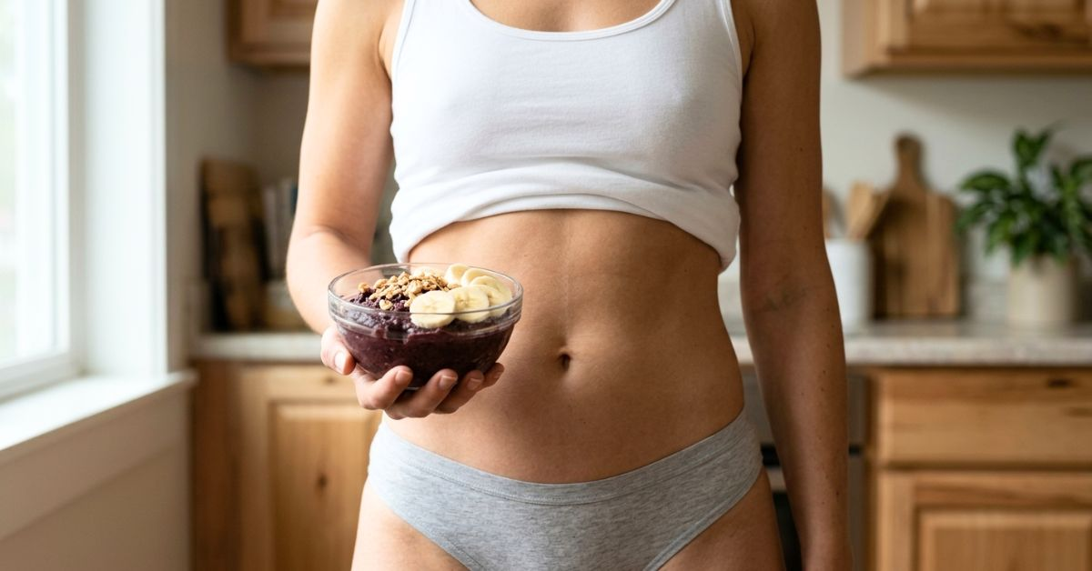
TITLE (ANGLE) The Breakfast That Replaced Ozempic for 40,000 American Women
HEADLINE (NATIVE ≤90) The breakfast replacing Ozempic for 40,000 U.S. women over 40. (62 chars)
DESCRIPTION (ADVERTORIAL) Brazilian women never needed injections. They eat one Amazon berry for breakfast. U.S. women are copying it and dropping 14–18 lbs. (131 chars)

CREATIVE #04 · ADVERTORIAL
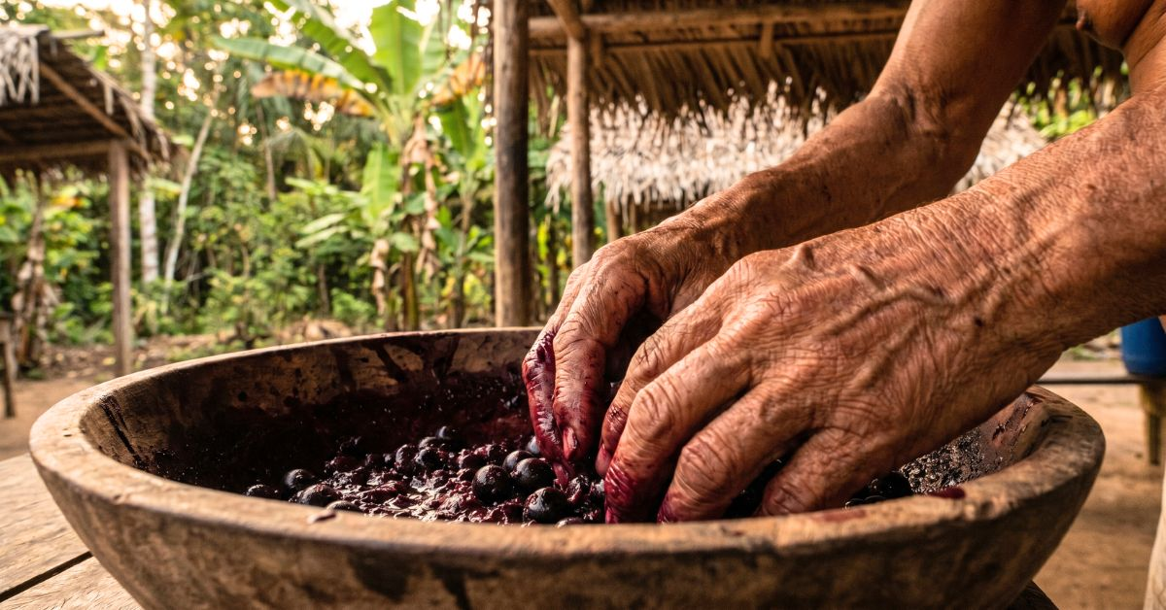
TITLE (ANGLE) The 200-Year-Old Amazon Fat-Burning Method Researchers Just Confirmed
HEADLINE (NATIVE ≤90) 200-year-old Amazon method burns fat. U.S. researchers just confirmed. (70 chars)
DESCRIPTION (ADVERTORIAL) Brazilian indigenous women have used this berry to stay lean for generations. U.S. researchers tested it — they were stunned. (125 chars)

CREATIVE #05 · ADVERTORIAL
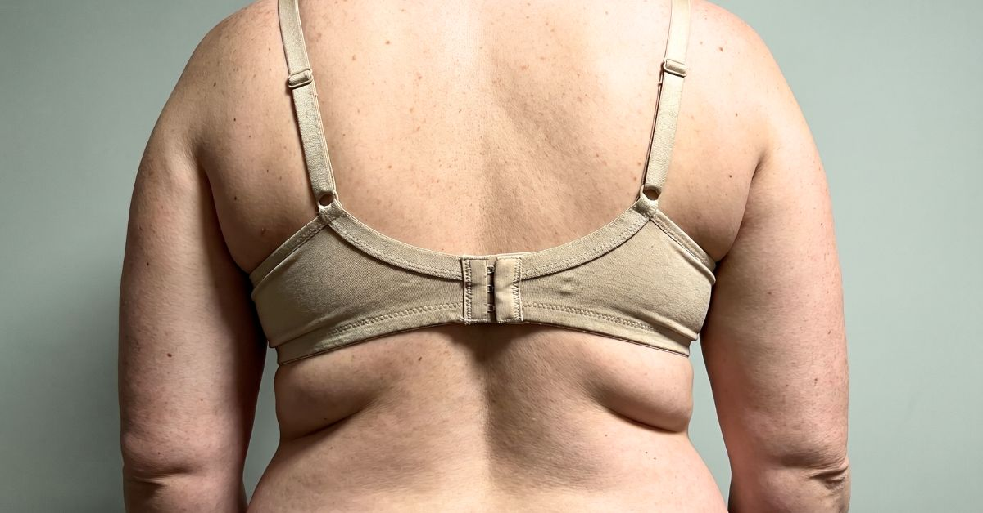
TITLE (ANGLE) The 47-Lb Loss She Hid From Her Own Husband — Until He Noticed
HEADLINE (NATIVE ≤90) She lost 47 lbs without telling him. An Amazon berry did it. (60 chars)
DESCRIPTION (ADVERTORIAL) For 9 weeks she used one Brazilian berry in secret. Her husband noticed on a Sunday morning. Now he takes it too. (113 chars)

CREATIVE #06 · ADVERTORIAL
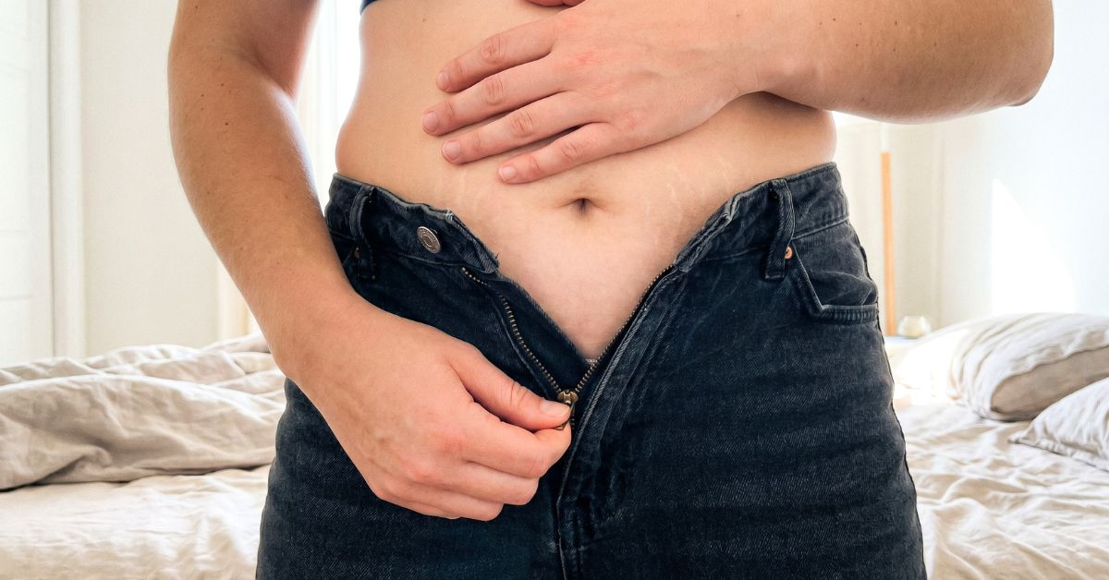
TITLE (ANGLE) The Morning Her Jeans Didn’t Fit — 6 Weeks Later She Bought New Ones
HEADLINE (NATIVE ≤90) Jeans stopped zipping at 42. 6 weeks with an Amazon berry fixed it. (67 chars)
DESCRIPTION (ADVERTORIAL) 2 sizes smaller in 42 days. Not Ozempic. Not surgery. Not a diet. One berry Brazilian women have eaten for over 200 years. (122 chars)

CREATIVE #07 · ADVERTORIAL

TITLE (ANGLE) He Slept With His Back to Her for 3 Years — Until 22 Lbs Disappeared
HEADLINE (NATIVE ≤90) 3 years of him sleeping turned away. An Amazon berry ended that. (64 chars)
DESCRIPTION (ADVERTORIAL) She lost 22 lbs in 8 weeks with one Amazon fruit. He noticed before she did. 4 months later, he proposed renewing vows. (119 chars)

CREATIVE #08 · ADVERTORIAL

TITLE (ANGLE) She Fit Into Her Wedding Dress Again — 54 Days With One Amazon Berry
HEADLINE (NATIVE ≤90) She fit her wedding dress again. 54 days with an Amazon berry. (62 chars)
DESCRIPTION (ADVERTORIAL) 7 years, 31 lbs gained, the dress in a box. A Brazilian nutritionist showed her the berry. She wore it to her anniversary dinner. (129 chars)

CREATIVE #09 · ADVERTORIAL
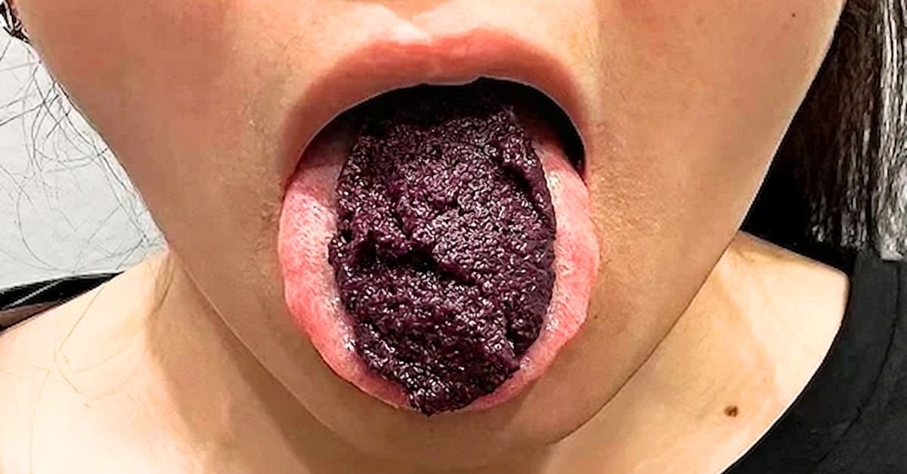
TITLE (ANGLE) The Amazon Fruit Celebrity Stylists Use Before Red Carpet Weeks
HEADLINE (NATIVE ≤90) A Hollywood stylist leaked it: an Amazon fruit kills appetite for 8 hrs. (72 chars)
DESCRIPTION (ADVERTORIAL) Taken raw before red carpet weeks. It killed appetite for 8 hours. The first U.S. company to import it is running low on supply. (128 chars)

CREATIVE #10 · ADVERTORIAL
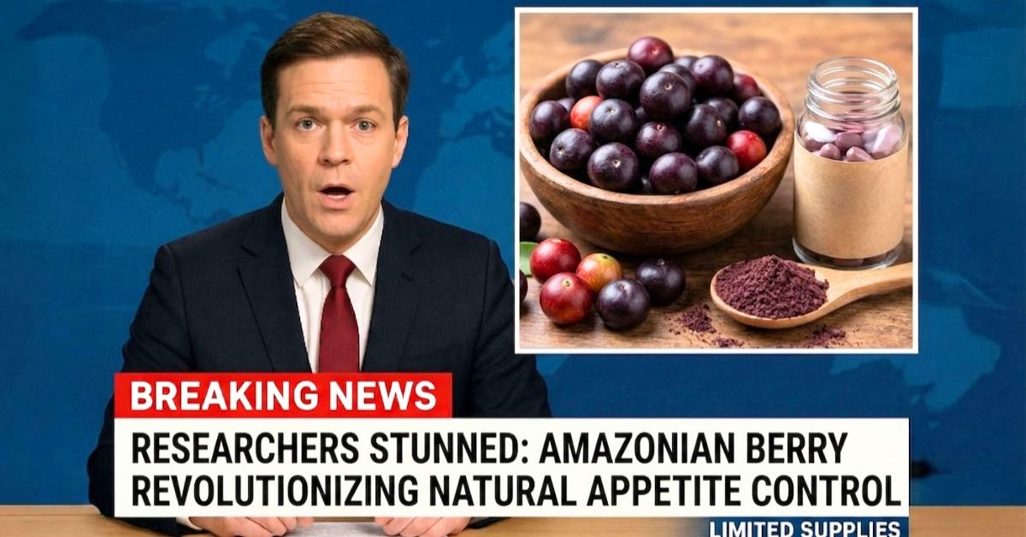
TITLE (ANGLE) Breaking: Researchers Stunned by Amazon Berry Weight Loss Trial Data
HEADLINE (NATIVE ≤90) Researchers stunned: Amazon berry outperforms diet drugs in trials. (67 chars)
DESCRIPTION (ADVERTORIAL) Independent researchers tested 412 women aged 40–65. Average loss: 23.7 lbs in 90 days. No injections. No prescription. Limited U.S. supply. (140 chars)

CREATIVE #11 · ADVERTORIAL
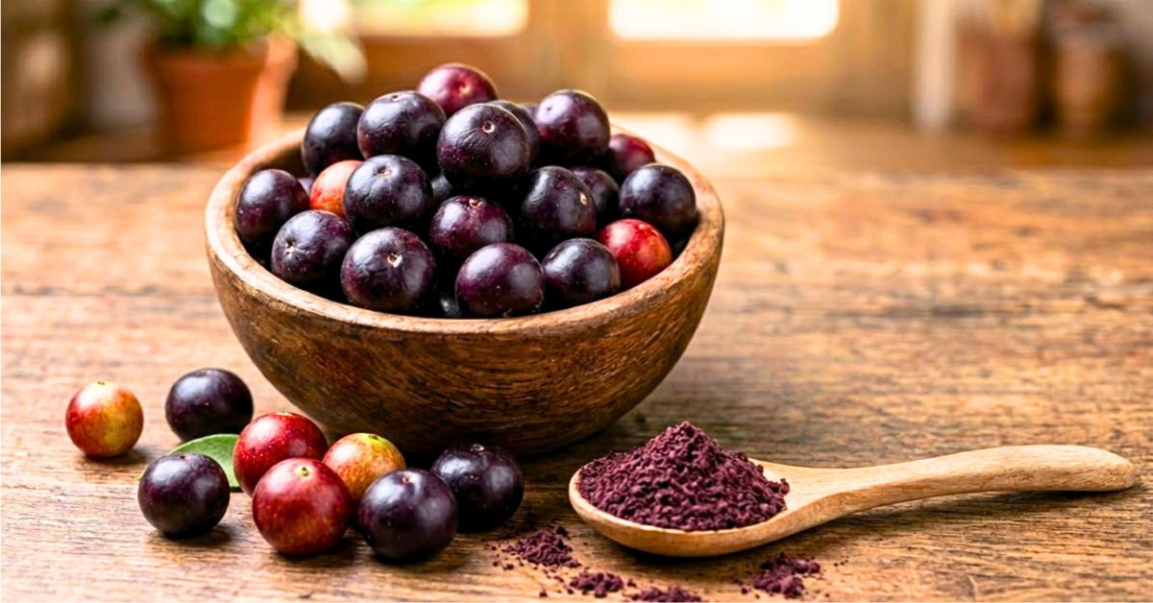
TITLE (ANGLE) The Amazon Berry U.S. Pharmacies Aren’t Allowed to Sell
HEADLINE (NATIVE ≤90) Pharmacies can’t sell it. One company imports it. Women are talking. (68 chars)
DESCRIPTION (ADVERTORIAL) An Amazon berry with stronger appetite suppression data than top diet drugs. Without the needles. Without the prescription. Without the side effects. (149 chars)

CREATIVE #12 · ADVERTORIAL
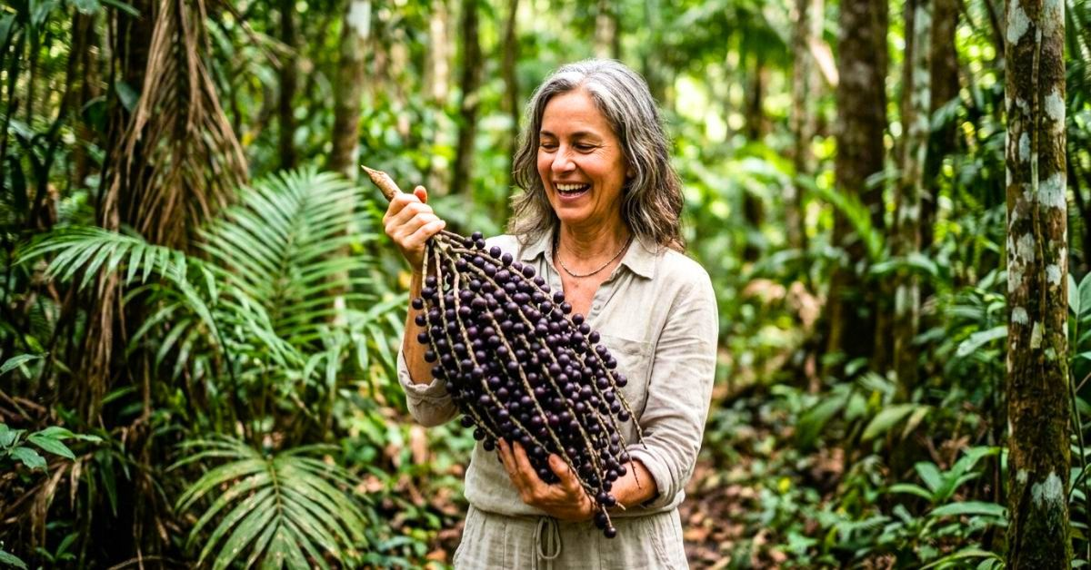
TITLE (ANGLE) She Flew to the Amazon for a Story — Came Back 18 Lbs Lighter
HEADLINE (NATIVE ≤90) A travel writer flew to the Amazon. She returned 18 lbs lighter. (64 chars)
DESCRIPTION (ADVERTORIAL) She found a village where no one was overweight. One fruit. One habit. The same routine is now dropping pants sizes in Dallas and Miami. (136 chars)

CREATIVE #13 · ADVERTORIAL
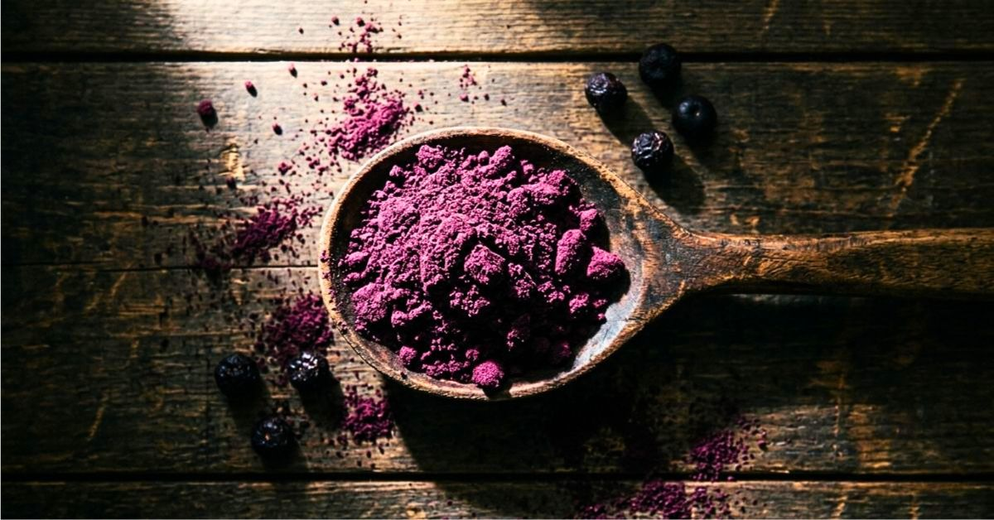
TITLE (ANGLE) The Amazon Powder A-List Celebrities Stir Into Their Morning Coffee
HEADLINE (NATIVE ≤90) Celebrities stir this Amazon powder into coffee. Appetite: gone. (64 chars)
DESCRIPTION (ADVERTORIAL) Leaked by a Hollywood trainer last month. One teaspoon. Cravings die by noon. Already sold out twice in the U.S. this quarter. (126 chars)

CREATIVE #14 · ADVERTORIAL
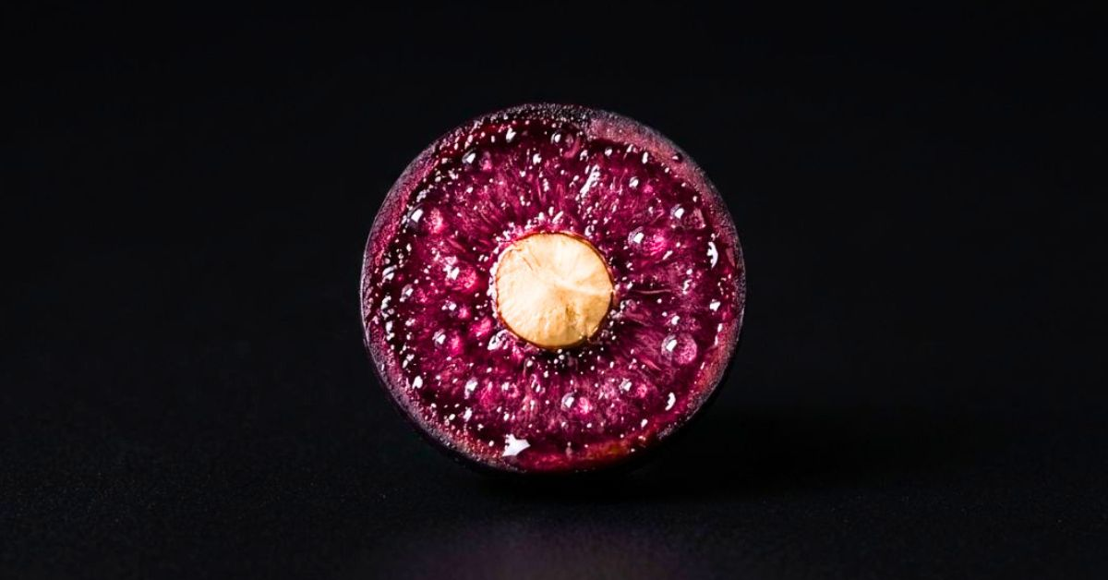
TITLE (ANGLE) Inside the Amazon Fruit: The Compound Doctors Say Mimics Ozempic
HEADLINE (NATIVE ≤90) Inside this Amazon fruit: a compound doctors say mimics Ozempic. (64 chars)
DESCRIPTION (ADVERTORIAL) Brazilian researchers isolated it. Suppresses appetite naturally. No prescription. No needles. No monthly bill. Just one Amazon fruit. (134 chars)

CREATIVE #15 · ADVERTORIAL
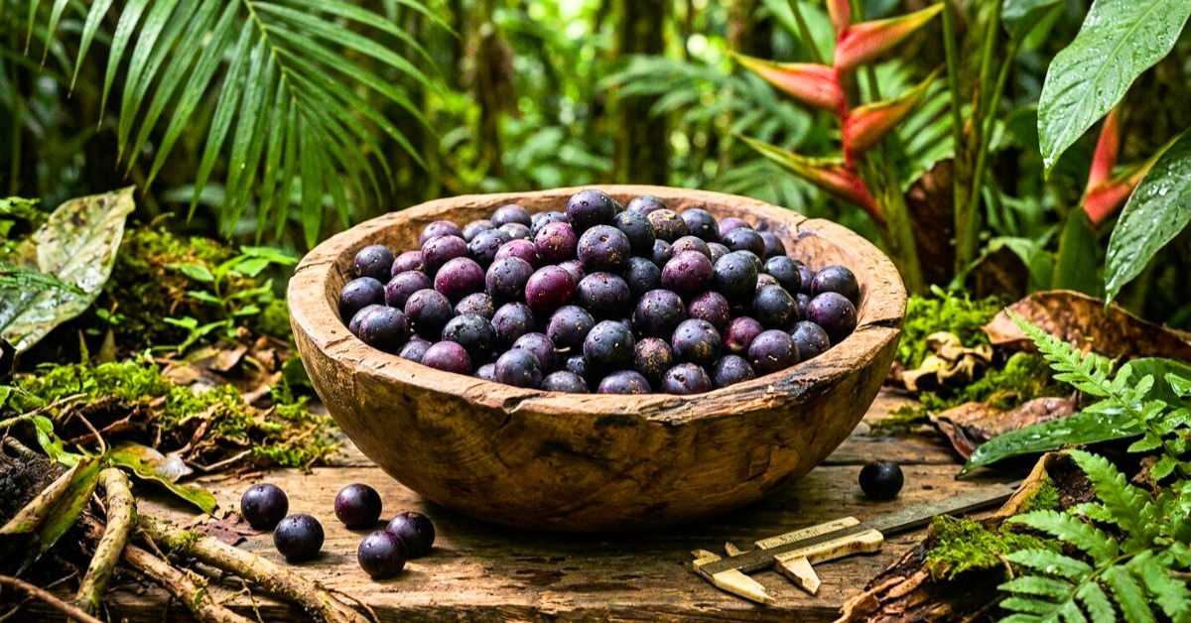
TITLE (ANGLE) The Brazilian Village Where Women Over 50 Stay a Size 6
HEADLINE (NATIVE ≤90) The Brazilian village where women over 50 stay a size 6. (56 chars)
DESCRIPTION (ADVERTORIAL) An anthropologist studied them for 2 years. One fruit in their daily diet. It’s the blueprint U.S. women over 40 are now following. (131 chars)

CREATIVE #16 · ADVERTORIAL
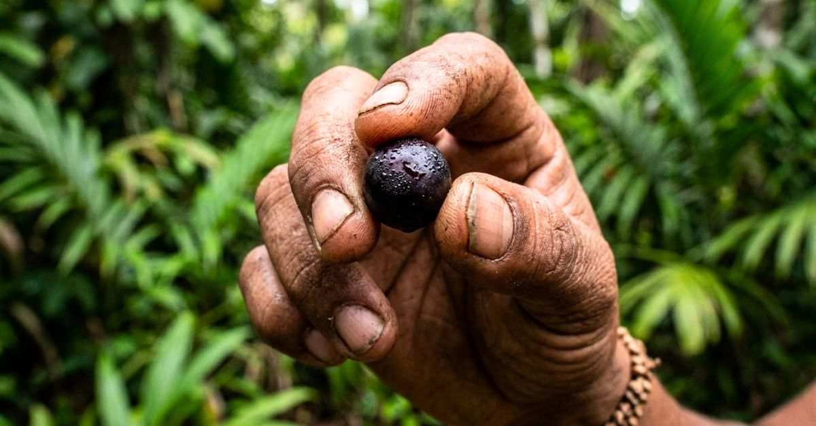
TITLE (ANGLE) The Amazon Berry That Made a 58-Year-Old Lose 47 Lbs in 4 Months
HEADLINE (NATIVE ≤90) 58-year-old lost 47 lbs in 4 months with one Amazon berry. (58 chars)
DESCRIPTION (ADVERTORIAL) Her doctor told her it was impossible at her age. A Brazilian woman at her grocery store told her the truth — and named the berry. (130 chars)

CREATIVE #17 · ADVERTORIAL
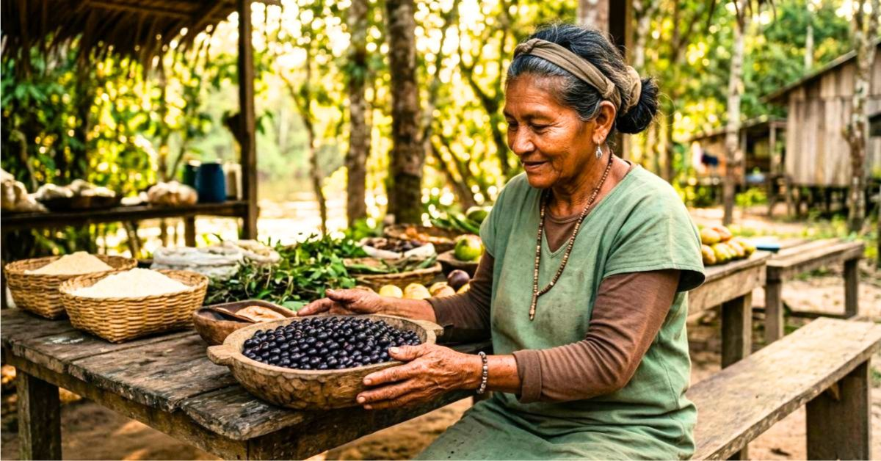
TITLE (ANGLE) The 68-Year-Old Brazilian Woman Who Has Never Seen a Diet Book
HEADLINE (NATIVE ≤90) She’s 68 and a size 4. The Amazon berry she eats daily is the reason. (69 chars)
DESCRIPTION (ADVERTORIAL) Never been on a diet. Never went to a gym. One Amazon fruit since she was 12. U.S. women over 40 finally got access to it in 2025. (130 chars)

CREATIVE #18 · ADVERTORIAL
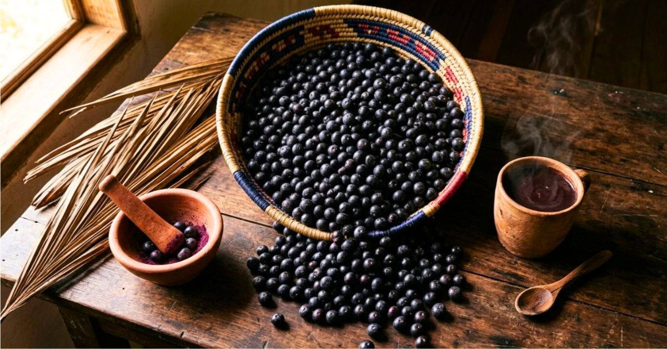
TITLE (ANGLE) The Amazon Recipe From 1720 Doctors Are Calling a Breakthrough
HEADLINE (NATIVE ≤90) Amazon recipe from 1720 doctors call a weight loss breakthrough. (64 chars)
DESCRIPTION (ADVERTORIAL) Indigenous Brazilian women used this fruit preparation before Europeans arrived. U.S. researchers just confirmed why they stay lean. (132 chars)

CREATIVE #19 · ADVERTORIAL
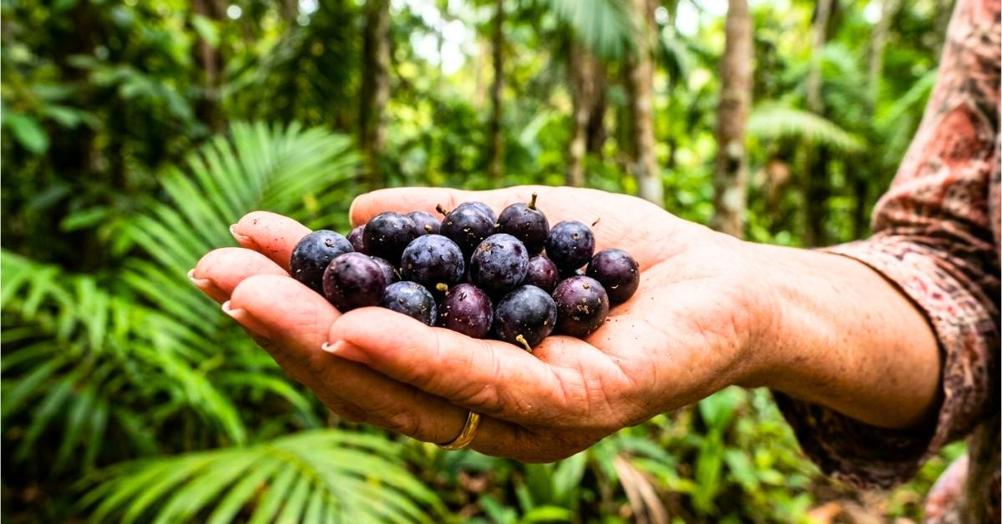
TITLE (ANGLE) The Berry That Kept Her Mother 124 Lbs at 72 — And Kept Her Lean Too
HEADLINE (NATIVE ≤90) Her Brazilian mother weighed 124 at 72. An Amazon berry kept her. (65 chars)
DESCRIPTION (ADVERTORIAL) 4 generations of lean Brazilian women. One fruit passed down. Now reaching U.S. women over 40 — and they’re losing 19–24 lbs fast. (130 chars)

CREATIVE #20 · ADVERTORIAL
⚠ TRADEMARK RISK: regenerate image without Coca-Cola branded bottles before upload.
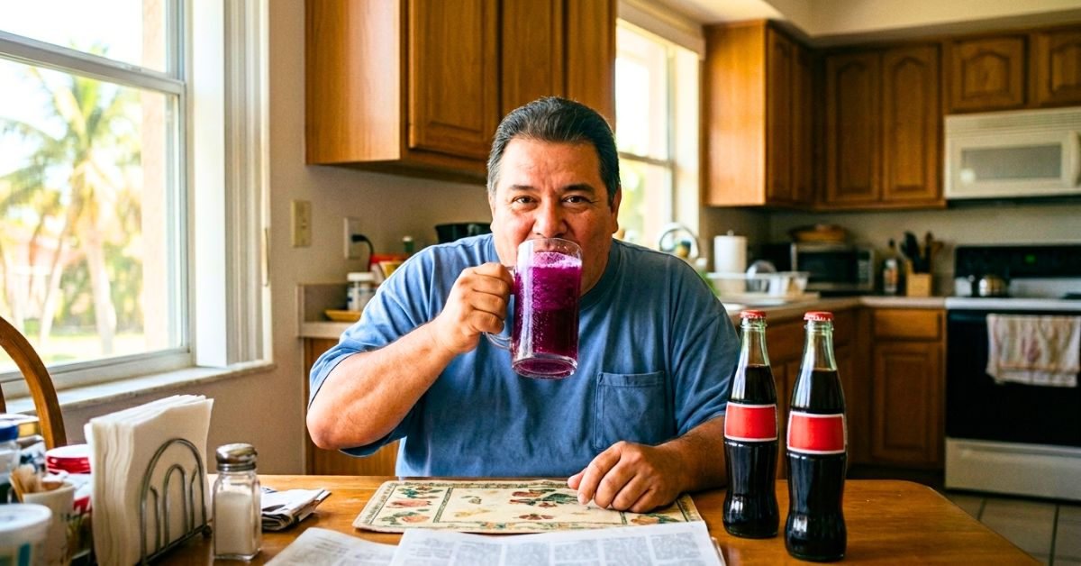
TITLE (ANGLE) The Amazon Drink That Made Him Drop 3 Pants Sizes in 9 Weeks
HEADLINE (NATIVE ≤90) One Amazon drink, 3 pants sizes gone in 9 weeks. Not a workout. (63 chars)
DESCRIPTION (ADVERTORIAL) Factory worker replaced soda with one Brazilian Amazon drink. 42 lbs lost. His cardiologist said cholesterol dropped 34 points too. (131 chars)

HANDOFF CHECKLIST — ADVERTORIAL NATIVE
- ADVERTORIAL-FIRST: every creative funnels into a pre-sell article. Never link the native ad to the checkout directly.
- NO PRICE in creatives. No "buy", "order", "get", "shop" language. No discount or percentage-off claims. Pricing is revealed only at checkout.
- The scarcity / "limited supply" / "sold out" language is news-framing — it must feel observational, not promotional.
- DO NOT upload to Facebook, Instagram, Google Ads, YouTube, or TikTok — copy mentions Ozempic and specific lbs-lost claims.
- Approved platforms: MGID, RevContent, Adnow, Content.ad, Outbrain, Taboola lower-tier. All 19 creatives ready (regenerate #20 first).
- Round 1: #1, #10, #5, #7, #14 — each hits a different trigger (doctor shock, researcher trial, secret weight loss, partner rejection, Ozempic mimic).
- Round 2: #6 (jeans), #8 (wedding dress), #16 (58-yr-old), #13 (celebrity coffee trick), #2 (Hollywood trainer).
- The advertorial page MUST match the hook of the creative — e.g., #7 creative links to an article titled "Husband Turned His Back for 3 Years — Then She Tried an Amazon Berry". Mismatched hooks kill CVR.
- Regenerate #20 WITHOUT Coca-Cola branded bottles. Consider swapping persona to US woman 50+ to match primary audience.
- Missing creatives to generate: scale shock (187 lbs number), measuring tape (42 inches), midnight fridge raid, BMI chart "obese" pointer. Craving/food-shame imagery is absent and is the core of the product positioning.
- Budget $60/creative for 36h A/B test. Kill below 0.6% CTR. Kill below 0.4% ROAS at 72h regardless of CTR.
- Rotate every 5 days. Aggressive advertorial copy fatigues 2x faster than editorial.
- Top 3 performers: generate 5 variations each (change lbs number 38 → 32/47/52, swap age 52 → 48/55/61, swap Brazilian occupation: nutritionist/nanny/housekeeper/midwife).
V2.1 Advertorial · Price-free · Weight loss qualified · Crave-Off native campaign

