Student Number:
Programme:(e.g. International Foundation Year in business management)
Module Title: (e.g. english for Academic Research and Study Skills)
Module Code: (e.g. LC3004) |  | Word Count
I confirm that no part of this assignment, except where clearly quoted and referenced has been copied from material belonging to any other person e.g. from a book, handout, another student. I am aware that it is a breach of UEL regulations to copy the work of another without clear acknowledgement and that attempting to do so renders me liable to disciplinary proceedings.

Table of Contents
Introduction 1
Part 1: Economic and Business Environment Analysis 1
1.1 Greggs’ Business Model and Expansion Strategy 1
1.2 Targeted UK PESTLE Analysis 2
1.3 Graphs of UK Economy 3
UK CPI Inflation Rate (ONS Data) 3
Bank of England Base Interest Rate 4
1.4 Economic Explanation 4
1.5 Reflection 5
Part 2: Microeconomic Analysis 5
2.1 Market Structure 5
2.2 Price Elasticity of Demand 6
2.3 Microeconomic Diagram 6
2.4 Competitor Mapping Table 7
Porter Five Forces Summary 7
2.5 Reflection 8
Part 3: Factor Market Evaluation 8
3.1 Labour Market Analysis 8
3.2 Input Market Analysis 8
3.4 UK National Living Wage Trend 9
3.5 Reflection 10
Part 4: Macroeconomic Policy and Expansion Feasibility 10
4.1 Macro Indicators Comparison 10
4.2 Government Policy Evaluation 10
4.3 Expansion Decision Matrix 11
4.4 Economic Recommendation 11
4.5 Reflection 11
Part 5: Final Reflection and Conclusion 11
References 12

Table of Figures
Figure 1: Uk inflation Rate in April 3
Figure 2: Uk interest rate 4
Figure 3: Price Elastic Demand Curve 6
Figure 4: National Living Wage Increase in the UK 9
Figure 5: UK macro indicator 10

Abstract
This report evaluates whether continued expansion of Greggs plc is economically viable within the current United Kingdom economic environment. The analysis combines both macroeconomic and microeconomic perspectives to examine the factors influencing Greggs’ business operations and strategic decisions. The report considers key macroeconomic pressures including inflation, rising interest rates, and wage growth, all of which have significantly affected consumer purchasing power and business costs across the UK economy. Using economic data from the Office for National Statistics (ONS), the Bank of England, and HM Treasury, the report assesses the broader economic conditions influencing the food-to-go market.
The study first evaluates Greggs’ business model and expansion strategy, followed by a targeted PESTLE analysis to identify external economic pressures affecting the firm. The report then applies microeconomic theory, including market structure and price elasticity of demand, to understand Greggs’ pricing strategy and competitive positioning. Additionally, the analysis examines factor markets such as labor, energy, and raw material inputs, which play a critical role in determining production costs.
Finally, the report evaluates government macroeconomic policies and assesses whether Greggs should continue expanding its store network. Based on economic evidence and theoretical application, the report provides a recommendation regarding the firm’s future expansion strategy while considering risks related to inflation, labor costs, and interest rates.

Introduction
Greggs plc is a well-known bakery and food-to-go retailer operating across the United Kingdom. The company sells a wide range of bakery products, sandwiches, hot drinks and snacks through thousands of retail outlets located in high-traffic areas such as city centers, train stations and shopping centers. In recent years the company has expanded rapidly by opening new stores and introducing innovative formats such as drive-through locations and partnerships with major retailers including Tesco, Sainsbury’s and Primark.
However, the economic environment in the United Kingdom has become more challenging. Inflation has increased significantly due to rising energy prices, supply chain disruptions and higher production costs. According to the Office for National Statistics, inflation has increased the cost of living for households and the cost of production for businesses (Statistics, 2025). At the same time, the Bank of England has increased interest rates to control inflation, which has raised borrowing costs and slowed economic growth (England, 2025).
The purpose of this report is to evaluate whether Greggs’ continued expansion is economically viable within the current UK economic environment. The report applies both microeconomic and macroeconomic analysis to examine Greggs’ business strategy, competitive environment and cost structure. Data from the Office for National Statistics, Bank of England and other UK economic sources is used to support the analysis. The report is organized into five sections covering economic conditions, microeconomic analysis, factor markets, macroeconomic policy and an overall evaluation of expansion feasibility.

Part 1: Economic and Business Environment Analysis

1.1 Greggs’ Business Model and Expansion Strategy
Greggs operates a business model focused on offering convenient and affordable food products to a wide customer base. The company sells bakery items, sandwiches and hot drinks that are typically priced lower than many competitors in the food-to-go market. This value-based pricing strategy allows Greggs to attract customers who are looking for quick and inexpensive meal options (Greggs, 2024).
A key feature of Greggs’ operations is its high-volume production system. The company produces large quantities of products through centralized production facilities and then distributes them to individual retail stores. This approach allows Greggs to reduce production costs and maintain consistent product quality across its store network.
Another important element of the business model is vertical integration. Greggs operates its own production centers and distribution network, which gives the company greater control over supply chains and costs. This strategy helps the company maintain its competitive pricing while managing fluctuations in input costs.
In recent years Greggs has also expanded through drive-through stores and retail partnerships. Drive-through outlets allow the company to reach customers in suburban areas and retail parks, while partnerships with companies such as Tesco, Sainsbury’s and Primark allow Greggs to access locations with high customer traffic (Greggs, 2024).
The company has also invested in automation and technology within its production and logistics systems. Automation improves efficiency and reduces reliance on labor, which is particularly important in a period where wages and operating costs are increasing.
Overall, Greggs’ expansion strategy relies on maintaining strong consumer demand for affordable convenience food while controlling costs through operational efficiency and supply chain management.

1.2 Targeted UK PESTLE Analysis
Factor | Economics | Impact on Greggs | Sources
Political | Government wage policies and economic regulation | Higher labour costs but potential stability through policy support | (Treasury, 2024)
Economic | Rising inflation and interest rates | Increased production costs and pressure on consumer spending | (England, 2025)
Social | Demand for convenient food options | Supports Greggs’ low-cost convenience strategy | (Greggs, 2024)
Technological | Digital ordering and automation | Improves efficiency and productivity | (Greggs, 2024)
Legal | Labour laws and food safety regulations | Increased compliance costs | (Treasury, 2024)
Environmental | Sustainability requirements | Need for environmentally friendly packaging and supply chains | (Treasury, 2024)

Overall, the economic and social factors have the greatest influence on Greggs’ business performance. Rising inflation and wage increases directly affect production costs, while consumer demand for convenient and affordable food supports Greggs’ market position. These external factors shape the strategic decisions made by the company regarding pricing, expansion and operational efficiency.

1.3 Graphs of UK Economy

UK CPI Inflation Rate (ONS Data)

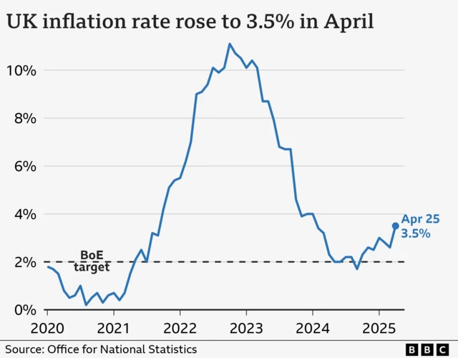
Figure 1: Uk inflation Rate in April

Bank of England Base Interest Rate
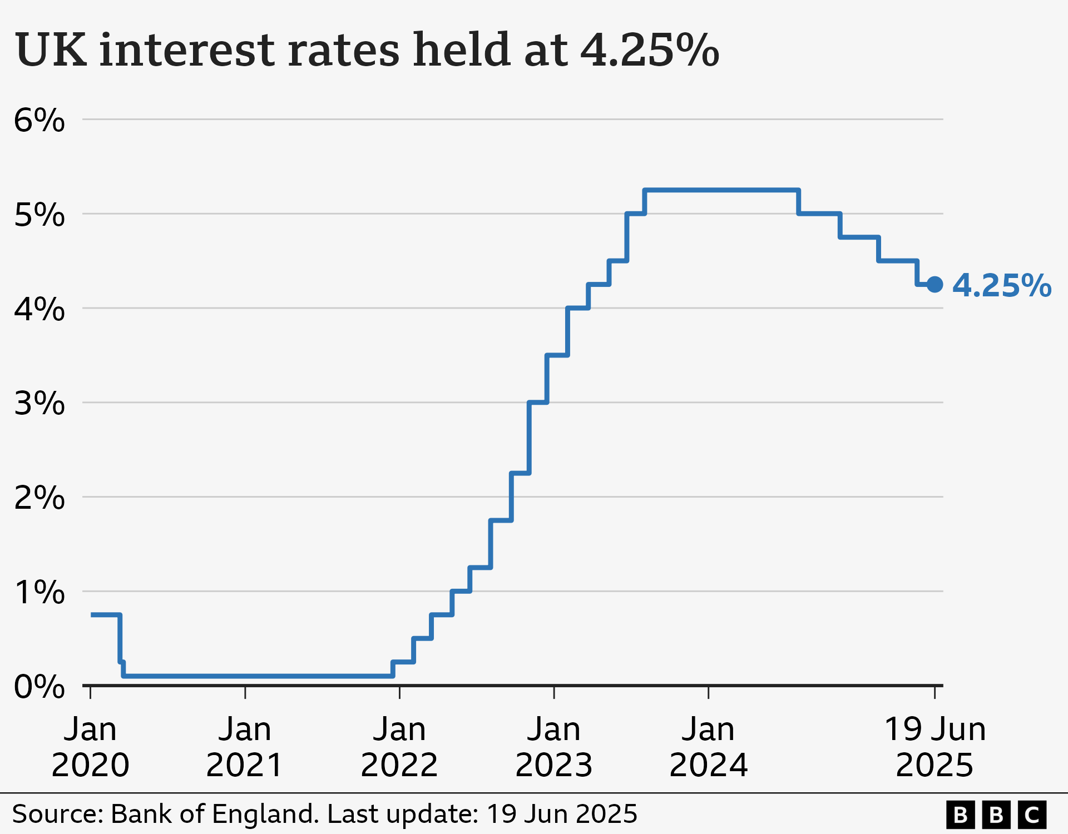
Figure 2: Uk interest rate

1.4 Economic Explanation
One important economic concept affecting Greggs is cost-push inflation. Cost-push inflation occurs when the cost of production increases due to rising prices of inputs such as labour, energy or raw materials. Businesses may respond by increasing the price of their products to maintain profit margins (Statistics, 2025).
Greggs has experienced cost pressures from rising wheat prices, energy costs and wage increases. When these costs increase, the company must decide whether to increase prices or absorb some of the cost increases. Increasing prices too much could reduce demand because consumers may switch to alternative products.
Another important factor is the real income effect. When inflation rises faster than wages, consumers experience a reduction in real purchasing power. This means households may reduce spending on expensive food options and instead purchase cheaper alternatives (Statistics, 2025).
In this situation Greggs may benefit because its products are relatively affordable compared with restaurant meals. As a result, some consumers may substitute expensive meals with cheaper food-to-go options.
Interest rates also influence Greggs’ expansion decisions. Higher interest rates increase the cost of borrowing money for investment (England, 2025). This can make it more expensive for Greggs to finance new store openings or expansion projects.

1.5 Reflection
Among the different macroeconomic pressures affecting Greggs, inflation appears to have the greatest impact. Rising inflation increases production costs through higher wages, energy prices and raw material costs. At the same time, inflation reduces consumers’ real purchasing power. Although Greggs’ affordable pricing may help maintain demand, prolonged inflation can reduce profit margins and increase financial risk for the company.

Part 2: Microeconomic Analysis

2.1 Market Structure
The market in which Greggs operates can be described as monopolistic competition. In this type of market structure many firms sell similar products but differentiate themselves through branding, quality or location.
Greggs competes with several food-to-go retailers such as Pret a Manger, Costa Coffee and supermarkets like Tesco. Each of these businesses sells food products that are similar but not identical. For example, Pret A Manger focuses on premium sandwiches and organic ingredients, while Greggs focuses on affordable bakery products.
Because products are differentiated, firms have some pricing power. Greggs can adjust prices slightly without losing all customers, but it cannot increase prices too much because consumers can switch to alternative products.
Barriers to entry in this market are relatively low compared with industries such as manufacturing. New coffee shops or food outlets can enter the market relatively easily, although established brands still benefit from brand recognition and economies of scale.
Economic growth also plays an important role in determining the success of retail businesses such as Greggs. Gross Domestic Product (GDP) measures the total value of goods and services produced within an economy. When GDP is growing, employment and income generally increase, which leads to higher consumer spending.

However, periods of slow economic growth or economic uncertainty may reduce consumer confidence and spending. According to UK economic data, growth has slowed during periods of high inflation and rising interest rates (Treasury, 2024). Slower economic growth may reduce demand for non-essential goods and services.

Despite this, Greggs may be less affected compared with premium food retailers because its products are relatively affordable. During economic downturns, some consumers may shift from more expensive restaurants to cheaper food-to-go options such as Greggs. This substitute effect can help maintain demand even when overall economic growth slows.

2.2 Price Elasticity of Demand
Price elasticity of demand measures how sensitive consumer demand is to changes in price.
PED formula:
PED = % Change in Quantity Demanded / % Change in Price
Demand for Greggs products is likely to be elastic because there are many substitute products available. Consumers can choose between bakeries, supermarkets, coffee shops and fast-food outlets.
Because demand is elastic, increasing prices significantly could reduce total revenue. Therefore, Greggs maintains relatively low prices to attract customers and maintain strong demand.
Cross-price elasticity also plays a role in Greggs’ pricing strategy. If competitors such as Costa Coffee increase their prices, some consumers may switch to Greggs products. Similarly, income elasticity may influence demand. During economic downturns, some consumers may shift from expensive restaurants to cheaper food options, which could increase demand for Greggs products.

2.3 Microeconomic Diagram
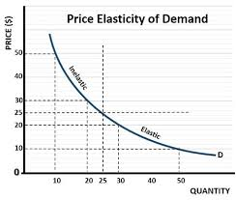
Figure 3: Price Elastic Demand Curve

Explanation:
The diagram shows a downward-sloping demand curve representing consumer demand for Greggs products. When the price decreases, the quantity demand increases significantly. This indicates elastic demand where consumers are sensitive to price changes.

2.4 Competitor Mapping Table

Firm | Price | Product Type | Target Market
Greggs | low | Bakery and Snacks | Mass market
Pret A manager | High | Premium Sandwiches | Professionals
Costa Coffee | Medium | Coffee and snacks | Coffee consumers
Tesco | Low | Supermarket ready food | Budget consumers

Porter Five Forces Summary
Force | Impact
Competitive rivalry | High
Threat of new entrants | Moderate
Bargaining power of suppliers | Moderate
Bargaining power of customers | High
Threats of substitutes | High

The Porter Five Forces framework helps analyse the competitive environment of an industry by examining different market pressures that influence profitability. In the case of Greggs plc, the threat of new recruits exists but is moderate because although opening a bakery requires relatively low capital investment, establishing a strong brand and national retail network similar to Greggs requires significant resources and time. The bargaining power of suppliers is moderate because Greggs relies on agricultural inputs such as wheat and energy, which are subject to price fluctuations in global markets. The bargaining power of buyers is relatively high because customers have many alternative options for quick food and beverages, including supermarkets and coffee chains. The threat of substitutes is also high as consumers can easily choose alternative breakfast or snack options such as supermarket bakery items or café products. Finally, competitive rivalry is intense due to the presence of many firms offering similar products within the quick-service food sector. Overall, this analysis indicates that Greggs operates in a highly competitive market environment where maintaining competitive pricing and strong brand value is essential for sustaining market share (Greggs, 2024).
.

2.5 Reflection
While microeconomic theory explains many aspects of Greggs’ pricing strategy, it does not fully explain consumer behavior. Factors such as brand loyalty, convenience and marketing also influence purchasing decisions. Behavioral factors may lead consumers to prefer certain brands even when cheaper alternatives exist.

Part 3: Factor Market Evaluation

3.1 Labour Market Analysis

Labour is a critical factor in production for Greggs because the company operates a large network of retail stores that require staff to prepare and sell food products. In the United Kingdom, labour market conditions have changed significantly in recent years due to economic recovery after the COVID-19 pandemic and government policy changes.
One important factor affecting businesses is the National Living Wage. The UK government has gradually increased the minimum wage to improve living standards for workers. While this policy benefits employees, it also increases labour costs for businesses such as Greggs.
According to (market, 2024), the UK labour market has also experienced periods of high vacancy rates, meaning that businesses may find it difficult to recruit workers (market, 2024). Labour shortages can force firms to offer higher wages to attract employees.
From an economic perspective, labour demand is considered derived from demand because it depends on the demand for the final product. If demand for Greggs products increases, the company will need to hire more employees. However, if labour costs increase significantly, the company may attempt to reduce labour demand through automation and technology.
Higher wages increase the marginal cost of production, which may lead businesses to increase prices or reduce expansion plans.

3.2 Input Market Analysis
Greggs also depends on various raw materials and inputs including wheat, energy and packaging materials. Fluctuations in the prices of these inputs can significantly affect production costs.
Wheat is a key ingredient used in bakery products such as bread and pastries. Global wheat prices have been volatile due to supply disruptions, climate conditions and geopolitical events. When wheat prices increase, the cost of producing bakery products also increases.
Energy is another important input because production facilities and retail stores require electricity and heating. Rising energy prices have increased operating costs for many businesses in the UK.
Supply chain disruptions can also increase costs by delaying deliveries or increasing transportation expenses. These factors create cost-push inflation pressures for businesses like Greggs.

Indicator | Trend | Risk Level | Impact on Expansion
Labour wages | Increasing | High | Raise operating costs
Wheat prices | Volatile | Medium | Affects production cost
Energy costs | Increasing | High | Raises operating expenses

3.4 UK National Living Wage Trend
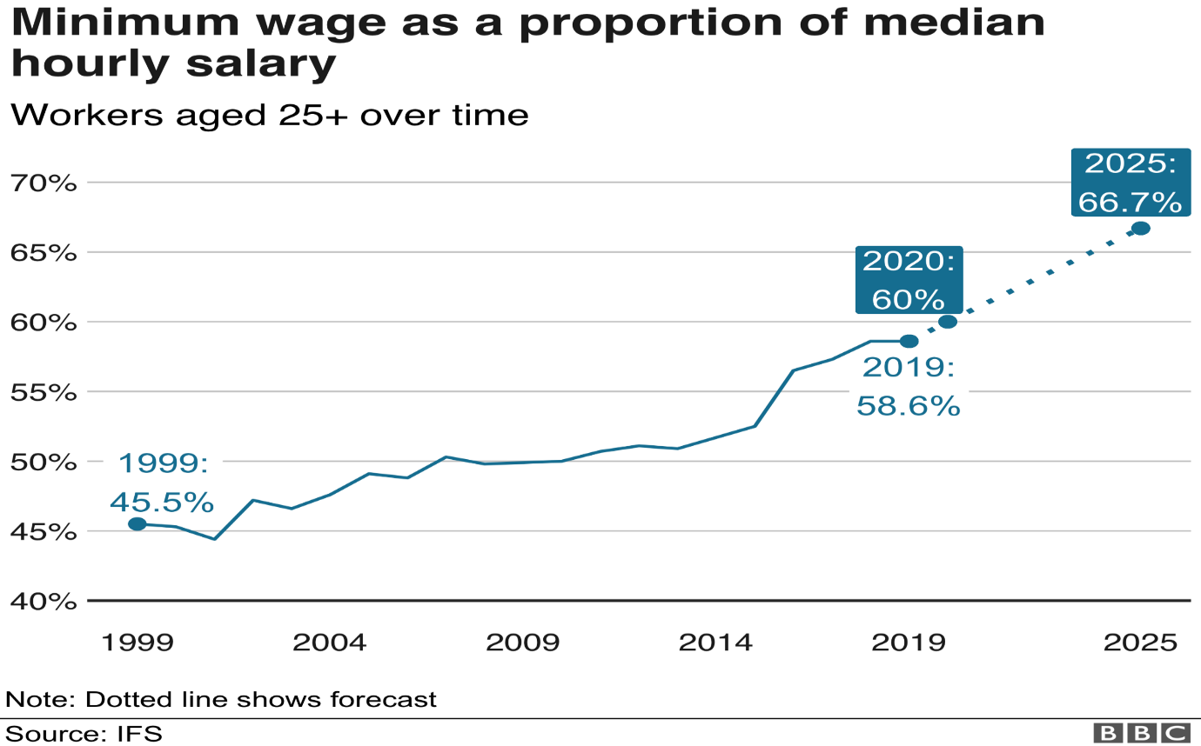
Figure 4: National Living Wage Increase in the UK

3.5 Reflection
Among the different factors affecting Greggs, labour costs represent the greatest risk. Wage increases directly affect operating expenses because retail stores require staff to operate effectively. Although energy and input prices also influence costs, labour expenses are likely to remain a long-term structural cost for the company.

Part 4: Macroeconomic Policy and Expansion Feasibility

4.1 Macro Indicators Comparison

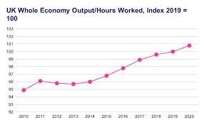
Figure 5: UK macro indicator

The UK economy has experienced a combination of inflation, rising interest rates and slow economic growth. Inflation reduces real income for consumers, which may reduce spending. At the same time, higher interest rates increase borrowing costs for businesses and reduce investment.

4.2 Government Policy Evaluation
Government policies also influence the economic environment for businesses. One example is the Energy Price Guarantee, which was introduced to limit the impact of rising energy prices on households and businesses (Treasury, 2024).
Another important policy is the National Living Wage, which increases the minimum wage for workers. While this improves living standards, it also increases labour costs for businesses.
The government also applies VAT rules on takeaway food, which influence pricing decisions for food retailers.
Fiscal policies such as government spending and taxation influence economic demand, while monetary policy conducted by the Bank of England influences interest rates and inflation.

4.3 Expansion Decision Matrix

Benefit | Risk
Increased market share | Cost Volatility
Economics of scale | Weak consumer demand
Automation efficiency | Higher borrowing costs

4.4 Economic Recommendation
Based on the economic evidence presented in this report, the most appropriate strategy for Greggs would be to slow expansion while focusing on efficiency improvements.
Although demand for affordable food remains relatively strong, economic conditions such as inflation, wage increases and high interest rates create uncertainty. Expanding too rapidly during this period could increase financial risk.
A more cautious approach would allow Greggs to continue growing while managing cost pressures and economic uncertainty.

4.5 Reflection
Over the next two to three years, Greggs’ performance will depend heavily on inflation trends and interest rate policies. If inflation decreases and interest rates fall, consumer spending may recover and create opportunities for expansion. However, if economic uncertainty continues, the company may need to prioritize efficiency and cost control rather than aggressive growth.

Part 5: Final Reflection and Conclusion
This report analyzed Greggs plc’s expansion strategy using both microeconomic and macroeconomic perspectives. Several economic theories were useful in understanding the company’s strategic decisions.
Elasticity theory helped explain why Greggs focuses on maintaining affordable prices in a market with many substitutes. Market structure theory showed that the company operates within monopolistic competition, were product differentiation and branding influence consumer choices. Cost curve analysis also helped explain how rising production costs affect pricing decisions.
However, economic models also have limitations. Many models rely on simplified assumptions such as ceteris paribus, which assumes that other factors remain constant. Economic conditions change frequently and unexpected events such as supply chain disruptions or global crises can influence business outcomes.
One important learning outcome from this analysis is the importance of using real economic data when evaluating business strategies. By analyzing data from organizations such as the Office for National Statistics and the Bank of England, it is possible to apply economic theory to real-world decision making.
Overall, Greggs continues to operate in a competitive but resilient market. Although economic pressures create risks, the company’s affordable pricing strategy and strong brand presence position it well to adapt to changing economic conditions.

References

Bank of England (2024) Monetary policy and interest rates. London: Bank of England. Available at: https://www.bankofengland.co.uk (Accessed: 15 March 2026).
Greggs plc (2023) Annual report and accounts 2023. Newcastle upon Tyne: Greggs plc. Available at: https://corporate.greggs.co.uk (Accessed: 15 March 2026).
HM Treasury (2024) UK economic outlook and fiscal policy. London: HM Treasury. Available at: https://www.gov.uk/government/organisations/hm-treasury (Accessed: 15 March 2026).
Office for National Statistics (2024) Consumer price inflation, UK. London: ONS. Available at: https://www.ons.gov.uk (Accessed: 15 March 2026).
Office for National Statistics (2024) Labour market overview, UK. London: ONS. Available at: https://www.ons.gov.uk (Accessed: 15 March 2026).
Statista (2024) Food-to-go market revenue in the United Kingdom. Available at: https://www.statista.com (Accessed: 15 March 2026).
Trading Economics (2024) United Kingdom economic indicators. Available at: https://tradingeconomics.com/united-kingdom (Accessed: 15 March 2026).

