**Model used to predict ratings (built by combining whole dataset’s pros and cons reviews)**

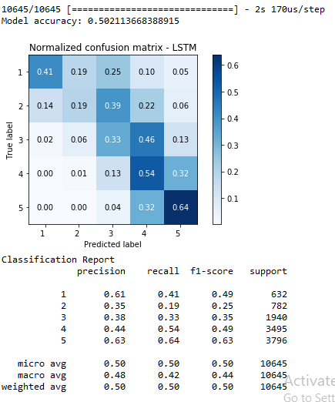 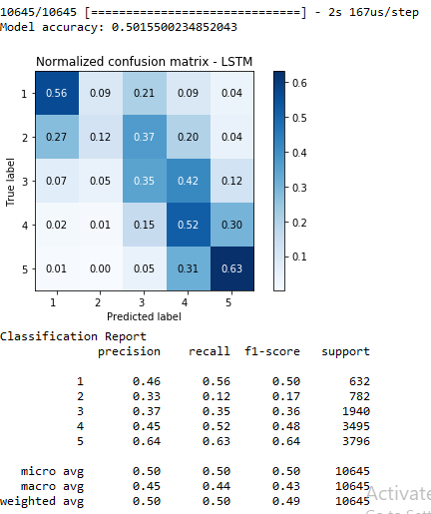

**Model used to prove there is no significant relationship between reviews and ratings (improved but still can achieve higher)**

**Most intuitive models ((12 cons, 3 combine, 45 pros) and (1 cons, 234 combine, 5 pros))**

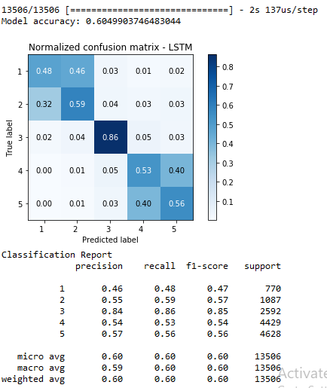 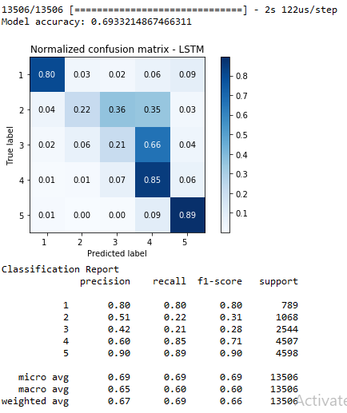

**Not intuitive models (3 combine, 15 pros, 24 cons, but highest performance measures)**

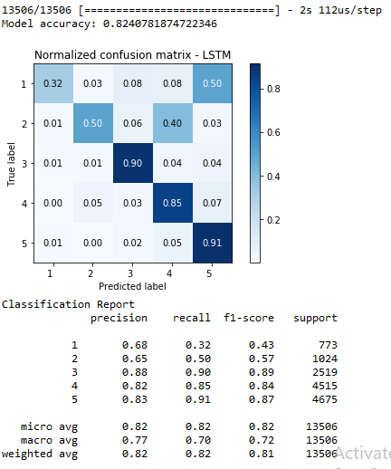 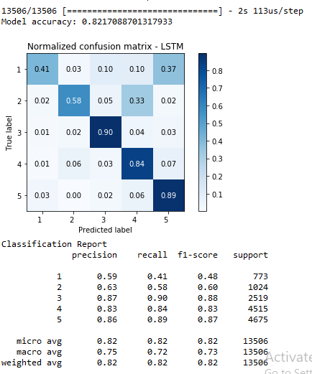

**Model used to predict ratings (For training data, selectively choosing pros or cons or combine reviews based on overall rating. For testing data, selectively choosing pros or cons or combine reviews based on predicted overall rating)**

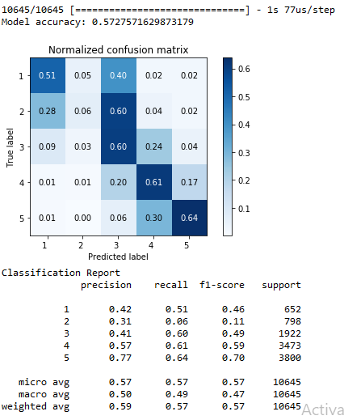 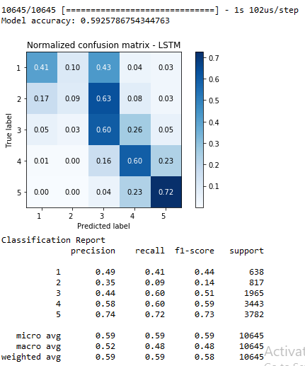

**Model used to predict ratings (For training data, selectively choosing pros or cons or combine reviews based on overall rating. For validation and testing data, we combine pros and cons reviews)**

