Embedding trainable = false , Trainable = true (glove) > false

Ratings 1,2,3= cons; rating 4 = combine, ratings 5 = pros, Epoch = 10, normal (test 55.8%) (avg 56%)

|  |  |  |  |  |
| --- | --- | --- | --- | --- |
| rating | precision | recall | F1 | support |
| 1 | 0.55 | 0.37 | 0.44 | 721 |
| 2 | 0.39 | 0.13 | 0.19 | 995 |
| 3 | 0.43 | 0.48 | 0.46 | 2263 |
| 4 | 0.52 | 0.64 | 0.57 | 4061 |
| 5 | 0.71 | 0.66 | 0.69 | 4125 |
| Micro avg | 0.56 | 0.56 | 0.56 | 12165 |
| Macro avg | 0.52 | 0.46 | 0.47 | 12165 |
| Weighted avg | 0.56 | 0.56 | 0.55 | 12165 |

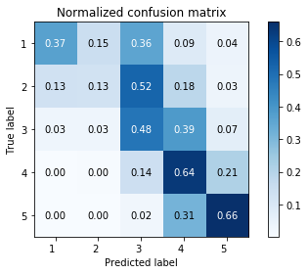

1. 0.5585 2) 0.5424
2. 0.5321 4) 0.5498
3. 0.5383 6) Avg = 0.5442

Ratings 1= cons; rating 2,3,4 = combine, ratings 5 = pros, Epoch = 10, normal (52%) (avg 56%)

|  |  |  |  |  |
| --- | --- | --- | --- | --- |
| rating | precision | recall | F1 | support |
| 1 | 0.56 | 0.48 | 0.51 | 711 |
| 2 | 0.33 | 0.22 | 0.26 | 984 |
| 3 | 0.36 | 0.41 | 0.38 | 2283 |
| 4 | 0.49 | 0.59 | 0.53 | 4030 |
| 5 | 0.73 | 0.60 | 0.66 | 4157 |
| Micro avg | 0.52 | 0.52 | 0.52 | 12165 |
| Macro avg | 0.49 | 0.46 | 0.47 | 12165 |
| Weighted avg | 0.54 | 0.52 | 0.53 | 12165 |

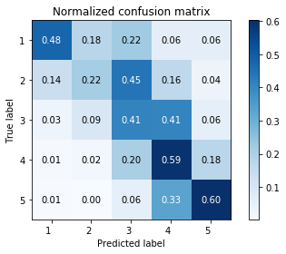

1. 0.5259 2) 0.5259
2. 0.5230 4) 0.5378
3. 0.5166 6) Avg = 0.5258

Ratings 1= cons; rating 2 = combine, ratings 3,4,5 = pros, Epoch = 10, normal (45%) (avg 53%)

|  |  |  |  |  |
| --- | --- | --- | --- | --- |
| rating | precision | recall | F1 | support |
| 1 | 0.43 | 0.68 | 0.53 | 722 |
| 2 | 0.37 | 0.18 | 0.24 | 1005 |
| 3 | 0.32 | 0.21 | 0.26 | 2248 |
| 4 | 0.42 | 0.42 | 0.42 | 3991 |
| 5 | 0.53 | 0.64 | 0.58 | 4119 |
| Micro avg | 0.45 | 0.45 | 0.45 | 12165 |
| Macro avg | 0.41 | 0.43 | 0.51 | 12165 |
| Weighted avg | 0.44 | 0.45 | 0.44 | 12165 |

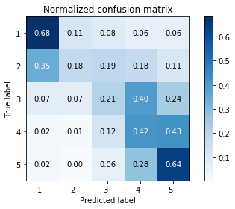

Ratings 1,2 = cons; rating 3,4 = combine, ratings 5 = pros, Epoch = 10, normal (52%) (avg 49~50) (not suitable see pic2 , rating 1,2,3 tends to be the next rating

|  |  |  |  |  |
| --- | --- | --- | --- | --- |
| rating | precision | recall | F1 | support |
| 1 | 0.46 | 0.55 | 0.50 | 707 |
| 2 | 0.37 | 0.22 | 0.28 | 1007 |
| 3 | 0.39 | 0.34 | 0.36 | 2332 |
| 4 | 0.49 | 0.60 | 0.54 | 4002 |
| 5 | 0.69 | 0.64 | 0.66 | 4117 |
| Micro avg | 0.53 | 0.53 | 0.53 | 12165 |
| Macro avg | 0.48 | 0.47 | 0.47 | 12165 |
| Weighted avg | 0.53 | 0.53 | 0.52 | 12165 |

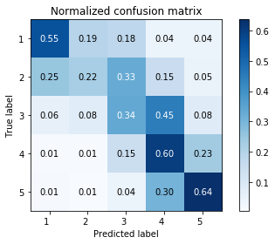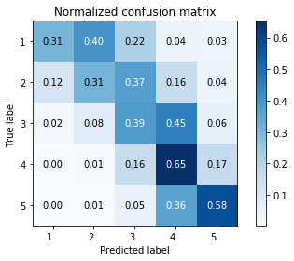

1. 0.5367 2) 0.5270
2. 0.5307 4) 0.5393
3. 0.5308 Acc: 0.5329

Ratings 1 = cons; rating 2,3 = combine, ratings 4,5 = pros, Epoch = 10, normal (49~50%)

|  |  |  |  |  |
| --- | --- | --- | --- | --- |
| rating | precision | recall | F1 | support |
| 1 | 0.51 | 0.58 | 0.54 | 752 |
| 2 | 0.34 | 0.19 | 0.24 | 966 |
| 3 | 0.45 | 0.40 | 0.42 | 2208 |
| 4 | 0.47 | 0.30 | 0.36 | 4128 |
| 5 | 0.54 | 0.82 | 0.65 | 4111 |
| Micro avg | 0.50 | 0.50 | 0.50 | 12165 |
| Macro avg | 0.46 | 0.46 | 0.44 | 12165 |
| Weighted avg | 0.48 | 0.50 | 0.47 | 12165 |

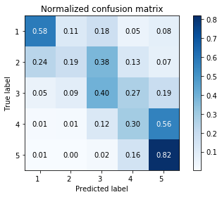

Ratings 1,2 = cons; rating 3 = combine, ratings 4,5 = pros, Epoch = 10, normal (49~50%)

|  |  |  |  |  |
| --- | --- | --- | --- | --- |
| rating | precision | recall | F1 | support |
| 1 | 0.42 | 0.68 | 0.52 | 741 |
| 2 | 0.35 | 0.16 | 0.22 | 998 |
| 3 | 0.46 | 0.37 | 0.41 | 2314 |
| 4 | 0.46 | 0.43 | 0.44 | 4065 |
| 5 | 0.57 | 0.69 | 0.62 | 4047 |
| Micro avg | 0.50 | 0.50 | 0.50 | 12165 |
| Macro avg | 0.45 | 0.46 | 0.44 | 12165 |
| Weighted avg | 0.49 | 0.50 | 0.48 | 12165 |

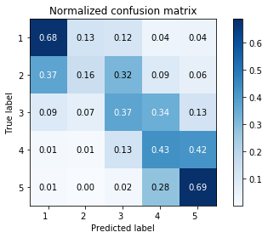

**Special case, trainable = false (pic1&2, because true positive rate of rating 1 same as rating 2 when pair together with 3, model keep predicting rating 1&2’s review to be rating 3, 而且把2和4配一起的话，不止偏向3还偏向4，更加分散2的tpr)**

Ratings 1,3= cons; rating 2,4 = combine, ratings 5 = pros, Epoch = 10, normal (52~53%) (avg 55)

|  |  |  |  |  |
| --- | --- | --- | --- | --- |
| rating | precision | recall | F1 | support |
| 1 | 0.48 | 0.25 | 0.33 | 672 |
| 2 | 0.39 | 0.21 | 0.27 | 984 |
| 3 | 0.42 | 0.49 | 0.45 | 2333 |
| 4 | 0.48 | 0.63 | 0.54 | 4019 |
| 5 | 0.75 | 0.60 | 0.66 | 4157 |
| Micro | 0.54 | 0.54 | 0.54 | 12165 |
| Macro | 0.50 | 0.44 | 0.45 | 12165 |
| Weighted | 0.55 | 0.54 | 0.53 | 12165 |

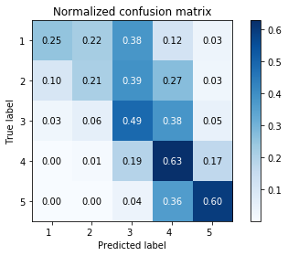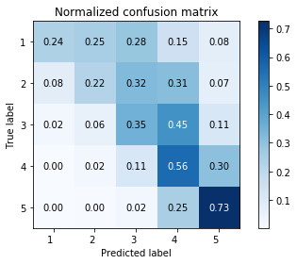

1. 0.5261 2) 0.5191

3) 0.5257 4) 0.5355

5) 0.5274 Acc: 0.5289

Ratings 3= cons; rating 1,2,4 = combine, ratings 5 = pros, Epoch = 10, normal (53% !!!) (avg 55) (**把2和4配一起的话，不止偏向3还偏向4，更加分散2的tpr)**

|  |  |  |  |  |
| --- | --- | --- | --- | --- |
| rating | precision | recall | F1 | support |
| 1 | 0.56 | 0.33 | 0.41 | 707 |
| 2 | 0.32 | 0.21 | 0.25 | 954 |
| 3 | 0.44 | 0.49 | 0.46 | 2279 |
| 4 | 0.47 | 0.58 | 0.52 | 3987 |
| 5 | 0.72 | 0.62 | 0.67 | 4283 |
| Micro | 0.54 | 0.54 | 0.54 | 12165 |
| Macro | 0.50 | 0.45 | 0.46 | 12165 |
| Weighted | 0.55 | 0.54 | 0.54 | 12165 |

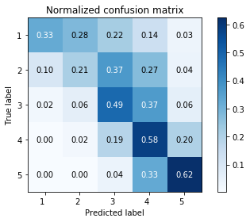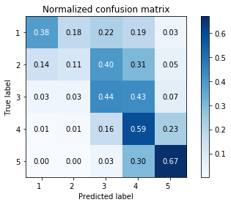

1. 0.5377 2) 0.5268

3) 0.5257 4) 0.5397

5) 0.5450 Acc: 0.5350

|  |  |  |  |  |
| --- | --- | --- | --- | --- |
| rating | precision | recall | F1 | support |
| 1 | 0.46 | 0.19 | 0.27 | 751 |
| 2 | 0.33 | 0.15 | 0.20 | 1025 |
| 3 | 0.43 | 0.51 | 0.46 | 2246 |
| 4 | 0.49 | 0.54 | 0.51 | 4012 |
| 5 | 0.67 | 0.69 | 0.68 | 4131 |
| Micro | 0.53 | 0.53 | 0.53 | 12165 |
| Macro | 0.48 | 0.42 | 0.43 | 12165 |
| Weighted | 0.52 | 0.53 | 0.52 | 12165 |

Ratings 3= cons; rating 2,4 = combine, ratings 1,5 = pros, Epoch = 10, normal (53% !!!) (avg 55)

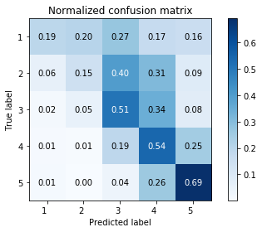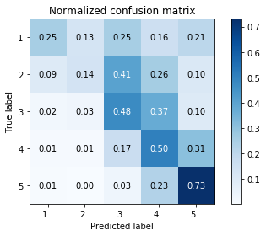

1. 0.5338 2) 0.5244

3) 0.5277 4) 0.5207

5) 0.5352 Acc: 0.5284

Ratings 3= cons; rating 1,4 = combine, ratings 2,5 = pros, Epoch = 10, normal (50~51% !!!) (avg 53)(**把2和5配一起的话，不止偏向3还偏向4 和5，更加分散2的tpr， 1和4 有同样的问题)**

|  |  |  |  |  |
| --- | --- | --- | --- | --- |
| rating | precision | recall | F1 | support |
| 1 | 0.50 | 0.25 | 0.34 | 720 |
| 2 | 0.28 | 0.16 | 0.21 | 964 |
| 3 | 0.43 | 0.40 | 0.42 | 2219 |
| 4 | 0.49 | 0.59 | 0.54 | 4032 |
| 5 | 0.63 | 0.64 | 0.63 | 4230 |
| Micro | 0.52 | 0.52 | 0.52 | 12165 |
| Macro | 0.47 | 0.41 | 0.43 | 12165 |
| Weighted | 0.51 | 0.52 | 0.51 | 12165 |

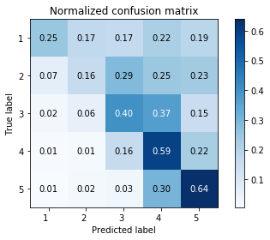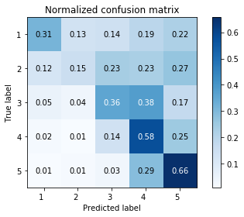

Ratings 1= cons; rating 2,4 = combine, ratings 3, 5 = pros, Epoch = 10, normal (47% !!!) (avg 50) (不值得因为1的rating很少，不值得去牺牲4和5的accuracy（4,5应该独立不跟别的掺，他们的instance最多，他们的accuracy高最重要）去提高1的accuracy）

|  |  |  |  |  |
| --- | --- | --- | --- | --- |
| rating | precision | recall | F1 | support |
| 1 | 0.56 | 0.56 | 0.56 | 762 |
| 2 | 0.27 | 0.24 | 0.26 | 925 |
| 3 | 0.36 | 0.31 | 0.33 | 2285 |
| 4 | 0.46 | 0.59 | 0.52 | 4029 |
| 5 | 0.57 | 0.48 | 0.52 | 4159 |
| Micro | 0.47 | 0.47 | 0.47 | 12165 |
| Macro | 0.44 | 0.44 | 0.44 | 12165 |
| Weighted | 0.47 | 0.47 | 0.47 | 12165 |

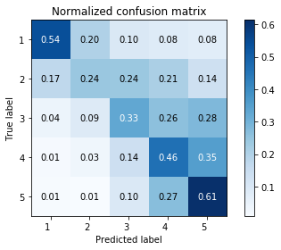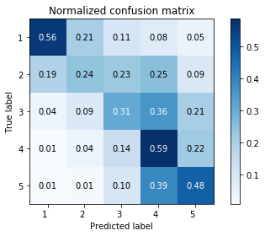

Instead of using the average of the 5 aspect ratings, we use that 5 aspect ratings to predict the overall ratings

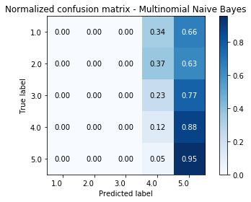LSTM(0.6615) Logistic(0.5828) MultinomialNB(0.3711)

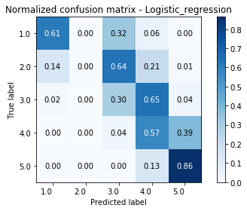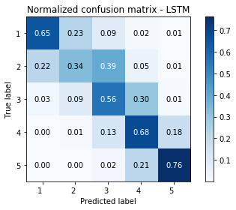

GaussianNB(0.6438) SVM(0.5721) RandomForest(0.6456)

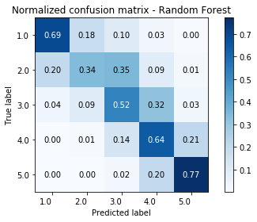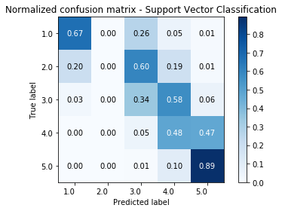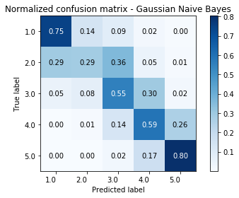

Semi final model (average accuracy of 3 runs)

13cons, 24combine, 5pros (0.566, 0.576, 0.573; avg_acc = 0.572)

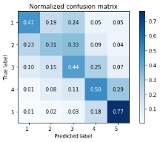 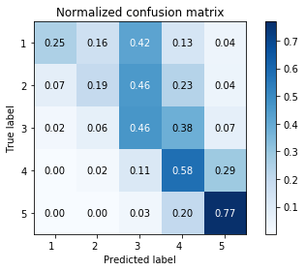 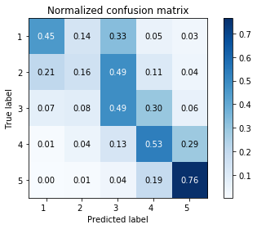

3cons, 124combine, 5pros (0.581, 0.581, 0.579; avg_acc = 0.580)

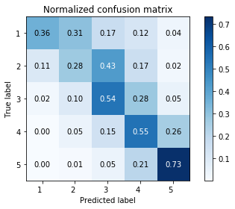 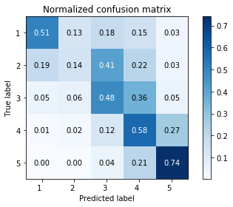 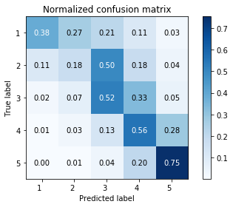

3cons, 24combine, 15pros (0.572, 0.565, 0.573; avg_acc = 0.57)

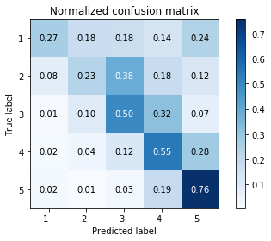 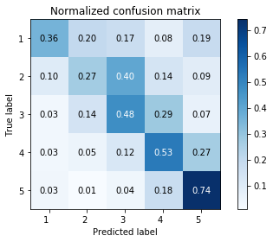 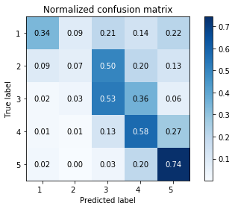

3cons, 14combine, 25pros (0.577, 0.570, 0.571; avg_acc = 0.573)

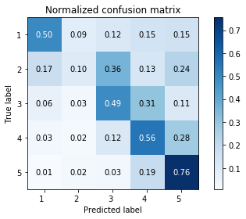 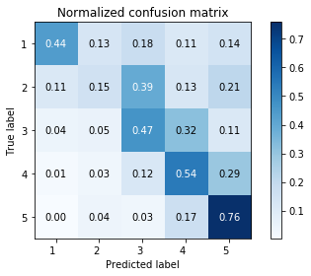 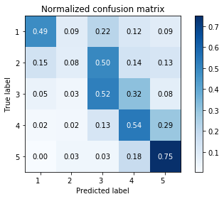

Classification Report

13cons, 24combine, 5pros

|  |  |  |  |  |
| --- | --- | --- | --- | --- |
| rating | precision | recall | F1 | support |
| 1 | 0.39 | 0.47 | 0.42 | 598 |
| 2 | 0.26 | 0.31 | 0.28 | 824 |
| 3 | 0.48 | 0.44 | 0.46 | 1950 |
| 4 | 0.58 | 0.50 | 0.53 | 3473 |
| 5 | 0.71 | 0.77 | 0.73 | 3800 |
| Micro | 0.57 | 0.57 | 0.57 | 10645 |
| Macro | 0.48 | 0.50 | 0.49 | 10645 |
| Wgted | 0.57 | 0.57 | 0.57 | 10645 |

|  |  |  |  |  |
| --- | --- | --- | --- | --- |
| rating | precision | recall | F1 | support |
| 1 | 0.61 | 0.25 | 0.36 | 663 |
| 2 | 0.34 | 0.19 | 0.25 | 784 |
| 3 | 0.44 | 0.46 | 0.45 | 1914 |
| 4 | 0.54 | 0.58 | 0.56 | 3551 |
| 5 | 0.70 | 0.77 | 0.73 | 3733 |
| Micro | 0.58 | 0.58 | 0.58 | 10645 |
| Macro | 0.52 | 0.45 | 0.47 | 10645 |
| Wgted | 0.57 | 0.58 | 0.57 | 10645 |

|  |  |  |  |  |
| --- | --- | --- | --- | --- |
| rating | precision | recall | F1 | support |
| 1 | 0.47 | 0.45 | 0.46 | 664 |
| 2 | 0.23 | 0.16 | 0.19 | 813 |
| 3 | 0.44 | 0.49 | 0.46 | 1924 |
| 4 | 0.57 | 0.53 | 0.55 | 3499 |
| 5 | 0.71 | 0.76 | 0.74 | 3745 |
| Micro | 0.57 | 0.57 | 0.57 | 10645 |
| Macro | 0.48 | 0.48 | 0.48 | 10645 |
| Wgted | 0.56 | 0.57 | 0.57 | 10645 |

|  |  |  |  |  |
| --- | --- | --- | --- | --- |
| rating | precision | recall | F1 | support |
| 1 | 0.54 | 0.51 | 0.52 | 663 |
| 2 | 0.28 | 0.14 | 0.19 | 784 |
| 3 | 0.47 | 0.48 | 0.48 | 1914 |
| 4 | 0.54 | 0.58 | 0.56 | 3551 |
| 5 | 0.71 | 0.74 | 0.73 | 3733 |
| Micro | 0.58 | 0.58 | 0.58 | 10645 |
| Macro | 0.51 | 0.49 | 0.50 | 10645 |
| Wgted | 0.57 | 0.58 | 0.57 | 10645 |

3cons, 124combine, 5pros

|  |  |  |  |  |
| --- | --- | --- | --- | --- |
| rating | precision | recall | F1 | support |
| 1 | 0.58 | 0.47 | 0.44 | 598 |
| 2 | 0.28 | 0.31 | 0.28 | 824 |
| 3 | 0.48 | 0.44 | 0.51 | 1950 |
| 4 | 0.55 | 0.50 | 0.55 | 3473 |
| 5 | 0.73 | 0.77 | 0.73 | 3800 |
| Micro | 0.58 | 0.58 | 0.58 | 10645 |
| Macro | 0.52 | 0.49 | 0.50 | 10645 |
| Wgted | 0.58 | 0.58 | 0.58 | 10645 |

|  |  |  |  |  |
| --- | --- | --- | --- | --- |
| rating | precision | recall | F1 | support |
| 1 | 0.62 | 0.38 | 0.47 | 664 |
| 2 | 0.25 | 0.18 | 0.21 | 813 |
| 3 | 0.47 | 0.52 | 0.49 | 1924 |
| 4 | 0.54 | 0.56 | 0.55 | 3499 |
| 5 | 0.71 | 0.75 | 0.73 | 3745 |
| Micro | 0.58 | 0.58 | 0.58 | 10645 |
| Macro | 0.52 | 0.48 | 0.49 | 10645 |
| Wgted | 0.57 | 0.58 | 0.57 | 10645 |

3cons, 24combine, 15pros

|  |  |  |  |  |
| --- | --- | --- | --- | --- |
| rating | precision | recall | F1 | support |
| 1 | 0.42 | 0.27 | 0.33 | 598 |
| 2 | 0.30 | 0.23 | 0.26 | 824 |
| 3 | 0.50 | 0.50 | 0.50 | 1950 |
| 4 | 0.55 | 0.55 | 0.55 | 3473 |
| 5 | 0.68 | 0.76 | 0.72 | 3800 |
| Micro | 0.57 | 0.57 | 0.57 | 10645 |
| Macro | 0.49 | 0.46 | 0.47 | 10645 |
| Wgted | 0.56 | 0.57 | 0.56 | 10645 |

|  |  |  |  |  |
| --- | --- | --- | --- | --- |
| rating | precision | recall | F1 | support |
| 1 | 0.39 | 0.36 | 0.37 | 663 |
| 2 | 0.26 | 0.27 | 0.27 | 784 |
| 3 | 0.48 | 0.48 | 0.48 | 1914 |
| 4 | 0.58 | 0.53 | 0.55 | 3551 |
| 5 | 0.68 | 0.74 | 0.71 | 3733 |
| Micro | 0.57 | 0.57 | 0.57 | 10645 |
| Macro | 0.48 | 0.48 | 0.48 | 10645 |
| Wgted | 0.56 | 0.57 | 0.56 | 10645 |

|  |  |  |  |  |
| --- | --- | --- | --- | --- |
| rating | precision | recall | F1 | support |
| 1 | 0.49 | 0.34 | 0.40 | 664 |
| 2 | 0.29 | 0.07 | 0.11 | 813 |
| 3 | 0.48 | 0.53 | 0.50 | 1924 |
| 4 | 0.54 | 0.58 | 0.56 | 3499 |
| 5 | 0.68 | 0.74 | 0.71 | 3745 |
| Micro | 0.57 | 0.57 | 0.57 | 10645 |
| Macro | 0.49 | 0.48 | 0.46 | 10645 |
| Wgted | 0.55 | 0.57 | 0.56 | 10645 |

|  |  |  |  |  |
| --- | --- | --- | --- | --- |
| rating | precision | recall | F1 | support |
| 1 | 0.51 | 0.49 | 0.50 | 664 |
| 2 | 0.17 | 0.08 | 0.11 | 813 |
| 3 | 0.47 | 0.52 | 0.50 | 1924 |
| 4 | 0.56 | 0.54 | 0.55 | 3499 |
| 5 | 0.68 | 0.75 | 0.71 | 3745 |
| Micro | 0.57 | 0.57 | 0.57 | 10645 |
| Macro | 0.48 | 0.48 | 0.47 | 10645 |
| Wgted | 0.55 | 0.57 | 0.56 | 10645 |

3cons, 14combine, 25pros

|  |  |  |  |  |
| --- | --- | --- | --- | --- |
| rating | precision | recall | F1 | support |
| 1 | 0.43 | 0.50 | 0.33 | 598 |
| 2 | 0.25 | 0.10 | 0.26 | 824 |
| 3 | 0.52 | 0.49 | 0.50 | 1950 |
| 4 | 0.56 | 0.56 | 0.55 | 3473 |
| 5 | 0.66 | 0.76 | 0.72 | 3800 |
| Micro | 0.58 | 0.58 | 0.58 | 10645 |
| Macro | 0.49 | 0.48 | 0.47 | 10645 |
| Wgted | 0.56 | 0.58 | 0.56 | 10645 |

|  |  |  |  |  |
| --- | --- | --- | --- | --- |
| rating | precision | recall | F1 | support |
| 1 | 0.55 | 0.44 | 0.49 | 663 |
| 2 | 0.21 | 0.15 | 0.18 | 784 |
| 3 | 0.48 | 0.47 | 0.47 | 1914 |
| 4 | 0.58 | 0.54 | 0.56 | 3551 |
| 5 | 0.65 | 0.76 | 0.70 | 3733 |
| Micro | 0.57 | 0.57 | 0.57 | 10645 |
| Macro | 0.49 | 0.47 | 0.48 | 10645 |
| Wgted | 0.56 | 0.57 | 0.56 | 10645 |

123 cons, 4combine, 5pros (0.584, 0.59, 0.576)

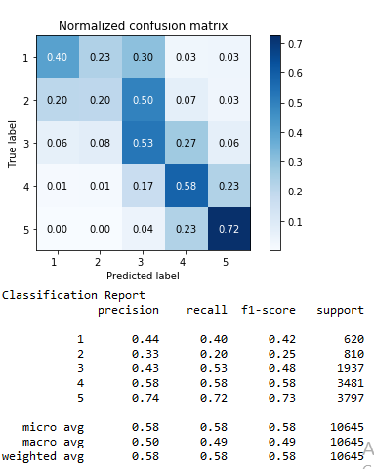 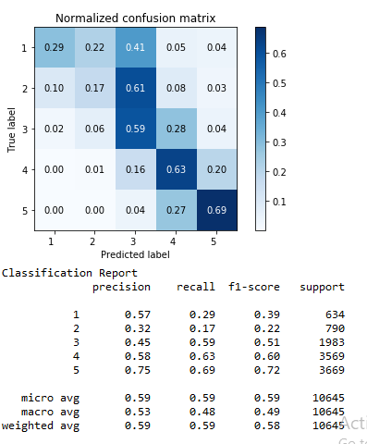 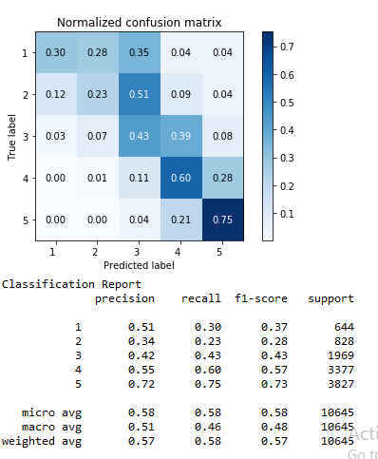

1cons, 234combine, 5pros (0.571, 0.574, 0.571)

