Instead of using the average of the 5 aspect ratings, we use that 5 aspect ratings to predict the overall ratings

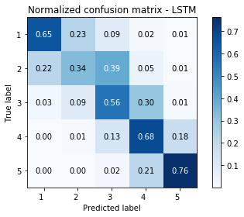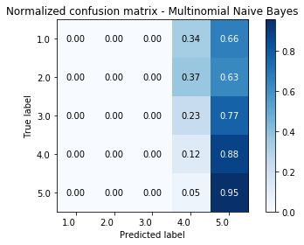LSTM(0.6615) Logistic(0.5828) MultinomialNB(0.3711)

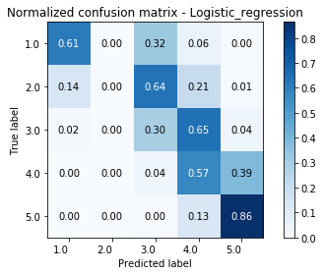

GaussianNB(0.6438) SVM(0.5721) RandomForest(0.6456)

