IT 2045C Computer Programming II
Prof. Tom Wulf
Lab 07C: Software Engineering Camp Part C: Battle Ship
Fall 2024 v1.0
20 pts

This is the third (Part C) in a series of sub-assignments in which we will practice the software engineering process presented in the course.
For each project we will:
- Derive a candidate class list from, requirements documents, Use-Cases. And subject matter knowledge
- Create CRC cards for the candidate classes and cull the unneeded classes
- Create a UML diagram showing the relationships between the classes in our design
- Implement our classes and create JUnit tests for them.

Part C: Battleship Project

Requirements:
Implement a java Swing GUI program that provides a single player version of the Battleship game (which is normally two players).
- The GUI will have
  - Title
  - Game board Grid of 10 by 10 JButton cells which contain
    - a light blue wave character or image for a BLANK cell
    - a yellow M character or image for a MISS cell (perhaps a splash image?)
    - a red X character or image for a HIT cell (perhaps an explosion image?)
  - Status displays that show:
    - The MISS counter [0-5]
    - The STRIKE counter [0-3]
    - TOTAL MISS counter [0-83]
    - TOTAL HIT counter [0-17]
  - Play again and Quit JButtons
How it will run:
- The program must randomly place the 5 ships {2, 3, 3, 4, 5} on the board before the start of the game. The cells on the visible board are all BLANK.
(See notes below on setting the board up.)
The MISS counter, STRIKE counter, TOTAL MISS counter, and TOTAL HIT counter are all set to zero.
- The player clicks on one of the BLANK board cells to fire a missile. The cell display now shows that it is either a HIT or a MISS.
(Once a cell is clicked, it should be disabled so it does not respond to future clicks within the same game. These clicks do not count as moves.)
if it is a HIT, the TOTAL HIT counter is incremented by 1 and the miss counter is reset to zero.
If it is the final hit on the ship then a popup msgDialog should indicate it is sunk!
If it is the final hit on the final ship then the user has won. Display a dialog msg and prompt the user to replay.
if it is a MISS the MISS counter and the TOTAL Miss counter are incremented by 1
If the miss counter has reached 5 (which means 5 misses in a row with no hits) we increment the STRIKE counter by 1 and reset the Miss counter to 0.
If the Strike Counter reaches 3 the user loses the game. Display a msg and prompt them to play again.
- The user can quit the game with the Quit JButton (prompt for replay)
- The user can quit and start a new game with the Play Again Button (“Are you sure?” prompt, then start new game or continue current one)

Tech Note: placing the ships on the board

You place the 5 ships {1, 3, 3, 4, 5} (note that there are two 3 ships) randomly on the board horizontally or vertically. Ships cannot overlap one another but can touch (i.e. be adjacent to one another. You can have more than one ship in a row or column of the board.)
One approach:
- Its more efficient to place the ships in descending order {5, 4, 3, 3, 2}
- randomize whether the placement is horizontal or vertical
- randomize the row or column
- scan the row or column for a sequence of BLANK cells equal to the size of the ship.
Ships can’t overlap but you can have more than one ship in a given row or column.
There may be more than one so, randomize which one to use.
(i.e. Ship 2 will occupy 2 adjacent cells either vertical or horizontal. For instance, on an empty row or column, Ship 2 can be paced in 9 different positions each starting at location 0 through 8. The first location spans cell 0 to 1 at the start of the row or column, the final one spans cell 8 to 9 at the end of the row or column.
This is actually the most ‘interesting’ aspect to implementing the game.

Directions

- Using the requirements create a list of candidate classes for the Battleship application.

Put your list here with candidate class names one per line.
BattleshipRunner (kept: program entry point (main))
BattleshipFrame (GUI) (kept)
Board / Game Board (kept)
Cell (BattleshipTile) (kept: JButton subclass that knows its row/col)
CellState (BLANK / MISS / HIT) (kept: enum)
Ship (kept)
ShotResult (kept: enum returned by Board.fire())
Scoreboard (counters) (kept: holds all four counters and the strike/lose rules)
Game (culled: game flow lives in BattleshipFrame + Board)
Player (culled: single player, no state of its own)
Missile (culled: a missile is just a click on a cell)
MissCounter (culled: merged into Scoreboard)
StrikeCounter (culled: merged into Scoreboard)
TotalMissCounter (culled: merged into Scoreboard)
TotalHitCounter (culled: merged into Scoreboard)
StatusDisplay (culled: plain JLabels in BattleshipFrame)
Title (culled: plain JLabel)
PlayAgainButton (culled: plain JButton)
QuitButton (culled: plain JButton)
MessageDialog (culled: JOptionPane already does this)
ShipPlacer (culled: became Board.placeShipsRandomly())
- Now, create the CRC cards for each class noting the class name, class responsibilities, and any collaborators. At this point, you can cull the classes from the candidate list that you do not use. LEAVE THEM IN THE LIST BUT USE THE STRIKETHROUGH FONT TO SHOW THEY ARE ELIMINATED.
Put the CRC cards here for the classes:

BattleshipRunner
Responsibilities | Collaborators
• Start the program  • Create, size, center and show the BattleshipFrame | • BattleshipFrame

BattleshipFrame
Responsibilities | Collaborators
• Build the GUI: title, 10x10 grid, status labels, Play Again / Quit buttons  • Handle a cell click: fire at the Board and update the tile  • Update the four status counters  • Show Sunk, Strike, Win and Lose dialogs and prompt to play again  • Confirm Play Again ("Are you sure?") and Quit  • Start a new game (reset board, counters, tiles) | • Board  • Scoreboard  • BattleshipTile  • ShotResult  • JOptionPane

BattleshipTile
Responsibilities | Collaborators
• Be one clickable cell on the grid (extends JButton)  • Remember its row and column  • Display wave / yellow M / red X for its CellState  • Disable itself once it has been fired on | • CellState  • BattleshipFrame

Board
Responsibilities | Collaborators
• Hold the 10x10 grid of CellStates  • Randomly place the 5 ships {5,4,3,3,2} horizontally or vertically with no overlap  • Fire a missile at a cell and report MISS / HIT / SUNK / ALL_SUNK  • Know whether all ships are sunk  • Clear itself for a new game | • Ship  • CellState  • ShotResult  • Random

Ship
Responsibilities | Collaborators
• Know its size and the cells it occupies  • Count hits  • Know if it is sunk | • Board

Scoreboard
Responsibilities | Collaborators
• Track MISS counter (0-5), STRIKE counter (0-3), TOTAL MISS, TOTAL HIT  • Reset the miss counter on a hit  • Turn 5 misses in a row into a strike  • Know when the player has lost (3 strikes)  • Reset for a new game | • BattleshipFrame

CellState (enum)
Responsibilities | Collaborators
• Represent a cell as BLANK, MISS or HIT | • Board  • BattleshipTile

ShotResult (enum)
Responsibilities | Collaborators
• Represent the result of a shot: MISS, HIT, SUNK, ALL_SUNK | • Board  • BattleshipFrame

- Now create a complete UML diagram that shows all the classes that you did not cull and their relationships.
Insert the UML Diagram here.
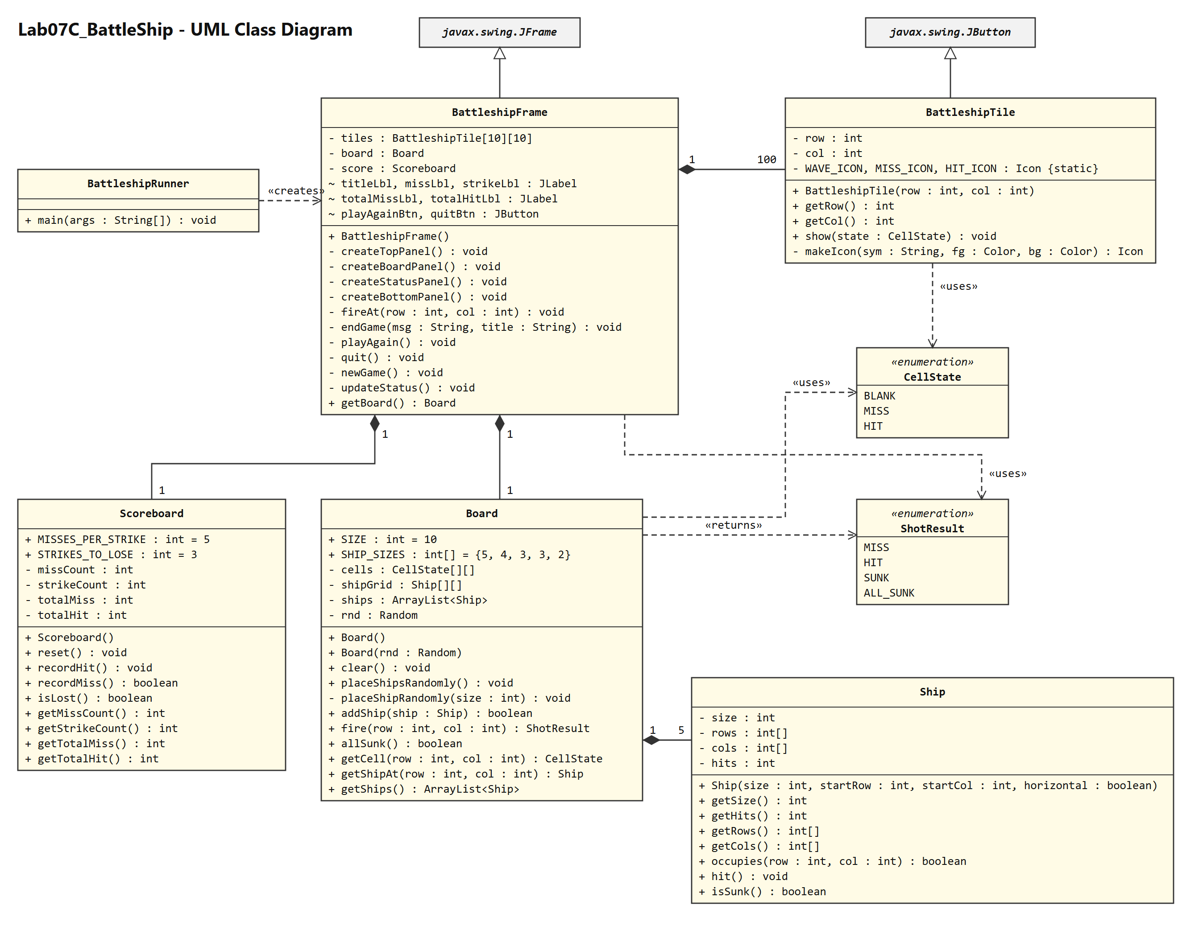
Solid line + filled diamond = composition (multiplicity shown), hollow triangle = inheritance, dashed arrow = dependency (uses / creates / returns).
- Now, Implement Battleship as a Java Swing GUI Project using the new objects that you developed.
Project Name: Lab07C_BattleShip
- Provide a variety of screen shots that show that you completed the lab:
  - HIT
  - MISS
  - WIN (prompt to play again)
  - LOSS (prompt to play again)
Screen Shots
Figure 1: New game: the 5 ships are placed randomly and hidden, every cell is a light blue wave, all counters are zero.
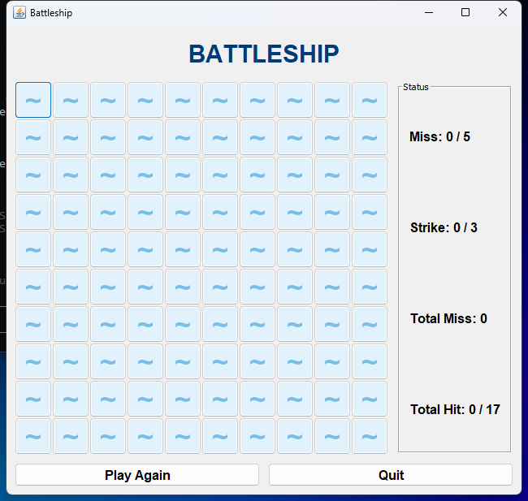
Figure 2: MISS: three missed shots show a yellow M and the cells are disabled. Miss = 3/5 and Total Miss = 3.
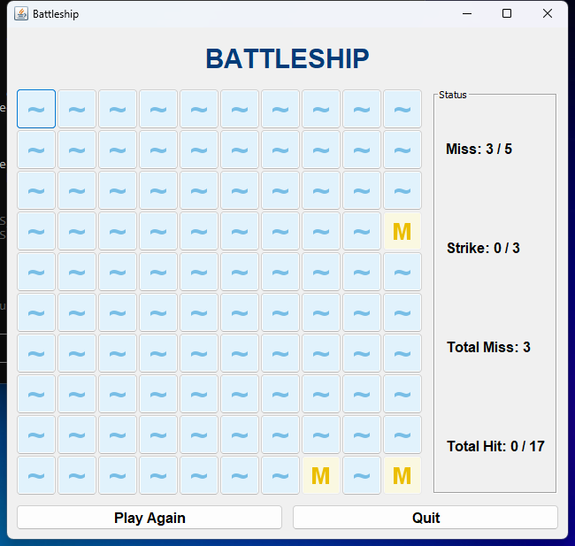
Figure 3: HIT: a hit shows a red X. Total Hit goes to 1 and the Miss counter resets to 0.
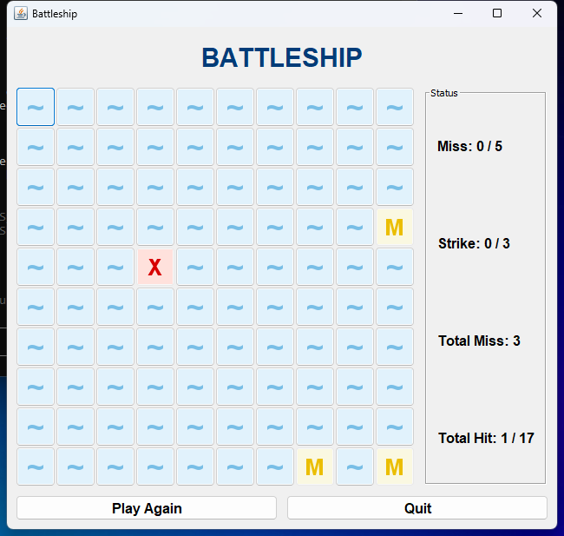
Figure 4: Final hit on a ship pops up a "You sunk a ship!" message.
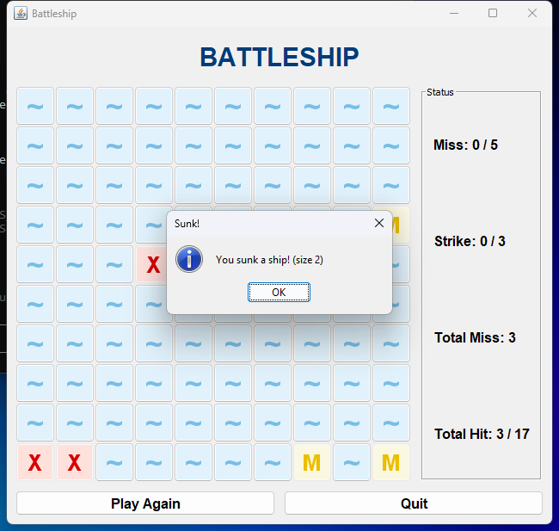
Figure 5: WIN: the final hit on the final ship (Total Hit 17/17) shows the win message and prompts to play again.
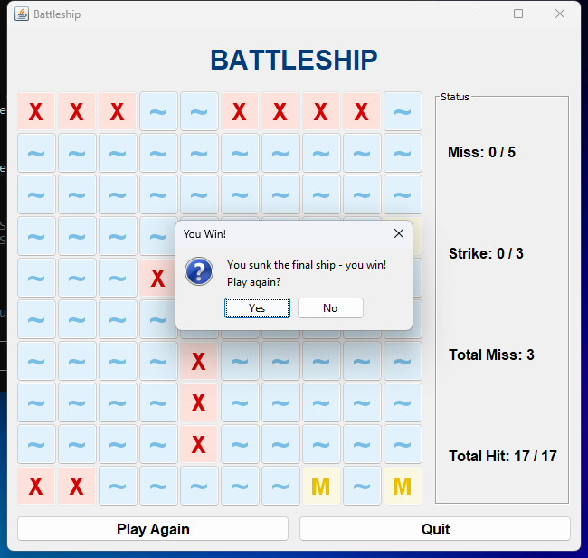
Figure 6: After clicking Yes, a new game starts with a fresh random board and counters reset.
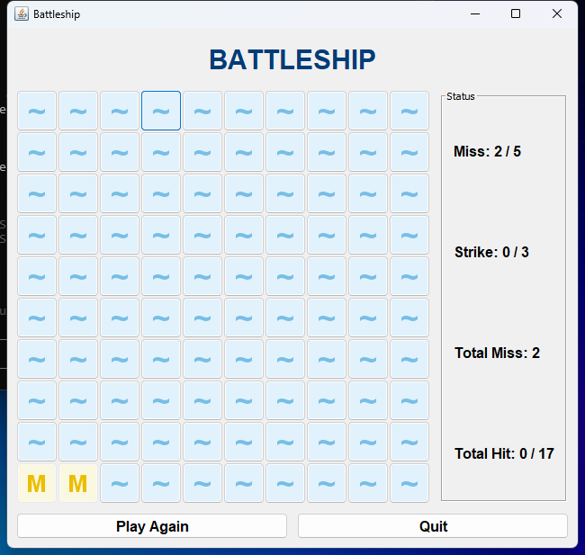
Figure 7: 5 misses in a row: the Strike counter goes up by 1 and the Miss counter resets to 0.
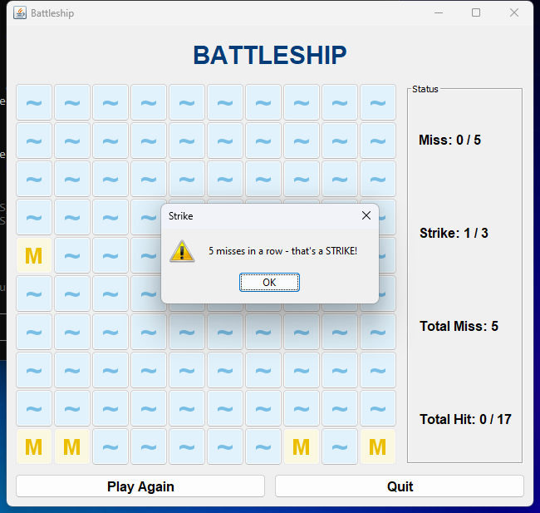
Figure 8: LOSS: the third strike (15 misses with no hits) shows the lose message and prompts to play again.
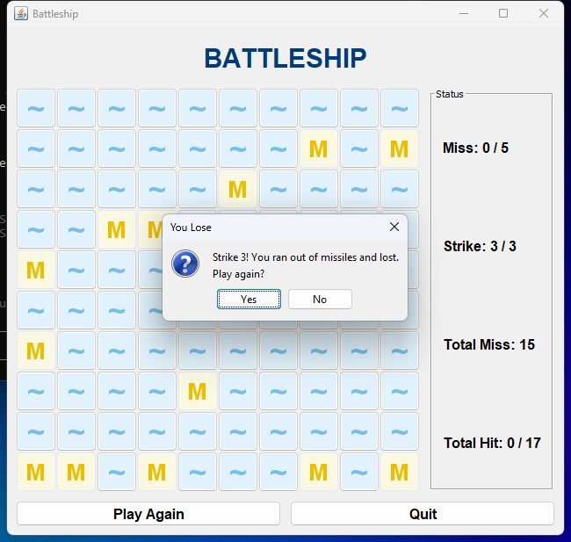
Figure 9: Play Again button asks "Are you sure?" before ending the current game.
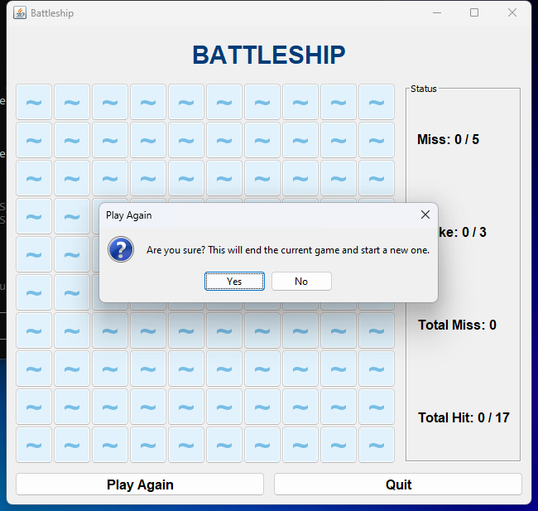
Figure 10: Quit button prompts to play again instead, quit, or cancel.
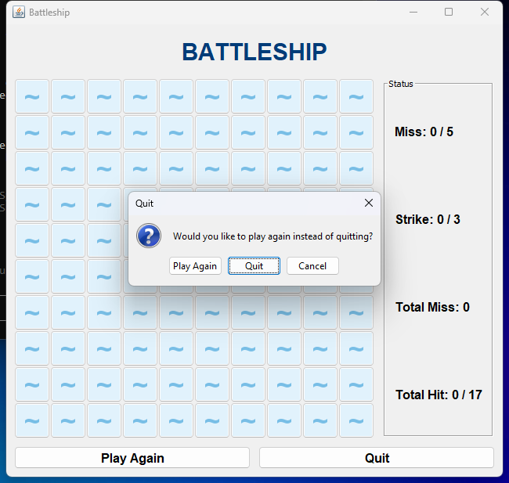

Use the Canvas Assignment mechanism to submit the link to your GitHub repo for this project and after inserting your screen and code shots this file renamed LastnameFirstname _Lab_07C_Battleship.docx (using your actual name).
Code
GitHub repo: https://github.com/123rbe344/Lab07C_BattleShip
JUnit 5 tests (test/ShipTest, test/BoardTest, test/ScoreboardTest): 15 tests found, 15 tests successful, 0 failed. BoardTest places ships randomly 200 times and checks every board has 5 ships covering exactly 17 cells with no overlap.
src/BattleshipRunner.java
import javax.swing.*;
public class BattleshipRunner
{
public static void main(String[] args)
{
SwingUtilities.invokeLater(() ->
{
BattleshipFrame frame = new BattleshipFrame();
frame.pack();
frame.setLocationRelativeTo(null);
frame.setVisible(true);
});
}
}

src/BattleshipFrame.java
import javax.swing.*;
import java.awt.*;
import java.awt.event.ActionEvent;
import java.awt.event.ActionListener;
public class BattleshipFrame extends JFrame
{
JPanel mainPnl;
JPanel topPnl;
JPanel boardPnl;
JPanel statusPnl;
JPanel bottomPnl;
JLabel titleLbl;
JLabel missLbl;
JLabel strikeLbl;
JLabel totalMissLbl;
JLabel totalHitLbl;
JButton playAgainBtn;
JButton quitBtn;
Font titleFont = new Font("SansSerif", Font.BOLD, 30);
Font statusFont = new Font("SansSerif", Font.BOLD, 16);
Font buttonFont = new Font("SansSerif", Font.BOLD, 16);
private BattleshipTile[][] tiles = new BattleshipTile[Board.SIZE][Board.SIZE];
private Board board = new Board();
private Scoreboard score = new Scoreboard();

public BattleshipFrame()
{
super("Battleship");
mainPnl = new JPanel();
mainPnl.setLayout(new BorderLayout(10, 10));
mainPnl.setBorder(BorderFactory.createEmptyBorder(10, 10, 10, 10));
createTopPanel();
mainPnl.add(topPnl, BorderLayout.NORTH);
createBoardPanel();
mainPnl.add(boardPnl, BorderLayout.CENTER);
createStatusPanel();
mainPnl.add(statusPnl, BorderLayout.EAST);
createBottomPanel();
mainPnl.add(bottomPnl, BorderLayout.SOUTH);
add(mainPnl);
setDefaultCloseOperation(JFrame.EXIT_ON_CLOSE);
newGame();
}
private void createTopPanel()
{
topPnl = new JPanel();
titleLbl = new JLabel("BATTLESHIP");
titleLbl.setFont(titleFont);
titleLbl.setForeground(new Color(0, 60, 120));
topPnl.add(titleLbl);
}
private void createBoardPanel()
{
boardPnl = new JPanel();
boardPnl.setLayout(new GridLayout(Board.SIZE, Board.SIZE));
TileListener listener = new TileListener();
for (int row = 0; row < Board.SIZE; row++)
{
for (int col = 0; col < Board.SIZE; col++)
{
tiles[row][col] = new BattleshipTile(row, col);
tiles[row][col].addActionListener(listener);
boardPnl.add(tiles[row][col]);
}
}
}
private void createStatusPanel()
{
statusPnl = new JPanel();
statusPnl.setLayout(new GridLayout(4, 1, 0, 10));
statusPnl.setBorder(BorderFactory.createTitledBorder("Status"));
missLbl = new JLabel();
strikeLbl = new JLabel();
totalMissLbl = new JLabel();
totalHitLbl = new JLabel();
for (JLabel lbl : new JLabel[]{missLbl, strikeLbl, totalMissLbl, totalHitLbl})
{
lbl.setFont(statusFont);
lbl.setBorder(BorderFactory.createEmptyBorder(0, 10, 0, 10));
statusPnl.add(lbl);
}
}
private void createBottomPanel()
{
bottomPnl = new JPanel();
bottomPnl.setLayout(new GridLayout(1, 2, 10, 0));
playAgainBtn = new JButton("Play Again");
playAgainBtn.setFont(buttonFont);
playAgainBtn.addActionListener((ae) -> playAgain());
quitBtn = new JButton("Quit");
quitBtn.setFont(buttonFont);
quitBtn.addActionListener((ae) -> quit());
bottomPnl.add(playAgainBtn);
bottomPnl.add(quitBtn);
}
private class TileListener implements ActionListener
{
@Override
public void actionPerformed(ActionEvent ae)
{
BattleshipTile tile = (BattleshipTile) ae.getSource();
fireAt(tile.getRow(), tile.getCol());
}
}
private void fireAt(int row, int col)
{
if (board.getCell(row, col) != CellState.BLANK)
{
return;
}
ShotResult result = board.fire(row, col);
tiles[row][col].show(board.getCell(row, col));
if (result == ShotResult.MISS)
{
boolean strike = score.recordMiss();
updateStatus();
if (score.isLost())
{
endGame("Strike 3! You ran out of missiles and lost.\nPlay again?", "You Lose");
}
else if (strike)
{
JOptionPane.showMessageDialog(this, "5 misses in a row - that's a STRIKE!", "Strike", JOptionPane.WARNING_MESSAGE);
}
return;
}
score.recordHit();
updateStatus();
if (result == ShotResult.SUNK)
{
int size = board.getShipAt(row, col).getSize();
JOptionPane.showMessageDialog(this, "You sunk a ship! (size " + size + ")", "Sunk!", JOptionPane.INFORMATION_MESSAGE);
}
else if (result == ShotResult.ALL_SUNK)
{
endGame("You sunk the final ship - you win!\nPlay again?", "You Win!");
}
}
private void endGame(String msg, String title)
{
int choice = JOptionPane.showConfirmDialog(this, msg, title, JOptionPane.YES_NO_OPTION);
if (choice == JOptionPane.YES_OPTION)
{
newGame();
}
else
{
System.exit(0);
}
}
private void playAgain()
{
int choice = JOptionPane.showConfirmDialog(this, "Are you sure? This will end the current game and start a new one.", "Play Again", JOptionPane.YES_NO_OPTION);
if (choice == JOptionPane.YES_OPTION)
{
newGame();
}
}
private void quit()
{
String[] options = {"Play Again", "Quit", "Cancel"};
int choice = JOptionPane.showOptionDialog(this, "Would you like to play again instead of quitting?", "Quit", JOptionPane.YES_NO_CANCEL_OPTION, JOptionPane.QUESTION_MESSAGE, null, options, options[1]);
if (choice == 0)
{
newGame();
}
else if (choice == 1)
{
System.exit(0);
}
}
private void newGame()
{
board.placeShipsRandomly();
score.reset();
for (int row = 0; row < Board.SIZE; row++)
{
for (int col = 0; col < Board.SIZE; col++)
{
tiles[row][col].show(CellState.BLANK);
}
}
updateStatus();
}
private void updateStatus()
{
missLbl.setText("Miss: " + score.getMissCount() + " / " + Scoreboard.MISSES_PER_STRIKE);
strikeLbl.setText("Strike: " + score.getStrikeCount() + " / " + Scoreboard.STRIKES_TO_LOSE);
totalMissLbl.setText("Total Miss: " + score.getTotalMiss());
totalHitLbl.setText("Total Hit: " + score.getTotalHit() + " / 17");
}
public Board getBoard()
{
return board;
}
}

src/BattleshipTile.java
import javax.swing.*;
import java.awt.*;
import java.awt.image.BufferedImage;
public class BattleshipTile extends JButton
{
private static final int ICON_SIZE = 40;
private static final Icon WAVE_ICON = makeIcon("~", new Color(120, 190, 230), new Color(225, 242, 252));
private static final Icon MISS_ICON = makeIcon("M", new Color(235, 190, 0), new Color(250, 248, 225));
private static final Icon HIT_ICON = makeIcon("X", new Color(215, 0, 0), new Color(255, 225, 220));
private int row;
private int col;

public BattleshipTile(int row, int col)
{
super();
this.row = row;
this.col = col;
setFocusPainted(false);
setMargin(new Insets(0, 0, 0, 0));
setPreferredSize(new Dimension(ICON_SIZE + 6, ICON_SIZE + 6));
show(CellState.BLANK);
}
public int getRow()
{
return row;
}
public int getCol()
{
return col;
}
public void show(CellState state)
{
Icon icon = WAVE_ICON;
if (state == CellState.MISS)
{
icon = MISS_ICON;
}
else if (state == CellState.HIT)
{
icon = HIT_ICON;
}
setIcon(icon);
setDisabledIcon(icon);
setEnabled(state == CellState.BLANK);
}
private static Icon makeIcon(String symbol, Color fg, Color bg)
{
BufferedImage img = new BufferedImage(ICON_SIZE, ICON_SIZE, BufferedImage.TYPE_INT_ARGB);
Graphics2D g = img.createGraphics();
g.setRenderingHint(RenderingHints.KEY_ANTIALIASING, RenderingHints.VALUE_ANTIALIAS_ON);
g.setRenderingHint(RenderingHints.KEY_TEXT_ANTIALIASING, RenderingHints.VALUE_TEXT_ANTIALIAS_ON);
g.setColor(bg);
g.fillRect(0, 0, ICON_SIZE, ICON_SIZE);
g.setColor(fg);
g.setFont(new Font("SansSerif", Font.BOLD, symbol.equals("~") ? 34 : 26));
FontMetrics fm = g.getFontMetrics();
int x = (ICON_SIZE - fm.stringWidth(symbol)) / 2;
int y = (ICON_SIZE - fm.getHeight()) / 2 + fm.getAscent();
g.drawString(symbol, x, y);
g.dispose();
return new ImageIcon(img);
}
}

src/Board.java
import java.util.ArrayList;
import java.util.Random;
public class Board
{
public static final int SIZE = 10;
public static final int[] SHIP_SIZES = {5, 4, 3, 3, 2};
private CellState[][] cells = new CellState[SIZE][SIZE];
private Ship[][] shipGrid = new Ship[SIZE][SIZE];
private ArrayList<Ship> ships = new ArrayList<>();
private Random rnd;

public Board()
{
this(new Random());
}
public Board(Random rnd)
{
this.rnd = rnd;
clear();
}
public void clear()
{
ships.clear();
for (int row = 0; row < SIZE; row++)
{
for (int col = 0; col < SIZE; col++)
{
cells[row][col] = CellState.BLANK;
shipGrid[row][col] = null;
}
}
}
public void placeShipsRandomly()
{
clear();
for (int size : SHIP_SIZES)
{
placeShipRandomly(size);
}
}
private void placeShipRandomly(int size)
{
while (true)
{
boolean horizontal = rnd.nextBoolean();
int line = rnd.nextInt(SIZE);
ArrayList<Integer> starts = new ArrayList<>();
int run = 0;
for (int i = 0; i < SIZE; i++)
{
int row = horizontal ? line : i;
int col = horizontal ? i : line;
run = shipGrid[row][col] == null ? run + 1 : 0;
if (run >= size)
{
starts.add(i - size + 1);
}
}
if (!starts.isEmpty())
{
int start = starts.get(rnd.nextInt(starts.size()));
if (horizontal)
{
addShip(new Ship(size, line, start, true));
}
else
{
addShip(new Ship(size, start, line, false));
}
return;
}
}
}
public boolean addShip(Ship ship)
{
int[] rows = ship.getRows();
int[] cols = ship.getCols();
for (int i = 0; i < ship.getSize(); i++)
{
if (rows[i] < 0 || rows[i] >= SIZE || cols[i] < 0 || cols[i] >= SIZE)
{
return false;
}
if (shipGrid[rows[i]][cols[i]] != null)
{
return false;
}
}
for (int i = 0; i < ship.getSize(); i++)
{
shipGrid[rows[i]][cols[i]] = ship;
}
ships.add(ship);
return true;
}
public ShotResult fire(int row, int col)
{
if (cells[row][col] != CellState.BLANK)
{
throw new IllegalStateException("Cell already fired on");
}
Ship ship = shipGrid[row][col];
if (ship == null)
{
cells[row][col] = CellState.MISS;
return ShotResult.MISS;
}
cells[row][col] = CellState.HIT;
ship.hit();
if (!ship.isSunk())
{
return ShotResult.HIT;
}
return allSunk() ? ShotResult.ALL_SUNK : ShotResult.SUNK;
}
public boolean allSunk()
{
for (Ship ship : ships)
{
if (!ship.isSunk())
{
return false;
}
}
return !ships.isEmpty();
}
public CellState getCell(int row, int col)
{
return cells[row][col];
}
public Ship getShipAt(int row, int col)
{
return shipGrid[row][col];
}
public ArrayList<Ship> getShips()
{
return ships;
}
}

src/Ship.java
public class Ship
{
private int size;
private int[] rows;
private int[] cols;
private int hits = 0;

public Ship(int size, int startRow, int startCol, boolean horizontal)
{
this.size = size;
rows = new int[size];
cols = new int[size];
for (int i = 0; i < size; i++)
{
rows[i] = horizontal ? startRow : startRow + i;
cols[i] = horizontal ? startCol + i : startCol;
}
}
public int getSize()
{
return size;
}
public int getHits()
{
return hits;
}
public int[] getRows()
{
return rows;
}
public int[] getCols()
{
return cols;
}
public boolean occupies(int row, int col)
{
for (int i = 0; i < size; i++)
{
if (rows[i] == row && cols[i] == col)
{
return true;
}
}
return false;
}
public void hit()
{
if (hits < size)
{
hits++;
}
}
public boolean isSunk()
{
return hits == size;
}
}

src/Scoreboard.java
public class Scoreboard
{
public static final int MISSES_PER_STRIKE = 5;
public static final int STRIKES_TO_LOSE = 3;
private int missCount;
private int strikeCount;
private int totalMiss;
private int totalHit;

public Scoreboard()
{
reset();
}
public void reset()
{
missCount = 0;
strikeCount = 0;
totalMiss = 0;
totalHit = 0;
}
public void recordHit()
{
totalHit++;
missCount = 0;
}
public boolean recordMiss()
{
missCount++;
totalMiss++;
if (missCount == MISSES_PER_STRIKE)
{
strikeCount++;
missCount = 0;
return true;
}
return false;
}
public boolean isLost()
{
return strikeCount >= STRIKES_TO_LOSE;
}
public int getMissCount()
{
return missCount;
}
public int getStrikeCount()
{
return strikeCount;
}
public int getTotalMiss()
{
return totalMiss;
}
public int getTotalHit()
{
return totalHit;
}
}

src/CellState.java
public enum CellState
{
BLANK,
MISS,
HIT
}

src/ShotResult.java
public enum ShotResult
{
MISS,
HIT,
SUNK,
ALL_SUNK
}

test/ShipTest.java
import org.junit.jupiter.api.BeforeEach;
import org.junit.jupiter.api.Test;
import static org.junit.jupiter.api.Assertions.*;

public class ShipTest
{
private Ship horizontal;
private Ship vertical;

@BeforeEach
public void setUp()
{
horizontal = new Ship(3, 2, 4, true);
vertical = new Ship(2, 5, 0, false);
}

@Test
public void testConstructor()
{
assertEquals(3, horizontal.getSize());
assertEquals(0, horizontal.getHits());
assertFalse(horizontal.isSunk());
}

@Test
public void testOccupiesHorizontal()
{
assertTrue(horizontal.occupies(2, 4));
assertTrue(horizontal.occupies(2, 5));
assertTrue(horizontal.occupies(2, 6));
assertFalse(horizontal.occupies(2, 7));
assertFalse(horizontal.occupies(3, 4));
}

@Test
public void testOccupiesVertical()
{
assertTrue(vertical.occupies(5, 0));
assertTrue(vertical.occupies(6, 0));
assertFalse(vertical.occupies(7, 0));
assertFalse(vertical.occupies(5, 1));
}

@Test
public void testSunkAfterAllHits()
{
vertical.hit();
assertFalse(vertical.isSunk());
vertical.hit();
assertTrue(vertical.isSunk());
vertical.hit();
assertEquals(2, vertical.getHits());
}
}

test/BoardTest.java
import org.junit.jupiter.api.BeforeEach;
import org.junit.jupiter.api.Test;
import static org.junit.jupiter.api.Assertions.*;
import java.util.Random;

public class BoardTest
{
private Board board;

@BeforeEach
public void setUp()
{
board = new Board(new Random(42));
}

@Test
public void testNewBoardIsBlank()
{
for (int row = 0; row < Board.SIZE; row++)
{
for (int col = 0; col < Board.SIZE; col++)
{
assertEquals(CellState.BLANK, board.getCell(row, col));
}
}
assertFalse(board.allSunk());
}

@Test
public void testRandomPlacementPlacesAllShipsWithoutOverlap()
{
for (int trial = 0; trial < 200; trial++)
{
board.placeShipsRandomly();
assertEquals(5, board.getShips().size());
int occupied = 0;
for (int row = 0; row < Board.SIZE; row++)
{
for (int col = 0; col < Board.SIZE; col++)
{
if (board.getShipAt(row, col) != null)
{
occupied++;
}
}
}
assertEquals(17, occupied);
}
}

@Test
public void testAddShipRejectsOverlapAndOutOfBounds()
{
assertTrue(board.addShip(new Ship(3, 0, 0, true)));
assertFalse(board.addShip(new Ship(2, 0, 2, false)));
assertFalse(board.addShip(new Ship(4, 0, 8, true)));
assertTrue(board.addShip(new Ship(2, 1, 0, true)));
}

@Test
public void testFireMissAndHit()
{
board.addShip(new Ship(2, 4, 4, true));
assertEquals(ShotResult.MISS, board.fire(0, 0));
assertEquals(CellState.MISS, board.getCell(0, 0));
assertEquals(ShotResult.HIT, board.fire(4, 4));
assertEquals(CellState.HIT, board.getCell(4, 4));
}

@Test
public void testFireSunkAndAllSunk()
{
board.addShip(new Ship(2, 0, 0, true));
board.addShip(new Ship(2, 5, 5, false));
board.fire(0, 0);
assertEquals(ShotResult.SUNK, board.fire(0, 1));
board.fire(5, 5);
assertEquals(ShotResult.ALL_SUNK, board.fire(6, 5));
assertTrue(board.allSunk());
}

@Test
public void testFireSameCellTwiceThrows()
{
board.fire(3, 3);
assertThrows(IllegalStateException.class, () -> board.fire(3, 3));
}
}

test/ScoreboardTest.java
import org.junit.jupiter.api.BeforeEach;
import org.junit.jupiter.api.Test;
import static org.junit.jupiter.api.Assertions.*;

public class ScoreboardTest
{
private Scoreboard score;

@BeforeEach
public void setUp()
{
score = new Scoreboard();
}

@Test
public void testStartsAtZero()
{
assertEquals(0, score.getMissCount());
assertEquals(0, score.getStrikeCount());
assertEquals(0, score.getTotalMiss());
assertEquals(0, score.getTotalHit());
assertFalse(score.isLost());
}

@Test
public void testHitResetsMissCounter()
{
score.recordMiss();
score.recordMiss();
score.recordHit();
assertEquals(0, score.getMissCount());
assertEquals(2, score.getTotalMiss());
assertEquals(1, score.getTotalHit());
}

@Test
public void testFiveMissesIsStrike()
{
for (int i = 0; i < 4; i++)
{
assertFalse(score.recordMiss());
}
assertTrue(score.recordMiss());
assertEquals(1, score.getStrikeCount());
assertEquals(0, score.getMissCount());
assertEquals(5, score.getTotalMiss());
}

@Test
public void testThreeStrikesLoses()
{
for (int i = 0; i < 15; i++)
{
score.recordMiss();
}
assertEquals(3, score.getStrikeCount());
assertTrue(score.isLost());
}

@Test
public void testReset()
{
score.recordMiss();
score.recordHit();
score.reset();
assertEquals(0, score.getTotalMiss());
assertEquals(0, score.getTotalHit());
}
}

