

Stamford University of Bangladesh

ER Diagram and Database

Report-4

Course title: Software Engineering

Course code: CSI 332

Project Name: Fun Learns

Submitted to:

Name: Ashfaq Ali Shafin

Designation: Lecturer

Stamford University Bangladesh

Submitted by:

Group Name: Tierce

|  |  |
| --- | --- |
| Nafisa Lubaba Rafisa | CSE 063 07432 |
| Naimul Islam | CSE 063 07444 |
| Rezwana Karim | CSE 063 07453 |

**Introduction:**

This report is about Entity relationship diagram of our project. An entity-relationship diagram (ERD) is a data modeling technique that graphically illustrates an information system's entities and the relationships between those entities. An ERD is a conceptual and representational model of data used to represent the entity framework infrastructure.

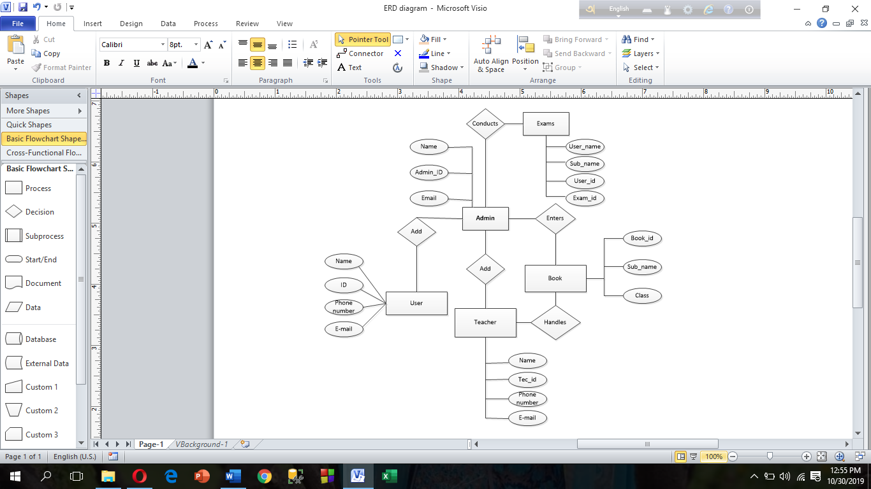

**Database tables, Attributes and Data type:**

|  |  |  |
| --- | --- | --- |
| **Table Name** | **Attribute** | **Data Type** |
| Admin | A_name | Varchar (50) |
| ADID | Varchar (15) (Primary key) |
| Email | Varchar (30) |
| TID | Varchar (15) (Foreign key) |
| UID | Varchar (15) (Foreign key) |
| BID | Varchar (10) (Foreign key) |
| EID | Varchar (10) (Foreign key) |
| Teacher | T_name | Varchar (50) |
| TID | Varchar (15) (Primary key) |
| Phone_number | Int (20) |
| Email | Varchar (30) |
| BID | Varchar (10) (Foreign key) |
| EID | Varchar (10) (Foreign key) |
| User | UID | Varchar (15) (Primary key) |
| User_name | Varchar (50) |
| Phone number | Int (20) |
| Email | Varchar (30) |
| Class | Int (10) |
| EID | Varchar (10) (Foreign key) |
| Book | BID | Varchar (10) (Primary key) |
| Sub_name | Varchar (20) |
| Class | Int (10) |
| Exam | User_name | Varchar (50) |
| Sub_name | Varchar (20) |
| UID | Varchar (15) (Foreign key) |
| EID | Varchar (10) (Primary key) |