**STATS 202 | HW:2 | Sagar Ganapaneni | SUID# 06167633**

**Problem: 3**

1. **Using hierarchical clustering with complete linkage and Euclidean distance, cluster the states.**

set.seed(12)

arrests_complete <- hclust(dist(USArrests), method = "complete")

plot(arrests_complete,main='Clustering (with complete Linkage)')

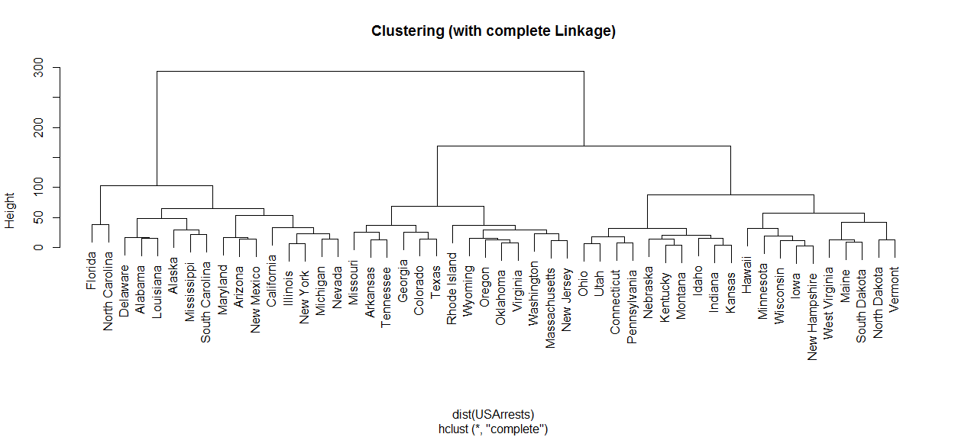

1. **Cut the dendrogram at a height that results in three distinct clusters. Which states belong to which clusters?**

cluster_mapping<- cutree(arrests_complete, 3)

cluster1 <- USArrests[cluster_mapping == 1,]

cluster2 <- USArrests[cluster_mapping == 2,]

cluster3 <- USArrests[cluster_mapping == 3,]

print(cluster1)

## Murder Assault UrbanPop Rape

## Alabama 13.2 236 58 21.2

## Alaska 10.0 263 48 44.5

## Arizona 8.1 294 80 31.0

## California 9.0 276 91 40.6

## Delaware 5.9 238 72 15.8

## Florida 15.4 335 80 31.9

## Illinois 10.4 249 83 24.0

## Louisiana 15.4 249 66 22.2

## Maryland 11.3 300 67 27.8

## Michigan 12.1 255 74 35.1

## Mississippi 16.1 259 44 17.1

## Nevada 12.2 252 81 46.0

## New Mexico 11.4 285 70 32.1

## New York 11.1 254 86 26.1

## North Carolina 13.0 337 45 16.1

## South Carolina 14.4 279 48 22.5

print(cluster2)

## Murder Assault UrbanPop Rape

## Arkansas 8.8 190 50 19.5

## Colorado 7.9 204 78 38.7

## Georgia 17.4 211 60 25.8

## Massachusetts 4.4 149 85 16.3

## Missouri 9.0 178 70 28.2

## New Jersey 7.4 159 89 18.8

## Oklahoma 6.6 151 68 20.0

## Oregon 4.9 159 67 29.3

## Rhode Island 3.4 174 87 8.3

## Tennessee 13.2 188 59 26.9

## Texas 12.7 201 80 25.5

## Virginia 8.5 156 63 20.7

## Washington 4.0 145 73 26.2

## Wyoming 6.8 161 60 15.6

print(cluster3)

## Murder Assault UrbanPop Rape

## Connecticut 3.3 110 77 11.1

## Hawaii 5.3 46 83 20.2

## Idaho 2.6 120 54 14.2

## Indiana 7.2 113 65 21.0

## Iowa 2.2 56 57 11.3

## Kansas 6.0 115 66 18.0

## Kentucky 9.7 109 52 16.3

## Maine 2.1 83 51 7.8

## Minnesota 2.7 72 66 14.9

## Montana 6.0 109 53 16.4

## Nebraska 4.3 102 62 16.5

## New Hampshire 2.1 57 56 9.5

## North Dakota 0.8 45 44 7.3

## Ohio 7.3 120 75 21.4

## Pennsylvania 6.3 106 72 14.9

## South Dakota 3.8 86 45 12.8

## Utah 3.2 120 80 22.9

## Vermont 2.2 48 32 11.2

## West Virginia 5.7 81 39 9.3

## Wisconsin 2.6 53 66 10.8

1. **Hierarchically cluster the states using complete linkage and Euclidean distance, after scaling the variables to have standard deviation one**

USArrests_scalled <- scale(USArrests)

arrests_scalled_complete <- hclust(dist(USArrests_scalled), method = "complete")

plot(arrests_scalled_complete,main='Cluster Dendrogram(Complete) with scalled data')

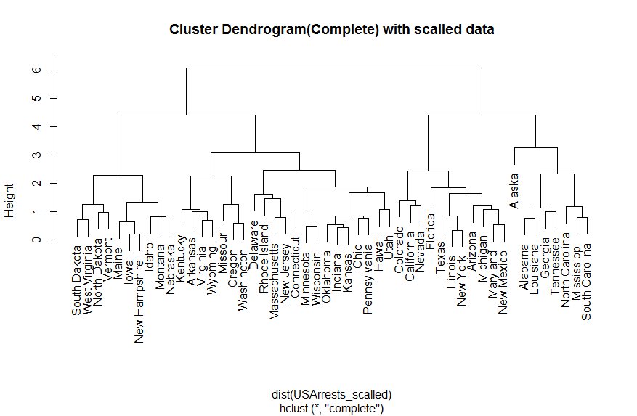

cluster_mapping<- cutree(arrests_scalled_complete, 3)

cluster1 <- USArrests[cluster_mapping == 1,]

cluster2 <- USArrests[cluster_mapping == 2,]

cluster3 <- USArrests[cluster_mapping == 3,]

print(cluster1)

## Murder Assault UrbanPop Rape

## Alabama 13.2 236 58 21.2

## Alaska 10.0 263 48 44.5

## Georgia 17.4 211 60 25.8

## Louisiana 15.4 249 66 22.2

## Mississippi 16.1 259 44 17.1

## North Carolina 13.0 337 45 16.1

## South Carolina 14.4 279 48 22.5

## Tennessee 13.2 188 59 26.9

print(cluster2)

## Murder Assault UrbanPop Rape

## Arizona 8.1 294 80 31.0

## California 9.0 276 91 40.6

## Colorado 7.9 204 78 38.7

## Florida 15.4 335 80 31.9

## Illinois 10.4 249 83 24.0

## Maryland 11.3 300 67 27.8

## Michigan 12.1 255 74 35.1

## Nevada 12.2 252 81 46.0

## New Mexico 11.4 285 70 32.1

## New York 11.1 254 86 26.1

## Texas 12.7 201 80 25.5

print(cluster3)

## Murder Assault UrbanPop Rape

## Arkansas 8.8 190 50 19.5

## Connecticut 3.3 110 77 11.1

## Delaware 5.9 238 72 15.8

## Hawaii 5.3 46 83 20.2

## Idaho 2.6 120 54 14.2

## Indiana 7.2 113 65 21.0

## Iowa 2.2 56 57 11.3

## Kansas 6.0 115 66 18.0

## Kentucky 9.7 109 52 16.3

## Maine 2.1 83 51 7.8

## Massachusetts 4.4 149 85 16.3

## Minnesota 2.7 72 66 14.9

## Missouri 9.0 178 70 28.2

## Montana 6.0 109 53 16.4

## Nebraska 4.3 102 62 16.5

## New Hampshire 2.1 57 56 9.5

## New Jersey 7.4 159 89 18.8

## North Dakota 0.8 45 44 7.3

## Ohio 7.3 120 75 21.4

## Oklahoma 6.6 151 68 20.0

## Oregon 4.9 159 67 29.3

## Pennsylvania 6.3 106 72 14.9

## Rhode Island 3.4 174 87 8.3

## South Dakota 3.8 86 45 12.8

## Utah 3.2 120 80 22.9

## Vermont 2.2 48 32 11.2

## Virginia 8.5 156 63 20.7

## Washington 4.0 145 73 26.2

## West Virginia 5.7 81 39 9.3

## Wisconsin 2.6 53 66 10.8

## Wyoming 6.8 161 60 15.6

1. **What effect does scaling the variables have on the hierarchical clustering obtained? In your opinion, should the variables be scaled before the inter-observation dissimilarities are computed?**
2. table(cutree(arrests_complete, 3), cutree(arrests_scalled_complete, 3))
3. ##
4. ## 1 2 3
5. ## 1 6 9 1
6. ## 2 2 2 10
7. ## 3 0 0 20

Scaling does effected clustering, before scaling variables: Assault and Urban population draw more weightage in grouping states together. After scaling all the variable were considered on relative scale.

For example, States like Arizona and California are grouped with Alabama mainly due to similar Assaults even though urban population is significantly lower than the other two states.

Scaling should be done before measuring the dissimilarities are computed as scaling after measuring dissimilarities might minimize the true distinctions between two data points thus leading to in accurate clustering.

**Problem 4**

1. **Generate a simulated data set with 20 observations in each of three classes (i.e. 60 observations total), and 50 variables.**

set.seed(12)

groups <- c(rep(1, 20), rep(2, 20), rep(3, 20))

data <- matrix(rnorm(60*50, mean = 0, sd = 0.001), ncol = 50)

*## adding mean shifters*

data[1:20,group=1]<-data[1:20,group=1]+10

data[21:40,group=2]<- data[21:40,group=2]-10

data[21:40,group=2]<- data[21:40,group=2]+10

data[41:60,group=3]<- data[41:60,group=3]-10

1. **Perform PCA on the 60 observations and plot the first two principal component score vectors. Use a different color to indicate the observations in each of the three classes**

data_pca =prcomp(data, scale =FALSE)

*# Plot the first two principal component score vectors*

plot(data_pca$x[,1:2], col=1:3, pch =19, xlab ="First principal component", ylab="Second principal component")

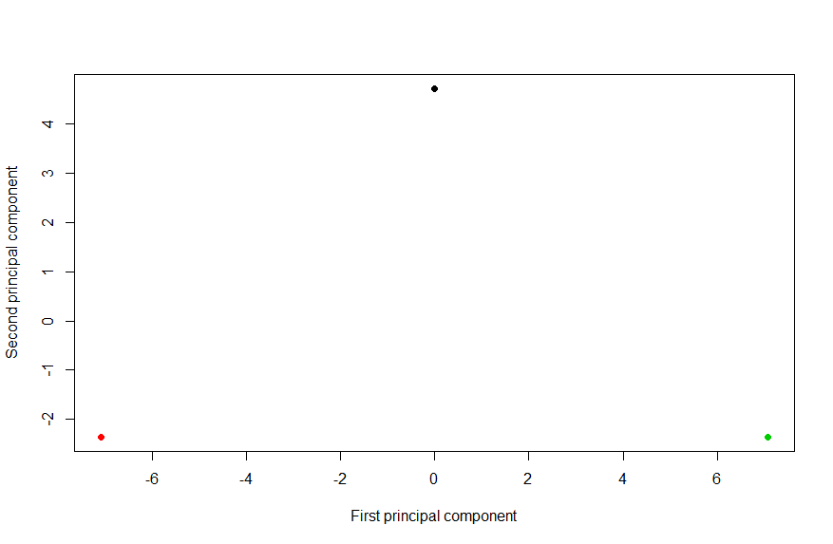

1. **Perform KK-means clustering of the observations with K=3K=3. How well do the clusters that you obtained in KK-means clustering compare to the true class labels?**

data_kmeans <- kmeans(data, 3, nstart = 20)

table(groups, data_kmeans$cluster)

##

## groups 1 2 3

## 1 20 0 0

## 2 0 20 0

## 3 0 0 20

The results show that clusters are formed perfectly

1. **Perform KK-means clustering with K=2K=2. Describe your results.**

*## 2 Cluster*

data_kmeans <- kmeans(data, 2, nstart = 20)

table(groups, data_kmeans$cluster)

##

## groups 1 2

## 1 0 20

## 2 0 20

## 3 20 0

All Observations from one of the cluster moved to one of the other two clusters

1. **Now perform K-means clustering with K = 4, and describe your results.**

*## 4 Cluster*

data_kmeans <- kmeans(data, 4, nstart = 20)

table(groups, data_kmeans$cluster)

##

## groups 1 2 3 4

## 1 20 0 0 0

## 2 0 0 20 0

## 3 0 9 0 11

3rd cluster broken in to two clusters now 3 and 4

1. **Now perform K-means clustering with K = 3 on the first two principal component score vectors, rather than on the raw data.**

*## kmeans over PCA vectors*

data_kmeans <- kmeans(data_pca$x[,1:2], 3, nstart = 20)

table(groups, data_kmeans$cluster)

##

## groups 1 2 3

## 1 0 20 0

## 2 20 0 0

## 3 0 0 20

All observations are perfectly clustered with PCA vectors

1. **Using the scale() function, perform K-means clustering with K = 3**

*## kmeans over scaled data*

data_kmeans <- kmeans(scale(data), 3, nstart = 20)

table(groups, data_kmeans$cluster)

##

## groups 1 2 3

## 1 12 1 7

## 2 5 4 11

## 3 0 15 5

Scaling has distorted the results in this case. Unnecessary scaling leads to inaccurate distance Euclidean between observation points.

**Problem 5**

Given: a data set with 100 observations, one quantitative response variable and with following possible fits:

1. Linear fit:

Y = beta_0 + beta_1 X + beta_2 X^2 + beta_3 X^3 +epsilon

1. Cubic fit:

Y = beta_0 + beta_1 X +epsilon

1. **Assuming actual data is close to liner fit**

As we do not have complete information about the training data, it is difficult to know which training RSS is lower between linear or cubic. But if true relationship between X and Y is linear we expect training RSS to be lower in linear model compared to cubic model

1. **Answer (a) using test rather than training RSS.**

Even in this case we don’t have enough information about test data to comment on Test RSS. However, we may assume that cubic fit is more complex fit, can over fit the training data that can lead to higher Test RSS value compared to test RSS for liner fit

1. **Suppose that the true relationship between X and Y is not linear**

In general Polynomial (complex) fits has lower train RSS than the linear fit because of higher flexibility. As the actual fit is not linear it is more likely that cubit fit overt fits the training data to give lower RSS compared to a Linear fit RSS.

1. **Answer (c) using test rather than training RSS.**

As we are not aware of true nature of training and test data, it is difficult to comment on Test RSS for both the models.

It all depends on true nature of the data, how linear is it, this will decide the bias variance tradeoff.

**Problem 6**

1. **Produce a scatterplot matrix which includes all of the variables in the data set.**

data(Auto)

pairs(Auto, main='Scatterplot for Auto Data')

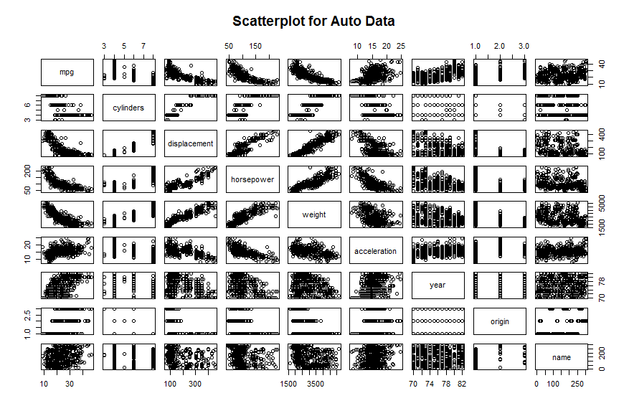

1. **Compute the matrix of correlations between the variables using the function cor().**

cor(Auto[1:8])

## mpg cylinders displacement horsepower weight

## mpg 1.0000000 -0.7776175 -0.8051269 -0.7784268 -0.8322442

## cylinders -0.7776175 1.0000000 0.9508233 0.8429834 0.8975273

## displacement -0.8051269 0.9508233 1.0000000 0.8972570 0.9329944

## horsepower -0.7784268 0.8429834 0.8972570 1.0000000 0.8645377

## weight -0.8322442 0.8975273 0.9329944 0.8645377 1.0000000

## acceleration 0.4233285 -0.5046834 -0.5438005 -0.6891955 -0.4168392

## year 0.5805410 -0.3456474 -0.3698552 -0.4163615 -0.3091199

## origin 0.5652088 -0.5689316 -0.6145351 -0.4551715 -0.5850054

## acceleration year origin

## mpg 0.4233285 0.5805410 0.5652088

## cylinders -0.5046834 -0.3456474 -0.5689316

## displacement -0.5438005 -0.3698552 -0.6145351

## horsepower -0.6891955 -0.4163615 -0.4551715

## weight -0.4168392 -0.3091199 -0.5850054

## acceleration 1.0000000 0.2903161 0.2127458

## year 0.2903161 1.0000000 0.1815277

## origin 0.2127458 0.1815277 1.0000000

1. **Use the lm() function to perform a multiple linear regression with mpg as the response and all other variables except name as the predictors.**
2. Is there a relationship between the predictors and the response?

lm_fit <- lm(mpg ~ . - name, data = Auto)

summary(lm_fit)

##

## Call:

## lm(formula = mpg ~ . - name, data = Auto)

##

## Residuals:

## Min 1Q Median 3Q Max

## -9.5903 -2.1565 -0.1169 1.8690 13.0604

##

## Coefficients:

## Estimate Std. Error t value Pr(>|t|)

## (Intercept) -17.218435 4.644294 -3.707 0.00024 ***

## cylinders -0.493376 0.323282 -1.526 0.12780

## displacement 0.019896 0.007515 2.647 0.00844 **

## horsepower -0.016951 0.013787 -1.230 0.21963

## weight -0.006474 0.000652 -9.929 < 2e-16 ***

## acceleration 0.080576 0.098845 0.815 0.41548

## year 0.750773 0.050973 14.729 < 2e-16 ***

## origin 1.426141 0.278136 5.127 4.67e-07 ***

## ---

## Signif. codes: 0 '***' 0.001 '**' 0.01 '*' 0.05 '.' 0.1 ' ' 1

##

## Residual standard error: 3.328 on 384 degrees of freedom

## Multiple R-squared: 0.8215, Adjusted R-squared: 0.8182

## F-statistic: 252.4 on 7 and 384 DF, p-value: < 2.2e-16

We can look at P value to evaluate if there is any relationship between mpg and other predictors, we can see many p values are less than 0.05 hence there are relationships between mpg and other predictors. For example: year, origin and weight. etc.

1. Which predictors appear to have a statistically significant relationship to the response?

All predictors are statistically significant except cylinders, horsepower and acceleration.

1. What does the coefficient for the “year” variable suggest?

Coefficient of year is 0.750773, this value suggests that there is positive relationship between year and mpg. Meaning Auto mpg’s are improving year by year in general.

1. **Use the plot() function to produce diagnostic plots of the linear regression fit. Comment on any problems you see with the fit. Do the residual plots suggest any unusually large outliers ? Does the leverage plots identify any observations with unusually high leverages ?**

par(mfrow = c(2, 2))

plot(lm_fit)

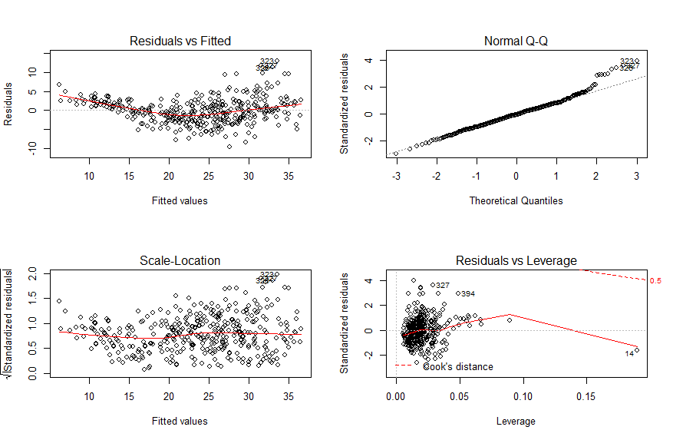

* Residuals Vs Fitted plot indicates the presence of slight non linearity in the data.
* Standardized residuals Vs Leverage plot indicates the presence of a few outliers (higher than 2 or lower than -2) and one high leverage point (14)

**Problem 7**

**Collinearity problem**

1. **Perform the following commands in R.**

set.seed(1)

x1 <- runif(100)

x2 <- 0.5 * x1 + rnorm(100)/10

y <- 2 + 2 * x1 + 0.3 * x2 + rnorm(100)

**The last line corresponds to creating a linear model in which “y” is a function of “x1” and “x2”. Write out the form of the linear model. What are the regression coefficients ?**

Y = 2 + 2X_1 +0.3X_2 + epsilon

with ε : N(0,1) random variable. The regression coefficients are 2, 2 & 0.3 respectively

1. **What is the correlation between “x1” and “x2” ? Create a scatterplot displaying the relationship between the variables**

cor(x1, x2)

## [1] 0.8351212

plot(x1, x2)

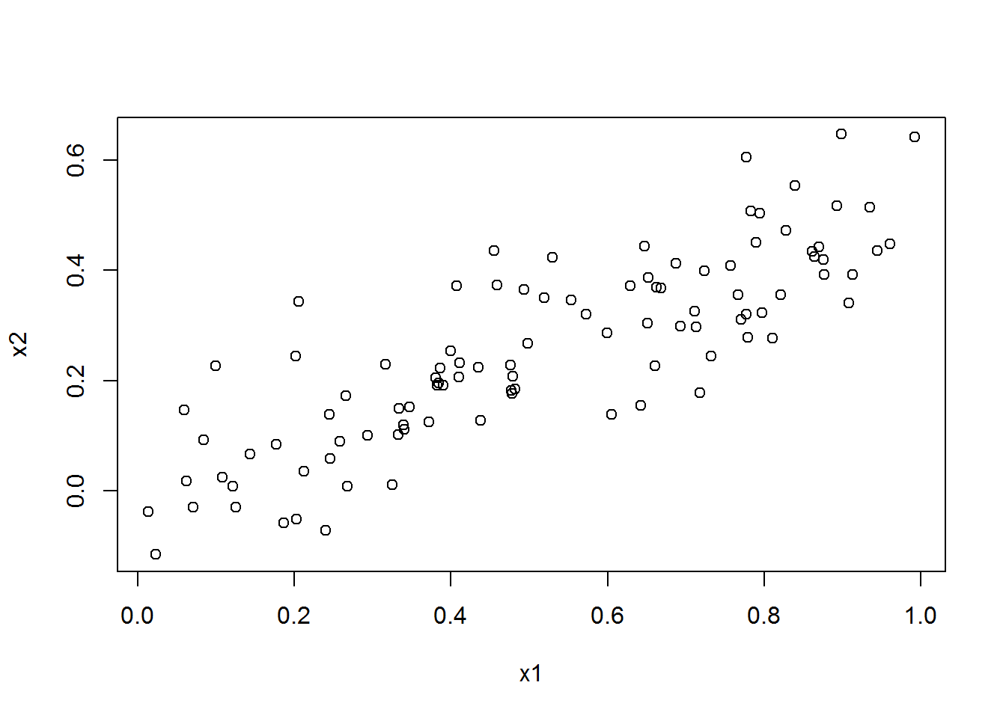

X1 and X2 Highly correlated

1. **Using this data, fit a least squares regression to predict “y” using “x1” and “x2”.**

Model <- lm(y ~ x1 + x2)

summary(Model)

##

## Call:

## lm(formula = y ~ x1 + x2)

##

## Residuals:

## Min 1Q Median 3Q Max

## -2.8311 -0.7273 -0.0537 0.6338 2.3359

##

## Coefficients:

## Estimate Std. Error t value Pr(>|t|)

## (Intercept) 2.1305 0.2319 9.188 7.61e-15 ***

## x1 1.4396 0.7212 1.996 0.0487 *

## x2 1.0097 1.1337 0.891 0.3754

## ---

## Signif. codes: 0 '***' 0.001 '**' 0.01 '*' 0.05 '.' 0.1 ' ' 1

##

## Residual standard error: 1.056 on 97 degrees of freedom

## Multiple R-squared: 0.2088, Adjusted R-squared: 0.1925

## F-statistic: 12.8 on 2 and 97 DF, p-value: 1.164e-05

* beta_0: 2.1305; p < 0.05 🡺 can reject the Null Hypothesis for beta_0, also this intercept is close to actual beta_0
* beta_1: 1.4396; p < 0.05 🡺 can reject the Null Hypothesis for beta_1
* beta_2: 1.0097; p > 0.05 🡺 cannot reject the Null Hypothesis for beta_2

1. **Now fit a least squares regression to predict “y” using only “x1”.**

Model1 <- lm(y ~ x1)

summary(Model1)

## Call:

## lm(formula = y ~ x1)

##

## Residuals:

## Min 1Q Median 3Q Max

## -2.89495 -0.66874 -0.07785 0.59221 2.45560

##

## Coefficients:

## Estimate Std. Error t value Pr(>|t|)

## (Intercept) 2.1124 0.2307 9.155 8.27e-15 ***

## x1 1.9759 0.3963 4.986 2.66e-06 ***

## ---

## Signif. codes: 0 '***' 0.001 '**' 0.01 '*' 0.05 '.' 0.1 ' ' 1

##

## Residual standard error: 1.055 on 98 degrees of freedom

## Multiple R-squared: 0.2024, Adjusted R-squared: 0.1942

## F-statistic: 24.86 on 1 and 98 DF, p-value: 2.661e-06

* beta_1: 1.9759; different from above scenario with two predictors

1. **Now fit a least squares regression to predict “y” using only “x2”.**

Model2 <- lm(y ~ x2)

summary(Model2)

##

## Call:

## lm(formula = y ~ x2)

##

## Residuals:

## Min 1Q Median 3Q Max

## -2.62687 -0.75156 -0.03598 0.72383 2.44890

##

## Coefficients:

## Estimate Std. Error t value Pr(>|t|)

## (Intercept) 2.3899 0.1949 12.26 < 2e-16 ***

## x2 2.8996 0.6330 4.58 1.37e-05 ***

## ---

## Signif. codes: 0 '***' 0.001 '**' 0.01 '*' 0.05 '.' 0.1 ' ' 1

##

## Residual standard error: 1.072 on 98 degrees of freedom

## Multiple R-squared: 0.1763, Adjusted R-squared: 0.1679

## F-statistic: 20.98 on 1 and 98 DF, p-value: 1.366e-05

* beta_2: 2.8996, is different from above scenario with two predictors and X2 is significant as p values is < 0.05

1. **Do the results obtained in (c)-(e) contradict each other?**

* No the results are not contradicting, as X1 and X2 are highly correlated, it is difficult to measure how r=each predictors effects the response variable, this scenario is called ‘collinearity’
* With collinearity: we are unable to estimate beta values correctly also leads to high standard errors

1. **Now suppose we obtain one additional observation, which was unfortunately mismeasured**

x1 <- c(x1, 0.1)

x2 <- c(x2, 0.8)

y <- c(y, 6)

Model_new <- lm(y ~ x1 + x2)

Model1_new <- lm(y ~ x1)

Model2_new <- lm(y ~ x2)

summary(Model_new)

##

## Call:

## lm(formula = y ~ x1 + x2)

##

## Residuals:

## Min 1Q Median 3Q Max

## -2.73348 -0.69318 -0.05263 0.66385 2.30619

##

## Coefficients:

## Estimate Std. Error t value Pr(>|t|)

## (Intercept) 2.2267 0.2314 9.624 7.91e-16 ***

## x1 0.5394 0.5922 0.911 0.36458

## x2 2.5146 0.8977 2.801 0.00614 **

## ---

## Signif. codes: 0 '***' 0.001 '**' 0.01 '*' 0.05 '.' 0.1 ' ' 1

##

## Residual standard error: 1.075 on 98 degrees of freedom

## Multiple R-squared: 0.2188, Adjusted R-squared: 0.2029

## F-statistic: 13.72 on 2 and 98 DF, p-value: 5.564e-06

summary(Model1_new)

##

## Call:

## lm(formula = y ~ x1)

##

## Residuals:

## Min 1Q Median 3Q Max

## -2.8897 -0.6556 -0.0909 0.5682 3.5665

##

## Coefficients:

## Estimate Std. Error t value Pr(>|t|)

## (Intercept) 2.2569 0.2390 9.445 1.78e-15 ***

## x1 1.7657 0.4124 4.282 4.29e-05 ***

## ---

## Signif. codes: 0 '***' 0.001 '**' 0.01 '*' 0.05 '.' 0.1 ' ' 1

##

## Residual standard error: 1.111 on 99 degrees of freedom

## Multiple R-squared: 0.1562, Adjusted R-squared: 0.1477

## F-statistic: 18.33 on 1 and 99 DF, p-value: 4.295e-05

summary(Model2_new)

##

## Call:

## lm(formula = y ~ x2)

##

## Residuals:

## Min 1Q Median 3Q Max

## -2.64729 -0.71021 -0.06899 0.72699 2.38074

##

## Coefficients:

## Estimate Std. Error t value Pr(>|t|)

## (Intercept) 2.3451 0.1912 12.264 < 2e-16 ***

## x2 3.1190 0.6040 5.164 1.25e-06 ***

## ---

## Signif. codes: 0 '***' 0.001 '**' 0.01 '*' 0.05 '.' 0.1 ' ' 1

##

## Residual standard error: 1.074 on 99 degrees of freedom

## Multiple R-squared: 0.2122, Adjusted R-squared: 0.2042

## F-statistic: 26.66 on 1 and 99 DF, p-value: 1.253e-06

par(mfrow = c(2, 2))

plot(Model_new)

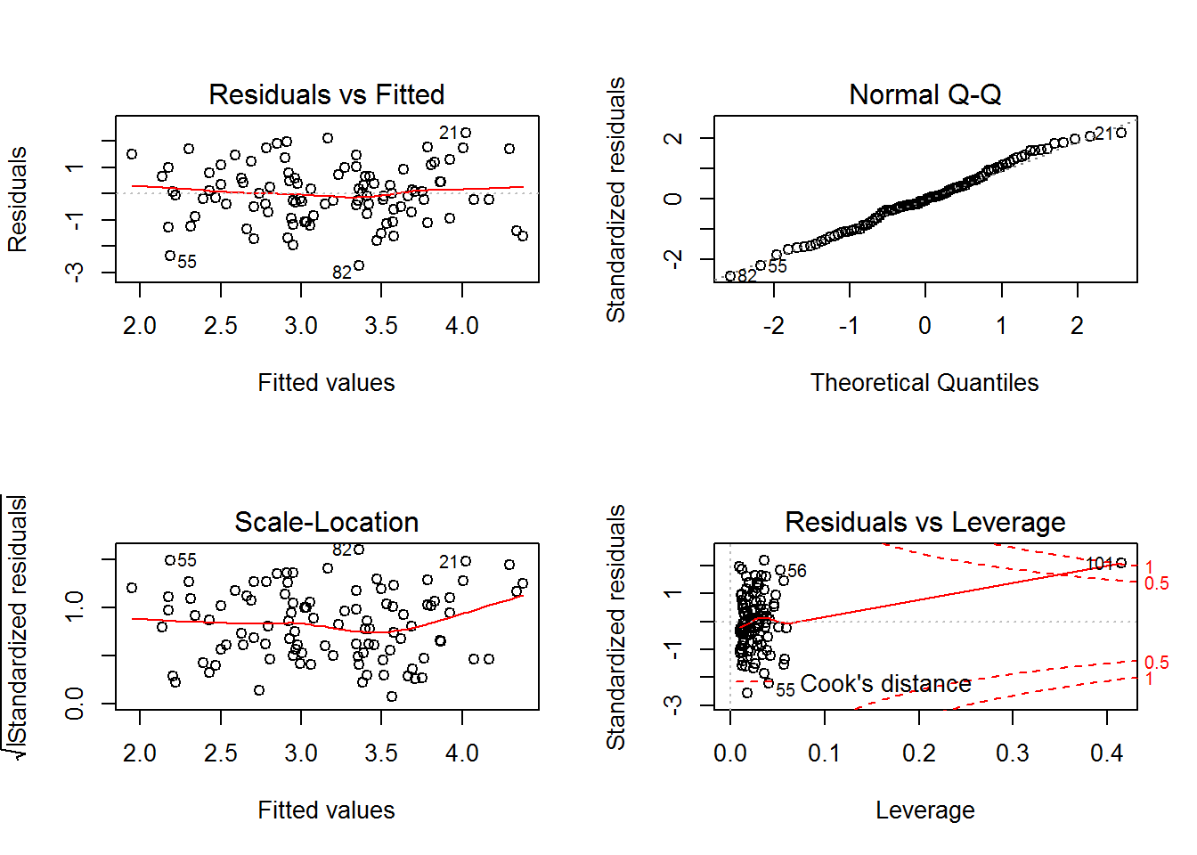

* last point is a high-leverage point.

par(mfrow = c(2, 2))

plot(Model1_new)

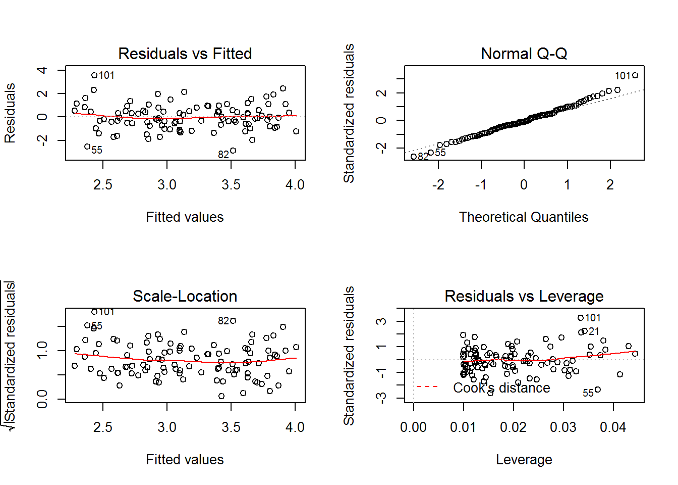

* The last point is an outlier and residuals & Fitted plot indicates high linearity of the model

par(mfrow = c(2, 2))

plot(Model2_new)

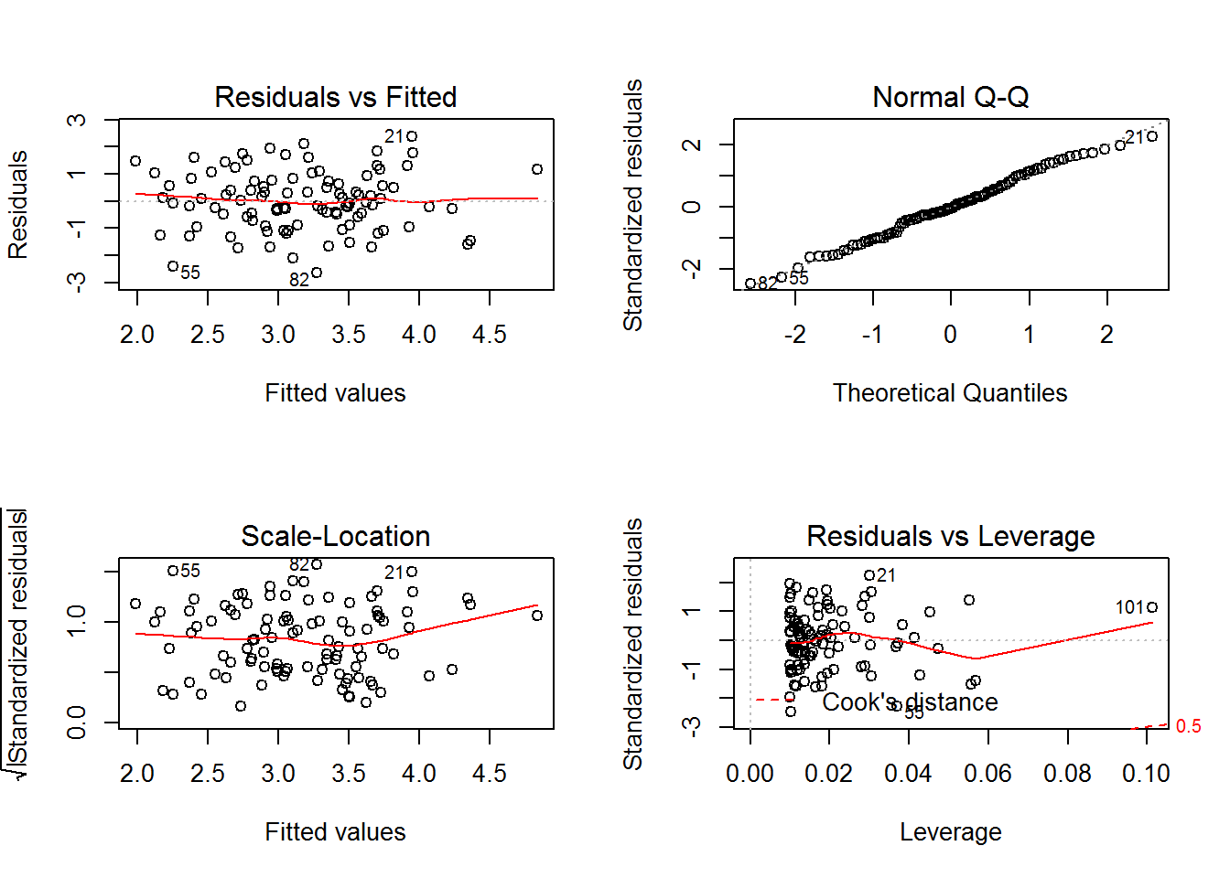

* The point is again a high leverage point

#### Problem 8

“Boston” data set

1. **For each predictor, fit a simple linear regression model to predict the response. Describe your results. In which of the models is there a statistically significant association between the predictor and the response?**

library(MASS)  
attach(Boston)  
model_zn <- lm(crim ~ zn)  
summary(model_zn)

##   
## Call:  
## lm(formula = crim ~ zn)  
##   
## Residuals:  
## Min 1Q Median 3Q Max   
## -4.429 -4.222 -2.620 1.250 84.523   
##   
## Coefficients:  
## Estimate Std. Error t value Pr(>|t|)   
## (Intercept) 4.45369 0.41722 10.675 < 2e-16 ***  
## zn -0.07393 0.01609 -4.594 5.51e-06 ***  
## ---  
## Signif. codes: 0 '***' 0.001 '**' 0.01 '*' 0.05 '.' 0.1 ' ' 1  
##   
## Residual standard error: 8.435 on 504 degrees of freedom  
## Multiple R-squared: 0.04019, Adjusted R-squared: 0.03828   
## F-statistic: 21.1 on 1 and 504 DF, p-value: 5.506e-06

model_indus <- lm(crim ~ indus)  
summary(model_indus)

##   
## Call:  
## lm(formula = crim ~ indus)  
##   
## Residuals:  
## Min 1Q Median 3Q Max   
## -11.972 -2.698 -0.736 0.712 81.813   
##   
## Coefficients:  
## Estimate Std. Error t value Pr(>|t|)   
## (Intercept) -2.06374 0.66723 -3.093 0.00209 **   
## indus 0.50978 0.05102 9.991 < 2e-16 ***  
## ---  
## Signif. codes: 0 '***' 0.001 '**' 0.01 '*' 0.05 '.' 0.1 ' ' 1  
##   
## Residual standard error: 7.866 on 504 degrees of freedom  
## Multiple R-squared: 0.1653, Adjusted R-squared: 0.1637   
## F-statistic: 99.82 on 1 and 504 DF, p-value: < 2.2e-16

chas <- as.factor(chas)  
model_chas <- lm(crim ~ chas)  
summary(model_chas)

##   
## Call:  
## lm(formula = crim ~ chas)  
##   
## Residuals:  
## Min 1Q Median 3Q Max   
## -3.738 -3.661 -3.435 0.018 85.232   
##   
## Coefficients:  
## Estimate Std. Error t value Pr(>|t|)   
## (Intercept) 3.7444 0.3961 9.453 <2e-16 ***  
## chas1 -1.8928 1.5061 -1.257 0.209   
## ---  
## Signif. codes: 0 '***' 0.001 '**' 0.01 '*' 0.05 '.' 0.1 ' ' 1  
##   
## Residual standard error: 8.597 on 504 degrees of freedom  
## Multiple R-squared: 0.003124, Adjusted R-squared: 0.001146   
## F-statistic: 1.579 on 1 and 504 DF, p-value: 0.2094

model_nox <- lm(crim ~ nox)  
summary(model_nox)

##   
## Call:  
## lm(formula = crim ~ nox)  
##   
## Residuals:  
## Min 1Q Median 3Q Max   
## -12.371 -2.738 -0.974 0.559 81.728   
##   
## Coefficients:  
## Estimate Std. Error t value Pr(>|t|)   
## (Intercept) -13.720 1.699 -8.073 5.08e-15 ***  
## nox 31.249 2.999 10.419 < 2e-16 ***  
## ---  
## Signif. codes: 0 '***' 0.001 '**' 0.01 '*' 0.05 '.' 0.1 ' ' 1  
##   
## Residual standard error: 7.81 on 504 degrees of freedom  
## Multiple R-squared: 0.1772, Adjusted R-squared: 0.1756   
## F-statistic: 108.6 on 1 and 504 DF, p-value: < 2.2e-16

model_rm <- lm(crim ~ rm)  
summary(model_rm)

##   
## Call:  
## lm(formula = crim ~ rm)  
##   
## Residuals:  
## Min 1Q Median 3Q Max   
## -6.604 -3.952 -2.654 0.989 87.197   
##   
## Coefficients:  
## Estimate Std. Error t value Pr(>|t|)   
## (Intercept) 20.482 3.365 6.088 2.27e-09 ***  
## rm -2.684 0.532 -5.045 6.35e-07 ***  
## ---  
## Signif. codes: 0 '***' 0.001 '**' 0.01 '*' 0.05 '.' 0.1 ' ' 1  
##   
## Residual standard error: 8.401 on 504 degrees of freedom  
## Multiple R-squared: 0.04807, Adjusted R-squared: 0.04618   
## F-statistic: 25.45 on 1 and 504 DF, p-value: 6.347e-07

model_age <- lm(crim ~ age)  
summary(model_age)

##   
## Call:  
## lm(formula = crim ~ age)  
##   
## Residuals:  
## Min 1Q Median 3Q Max   
## -6.789 -4.257 -1.230 1.527 82.849   
##   
## Coefficients:  
## Estimate Std. Error t value Pr(>|t|)   
## (Intercept) -3.77791 0.94398 -4.002 7.22e-05 ***  
## age 0.10779 0.01274 8.463 2.85e-16 ***  
## ---  
## Signif. codes: 0 '***' 0.001 '**' 0.01 '*' 0.05 '.' 0.1 ' ' 1  
##   
## Residual standard error: 8.057 on 504 degrees of freedom  
## Multiple R-squared: 0.1244, Adjusted R-squared: 0.1227   
## F-statistic: 71.62 on 1 and 504 DF, p-value: 2.855e-16

model_dis <- lm(crim ~ dis)  
summary(model_dis)

##   
## Call:  
## lm(formula = crim ~ dis)  
##   
## Residuals:  
## Min 1Q Median 3Q Max   
## -6.708 -4.134 -1.527 1.516 81.674   
##   
## Coefficients:  
## Estimate Std. Error t value Pr(>|t|)   
## (Intercept) 9.4993 0.7304 13.006 <2e-16 ***  
## dis -1.5509 0.1683 -9.213 <2e-16 ***  
## ---  
## Signif. codes: 0 '***' 0.001 '**' 0.01 '*' 0.05 '.' 0.1 ' ' 1  
##   
## Residual standard error: 7.965 on 504 degrees of freedom  
## Multiple R-squared: 0.1441, Adjusted R-squared: 0.1425   
## F-statistic: 84.89 on 1 and 504 DF, p-value: < 2.2e-16

model_rad <- lm(crim ~ rad)  
summary(model_rad)

##   
## Call:  
## lm(formula = crim ~ rad)  
##   
## Residuals:  
## Min 1Q Median 3Q Max   
## -10.164 -1.381 -0.141 0.660 76.433   
##   
## Coefficients:  
## Estimate Std. Error t value Pr(>|t|)   
## (Intercept) -2.28716 0.44348 -5.157 3.61e-07 ***  
## rad 0.61791 0.03433 17.998 < 2e-16 ***  
## ---  
## Signif. codes: 0 '***' 0.001 '**' 0.01 '*' 0.05 '.' 0.1 ' ' 1  
##   
## Residual standard error: 6.718 on 504 degrees of freedom  
## Multiple R-squared: 0.3913, Adjusted R-squared: 0.39   
## F-statistic: 323.9 on 1 and 504 DF, p-value: < 2.2e-16

model_tax <- lm(crim ~ tax)  
summary(model_tax)

##   
## Call:  
## lm(formula = crim ~ tax)  
##   
## Residuals:  
## Min 1Q Median 3Q Max   
## -12.513 -2.738 -0.194 1.065 77.696   
##   
## Coefficients:  
## Estimate Std. Error t value Pr(>|t|)   
## (Intercept) -8.528369 0.815809 -10.45 <2e-16 ***  
## tax 0.029742 0.001847 16.10 <2e-16 ***  
## ---  
## Signif. codes: 0 '***' 0.001 '**' 0.01 '*' 0.05 '.' 0.1 ' ' 1  
##   
## Residual standard error: 6.997 on 504 degrees of freedom  
## Multiple R-squared: 0.3396, Adjusted R-squared: 0.3383   
## F-statistic: 259.2 on 1 and 504 DF, p-value: < 2.2e-16

model_ptratio <- lm(crim ~ ptratio)  
summary(model_ptratio)

##   
## Call:  
## lm(formula = crim ~ ptratio)  
##   
## Residuals:  
## Min 1Q Median 3Q Max   
## -7.654 -3.985 -1.912 1.825 83.353   
##   
## Coefficients:  
## Estimate Std. Error t value Pr(>|t|)   
## (Intercept) -17.6469 3.1473 -5.607 3.40e-08 ***  
## ptratio 1.1520 0.1694 6.801 2.94e-11 ***  
## ---  
## Signif. codes: 0 '***' 0.001 '**' 0.01 '*' 0.05 '.' 0.1 ' ' 1  
##   
## Residual standard error: 8.24 on 504 degrees of freedom  
## Multiple R-squared: 0.08407, Adjusted R-squared: 0.08225   
## F-statistic: 46.26 on 1 and 504 DF, p-value: 2.943e-11

model_black <- lm(crim ~ black)  
summary(model_black)

##   
## Call:  
## lm(formula = crim ~ black)  
##   
## Residuals:  
## Min 1Q Median 3Q Max   
## -13.756 -2.299 -2.095 -1.296 86.822   
##   
## Coefficients:  
## Estimate Std. Error t value Pr(>|t|)   
## (Intercept) 16.553529 1.425903 11.609 <2e-16 ***  
## black -0.036280 0.003873 -9.367 <2e-16 ***  
## ---  
## Signif. codes: 0 '***' 0.001 '**' 0.01 '*' 0.05 '.' 0.1 ' ' 1  
##   
## Residual standard error: 7.946 on 504 degrees of freedom  
## Multiple R-squared: 0.1483, Adjusted R-squared: 0.1466   
## F-statistic: 87.74 on 1 and 504 DF, p-value: < 2.2e-16

model_lstat <- lm(crim ~ lstat)  
summary(model_lstat)

##   
## Call:  
## lm(formula = crim ~ lstat)  
##   
## Residuals:  
## Min 1Q Median 3Q Max   
## -13.925 -2.822 -0.664 1.079 82.862   
##   
## Coefficients:  
## Estimate Std. Error t value Pr(>|t|)   
## (Intercept) -3.33054 0.69376 -4.801 2.09e-06 ***  
## lstat 0.54880 0.04776 11.491 < 2e-16 ***  
## ---  
## Signif. codes: 0 '***' 0.001 '**' 0.01 '*' 0.05 '.' 0.1 ' ' 1  
##   
## Residual standard error: 7.664 on 504 degrees of freedom  
## Multiple R-squared: 0.2076, Adjusted R-squared: 0.206   
## F-statistic: 132 on 1 and 504 DF, p-value: < 2.2e-16

model_medv <- lm(crim ~ medv)  
summary(model_medv)

##   
## Call:  
## lm(formula = crim ~ medv)  
##   
## Residuals:  
## Min 1Q Median 3Q Max   
## -9.071 -4.022 -2.343 1.298 80.957   
##   
## Coefficients:  
## Estimate Std. Error t value Pr(>|t|)   
## (Intercept) 11.79654 0.93419 12.63 <2e-16 ***  
## medv -0.36316 0.03839 -9.46 <2e-16 ***  
## ---  
## Signif. codes: 0 '***' 0.001 '**' 0.01 '*' 0.05 '.' 0.1 ' ' 1  
##   
## Residual standard error: 7.934 on 504 degrees of freedom  
## Multiple R-squared: 0.1508, Adjusted R-squared: 0.1491   
## F-statistic: 89.49 on 1 and 504 DF, p-value: < 2.2e-16

* All predictors are statistically significant except for ‘chas’ as p values is > 0.05

1. **Fit a multiple regression model to predict the response using all of the predictors.**

model_all <- lm(crim ~ ., data = Boston)  
summary(model_all)

##   
## Call:  
## lm(formula = crim ~ ., data = Boston)  
##   
## Residuals:  
## Min 1Q Median 3Q Max   
## -9.924 -2.120 -0.353 1.019 75.051   
##   
## Coefficients:  
## Estimate Std. Error t value Pr(>|t|)   
## (Intercept) 17.033228 7.234903 2.354 0.018949 *   
## zn 0.044855 0.018734 2.394 0.017025 *   
## indus -0.063855 0.083407 -0.766 0.444294   
## chas -0.749134 1.180147 -0.635 0.525867   
## nox -10.313535 5.275536 -1.955 0.051152 .   
## rm 0.430131 0.612830 0.702 0.483089   
## age 0.001452 0.017925 0.081 0.935488   
## dis -0.987176 0.281817 -3.503 0.000502 ***  
## rad 0.588209 0.088049 6.680 6.46e-11 ***  
## tax -0.003780 0.005156 -0.733 0.463793   
## ptratio -0.271081 0.186450 -1.454 0.146611   
## black -0.007538 0.003673 -2.052 0.040702 *   
## lstat 0.126211 0.075725 1.667 0.096208 .   
## medv -0.198887 0.060516 -3.287 0.001087 **   
## ---  
## Signif. codes: 0 '***' 0.001 '**' 0.01 '*' 0.05 '.' 0.1 ' ' 1  
##   
## Residual standard error: 6.439 on 492 degrees of freedom  
## Multiple R-squared: 0.454, Adjusted R-squared: 0.4396   
## F-statistic: 31.47 on 13 and 492 DF, p-value: < 2.2e-16

* Coefficients of zn, dis, rad, black and medv are significant hence we can reject the Null hypothesis for these predictors

1. **How do your results from (a) compare to your results from (b)**

simple_reg <- vector("numeric",0)  
simple_reg <- c(simple_reg, model_zn$coefficient[2])  
simple_reg <- c(simple_reg, model_indus$coefficient[2])  
simple_reg <- c(simple_reg, model_chas$coefficient[2])  
simple_reg <- c(simple_reg, model_nox$coefficient[2])  
simple_reg <- c(simple_reg, model_rm$coefficient[2])  
simple_reg <- c(simple_reg, model_age$coefficient[2])  
simple_reg <- c(simple_reg, model_dis$coefficient[2])  
simple_reg <- c(simple_reg, model_rad$coefficient[2])  
simple_reg <- c(simple_reg, model_tax$coefficient[2])  
simple_reg <- c(simple_reg, model_ptratio$coefficient[2])  
simple_reg <- c(simple_reg, model_black$coefficient[2])  
simple_reg <- c(simple_reg, model_lstat$coefficient[2])  
simple_reg <- c(simple_reg, model_medv$coefficient[2])  
mult_reg <- vector("numeric", 0)  
mult_reg <- c(mult_reg, model_all$coefficients)  
mult_reg <- mult_reg[-1]  
plot(simple_reg, mult_reg, col = "green")

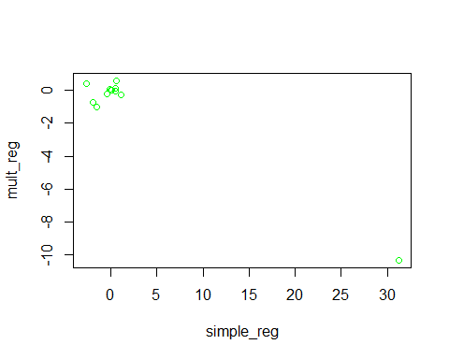

* The difference between simple and multiple regression coefficients is due to correlation among predictors
* This leads to no storing relation with multiple regression

cor(Boston[-c(1, 4)])

## zn indus nox rm age dis  
## zn 1.0000000 -0.5338282 -0.5166037 0.3119906 -0.5695373 0.6644082  
## indus -0.5338282 1.0000000 0.7636514 -0.3916759 0.6447785 -0.7080270  
## nox -0.5166037 0.7636514 1.0000000 -0.3021882 0.7314701 -0.7692301  
## rm 0.3119906 -0.3916759 -0.3021882 1.0000000 -0.2402649 0.2052462  
## age -0.5695373 0.6447785 0.7314701 -0.2402649 1.0000000 -0.7478805  
## dis 0.6644082 -0.7080270 -0.7692301 0.2052462 -0.7478805 1.0000000  
## rad -0.3119478 0.5951293 0.6114406 -0.2098467 0.4560225 -0.4945879  
## tax -0.3145633 0.7207602 0.6680232 -0.2920478 0.5064556 -0.5344316  
## ptratio -0.3916785 0.3832476 0.1889327 -0.3555015 0.2615150 -0.2324705  
## black 0.1755203 -0.3569765 -0.3800506 0.1280686 -0.2735340 0.2915117  
## lstat -0.4129946 0.6037997 0.5908789 -0.6138083 0.6023385 -0.4969958  
## medv 0.3604453 -0.4837252 -0.4273208 0.6953599 -0.3769546 0.2499287  
## rad tax ptratio black lstat medv  
## zn -0.3119478 -0.3145633 -0.3916785 0.1755203 -0.4129946 0.3604453  
## indus 0.5951293 0.7207602 0.3832476 -0.3569765 0.6037997 -0.4837252  
## nox 0.6114406 0.6680232 0.1889327 -0.3800506 0.5908789 -0.4273208  
## rm -0.2098467 -0.2920478 -0.3555015 0.1280686 -0.6138083 0.6953599  
## age 0.4560225 0.5064556 0.2615150 -0.2735340 0.6023385 -0.3769546  
## dis -0.4945879 -0.5344316 -0.2324705 0.2915117 -0.4969958 0.2499287  
## rad 1.0000000 0.9102282 0.4647412 -0.4444128 0.4886763 -0.3816262  
## tax 0.9102282 1.0000000 0.4608530 -0.4418080 0.5439934 -0.4685359  
## ptratio 0.4647412 0.4608530 1.0000000 -0.1773833 0.3740443 -0.5077867  
## black -0.4444128 -0.4418080 -0.1773833 1.0000000 -0.3660869 0.3334608  
## lstat 0.4886763 0.5439934 0.3740443 -0.3660869 1.0000000 -0.7376627  
## medv -0.3816262 -0.4685359 -0.5077867 0.3334608 -0.7376627 1.0000000

1. **Is there evidence of non-linear association between any of the predictors and the response?**

library(MASS)  
attach(Boston)  
poly_model_zn <- lm(crim ~ poly(zn))  
summary(poly_model_zn)

##   
## Call:  
## lm(formula = crim ~ poly(zn))  
##   
## Residuals:  
## Min 1Q Median 3Q Max   
## -4.429 -4.222 -2.620 1.250 84.523   
##   
## Coefficients:  
## Estimate Std. Error t value Pr(>|t|)   
## (Intercept) 3.614 0.375 9.636 < 2e-16 ***  
## poly(zn) -38.750 8.435 -4.594 5.51e-06 ***  
## ---  
## Signif. codes: 0 '***' 0.001 '**' 0.01 '*' 0.05 '.' 0.1 ' ' 1  
##   
## Residual standard error: 8.435 on 504 degrees of freedom  
## Multiple R-squared: 0.04019, Adjusted R-squared: 0.03828   
## F-statistic: 21.1 on 1 and 504 DF, p-value: 5.506e-06

poly_model_indus <- lm(crim ~ poly( indus))  
summary(poly_model_indus)

##   
## Call:  
## lm(formula = crim ~ poly(indus))  
##   
## Residuals:  
## Min 1Q Median 3Q Max   
## -11.972 -2.698 -0.736 0.712 81.813   
##   
## Coefficients:  
## Estimate Std. Error t value Pr(>|t|)   
## (Intercept) 3.6135 0.3497 10.333 <2e-16 ***  
## poly(indus) 78.5908 7.8663 9.991 <2e-16 ***  
## ---  
## Signif. codes: 0 '***' 0.001 '**' 0.01 '*' 0.05 '.' 0.1 ' ' 1  
##   
## Residual standard error: 7.866 on 504 degrees of freedom  
## Multiple R-squared: 0.1653, Adjusted R-squared: 0.1637   
## F-statistic: 99.82 on 1 and 504 DF, p-value: < 2.2e-16

poly_model_nox <- lm(crim ~ poly( nox))  
summary(poly_model_nox)

##   
## Call:  
## lm(formula = crim ~ poly(nox))  
##   
## Residuals:  
## Min 1Q Median 3Q Max   
## -12.371 -2.738 -0.974 0.559 81.728   
##   
## Coefficients:  
## Estimate Std. Error t value Pr(>|t|)   
## (Intercept) 3.6135 0.3472 10.41 <2e-16 ***  
## poly(nox) 81.3720 7.8100 10.42 <2e-16 ***  
## ---  
## Signif. codes: 0 '***' 0.001 '**' 0.01 '*' 0.05 '.' 0.1 ' ' 1  
##   
## Residual standard error: 7.81 on 504 degrees of freedom  
## Multiple R-squared: 0.1772, Adjusted R-squared: 0.1756   
## F-statistic: 108.6 on 1 and 504 DF, p-value: < 2.2e-16

poly_model_rm <- lm(crim ~ poly( rm))  
summary(poly_model_rm)

##   
## Call:  
## lm(formula = crim ~ poly(rm))  
##   
## Residuals:  
## Min 1Q Median 3Q Max   
## -6.604 -3.952 -2.654 0.989 87.197   
##   
## Coefficients:  
## Estimate Std. Error t value Pr(>|t|)   
## (Intercept) 3.6135 0.3735 9.676 < 2e-16 ***  
## poly(rm) -42.3794 8.4006 -5.045 6.35e-07 ***  
## ---  
## Signif. codes: 0 '***' 0.001 '**' 0.01 '*' 0.05 '.' 0.1 ' ' 1  
##   
## Residual standard error: 8.401 on 504 degrees of freedom  
## Multiple R-squared: 0.04807, Adjusted R-squared: 0.04618   
## F-statistic: 25.45 on 1 and 504 DF, p-value: 6.347e-07

poly_model_age <- lm(crim ~ poly( age))  
summary(poly_model_age)

##   
## Call:  
## lm(formula = crim ~ poly(age))  
##   
## Residuals:  
## Min 1Q Median 3Q Max   
## -6.789 -4.257 -1.230 1.527 82.849   
##   
## Coefficients:  
## Estimate Std. Error t value Pr(>|t|)   
## (Intercept) 3.6135 0.3582 10.089 < 2e-16 ***  
## poly(age) 68.1820 8.0566 8.463 2.85e-16 ***  
## ---  
## Signif. codes: 0 '***' 0.001 '**' 0.01 '*' 0.05 '.' 0.1 ' ' 1  
##   
## Residual standard error: 8.057 on 504 degrees of freedom  
## Multiple R-squared: 0.1244, Adjusted R-squared: 0.1227   
## F-statistic: 71.62 on 1 and 504 DF, p-value: 2.855e-16

poly_model_dis <- lm(crim ~ poly( dis))  
summary(poly_model_dis)

##   
## Call:  
## lm(formula = crim ~ poly(dis))  
##   
## Residuals:  
## Min 1Q Median 3Q Max   
## -6.708 -4.134 -1.527 1.516 81.674   
##   
## Coefficients:  
## Estimate Std. Error t value Pr(>|t|)   
## (Intercept) 3.6135 0.3541 10.205 <2e-16 ***  
## poly(dis) -73.3886 7.9654 -9.213 <2e-16 ***  
## ---  
## Signif. codes: 0 '***' 0.001 '**' 0.01 '*' 0.05 '.' 0.1 ' ' 1  
##   
## Residual standard error: 7.965 on 504 degrees of freedom  
## Multiple R-squared: 0.1441, Adjusted R-squared: 0.1425   
## F-statistic: 84.89 on 1 and 504 DF, p-value: < 2.2e-16

poly_model_rad <- lm(crim ~ poly( rad))  
summary(poly_model_rad)

##   
## Call:  
## lm(formula = crim ~ poly(rad))  
##   
## Residuals:  
## Min 1Q Median 3Q Max   
## -10.164 -1.381 -0.141 0.660 76.433   
##   
## Coefficients:  
## Estimate Std. Error t value Pr(>|t|)   
## (Intercept) 3.6135 0.2986 12.1 <2e-16 ***  
## poly(rad) 120.9074 6.7178 18.0 <2e-16 ***  
## ---  
## Signif. codes: 0 '***' 0.001 '**' 0.01 '*' 0.05 '.' 0.1 ' ' 1  
##   
## Residual standard error: 6.718 on 504 degrees of freedom  
## Multiple R-squared: 0.3913, Adjusted R-squared: 0.39   
## F-statistic: 323.9 on 1 and 504 DF, p-value: < 2.2e-16

poly_model_tax <- lm(crim ~ poly( tax))  
summary(poly_model_tax)

##   
## Call:  
## lm(formula = crim ~ poly(tax))  
##   
## Residuals:  
## Min 1Q Median 3Q Max   
## -12.513 -2.738 -0.194 1.065 77.696   
##   
## Coefficients:  
## Estimate Std. Error t value Pr(>|t|)   
## (Intercept) 3.6135 0.3111 11.62 <2e-16 ***  
## poly(tax) 112.6458 6.9969 16.10 <2e-16 ***  
## ---  
## Signif. codes: 0 '***' 0.001 '**' 0.01 '*' 0.05 '.' 0.1 ' ' 1  
##   
## Residual standard error: 6.997 on 504 degrees of freedom  
## Multiple R-squared: 0.3396, Adjusted R-squared: 0.3383   
## F-statistic: 259.2 on 1 and 504 DF, p-value: < 2.2e-16

poly_model_ptratio <- lm(crim ~ poly( ptratio))  
summary(poly_model_ptratio)

##   
## Call:  
## lm(formula = crim ~ poly(ptratio))  
##   
## Residuals:  
## Min 1Q Median 3Q Max   
## -7.654 -3.985 -1.912 1.825 83.353   
##   
## Coefficients:  
## Estimate Std. Error t value Pr(>|t|)   
## (Intercept) 3.6135 0.3663 9.864 < 2e-16 ***  
## poly(ptratio) 56.0452 8.2402 6.801 2.94e-11 ***  
## ---  
## Signif. codes: 0 '***' 0.001 '**' 0.01 '*' 0.05 '.' 0.1 ' ' 1  
##   
## Residual standard error: 8.24 on 504 degrees of freedom  
## Multiple R-squared: 0.08407, Adjusted R-squared: 0.08225   
## F-statistic: 46.26 on 1 and 504 DF, p-value: 2.943e-11

poly_model_black <- lm(crim ~ poly( black))  
summary(poly_model_black)

##   
## Call:  
## lm(formula = crim ~ poly(black))  
##   
## Residuals:  
## Min 1Q Median 3Q Max   
## -13.756 -2.299 -2.095 -1.296 86.822   
##   
## Coefficients:  
## Estimate Std. Error t value Pr(>|t|)   
## (Intercept) 3.6135 0.3532 10.229 <2e-16 ***  
## poly(black) -74.4312 7.9462 -9.367 <2e-16 ***  
## ---  
## Signif. codes: 0 '***' 0.001 '**' 0.01 '*' 0.05 '.' 0.1 ' ' 1  
##   
## Residual standard error: 7.946 on 504 degrees of freedom  
## Multiple R-squared: 0.1483, Adjusted R-squared: 0.1466   
## F-statistic: 87.74 on 1 and 504 DF, p-value: < 2.2e-16

poly_model_lstat <- lm(crim ~ poly( lstat))  
summary(poly_model_lstat)

##   
## Call:  
## lm(formula = crim ~ poly(lstat))  
##   
## Residuals:  
## Min 1Q Median 3Q Max   
## -13.925 -2.822 -0.664 1.079 82.862   
##   
## Coefficients:  
## Estimate Std. Error t value Pr(>|t|)   
## (Intercept) 3.6135 0.3407 10.61 <2e-16 ***  
## poly(lstat) 88.0697 7.6645 11.49 <2e-16 ***  
## ---  
## Signif. codes: 0 '***' 0.001 '**' 0.01 '*' 0.05 '.' 0.1 ' ' 1  
##   
## Residual standard error: 7.664 on 504 degrees of freedom  
## Multiple R-squared: 0.2076, Adjusted R-squared: 0.206   
## F-statistic: 132 on 1 and 504 DF, p-value: < 2.2e-16

poly_model_medv <- lm(crim ~ poly( medv))  
summary(poly_model_medv)

##   
## Call:  
## lm(formula = crim ~ poly(medv))  
##   
## Residuals:  
## Min 1Q Median 3Q Max   
## -9.071 -4.022 -2.343 1.298 80.957   
##   
## Coefficients:  
## Estimate Std. Error t value Pr(>|t|)   
## (Intercept) 3.6135 0.3527 10.24 <2e-16 ***  
## poly(medv) -75.0576 7.9345 -9.46 <2e-16 ***  
## ---  
## Signif. codes: 0 '***' 0.001 '**' 0.01 '*' 0.05 '.' 0.1 ' ' 1  
##   
## Residual standard error: 7.934 on 504 degrees of freedom  
## Multiple R-squared: 0.1508, Adjusted R-squared: 0.1491   
## F-statistic: 89.49 on 1 and 504 DF, p-value: < 2.2e-16

* Following predictors are statistically significant as per p-value

zn, rm, rad, tax and lstat

* Not significant predictors

indus, nox, age, dis, ptratio and medv