**STATS 202 | HW:6 | Sagar Ganapaneni | SUID# 06167633**

**Problem: 1**

Suppose we fit a curve with basis functions

b1(X)=I(0≤X≤2)−(X−1)I(1≤X≤2)b1(X)=I(0≤X≤2)−(X−1)I(1≤X≤2),

b2(X)=(X−3)I(3≤X≤4)+I(4≤X≤5)b2(X)=(X−3)I(3≤X≤4)+I(4≤X≤5).

We fit the linear regression model: Y=β0+β1b1(X)+β2b2(X)+ε,

and obtain coefficient estimates β^0=1, β^1=1 , β^2=3

Sketch the estimated curve between X=−2 and X=2. Note the intercepts, slopes, and other relevant information.

x = -2:2  
y = c(1 + 0 + 0, # x = -2  
 1 + 0 + 0, # x = -1  
 1 + 1 + 0, # x = 0  
 1 + (1-0) + 0, # x = 1  
 1 + (1-1) + 0 # x =2  
 )  
plot(x,y)

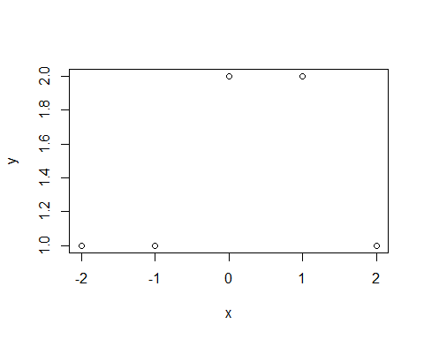

The curve is

* constant between −2 and -1 ( y=1) (slope: zero)
* linear between -1 and 0 with y= 2+ x (slope 1, intercept: 2)
* constant between 0 and 1 ( y=2) (slope: zero)
* linear between 1 and 2 with y= 3- x (slope: 1, intercept: 3)

**Problem: 2**

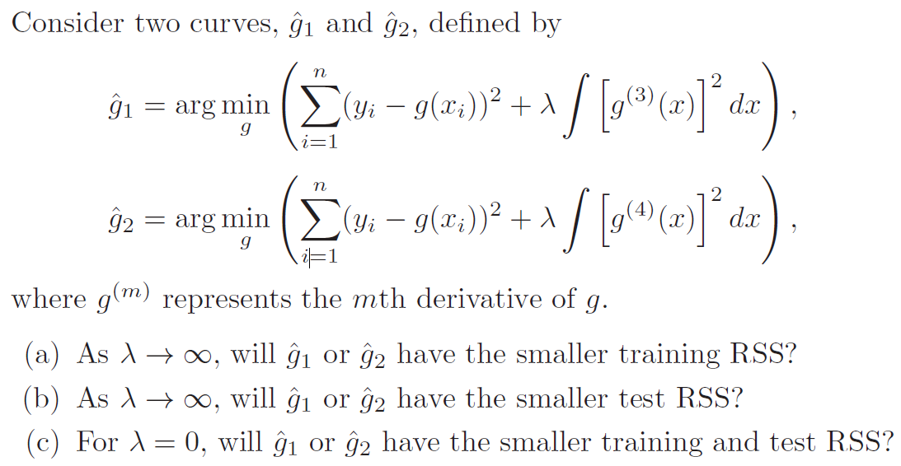

1. As λ→∞ will g^1 or g^2 have the smaller training RSS?

* As λ→∞, the weight of penalty term increases and with higher order of derivative in the penalty term, g^2 is more flexible compared to g^1. Hence the training error would be less for g^2

1. As λ→∞ will g^1 or g^2 have the smaller test RSS?

* As mentioned above we expect g^2 to be more flexible which can lead to model over fit on the training data. g^2 might have higher Test RSS compared to g^1. Hence g^1 likely to have low Test RSS value

1. For λ=0, will g^1 or g^2 have the smaller training and test RSS?

* With λ=0 🡺 g^1=g^2. Hence both will have same training and test RSS values.

**Problem: 3**

Find at least one non-linear estimate which does better than linear regression, and justify this using a t-test or by showing an improvement in the cross-validation error with respect to a linear model. You must also produce a plot of the predictor X vs. the non-linear estimate f^(X)

set.seed(12)  
library(ISLR)

## Warning: package 'ISLR' was built under R version 3.2.5

library(glmnet)

## Warning: package 'glmnet' was built under R version 3.2.5

## Loading required package: Matrix

## Loading required package: foreach

## Loaded glmnet 2.0-5

library(boot)  
data(Auto)  
summary(Auto)

## mpg cylinders displacement horsepower   
## Min. : 9.00 Min. :3.000 Min. : 68.0 Min. : 46.0   
## 1st Qu.:17.00 1st Qu.:4.000 1st Qu.:105.0 1st Qu.: 75.0   
## Median :22.75 Median :4.000 Median :151.0 Median : 93.5   
## Mean :23.45 Mean :5.472 Mean :194.4 Mean :104.5   
## 3rd Qu.:29.00 3rd Qu.:8.000 3rd Qu.:275.8 3rd Qu.:126.0   
## Max. :46.60 Max. :8.000 Max. :455.0 Max. :230.0   
##   
## weight acceleration year origin   
## Min. :1613 Min. : 8.00 Min. :70.00 Min. :1.000   
## 1st Qu.:2225 1st Qu.:13.78 1st Qu.:73.00 1st Qu.:1.000   
## Median :2804 Median :15.50 Median :76.00 Median :1.000   
## Mean :2978 Mean :15.54 Mean :75.98 Mean :1.577   
## 3rd Qu.:3615 3rd Qu.:17.02 3rd Qu.:79.00 3rd Qu.:2.000   
## Max. :5140 Max. :24.80 Max. :82.00 Max. :3.000   
##   
## name   
## amc matador : 5   
## ford pinto : 5   
## toyota corolla : 5   
## amc gremlin : 4   
## amc hornet : 4   
## chevrolet chevette: 4   
## (Other) :365

pairs(Auto, main='Scatterplot for Auto Data')

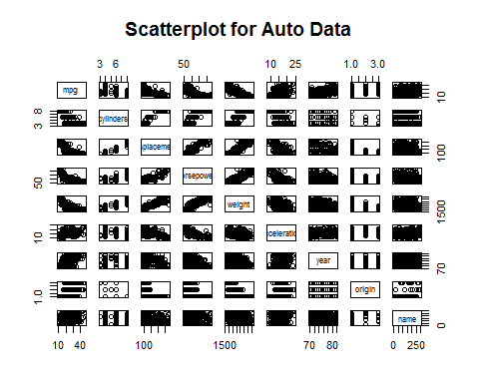  
"mpg" is negatively correlated with "cylindes", "displacement", "horsepower" and "weight"

Let us start with Polynomial Models of mpg vs displacement

**Polynomial function**

MSE <- rep(NA, 15)  
for (i in 1:15) {  
 fit <- glm(mpg ~ poly(displacement, i), data = Auto)  
 MSE[i] <- cv.glm(Auto, fit, K = 10)$delta[1]  
}  
plot(1:15, MSE, xlab = "Degree", ylab = "Test MSE", type = "l", main = "Polynomical Degree vs Test MSE")  
points(which.min(MSE), MSE[which.min(MSE)], col = "red", cex = 2, pch = 20)

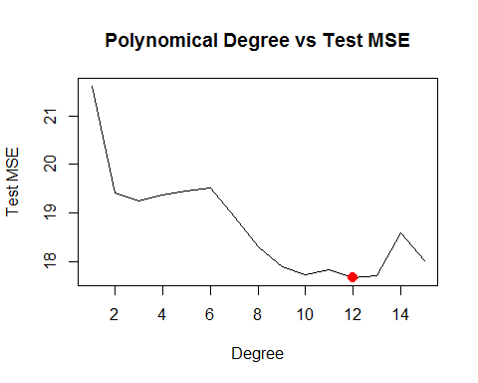  
The optimal degree for the polynomial here is 12th degree with CV TEST MSE:

MSE[which.min(MSE)]

**## [1] 17.66336**

So we need to find a nonlinear model with Test MSE less than 17.66336

**Step function**

MSE <- rep(NA, 15)  
for (i in 2:15) {  
 Auto$dis_cut <- cut(Auto$displacement, i)  
 fit <- glm(mpg ~ dis_cut, data = Auto)  
 MSE[i] <- cv.glm(Auto, fit, K = 10)$delta[1]  
}  
plot(2:15, MSE[-1], xlab = "Cuts", ylab = "Test MSE", type = "l", main = "# Cuts vs Test MSE")  
points(which.min(MSE), MSE[which.min(MSE)], col = "red", cex = 2, pch = 20)

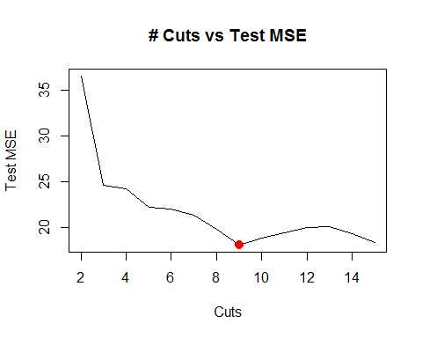  
We may see that the error is minimum for 9 cuts with CV TEST MSE

MSE[which.min(MSE)]

**## [1] 18.12879**

**Spline functions**

library(splines)  
MSE <- rep(NA, 20)  
for (i in 3:20) {  
 fit <- glm(mpg ~ ns(displacement, df = i), data = Auto)  
 MSE[i] <- cv.glm(Auto, fit, K = 10)$delta[1]  
}  
plot(3:20, MSE[-c(1, 2)], xlab = "degrees of freedom", ylab = "Test MSE", type = "l", main="Test MSE vs Splines degree of freedom")  
d.min <- which.min(MSE)  
points(which.min(MSE), MSE[which.min(MSE)], col = "red", cex = 2, pch = 20)

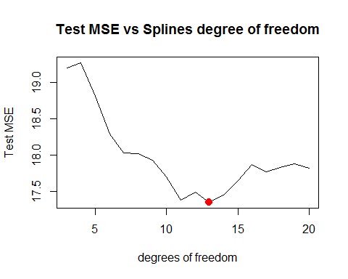  
We may see that the error is minimum for 13 degrees of freedom with CV TEST MSE

MSE[which.min(MSE)]

**## [1] 17.34765**

**17.34765< 17.66336** Hence we found a nonlinear model which performs better than a Linear Model.

**Potting the Nonlinear estimates**

Plotting X vs. the non-linear estimate f^(X)

fit <- glm(mpg ~ ns(displacement, df = which.min(MSE)), data = Auto)  
 par(mfrow = c(2,2))  
 plot(fit)

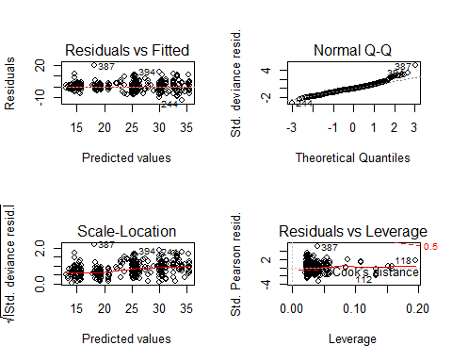  
**GAM**

library(gam)

## Warning: package 'gam' was built under R version 3.2.5

## Loaded gam 1.14

fit <- gam(mpg ~ s(displacement, 4) + s(horsepower, 4), data = Auto)  
summary(fit)

##   
## Call: gam(formula = mpg ~ s(displacement, 4) + s(horsepower, 4), data = Auto)  
## Deviance Residuals:  
## Min 1Q Median 3Q Max   
## -11.2982 -2.1592 -0.4394 2.1247 17.0946   
##   
## (Dispersion Parameter for gaussian family taken to be 15.3543)  
##   
## Null Deviance: 23818.99 on 391 degrees of freedom  
## Residual Deviance: 5880.697 on 382.9999 degrees of freedom  
## AIC: 2194.05   
##   
## Number of Local Scoring Iterations: 2   
##   
## Anova for Parametric Effects  
## Df Sum Sq Mean Sq F value Pr(>F)   
## s(displacement, 4) 1 15254.9 15254.9 993.524 < 2e-16 ***  
## s(horsepower, 4) 1 1038.4 1038.4 67.632 3.1e-15 ***  
## Residuals 383 5880.7 15.4   
## ---  
## Signif. codes: 0 '***' 0.001 '**' 0.01 '*' 0.05 '.' 0.1 ' ' 1  
##   
## Anova for Nonparametric Effects  
## Npar Df Npar F Pr(F)   
## (Intercept)   
## s(displacement, 4) 3 13.613 1.863e-08 ***  
## s(horsepower, 4) 3 15.606 1.349e-09 ***  
## ---  
## Signif. codes: 0 '***' 0.001 '**' 0.01 '*' 0.05 '.' 0.1 ' ' 1

library(DAAG)

## Loading required package: lattice

##   
## Attaching package: 'lattice'

## The following object is masked from 'package:boot':  
##   
## melanoma

lm_fit <- lm(mpg ~ displacement, data = Auto)  
a<-cv.lm(data = Auto, form.lm = formula(mpg ~ displacement),m=10)

## Analysis of Variance Table  
##   
## Response: mpg  
## Df Sum Sq Mean Sq F value Pr(>F)   
## displacement 1 15440 15440 719 <2e-16 ***  
## Residuals 390 8379 21   
## ---  
## Signif. codes: 0 '***' 0.001 '**' 0.01 '*' 0.05 '.' 0.1 ' ' 1

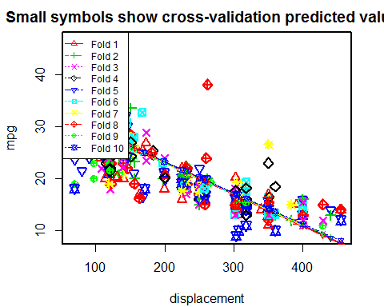

##   
## fold 1   
## Observations in test set: 39   
## 1 7 10 12 14 17 22 23 35  
## displacement 307.00 454.00 390.00 340.000 455.0 199.0 107.00 104.00 225.00  
## cvpred 16.62 7.66 11.56 14.611 7.6 23.2 28.81 28.99 21.62  
## mpg 18.00 14.00 15.00 14.000 14.0 18.0 24.00 25.00 16.00  
## CV residual 1.38 6.34 3.44 -0.611 6.4 -5.2 -4.81 -3.99 -5.62  
## 56 61 74 81 108 120 125 165 185  
## displacement 97.00 140.0 307.00 122.0 232.00 114.00 350 231.000 140.0  
## cvpred 29.42 26.8 16.62 27.9 21.19 28.38 14 21.254 26.8  
## mpg 27.00 20.0 13.00 22.0 18.00 20.00 11 21.000 25.0  
## CV residual -2.42 -6.8 -3.62 -5.9 -3.19 -8.38 -3 -0.254 -1.8  
## 189 192 196 208 252 254 260 269  
## displacement 318.0000 225.00 85.00 130.00 302.00 200.00 200.00 119.00  
## cvpred 15.9517 21.62 30.15 27.41 16.93 23.14 23.14 28.08  
## mpg 16.0000 22.00 29.00 20.00 20.20 20.50 20.80 27.20  
## CV residual 0.0483 0.38 -1.15 -7.41 3.27 -2.64 -2.34 -0.88  
## 275 276 290 295 308 310 320 360 362  
## displacement 131.00 163.0 350.0 86.00 173.00 98.0 120.00 141.00 168.000  
## cvpred 27.35 25.4 14.0 30.09 24.79 29.4 28.02 26.74 25.093  
## mpg 20.30 17.0 16.9 34.10 26.80 41.5 31.30 28.10 25.400  
## CV residual -7.05 -8.4 2.9 4.01 2.01 12.1 3.28 1.36 0.307  
## 364 375 380 381  
## displacement 231.00 105.00 120.00 107.00  
## cvpred 21.25 28.93 28.02 28.81  
## mpg 22.40 36.00 36.00 36.00  
## CV residual 1.15 7.07 7.98 7.19  
##   
## Sum of squares = 942 Mean square = 24.1 n = 39   
##   
## fold 2   
## Observations in test set: 40   
## 3 43 55 67 71 85 95 97  
## displacement 318.00 383.000 72.00 304.000 400.00 97.0 440.00 360.000  
## cvpred 16.01 12.164 30.59 16.844 11.16 29.1 8.79 13.527  
## mpg 18.00 12.000 35.00 17.000 13.00 27.0 13.00 13.000  
## CV residual 1.99 -0.164 4.41 0.156 1.84 -2.1 4.21 -0.527  
## 99 124 126 140 153 155 166 168  
## displacement 250.00 156.00 198.00 302.00 225.00 250.00 262.000 97.000  
## cvpred 20.04 25.61 23.12 16.96 21.52 20.04 19.331 29.104  
## mpg 16.00 20.00 20.00 14.00 19.00 15.00 20.000 29.000  
## CV residual -4.04 -5.61 -3.12 -2.96 -2.52 -5.04 0.669 -0.104  
## 172 181 188 199 230 240 256 257  
## displacement 134.00 121.00 305.000 91.00 400.00 97.000 140.00 225.00  
## cvpred 26.91 27.68 16.784 29.46 11.16 29.104 26.56 21.52  
## mpg 24.00 25.00 17.500 33.00 16.00 30.000 25.10 20.50  
## CV residual -2.91 -2.68 0.716 3.54 4.84 0.896 -1.46 -1.02  
## 272 273 284 285 297 304 309 319  
## displacement 156.00 151.00 232.000 225.000 121.000 85.00 151.00 134.00  
## cvpred 25.61 25.91 21.108 21.523 27.683 29.82 25.91 26.91  
## mpg 23.20 23.80 20.200 20.600 27.400 31.80 33.50 29.80  
## CV residual -2.41 -2.11 -0.908 -0.923 -0.283 1.98 7.59 2.89  
## 328 330 348 370 377 379 396 397  
## displacement 121.00 91.0 85.00 112.00 91.00 98.00 120.000 119.0  
## cvpred 27.68 29.5 29.82 28.22 29.46 29.05 27.742 27.8  
## mpg 36.40 44.6 37.00 34.00 31.00 36.00 28.000 31.0  
## CV residual 8.72 15.1 7.18 5.78 1.54 6.95 0.258 3.2  
##   
## Sum of squares = 737 Mean square = 18.4 n = 40   
##   
## fold 3   
## Observations in test set: 40   
## 16 47 63 77 91 94 104 105  
## displacement 198.00 140.00 350.00 121.00 429.00 318.00 400.000 400.000  
## cvpred 23.28 26.74 14.22 27.87 9.51 16.13 11.243 11.243  
## mpg 22.00 22.00 13.00 18.00 12.00 14.00 11.000 12.000  
## CV residual -1.28 -4.74 -1.22 -9.87 2.49 -2.13 -0.243 0.757  
## 111 119 149 156 161 177 184 194  
## displacement 108.00 116.00 116.00 250.00 231.00 232.00 116.00 200.000  
## cvpred 28.64 28.17 28.17 20.18 21.31 21.25 28.17 23.161  
## mpg 22.00 24.00 26.00 15.00 17.00 19.00 25.00 24.000  
## CV residual -6.64 -4.17 -2.17 -5.18 -4.31 -2.25 -3.17 0.839  
## 202 214 215 219 221 227 228 229 232  
## displacement 250.00 350.00 302.00 79.00 85.00 231.000 225.00 250.00 400.00  
## cvpred 20.18 14.22 17.08 30.37 30.01 21.313 21.67 20.18 11.24  
## mpg 18.50 13.00 13.00 36.00 33.50 20.500 19.00 18.50 15.50  
## CV residual -1.68 -1.22 -4.08 5.63 3.49 -0.813 -2.67 -1.68 4.26  
## 245 264 265 274 283 294 300 307 318  
## displacement 90.0 231.00 302.00 119.00 140.00 89.00 141.000 173.00 97.0  
## cvpred 29.7 21.31 17.08 27.99 26.74 29.77 26.676 24.77 29.3  
## mpg 43.1 17.70 18.10 23.90 22.30 31.90 27.200 28.80 34.3  
## CV residual 13.4 -3.61 1.02 -4.09 -4.44 2.13 0.524 4.03 5.0  
## 341 342 350 353 374 383  
## displacement 156.0000 173.00 91.00 98.000 140.00 91.00  
## cvpred 25.7824 24.77 29.66 29.238 26.74 29.66  
## mpg 25.8000 23.50 34.10 29.900 24.00 38.00  
## CV residual 0.0176 -1.27 4.44 0.662 -2.74 8.34  
##   
## Sum of squares = 730 Mean square = 18.2 n = 40   
##   
## fold 4   
## Observations in test set: 39   
## 24 31 39 48 51 80 90 123  
## displacement 121.00 140.00 350.0000 250.00 116.000 96.00 318.00 121.00  
## cvpred 27.86 26.71 14.0399 20.07 28.158 29.36 15.97 27.86  
## mpg 26.00 28.00 14.0000 19.00 28.000 26.00 15.00 24.00  
## CV residual -1.86 1.29 -0.0399 -1.07 -0.158 -3.36 -0.97 -3.86  
## 134 147 150 159 164 178 180 203  
## displacement 250.00 90.00 120.00 318.0000 225.00 115.00 121.00 258.00  
## cvpred 20.07 29.73 27.92 15.9705 21.58 28.22 27.86 19.59  
## mpg 16.00 28.00 24.00 16.0000 18.00 23.00 22.00 17.50  
## CV residual -4.07 -1.73 -3.92 0.0295 -3.58 -5.22 -5.86 -2.09  
## 216 217 222 243 255 281 287 288  
## displacement 318.00 98.00 305.000 121.00 200.00 231.000 302.000 351.00  
## cvpred 15.97 29.24 16.755 27.86 23.09 21.219 16.936 13.98  
## mpg 13.00 31.50 17.500 21.50 20.20 21.500 17.600 16.50  
## CV residual -2.97 2.26 0.745 -6.36 -2.89 0.281 0.664 2.52  
## 289 293 298 299 302 316 322 336  
## displacement 318.00 360.00 183.00 350.00 105.00 151.00 108.00 122.0  
## cvpred 15.97 13.44 24.12 14.04 28.82 26.05 28.64 27.8  
## mpg 18.20 18.50 25.40 23.00 34.20 24.30 32.20 35.0  
## CV residual 2.23 5.06 1.28 8.96 5.38 -1.75 3.56 7.2  
## 339 347 349 358 359 366 392  
## displacement 135.000 97.0 89.00 119.00 120.00 200.00 151.000  
## cvpred 27.011 29.3 29.79 27.98 27.92 23.09 26.046  
## mpg 27.200 32.3 37.70 32.90 31.60 20.20 27.000  
## CV residual 0.189 3.0 7.91 4.92 3.68 -2.89 0.954  
##   
## Sum of squares = 545 Mean square = 14 n = 39   
##   
## fold 5   
## Observations in test set: 39   
## 8 41 49 53 58 78 82 89  
## displacement 440.00 351.0000 250.00 88.0000 113.00 121.00 97.0 302.00  
## cvpred 8.63 14.0473 20.19 30.0521 28.53 28.04 29.5 17.03  
## mpg 14.00 14.0000 18.00 30.0000 24.00 22.00 28.0 14.00  
## CV residual 5.37 -0.0473 -2.19 -0.0521 -4.53 -6.04 -1.5 -3.03  
## 98 114 118 128 136 139 148 157  
## displacement 225.00 155.00 68.00 232.00 225.00 318.00 90.00 400.00  
## cvpred 21.72 25.97 31.27 21.29 21.72 16.06 29.93 11.07  
## mpg 18.00 21.00 29.00 19.00 18.00 14.00 24.00 16.00  
## CV residual -3.72 -4.97 -2.27 -2.29 -3.72 -2.06 -5.93 4.93  
## 160 162 171 174 186 193 209 212  
## displacement 351.0000 250.00 140.00 119.00 98.00 250.00 318.00 168.00  
## cvpred 14.0473 20.19 26.89 28.17 29.44 20.19 16.06 25.18  
## mpg 14.0000 16.00 23.00 24.00 26.00 22.00 13.00 16.50  
## CV residual -0.0473 -4.19 -3.89 -4.17 -3.44 1.81 -3.06 -8.68  
## 223 244 250 268 270 282 329 335 352  
## displacement 260.00 80.00 260.000 134.000 105.00 200.00 146.00 70.00 98.00  
## cvpred 19.59 30.54 19.585 27.253 29.02 23.24 26.52 31.15 29.44  
## mpg 17.00 21.50 19.900 27.500 30.90 19.80 30.00 23.70 34.40  
## CV residual -2.59 -9.04 0.315 0.247 1.88 -3.44 3.48 -7.45 4.96  
## 356 363 369 376 390 395  
## displacement 107.0 146.00 112.00 91.00 144.00 135.00  
## cvpred 28.9 26.52 28.59 29.87 26.64 27.19  
## mpg 33.7 24.20 27.00 37.00 32.00 32.00  
## CV residual 4.8 -2.32 -1.59 7.13 5.36 4.81  
##   
## Sum of squares = 708 Mean square = 18.2 n = 39   
##   
## fold 6   
## Observations in test set: 39   
## 2 13 19 20 38 64 75 86 87  
## displacement 350.000 400.00 97.00 97.00 232.00 400.00 302.00 350.00 304.00  
## cvpred 14.087 11.13 29.07 29.07 21.07 11.13 16.93 14.09 16.81  
## mpg 15.000 15.00 27.00 26.00 18.00 14.00 13.00 13.00 14.00  
## CV residual 0.913 3.87 -2.07 -3.07 -3.07 2.87 -3.93 -1.09 -2.81  
## 88 100 102 106 117 131 138 144  
## displacement 350.00 232.00 198.0000 360.000 400.00 122.00 350.00 97.00  
## cvpred 14.09 21.07 23.0861 13.495 11.13 27.59 14.09 29.07  
## mpg 13.00 18.00 23.0000 13.000 16.00 26.00 13.00 26.00  
## CV residual -1.09 -3.07 -0.0861 -0.495 4.87 -1.59 -1.09 -3.07  
## 146 167 176 198 205 213 218 248 251  
## displacement 83.00 302.00 90.00 90.00 85.00 350.00 111.00 85.00 318.00  
## cvpred 29.89 16.93 29.48 29.48 29.78 14.09 28.24 29.78 15.98  
## mpg 32.00 13.00 29.00 29.00 32.00 16.50 30.00 39.40 19.40  
## CV residual 2.11 -3.93 -0.48 -0.48 2.22 2.41 1.76 9.62 3.42  
## 261 262 266 321 324 327 333 334 343  
## displacement 225.00 258.00 318.00 119.00 156.00 90.0 89.00 168.00 135.00  
## cvpred 21.49 19.53 15.98 27.76 25.57 29.5 29.54 24.86 26.82  
## mpg 18.60 18.10 17.50 37.00 27.90 43.4 29.80 32.70 30.00  
## CV residual -2.89 -1.43 1.52 9.24 2.33 13.9 0.26 7.84 3.18  
## 351 361 373 378  
## displacement 105.00 145.00 151.00 105.00  
## cvpred 28.59 26.22 25.87 28.59  
## mpg 34.70 30.70 27.00 38.00  
## CV residual 6.11 4.48 1.13 9.41  
##   
## Sum of squares = 774 Mean square = 19.8 n = 39   
##   
## fold 7   
## Observations in test set: 39   
## 11 18 37 40 42 44 46 57 59  
## displacement 383.00 200.00 250.00 400.00 318.00 400.00 258.00 91.00 97.50  
## cvpred 12.03 23.03 20.02 11.01 15.94 11.01 19.54 29.58 29.19  
## mpg 15.00 21.00 19.00 14.00 14.00 13.00 18.00 26.00 25.00  
## CV residual 2.97 -2.03 -1.02 2.99 -1.94 1.99 -1.54 -3.58 -4.19  
## 110 129 191 197 201 206 207 210  
## displacement 140.00 250.00 351.000 98.00 250.00 97.00 140.000 120.00  
## cvpred 26.63 20.02 13.955 29.16 20.02 29.22 26.634 27.84  
## mpg 21.00 15.00 14.500 24.50 18.00 28.00 26.500 19.00  
## CV residual -5.63 -5.02 0.545 -4.66 -2.02 -1.22 -0.134 -8.84  
## 226 233 234 235 238 258 263 280  
## displacement 250.00 351.00 97.000 151.00 98.00 232.00 305.00 98.000  
## cvpred 20.02 13.96 29.218 25.97 29.16 21.11 16.72 29.158  
## mpg 17.50 16.00 29.000 24.50 30.50 19.40 19.20 29.500  
## CV residual -2.52 2.04 -0.218 -1.47 1.34 -1.71 2.48 0.342  
## 286 296 303 312 314 326 338 365 367  
## displacement 305.000 98.00 105.00 98.00 151.00 90.0 107.00 350.0 225.00  
## cvpred 16.719 29.16 28.74 29.16 25.97 29.6 28.62 14.0 21.53  
## mpg 17.000 35.70 34.50 32.10 28.00 44.3 32.40 26.6 17.60  
## CV residual 0.281 6.54 5.76 2.94 2.03 14.7 3.78 12.6 -3.93  
## 371 372 388 393 394  
## displacement 112.00 135.00 156.000 140.000 97.0  
## cvpred 28.32 26.93 25.673 26.634 29.2  
## mpg 31.00 29.00 26.000 27.000 44.0  
## CV residual 2.68 2.07 0.327 0.366 14.8  
##   
## Sum of squares = 972 Mean square = 24.9 n = 39   
##   
## fold 8   
## Observations in test set: 39   
## 4 5 6 9 15 34 36 50  
## displacement 304.00 302.0000 429.00 455.00 113.00 232.00 250.00 122.00  
## cvpred 16.78 16.9021 9.13 7.54 28.47 21.19 20.08 27.92  
## mpg 16.00 17.0000 15.00 14.00 24.00 19.00 17.00 23.00  
## CV residual -0.78 0.0979 5.87 6.46 -4.47 -2.19 -3.08 -4.92  
## 70 73 83 92 107 113 121 141 145  
## displacement 350.00 304.00 120.00 400.0 350.00 122.00 121.00 304.00 76.000  
## cvpred 13.96 16.78 28.04 10.9 13.96 27.92 27.98 16.78 30.733  
## mpg 12.00 15.00 23.00 13.0 12.00 19.00 19.00 14.00 31.000  
## CV residual -1.96 -1.78 -5.04 2.1 -1.96 -8.92 -8.98 -2.78 0.267  
## 158 163 169 187 211 220 225 237 239  
## displacement 350.00 258.00 140.00 101.0 156.00 122.00 302.0 140.00 98.00  
## cvpred 13.96 19.59 26.82 29.2 25.84 27.92 16.9 26.82 29.39  
## mpg 15.00 15.00 23.00 27.0 19.00 25.50 15.0 25.50 33.50  
## CV residual 1.04 -4.59 -3.82 -2.2 -6.84 -2.42 -1.9 -1.32 4.11  
## 242 267 278 291 301 306 345 354 357  
## displacement 146.00 98.000 163.00 351.0 260.00 151.00 86.00 105.00 108.00  
## cvpred 26.45 29.387 25.41 13.9 19.47 26.14 30.12 28.96 28.77  
## mpg 22.00 30.000 16.20 15.5 23.90 28.40 39.00 33.00 32.40  
## CV residual -4.45 0.613 -9.21 1.6 4.43 2.26 8.88 4.04 3.63  
## 384 386 387 389  
## displacement 91.00 181.000 262.0 232.000  
## cvpred 29.82 24.307 19.4 21.186  
## mpg 32.00 25.000 38.0 22.000  
## CV residual 2.18 0.693 18.6 0.814  
##   
## Sum of squares = 1055 Mean square = 27 n = 39   
##   
## fold 9   
## Observations in test set: 39   
## 21 32 60 62 65 68 72 84 93  
## displacement 110.00 113.00 97.00 122.0 318.00 429.00 70.0 98.00 351.00  
## cvpred 28.41 28.23 29.18 27.7 16.07 9.48 30.8 29.12 14.11  
## mpg 25.00 25.00 23.00 21.0 15.00 11.00 19.0 28.00 13.00  
## CV residual -3.41 -3.23 -6.18 -6.7 -1.07 1.52 -11.8 -1.12 -1.11  
## 109 116 132 142 151 152 170 173 179  
## displacement 97.00 350.000 71.00 98.000 108.00 79.000 232.00 90.0 120.00  
## cvpred 29.18 14.171 30.73 29.124 28.53 30.251 21.17 29.6 27.82  
## mpg 20.00 15.000 32.00 29.000 26.00 31.000 20.00 25.0 23.00  
## CV residual -9.18 0.829 1.27 -0.124 -2.53 0.749 -1.17 -4.6 -4.82  
## 182 190 195 204 224 241 259 271 277  
## displacement 91.00 304.0 232.00 97.000 318.00 97.00 231.000 134.00 121.00  
## cvpred 29.54 16.9 21.17 29.183 16.07 29.18 21.232 26.99 27.76  
## mpg 33.00 15.5 22.50 29.500 15.50 30.50 20.600 21.10 21.60  
## CV residual 3.46 -1.4 1.33 0.317 -0.57 1.32 -0.632 -5.89 -6.16  
## 279 292 305 311 313 323 325 332 340 344  
## displacement 89.00 267.000 91.00 89.00 86.00 86.0 85.0 97.00 151.000 79.00  
## cvpred 29.66 19.096 29.54 29.66 29.84 29.8 29.9 29.18 25.979 30.25  
## mpg 31.50 19.200 37.30 38.10 37.20 46.6 40.8 33.80 26.600 39.10  
## CV residual 1.84 0.104 7.76 8.44 7.36 16.8 10.9 4.62 0.621 8.85  
## 346 382  
## displacement 81.00 108.00  
## cvpred 30.13 28.53  
## mpg 35.10 34.00  
## CV residual 4.97 5.47  
##   
## Sum of squares = 1224 Mean square = 31.4 n = 39   
##   
## fold 10   
## Observations in test set: 39   
## 25 26 27 28 29 30 45 52 54  
## displacement 199.00 360.0 307.00 318.00 304.00 97.0 400.00 79.000 71.0000  
## cvpred 23.31 13.7 16.87 16.21 17.05 29.4 11.32 30.477 30.9541  
## mpg 21.00 10.0 10.00 11.00 9.00 27.0 13.00 30.000 31.0000  
## CV residual -2.31 -3.7 -6.87 -5.21 -8.05 -2.4 1.68 -0.477 0.0459  
## 66 69 76 79 96 101 103 112 115  
## displacement 351.00 350.0 318.00 120.00 455.00 250.00 97.0 70 98.00  
## cvpred 14.24 14.3 16.21 28.03 8.03 20.27 29.4 31 29.34  
## mpg 14.00 13.0 14.00 21.00 12.00 18.00 26.0 18 26.00  
## CV residual -0.24 -1.3 -2.21 -7.03 3.97 -2.27 -3.4 -13 -3.34  
## 122 130 133 135 137 143 154 175  
## displacement 318.00 79.000 140.00 258.00 302.00 79.00 250.00 171.00  
## cvpred 16.21 30.477 26.84 19.79 17.17 30.48 20.27 24.98  
## mpg 15.00 31.000 25.00 16.00 16.00 26.00 18.00 18.00  
## CV residual -1.21 0.523 -1.84 -3.79 -1.17 -4.48 -2.27 -6.98  
## 183 200 231 236 246 247 249 253 315  
## displacement 107.000 225.00 350.0 97.0 98.00 78.00 91.00 231.0 140.000  
## cvpred 28.805 21.76 14.3 29.4 29.34 30.54 29.76 21.4 26.835  
## mpg 28.000 20.00 15.5 26.0 36.10 32.80 36.10 19.2 26.400  
## CV residual -0.805 -1.76 1.2 -3.4 6.76 2.26 6.34 -2.2 -0.435  
## 317 368 385 391  
## displacement 225.00 112.000 91.00 135.00  
## cvpred 21.76 28.507 29.76 27.13  
## mpg 19.10 28.000 38.00 36.00  
## CV residual -2.66 -0.507 8.24 8.87  
##   
## Sum of squares = 797 Mean square = 20.4 n = 39   
##   
## Overall (Sum over all 39 folds)   
## ms   
## 21.6

**Problem: 4**

November 15, 2016

1. Use the "poly()" function to fit a cubic polynomial regression to predict "nox" using "dis". Report the regression output, and plot the resulting data and polynomial fits.

set.seed(12)  
par(mfrow = c(1,1))  
  
library(MASS)  
library(boot)  
library(splines)  
df<-Boston  
fit <- lm(nox ~ poly(dis, 3), data = df)  
summary(fit)

##   
## Call:  
## lm(formula = nox ~ poly(dis, 3), data = df)  
##   
## Residuals:  
## Min 1Q Median 3Q Max   
## -0.121130 -0.040619 -0.009738 0.023385 0.194904   
##   
## Coefficients:  
## Estimate Std. Error t value Pr(>|t|)   
## (Intercept) 0.554695 0.002759 201.021 < 2e-16 ***  
## poly(dis, 3)1 -2.003096 0.062071 -32.271 < 2e-16 ***  
## poly(dis, 3)2 0.856330 0.062071 13.796 < 2e-16 ***  
## poly(dis, 3)3 -0.318049 0.062071 -5.124 4.27e-07 ***  
## ---  
## Signif. codes: 0 '***' 0.001 '**' 0.01 '*' 0.05 '.' 0.1 ' ' 1  
##   
## Residual standard error: 0.06207 on 502 degrees of freedom  
## Multiple R-squared: 0.7148, Adjusted R-squared: 0.7131   
## F-statistic: 419.3 on 3 and 502 DF, p-value: < 2.2e-16

dis_range = range(df$dis)  
dis_seq = seq(from = dis_range[1], to = dis_range[2])  
prediction = predict(fit, list(dis = dis_seq))  
plot(nox ~ dis, data = df,col="red")  
lines(dis_seq, prediction, lwd = 2, col = 'blue')

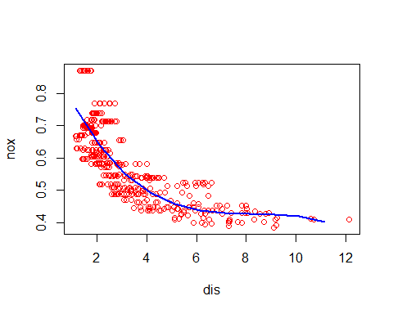  
**By looking at p values we can conclude that all polynomial terms are significant.**

1. Plot the polynomial fits for a range of different polynomial degrees (say, from 1 to 10), and report the associated residual sum of squares.

RSS <- rep(NA, 10)  
for (i in 1:10) {  
 fit <- lm(nox ~ poly(dis, i), data = Boston)  
 RSS[i] <- sum(fit$residuals^2)  
}  
plot(1:10, RSS, xlab = "Degree", ylab = "RSS", type = "l")  
points(which.min(RSS), RSS[which.min(RSS)], col = "red", cex = 2, pch = 20)

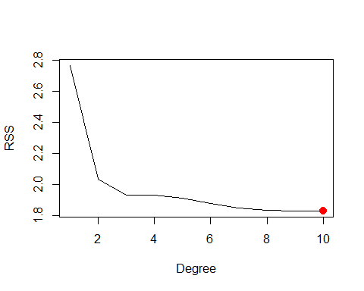  
**RSS monotonically decreases as we increase degree of polynomial. minimum RSS is achieved at degree 10**

1. Perform cross-validation or another approach to select the optimal degree for the polynomial, and explain your results.

MSE <- rep(NA, 10)  
for (i in 1:10) {  
 fit <- glm(nox ~ poly(dis, i), data = Boston)  
 MSE[i] <- cv.glm(Boston, fit, K = 10)$delta[1]  
}  
plot(1:10, MSE, xlab = "Degree", ylab = "10 fold CV Error", type = "l")  
points(which.min(MSE), MSE[which.min(MSE)], col = "red", cex = 2, pch = 20)

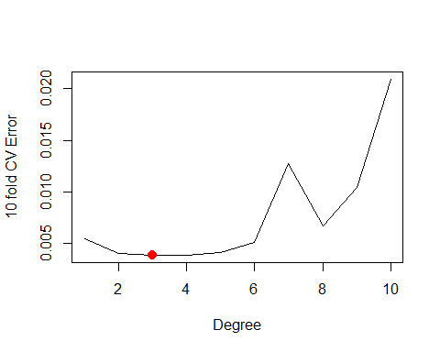  
**We can say that polynomial of degree 4 minimizes the test MSE.**

1. Use the "bs()" function to fit a regression spline to predict "nox" using "dis". Report the output for the fit using 7 degrees of freedom (3 knots)

fit <- lm(nox ~ bs(dis, df = 4, knots = c(3, 7, 11)), data = df)  
summary(fit)

##   
## Call:  
## lm(formula = nox ~ bs(dis, df = 4, knots = c(3, 7, 11)), data = df)  
##   
## Residuals:  
## Min 1Q Median 3Q Max   
## -0.130710 -0.039850 -0.008357 0.027792 0.188518   
##   
## Coefficients:  
## Estimate Std. Error t value  
## (Intercept) 0.714346 0.015846 45.081  
## bs(dis, df = 4, knots = c(3, 7, 11))1 -0.006626 0.024307 -0.273  
## bs(dis, df = 4, knots = c(3, 7, 11))2 -0.296980 0.018293 -16.234  
## bs(dis, df = 4, knots = c(3, 7, 11))3 -0.222840 0.033763 -6.600  
## bs(dis, df = 4, knots = c(3, 7, 11))4 -0.379811 0.042317 -8.975  
## bs(dis, df = 4, knots = c(3, 7, 11))5 -0.222959 0.086870 -2.567  
## bs(dis, df = 4, knots = c(3, 7, 11))6 -0.304346 0.063378 -4.802  
## Pr(>|t|)   
## (Intercept) < 2e-16 ***  
## bs(dis, df = 4, knots = c(3, 7, 11))1 0.7853   
## bs(dis, df = 4, knots = c(3, 7, 11))2 < 2e-16 ***  
## bs(dis, df = 4, knots = c(3, 7, 11))3 1.05e-10 ***  
## bs(dis, df = 4, knots = c(3, 7, 11))4 < 2e-16 ***  
## bs(dis, df = 4, knots = c(3, 7, 11))5 0.0106 *   
## bs(dis, df = 4, knots = c(3, 7, 11))6 2.08e-06 ***  
## ---  
## Signif. codes: 0 '***' 0.001 '**' 0.01 '*' 0.05 '.' 0.1 ' ' 1  
##   
## Residual standard error: 0.06137 on 499 degrees of freedom  
## Multiple R-squared: 0.7229, Adjusted R-squared: 0.7196   
## F-statistic: 217 on 6 and 499 DF, p-value: < 2.2e-16

pred <- predict(fit, list(dis = dis_seq))  
plot(nox ~ dis, data = Boston, col = "red")  
lines(dis_seq, pred, col = "blue", lwd = 2)

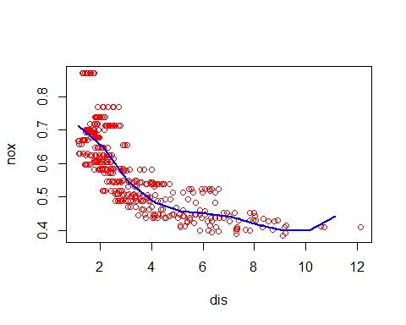

1. Now fit a regression spline for a range of degrees of freedom, and plot the resulting fits and report the resulting RSS. Describe the results obtained.

RSS <- rep(NA, 16)  
for (i in 3:16) {  
 fit <- lm(nox ~ bs(dis, df = i), data = Boston)  
 RSS[i] <- sum(fit$residuals^2)  
}  
plot(3:16, RSS[-c(1, 2)], xlab = "Degrees of freedom", ylab = "RSS", type = "l")  
points(which.min(RSS), RSS[which.min(RSS)], col = "red", cex = 2, pch = 20)

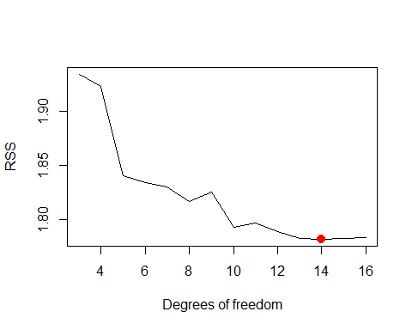  
**We may see that RSS decreases until 14 and then slightly increases after that. Minimum RSS is achieved with splines of degrees of freedom 14**

1. Perform cross-validation or another approach in order to select the best degrees of freedom for a regression spline on this data. Describe your results.

CVError <- rep(NA, 16)  
for (i in 3:16) {  
 fit <- glm(nox ~ bs(dis, df = i), data = Boston)  
 CVError[i] <- cv.glm(Boston, fit, K = 10)$delta[1]  
}

## Warning in bs(dis, degree = 3L, knots = numeric(0), Boundary.knots =  
## c(1.1296, : some 'x' values beyond boundary knots may cause ill-conditioned  
## bases  
  
## Warning in bs(dis, degree = 3L, knots = numeric(0), Boundary.knots =  
## c(1.1296, : some 'x' values beyond boundary knots may cause ill-conditioned  
## bases

## Warning in bs(dis, degree = 3L, knots = numeric(0), Boundary.knots =  
## c(1.137, : some 'x' values beyond boundary knots may cause ill-conditioned  
## bases  
  
## Warning in bs(dis, degree = 3L, knots = numeric(0), Boundary.knots =  
## c(1.137, : some 'x' values beyond boundary knots may cause ill-conditioned  
## bases

## Warning in bs(dis, degree = 3L, knots = structure(3.1675, .Names =  
## "50%"), : some 'x' values beyond boundary knots may cause ill-conditioned  
## bases  
  
## Warning in bs(dis, degree = 3L, knots = structure(3.1675, .Names =  
## "50%"), : some 'x' values beyond boundary knots may cause ill-conditioned  
## bases

## Warning in bs(dis, degree = 3L, knots = structure(3.1827, .Names =  
## "50%"), : some 'x' values beyond boundary knots may cause ill-conditioned  
## bases  
  
## Warning in bs(dis, degree = 3L, knots = structure(3.1827, .Names =  
## "50%"), : some 'x' values beyond boundary knots may cause ill-conditioned  
## bases

## Warning in bs(dis, degree = 3L, knots = structure(c(2.3727,  
## 4.36263333333333: some 'x' values beyond boundary knots may cause ill-  
## conditioned bases  
  
## Warning in bs(dis, degree = 3L, knots = structure(c(2.3727,  
## 4.36263333333333: some 'x' values beyond boundary knots may cause ill-  
## conditioned bases

## Warning in bs(dis, degree = 3L, knots = structure(c(2.4212,  
## 4.23913333333333: some 'x' values beyond boundary knots may cause ill-  
## conditioned bases  
  
## Warning in bs(dis, degree = 3L, knots = structure(c(2.4212,  
## 4.23913333333333: some 'x' values beyond boundary knots may cause ill-  
## conditioned bases

## Warning in bs(dis, degree = 3L, knots = structure(c(2.10035, 3.2157,  
## 5.16495: some 'x' values beyond boundary knots may cause ill-conditioned  
## bases  
  
## Warning in bs(dis, degree = 3L, knots = structure(c(2.10035, 3.2157,  
## 5.16495: some 'x' values beyond boundary knots may cause ill-conditioned  
## bases

## Warning in bs(dis, degree = 3L, knots = structure(c(2.0754, 3.1323,  
## 5.11735: some 'x' values beyond boundary knots may cause ill-conditioned  
## bases  
  
## Warning in bs(dis, degree = 3L, knots = structure(c(2.0754, 3.1323,  
## 5.11735: some 'x' values beyond boundary knots may cause ill-conditioned  
## bases

## Warning in bs(dis, degree = 3L, knots = structure(c(1.96376, 2.66502,  
## 3.9175, : some 'x' values beyond boundary knots may cause ill-conditioned  
## bases  
  
## Warning in bs(dis, degree = 3L, knots = structure(c(1.96376, 2.66502,  
## 3.9175, : some 'x' values beyond boundary knots may cause ill-conditioned  
## bases

## Warning in bs(dis, degree = 3L, knots = structure(c(1.9512, 2.6403,  
## 3.9454, : some 'x' values beyond boundary knots may cause ill-conditioned  
## bases  
  
## Warning in bs(dis, degree = 3L, knots = structure(c(1.9512, 2.6403,  
## 3.9454, : some 'x' values beyond boundary knots may cause ill-conditioned  
## bases

## Warning in bs(dis, degree = 3L, knots = structure(c(1.8651,  
## 2.41306666666667, : some 'x' values beyond boundary knots may cause ill-  
## conditioned bases  
  
## Warning in bs(dis, degree = 3L, knots = structure(c(1.8651,  
## 2.41306666666667, : some 'x' values beyond boundary knots may cause ill-  
## conditioned bases

## Warning in bs(dis, degree = 3L, knots = structure(c(1.86156666666667,  
## 2.38403333333333, : some 'x' values beyond boundary knots may cause ill-  
## conditioned bases  
  
## Warning in bs(dis, degree = 3L, knots = structure(c(1.86156666666667,  
## 2.38403333333333, : some 'x' values beyond boundary knots may cause ill-  
## conditioned bases

## Warning in bs(dis, degree = 3L, knots = structure(c(1.78037142857143,  
## 2.2044, : some 'x' values beyond boundary knots may cause ill-conditioned  
## bases  
  
## Warning in bs(dis, degree = 3L, knots = structure(c(1.78037142857143,  
## 2.2044, : some 'x' values beyond boundary knots may cause ill-conditioned  
## bases

## Warning in bs(dis, degree = 3L, knots = structure(c(1.81317142857143,  
## 2.25881428571429, : some 'x' values beyond boundary knots may cause ill-  
## conditioned bases  
  
## Warning in bs(dis, degree = 3L, knots = structure(c(1.81317142857143,  
## 2.25881428571429, : some 'x' values beyond boundary knots may cause ill-  
## conditioned bases

## Warning in bs(dis, degree = 3L, knots = structure(c(1.743225, 2.0754,  
## 2.4999, : some 'x' values beyond boundary knots may cause ill-conditioned  
## bases  
  
## Warning in bs(dis, degree = 3L, knots = structure(c(1.743225, 2.0754,  
## 2.4999, : some 'x' values beyond boundary knots may cause ill-conditioned  
## bases

## Warning in bs(dis, degree = 3L, knots = structure(c(1.6732,  
## 2.00496666666667, : some 'x' values beyond boundary knots may cause ill-  
## conditioned bases  
  
## Warning in bs(dis, degree = 3L, knots = structure(c(1.6732,  
## 2.00496666666667, : some 'x' values beyond boundary knots may cause ill-  
## conditioned bases

## Warning in bs(dis, degree = 3L, knots = structure(c(1.6723,  
## 2.00613333333333, : some 'x' values beyond boundary knots may cause ill-  
## conditioned bases  
  
## Warning in bs(dis, degree = 3L, knots = structure(c(1.6723,  
## 2.00613333333333, : some 'x' values beyond boundary knots may cause ill-  
## conditioned bases

## Warning in bs(dis, degree = 3L, knots = structure(c(1.6362, 1.9865,  
## 2.288, : some 'x' values beyond boundary knots may cause ill-conditioned  
## bases  
  
## Warning in bs(dis, degree = 3L, knots = structure(c(1.6362, 1.9865,  
## 2.288, : some 'x' values beyond boundary knots may cause ill-conditioned  
## bases

## Warning in bs(dis, degree = 3L, knots = structure(c(1.64668, 1.96376,  
## 2.28422, : some 'x' values beyond boundary knots may cause ill-conditioned  
## bases  
  
## Warning in bs(dis, degree = 3L, knots = structure(c(1.64668, 1.96376,  
## 2.28422, : some 'x' values beyond boundary knots may cause ill-conditioned  
## bases

## Warning in bs(dis, degree = 3L, knots = structure(c(1.60816363636364,  
## 1.87607272727273, : some 'x' values beyond boundary knots may cause ill-  
## conditioned bases  
  
## Warning in bs(dis, degree = 3L, knots = structure(c(1.60816363636364,  
## 1.87607272727273, : some 'x' values beyond boundary knots may cause ill-  
## conditioned bases

## Warning in bs(dis, degree = 3L, knots = structure(c(1.59590909090909,  
## 1.87607272727273, : some 'x' values beyond boundary knots may cause ill-  
## conditioned bases  
  
## Warning in bs(dis, degree = 3L, knots = structure(c(1.59590909090909,  
## 1.87607272727273, : some 'x' values beyond boundary knots may cause ill-  
## conditioned bases

## Warning in bs(dis, degree = 3L, knots = structure(c(1.58948333333333,  
## 1.8301, : some 'x' values beyond boundary knots may cause ill-conditioned  
## bases  
  
## Warning in bs(dis, degree = 3L, knots = structure(c(1.58948333333333,  
## 1.8301, : some 'x' values beyond boundary knots may cause ill-conditioned  
## bases

## Warning in bs(dis, degree = 3L, knots = structure(c(1.60973333333333,  
## 1.8651, : some 'x' values beyond boundary knots may cause ill-conditioned  
## bases  
  
## Warning in bs(dis, degree = 3L, knots = structure(c(1.60973333333333,  
## 1.8651, : some 'x' values beyond boundary knots may cause ill-conditioned  
## bases

## Warning in bs(dis, degree = 3L, knots = structure(c(1.5523,  
## 1.79772307692308, : some 'x' values beyond boundary knots may cause ill-  
## conditioned bases  
  
## Warning in bs(dis, degree = 3L, knots = structure(c(1.5523,  
## 1.79772307692308, : some 'x' values beyond boundary knots may cause ill-  
## conditioned bases

## Warning in bs(dis, degree = 3L, knots = structure(c(1.5895, 1.8195,  
## 2.0407, : some 'x' values beyond boundary knots may cause ill-conditioned  
## bases  
  
## Warning in bs(dis, degree = 3L, knots = structure(c(1.5895, 1.8195,  
## 2.0407, : some 'x' values beyond boundary knots may cause ill-conditioned  
## bases

## Warning in bs(dis, degree = 3L, knots = structure(c(1.5311,  
## 1.78037142857143, : some 'x' values beyond boundary knots may cause ill-  
## conditioned bases  
  
## Warning in bs(dis, degree = 3L, knots = structure(c(1.5311,  
## 1.78037142857143, : some 'x' values beyond boundary knots may cause ill-  
## conditioned bases

plot(3:16, CVError[-c(1, 2)], xlab = "Degrees of freedom", ylab = "10 fold CV Error", type = "l")

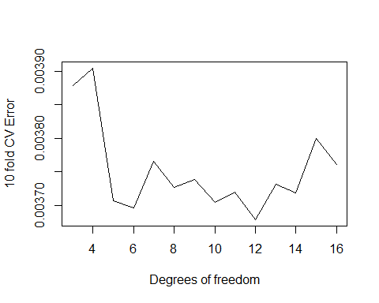

**minimum CV error is achieved at degrees od fredom12**

**Problem 5:**

This question relates to the College data set.

* 1. Split the data into a training set and a test set. Using out-of-state tuition as the response and the other variables as the predictors, perform forward stepwise selection on the training set in order to identify a satisfactory model that uses just a subset of the predictors.

library(ISLR)

## Warning: package 'ISLR' was built under R version 3.2.5

library(leaps)

## Warning: package 'leaps' was built under R version 3.2.5

library(gam)

## Warning: package 'gam' was built under R version 3.2.5

## Loading required package: splines

## Loading required package: foreach

## Loaded gam 1.14

data("College")  
attach(College)  
train <- sample(length(Outstate), length(Outstate) / 2)  
test <- -train  
College_train <- College[train, ]  
College_test <- College[test, ]  
fit <- regsubsets(Outstate ~ ., data = College_train, nvmax = 17, method = "forward")  
fit.summary <- summary(fit)  
par(mfrow = c(1, 3))  
plot(fit.summary$cp, xlab = "Number of variables", ylab = "Cp", type = "l")  
min_cp <- min(fit.summary$cp)  
std_cp <- sd(fit.summary$cp)  
abline(h = min_cp + 0.2 * std_cp, col = "red", lty = 2)  
abline(h = min_cp - 0.2 * std_cp, col = "red", lty = 2)  
plot(fit.summary$bic, xlab = "Number of variables", ylab = "BIC", type='l')  
min_bic <- min(fit.summary$bic)  
std_bic <- sd(fit.summary$bic)  
abline(h = min_bic + 0.2 * std_bic, col = "red", lty = 2)  
abline(h = min_bic - 0.2 * std_bic, col = "red", lty = 2)  
plot(fit.summary$adjr2, xlab = "Number of variables", ylab = "Adjusted R2", type = "l", ylim = c(0.4, 0.84))  
max_adjR2 <- max(fit.summary$adjr2)  
std_adjR2 <- sd(fit.summary$adjr2)  
abline(h = max_adjR2 + 0.2 * std_adjR2, col = "red", lty = 2)  
abline(h = max_adjR2 - 0.2 * std_adjR2, col = "red", lty = 2)

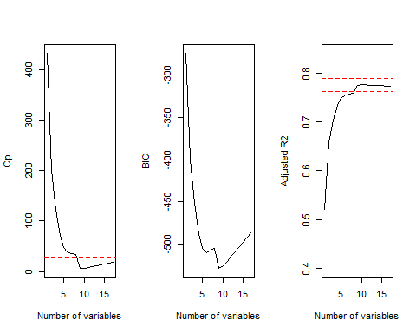

**Cp, BIC and AdjR2 show that size 8 is the minimum size for the subset for which the scores are within 0.2 standard deviations of optimum.**

fit <- regsubsets(Outstate ~ ., data = College, method = "forward")  
coeffs <- coef(fit, id = 6)  
names(coeffs)

## [1] "(Intercept)" "PrivateYes" "Room.Board" "PhD" "perc.alumni"  
## [6] "Expend" "Grad.Rate"

1. Fit a GAM on the training data, using out-of-state tuition as the response and the features selected in the previous step as the predictors. Plot the results, and explain your findings.

fit <- gam(Outstate ~ Private + s(Room.Board, df = 2) + s(PhD, df = 2) + s(perc.alumni, df = 2) + s(Expend, df = 5) + s(Grad.Rate, df = 2), data=College_train)  
par(mfrow = c(2, 3))  
plot(fit, se = T, col = "blue")

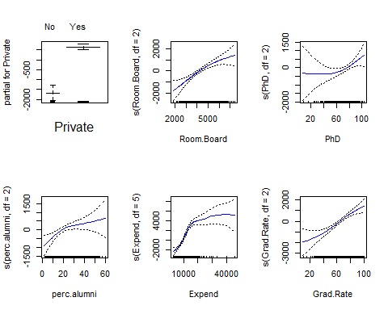

1. Evaluate the model obtained on the test set, and explain the results obtained.

preds <- predict(fit, College_test)  
err <- mean((College_test$Outstate - preds)^2)  
err

## [1] 3706367

tss <- mean((College_test$Outstate - mean(College_test$Outstate))^2)  
rss <- 1 - err / tss  
rss

## [1] 0.7764983

**We obtain a test R2 of 0.77 using GAM with 6 predictors.**

summary(fit)

##   
## Call: gam(formula = Outstate ~ Private + s(Room.Board, df = 2) + s(PhD,   
## df = 2) + s(perc.alumni, df = 2) + s(Expend, df = 5) + s(Grad.Rate,   
## df = 2), data = College_train)  
## Deviance Residuals:  
## Min 1Q Median 3Q Max   
## -7457.88 -1066.58 10.69 1205.80 4269.38   
##   
## (Dispersion Parameter for gaussian family taken to be 3322454)  
##   
## Null Deviance: 6102207011 on 387 degrees of freedom  
## Residual Deviance: 1239276076 on 373.0002 degrees of freedom  
## AIC: 6944.09   
##   
## Number of Local Scoring Iterations: 2   
##   
## Anova for Parametric Effects  
## Df Sum Sq Mean Sq F value Pr(>F)   
## Private 1 1650304201 1650304201 496.712 < 2.2e-16 ***  
## s(Room.Board, df = 2) 1 1241956325 1241956325 373.807 < 2.2e-16 ***  
## s(PhD, df = 2) 1 439487340 439487340 132.278 < 2.2e-16 ***  
## s(perc.alumni, df = 2) 1 220881872 220881872 66.481 5.431e-15 ***  
## s(Expend, df = 5) 1 617867577 617867577 185.967 < 2.2e-16 ***  
## s(Grad.Rate, df = 2) 1 145332274 145332274 43.742 1.301e-10 ***  
## Residuals 373 1239276076 3322454   
## ---  
## Signif. codes: 0 '***' 0.001 '**' 0.01 '*' 0.05 '.' 0.1 ' ' 1  
##   
## Anova for Nonparametric Effects  
## Npar Df Npar F Pr(F)   
## (Intercept)   
## Private   
## s(Room.Board, df = 2) 1 2.6037 0.10745   
## s(PhD, df = 2) 1 2.6635 0.10352   
## s(perc.alumni, df = 2) 1 4.7013 0.03077 *   
## s(Expend, df = 5) 4 15.5625 8.735e-12 ***  
## s(Grad.Rate, df = 2) 1 3.1876 0.07501 .   
## ---  
## Signif. codes: 0 '***' 0.001 '**' 0.01 '*' 0.05 '.' 0.1 ' ' 1

**By Looking at the p values: We can say there is a**

* **Strong of non-linear relationship between "Outstate" and "Expend"",**
* **Moderately strong non-linear relationship between “Outstate" and "Grad.Rate"" or "PhD".**

**Problem 6**

In Section 7.7, it was mentioned that GAMs are generally fit using a *back fitting* approach. The idea behind back fitting is actually quite simple. We will now explore back fitting in the context of multiple linear regression. Suppose that we would like to perform multiple linear regression, but we do not have software to do so. Instead, we only have software to perform simple linear regression. Therefore, we take the following iterative approach: we repeatedly hold all but one coefficient estimate fixed at its current value, and update only that coefficient estimate using a simple linear regression. The process is continued until *convergence*—that is, until the coefficient estimates stop changing. We now try this out on a toy example.

**Part (a) Generate a response Y and two predictors X1 and X2, with n = 100.**

N = 100  
X1 = rnorm(N)  
X2 = rnorm(N)  
e = rnorm(100, sd = 1)  
Y = 1 + 2*X1 + 3*X2

**Part (b)(c)**

b1 <-12  
a <- Y - b1*X1  
b2 <- lm(a ~ X2)$coef[2]

a<-Y - b2*X2  
b1 <- lm(a ~ X1)$coef[2]

**part (d)(e) Accumulate results of 1000 iterations in the beta arrays.**

b0 <-rep(NA, 1000)  
for (i in 1:1000) {  
 a = Y - b1[i] * X1  
 b2[i] = lm(a ~ X2)$coef[2]  
 a = Y - b2[i] * X2  
 lm_fit = lm(a ~ X1)  
 if (i < 1000) {  
 b1[i + 1] = lm_fit$coef[2]  
 }  
 b0[i] = lm_fit$coef[1]  
}  
plot(1:1000, b0, type = "l", xlab = "iteration", ylab = "betas", ylim = c(-5,   
 5), col = "gold")  
lines(1:1000, b1, col = "red")  
lines(1:1000, b2, col = "blue")  
legend("center", c("beta0", "b1", "b2"), lty = 1, col = c("gold", "red",   
 "blue"))

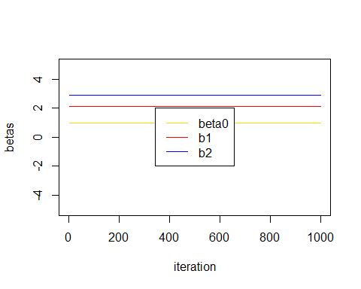

**The coefficients quickly attain their least square values.**

**part (f)**

lm_fit = lm(Y ~ X1 + X2)  
plot (1:1000, b0, lwd = 5, type = 'l', xlab = 'Iteration #i', ylab = 'Beta values', ylim = c(-5, 5), col = 'blue')  
lines(1:1000, b1, lwd = 5, col = 'red')  
lines(1:1000, b2, lwd = 5, col = 'gold')  
abline(h = lm_fit$coef[1], lty = 'dotted', lwd = 2, col = rgb(0, 0, 0, alpha = 0.5))  
abline(h = lm_fit$coef[2], lty = 'dotted', lwd = 2, col = rgb(0, 0, 0, alpha = 0.5))  
abline(h = lm_fit$coef[3], lty = 'dotted', lwd = 2, col = rgb(0, 0, 0, alpha = 0.5))  
legend('bottom', c('b0', 'b1', 'b2', 'Multiple regression'), lty = c(1, 1, 1, 2), col = c('blue', 'red', 'gold', 'dark blue'))

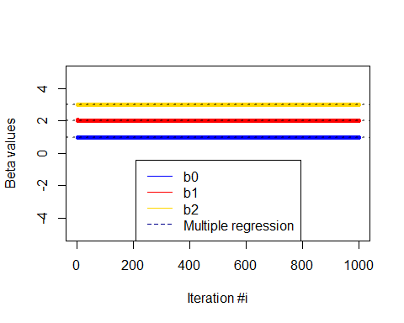

**Overlap of Dotted lines with solid line indicates that estimated multiple regression coefficients match exactly with the coefficients obtained using back fitting.**