HW6p6

Sagar Ganapaneni

November 15, 2016

Generate a response Y and two predictors X1 and X2, with n = 100.

set.seed(12)  
N = 100  
X1 = rnorm(N)  
X2 = rnorm(N)  
e = rnorm(100, sd = 1)  
Y = 1 + 2*X1 + 3*X2 +e

1. Initialize ??1 to take on a value of your choice. It does not matter what value you choose.
2. Keeping ??1 fixed, fit the model

b1 <-12  
a <- Y - b1*X1  
b2 <- lm(a ~ X2)$coef[2]

a<- Y - b2*X2  
b1 <- lm(a ~ X1)$coef[2]

(c)(d)(e) Accumulate results of 1000 iterations in the beta arrays.

b0 <-rep(NA, 1000)  
for (i in 1:1000) {  
 a = Y - b1[i] * X1  
 b2[i] = lm(a ~ X2)$coef[2]  
 a = Y - b2[i] * X2  
 lm_fit = lm(a ~ X1)  
 if (i < 1000) {  
 b1[i + 1] = lm_fit$coef[2]  
 }  
 b0[i] = lm_fit$coef[1]  
}  
plot(1:1000, b0, type = "l", xlab = "iteration", ylab = "betas", ylim = c(-5,   
 5), col = "gold")  
lines(1:1000, b1, col = "red")  
lines(1:1000, b2, col = "blue")  
legend("center", c("beta0", "b1", "b2"), lty = 1, col = c("gold", "red",   
 "blue"))

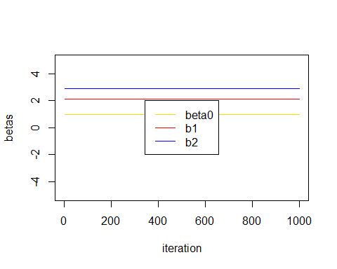  
(f)

lm_fit = lm(Y ~ X1 + X2)  
plot (1:1000, b0, lwd = 5, type = 'l', xlab = 'Iteration #i', ylab = 'Beta values', ylim = c(-5, 5), col = 'blue')  
lines(1:1000, b1, lwd = 5, col = 'red')  
lines(1:1000, b2, lwd = 5, col = 'gold')  
abline(h = lm_fit$coef[1], lty = 'dotted', lwd = 2, col = rgb(0, 0, 0, alpha = 0.5))  
abline(h = lm_fit$coef[2], lty = 'dotted', lwd = 2, col = rgb(0, 0, 0, alpha = 0.5))  
abline(h = lm_fit$coef[3], lty = 'dotted', lwd = 2, col = rgb(0, 0, 0, alpha = 0.5))  
legend('bottom', c('b0', 'b1', 'b2', 'Multiple regression'), lty = c(1, 1, 1, 2), col = c('blue', 'red', 'gold', 'dark blue'))

  
