Practical-3

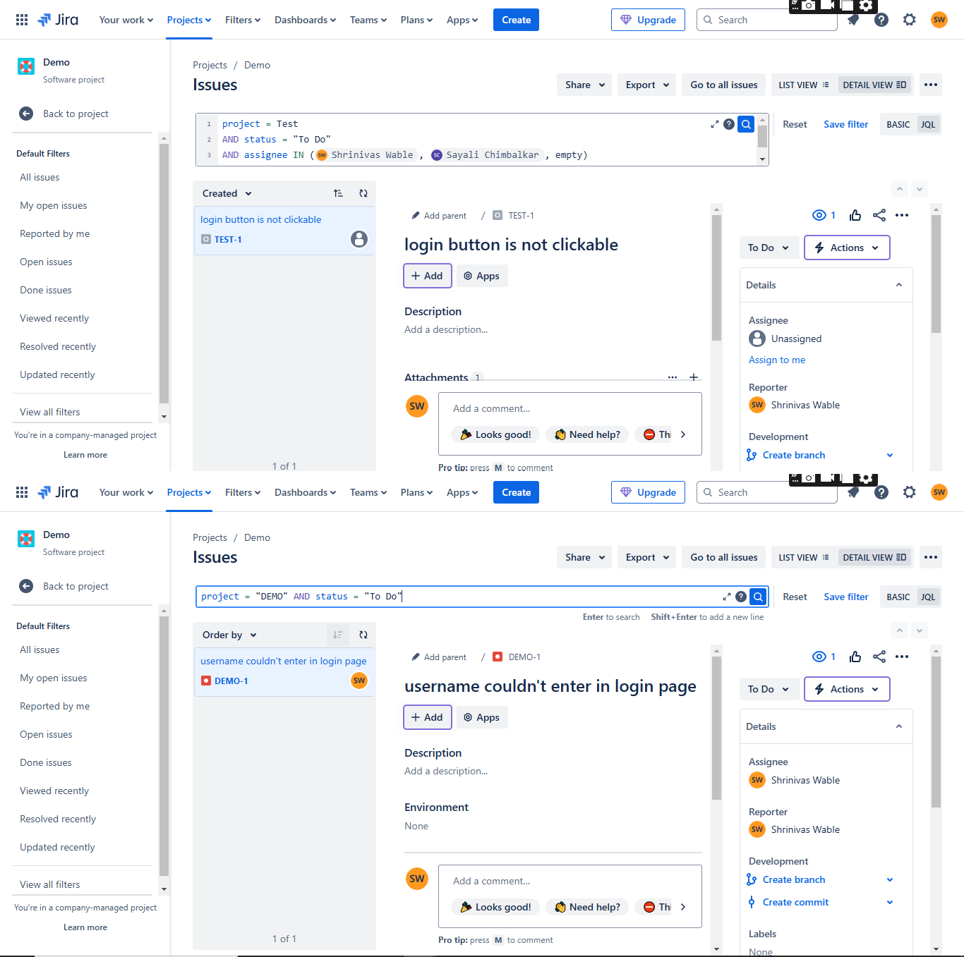

■■■ ., Jira Yourworkv Projectsv Filtersv Dashboardsv Teamsv Plansv Appsv - I Upgrade ] [ Q Search ] ***1f* G 0**

Projects / Demo

Issues Share v Export v Go to all issues LISTVIEW ,;; DETAILVIM!□

(status. - To OoN AND project - Demo) AND assignee HJ (empty, currentUser())

. **Gm** Res.et Save filter BASIC JQL

� �

Order by v

us.ername couldn't enter in login page

D DEMO-t

, Add p.-.reril / **a** DEM0-1

# username couldn't enter in login page

I +Add I ® Apps

## Description

Add a description...



To Do v ,f, Actions v I

Details

Assignee

S.hrinivas Wable

Environment

None

Reporter

Shrinivas Wable

Development



Add a comment..

!!,t, Looks good! C Need help? **0** This is blocked... o_. t >

I, Create branch Create commit

1. of 1 Pro tip; f>l"e"iS M lo cornm ril Labels



■■■ ., Jira Yourworkv Projectsv Filtersv Dashboardsv Teamsv Plansv Appsv -

Projects / Demo

Issues Share v Export v Go to all issues LIST VIEW ,:, DETAIL VIEW □

(status = "To DoN AND project = Demq)

1. AND assignee IN ( shrinivas Wable , e11pty)

. **mG**

Reset Save filter BASIC JQL

Order by v

us.emame couldn't enter in login page

DDEM0-1

, Add parent / D DEM0-1

# username couldn't enter in login page

®Apps

## Description

Add a description...

Enler lo s llrch Shiff+Ent lo lldd a w Ii



To Do v ,f, Actions v I

Details

A ignee

Shrinivas Wable

Environment None

Reporter

Shrinivas Wable

w

Development

I, Create branch

Create commit

Add a comment...

!!,t, Looks good! C Need help? **0** This is blocked... o_. 1 >

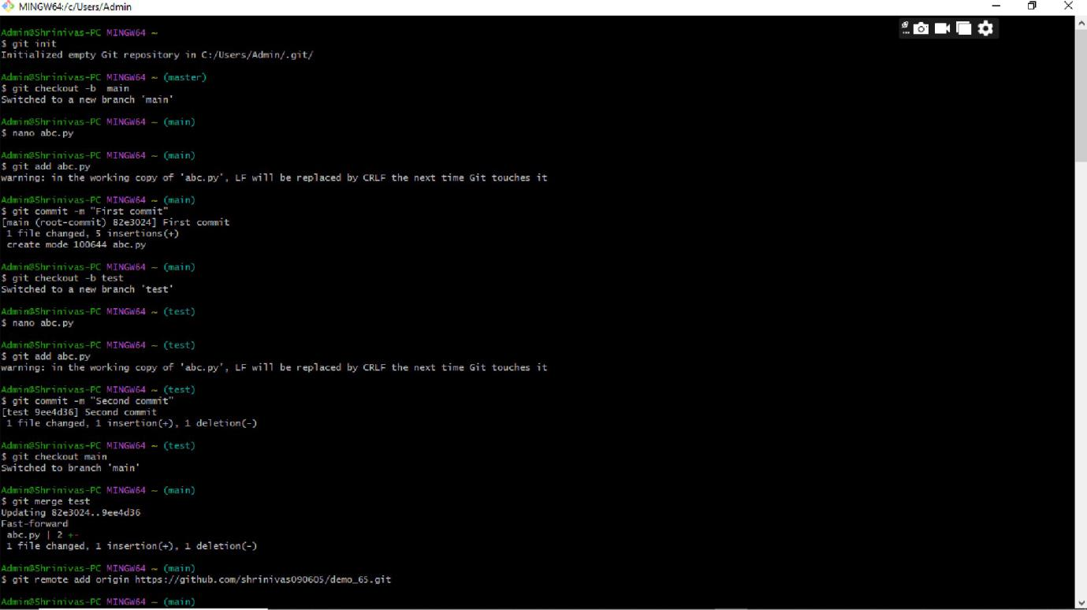

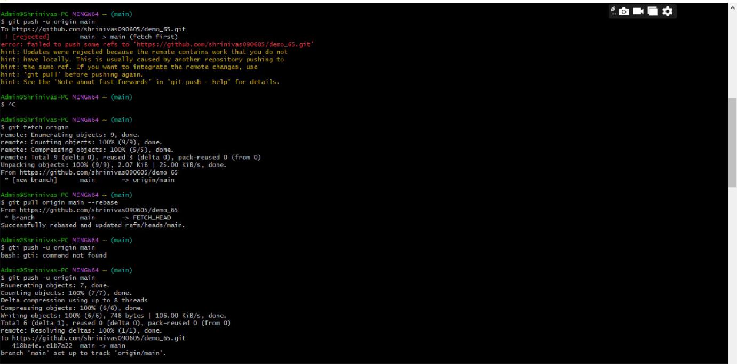

MINGW64Jc/Usen/Admin

"

X