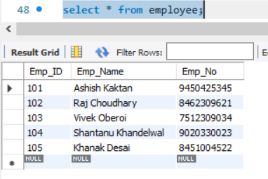 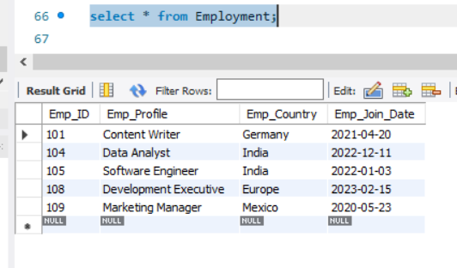

 Join these two tables together using a SELECT statement,

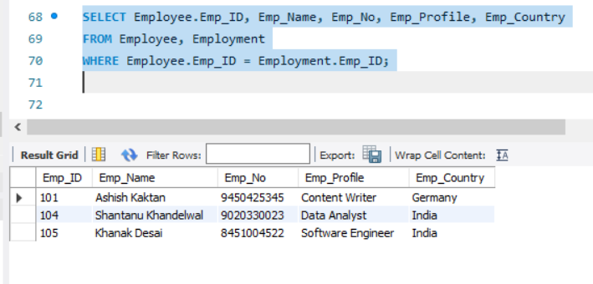

 INNER JOIN on these two tables using a SELECT statement

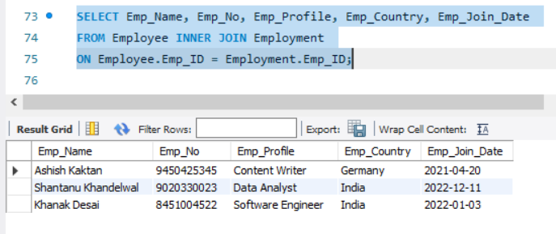

LEFT JOIN on these two tables using a SELECT statement

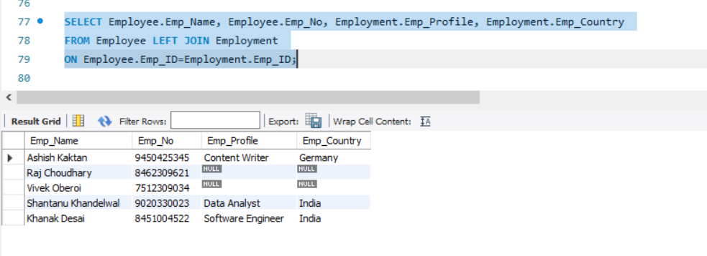

LEFT JOIN on these two tables using a SELECT statement

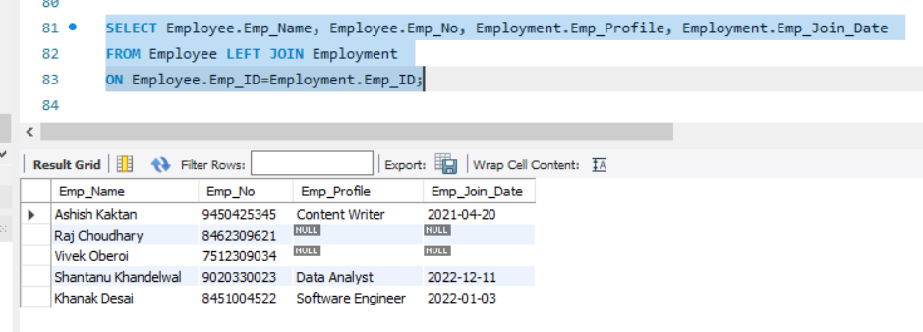

RIGHT JOIN on these two tables using a SELECT statement

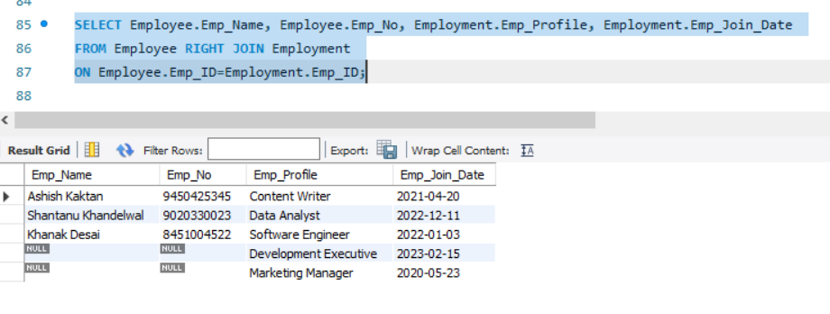

3rd Table

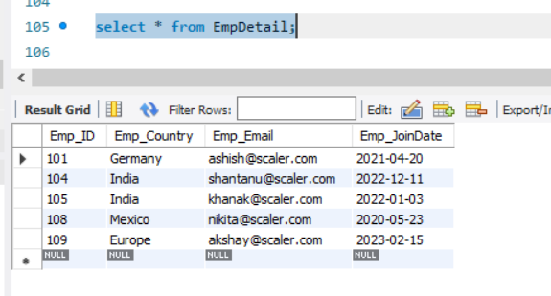

**SQL query to join three tables**

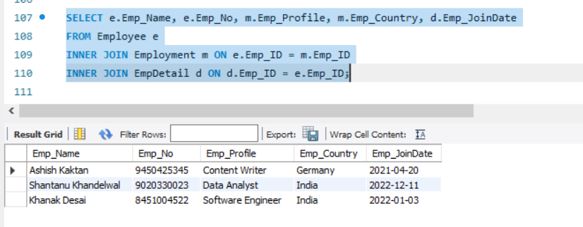

### How should data be structured to support Join Operations in a many-to-many relationship?

### natural join

### 

### Equi Join

### 

### Non-Equi Join

### 

### Cross Join

### 

**Q2) Create Student table with the fields (rollno,sname,saddress,gender) apply all possible constraints on Student table**

