Stephanie Peguero
Professor James Thorn
Computer Architecture
Assignment 3
25 May 2025

Part 1: Understanding Memory Hierarchy

1.1 Introduction: The Significance of Memory Hierarchy Design
The memory hierarchy is an important element of modern computer architecture. Its design is paramount in achieving high-performance computing because processors operate at speeds far exceeding those of main memory. The core principle behind memory hierarchy design is to exploit the phenomenon of locality of reference (Hennessy & Patterson, 2017, p. 85), which has two main types:
- Temporal Locality: If a memory location is referenced, it will likely be referenced again soon (Hennessy & Patterson, 2017, p. 85). Caches are designed to keep recently accessed data closer to the processor.
- Spatial Locality: If a memory location is referenced, locations with nearby addresses are likely to be referenced soon (Hennessy & Patterson, 2017, p. 85). Caches fetch data in blocks (cache lines) to bring in adjacent data along with the requested item.
By organizing memory into multiple levels, each level smaller, faster, and more expensive per bit than the next lower level (Hennessy & Patterson, 2017, p. 86) A well-designed hierarchy can provide the illusion of a very large, very fast memory system at a reasonable cost. The significance lies in its ability to:
- Reduce Average Memory Access Time (AMAT): By satisfying most memory requests from faster upper levels (caches), the effective time to access data is significantly reduced (Hennessy & Patterson, 2017, p. 91).
- Enable Larger Problem Sizes: Virtual memory, a key component of the hierarchy, allows programs to operate as if they have access to a much larger memory space than physically available (Hennessy & Patterson, 2017, p. 114).
- Improve System Throughput: Faster data access allows the CPU to execute more instructions per unit of time, leading to better overall system performance and responsiveness.

1.2 Memory Technologies
The memory hierarchy is constructed using various technologies, each with distinct speed, cost, density, and power consumption characteristics. Understanding these technologies is crucial for their effective placement and utilization within the hierarchy.
- Static RAM (SRAM):
  - Characteristics: Very fast access times (nanoseconds or less), high cost per bit, lower density, and higher power consumption when active compared to DRAM. SRAM cells use flip-flops (typically six transistors) to store each bit and do not require refreshing (Hennessy & Patterson, 2017, p. 93).
  - Placement: Primarily used for CPU registers and cache memories (L1, L2, and often L3) due to its speed, which is necessary to keep pace with the processor (Hennessy & Patterson, 2017, p. 93).
  - Impact: Enables low-latency access for frequently used data and instructions, significantly boosting CPU performance.

- Dynamic RAM (DRAM):
  - Characteristics: Slower access times than SRAM (tens of nanoseconds), lower cost per bit, higher density (allowing for larger capacities), and lower active power consumption per bit. DRAM cells use a transistor and a capacitor to store each bit and require periodic refreshing to maintain data integrity (Hennessy & Patterson, 2017, p. 94).
  - Placement: Used for the main memory (system RAM) (Hennessy & Patterson, 2017, p. 93).
  - Impact: Provides a large, relatively inexpensive pool of memory for active programs and data. The speed gap between DRAM and CPUs is a primary driver for complex cache hierarchies. Various types of DRAM (e.g., SDRAM, DDR, DDR5, LPDDR) offer different bandwidth and power characteristics (Hennessy & Patterson, 2017, pp. 95-97).

- Flash Memory (NAND/NOR):
  - Characteristics: Non-volatile (retains data without power) (Hennessy & Patterson, 2017, p. 98), slower than DRAM but faster than magnetic disks, moderate cost. NAND flash is standard for Solid State Drives (SSDs) due to its higher density and lower cost per bit compared to NOR flash (Hennessy & Patterson, 2017, p. 98). NOR flash offers faster read speeds and is sometimes used for firmware storage.
  - Placement: Used in SSDs (as a replacement or supplement to hard disk drives), USB drives, memory cards, and increasingly as a persistent storage tier (Hennessy & Patterson, 2017, pp. 85-86, 98).
  - Impact: SSDs significantly improve boot times, application loading times, and overall system responsiveness compared to traditional hard drives.

- Magnetic Hard Disk Drives (HDDs):
  - Characteristics: Non-volatile, slowest access times (milliseconds) due to mechanical components (spinning platters and moving read/write heads), lowest cost per bit, highest capacity (Hennessy & Patterson, 2017, p. 86).
  - Placement: Traditionally used for secondary storage (long-term storage of operating systems, applications, and user data). Increasingly being supplemented or replaced by SSDs in many systems.
  - Impact: Provides vast, inexpensive storage but can be a major performance bottleneck if frequently accessed for active data.

1.3 Advanced Cache Optimization Techniques
- Prefetching (Hardware and Compiler-Controlled):
  - Concept: Bringing data into the cache before it is explicitly requested by the processor (Hennessy & Patterson, 2017, p. 107).
  - Hardware Prefetching: The hardware monitors memory access patterns (e.g., sequential accesses) and proactively fetches subsequent blocks. For instance, on a miss to block B, the hardware might also fetch block B+1 (Hennessy & Patterson, 2017, p. 107). This is effective for regular, strided access patterns common in scientific and multimedia applications.
  - Compiler-Controlled Prefetching (Software Prefetching): The compiler analyzes the code and inserts special prefetch instructions to bring data into the cache before its use (Hennessy & Patterson, 2017, p. 108). This allows for more sophisticated prefetching based on program structure (e.g., pointer-chasing) that might be difficult for hardware to detect.
  - Impact: Reduces compulsory and capacity misses by ensuring data is already in the cache when needed. However, aggressive prefetching can also lead to cache pollution (evicting useful data for prefetched data that is not used) or increased memory bandwidth consumption (Hennessy & Patterson, 2017, p. 108).
- Victim Caches:
  - Concept: A small, typically fully-associative cache that stores blocks recently evicted from a main cache (e.g., L1 cache) due to conflict or capacity misses. While not extensively detailed in the main chapter sections discussed, the concept of victim caches is further elaborated in sources such as Hennessy & Patterson (2017, Appendix B).
  - Operation: When a block is evicted from the L1 cache, it is placed in the victim cache. If the processor then tries to access that same block shortly after, it can be retrieved quickly from the victim cache instead of incurring a full L2 cache access or main memory access. (General concepts related to reducing conflict misses through associativity are discussed in Hennessy & Patterson, 2017, Section 2.3, e.g., p. 100).
  - Impact: Primarily reduces the penalty of conflict misses in caches with lower associativity. It effectively increases the associativity for frequently contended cache sets at a lower hardware cost than directly increasing the main cache's associativity.

1.4 Virtual Memory and Virtual Machines
- Virtual Memory (VM):
Virtual memory is a memory management capability of an operating system (OS) that uses hardware and software to allow a computer to compensate for physical memory shortages by temporarily transferring data from random access memory (RAM) to disk storage (Hennessy & Patterson, 2017, p. 114). This creates the illusion for each process that it has access to a large, contiguous address space even if the available physical memory (RAM) is smaller or fragmented. Key concepts include:
  - Address Translation (Mapping): The CPU generates virtual addresses, which are translated by the Memory Management Unit (MMU) into physical addresses (Hennessy & Patterson, 2017, p. 114). Typically done using page tables.
  - Paging: Virtual and physical memory are divided into fixed-size blocks called pages (e.g., 4KB) (Hennessy & Patterson, 2017, p. 114). Page tables store the mapping between virtual pages and physical page frames.
  - Page Faults: If a process accesses a virtual page that is not currently in physical memory, a page fault occurs (Hennessy & Patterson, 2017, p. 114). The OS handles this by loading the required page from the disk.
  - Page Replacement Algorithms: When memory is full, algorithms like Least Recently Used (LRU) select a page to evict (Hennessy & Patterson, 2017, p. B-31, referred to by section 2.4).
  - Translation Lookaside Buffer (TLB): A specialized cache in the MMU storing recent virtual-to-physical address translations (page table entries) to speed up address translation (Hennessy & Patterson, 2017, p. 115). A TLB miss requires accessing the page table in memory.
Virtual memory is significant for efficient memory management, multiprogramming support, memory protection, and simplified programming (Hennessy & Patterson, 2017, pp. 114-115).
- Virtual Machines (VMs):
A virtual machine is a software emulation of a physical computer, allowing one host machine to run multiple guest operating systems (Hennessy & Patterson, 2017, p. 117).
  - Memory Hierarchy Relationship: VMs introduce complexities like two levels of address translation (Guest Virtual Address to Guest Physical Address, then Guest Physical Address to Host Physical Address) managed by the guest OS and the hypervisor (VMM) (Hennessy & Patterson, 2017, p. 119). The hypervisor manages host physical memory allocation and GPA-to-HPA mappings, often using shadow page tables or hardware assistance (e.g., Intel EPT, AMD NPT). This increases TLB pressure, addressed by hardware extensions like tagged TLB entries (Hennessy & Patterson, 2017, p. 120). Cache contention and I/O virtualization are also important considerations.
Both virtual memory and virtual machines add layers of abstraction that, while powerful, introduce overheads mitigated by the memory hierarchy (caches, TLBs).

1.5 Cross-Cutting Issues in Memory Hierarchy Design
- Performance vs. Cost: Faster technologies like SRAM are more expensive per bit than DRAM or Flash. Larger caches improve hit rates but increase cost. A balance involves using small, fast caches for upper levels and larger, cheaper memory for lower levels.
- Performance vs. Power Consumption: Larger, more associative caches can improve performance but consume more static and dynamic power (Hennessy & Patterson, 2017, p. 101). This is critical for mobile devices. Techniques include clock gating, low-power memory states, and energy-efficient parameter choices.
- Complexity of Design and Verification: Advanced optimizations increase design complexity and verification effort (Hennessy & Patterson, 2017, p. 113).
- Impact of Workloads: Optimal hierarchy parameters vary with workload access patterns. Designs often aim for balance or are tailored in Domain-Specific Architectures (DSAs).
- Cache Coherence in Multiprocessor Systems: Multiple processors with private caches require coherence protocols (e.g., snooping, directory-based) to maintain a consistent view of shared memory, adding complexity and potential overhead (Hennessy & Patterson, 2017, p. 121, Chapter 5).
- Scalability: Increasing core counts strain shared memory levels and coherence mechanisms, requiring scalable designs like multiple memory channels and Networks-on-Chip (NoCs).
- Security Considerations: Caches can be vulnerable to side-channel attacks (Branco & Lee, 2022), necessitating hardware and software countermeasures.
- Replacement Policies: The choice of policy (e.g., LRU) affects miss rates. True LRU is complex, so approximations are common (Hennessy & Patterson, 2017, p. B-11, referenced by chapter).

Part 2: gem5 Experiments
This section details the practical application of memory hierarchy design principles using the gem5 simulator. The first subsection focuses on cache subsystem experiments conducted in Syscall Emulation (SE) mode, while the second subsection outlines the setup for Full System (FS) mode simulations aimed at virtual memory exploration.

2.1 Cache Configuration Experiments (Syscall Emulation Mode)
The objective of this phase was to systematically investigate the impact of fundamental cache memory parameters on system performance using gem5 in Syscall Emulation (SE) mode. SE mode was chosen for its faster simulation speeds compared to Full System (FS) mode, making it suitable for these targeted studies of CPU and cache performance without the overhead of full OS modeling. The Python script used for these SE mode experiments was named mem_1.py.

2.1.1 Experimental Setup and Methodology
- Simulator: gem5 version 24.1.0.3.
- Host System: Simulations were conducted within a Docker container on an x86-64 (amd64) host system.
- Simulation Mode: Syscall Emulation (SE) mode.
- Board: SimpleBoard from the gem5 standard library. The SimpleBoard is suitable for SE mode and allows easy connection of processor, memory, and cache components.
- Processor: A SimpleProcessor configured to use a TimingSimpleCPU (CPUTypes.TIMING) with a single core (num_cores=1) and the X86 ISA. TimingSimpleCPU models instruction timing and memory accesses but not complex out-of-order execution.
- Memory System: SingleChannelDDR3_1600 with a size of "2GiB" was used for SE mode experiments.
- Cache Hierarchy (Baseline and Variations): The PrivateL1SharedL2CacheHierarchy from gem5.components.cachehierarchies.classic.private_l1_shared_l2_cache_hierarchy was used.
- Workload: The x86-npb-lu-size-s benchmark (NAS Parallel Benchmark LU, Class S, compiled for X86) was used for all SE mode cache experiments. It was obtained using obtain_resource("x86-npb-lu-size-s") and executed using board.set_se_binary_workload().
- Methodology: Starting from a baseline configuration, individual cache parameters were systematically modified one at a time, keeping all other parameters at their baseline values. For each simulation run, statistics were dumped, and key metrics were extracted.

2.1.2 Baseline Configuration (SE Mode)
The baseline cache configuration was the gem5 default:
- L1 Data Cache (L1D): 32KiB size, 8-way set associativity.
- L1 Instruction Cache (L1I): 32KiB size, 8-way set associativity.
- L2 Cache (Shared): 256KiB size, 16-way set associativity.
- Cache Block Size (Cache Line Size): 64 bytes, set system-wide via board.cache_line_size = 64.

2.1.3 Experiments Conducted
The following experiments were conducted by varying parameters from the baseline:
- L1 Data Cache Size: Changed from 32KiB to 64KiB.
- L1 Data Cache Associativity: For the 32KiB L1D cache, changed from 8-way to 4-way.
- L2 Cache Size: Changed from 256KiB to 512KiB.
- L2 Cache Associativity: For the 256KiB L2 cache, changed from 16-way to 8-way.
- Cache Block Size: Changed from 64 bytes to 32 bytes.

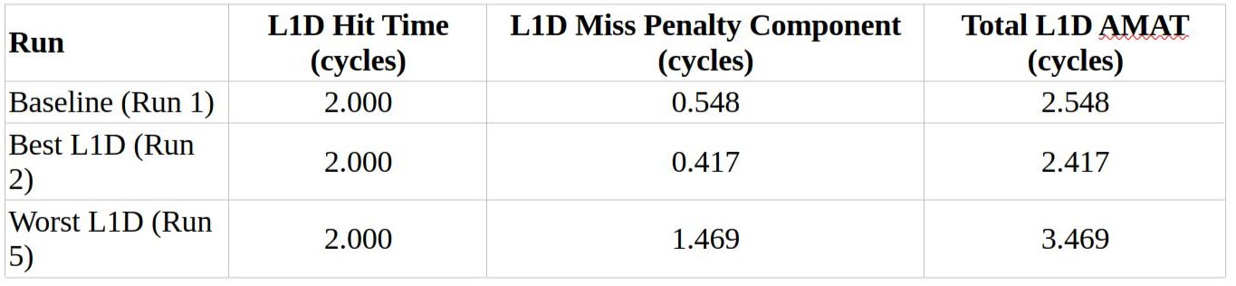

2.1.4 Key Metrics and AMAT Calculation
Key performance metrics extracted from stats.txt for each run included simSeconds (simulation wall-clock time), simInsts (simulated instructions), and for each cache level (L1I, L1D, L2): demand accesses, hits, misses, miss rates, and demandAvgMissLatency (in ticks).
Average Memory Access Time (AMAT) was calculated using the formula:

AMAT = \text{HitTime} + (\text{MissRate} \times \text{MissPenalty}_{\text{in_cycles}})

- Hit Times:
  - Hit Time (L1_HT): 2 CPU cycles.
  - Hit Time (L2_HT): 20 CPU cycles (representing a larger, slower SRAM structure).
- Miss Penalty (in CPU cycles): Calculated by dividing demandAvgMissLatency (reported in ticks by gem5) by the CPU clock period. For a 3GHz clock frequency, the clock period is approximately 333 ps (or 333 ticks if 1 tick = 1 ps, which is the default simFreq).

2.1.5 Troubleshooting Cache Block Size Configuration
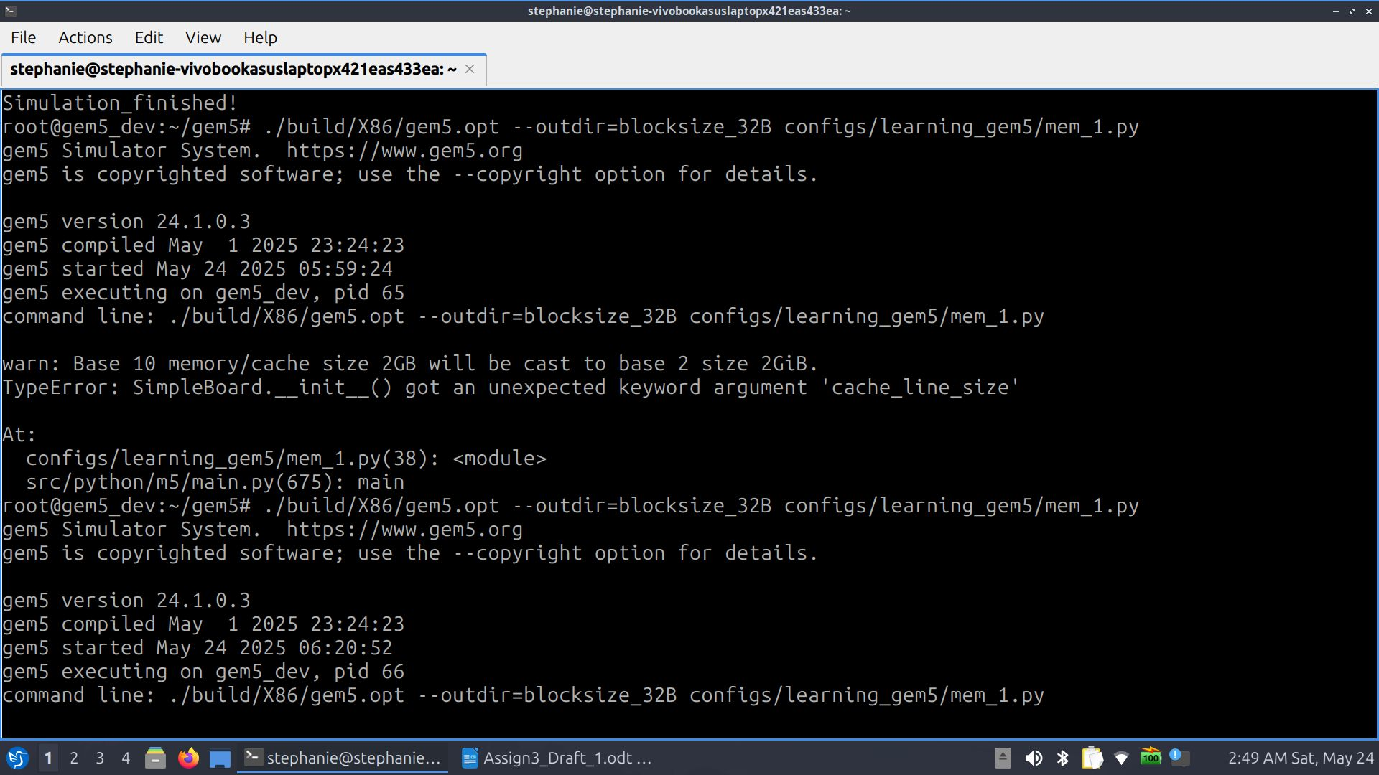

An initial challenge was correctly setting the system-wide cache block size for the experiments. For instance, in a comparable example found in configs/example/gpufs/system.py, the line system.cache_line_size = args.cacheline_size sets this attribute on a System object. In the gem5 standard library, SimpleBoard (which inherits from AbstractBoard) is itself a specialized System object. This means the board object created is the main system container. Given that passing cache_line_size to the SimpleBoard constructor resulted in a TypeError, and attempting board.system.cache_line_size led to an AttributeError, the correct method identified was to set the cache_line_size attribute directly on the board object after its instantiation.
The corrected action for the experiment changing cache block size to 32 bytes involved ensuring L1/L2 sizes and associativities were at their original baseline values in the PrivateL1SharedL2CacheHierarchy instantiation and setting board.cache_line_size = 32 directly on the instantiated SimpleBoard object. This approach aligns with the gem5 structure where SimpleBoard is a System, and cache_line_size is an attribute of System.

2.1.9 Overall Summary of Cache Experiment Findings
The SE mode experiments demonstrated that cache performance for the x86-npb-lu-size-s benchmark is highly sensitive to L1D size, L1D associativity, L2 size, and block size. Larger L1D and L2 caches reduced capacity misses. Adequate L1D associativity (8-way being better than 4-way for 32KiB L1D) was important for mitigating conflict misses. A 64-byte block size performed better than a 32-byte one, indicating good spatial locality in the workload, which larger blocks could exploit.

2.1.10 Relation to Advanced Cache Optimization Techniques
These experimental observations highlight scenarios where advanced cache optimization techniques, as discussed by Hennessy & Patterson (2017, Section 2.3), could be beneficial:
- Prefetching: The performance degradation with smaller 32B blocks (Run 5), despite a lower per-miss transfer time, suggests that the workload has significant spatial locality that was better captured by 64B blocks. If smaller blocks were mandated for other reasons, hardware prefetching (e.g., fetching block B+1 on a miss to B) or compiler-controlled prefetching could speculatively bring in adjacent blocks, thereby mitigating the higher miss count (Hennessy & Patterson, 2017, pp. 107-108).
- Victim Caches: The increased L1D miss rate when reducing associativity from 8-way to 4-way (Run 3) indicates a rise in conflict misses. A victim cache, a small fully-associative buffer storing recently evicted blocks, could potentially capture some of these conflicted blocks and reduce the penalty by providing a quick hit instead of an L2 access (a concept related to advanced cache optimizations, see Hennessy & Patterson, 2017, Section 2.3; victim caches are typically detailed in appendices like Appendix B).
- Way Prediction: If reduced L1D associativity were chosen to decrease hit time or power, way prediction could offer a compromise by attempting to achieve miss rates closer to higher associativity with the hit speed of lower associativity (Hennessy & Patterson, 2017, p. 100).
- Non-Blocking Caches: While the TimingSimpleCPU and its connected caches in the standard library components are typically non-blocking to some extent, the importance of this feature is amplified when miss rates are high. Non-blocking caches allow the CPU to continue with other work or service other cache hits while a miss is being resolved, reducing the effective miss penalty (Hennessy & Patterson, 2017, p. 102).

2.1.11 Power Considerations
While this study focused on performance metrics, cache design has significant power implications. Larger caches and higher associativity, while often reducing miss rates, generally consume more dynamic energy per access (more tags/data to check/select) and more static leakage power (larger area) (Hennessy & Patterson, 2017, p. 101). Modern systems, especially mobile and embedded ones, heavily prioritize energy efficiency (Muralidhar et al., 2022). Cache optimizations in such contexts involve a careful trade-off between performance gains and power consumption. The trend towards domain-specific architectures also involves tailoring memory hierarchies to optimize both performance and energy for specific workloads.

2.1.12 Conclusion of Cache Experiments
The systematic variation of cache parameters in gem5 demonstrated their profound impact on memory hierarchy performance for the x86-npb-lu-size-s benchmark. Key findings include:
- Larger L1D and L2 cache sizes generally improve performance by reducing capacity misses.
- Sufficient L1D associativity is crucial to mitigate conflict misses.
- Cache block size significantly affects performance based on the workload's spatial locality; for this benchmark, 64B blocks were superior to 32B blocks.
These experiments underscore the necessity of careful cache design tailored to workload characteristics and system constraints, and highlight scenarios where advanced optimization techniques can address specific performance bottlenecks.

2.2 Virtual Memory Exploration (FS Mode) - Setup, Challenges, and Theoretical Discussion
The exploration of virtual memory configurations, including Translation Lookaside Buffer (TLB) parameters and page sizes, was planned using gem5 in Full System (FS) mode. This mode allows for the detailed simulation of an entire operating system and its interaction with hardware, crucial for studying virtual memory phenomena. The strategy involved KVM acceleration for rapid OS booting, followed by checkpointing, and then restoring with a detailed CPU model (TimingSimpleCPU) and cache hierarchy (PrivateL1SharedL2CacheHierarchy) for in-depth analysis. The x86-ubuntu-24.04-npb-sp-s workload, which includes the NPB SP.S benchmark, was selected for these experiments.

2.2.1 Checkpoint Creation for FS Mode: Process and Troubleshooting
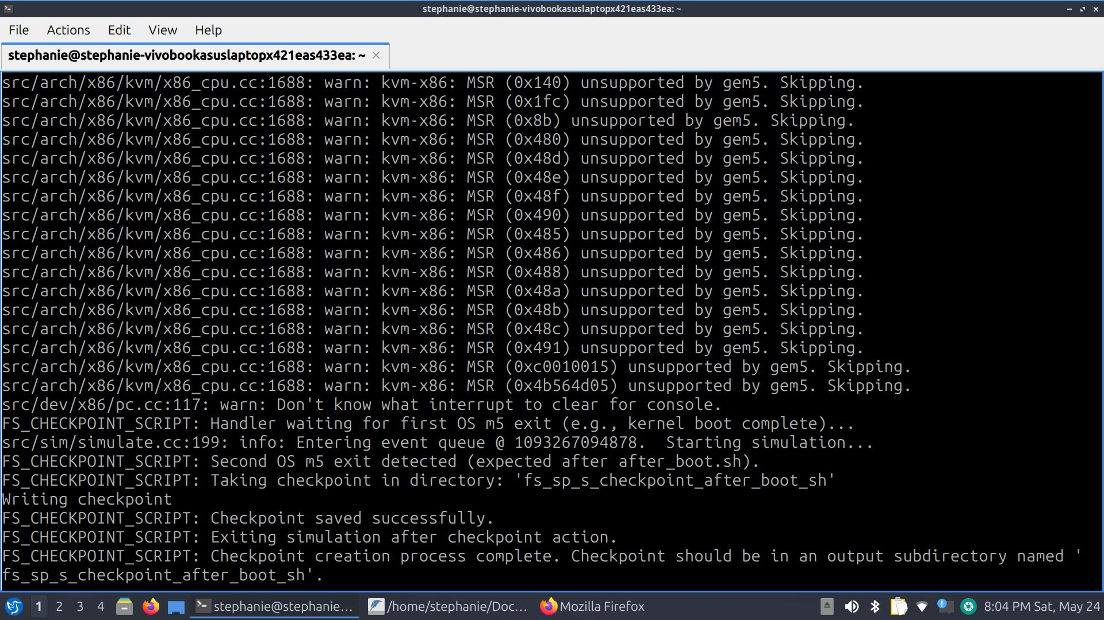

Creating a stable and correctly timed checkpoint in FS mode presented several challenges, primarily related to handling a sequence of exit events from the guest OS and the benchmark. The x86-ubuntu-24.04-npb-sp-s workload typically involves multiple m5 exit calls: one after the kernel boots, another after system initialization scripts (like after_boot.sh) run, and then m5_work_begin is issued by the benchmark itself to denote the Region of Interest (ROI).
Initial attempts to create checkpoints using a script (referred to as create_checkpoint_script.py) faced issues where the simulation would exit prematurely after the first OS-level m5 exit. This was due to the exit event handler not being set up to manage a sequence of events explicitly. Guidance for resolving this was drawn from gem5 documentation, examples such as x86-ubuntu-run-with-kvm-no-perf.py (which demonstrated handling sequential exits), the "Accelerating simulations" PDF (e.g., 03-take-a-checkpoint.py for general checkpointing logic), and simulator_exit_event_run.py (for multi-yield generator patterns).
The key solution involved using the expected_execution_order parameter in the Simulator setup, along with a multi-yield generator function for ExitEvent.EXIT. This allowed the script to correctly yield and continue after the first two OS ExitEvent.EXIT calls, and then trigger a specific checkpointing handler upon ExitEvent.WORKBEGIN from the NPB benchmark. This refined approach successfully created a checkpoint precisely at WORKBEGIN, with the OS booted and the benchmark ready to start its ROI, but still using the KVM CPU.
However, for reliable restoration with a detailed CPU model, gem5 community discussions (GitHub discussion https://github.com/orgs/gem5/discussions/1540) emphasized the necessity of switching to the detailed CPU before taking the checkpoint. This led to the development of a more robust script, kvm_switch_checkpoint.py. The strategy for this script was:
- Boot the system using SimpleSwitchableProcessor starting with CPUTypes.KVM and configured to switch to CPUTypes.TIMING. A NoCache configuration was used for the initial KVM boot phase to maximize speed.
- The script would handle the first two OS ExitEvent.EXIT events. Upon the second OS exit (indicating system stability, e.g., after after_boot.sh completed), the CPU would be switched from KVM to TimingSimpleCPU. Statistics were reset at this point.
- The simulation would continue, now running the OS and about to start the benchmark on TimingSimpleCPU.
- When the NPB SP.S benchmark executed its m5_work_begin instruction, the ExitEvent.WORKBEGIN handler would be triggered.
- Inside this WORKBEGIN handler, the checkpoint was saved. The simulation script then terminated.
This multi-stage process, leveraging KVM for boot, switching to TimingSimpleCPU, and then checkpointing at the benchmark's ROI start, aimed to provide a stable checkpoint suitable for detailed simulation.

2.2.2 Attempted Benchmark Execution and Outcome
A checkpoint created using the kvm_switch_checkpoint.py methodology (where TimingSimpleCPU was active during checkpointing) was used for the subsequent analysis phase with a script named restore_final.py. This script restored the system state and was configured to run the NPB SP.S benchmark with TimingSimpleCPU and the PrivateL1SharedL2CacheHierarchy (using baseline cache parameters: L1D/L1I 32KiB/8-way, L2 256KiB/16-way, 64B blocks).

Unfortunately, the restored simulation ran for over 15 real-time hours, consuming a significant amount of simulated ticks (approximately 17.24 trillion ticks, or 4.78 simulated hours), but the NPB SP.S benchmark did not complete. Analysis of the simulation statistics from this extended run revealed that the TimingSimpleCPU committed zero instructions throughout this period, indicating the guest OS/benchmark was stalled or in an idle state ineffective for benchmark progression. Consequently, it was not possible to collect the intended detailed performance statistics for various TLB configurations and page sizes.

2.2.3 Theoretical Discussion: Role of Virtual Memory and TLB Configurations
Despite the inability to gather quantitative experimental data for different virtual memory settings in FS mode, the theoretical importance of virtual memory and its associated hardware, like the TLB, remains central to understanding modern system performance.
Virtual memory is indispensable in modern OSes. It provides:
- Illusion of Large Memory Space: Each process operates within its own private virtual address space, which can be much larger than the physical RAM available. This simplifies programming and allows for the execution of large applications (Hennessy & Patterson, 2017, p. 114).
- Process Isolation and Protection: By giving each process its own address space, virtual memory prevents processes from interfering with each other or with the OS kernel, enhancing system stability and security (Hennessy & Patterson, 2017, pp. 114-115).
- Efficient Memory Utilization: Physical memory can be shared among processes (e.g., shared libraries), and pages are only loaded into RAM when needed (demand paging), improving overall memory utilization.
- Support for Multitasking: Enables many processes to be resident in memory simultaneously, facilitating efficient context switching and multitasking.
The Translation Lookaside Buffer (TLB) is a critical hardware cache for virtual-to-physical address translations (Hennessy & Patterson, 2017, p. 115). Its configuration significantly impacts performance:
- TLB Size: A larger TLB can hold more virtual-to-physical address translations, increasing the TLB hit rate. A TLB hit provides a fast translation, while a TLB miss requires accessing the page table in main memory (a "page walk"), which is much slower (Hennessy & Patterson, 2017, p. 115).
- TLB Associativity: Higher associativity in the TLB can reduce conflict misses, where multiple active translations map to the same TLB set.
- Page Size:
  - Larger Page Sizes (Huge Pages): Using larger pages (e.g., 2MB or 1GB instead of 4KB) means a single TLB entry can cover a larger region of memory. This can significantly reduce TLB pressure and increase the TLB reach (the total amount of memory addressable by TLB entries), leading to fewer TLB misses, especially for applications with large memory footprints and good spatial locality. However, larger pages can lead to increased internal fragmentation if only a small portion of a large page is used.
  - Smaller Page Sizes: Offer finer-grained memory management and less internal fragmentation but can lead to higher TLB miss rates as more translations are needed to cover the same memory region.
A high TLB miss rate directly increases the average memory access time due to frequent page walks. Page faults, where data is not in physical memory at all and must be fetched from disk, are far more expensive than TLB misses (Hennessy & Patterson, 2017, p. 114). While TLB configuration doesn't directly cause page faults, efficient TLB operation is integral to an efficient virtual memory system.

2.2.4 Reflection on FS Mode Challenges
The extensive troubleshooting and the eventual stall encountered during the FS mode restore run highlight the inherent complexities of full-system simulation. Factors such as the precise state of the guest OS at checkpoint, the interaction between the detailed CPU model and simulated devices, and potential subtleties in the KVM-to-detailed-CPU transition can significantly impact simulation behavior. While the planned quantitative analysis of virtual memory parameters was not achieved, the process underscored the critical need for robust checkpointing strategies and the detailed nature of performance analysis in complex simulated environments.

References
Branco, R., & Lee, B. (2022). Cache-related Hardware Capabilities and Their Impact on Information Security. ACM Computing Surveys, 55(6), Article 125.
https://doi.org/10.1145/3534962

gem5 Documentation and Tutorial Materials. (Specific PDFs and web pages as noted in setup sections).

Hennessy, J. L., & Patterson, D. A. (2017). Computer Architecture: A Quantitative Approach (6th ed.). Elsevier.

Muralidhar, R., Borovica-Gajic, R., & Buyya, R. (2022). Energy Efficient Computing Systems: Architectures, Abstractions and Modeling to Techniques and Standards. ACM Computing Surveys, 54(11s), Article 236.

