

**Tribhuvan University**

**Faculty of Humanities and Social Science**

A PROJECT REPORT

of

**ONLINE** **DENTAL CLINIC APPOINTMENT SYSTEM**

Submitted to

Department of Computer Application

Sagarmatha College for Higher Studies

Maitidevi Kathmandu.

*In partial fulfillment of the requirements for the Bachelors in Computer App*

Submitted by :

Name:Subash Panthi

BCA 4th Semester:

TU Registration No:

Symbol No:

Name:Sandip Budhathoki

BCA 4th Semester:

TU Registration No:

Symbol No:



**Tribhuvan University**

**Faculty of Humanities and Social Science**

**Sagarmath College for Higher Studies**

**Maitidevi, Kathmandu.**

## Bachelor in Computer Application (BCA)

# SUPERVISOR’S RECOMMENDATION

I hereby recommend that this project prepared under my supervision by **Sandip Budhthoki** and **Subash Panthi** entitled **“Dental Clinic Appointment System”** in the partial Fulfillment of requirement for the degree of Bachelor in Computer Application is recommended for that final evaluation.



**Tribhuvan University**

**Faculty of Humanities and Social Science**

**Sagarmath College for Higher Studies**

**Maitidevi, Kathmandu.**

LETTER OF APPROVAL

This is to certify that this project prepared by Subash Panthi and Sandip Budhathoki entitled “Dental Clinic Appointment System in partial fulfillment of the requirements for the degree of Bachelor in Computer Application has been evaluated. In our opinion it is satisfactory in the scope and quality as a project for the required degree.

**S**upervisor Coordinator

BCA Department

Internal Examiner External Examiner

**ABSTRACT**

The purpose of this project report is to present the design, development, and implementation of an Online Appointment System for [Dental Clinic Name]. In today's fast-paced world, leveraging technology to streamline processes and enhance user experiences has become essential. This project focuses on addressing the challenges faced by patients and staff in managing dental appointments efficiently.The Online Appointment System provides patients with the convenience of booking dental appointments through a user-friendly web interface. The system enables patients to view available time slots, select their preferred dentist, and schedule appointments based on their convenience. Moreover, the system offers flexibility for patients to reschedule or cancel appointments, thereby improving overall patient satisfaction.For the dental clinic staff, the system offers a centralized platform for managing appointments, reducing manual effort and minimizing scheduling conflicts. Dentists and administrative staff can access the system to review appointments, manage their schedules, and update patient records seamlessly.

**Keywords: HTML,CSS, desktop application, database.**

**ACKNOWLEDGEMENT**

We would like to express my special thanks of gratitude to our supervisor **Mr. Basanta Chapagain** who gave me the golden opportunity to do this wonderful project on the topic of Online Appointment System for Dental Clinic who also help me in doing a lot of research and I came to know about so many new tools and techniques.

I would like to express my special thanks of gratitude to our campus principal **……………...**Who gave me permission for doing this project.

I am highly indebted to Universal College for their guidance and constant supervision as well as for providing necessary information regarding the project and support in the completion.

I would like to thank our parents and friends who helped me a lot in finalizing this project within the limited time frame.

In the end, I would also like to thank Tribhuvan University for giving us this opportunity via this course of Computer Application to help us understand the project ethics at this early stage and helped us to evaluate my knowledge and expand it a little more.

**TABLE OF CONTENTS**

**SUPERVISOR’S RECOMMENDATION**

**LETTER OF APPROVAL**

**ABSTRACT……………………………………………………………………I**

**ACKNOWLEDGEMENT……………………………………………………II**

**Table of Contents……………………………………………………………..III**

**List of Figures………………………………………………………………...IV**

**List of Abbreviations………………………………………………………….V**

**Chapter 1: Introduction**

1.1 Introduction: 1

1.2 Problem of Statement: 2

1.3 Objectives: 2

1.4 Scopes and Limitation 2

1.5 Report Organizations 3

**Chapter 2: Background Study and Literature Review** 4

2.1. Background Study

2.2. Literature Review

**Chapter 3: System Analysis and Design** 6

3.1. System Analysis

3.1.1. Requirement Analysis

I. Functional Requirements (Illustrated using use case diagram/list)

ii. Non-Functional Requirements

3.1.2. Feasibility Analysis

I. Technical

ii. Operational

iii. Economic

iv. Schedule

3.1.3. Data Modelling (ER-Diagram)

3.1.4. Process Modelling (DFD)

3.2. System Design

3.2.1. Architectural Design

3.2.2. Database Schema Design

3.2.3. Interface Design

3.2.4. Physical DFD

**Chapter 4: Implementation and Testing**

4.1. Implementation

4.1.1. Tools Used (CASE tools, Programming languages, Database platforms)

4.1.2. Implementation Details of Modules (Description of procedures/functions)

4.2. Testing

4.2.1. Test Cases for Unit Testing

4.2.2. Test Cases for System Testing

**Chapter 5: Conclusion and Future Recommendations**

5.1. Lesson Learnt / Outcome

5.2. Conclusion

5.3. Future Recommendations

**List of Figures**

Figure 1: System Flowchart 5

Figure 2: Context Level Diagram 6

Figure 3: Data Flow Diagram 7

Figure 4: Login Page 8

Figure 5: Dashboard 9

Figure 6: Customer Details 9

Figure 7: ER Diagram 10

**Chapter: 1** **Introduction**

**1.1 Introduction**

Our very first project, "Internet Dental Clinic Appointment System," was created so that our patients could schedule appointments with doctors according to their availability. The primary goal of our project is to assist all patients in scheduling appointments while at home and for those who are unable to travel to the hospital only for appointments and avoid spending time in line. Today's world full of technology in different field they use technology for their business for example 'online movie ticket booking, bus ticket booking etc. There's so many field they using our technology for the good purpose. Exactly the online dental appointment system is going to provide the service to make easy for the patient. This system will not help only to patient it also help to manage their appointment efficiently.

This system will provide more features to the patient like time scheduling of doctors, available appointment date and time, show the services they are providing, how they will charge, confirm their appointment, reschedule the time and date, cancel appointment etc. The patient can use any of devices what they have computer or mobile.

**1.2 Problem Statement**

Wastage of time is the major problem in traditional appointment scheduling method. Those who are unable to physically visit the clinic only to make an appointment will not receive services in Nepal because there is always a line. There will be lot of time waste of patient and management doing physical appointment system. Patient will not able to know about right time to schedule an appointment hard to reschedule their appointment cannot cancel their appointment, hard to know about the charges according services patient have to do lot of struggle. Another side dental clinic management will face the problem like manage their appointment in efficient way. Data may can be lost and while storing in hardcopy. There will be high chance resulting missed appointment and late appointment cancellation etc.

To avoid these types of issues online dental appointment system will help in this case. The system will make easier to patient for their appointment. Along the clinic can manage their appointment schedule in efficient way.

**1.3 Objective**

There's so many objective of this system these are follows as:

1. Simplify for the patient to take an appointment with the doctors.

2. To use IT in medical section.

3. Decrease waiting time and provide convenience to patients in scheduling their appointments.

4. It can reduce the labor cost and required of manpower.

5. Patient can get information about their health online.

* 1. **Scope and Limitations**

**Scope:**

* Save lot of time, money and labor cost.
* Increase accessibility for the patient.
* Easy to manage the data.
* Provide high security.
* Effective communication between patient and doctors.
* Easy to update any data.

**Limitations**

* Technical Issues.
* Diagnostics Limitations.
* Digital Literacy and User Experience.
* Integration with new system.
* Appointment scheduling challenges.

**1.5 Report Organizations**

The system’s objectives have also been mentioned. The scope of this system and limitations till now has also been mentioned. Then there is a literature review and also the requirement analysis done. Further, feasibility study is covered under requirement analysis and also functional and nonfunctional requirements. I have also presented some diagrams to describe the system more vastly.

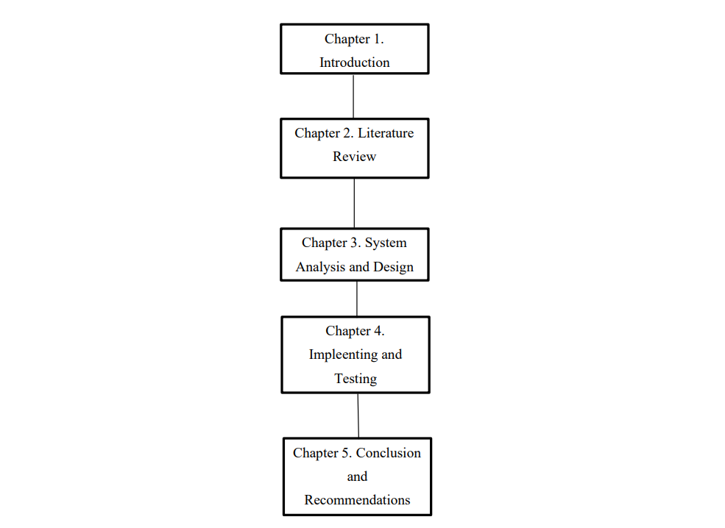

**Figure 1: Report Organization**

**Chapter:2**

**Background Study and Literature Review**

**2.1 Background Study**

Online dental appointment system aims to streamline the appointment booking process for dental clinics and patients. Traditional appointment booking methods can be time-consuming and inconvenient, leading to scheduling errors and patient dissatisfaction. This digital solution seeks to address these issues by providing a user-friendly platform where patients can easily view available appointment slots, choose a suitable time, and book appointments at their convenience By transitioning to an online system, dental clinics can enhance patient experience, reduce administrative workload, and optimize their scheduling efficiency.

**2.2 Literature Review**

**CHAPTER 3**

**System Analysis and Design**

**3.1. System Analysis**

It is a process of collecting and interpreting facts, identifying the problems, and decomposition of a system into its components. System analysis is conducted for the purpose of studying a system or its parts in order to identify its objectives. It is a problem-solving technique that improves the system and ensures that all the components of the system work efficiently to accomplish their purpose.

**3.1.1. Requirement Analysis**

**I. Functional Requirements**

**For Users**

• User registration and login: Patients should be able to create an account with their personal information, including name, contact information, and insurance details.

• Appointment scheduling: Patients should be able to view available appointment times and book appointments online. The system should show the availability of dentists.

• Appointment rescheduling and cancellation: Patients should be able to easily reschedule or cancel appointments online, and the system should send a confirmation of the change. For System

**Administrator**

• Appointment confirmation: The system should send an email or SMS confirmation to the patient and notify the clinic staff of the new appointment.

• Inform the dentist: The system should send the information about booked appointments.

**Use Case Diagram**

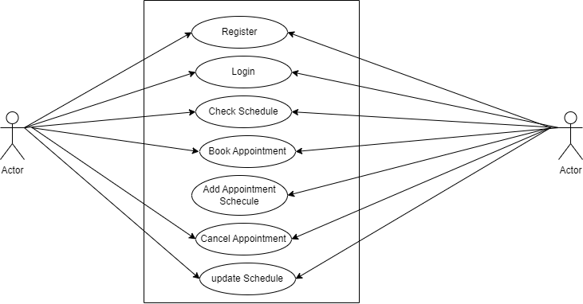

**Fig: Use Case Diagram**

**II. Non-Functional requirements**

• Security: The system should be secure and protect patient information, complying with industry-standard data privacy regulations.

• Reliability: The system should be always reliable and available, with minimal downtime.

• Scalability: The system should be able to handle an increasing number of users and appointments without any degradation in performance.

• User experience: The system should have a user-friendly interface that is easy to navigate and understand, with clear instructions and minimal steps.

**3.1.2. Feasibility Analysis**

**I. Technical**

In technical feasibility online dental clinic appointment system will be stable fastest and easy to book their appointment. For the design the different programming tools will be used for PHP JavaScript, HTML, CSS etc. Necessary hardware and software required for the development and implementation of system is available. The proposed system is technically feasible.

**ii. Operational**

This online dental clinic appointment system will make changes in clinic appointment system. The user need to have basic knowledge about internet and computer. System will help to the patient to book their appointment by staying anywhere. User can also easily access the system as it is user friendly in many aspects with good UI. The system is operationally feasible.

**iii. Economical**

Economical feasibility in online dental clinic appointment system is also important part for this project. To build the web software the initial cost will be involve. To maintain the software such as hosting and training for staff costs will be also added. Then the software will make easy for maintain the appointment and it will improve the satisfaction of patient. This will result in saving time and money also increase the revenue for clinic.

**iv. Schedule**

The system is completed within scheduled time and do not exceed the scheduled time.

**3.1.3 Data Modelling (ER-Diagram)**

The entity relationship diagram describes the relationship between entities, cardinality and their attributes. Entity–relationship model (ER model) is a data model for describing the data or information aspects of a business domain or its process requirements, in an abstract way that lends itself to ultimately being implemented in a database such as a relational database. The main components of ER models are entities (things) and the relationships that can exist among them.

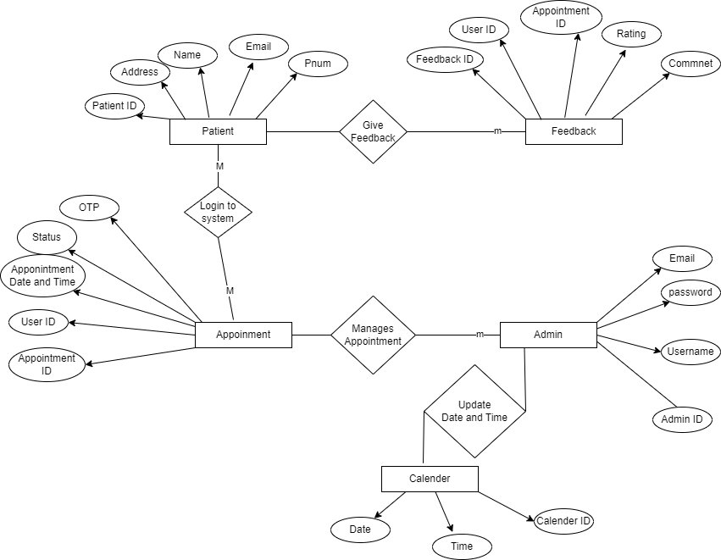

Fig: Entity Relationship Diagram