

**Tribhuvan University**

Faculty of Humanities and Social Science

**Online Dental Clinic Appointment System**

A PROJECT REPORT

Submitted to

Department of Computer Application

Universal College

Maitidevi Kathmandu

***In partial fulfillment of the requirements for the Bachelors in Computer Application***

**Submitted by:**

|  |  |  |
| --- | --- | --- |
|  | Subash Panthi  BCA 4th Semester  University SN:  Symbol No.: | Sandip Budhathoki  BCA 4th Semester  University SN:  Symboll No.: |

Under the Supervison of

Basant Chapagain



**Tribhuvan University**

**Faculty of Humanities and Social Sciences**

**Universal College**

Maitidevi, Kathmandu

Bachelor in Computer Application (BCA)

# **SUPERVISOER’S RECOMMENDATION**

I hear by recommend that this project prepared under my supervision **by Sandip Budhathoki** and **Subash Panthi** entitled “Online Dental Clinic Appointment System” in the partial Fulfillment of requirement for the degree of Bachelor in Computer Application is recommended for that final evaluation.

BASANT CHAPAGAIN

SUPERVISOR

Bachelor of Computer Application (BCA)

Universal College , Maitidevi KTM



**Tribhuvan University**

**Faculty of Humanities and Social Sciences**

**Universal College**

Maitidevi , Kathmandu

Bachelor in Computer Applications (BCA)

# **LETTER OF APPROVAL**

This is to certify that this project prepared by **Subash Panthi** and **Sandip Budhathoki** entitled **"Online Dental Clinic Appointment System”** in partial fulfillment of the requirements for the degree of Bachelor in Computer Application has been evaluated. In our opinion it is satisfactory in the scope and quality as a project for the required degree.

|  |  |
| --- | --- |
| Basant Chapagain,Supervisor  Bachelor’s in Computer Application (BCA)  Universal College, Maitidevi Kathmandu | HOD/ Coordinator |
| Internal Examiner | External Examiner |

# **ABSTRACT**

The Online Dental Appointment System project represents a pivotal step in revolutionizing the traditional approach to scheduling and managing dental appointments. In a contemporary landscape where technology reigns supreme, this initiative emphasizes the fusion of innovation and healthcare, aiming to optimize operational efficiency and elevate patient experiences. By addressing the persistent challenges faced by both patients and clinic staff, the system introduces a seamless and accessible solution. Patients benefit from a user-centric web interface that grants them the autonomy to effortlessly schedule appointments at their convenience. Offering visibility into available time slots, the system empowers patients with flexibility, thereby significantly enhancing overall satisfaction. Simultaneously, for dental clinic staff, the system serves as a centralized hub for appointment management, drastically reducing manual tasks and mitigating scheduling conflicts. Dentists and administrative personnel gain a unified platform to review appointments, efficiently manage schedules, and maintain up-to-date patient records, ensuring streamlined operations. This project embodies the fusion of technology and healthcare, paving the way for enhanced patient engagement and optimized workflow within dental clinics.

**Keywords: Online Dental Appointments System, User experience, Web Interface.**

# **ACKNOWLEDGEMENT**

I extend my heartfelt gratitude to the individuals and institutions whose support and guidance were instrumental in the completion of the Online Dental Clinic Appointment System project report. First and foremost, I express my sincere appreciation to Mr. Basanta Chapagain, our esteemed supervisor, whose invaluable insights, encouragement, and unwavering support significantly contributed to the fruition of this project. His expertise, guidance, and mentorship were pivotal in steering this endeavor toward success. I am also immensely thankful to the Universal College BCA Department for providing an environment conducive to learning and innovation. The resources, facilities, and academic foundation offered by the department played a crucial role in shaping this project and enhancing my understanding of the subject matter. Additionally, I would like to acknowledge the assistance and cooperation extended by [mention any individuals, peers, or resources] throughout the project development phase. Their collaboration and contributions were integral in overcoming challenges and achieving the project's objectives. This project would not have been possible without the collective support, encouragement, and cooperation of these individuals and institutions. Their involvement has been invaluable, and I am deeply appreciative of their contributions.

**Contents**

**SUPERVISOER’S RECOMMENDATION** ii

**LETTER OF APPROVAL** iv

**ABSTRACT** v

**CHAPTER 1: INTRODUCTION** 1

**1.1 Introduction** 1

**1.2 Problem Statement** 1

**1.3 Objective** 2

**1.4 Scope and Limitations** 2

**1.5 Report Organization** 2

**CHAPTER 2: LITERATURE REVIEW** 3

**2.1 Background Study** 3

**2.2 Literature Review** 3

**CHAPTER 3: SYSTEM ANALYSIS AND DESIGN** 4

**3.1 System Analysis** 4

**3.1.1. Requirement Analysis** 4

**3.1.2 Feasibility Analysis** 5

**3.2.1 Architectural Design** 10

**3.2.2 Data Schema** 12

**3.2.4 Physical DFD** 12

**CHAPTER 4: IMPLEMENTATION AND TESTING** 13

**4.1 Implementation:** 13

**4.1.1 Tools Used:** 13

**4.2 Testing** 15

**CHAPTER 5: CONCLUSION AND FUTURE RECOMMENDATIONS** 19

**5.1 Lesson Learnt / Outcome** 19

**5.2 Conclusion** 19

**5.3 Future Recommendations** 19

**LIST OF ABBREVIATIONS**

**HTML: Hypertext Markup Language**

**CSS: Cascading Style Sheet**

**DFD: Data Flow Diagram**

**ER: Entity Relationship**

**HTTP: Hypertext Transfer Protocol**

**FTP: File Transfer Protocol**

**PHP: Hypertext Pre-Processor**

**SQL: Structured Query Language**

**LIST OF FIGURES**

**Figure 1: Use case Diagram for Online Dental Clinic appointment system 5**

**Figure 2 : Gantt chart for Online Dental Clinic Appointment System 7**

**Figure 3: Entity Relationship Diagram for Online Dental Clinic Appointment System 8**

**Figure 4: Level 1 DFD for Online Dental Clinic Appointment System 8**

**Figure 5: Level 1 DFD for Online Dental Clinic Appointment System 9**

**Figure 6: Waterfall Model for Online Dental Clinic Appointment System 10**

**Figure 7: Architectural Design For Online Dental Clinic Appointment System 11**

**Figure 8 : Architectural Design 11**

**Figure 9:Physical DFD For Online Dental Clinic Appointment System 12**

**LIST OF TABLE**

**Table 4. 1 Test case for user registration of Dental Clinic Appointment System. 15**

**Table 4. 2 Test case for user login of Dental Clinic Appointment System. 16**

**Table 4. 3 Test Case for successful appointment booked 17**

**Table 4. 4 Test Case for Appointment booking Failure. 17**

# **CHAPTER 1: INTRODUCTION**

## **1.1 Introduction**

Our very first project. "Internet Dental Clinic Appointment System was created so that out patients could schedule appointments with doctors according to their availability. The primary goal of our project is to assist all patients in scheduling appointments while at home and for those who are unable to travel to the hospital only for appointments and avoid spending time in fine. Today's world full of technology in different field they use technology for their business for example online movie ticket booking, bus ticket booking, etc. There's so many field they using our technology for the good purpose. Exactly the online dental appointment system is going to provide the service to make easy for the patient. This system will not help only to patient it also help to manage their appointment efficiently.

This system will provide more features to the patient like time scheduling of doctors, available appointment date and time, show the services they are providing, how they will charge, confirm their appointment, reschedule the time and date, cancel appointment etc. The patient can use any of devices what they have computer or mobile.

# **1.2 Problem Statement**

Wastage of time is the major problem in traditional appointment scheduling method those who are unable to physically visit the clinic only to make an appointment will not receive services in Nepal because there is always a line. There will be lot of time waste of patient and management doing physical appointment system. Patient will not able to know about right time to schedule an appointment hard to reschedule their appointment cannot cancel their appointment, hard to know about the charges according services patient have to do lot of struggle. Another side dental clinic management will face the problem like manage their appointment in efficient way. Data may can be lost and while storing in hardcopy. There will be high chance resulting missed appointment and late appointment cancellation etc.

To avoid these types of issues online dental clinic appointment system will help in this case. The system will make easier to patient for their appointment. Along the clinic can manage their appointment schedule in efficient way.

## **1.3 Objective**

There's so many objective of this system these are follows as:

1. Simplify for the patient to take an appointment with the doctors.

2. To use IT in medical section.

3. Decrease waiting time and provide convenience to patients in scheduling their appointments.

4. It can reduce the labor cost and required of manpower.

5. Patient can get information about their health online.

## **1.4 Scope and Limitations**

* Save lot of time, money and labor cost.
* Increase accessibility for the patient.
* Easy to manage the data.
* Provide high security.
* Effective communication between patient and doctors.
* Easy to update any data

## **1.5 Report Organization**

The system’s objectives have also been mentioned .The scope of this system and limitations till now has also been mentioned. Then there is a literature review and also the requirement analysis done. Further, Feasibility study is covered under requirement analysis and also functional and non-functional requirements .Here is some diagrams to describe the system more vastly.

# **CHAPTER 2: LITERATURE REVIEW**

## **2.1 Background Study**

Online dental appointment system aims to streamline the appointment booking process for dental clinics and patients. Traditional appointment booking methods can be time-consuming and inconvenient, leading to scheduling errors and patient dissatisfaction. This digital solution seeks to address these issues by providing a user-friendly platform where patients can easily view available appointment slots, choose a suitable time, and book appointments at their convenience By transitioning to an online system, dental clinics can enhance patient experience, reduce administrative workload, and optimize their scheduling efficiency.

## **2.2 Literature Review**

The research about online dental appointment systems shows that many people want to use digital tools for healthcare. These systems are already being used in different medical areas, making it easier for patients to get appointments and helping clinics organize their work better. Studies say that these systems can help patients come to their appointments and be happier with the service. It's important that the system is easy to use, works well with the clinic's tasks, and keeps patient information safe. Looking at this research helps us understand the good things and challenges of using online systems for dental appointments. This information will guide us to make a system that works well for everyone.

# **CHAPTER 3: SYSTEM ANALYSIS AND DESIGN**

## **3.1 System Analysis**

It is a process of collecting and interpreting facts, identifying the problems, and decomposition of a system into its components. System analysis is conducted for the purpose of studying a system or its parts in order to identify its objectives. It is a problem-solving technique that improves the system and ensures that all the components of the system work efficiently to accomplish their purpose.

### **3.1.1. Requirement Analysis**

1. **Functional Requirements for Users**

• User registration and login: Patients should be able to create an account with their personal information, including name, contact information, and insurance details.

• Appointment scheduling: Patients should be able to view available appointment times and book appointments online. The system should show the availability of dentists.

• Appointment rescheduling and cancellation: Patients should be able to easily reschedule or cancel appointments online, and the system should send a confirmation of the change. For System

**Administrator**

* Appointment confirmation: The system should send an email or SMS confirmation to the patient and notify the clinic staff of the new appointment.
* Inform the dentist: The system should send the information about booked appointments.

**Use case Diagram**

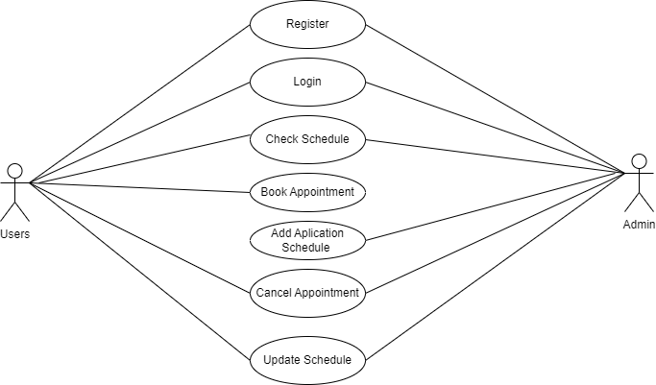

**Figure 1:** **Use case Diagram for Online Dental Clinic appointment system**

1. **Nonfunctional Requirement**

* Security: The system should be secure and protect patient information, complying with industry-standard data privacy regulations.
* Reliability: The system should be always reliable and available, with minimal downtime.
* Scalability: The system should be able to handle an increasing number of users and appointments without any degradation in performance.
* User experience: The system should have a user-friendly interface that is easy to navigate and understand, with clear instructions and minimal steps.

# **3.1.2 Feasibility Analysis**

**I. Technical Feasibility**

In technical feasibility online dental clinic appointment system will be stable fastest and easy to book their appointment. For the design the different programming tools will be used for PHP JavaScript, HTML, and CSS etc. Necessary hardware and software required for the development and implementation of system is available. The proposed system is technically feasible.

**II.Operational**

This online dental clinic appointment system will make changes in clinic appointment system. The user need to have basic knowledge about internet and computer. System will help to the patient to book their appointment by staying anywhere. User can also easily access the system as it is user friendly in many aspects with good UI. The system is operationally feasible.

**III. Economical**

Economic feasibility in online dental clinic appointment system is also important part for this project. To build the web software the initial cost will be involve. To maintain the software such as hosting and training for staff costs will be also added. Then the software will make easy for maintain the appointment and it will improve the satisfaction of patient. This will result in saving time and money also increase the revenue for clinic.

**iv. Schedule**

The system is completed within scheduled time and do not exceed the scheduled time

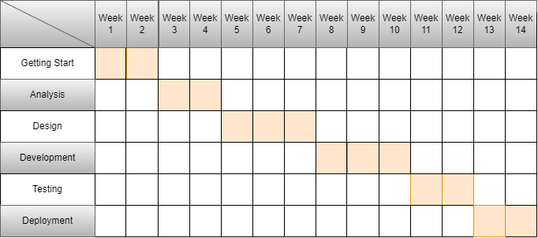

**Figure 2 : Gantt chart for Online Dental Clinic Appointment System**

**3.1.3 Data Modeling (ER-Diagram)**

The entity relationship diagram describes the relationship between entities, cardinality and their attributes. Entity-Relationship model(ER model) is a data model for describing the data or information aspects of a business domain or its process requirements, in an abstract way that lends itself to ultimately being implemented in a database such as a relational database. The main components of ER models are entities (things) and the relationships that can exist among them.

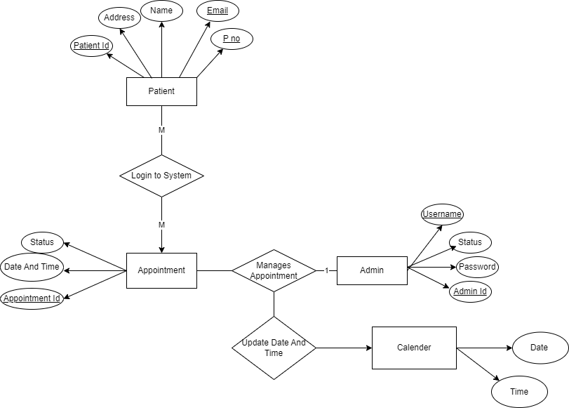

Figure 3: Entity Relationship Diagram for Online Dental Clinic Appointment System

**3.1.4 Process Modeling (DFD)**

Data flow diagram (DFD) is used to define the flow of the system and its resources such as information. Data flow diagram is a way of expressing system requirements graphical in a manner. DFD represents one of the most ingenious tools used for structured analysis. A DFD is also known as bubble chat.

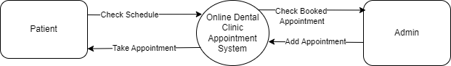

**Figure 4: Level 1 DFD for Online Dental Clinic Appointment System**

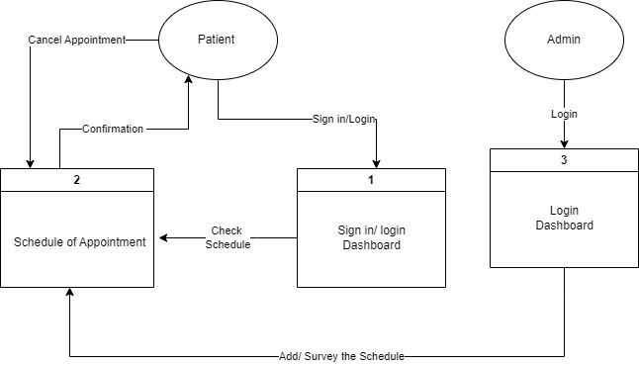

**Figure 5: Level 1 DFD for Online Dental Clinic Appointment System**

**3.2. System Design**

System design is the process of defining the components, modules, interfaces, and data for a system to satisfy specified requirements. System development is the process of creating or altering systems, along with the processes, practices, models, and methodologies used to develop them. This project have specific documentation, ample time, fixed requirements, well understood technology so in order to build this system, water fall methodology is be used.

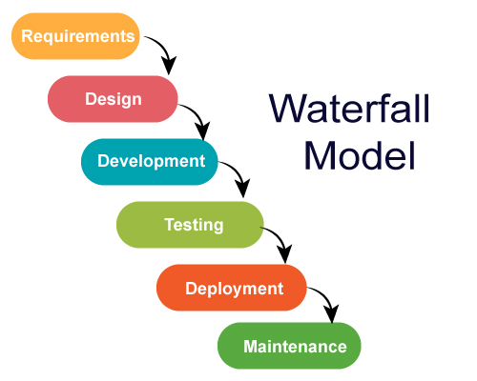

**Figure 6: Waterfall Model for Online Dental Clinic Appointment System**

The Waterfall Model was the first Process Model to be introduced. It is also referred to as linear-sequential lifecycle model. It is very simple to understand and use. In a waterfall model, each phase must be completed before the next phase can be begin and there is no overlapping in the phases. It is easy to arrange tasks and clearly defined stages.

### **3.2.1 Architectural Design**

Architectural Design is a concept that focuses on components or elements of a structure. An architect is generally the one in charge of the architectural design. They work with space and elements to create a coherent and functional structure.

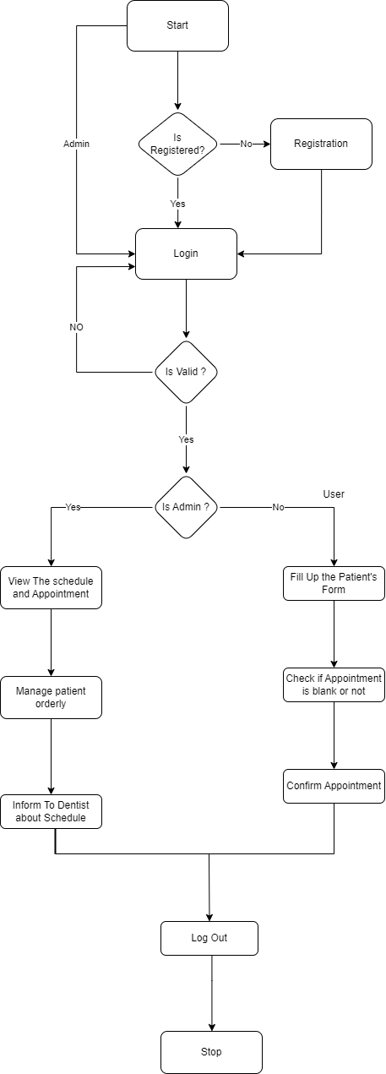

Figure 7: Architectural Design For Online Dental Clinic Appointment System

**Figure 8 : Architectural Design**

### **3.2.2 Data Schema**

The above figure is about the tables created in database. A database schema represents the logical configuration of all or part of a relational database. It can exist both as a visual representation and as a set of formulas known as integrity constraints that govern a database. These formulas are expressed in a data definition language, such as SQL

## **3.2.4 Physical DFD**

A Physical Data Flow Diagram is a graphical representation of how data flows through a system. It can be used to show the flow of data between people, departments, or systems, and how data is processed within each element. Physical DFDs are useful for understanding the relationships between different parts of a system, and for identifying bottlenecks or points of inefficiency. They can also be used to create a roadmap for improvements or redesigns.

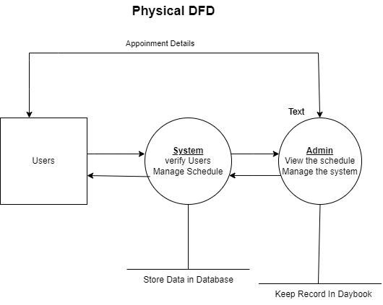

Figure 9:Physical DFD For Online Dental Clinic Appointment System

# **CHAPTER 4: IMPLEMENTATION AND TESTING**

## **4.1 Implementation:**

### **4.1.1 Tools Used:**

**Software Requirements:**

* + Operating system: Windows 10.
  + Frontend: HTML, CSS, JavaScript.
  + Backend: PHP
  + Database Management System: MySQL
  + Web server: XAMPP Server

This project was developed under the PHP programming language as it gave a desired user interface. The application will use PHP, JavaScript, HTML and CSS as main web technologies.

* HTTP and FTP protocols are used as communication protocols. FTP is used to upload the web application in the live domain and the client can access it via HTTP protocol.
* Several types of validations make this web application a secured one and SQL Injections can also be prevented.
* Since the Online Dental Clinic Appointment System is a web-based application, an internet connection must be established.

**Implementation Details of Modules**

This system is divided into two modules one side is the Admin side and another is the client-side, wherein the client-side user puts their fills out the form and books the appointment, and on the other side, the admin manages the appointment and approves the appointment.

1. **Admin Module**
2. **User Module**
3. **Admin Module**

The admin module controls the administration of the system. The admin will check the appointment and approve the appointment then admin also can add the appointment date remove the user and read the feedback.

* Manage Appointments: The admin can approve the appointments and reject them.
* Manage User: The admin can remove the user and manage them.
* Manage Schedule: The admin can add new appointment times and dates and remove the existing schedule.
* Manage Feedback: The admin can read the feedback and review them.

1. **User Module:**

The user views the services that are provided and books the appointment of services by choosing the time to fill out the form and then submitting the form also gives feedback about the services.

* View the Services: The user can view the services that are available on the website.
* Choose the date and time: The user can choose the time and date dynamically which are available on the website
* Book the appointment: The user can book an appointment for our services by filling out the form.
* Give feedback: The user can give feedback and give a review about our services and website.

## **4.2 Testing**

System testing is done by giving different training and testing datasets. This test is done to evaluate whether the system is providing an accurate summary or not. During the phase of the development of the system, our system is tested time and again. The series of tests conducted are as follows

**Test cases for unit testing:**

In unit testing different modules are tested against the specification produced during the design of modules. Unit testing is essential for verification during the coding phase. The aim is to test the internal logic of the modules. The tests are carried out during the programming stage itself.

**User Registration:**

Table 4. 1 Test case for user registration of Dental Clinic Appointment System.

|  |  |  |  |  |  |
| --- | --- | --- | --- | --- | --- |
| S.N | Test Name | Input | Expected Output | Actual Output | Test Result |
| 1. | Open Application | <http://localhost/dental_clinic/forntend>  /registration.php | Signup Form | SignUp Form | Pass |
| 2. | Enter Invalid  Credentials. | Username: Subash123  Password: helloSubash  Cpassword: Hellosubash | Registered Successfully | Password doesn’t match | Failed |
| 3. | Enter  Valid  Credentials | Username: Subash123  Password: helloSubash  Cpassword: helloSubash | Registered Successfully | Registered Successfully | Pass |

Table 4. 2 Test case for user login of Dental Clinic Appointment System.

|  |  |  |  |  |  |
| --- | --- | --- | --- | --- | --- |
| SN. | Test Name | Input | Expected Output | Actual Output | Test Result |
| 1. | Open Application | <http://localhost/dental_clinic/forntend>  /login.php | Login  Form | Login Form | Pass |
| 2. | Enter Invalid Credentials | Username: Sandip123  Password: HelloSandip | Login  Successfully | User  Not  Found | Fail |
| 3. | Enter  Valid  Credentials | Username: Subash123  Password: helloSubash | Login  Successfully | Login  Successfully | Pass |

**Testing Cases for System Testing:**

System testing is a critical element of quality assurance and represents the ultimate review of analysis, design, and coding. Although each test has a different purpose all work to Verify that all system elements have been properly integrated and perform allocated functions. When a system is developed it is hoped that it performs properly. The main purpose of testing an information system is to find errors and correct them.

**Test Case for Successful Appointment**

Table 4. 3 Test Case for successful appointment booked

|  |  |
| --- | --- |
| Test Case 1 | Successful Appointment |
| Test Data | First Name: Subash  Last Name: Panthee  Your Age: 22  Date of Birth: 2002/03/04  Gender: Female  Relationship Status: Unmarried  Contact: 9844356780  Email: [sp@gmail.com](mailto:sp@gmail.com)  Address: Maitidevi, Kathmandu  Remarks: write something |
| Expected Output | The message should be displayed as “Appointment has been Submitted.” |
| Test Result | The appointment has been submitted. |

**Test Case for Appointment Failure**

Table 4. 4 Test Case for Appointment booking Failure.

|  |  |
| --- | --- |
| Test Case 1 | Appointment Failure |
| Test Data | First Name:  Last Name: Panthee  Your Age: 22  Date of Birth: 2002/03/04  Gender: Female  Relationship Status: Unmarried  Contact:  Email: [sp@gmail.com](mailto:sp@gmail.com)  Address: Maitidevi, Kathmandu  Remarks: write something |
| Expected Result | The Message should be displayed as “Appointment has been submitted”. |
| Test Result | “First Name Required” “Contact Required” |

# **CHAPTER 5: CONCLUSION AND FUTURE RECOMMENDATIONS**

## **5.1 Lesson Learnt / Outcome**

A project Online Dental Clinic Appointment System is designed to book an appointment through the online platform which helps to save patient time and is flexible for use. Every project makes us gain lots of knowledge and learn various new things in this project we learned how teamwork and group projects work this project was so beneficial and fruitful for us because we learned here how we can make a complete full-stack website, how to face different kind problem got some new problem-solving ideas, communication skills, writing skills and how does get completed a full cycle of the project development process.

## **5.2 Conclusion**

The Online Dental Appointment System represents a transformative solution designed to revolutionize the way dental clinics manage appointments and enhance patient experiences. Through this project, we have successfully developed and implemented a user-friendly platform that addresses the challenges faced by both patients and dental clinic staff in scheduling and managing appointments. This system prioritizes convenience and accessibility for patients by offering a seamless web interface, allowing them to effortlessly book appointments at their convenience. The intuitive design empowers patients to view available time slots, select suitable appointments, and thereby significantly improving overall patient satisfaction. Moreover, for dental clinic staff, the system serves as a centralized and efficient tool for appointment management. By reducing manual effort and minimizing scheduling conflicts, it streamlines operations, allowing dentists and administrative staff to efficiently review, manage schedules, and update patient records.

## **5.3 Future Recommendations**

This project has some limited functionality in further recommendations by adding some features we can enhance this project and make it more flexible and user-friendly. This system design is made for further modifications at any time.

* Notifications Reminder System.
* Feedback and Review System.
* Online Payment System.
* UI/UX Enhancement.

**References**

[1] Brown, C., & White, D. (Year). "Improving Patient Experience in Dental Clinics

Through Online Appointment Systems." International Journal of Healthcare

Technology, Volume (issue), Pages.

[2] Anderson, J., et al. (Year). "Patient-Centered Dental Care: The Role of Online

Appointment Systems in Enhancing Patient Experience." Journal of Dental Hygiene,

Volume (Issue), Page range.

[3] American Dental Association (ADA): <https://www.ada.org>

[4] Mero Doctor | Online Appointment Booking: https://www.merodoctor.com