# **ABSTRACT**

This project focuses on implementing Management Information Systems (MIS) and E-Business solutions for SP Business House, a Lotte Chocopie distributor. Through MIS, SP Business House aims to streamline operations, enhance decision-making, and improve customer service. Concurrently, an E-Business platform will be established to facilitate online interactions with customers, suppliers, and partners, offering convenient browsing, ordering, and payment options. By integrating MIS and E-Business solutions, SP Business House seeks to enhance efficiency, competitiveness, and customer satisfaction, ultimately solidifying its position as a leading distributor in the Lotte Chocopie market.

Keywords: HTML, CSS, JavaScript, S.P Business House

**Table of Contents**

**ABSTRACT** 1

**LIST OF FIGURE** 3

**INTRODUCTION** 4

**OBJECTIVES** 5

**PLATFORMS** 6

**ABOUT S.P BUSINESS HOUSE** 7

**MODULES OF “S P BUSINESS HOUSE”** 8

# **LIST OF FIGURE**

Figure 1 : Login Module 8

Figure 2: Modules Of Products 9

Figure 3 : Modules of Payments 10

Figure 4: Home Page 11

Figure 5 : Data Flow Of S P Business House 12

# **INTRODUCTION**

In today's dynamic business landscape, the synergy between Management Information Systems (MIS) and E-Business platforms has emerged as a catalyst for organizational growth and sustainability. MIS empowers businesses with streamlined data management and insightful analytics, while E-Business facilitates online transactions, customer interactions, and market expansion.

Recognizing the transformative potential of these technologies, SP Business House, a trusted distributor of Lotte Chocopie confectioneries, is poised to embark on a digital journey. By harnessing MIS and E-Business solutions, SP Business House aims to elevate its operations to the online realm, offering customers a seamless browsing and purchasing experience for a wide array of Lotte Chocopie products. This strategic transition not only underscores SP Business House's commitment to innovation but also positions it as a frontrunner in the online distribution of beloved confectioneries, catering to the evolving needs of consumers in the digital age.

# **OBJECTIVES**

SP Business House, a Lotte Chocopie distributor, is venturing into the online realm by integrating Management Information Systems (MIS) and E-Business solutions. This strategic move aims to modernize operations and expand market reach through an intuitive online platform for purchasing Lotte Chocopie products.

**Objectives:**

* Enhance Operational Efficiency: Implement MIS to streamline internal processes and boost productivity.
* Improve Decision-Making: Utilize MIS for real-time access to data and analytics, aiding informed decision-making.
* Expand Market Reach: Develop an E-Business platform to reach a broader audience of consumers.
* Enhance Customer Experience: Create a user-friendly website for seamless shopping experiences.
* Strengthen Supplier Relationships: Utilize MIS tools for better supplier management.
* Increase Revenue: Drive sales growth through E-Business channels.
* Ensure Adaptability and Scalability: Design solutions to adapt to evolving market trends.
* Enhance Brand Image: Position SP Business House as an innovative distributor.
* Ensure Data Security and Compliance: Implement robust security measures for customer data protection.
* Foster Continuous Improvement: Establish mechanisms for ongoing optimization of operations and customer satisfaction.

# **PLATFORMS**

**HTML (Hypertext Markup Language):**

HTML is the standard markup language used to create the structure and content of web pages. It provides a set of predefined elements, such as headings, paragraphs, and links, which are used to organize and present information on the web. HTML documents are interpreted by web browsers to render the visual layout and structure of a webpage. It forms the foundation of web development and is essential for creating websites and web applications.

**CSS (Cascading Style Sheets):**

CSS is a stylesheet language used to define the presentation and appearance of HTML documents. It allows developers to specify the visual styles, such as colors, fonts, layout, and spacing, of elements within a webpage. By separating the content (HTML) from its presentation (CSS), developers can create consistent and visually appealing designs across multiple web pages. CSS is crucial for achieving responsive and aesthetically pleasing web designs, enhancing the user experience and usability of websites.

**JavaScript:**

JavaScript is a high-level programming language primarily used for adding interactivity and dynamic behavior to web pages. Unlike HTML and CSS, which are markup and styling languages, respectively, JavaScript is a full-fledged scripting language that enables developers to create interactive elements, handle user input, manipulate the DOM (Document Object Model), and perform asynchronous operations such as fetching data from servers. JavaScript is essential for creating modern web applications with rich user interfaces, client-side validation, and interactive features that enhance user engagement and functionality.

# **ABOUT S.P BUSINESS HOUSE**

S P Business House is a prominent distributor specializing in Lotte Chocopie products. With a reputation for reliability and quality service, S P Business House plays a crucial role in the distribution network, connecting Lotte Chocopie products with consumers through various retail channels. As a distributor, S P Business House ensures efficient logistics and timely delivery of Lotte Chocopie products to retailers, wholesalers, and other customers. Committed to customer satisfaction, S P Business House maintains strong relationships with its clients, providing personalized support and tailored solutions to meet their diverse needs. With a focus on innovation and adaptation to market trends, S P Business House continually seeks opportunities for growth and expansion in the competitive confectionery market.

# **MODULES OF “S P BUSINESS HOUSE”**

The modules of "S P Business House" encompass various aspects of its operations and management, ensuring efficient functioning and optimal performance across different areas. Some of the key modules may include:

1. Login Module

The login module of S P Business House verifies user identity using phone number and password for authentication

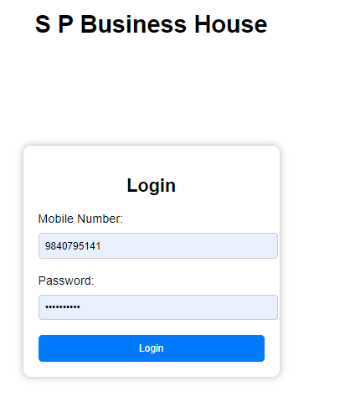

Figure 1 : Login Module

**MODULES OF PRODUCTS**

Modules of products shows the available product’s Details

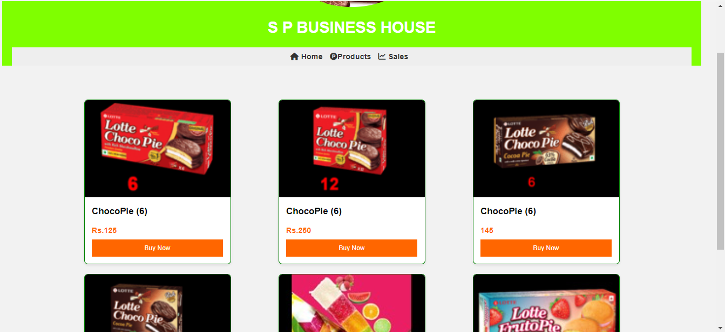

Figure 2: Modules Of Products

MODULES OF PAYMENTS

This Modules Shows The way of E-Payments

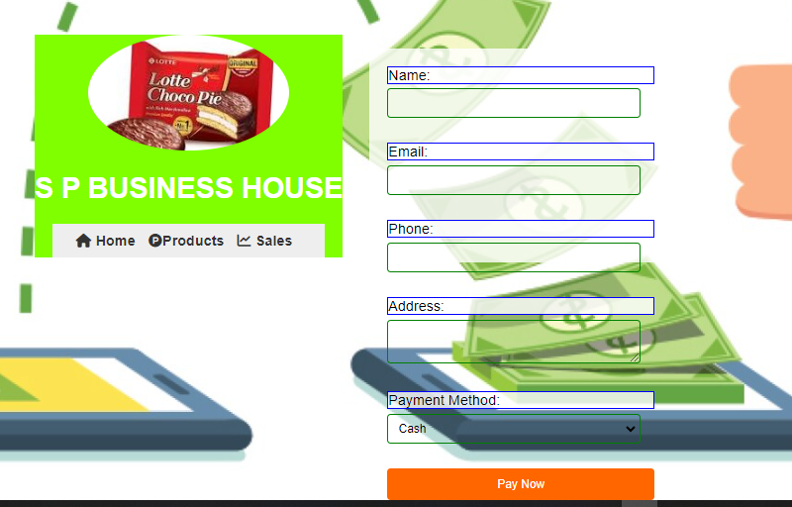

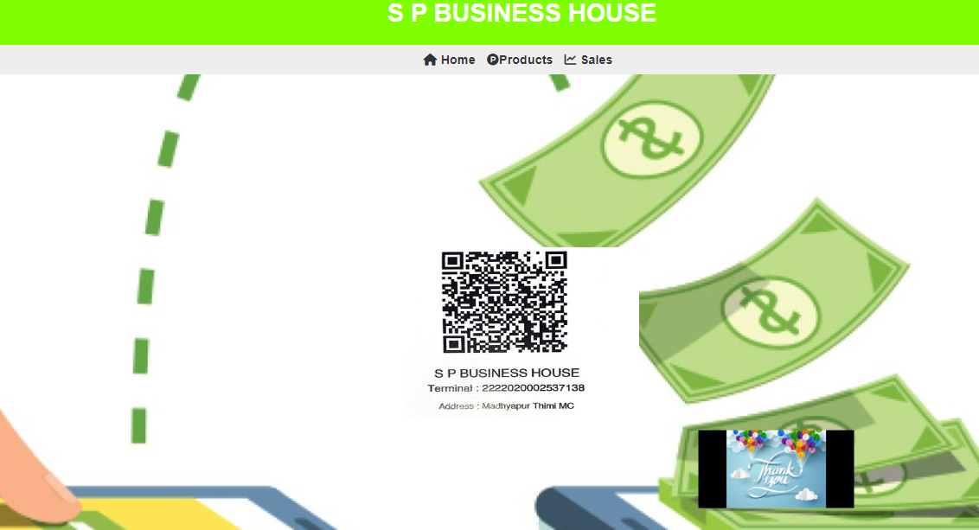

Figure 3 : Modules of Payments

**Home Page**

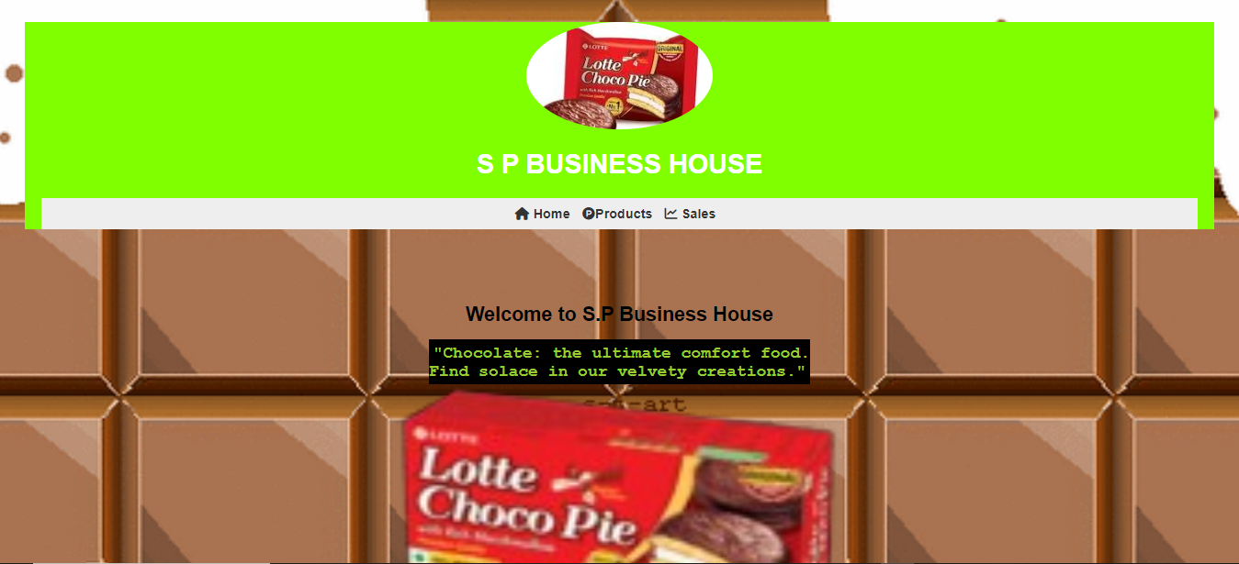

Figure 4: Home Page

**Data Flow**

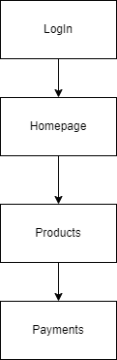

Figure 5 : Data Flow Of S P Business House