MASTER’S THESIS CONCEPT NOTE
Foundation Models Meet LiDAR: Individual Tree Crown Extraction in an Open Cross Timbers Savanna at LBJ National Grassland, Texas
Sudipta Poudel · M.S. Candidate, University of North Texas
Advisor: Dr. Pinliang Dong
October 2026 · Draft for discussion

1. Background and Problem Statement
Savannas and grasslands across the southern Great Plains are being transformed by woody plant encroachment, as fire-sensitive species such as eastern redcedar (Juniperus virginiana) expand into open grassland. Effective management requires tree-level information — where individual trees are, how large they are, and which species they belong to — across entire landscapes. Airborne imagery and LiDAR can supply this information, and recent advances in artificial intelligence now make automated individual tree crown extraction feasible.
Two families of methods lead this field. Task-specific deep learning detectors such as DeepForest were trained largely on closed forests of the National Ecological Observatory Network (NEON) (Weinstein et al., 2019, 2020). In parallel, vision foundation models such as the Segment Anything Model (SAM) can segment objects without task-specific training (Kirillov et al., 2023), but perform inconsistently on remote sensing imagery (Osco et al., 2023) and generally require good prompts or auxiliary elevation data to compete with trained detectors (Teng et al., 2025). Whether either approach works reliably in open savannas — where crowns are scattered, irregular, and embedded in a grass matrix — remains largely untested.

2. Research Gap
- Ecosystem bias. Deep learning and SAM-based crown extraction have been developed and evaluated mainly in closed forests, plantations and urban areas (Ball et al., 2023; Chen et al., 2025; Teng et al., 2025), not in open savanna.
- Benchmark gap. The NEON tree crown benchmark excludes the LBJ National Grassland site (CLBJ) because too few trees met its selection criteria (Weinstein et al., 2021), leaving open Cross Timbers savanna without a reference dataset.
- Methodological gap. Elevation data have been shown to improve SAM in forests (Teng et al., 2025), but no study identified in my review compares DeepForest, zero-shot SAM and LiDAR-guided SAM in an open savanna, or applies them to map juniper encroachment.

3. Aim and Objectives
Aim: To evaluate deep learning and foundation-model approaches for extracting individual tree crowns in an open Cross Timbers savanna, and to use the best approach to map oak and juniper trees at LBJ National Grassland.
- Compare crown detection and delineation by DeepForest, zero-shot SAM and SAM guided by LiDAR canopy height.
- Build a hand-checked reference crown dataset for CLBJ and assess accuracy against NEON field-surveyed trees.
- Classify extracted crowns into oaks, eastern redcedar and other broadleaf species, and quantify the contribution of RGB, LiDAR and hyperspectral data.
- (Optional) Quantify juniper change between NEON flights in 2017 and 2024 in burned versus unburned management units.

4. Research Questions and Hypotheses
 | Research question | Hypothesis
RQ1 | How accurately can individual tree crowns be detected and delineated in an open savanna using DeepForest, zero-shot SAM and LiDAR-guided SAM? | LiDAR guidance improves SAM over its zero-shot form and matches or exceeds DeepForest, especially for small and isolated crowns.
RQ2 | Can extracted crowns be classified into oaks, eastern redcedar and other broadleaf trees, and which data source contributes most? | Evergreen, conical juniper is separable from deciduous oaks; combining hyperspectral and LiDAR data yields the highest accuracy.
RQ3* | Where has juniper increased between 2017 and 2024, and does change differ between burned and unburned units? | Juniper cover has increased overall, with less expansion in prescribed-burn units.
*Optional, subject to time.

5. Study Area
The study is located at the Caddo–Lyndon B. Johnson National Grasslands (NEON site CLBJ), Wise County, Texas, approximately 30 miles northwest of UNT. The site lies in the West Cross Timbers and forms a mosaic of post oak–blackjack oak woodland and open grassland managed by the US Forest Service, which applies prescribed fire and cedar removal to limit woody encroachment. The site combines a documented management problem with one of the richest open-access airborne and field datasets available for any North American savanna.

6. Data
All datasets are openly available from NEON and have been verified for CLBJ:
Dataset (NEON product) | Availability at CLBJ | Role
High-resolution RGB, 10 cm (DP3.30010.001) | 2017–2025 (annual since 2021) | Crown extraction
LiDAR canopy height model (DP3.30015.001) | 2017–2025 (annual since 2021) | Height filtering; SAM prompts
Discrete-return LiDAR point cloud (DP1.30003.001) | 2017–2019, 2021–2025 | 3D crown structure
Hyperspectral reflectance (DP3.30006.001/.002) | 2016–2019, 2021–2025 | Species separation
Vegetation structure, field trees (DP1.10098.001) | 2015–2025; 47 plots | Ground truth
Field data contain 862 live trees ≥ 2 m, dominated by post oak (368), eastern redcedar (101) and blackjack oak (99); 517 of these are stem-mapped and positioned from survey-grade GPS plot markers.

7. Methodological Approach
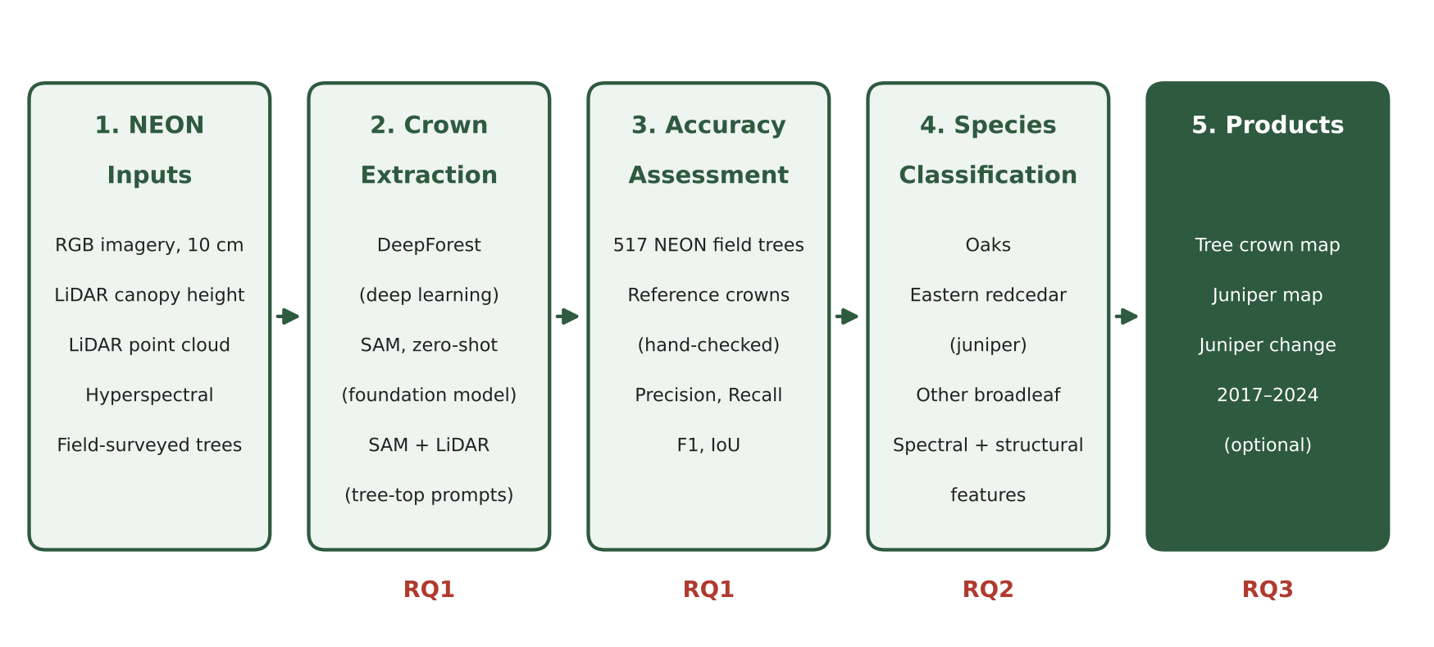
Figure 1. Research workflow linking NEON inputs, crown extraction, accuracy assessment and classification to the research questions.
- Crown extraction. DeepForest (pretrained and fine-tuned); SAM in automatic mode; SAM prompted with LiDAR-derived tree tops and filtered by canopy height (≥ 2 m).
- Accuracy assessment. Detection rate against 517 field-mapped trees, plus precision, recall, F1 and intersection-over-union against ~150–300 reference crowns delineated around selected plots.
- Classification. Random forest on crown-level spectral, structural and textural features, with feature-importance and data-source ablation analysis.

8. Expected Contributions and Novelty
- First savanna test: the first systematic comparison of DeepForest, zero-shot SAM and LiDAR-guided SAM for crown extraction in an open Cross Timbers savanna.
- Foundation model + LiDAR: a transferable strategy for guiding general-purpose foundation models with LiDAR structure in open landscapes.
- New reference dataset: an openly shareable crown dataset for CLBJ that fills a documented gap in the NEON benchmark.
- Management relevance: tree-level oak and juniper maps that directly support encroachment monitoring and prescribed-fire planning at LBJ.

9. Preliminary Work Completed
- Verified multi-year availability of all NEON airborne and field products for CLBJ.
- Processed NEON field data: species composition, height distribution, and georeferenced coordinates for 517 mapped trees.
- Selected five plots spanning woodland and grassland, and acquired the 2024 RGB and canopy height tiles covering them.
- Reviewed core literature on DeepForest, SAM and LiDAR-assisted crown segmentation.

10. Indicative Timeline
Period | Milestone
Months 1–2 | Proposal approval; literature review; data preparation
Months 3–5 | Reference crowns; DeepForest and SAM experiments (RQ1)
Months 6–7 | Crown classification (RQ2)
Months 8–9 | Change analysis (RQ3, optional); synthesis
Months 10–12 | Thesis writing, revision and defense

References
Ball, J. G. C., et al. (2023). Accurate delineation of individual tree crowns in tropical forests from aerial RGB imagery using Mask R-CNN. Remote Sensing in Ecology and Conservation, 9(5), 641–655.
Chen, et al. (2025). Zero-shot tree detection and segmentation from aerial forest imagery. arXiv:2506.03114.
Kirillov, A., et al. (2023). Segment Anything. Proceedings of the IEEE/CVF International Conference on Computer Vision (ICCV).
Osco, L. P., Wu, Q., de Lemos, E. L., et al. (2023). The Segment Anything Model (SAM) for remote sensing applications: From zero to one shot. International Journal of Applied Earth Observation and Geoinformation, 124, 103540.
Teng, M., Ouaknine, A., Laliberté, E., Bengio, Y., Rolnick, D., & Larochelle, H. (2025). Bringing SAM to new heights: Leveraging elevation data for tree crown segmentation from drone imagery. Advances in Neural Information Processing Systems (NeurIPS).
Weinstein, B. G., Marconi, S., Bohlman, S., Zare, A., & White, E. (2019). Individual tree-crown detection in RGB imagery using semi-supervised deep learning neural networks. Remote Sensing, 11(11), 1309.
Weinstein, B. G., Marconi, S., Aubry-Kientz, M., Vincent, G., Senyondo, H., & White, E. P. (2020). DeepForest: A Python package for RGB deep learning tree crown delineation. Methods in Ecology and Evolution, 11(12), 1743–1751.
Weinstein, B. G., et al. (2021). A benchmark dataset for canopy crown detection and delineation in co-registered airborne RGB, LiDAR and hyperspectral imagery from the National Ecological Observation Network. PLoS Computational Biology, 17(7), e1009180.
NEON (National Ecological Observatory Network). Vegetation structure (DP1.10098.001), RELEASE-2026. https://doi.org/10.48443/pypa-qf12

