MASTER’S THESIS CONCEPT NOTE
Deep Learning and Foundation Models (SAM, SAM 2) for Individual Tree Crown Delineation and Species Mapping in an Open Cross Timbers Savanna
A Multi-Sensor GeoAI Approach Integrating LiDAR and Hyperspectral Imagery at LBJ National Grassland, Texas
Sudipta Poudel · M.S. Candidate, University of North Texas
Advisor: Dr. Pinliang Dong
October 2026 · Draft for discussion

1. Background and Problem
Woody plant encroachment — particularly the expansion of eastern redcedar (Juniperus virginiana) — is transforming grassland–woodland mosaics across the southern Great Plains. Managing it requires tree-level information: where each tree is, how large its crown is, and which species it belongs to. No single sensor provides all three. High-resolution RGB imagery shows crown outlines, LiDAR measures height and three-dimensional structure, and hyperspectral imagery captures the biochemical signature that distinguishes species.
Recent AI methods can exploit these data. Supervised deep-learning detectors such as DeepForest and Mask R-CNN–based Detectree2 were trained mainly in forests (Weinstein et al., 2019, 2020; Ball et al., 2023), while vision foundation models such as the Segment Anything Model (SAM) and SAM 2 segment objects with little task-specific training but need good prompts or elevation data to perform well on trees (Kirillov et al., 2023; Osco et al., 2023; Teng et al., 2025). Hyperspectral data are well established for tree species classification (Fassnacht et al., 2016; Scholl et al., 2021), yet are rarely combined with foundation-model crown delineation. How these methods perform together in open savanna — where crowns are scattered, irregular and surrounded by grass — remains largely unknown.

2. Research Gap and Significance
- Ecosystem gap. Crown delineation and species mapping methods have been evaluated mostly in closed forests, plantations and urban areas; open Cross Timbers savanna presents a different structure and spectral background.
- Benchmark gap. The NEON tree-crown benchmark does not include a reference dataset for the CLBJ site (Weinstein et al., 2021), so locally checked crowns are needed.
- Integration gap. Foundation-model segmentation, LiDAR structure and hyperspectral species information have largely been studied separately. Few studies, to my knowledge, link all three in a single crown-to-species workflow, and none in a savanna undergoing juniper encroachment.

3. Aim and Objectives
Aim: To develop and evaluate a multi-sensor GeoAI workflow that integrates supervised deep learning, vision foundation models (SAM, SAM 2), LiDAR and hyperspectral imagery to delineate individual tree crowns and map tree species in an open Cross Timbers savanna.
- Benchmark crown delineation by supervised deep-learning models (DeepForest, Detectree2) and foundation models (SAM, SAM 2) in zero-shot and LiDAR/hyperspectral-guided modes.
- Build a quality-checked reference crown dataset for CLBJ and assess performance against field-mapped trees and manually delineated crowns.
- Classify delineated crowns into post oak, blackjack oak, eastern redcedar and other broadleaf trees using hyperspectral, LiDAR and RGB features, and quantify the contribution of each sensor.
Optional extension: examine changes in eastern redcedar between NEON acquisition years in burned and unburned management units.

4. Research Questions and Working Hypotheses
 | Research question | Working hypothesis
RQ1 | How do supervised deep-learning models (DeepForest, Detectree2) and foundation models (SAM, SAM 2) compare for delineating individual tree crowns in an open savanna, with and without LiDAR and hyperspectral guidance? | Guided foundation models will outperform their zero-shot forms and rival trained detectors without site-specific training; performance will vary with crown size and isolation.
RQ2 | How accurately can delineated crowns be classified to species, and how much do hyperspectral, LiDAR and RGB data each contribute? | Hyperspectral data will contribute most to species separation; combining them with LiDAR structure will give the highest accuracy, especially for evergreen redcedar versus deciduous oaks.
RQ3* | Where has eastern redcedar expanded between NEON acquisition years, and does change differ between burned and unburned units? | Redcedar has expanded overall, with less expansion in prescribed-burn units.
*Optional; not required for thesis completion.

5. Study Area and Data
The study area is the Caddo–Lyndon B. Johnson National Grasslands (NEON site CLBJ), Wise County, Texas, approximately 30 miles northwest of UNT. The landscape is a mosaic of open grassland and post oak–blackjack oak woodland in the West Cross Timbers, managed by the US Forest Service with prescribed fire and cedar removal to limit woody encroachment. NEON flies a single aircraft carrying an RGB camera, LiDAR and an imaging spectrometer over the site, so all three sensors are acquired together and co-registered.
Dataset (NEON product) | Availability at CLBJ | Role in this study
High-resolution RGB, 10 cm (DP3.30010.001) | 2017–2025; annual since 2021 | Crown delineation
LiDAR canopy height model (DP3.30015.001) | 2017–2025; annual since 2021 | Height filtering; tree-top prompts
Discrete-return LiDAR point cloud (DP1.30003.001) | 2017–2019, 2021–2025 | Crown structure metrics
Hyperspectral reflectance, 426 bands, 1 m (DP3.30006.001/.002) | 2016–2019, 2021–2025 | Species classification; vegetation masking
Vegetation structure, field trees (DP1.10098.001) | 2015–2025; 47 plots | Field reference and training labels
The field data contain 862 live trees ≥ 2 m — mainly post oak (368), eastern redcedar (101) and blackjack oak (99) — of which 517 are stem-mapped. Field points and image-derived crowns are different measurements, and the evaluation will account for this distinction.

6. Methods and Evaluation
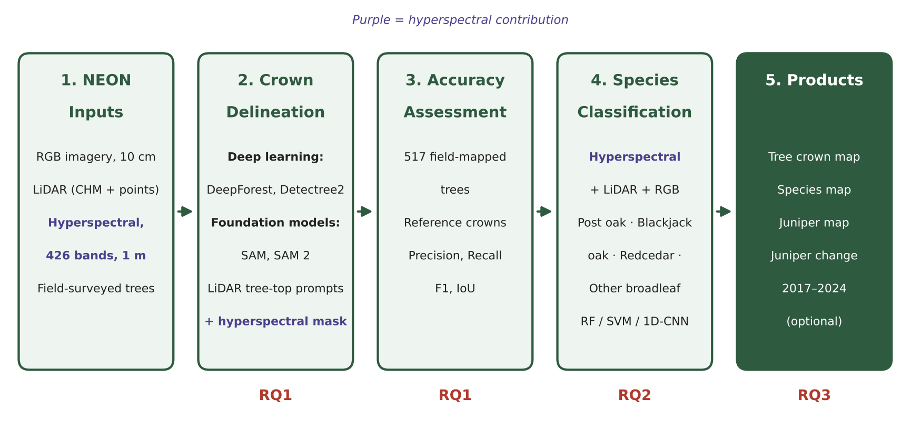
Figure 1. Multi-sensor workflow linking NEON inputs to the research questions; purple marks the hyperspectral contribution.
- Data preparation. Use co-acquired 2024 RGB, LiDAR and hyperspectral data (one year and one product version for consistency); remove noisy water-absorption bands; align all layers with field records over representative woodland and grassland plots.
- Crown delineation. Run supervised models (DeepForest; Detectree2/Mask R-CNN, pretrained and fine-tuned on local crowns) and foundation models (SAM, SAM 2) in zero-shot mode and guided by LiDAR tree-top prompts, a canopy-height filter (≥ 2 m) and a hyperspectral vegetation mask that removes grass and bare ground.
- Reference and accuracy. Delineate ~150–300 reference crowns with quality checks; report detection rate against 517 field-mapped trees, and precision, recall, F1 and IoU against reference crowns, analyzed by crown size and landscape context.
- Species classification. Extract crown-level mean spectra, vegetation indices and principal components with LiDAR height and structure metrics; train random forest, support vector machine and 1D-CNN classifiers; compare hyperspectral-only, LiDAR-only, RGB-only and fused inputs using spatially separated training and test data.
The primary outcome is the deep learning versus foundation-model crown-delineation benchmark (RQ1), followed by species classification (RQ2). Classes and features will be limited if the reference sample is small. Because hyperspectral pixels are 1 m, very small crowns may be under-represented; this will be reported as a limitation.

7. Expected Contributions and Novelty
- Integrated workflow: a systematic benchmark of supervised deep learning versus foundation models (SAM, SAM 2) for crowns in open savanna, and one of the first crown-to-species pipelines linking them with LiDAR and hyperspectral data.
- Sensor value: evidence on how much each sensor — RGB, LiDAR and hyperspectral — contributes to crown delineation and species identification.
- Reference dataset: a quality-checked crown and species dataset for CLBJ that fills a gap in the NEON benchmark.
- Management relevance: tree-level oak and redcedar maps to support encroachment monitoring and prescribed-fire planning at LBJ.

8. Preliminary Work Completed
- Verified availability of NEON RGB, LiDAR, hyperspectral and field products for CLBJ across multiple years.
- Processed field records: species composition, tree heights and coordinates for 517 mapped trees.
- Selected five plots spanning woodland and grassland; acquired 2024 RGB and canopy-height tiles covering them.
- Reviewed core literature on DeepForest, Detectree2, SAM/SAM 2, LiDAR-assisted segmentation and hyperspectral species mapping.

9. Indicative Timeline
Period | Milestone
Months 1–2 | Proposal approval; literature review; data preparation including hyperspectral tiles
Months 3–5 | Reference crowns; crown delineation experiments (RQ1)
Months 6–8 | Species classification and sensor comparison (RQ2)
Month 9 | Optional change analysis (RQ3); synthesis
Months 10–12 | Thesis writing, revision and defense

Selected References
Ball, J. G. C., et al. (2023). Accurate delineation of individual tree crowns in tropical forests from aerial RGB imagery using Mask R-CNN. Remote Sensing in Ecology and Conservation, 9(5), 641–655.
Fassnacht, F. E., et al. (2016). Review of studies on tree species classification from remotely sensed data. Remote Sensing of Environment, 186, 64–87.
Kirillov, A., et al. (2023). Segment Anything. Proceedings of the IEEE/CVF International Conference on Computer Vision (ICCV).
Osco, L. P., Wu, Q., de Lemos, E. L., et al. (2023). The Segment Anything Model (SAM) for remote sensing applications: From zero to one shot. International Journal of Applied Earth Observation and Geoinformation, 124, 103540.
Scholl, V. M., et al. (2021). Fusion neural networks for plant classification: Learning to combine RGB, hyperspectral, and lidar data. PeerJ, 9, e11790.
Teng, M., Ouaknine, A., Laliberté, E., Bengio, Y., Rolnick, D., & Larochelle, H. (2025). Bringing SAM to new heights: Leveraging elevation data for tree crown segmentation from drone imagery. Advances in Neural Information Processing Systems (NeurIPS).
Weinstein, B. G., Marconi, S., Bohlman, S., Zare, A., & White, E. (2019). Individual tree-crown detection in RGB imagery using semi-supervised deep learning neural networks. Remote Sensing, 11(11), 1309.
Weinstein, B. G., et al. (2020). DeepForest: A Python package for RGB deep learning tree crown delineation. Methods in Ecology and Evolution, 11(12), 1743–1751.
Weinstein, B. G., et al. (2021). A benchmark dataset for canopy crown detection and delineation in co-registered airborne RGB, LiDAR and hyperspectral imagery from the National Ecological Observation Network. PLoS Computational Biology, 17(7), e1009180.
Weinstein, B. G., et al. (2024). Individual canopy tree species maps for the National Ecological Observatory Network. PLoS Biology.
NEON (National Ecological Observatory Network). Vegetation structure (DP1.10098.001), RELEASE-2026. https://doi.org/10.48443/pypa-qf12

