Buyer Portal - Requirements

Contents

01. Summary 2

02. Release Notes 2

03. Prerequisites 2

04. Limitations 2

05. Look-and-Feel 3

06. Custom List MI Transactions (CMS015) 4

07. Key Search (CMS030) 4

1. Summary

Enables a buyer to aggregate purchase order proposals to a single vendor, while following shipping limits. Built with the H5 SDK.

1. Release Notes

Version 1.0.0.0

* Initial version

1. Prerequisites

The application uses information categories and custom MI transactions. These need to be configured in CMS010 and CMS015. It also uses key search (CMS030).

1. Limitations

None.

1. Look-and-Feel

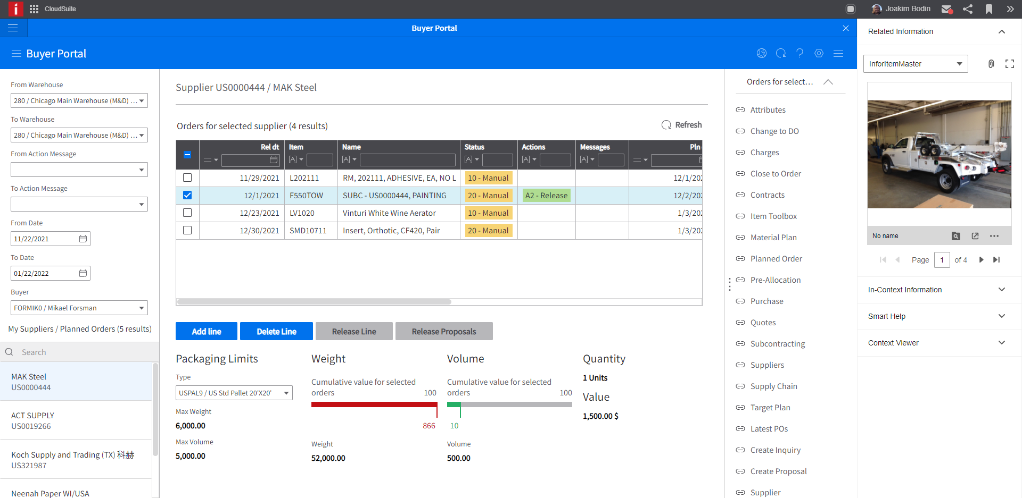

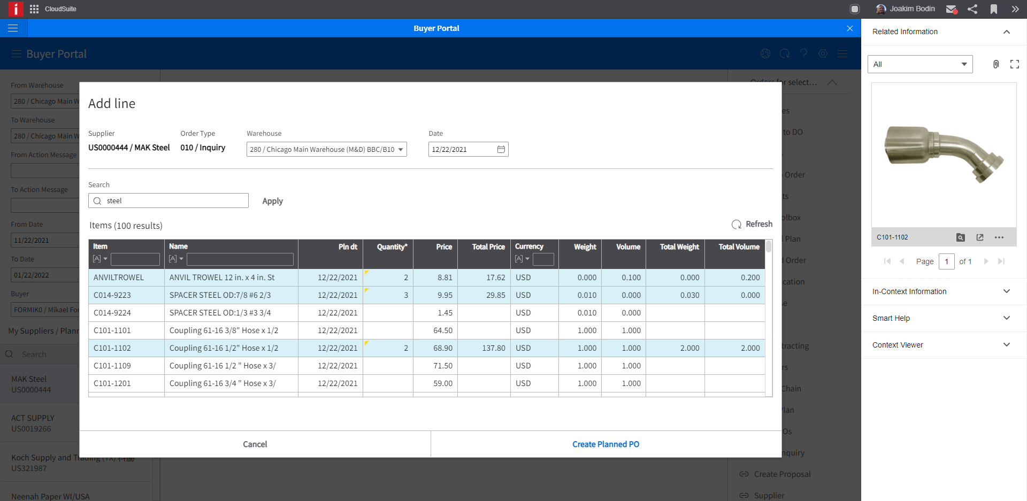

1. Custom List MI Transactions (CMS015)

These zip files need to be imported to the relevant company as configuration data through the H5 Administration pages:

* ConfigData_TRANS ID LSTZBP_MITBAL.xml.zip
* ConfigData_TRANS ID LSTZBP_MPAGRP.xml.zip
* ConfigData_TRANS ID LSTZBP_MPOPLP.xml.zip
* ConfigData_TRANS ID LSTZBP_MPOPLPS.xml.zip

The goal is for the transactions to show up in CMS015.

1. Key Search (CMS030)

These zip files need to be imported to the relevant company as configuration data through the H5 Administration pages:

* ConfigData_KEY SEARCH ZBP_ITEM_DESC.xml.zip

The goal is for the key search definitions to show up in CMS030.