Canary

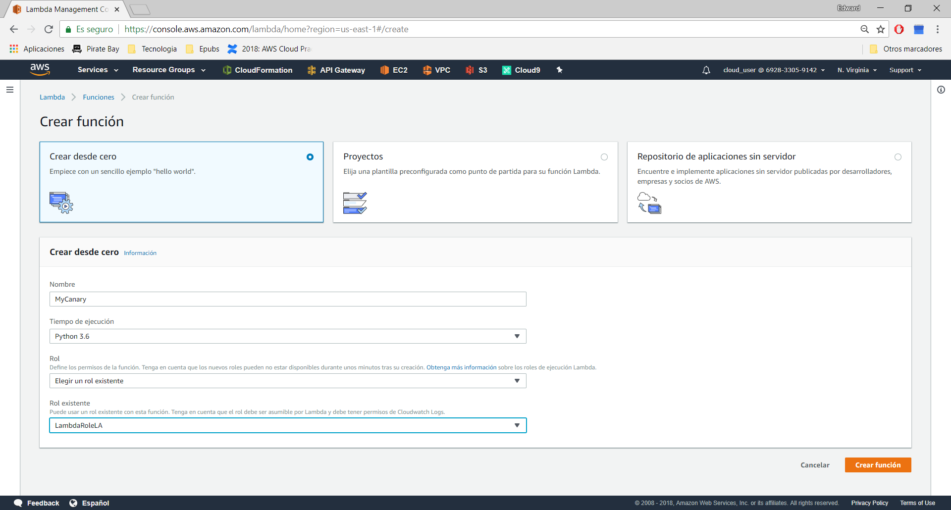

Role:

{  
 "Version": "2012-10-17",  
 "Statement": [  
 {  
 "Action": [  
 "application-autoscaling:DeleteScalingPolicy",  
 "application-autoscaling:DeregisterScalableTarget",  
 "application-autoscaling:DescribeScalableTargets",  
 "application-autoscaling:DescribeScalingActivities",  
 "application-autoscaling:DescribeScalingPolicies",  
 "application-autoscaling:PutScalingPolicy",  
 "application-autoscaling:RegisterScalableTarget",  
 "cloudwatch:DeleteAlarms",  
 "cloudwatch:DescribeAlarmHistory",  
 "cloudwatch:DescribeAlarms",  
 "cloudwatch:DescribeAlarmsForMetric",  
 "cloudwatch:GetMetricStatistics",  
 "cloudwatch:ListMetrics",  
 "cloudwatch:PutMetricAlarm",  
 "logs:CreateLogGroup",  
 "logs:CreateLogStream",  
 "logs:PutLogEvents",  
 "ec2:DescribeVpcs",  
 "ec2:DescribeSubnets",  
 "ec2:DescribeSecurityGroups",  
 "iam:GetRole",  
 "iam:ListRoles",  
 "sns:CreateTopic",  
 "sns:DeleteTopic",  
 "sns:ListSubscriptions",  
 "sns:ListSubscriptionsByTopic",  
 "sns:ListTopics",  
 "sns:Subscribe",  
 "sns:Unsubscribe",  
 "sns:Publish",  
 "sns:SetTopicAttributes",  
 "lambda:*",  
 "s3:*"  
 ],  
 "Resource": "*",  
 "Effect": "Allow"  
 }  
 ]  
}

Nos dara los permisos de la derecha:

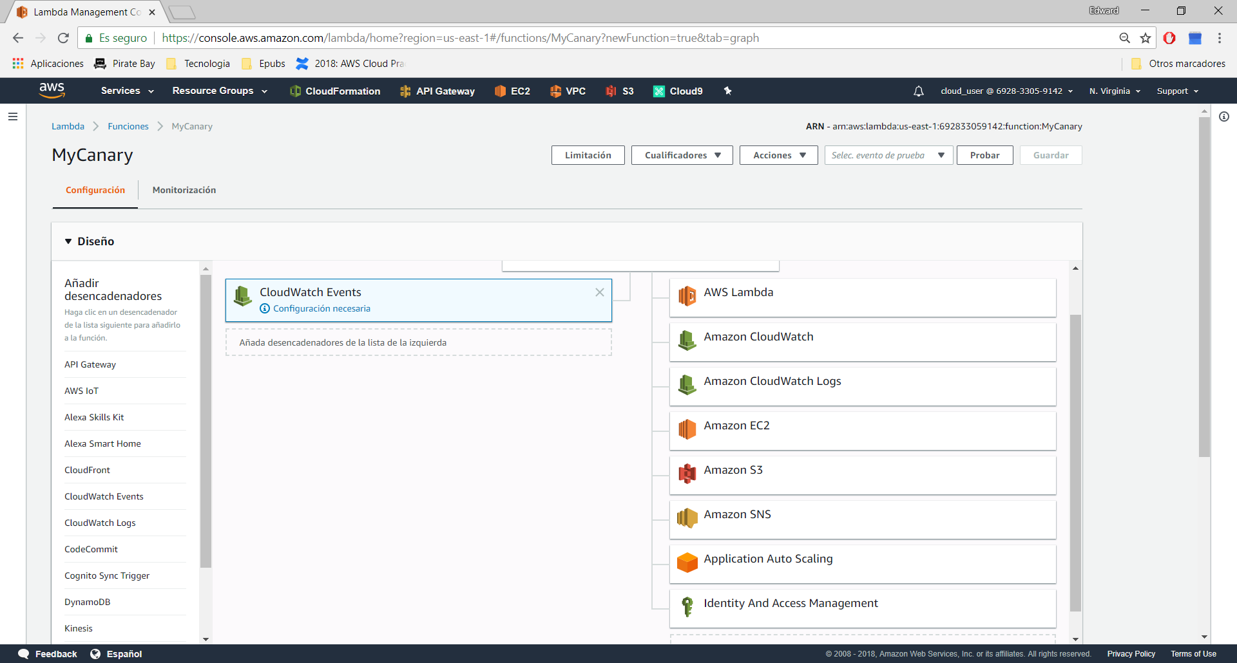

Elegimos Cloudwatch event como disparador

Configuramos el evento:

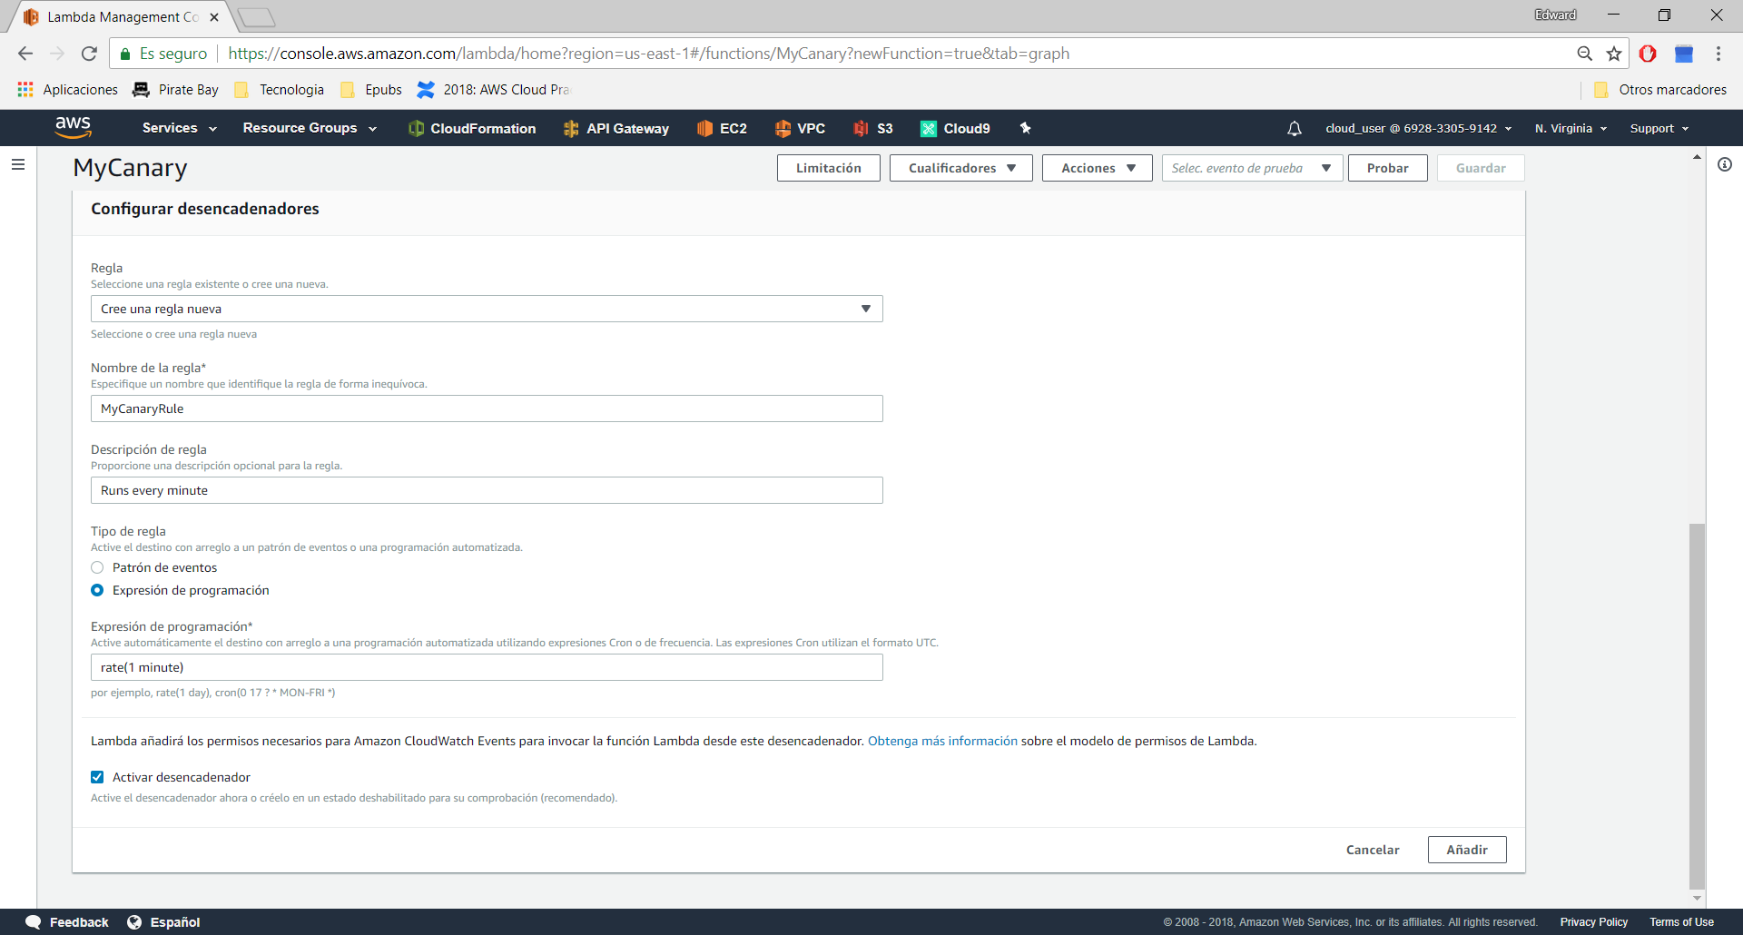

Añadir y Salvar

Pegar codigo Lambda:

https://github.com/123xedward/AWS_Lambda/blob/master/Canary/canary.py

Poner variables de entorno:

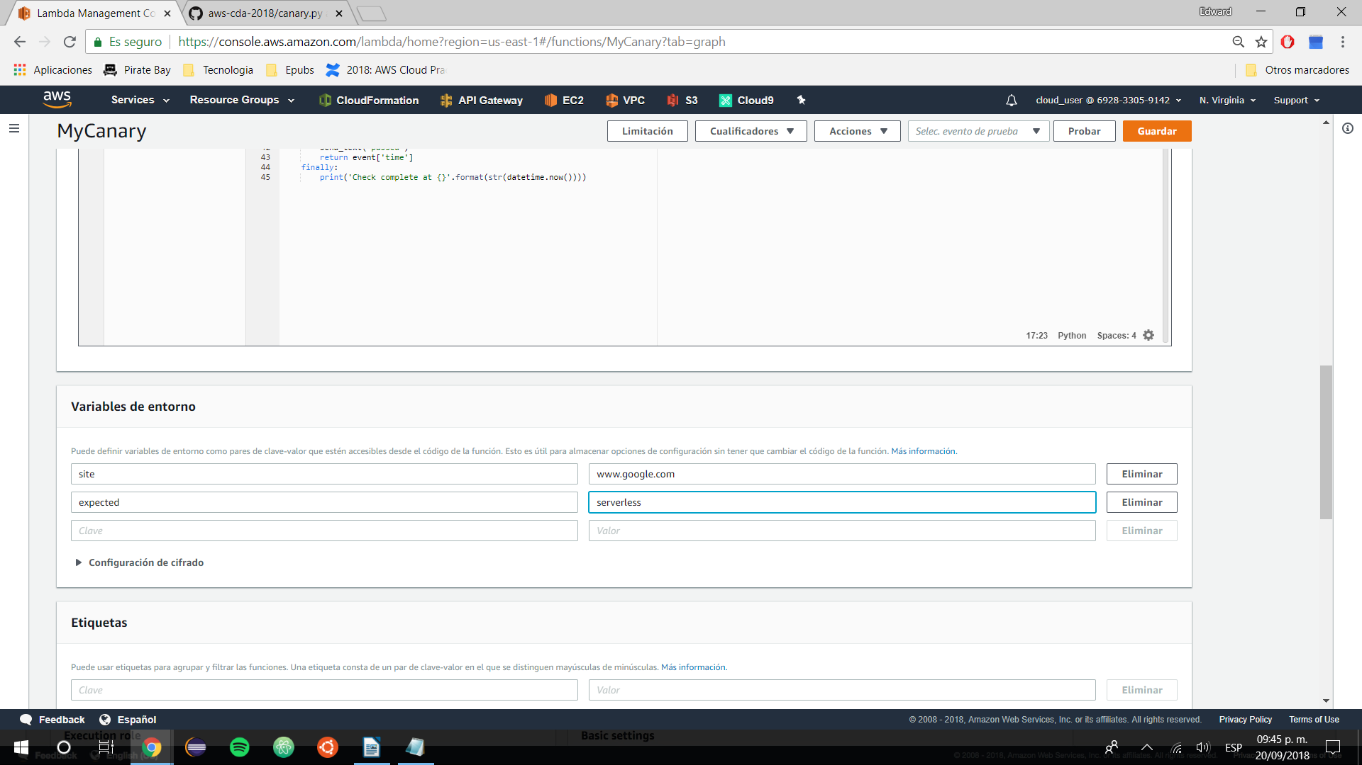

Probar:

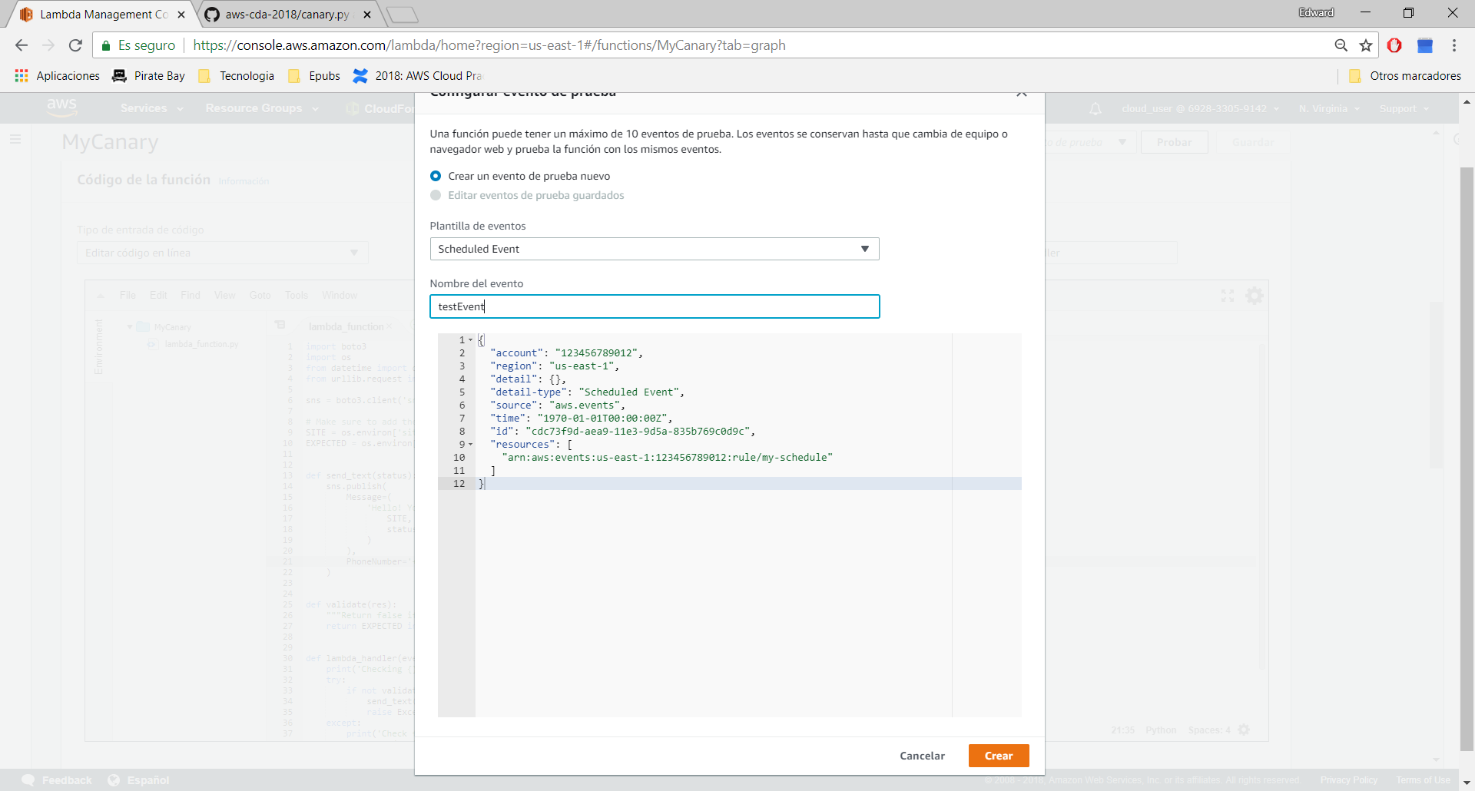

Enviara un sms al celular especificado.