Create Function 1:

https://github.com/123xedward/AWS_Lambda/blob/master/CanaryCodeDeployment/function1.py

Create Version 1

Later, create an Alias PROD.

APIGateway:

Create Structure

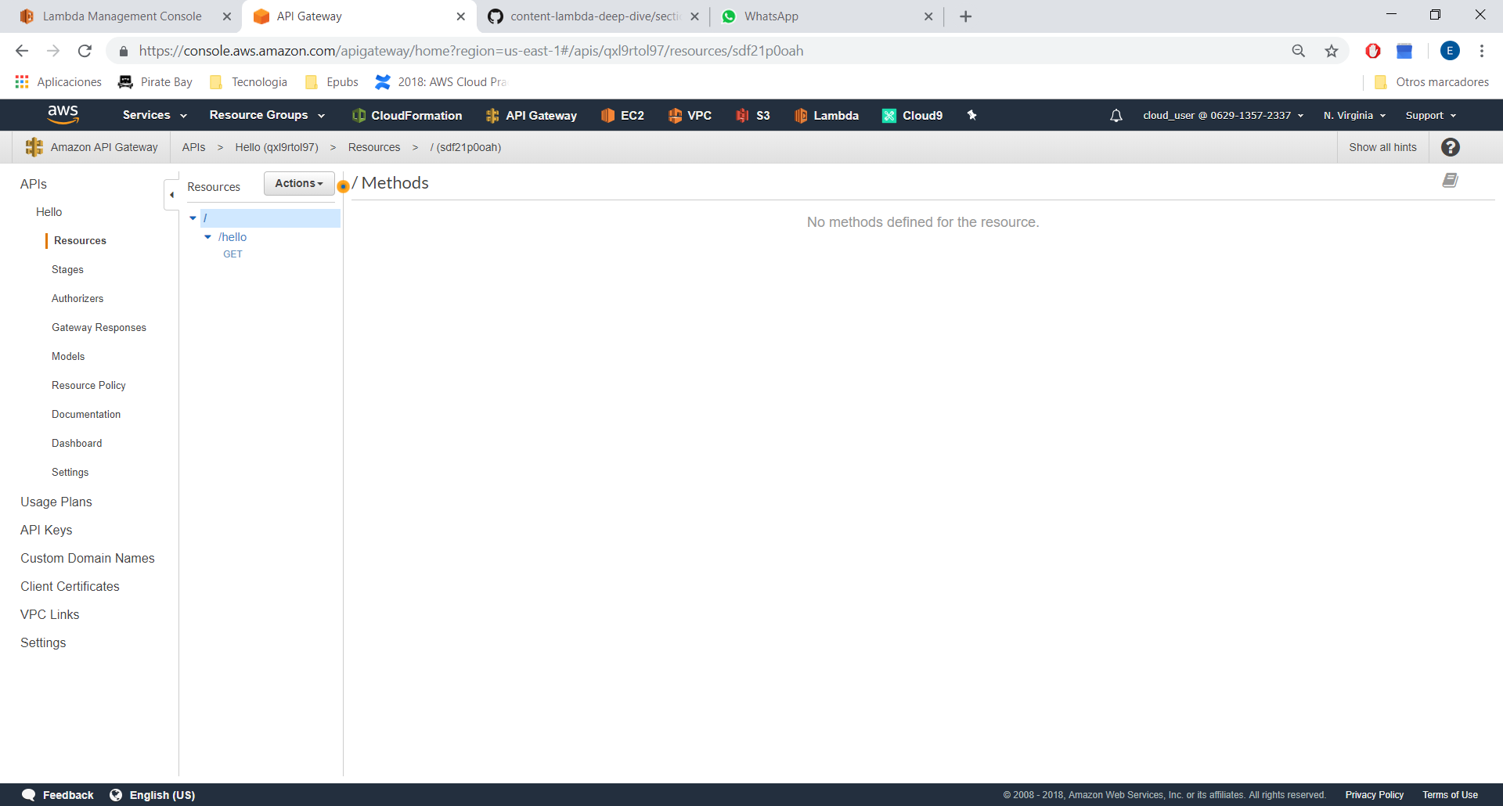

Get:

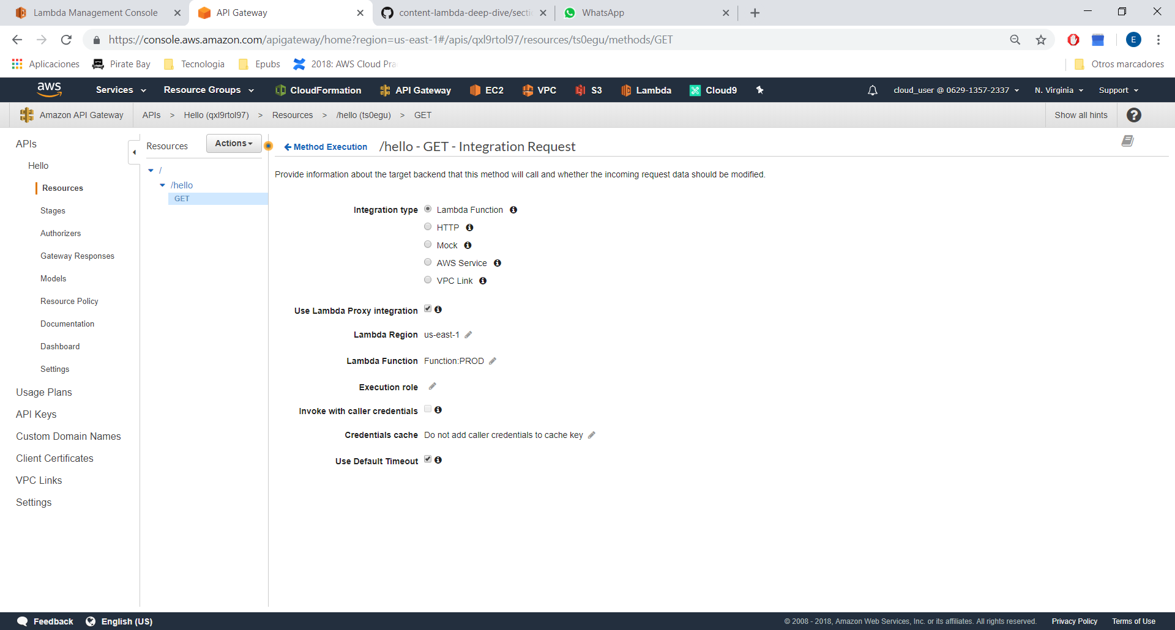

Important: Check Proxy Integration.

Return to Lambda:

Create Version 2 and attach to Alias PROD:

50%

