1) Creation of Lambda Function

2) Creation of API Gateway

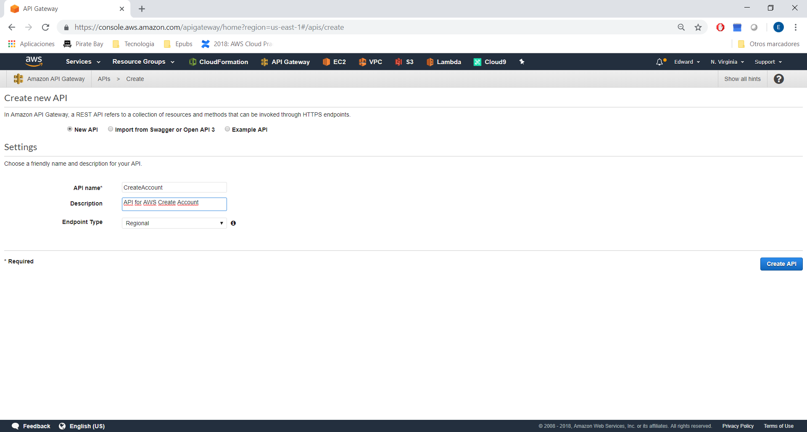

Create the resources:

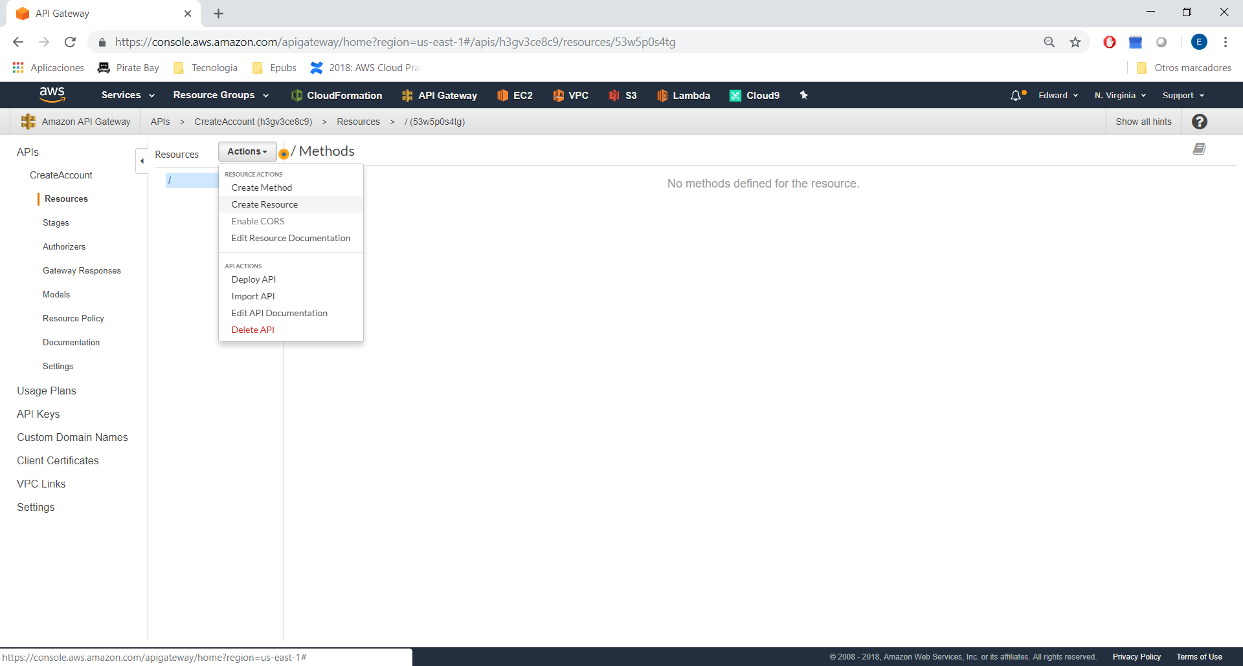

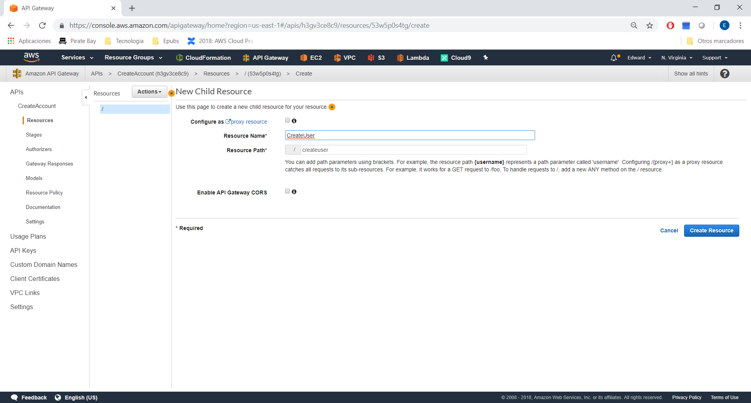

Create the HTTP Method:

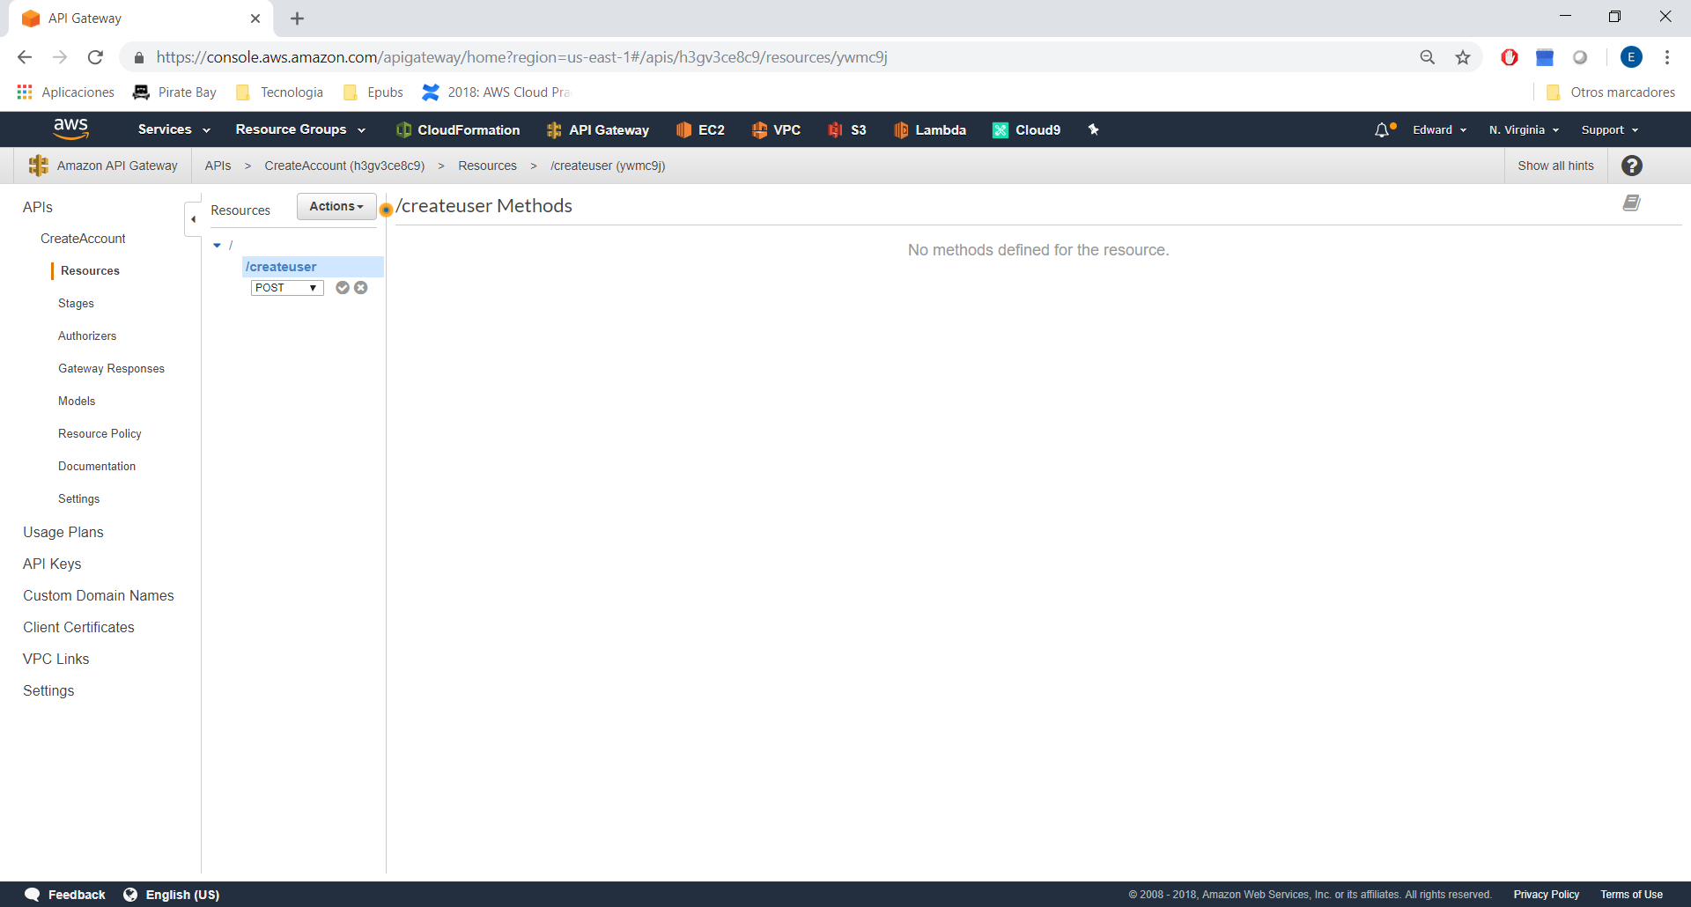

Choose Lambda Function:

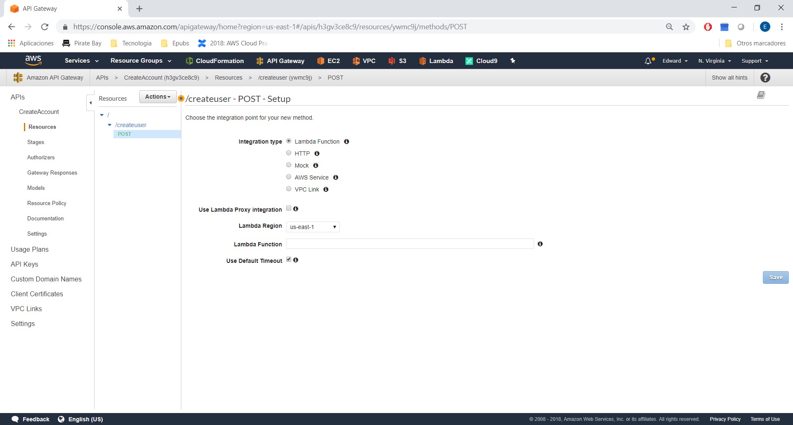

And select the lambda function (not ready yet), in this case choose Mock.