LambdaLexRole:

Check policy in github.

Create Lambda

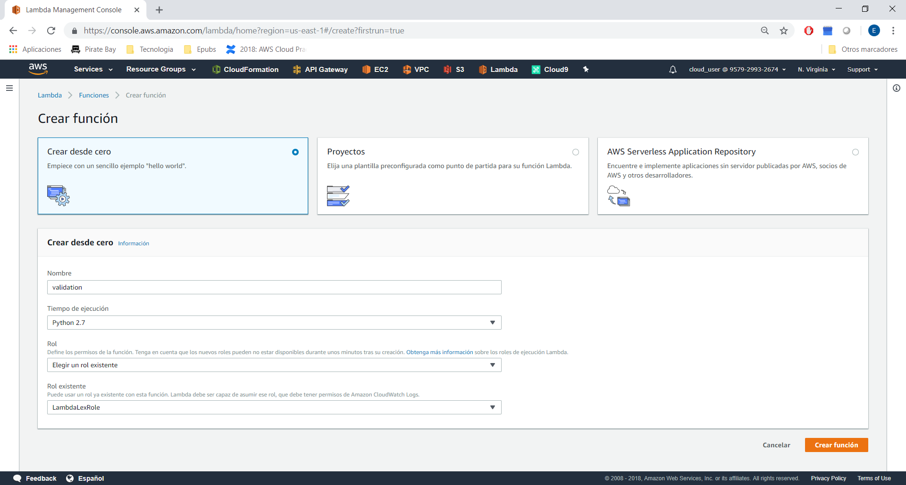

Copy the code of github:

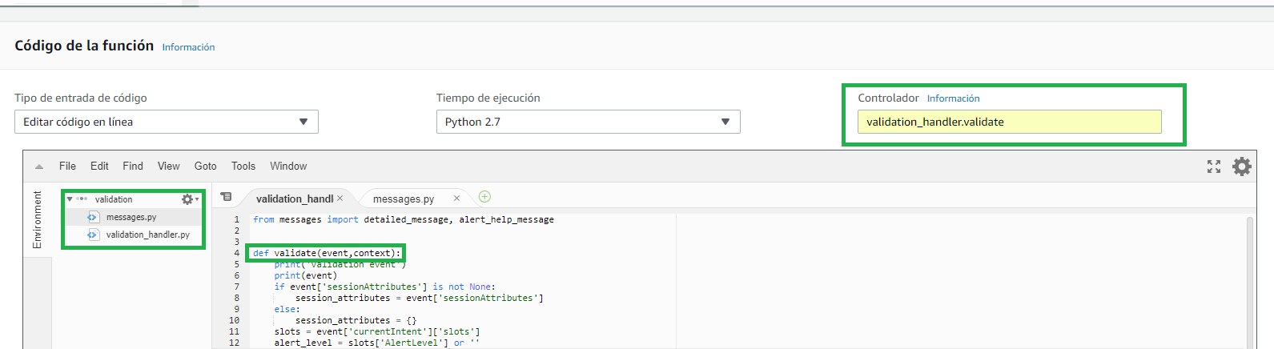

Create another lambda:

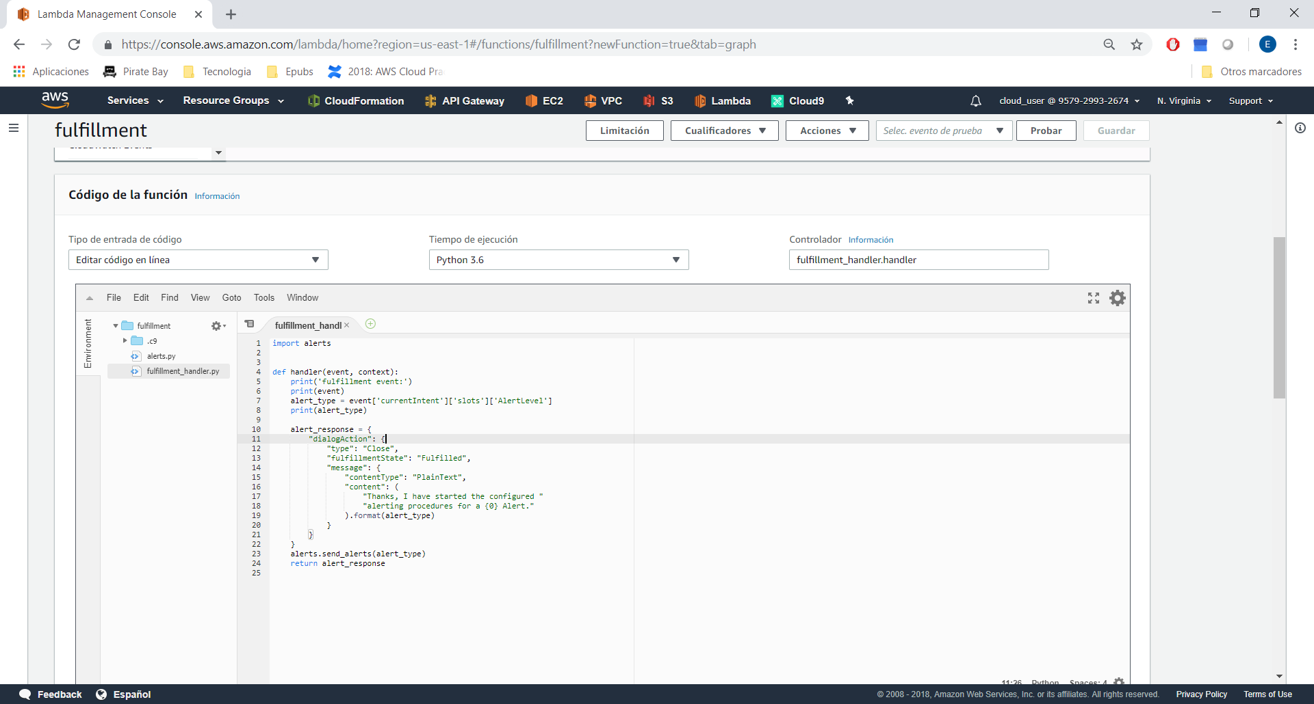

Creating Lex Bot.

Choose Amazon Lex → Get Started → Custom Bot

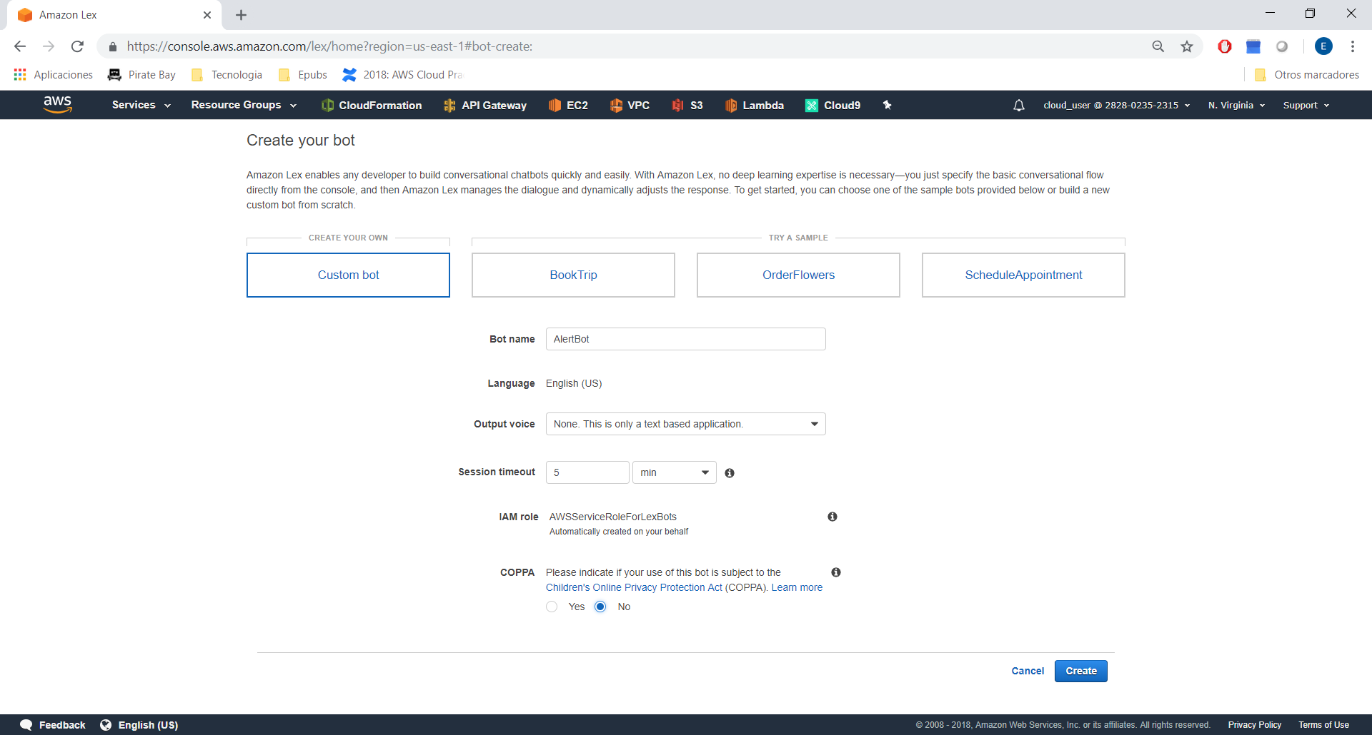

Create Intent →

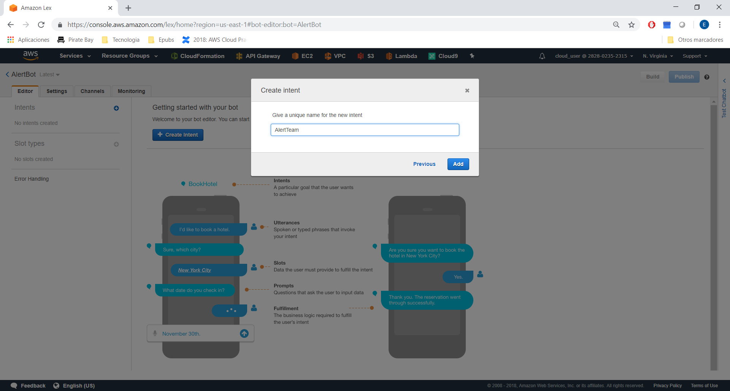

And add sample utterances:

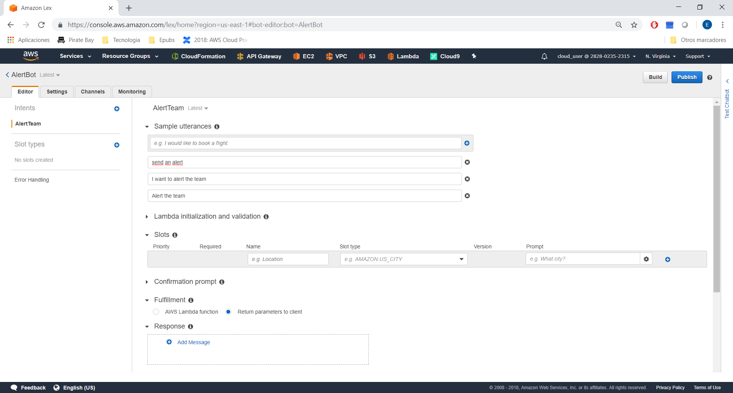

Save Intent.

Create a Slot type:

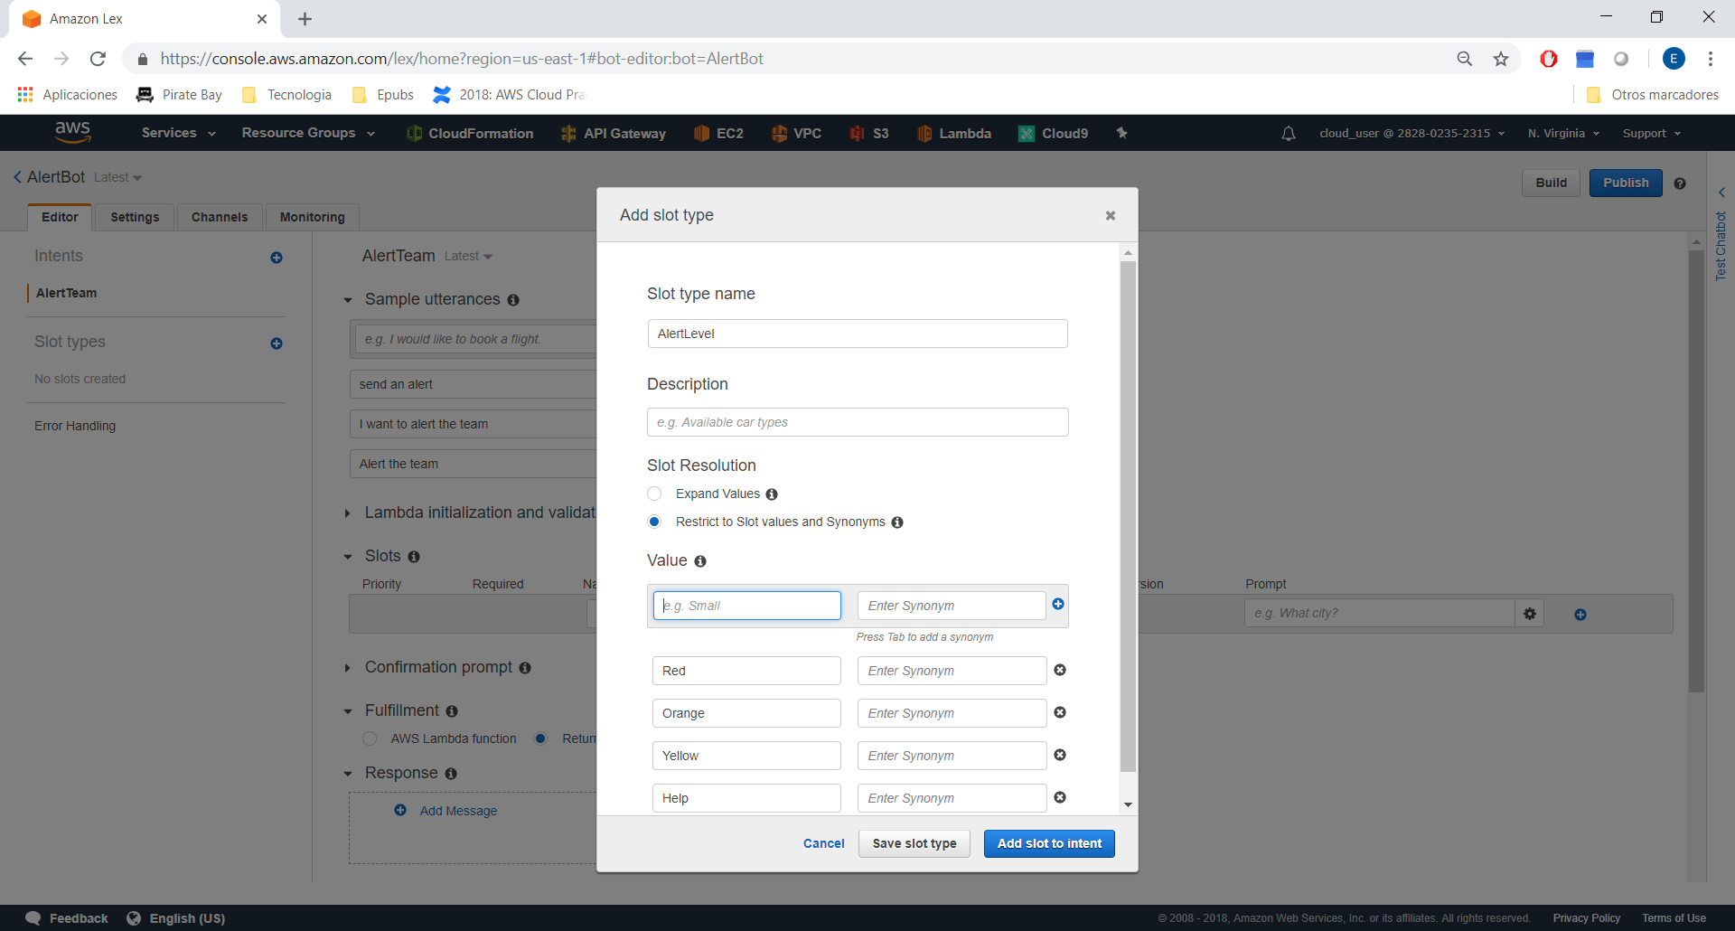

After Save Slot Type, check this configuration:

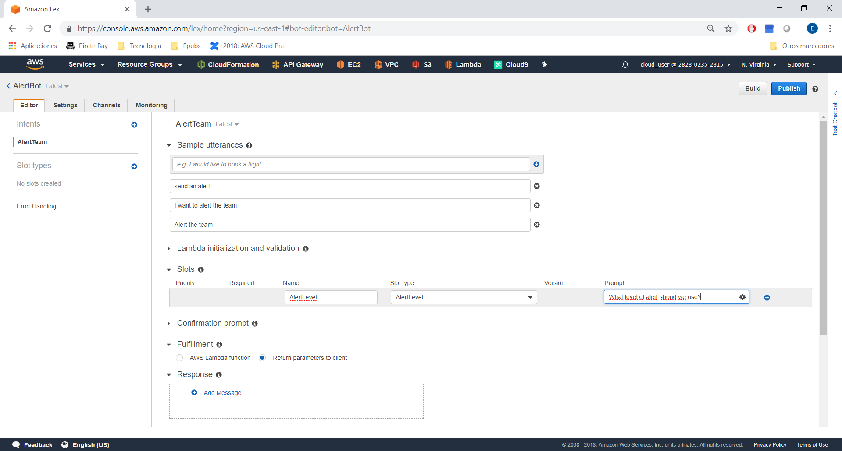

Build & Test:

Check this configuration:

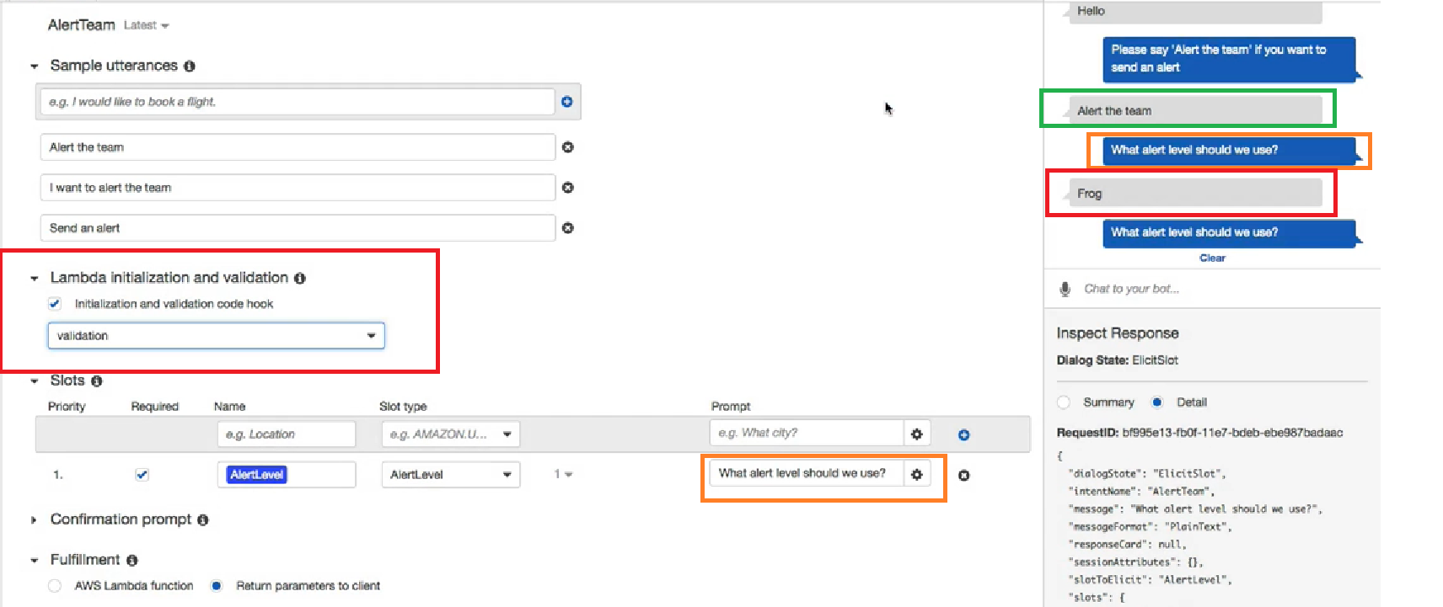

For example, if user type frog, we should use “validation” lambda.

