Diagram:

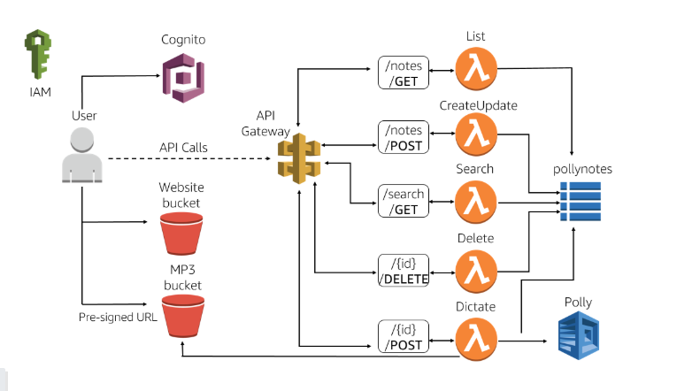

Cognito:

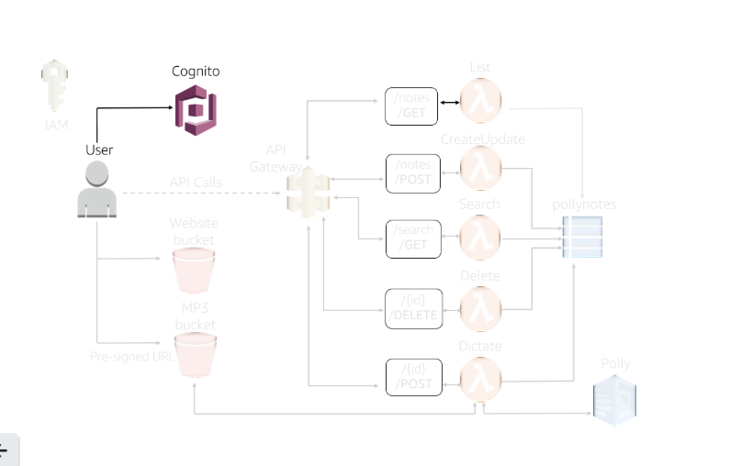

Cognito → Manage user pools

→ Create a user pool

PollyNotesPool

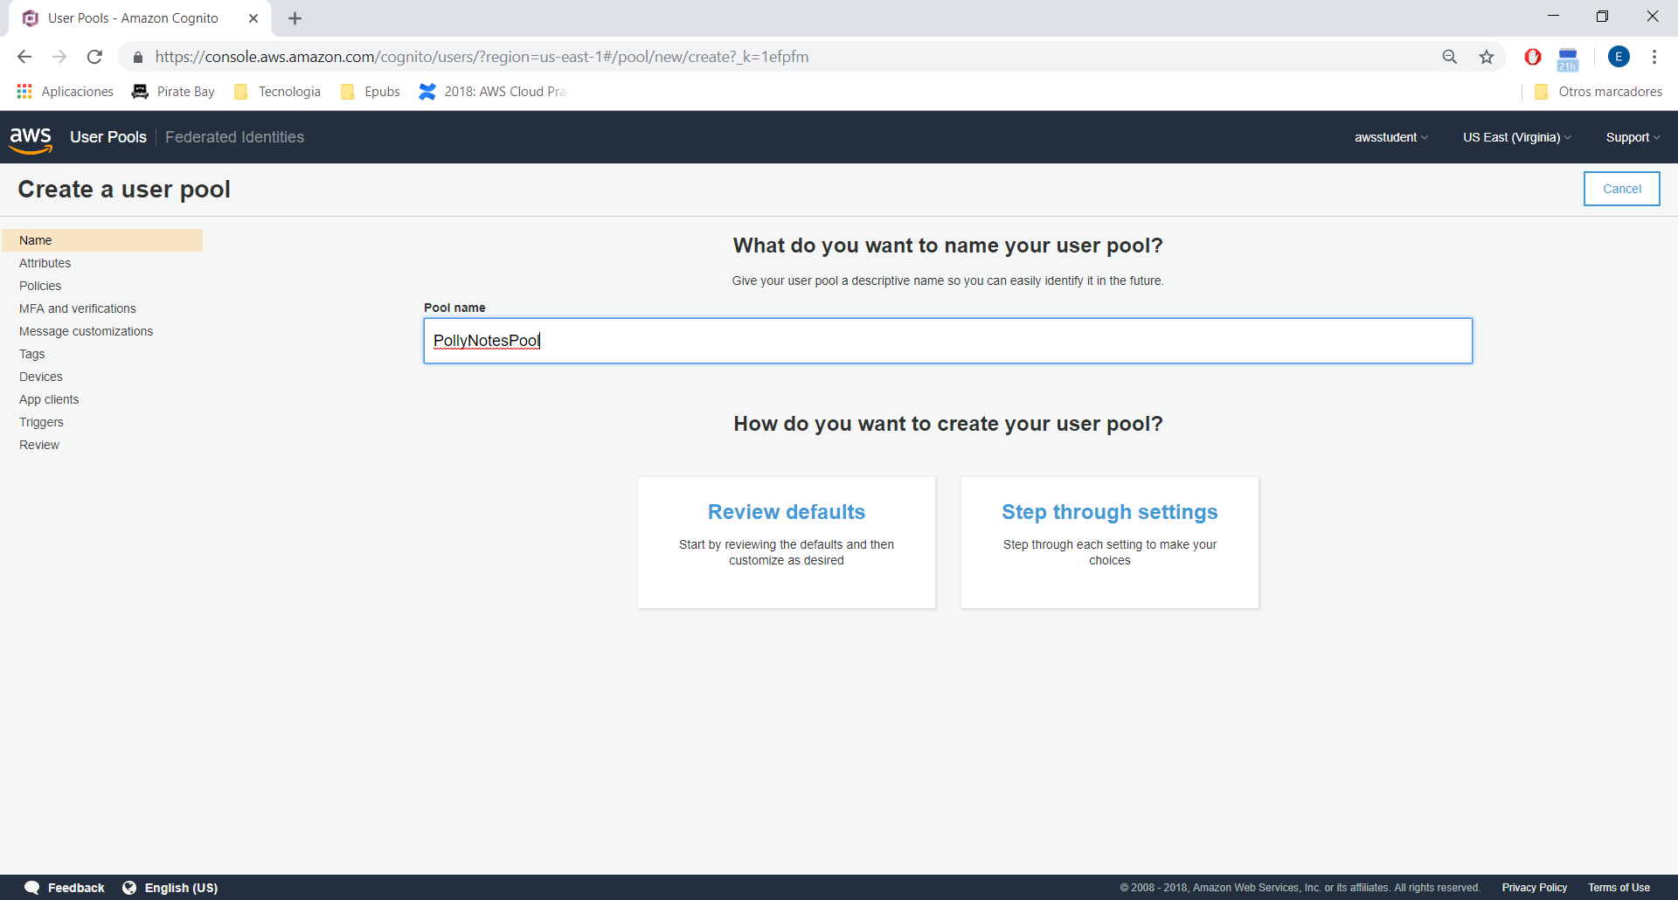

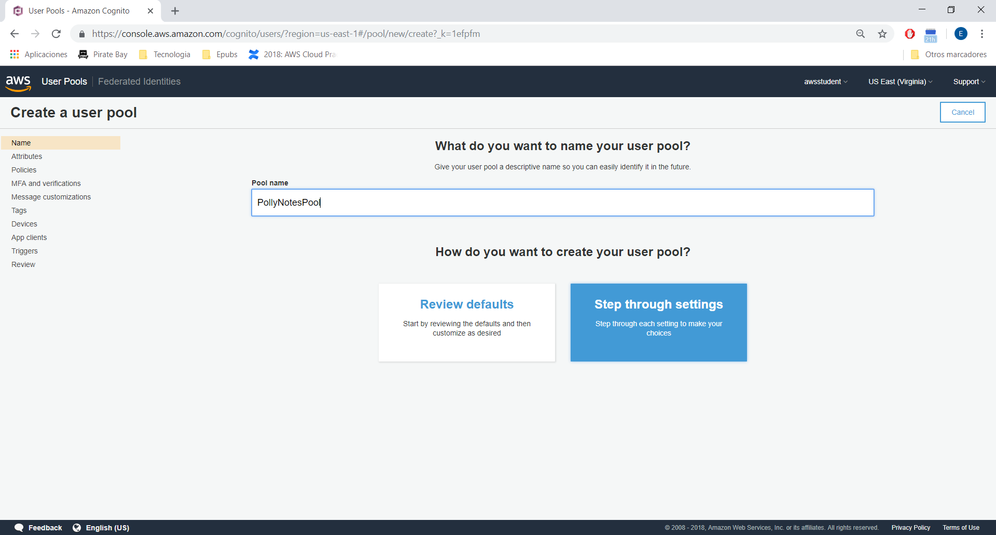

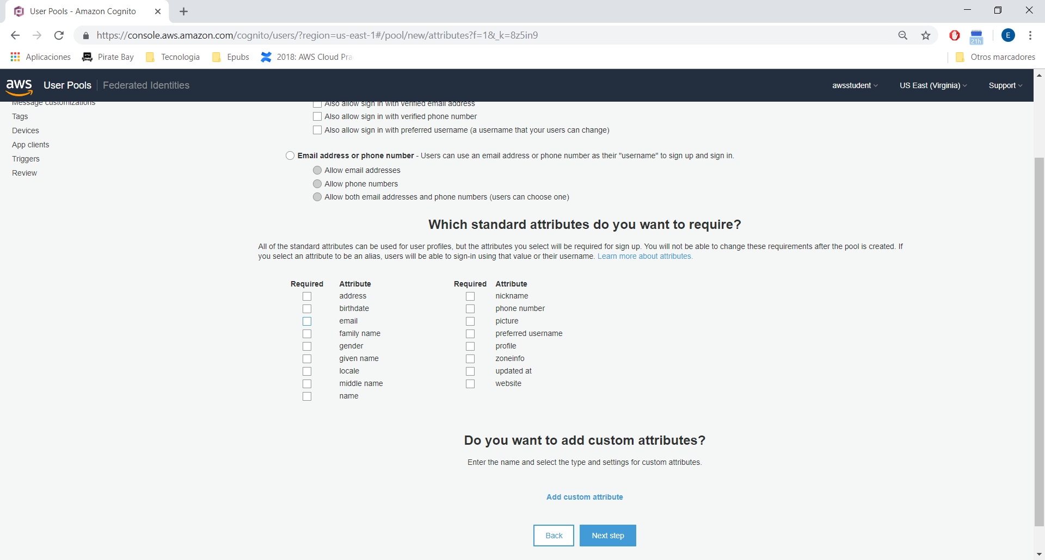

Next, next until App client:

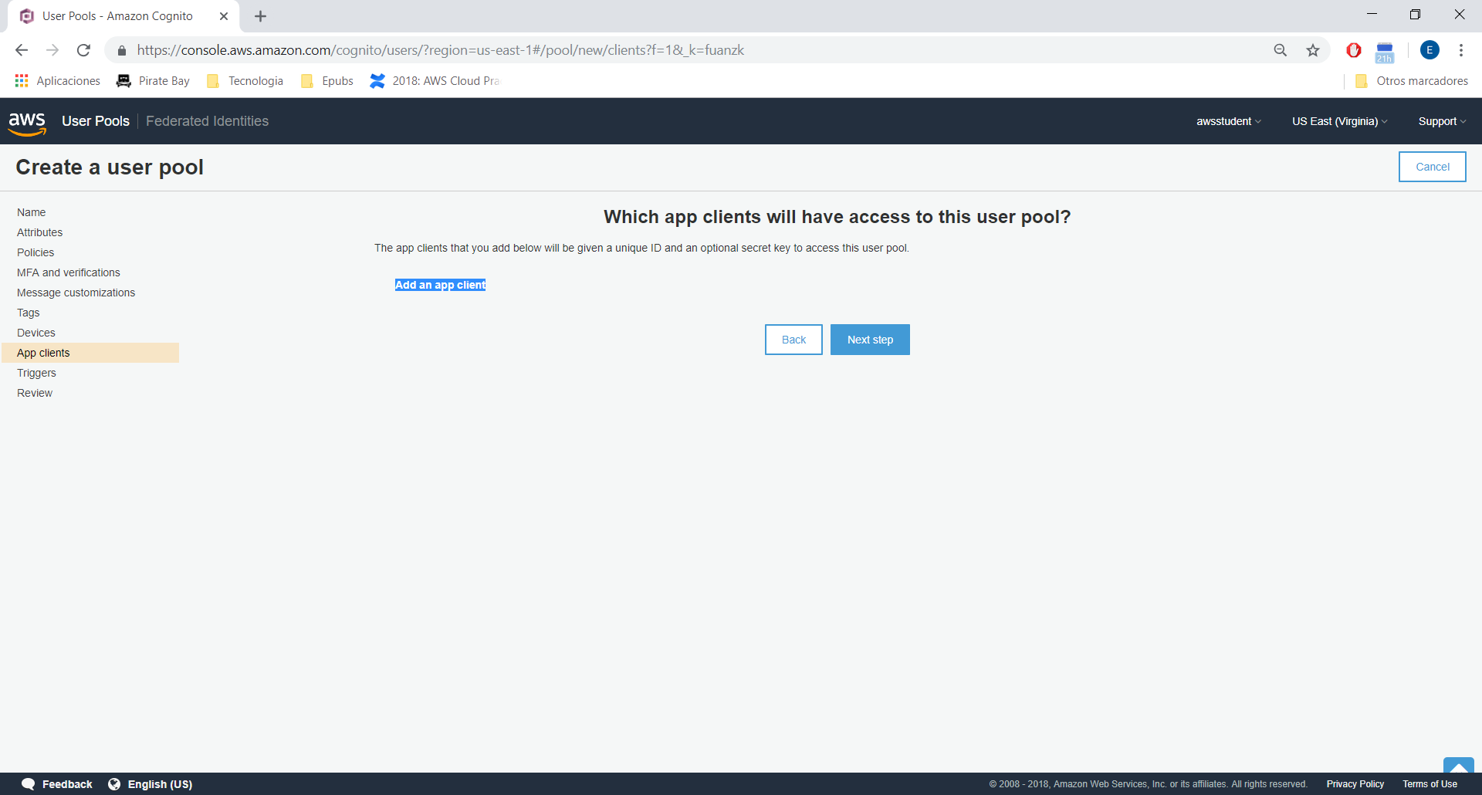

Add app client:

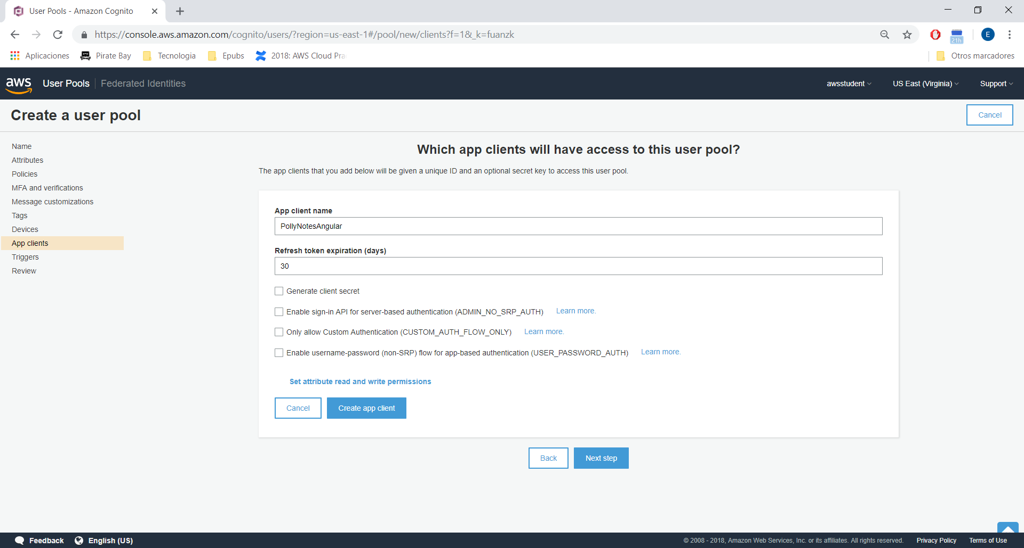

Check the ARN:

Pool ARN arn:aws:cognito-idp:us-east-1:674585477089:userpool/us-east-1_NI4wLNOhd

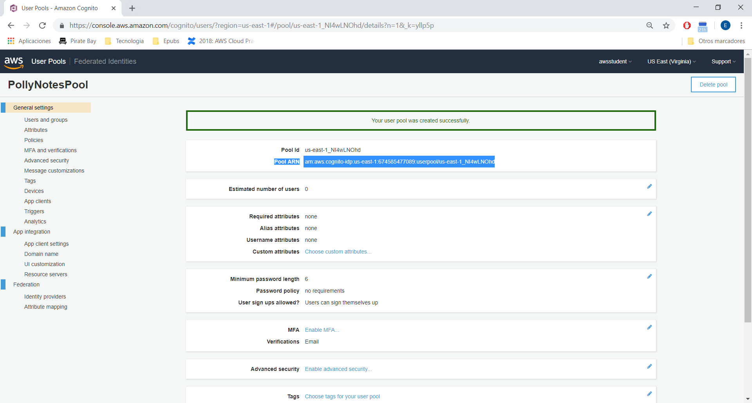

In left pane → App clients (click), and save App client id:

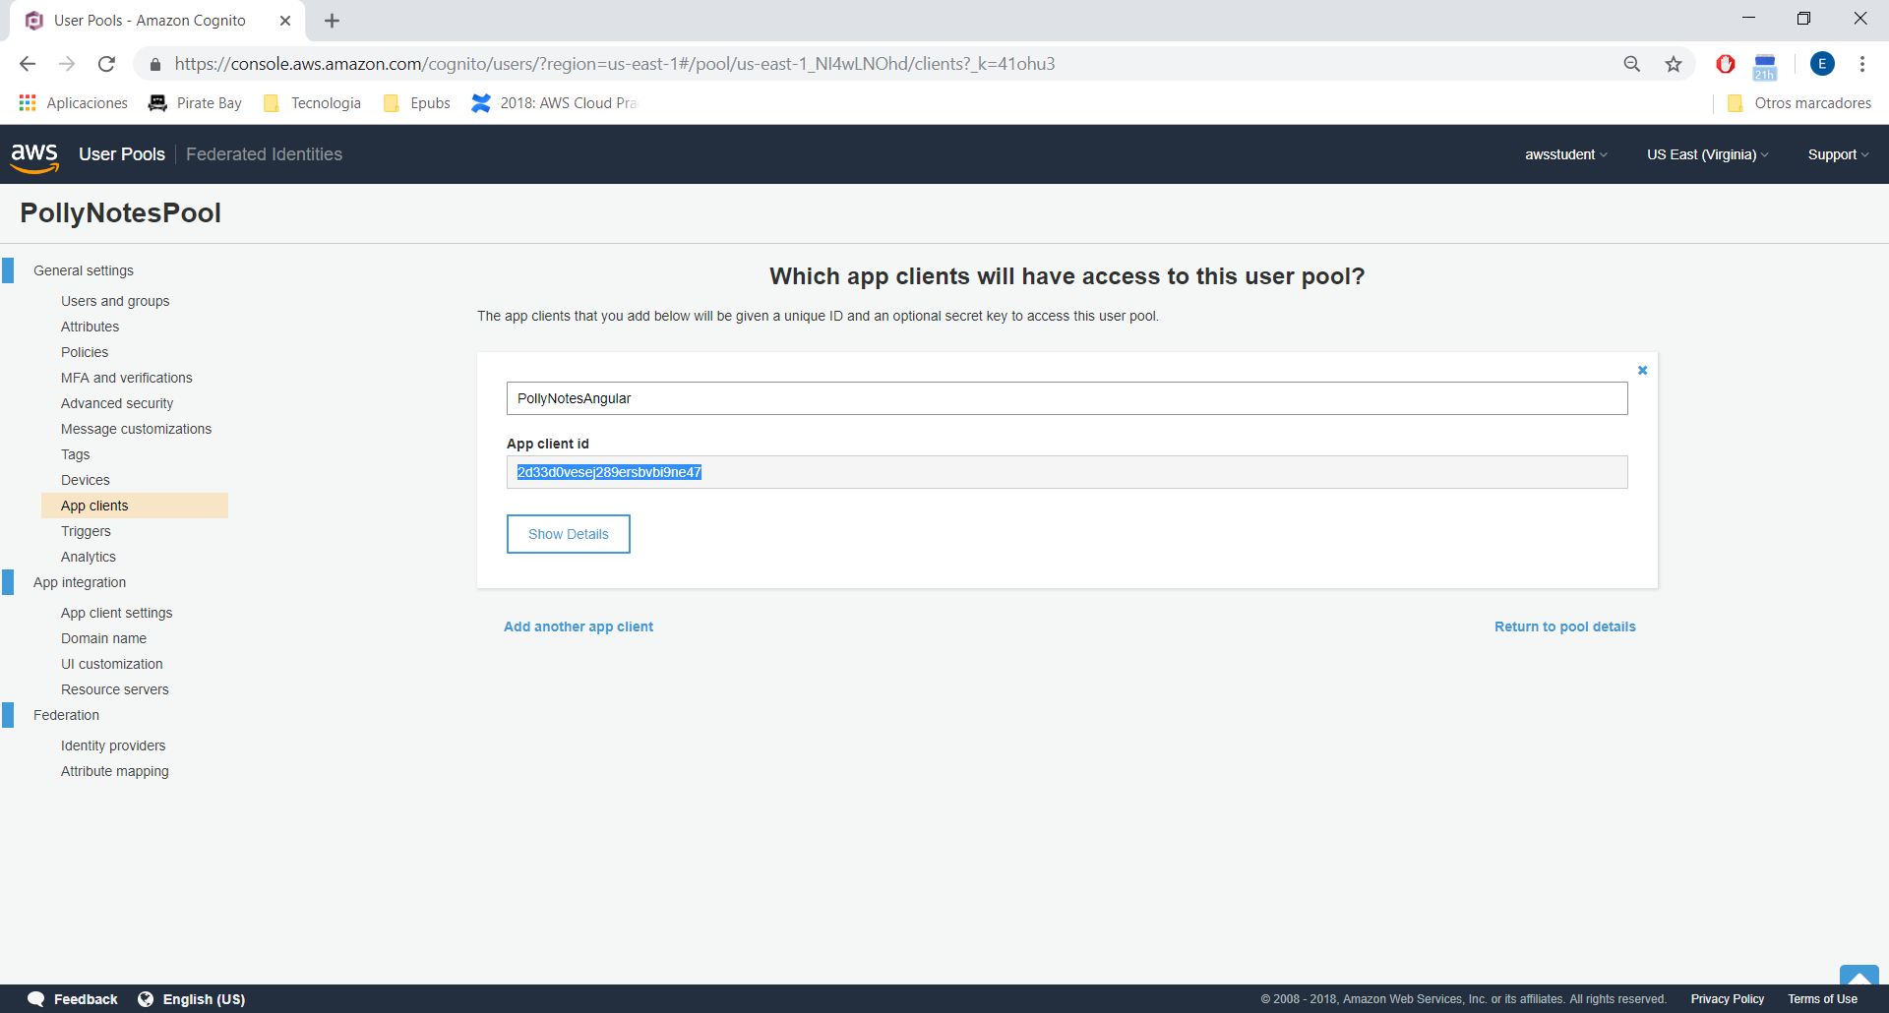

Creating a user for the Cognito User Pool:

aws cognito-idp sign-up --client-id change-me_app-client-id --username student --password student

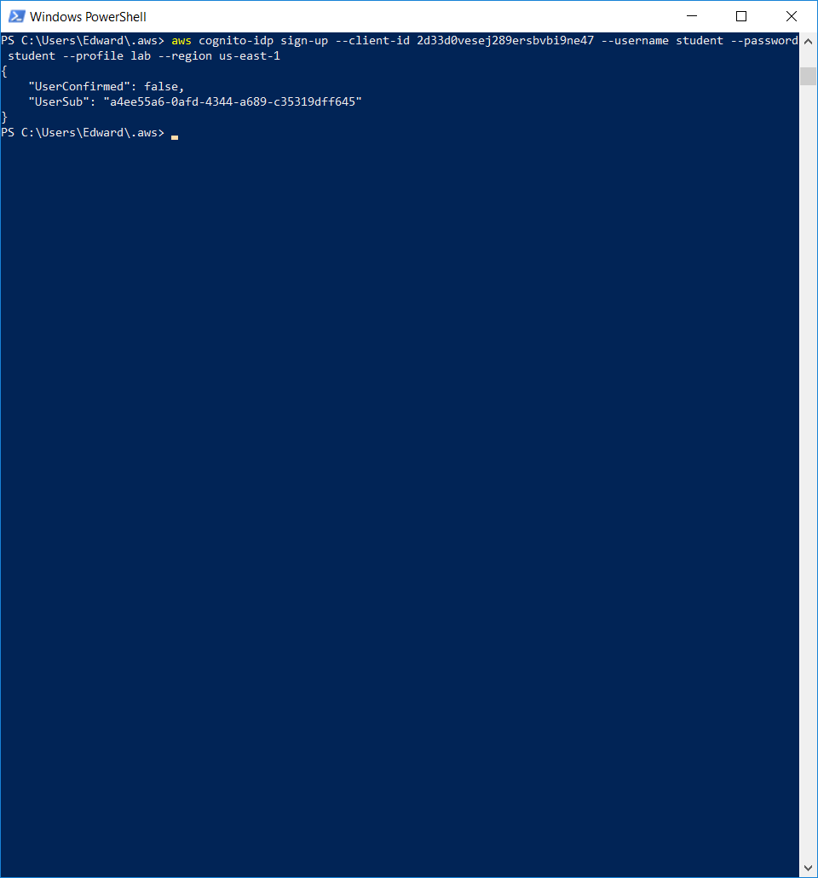

Confirm:

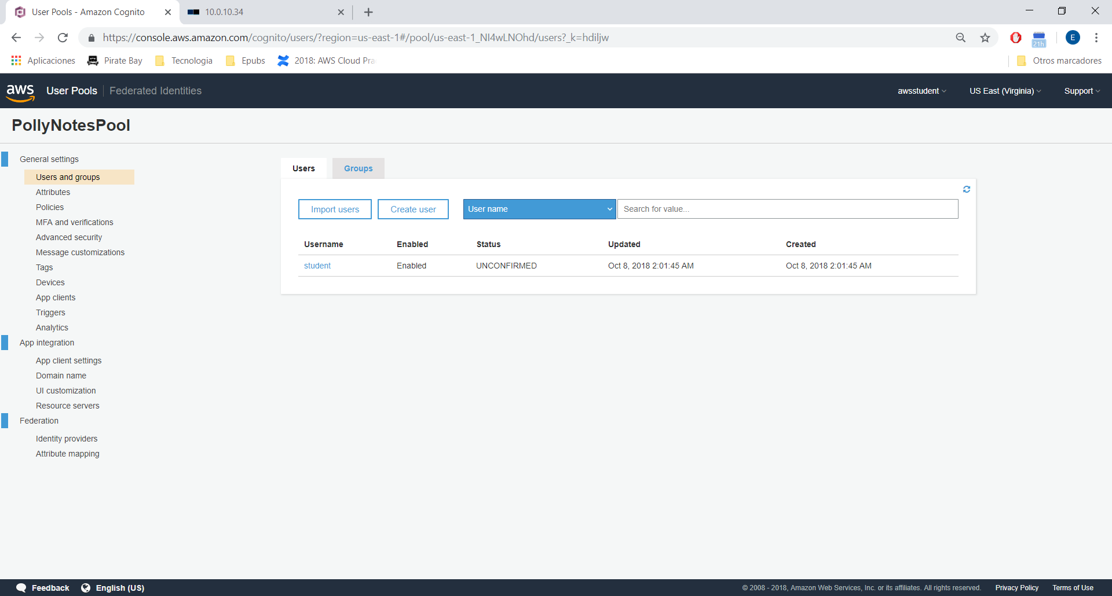

aws cognito-idp admin-confirm-sign-up --user-pool-id change-me_pool-id --username student

Real:

aws cognito-idp admin-confirm-sign-up --user-pool-id us-east-1_NI4wLNOhd --username student --profile lab --region us-east-1

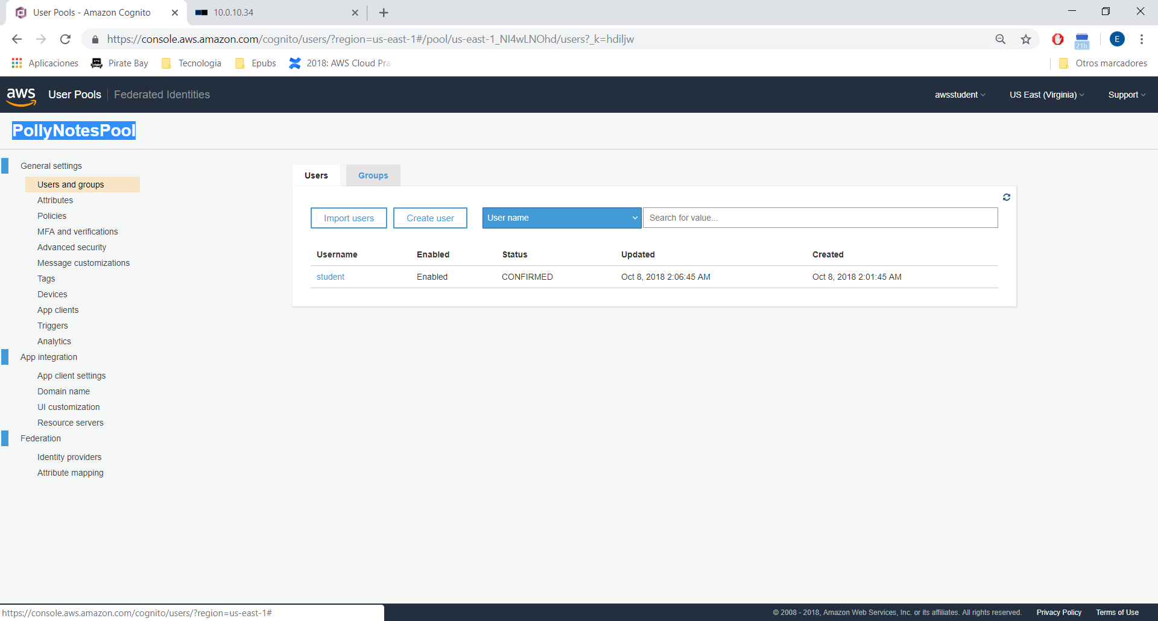

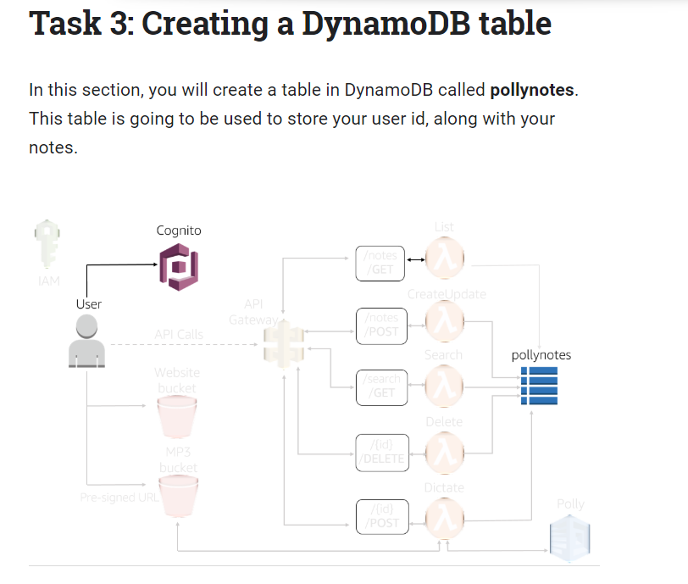

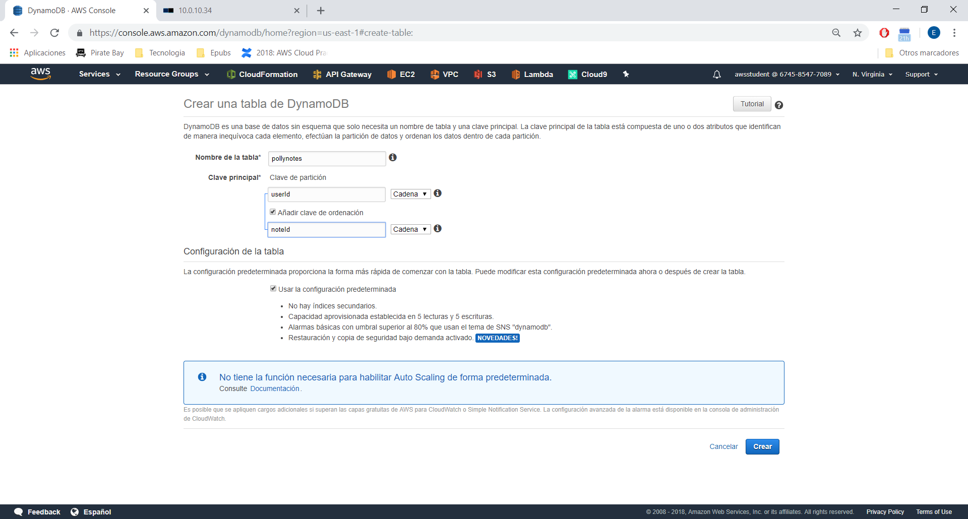

Add item:

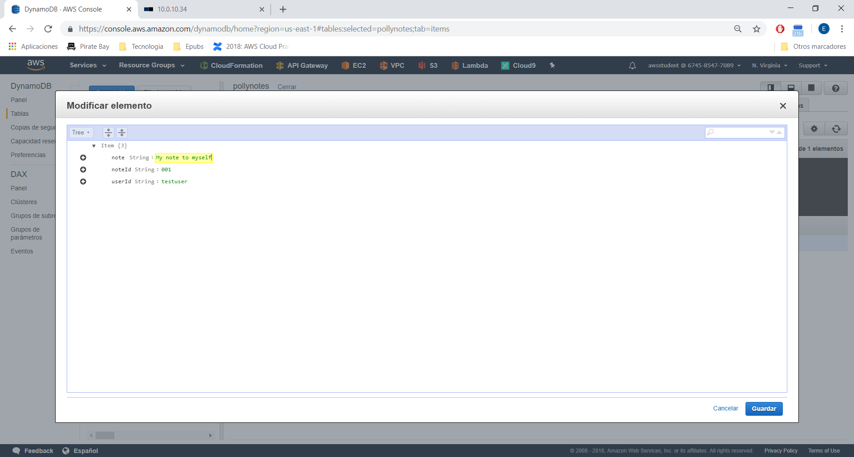

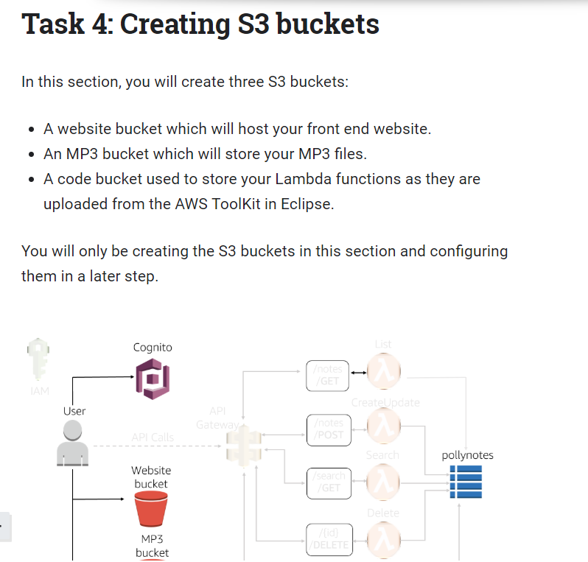

polly-notes-web-<firstname>-<lastname>

polly-notes-mp3-<firstname>-<lastname>

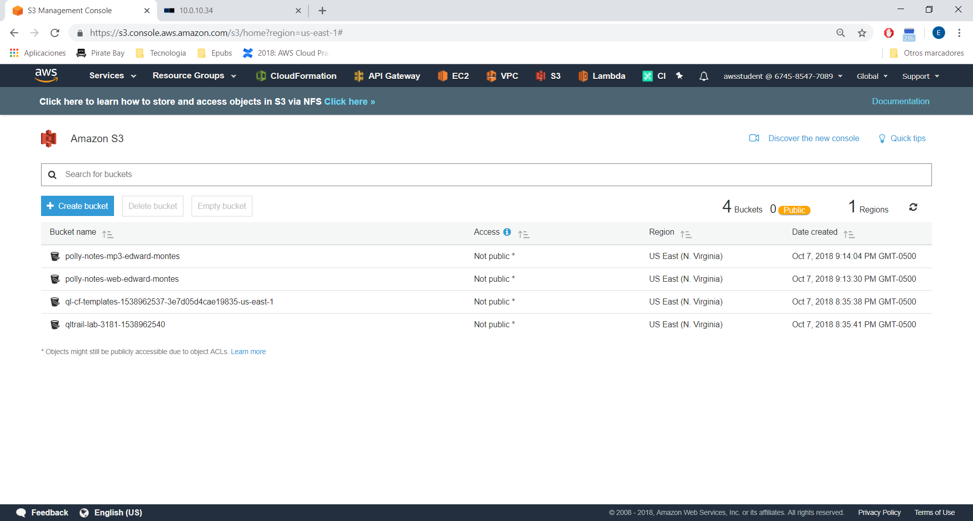

Create code Bucket:

polly-notes-code-<firstname>-<lastname>

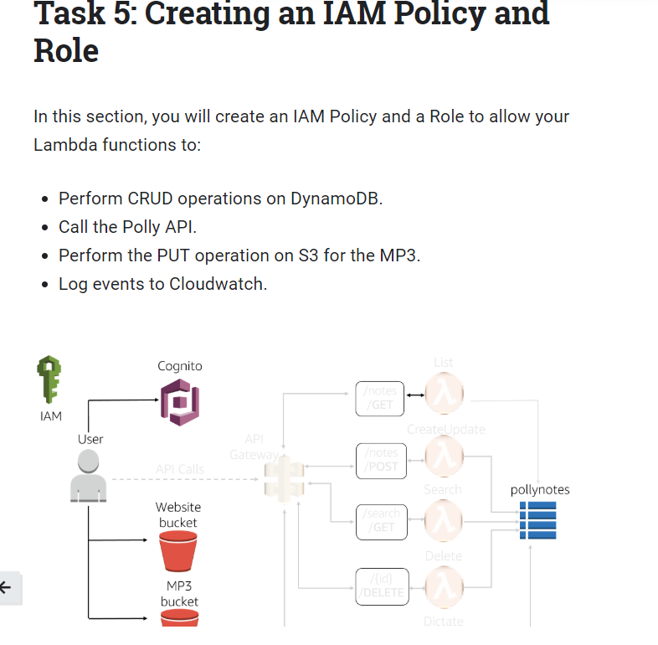

Create policy.json

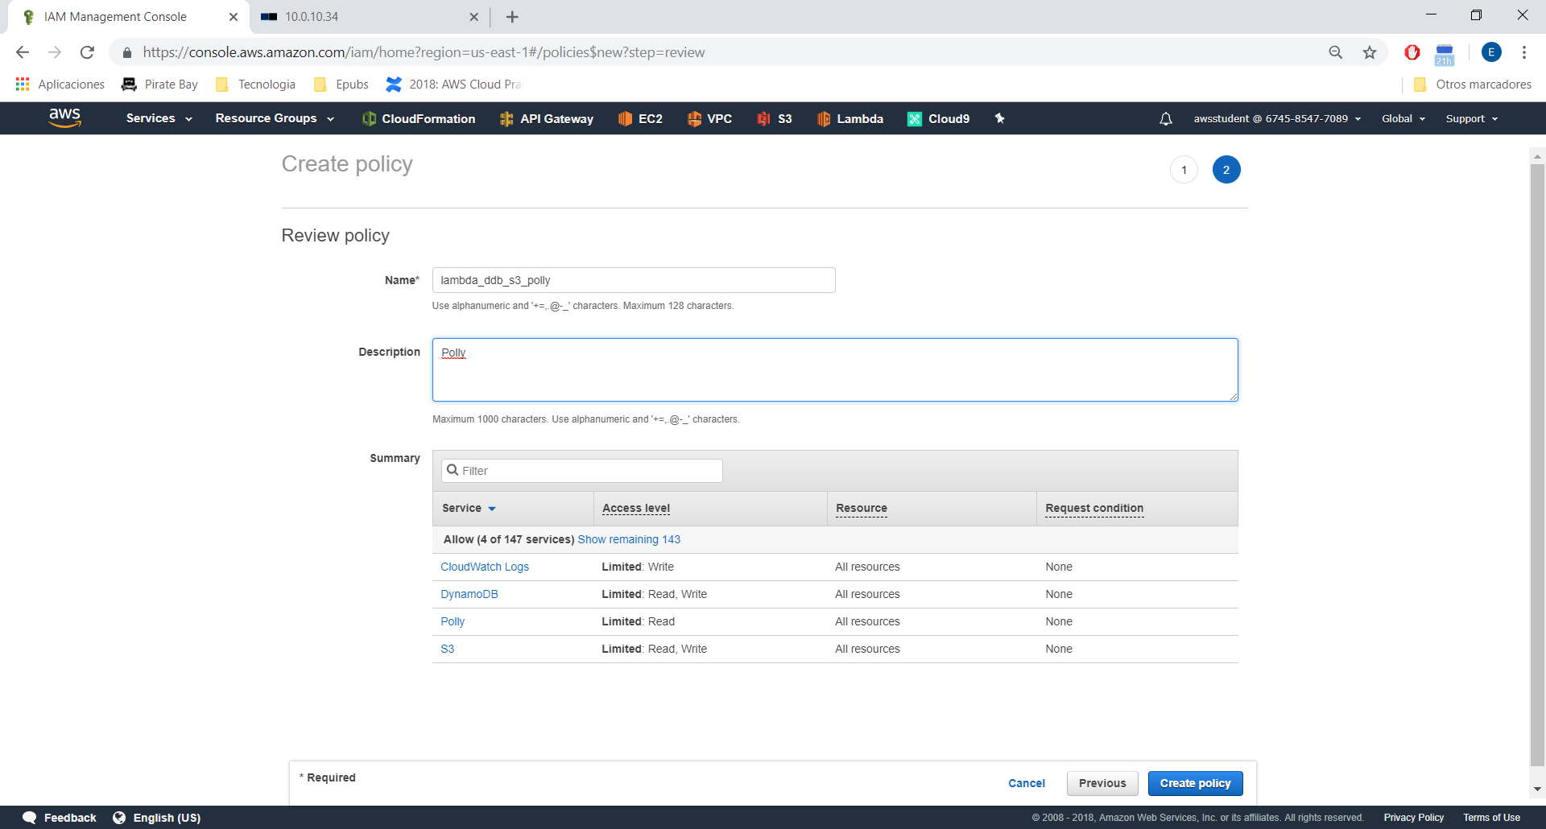

Create the Role

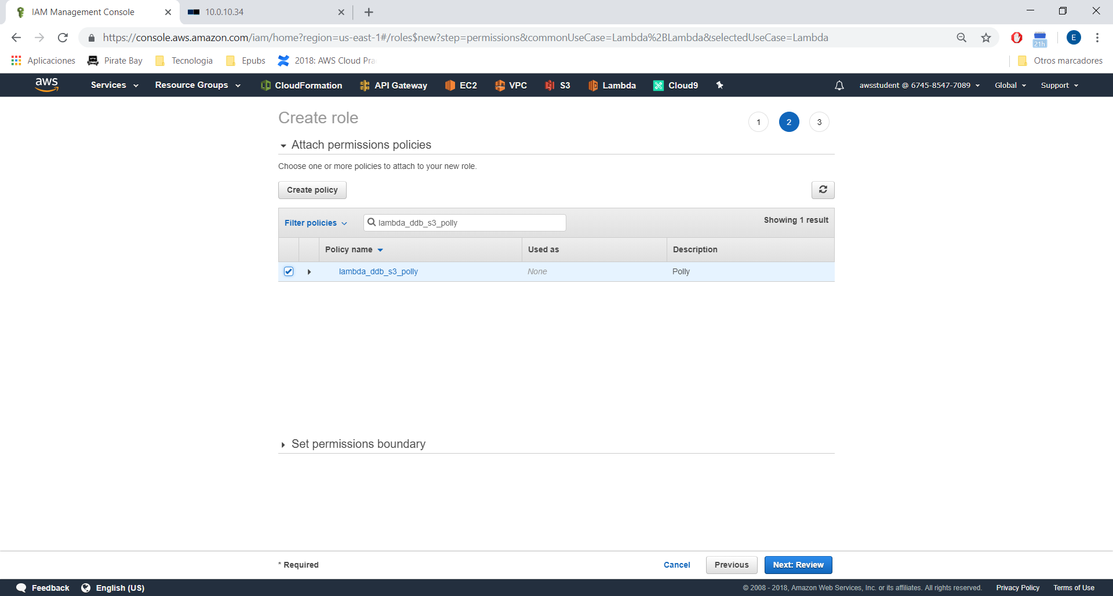

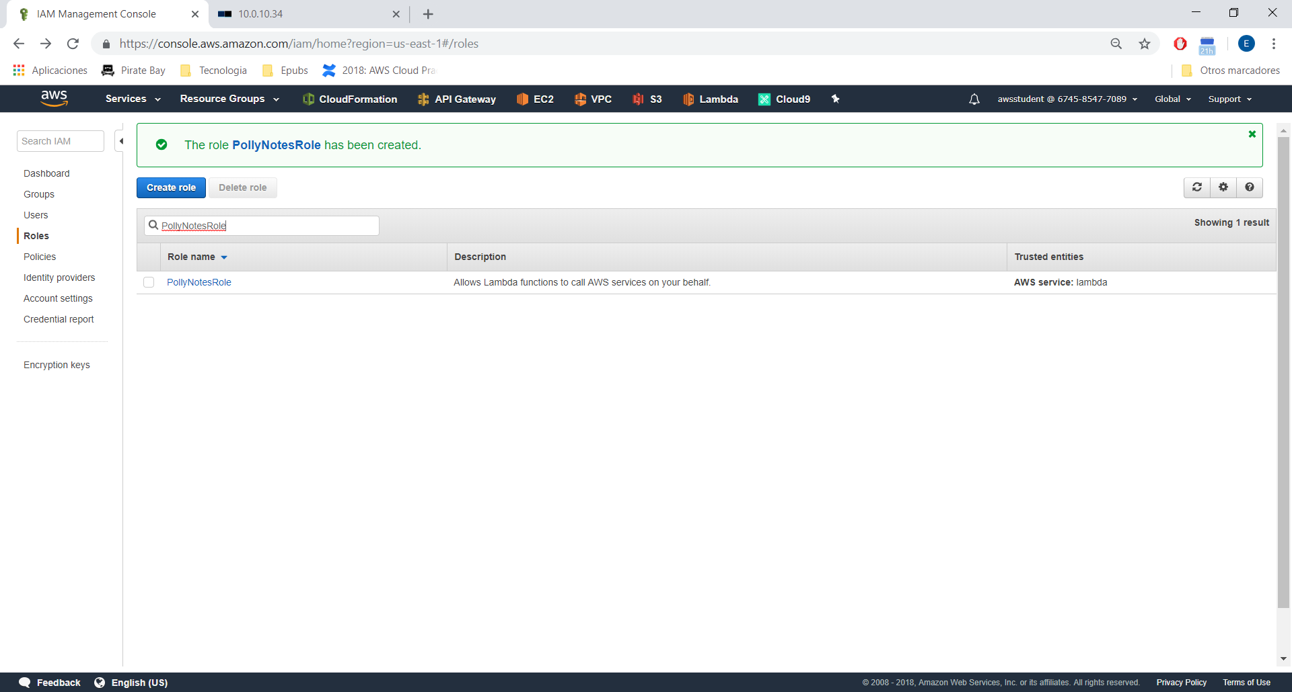

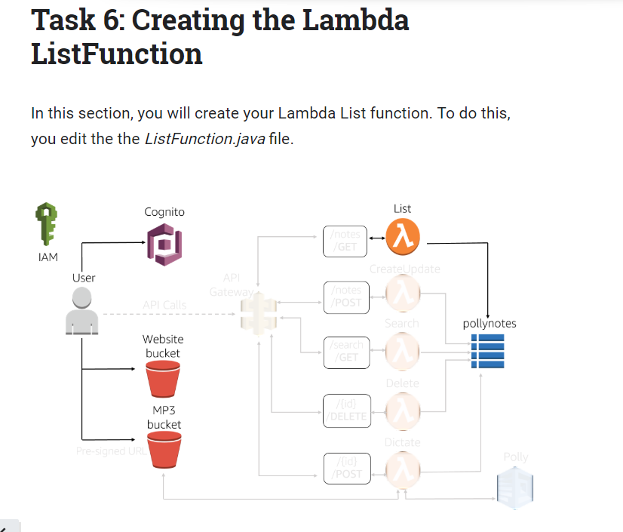

Check java classes in the project (XXXXSolution.java)

Create the artefact and upload.

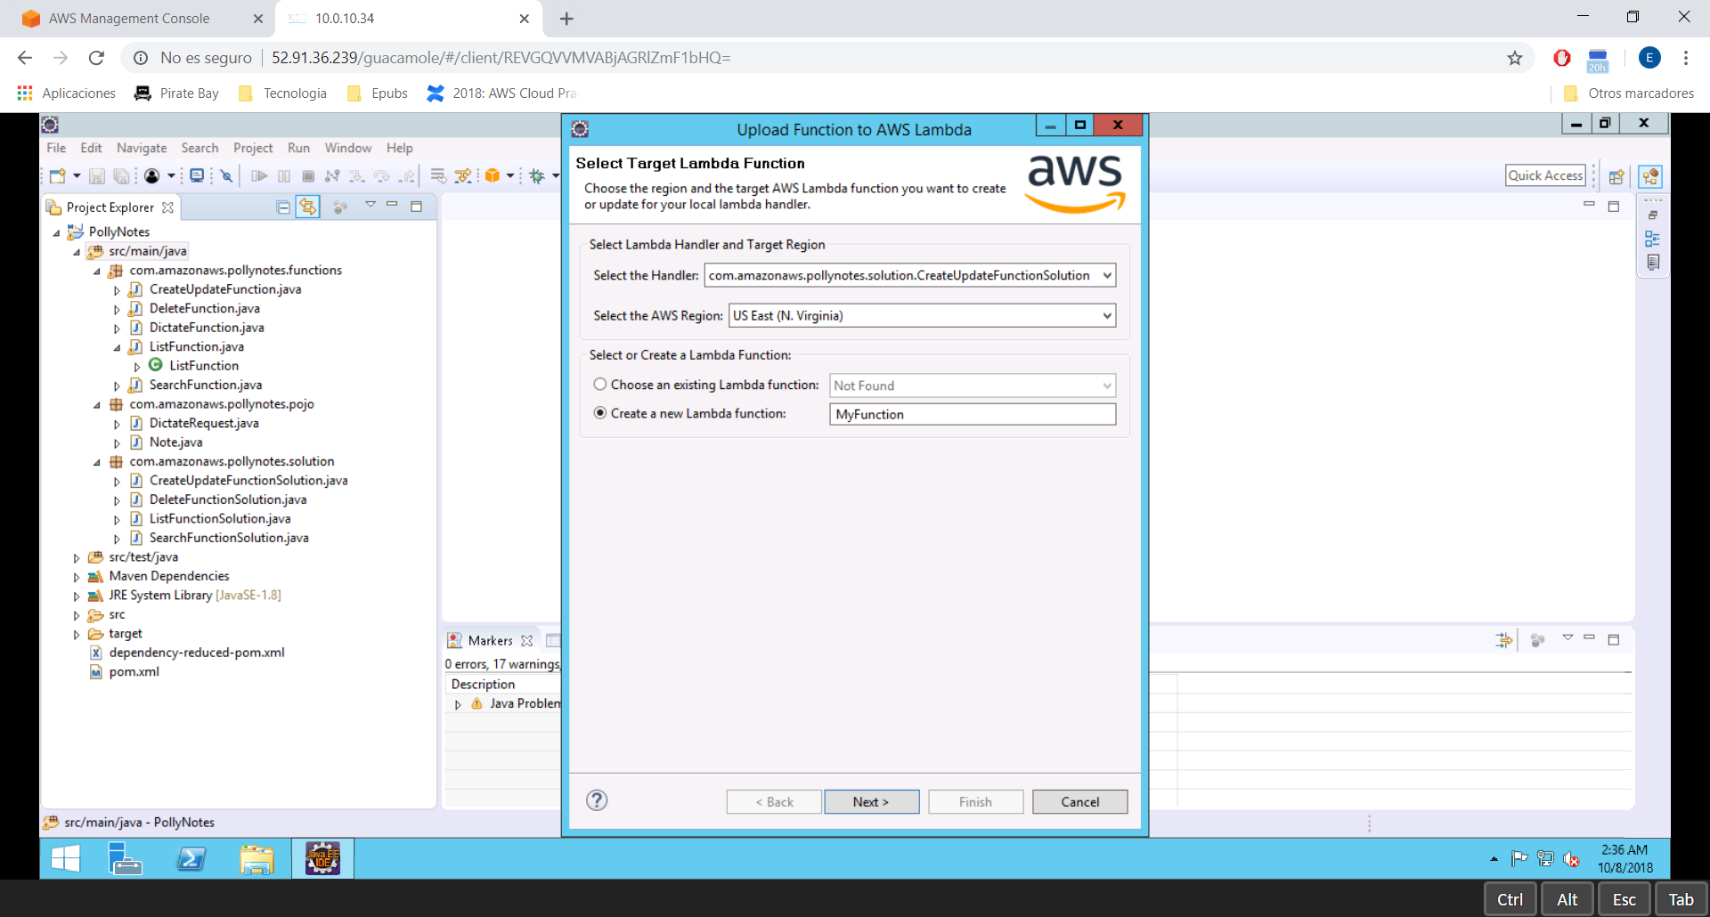

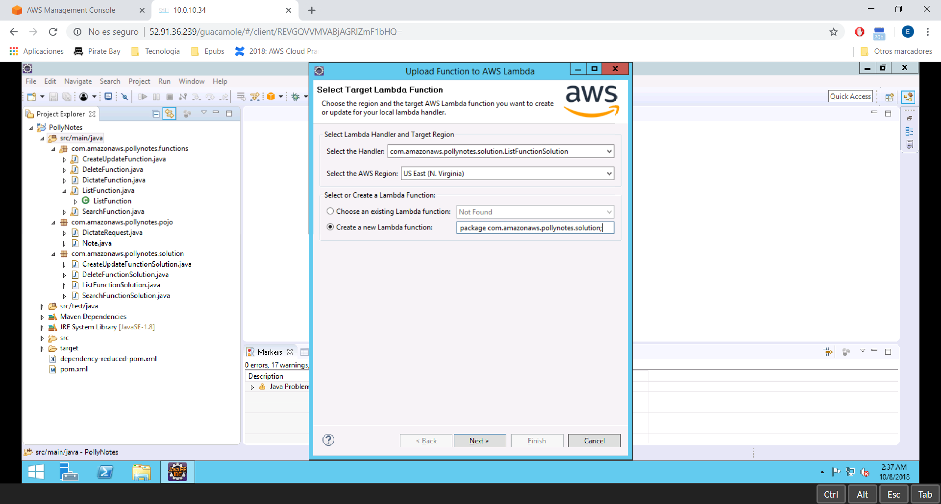

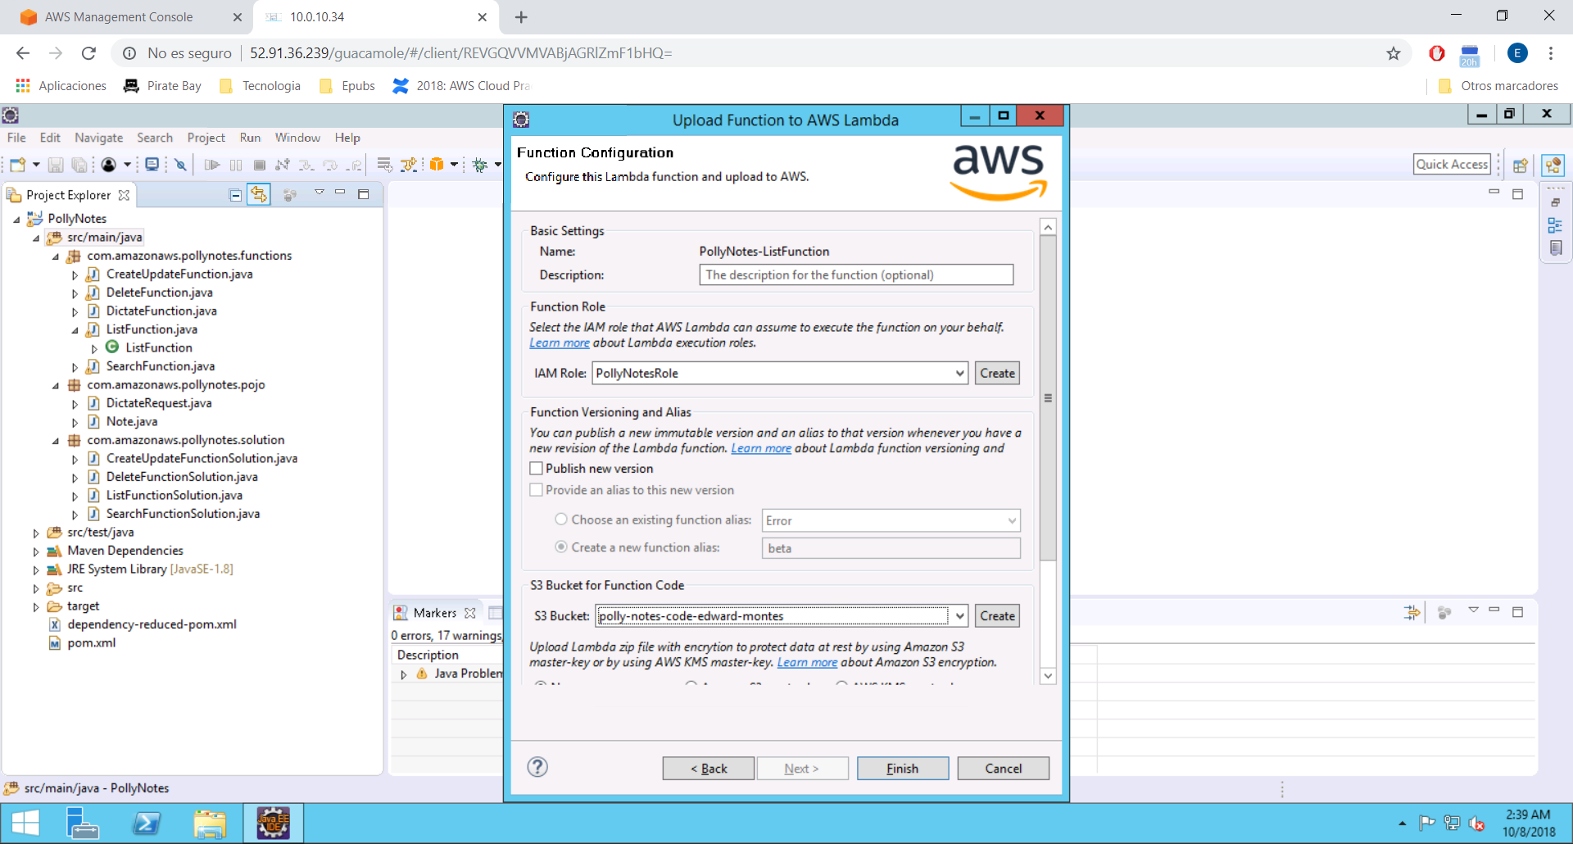

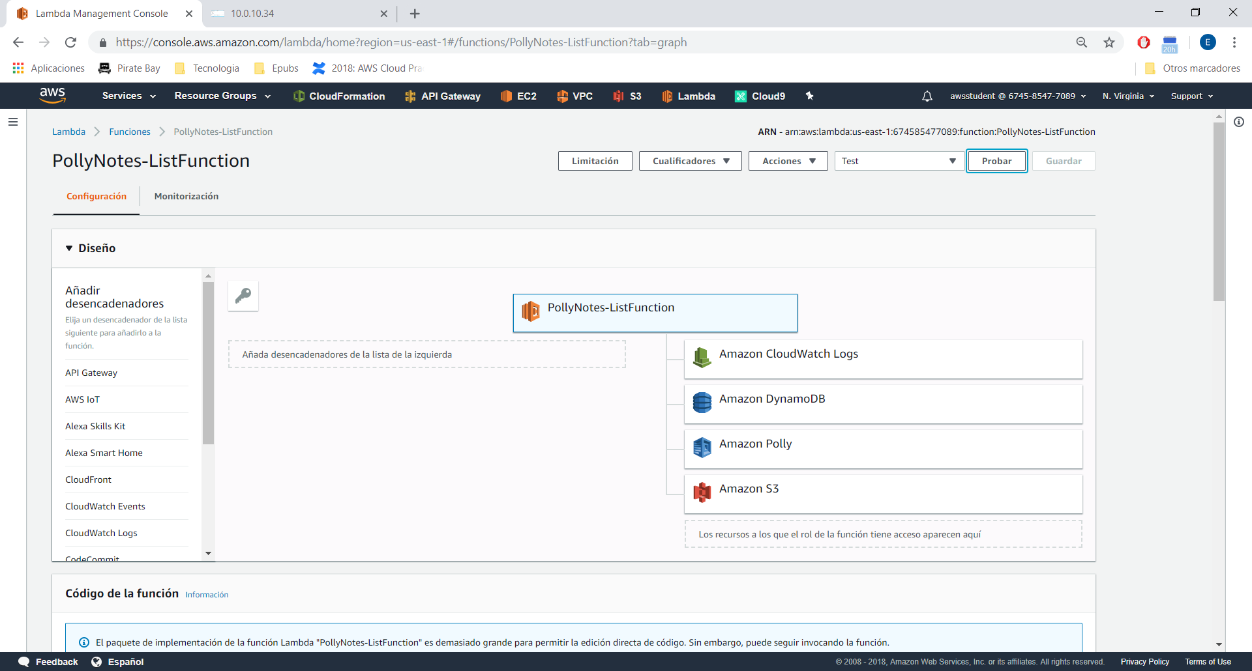

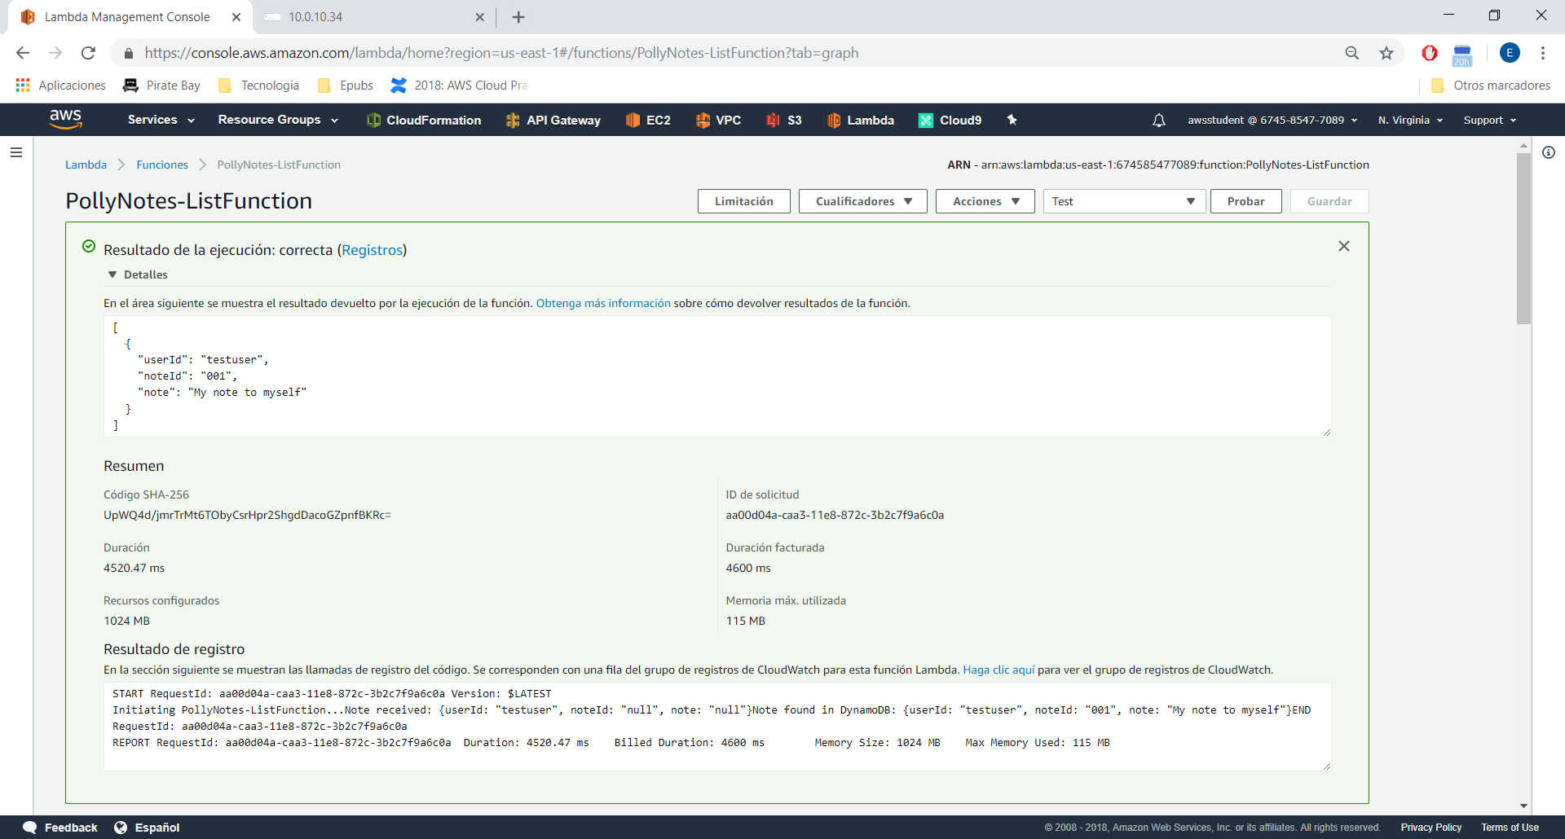

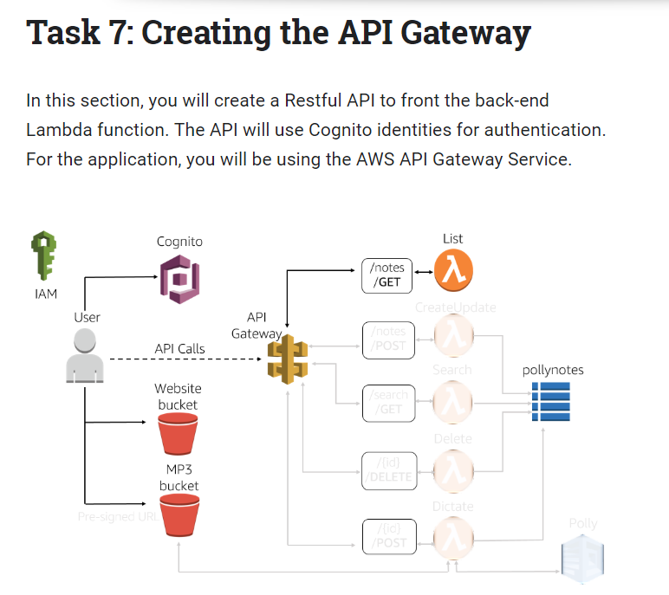

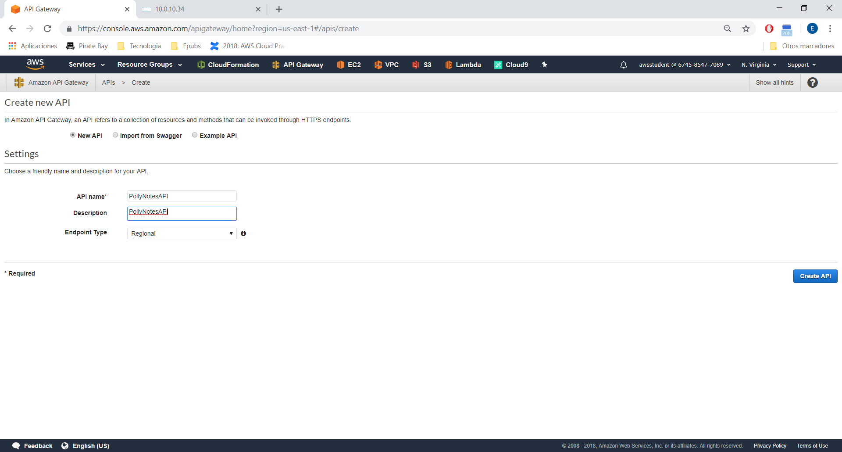

Go to Authorizer → Create new Authorizer

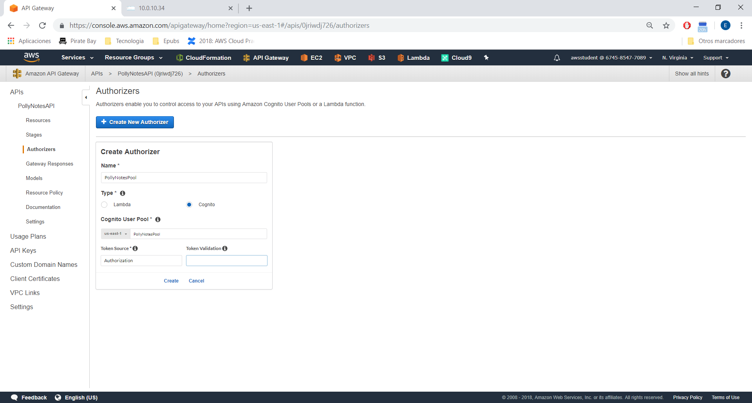

Creating the resources:

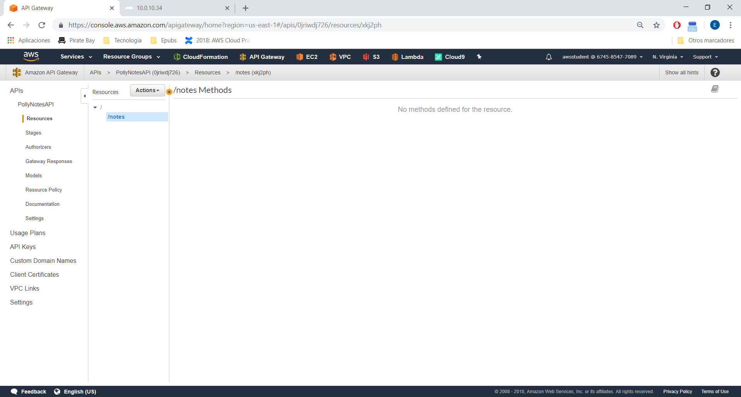

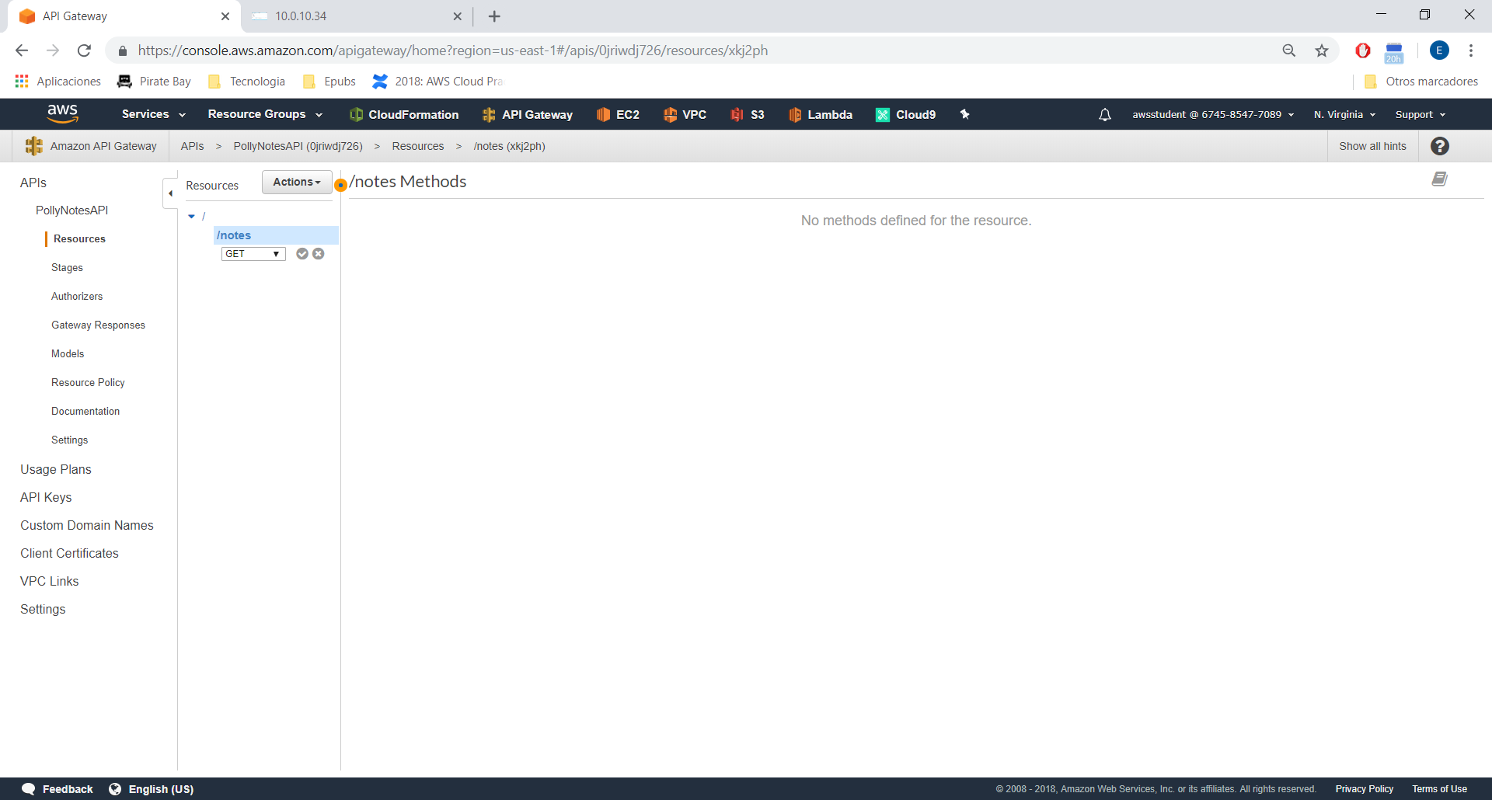

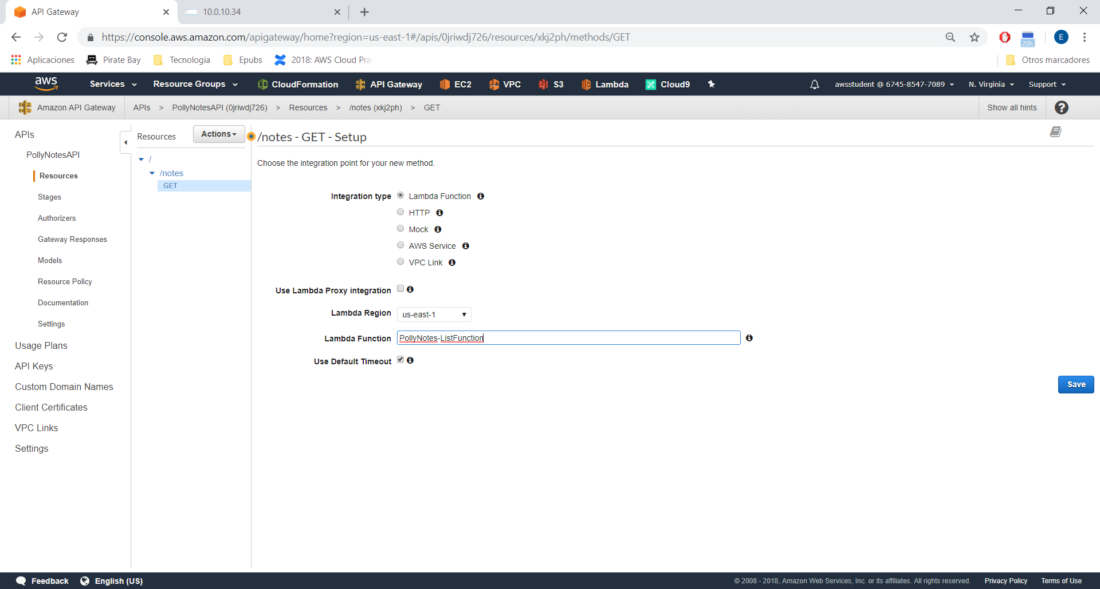

In integration requst:

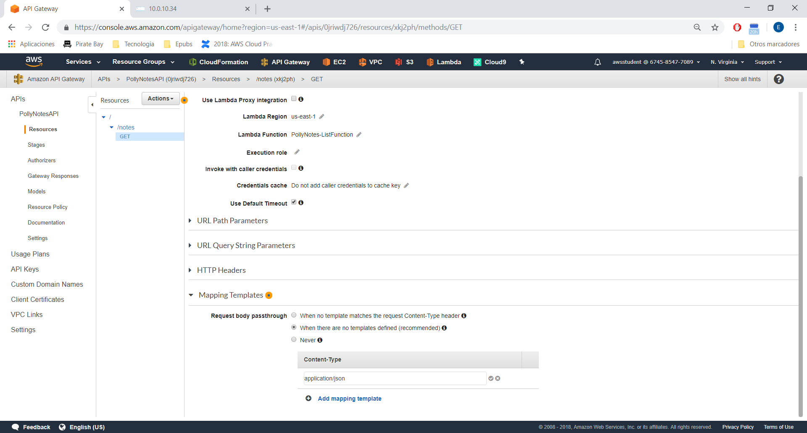

Copy the url:

<https://0jriwdj726.execute-api.us-east-1.amazonaws.com/prod>

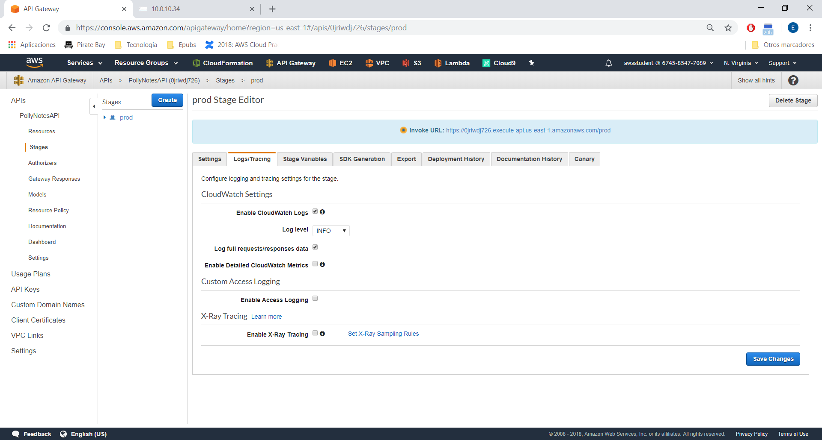

Download zip and modify lines:

// Change the following 3 variable's value

var API_GATEWAY_INVOKE_URL = "https://your-api-url"

var COGNITO_POOL_ID = 'us-east-1-xxxxxxxxxxx'

var COGNITO_APP_CLIENT_ID = 'xxxxxxxxxxxxxxxxxxxxxxxxxxxxx'

In S3 polly-notes-mp3-edward-montes

<?xml version="1.0" encoding="UTF-8"?>

<CORSConfiguration xmlns="http://s3.amazonaws.com/doc/2006-03-01/">

<CORSRule>

<AllowedOrigin>*</AllowedOrigin>

<AllowedMethod>GET</AllowedMethod>

<AllowedHeader>*</AllowedHeader>

</CORSRule>

</CORSConfiguration>

Go to s3: polly-notes-web-<firstname>-<lastname>

Upload the files and copy this policy:

{

"Version": "2012-10-17",

"Statement": [

{

"Sid": "PublicReadGetObject",

"Effect": "Allow",

"Principal": "*",

"Action": "s3:GetObject",

"Resource": "arn:aws:s3:::polly-notes-web-<firstname>-<lastname>/*"

}

]

}