Crear la funcion

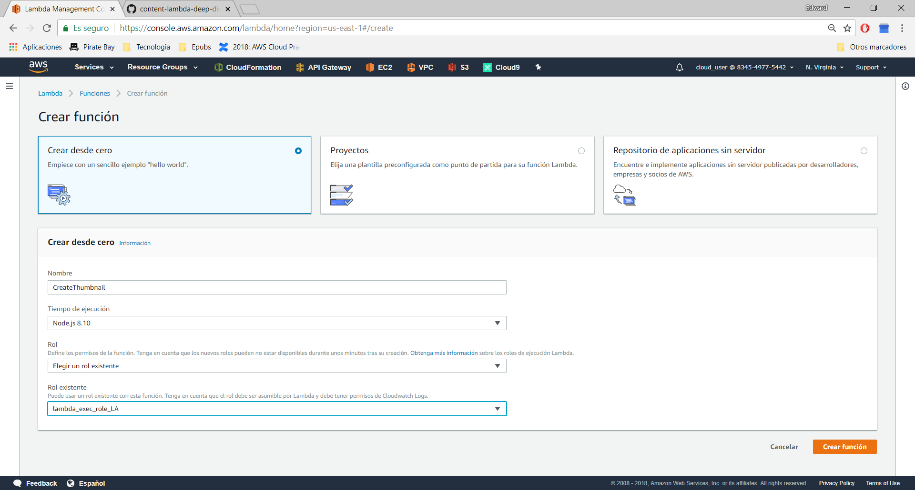

Role

{  
 "Version": "2012-10-17",  
 "Statement": [  
 {  
 "Action": [  
 "cloudwatch:DeleteAlarms",  
 "cloudwatch:DescribeAlarmHistory",  
 "cloudwatch:DescribeAlarms",  
 "cloudwatch:DescribeAlarmsForMetric",  
 "cloudwatch:GetMetricStatistics",  
 "cloudwatch:ListMetrics",  
 "cloudwatch:PutMetricAlarm",  
 "logs:CreateLogGroup",  
 "logs:CreateLogStream",  
 "logs:PutLogEvents",  
 "lambda:*",  
 "s3:*"  
 ],  
 "Resource": "*",  
 "Effect": "Allow"  
 }  
 ]  
}

Upload Zip

<https://github.com/123xedward/AWS_Lambda/blob/master/Versiones_Alias/lambda_function.zip>

Poner variable de entorno

DST_BUCKET= nombre del siguiente bucket

cfst-712-298391e6faa99e43ddad15d6d8b159ae-bucketb-m12xqgu7y850

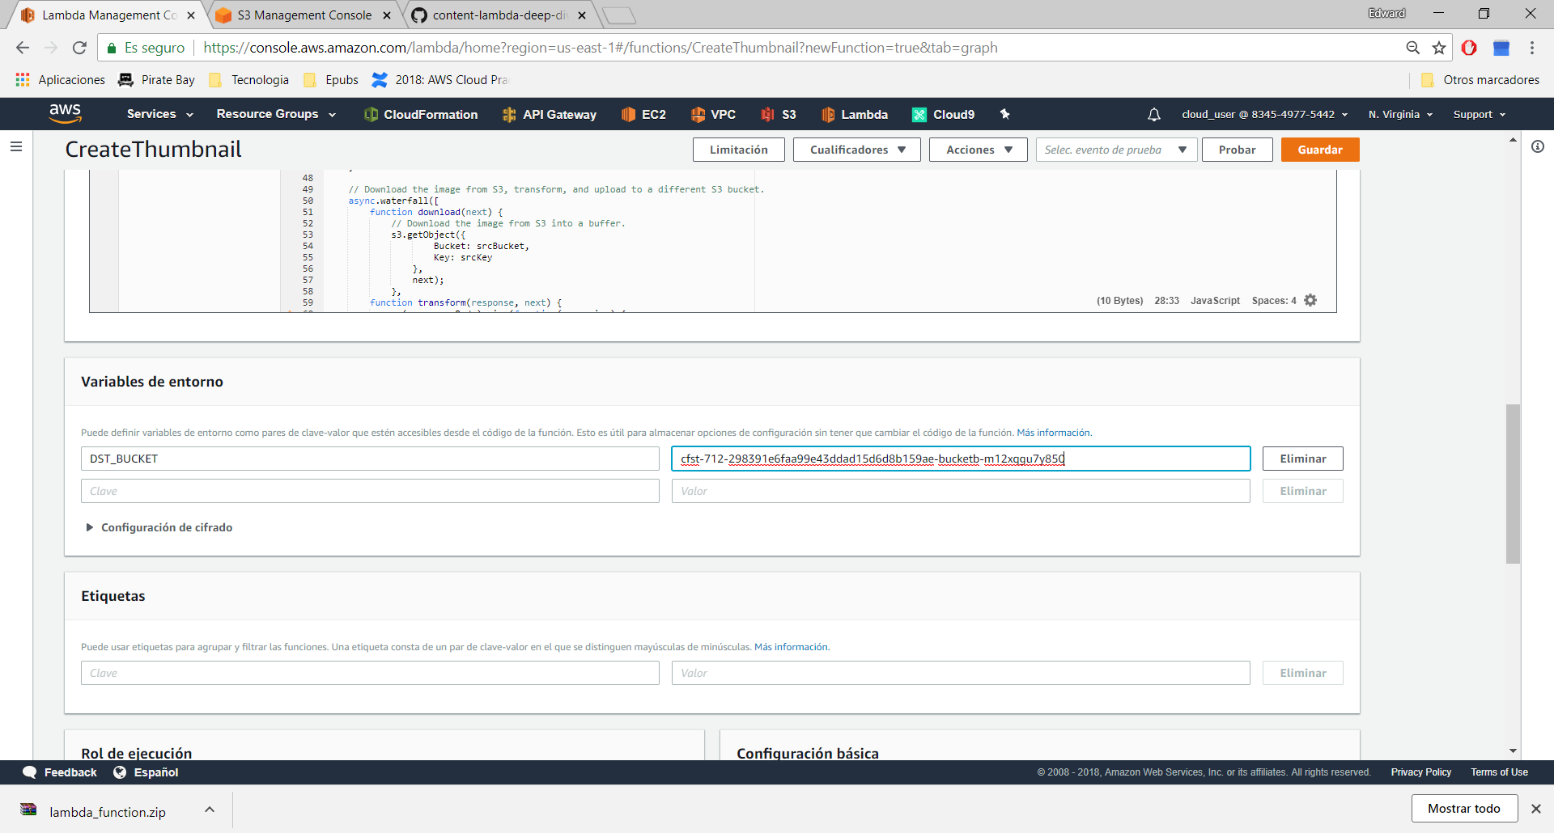

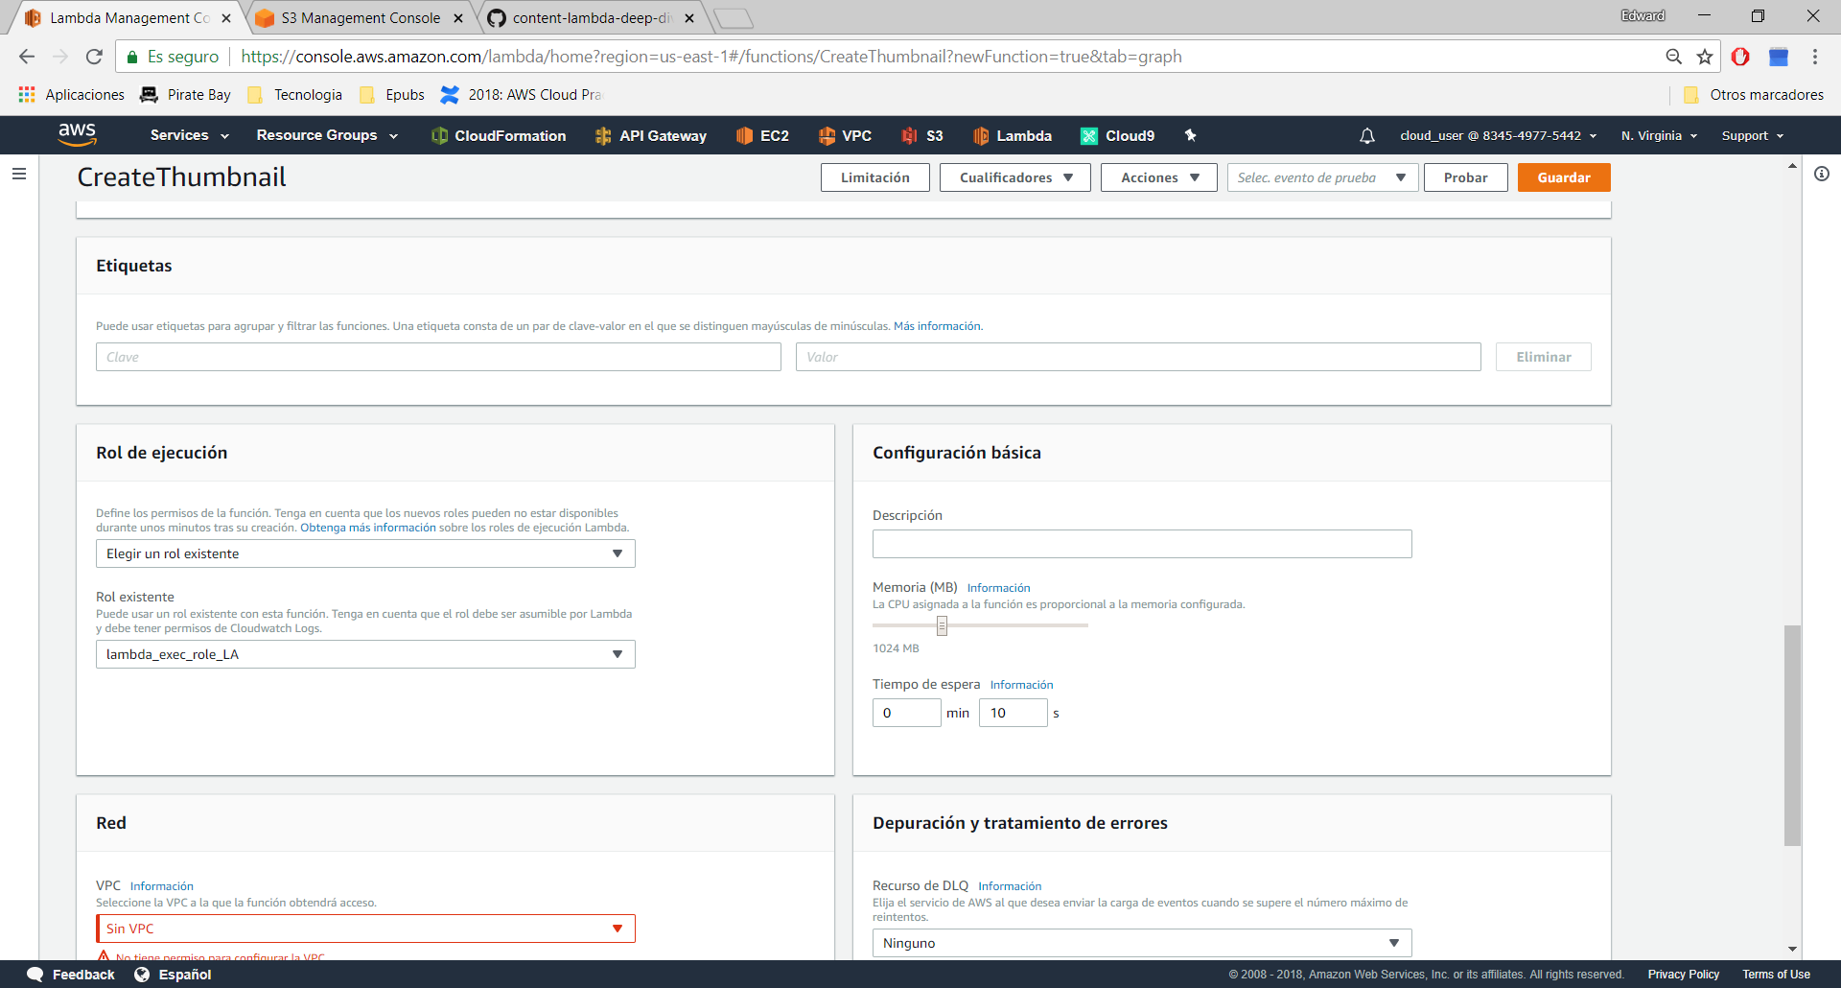

Poner Trigger S3

El disparador sera el bucketA

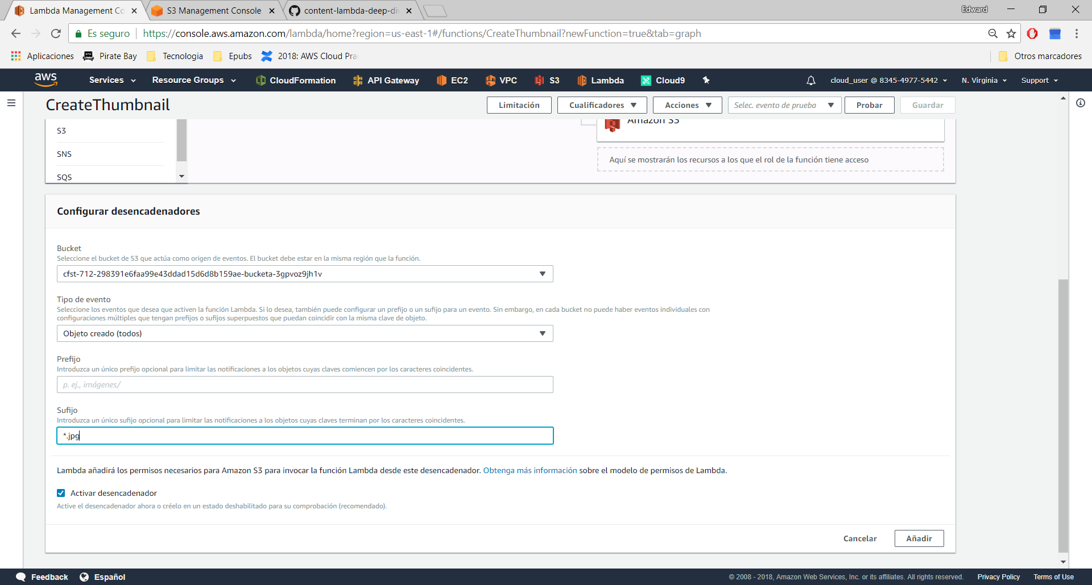

Publicar nueva version

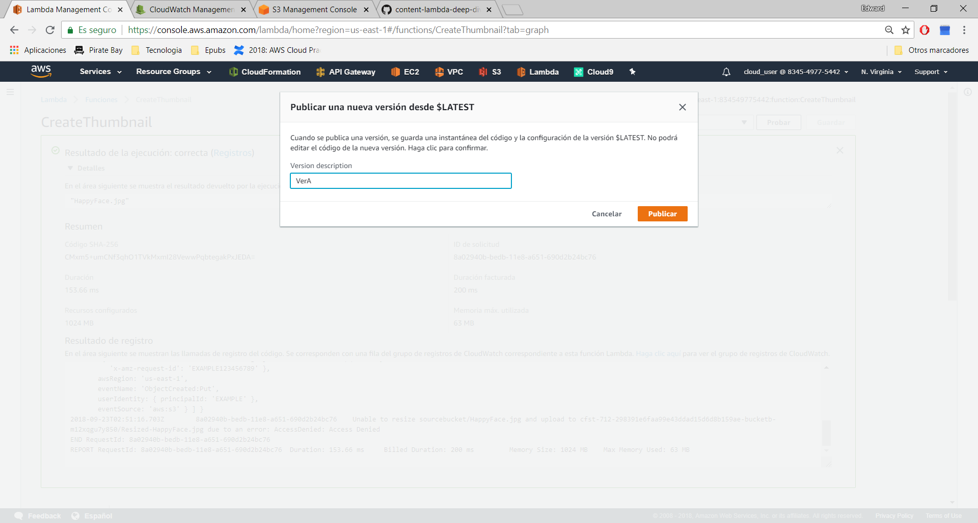

Despues creamos el alias PROD, y a este alias PROD, le asociamos el disparador S3 Bucket C

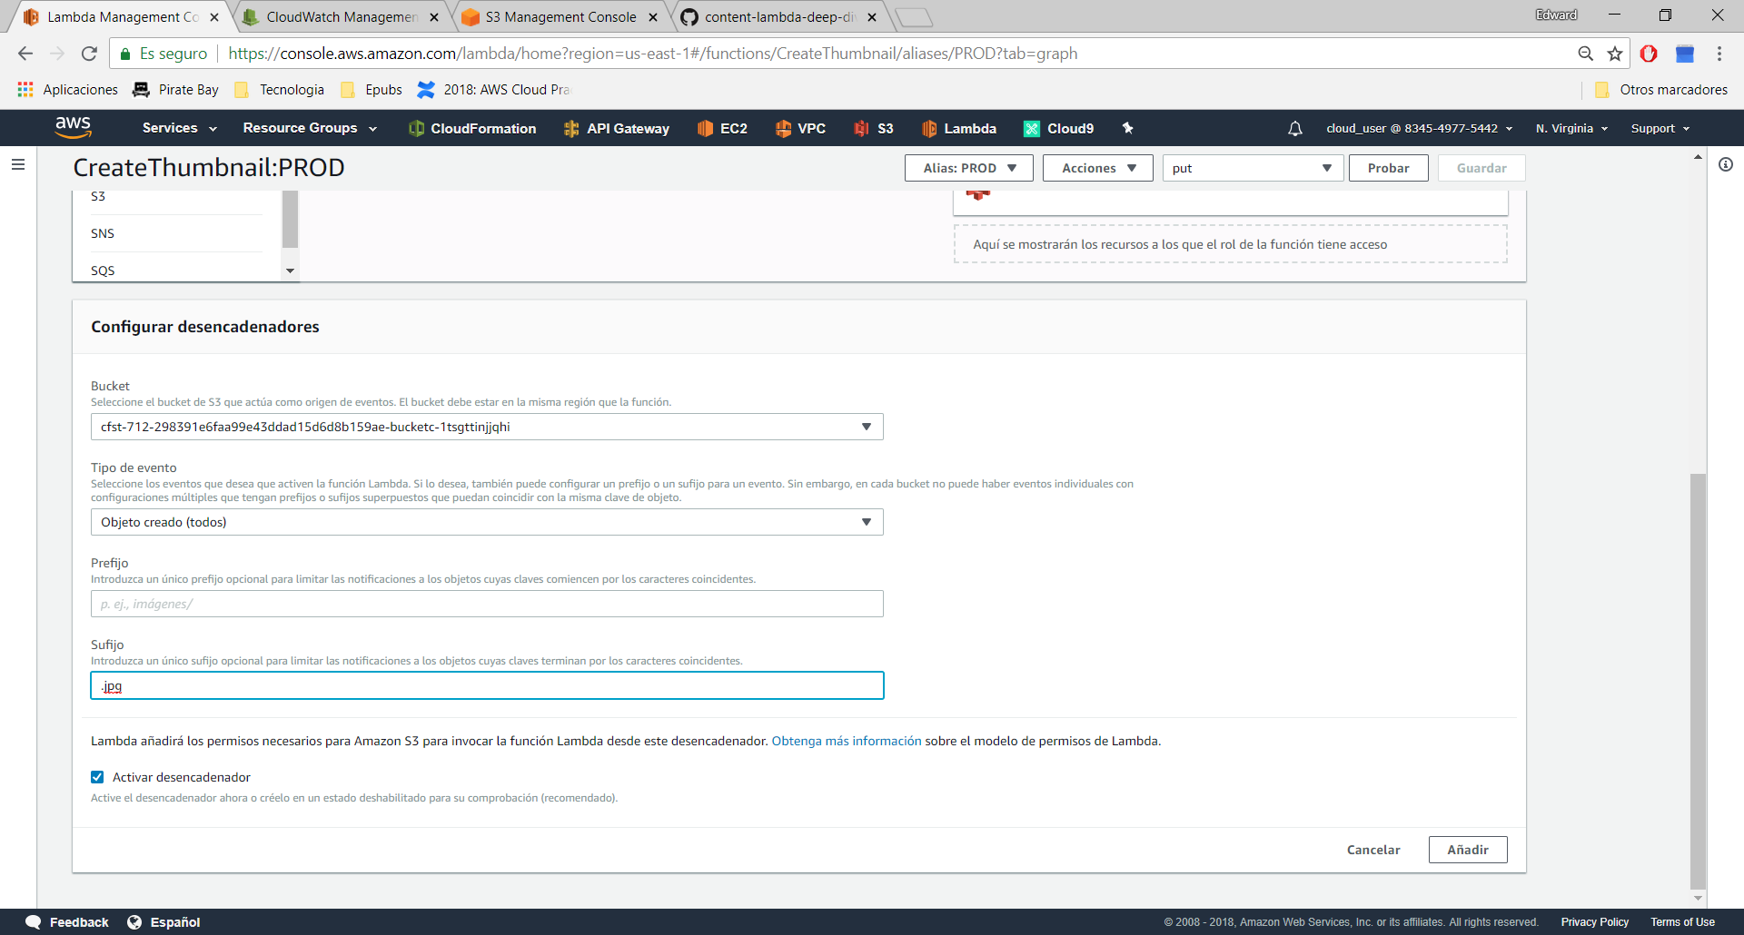

Creamos la Version B, solo movemos las contantes de 150 a 100

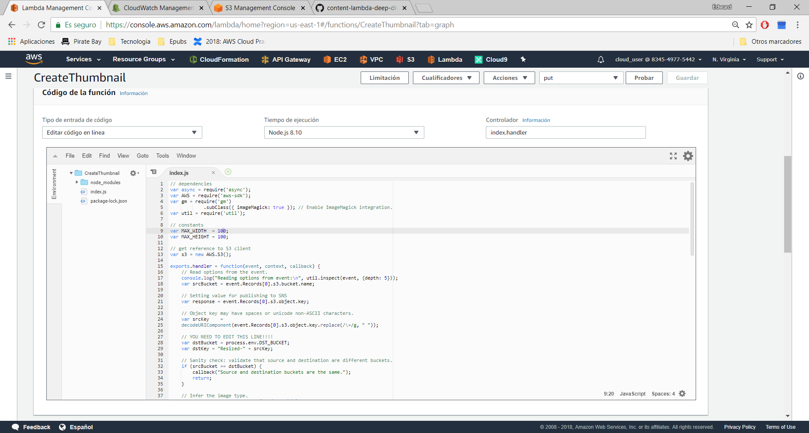

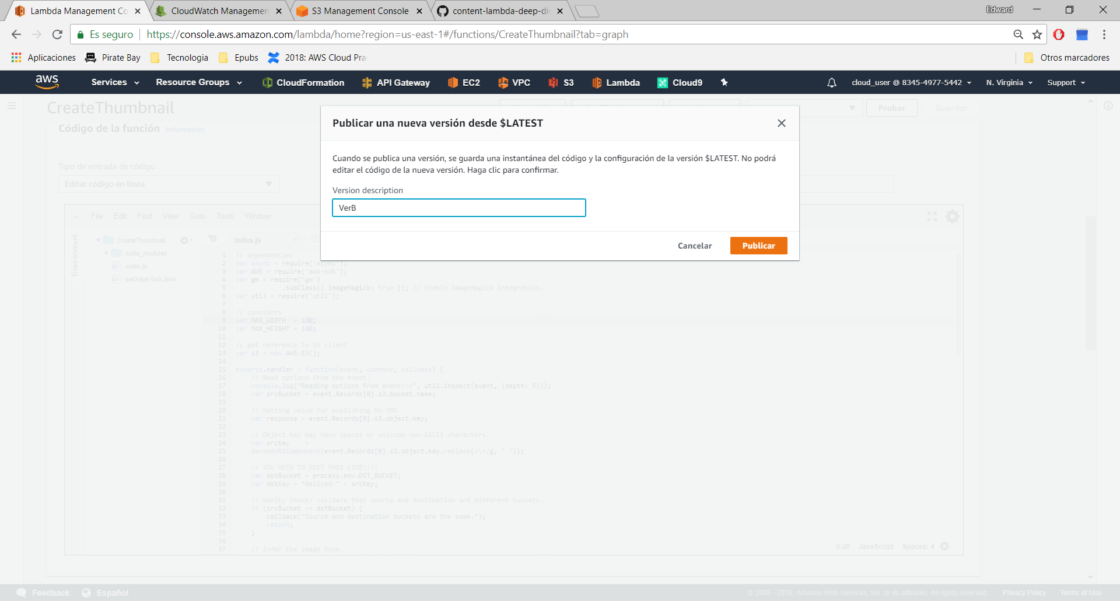

Nos vamos a Alias, elegimos PROD

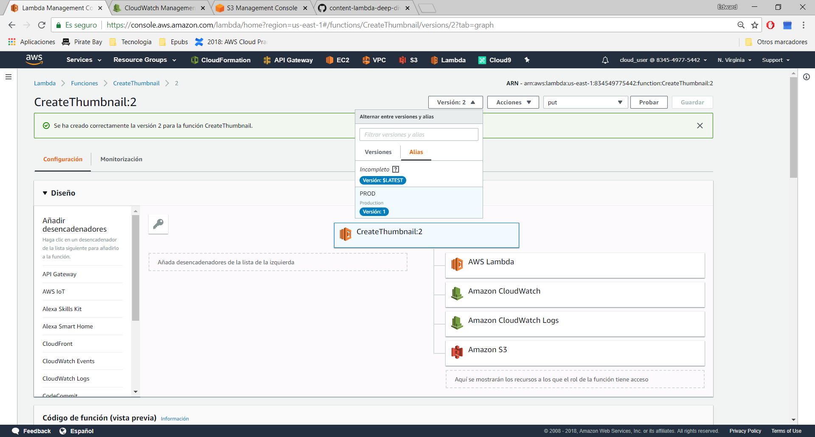

Asociamos la version 2 a PROD

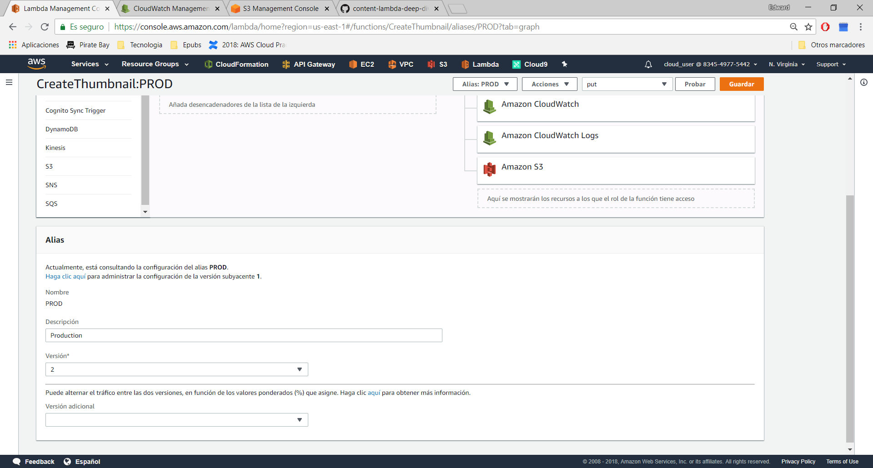

Y probamos de nuevo, subiendo al bucket C