Manual Lambda:

Create a bucket:
calculator-input-emh

Upload number.txt to bucket created:

Create new Role:
AmazonS3ReadOnlyAccess
AWSLambdaBasicExecutionRole

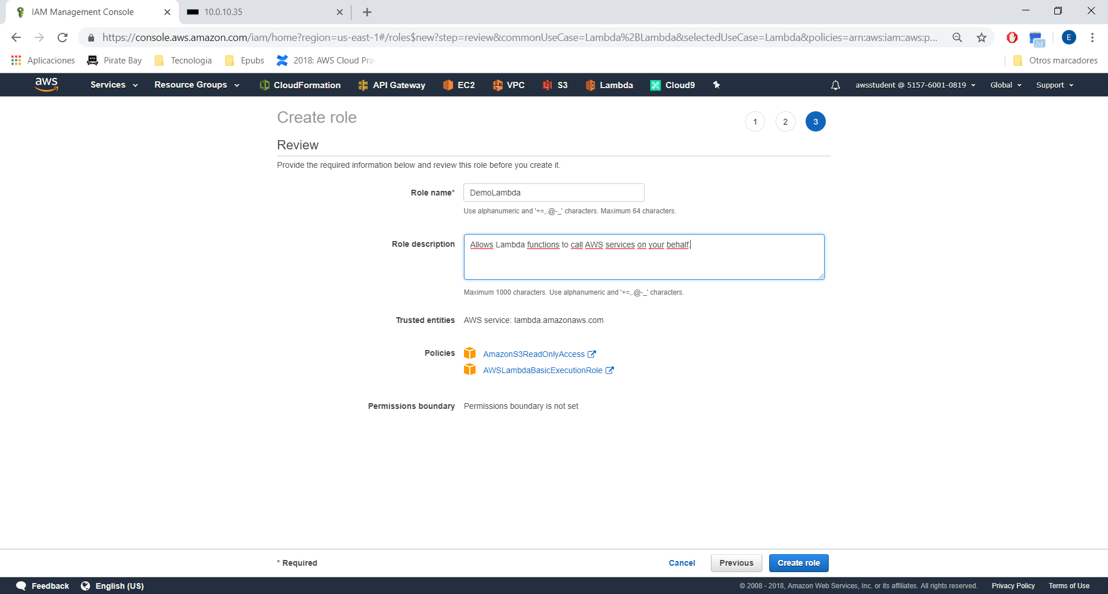

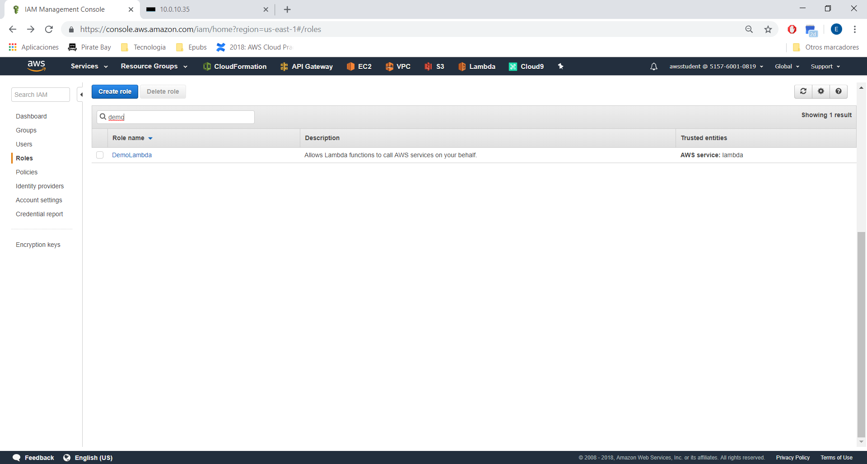
Create Lambda Function:

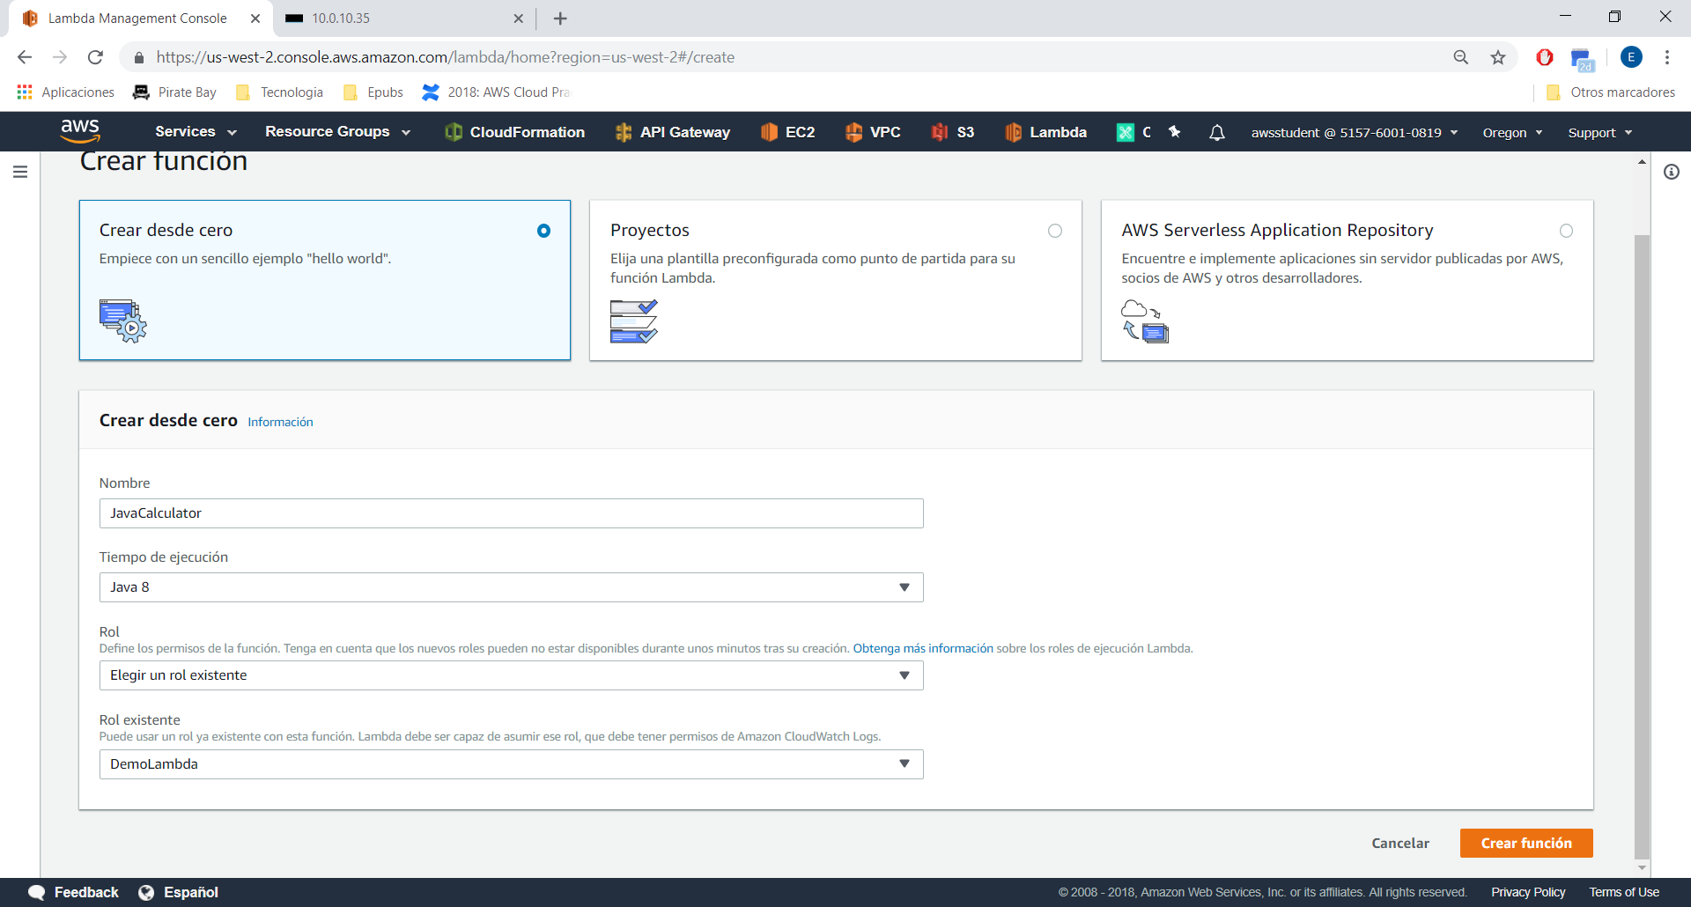
Specify Handler:
com.amazonaws.lambda.Calculator

Add S3 Trigger:
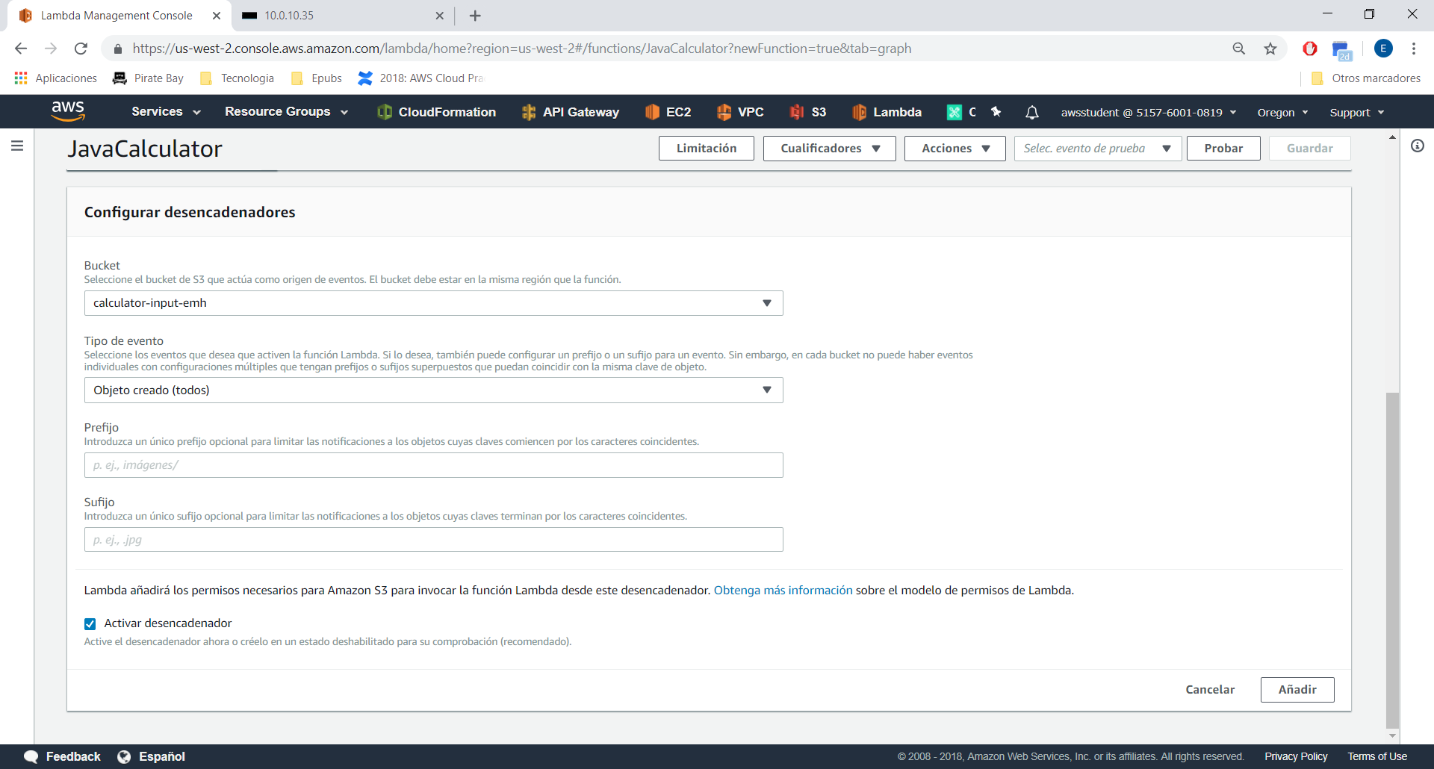
Save:

Upload the zip:
or update the function:

aws lambda update-function-code --function-name JavaCalculator --zip-file fileb://calculator-1.0.0.jar

Test:

Event:

{
"Records": [
{
"eventTime": "1970-01-01T00:00:00.000Z",
"s3": {
"object": {
"key": "numbers.txt"
},
"bucket": {
"name": "calculator-input-emh1"
}
}
}
]
}

