Go to IAM-→lambda exec role:

{
"Version": "2012-10-17",
"Statement": [
{
"Action": [
"cloudwatch:DeleteAlarms",
"cloudwatch:DescribeAlarmHistory",
"cloudwatch:DescribeAlarms",
"cloudwatch:DescribeAlarmsForMetric",
"cloudwatch:GetMetricStatistics",
"cloudwatch:ListMetrics",
"cloudwatch:PutMetricAlarm",
"logs:CreateLogGroup",
"logs:CreateLogStream",
"logs:PutLogEvents",
"lambda:*",
"ecs:*",
"ecr:*"
],
"Resource": "*",
"Effect": "Allow"
}
]
}

Create Credential for user:
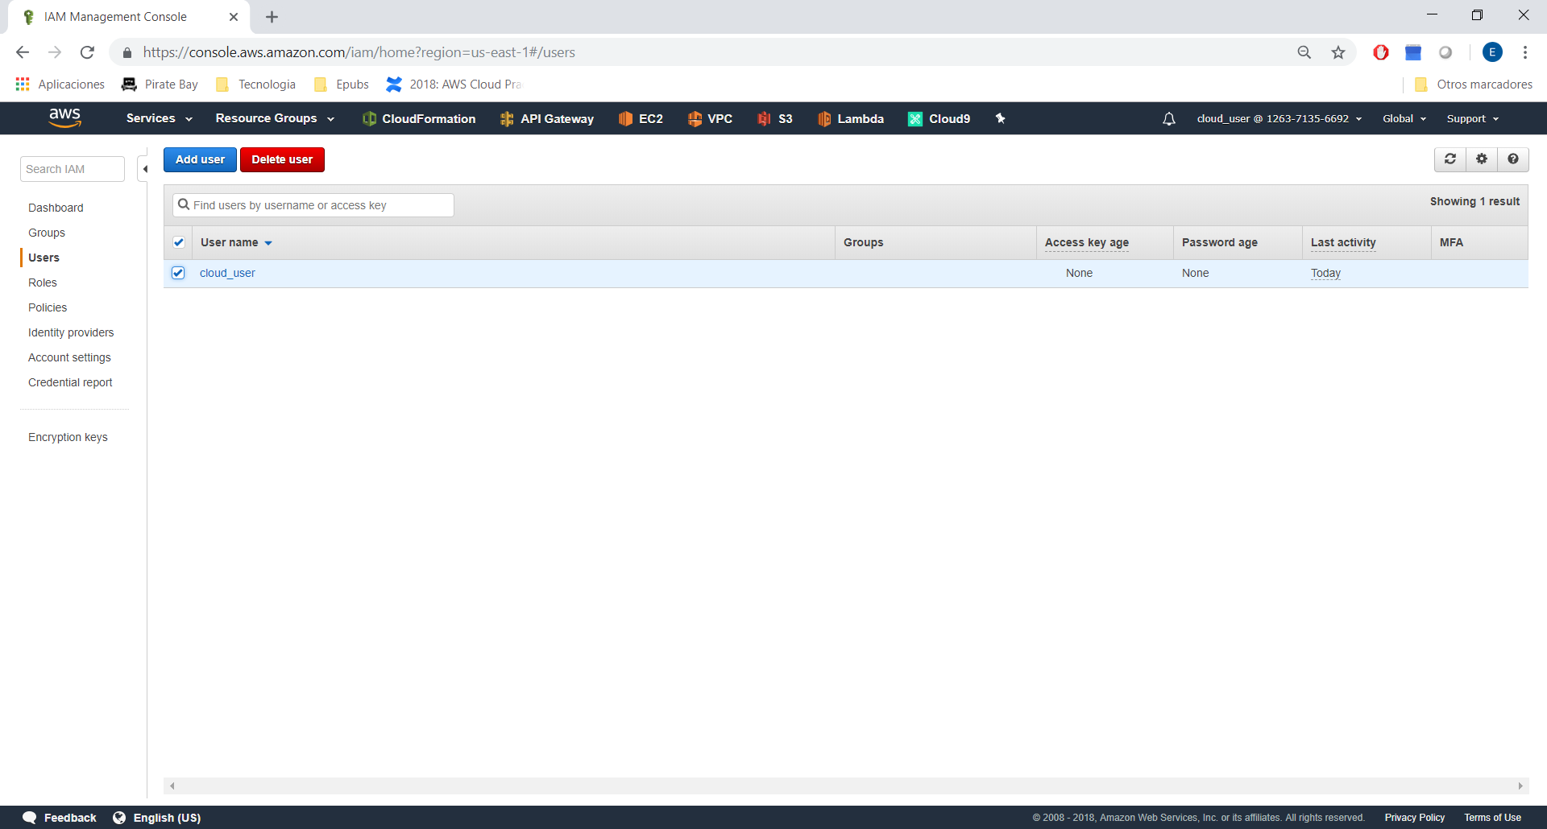
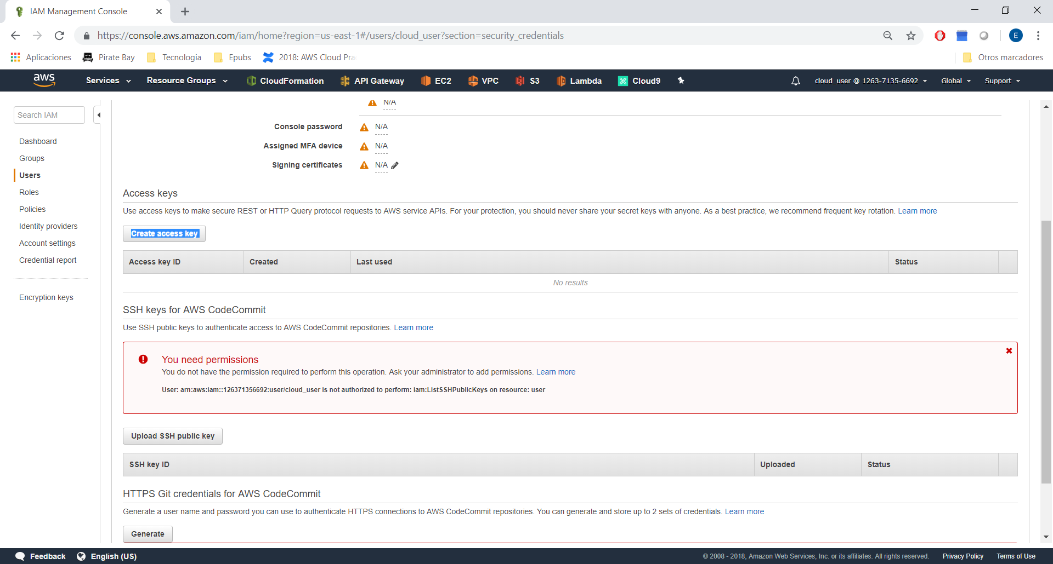
Test:
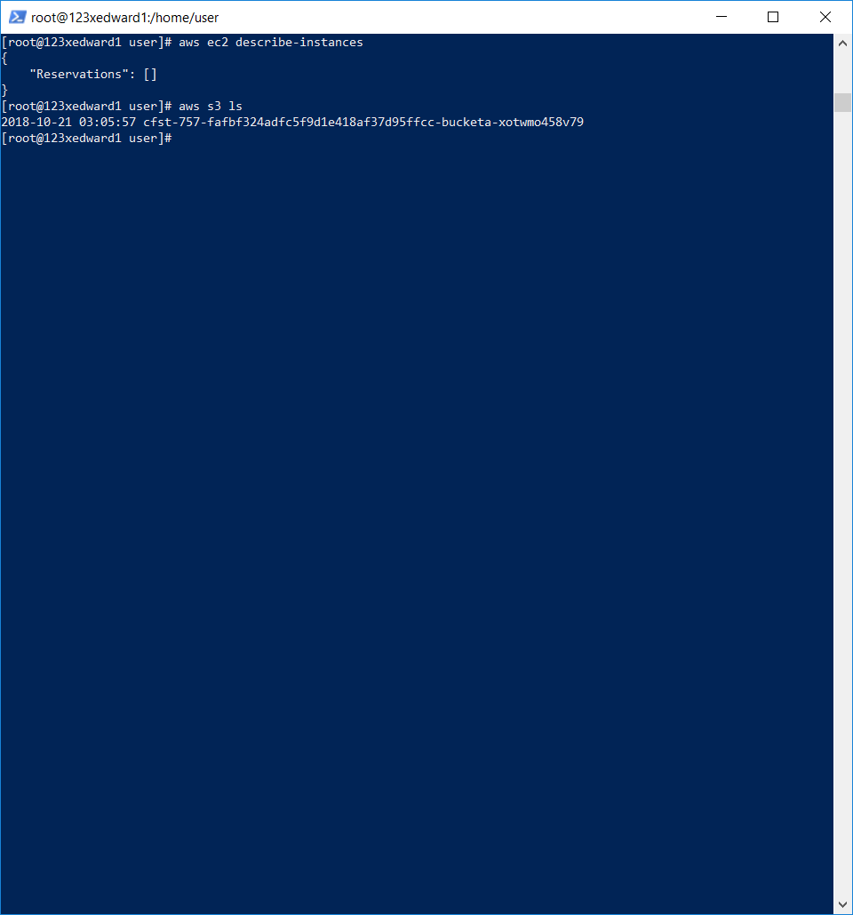

In the cloud server, install zip | unzip
sudo yum install zip
sudo yum install unzip

Go to ECS → Repositories:

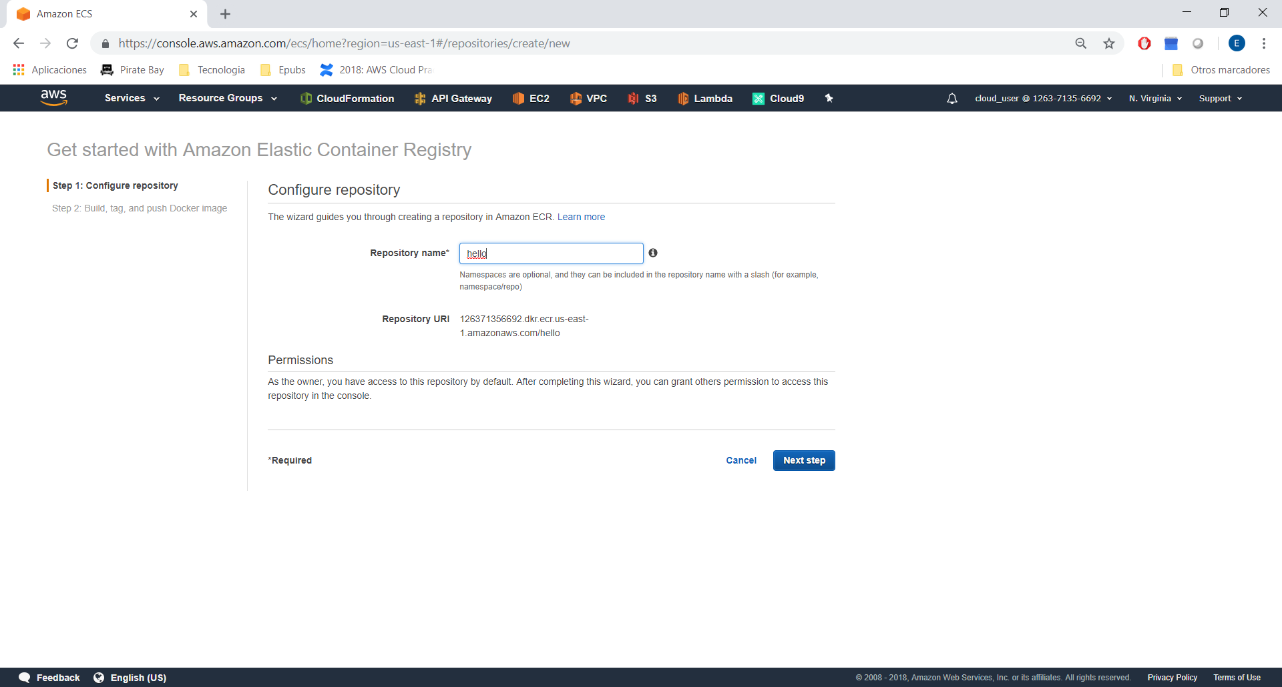

In cloud server, we need to create a folder “docker”
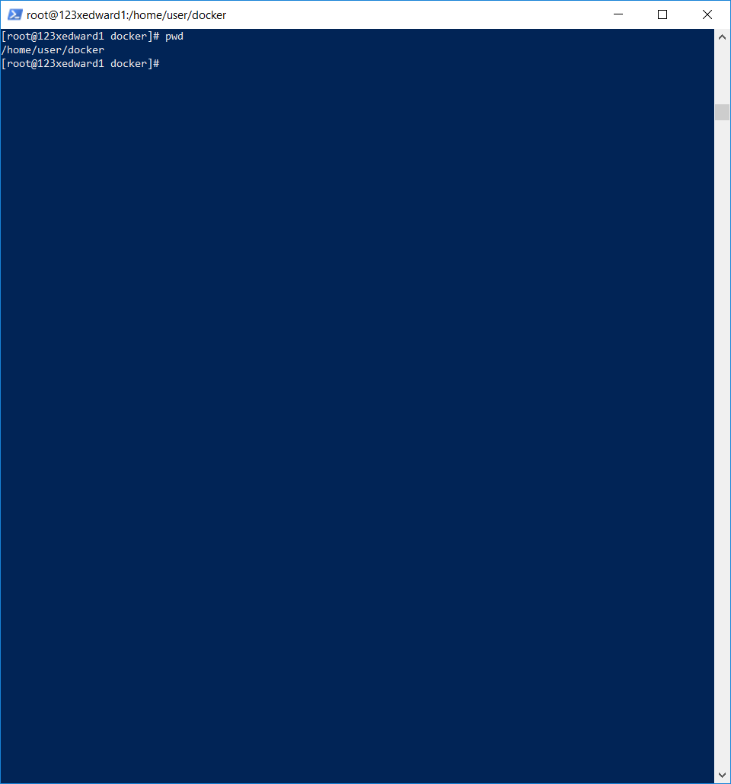

and download github url:

wget https://github.com/linuxacademy/content-lambda-deep-dive/raw/master/section_6/live_activity_12/docker-app.zip
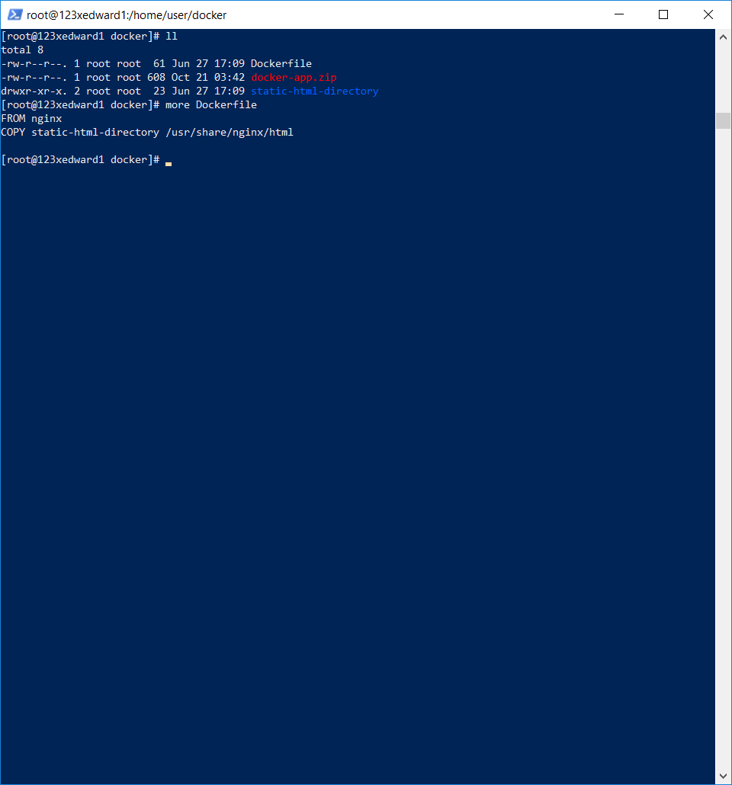
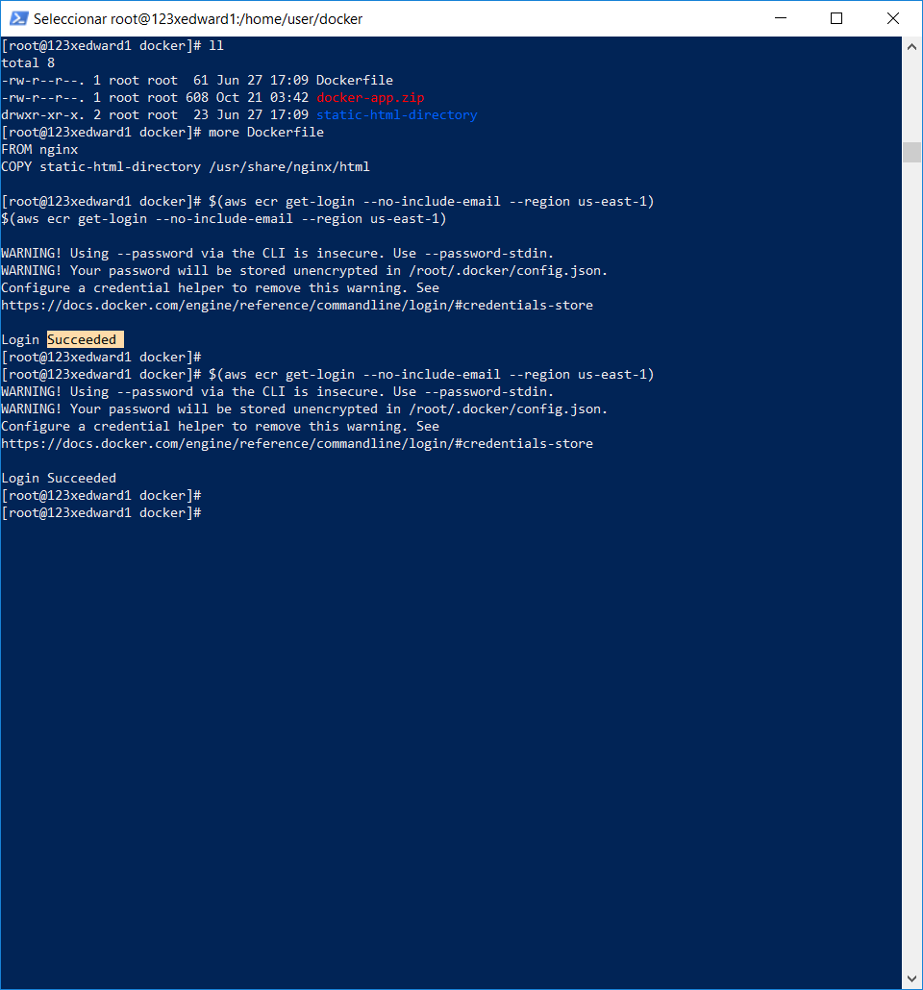
Run
docker build -t hello .

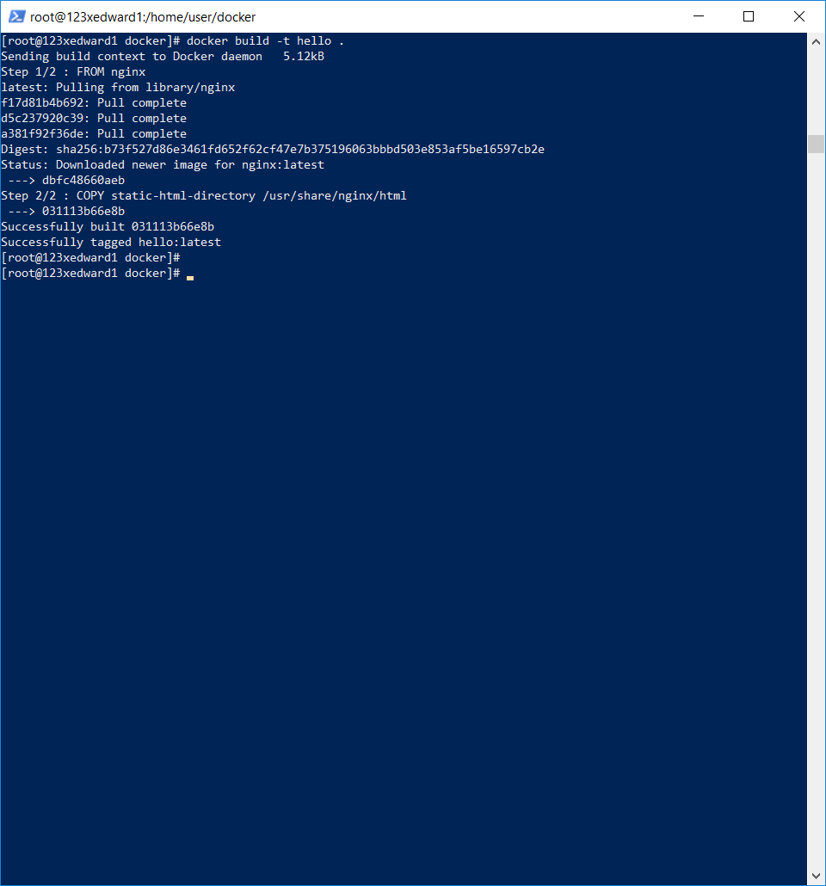
Run:
docker tag hello:latest 126371356692.dkr.ecr.us-east-1.amazonaws.com/hello:latest
docker push 126371356692.dkr.ecr.us-east-1.amazonaws.com/hello:latest

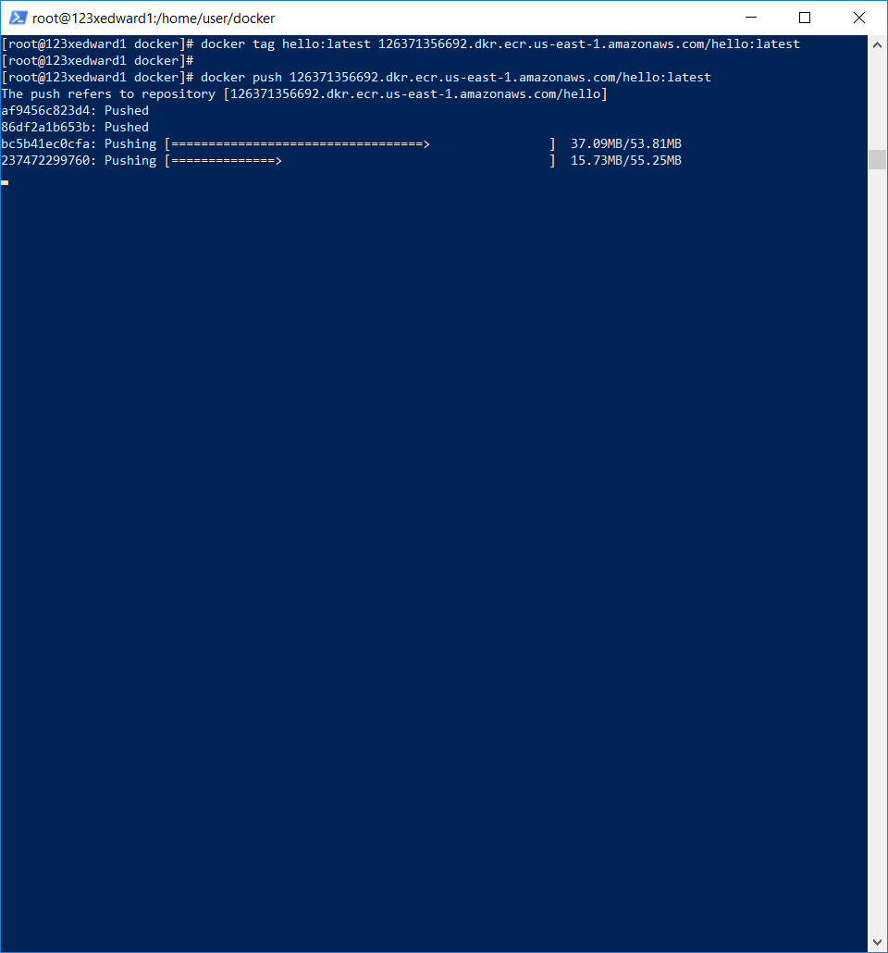
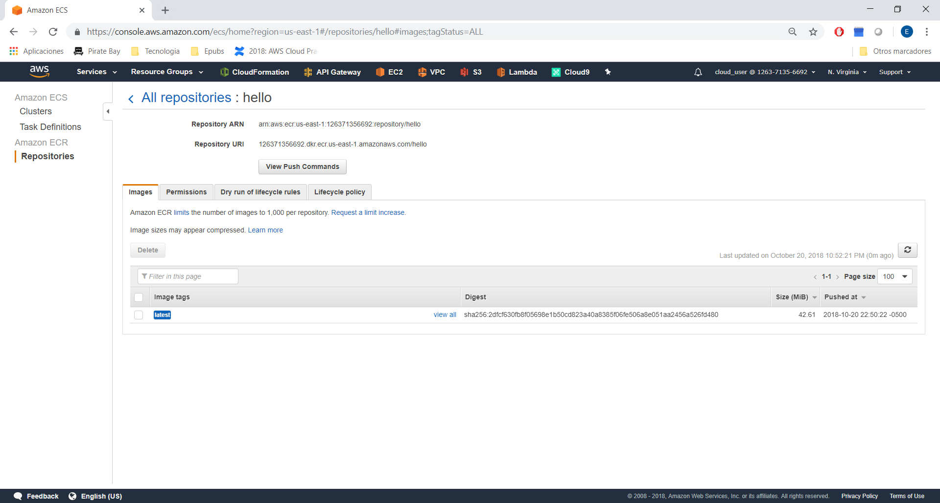
Now, create the cluster:

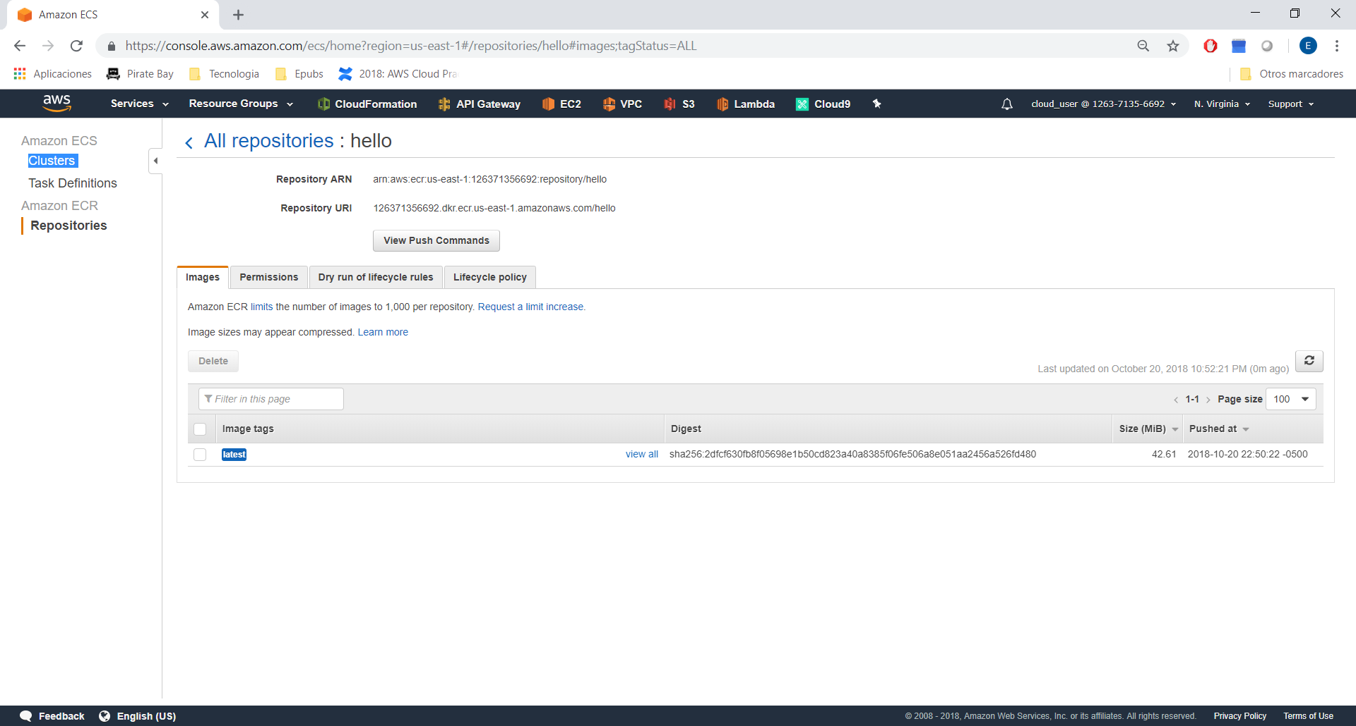
Click in custome, configure:

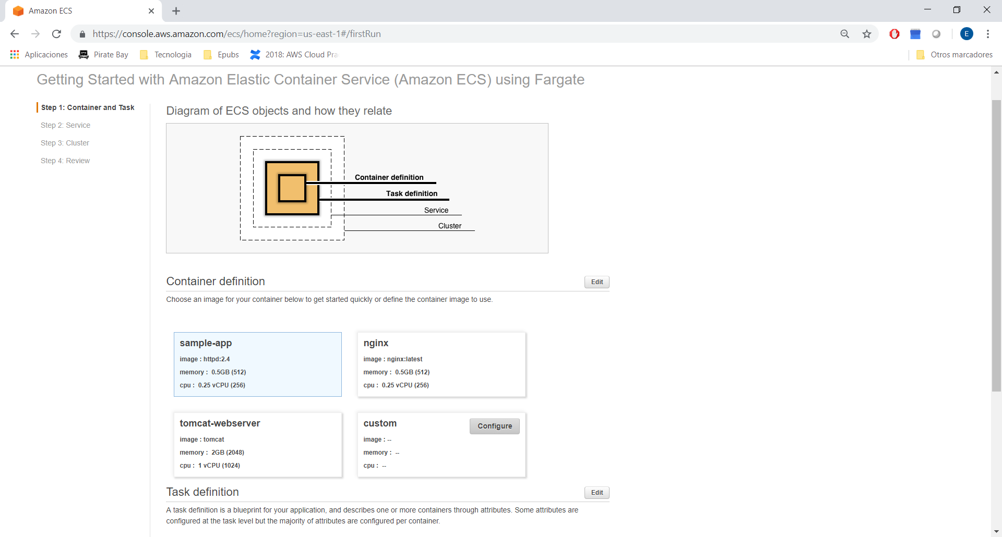
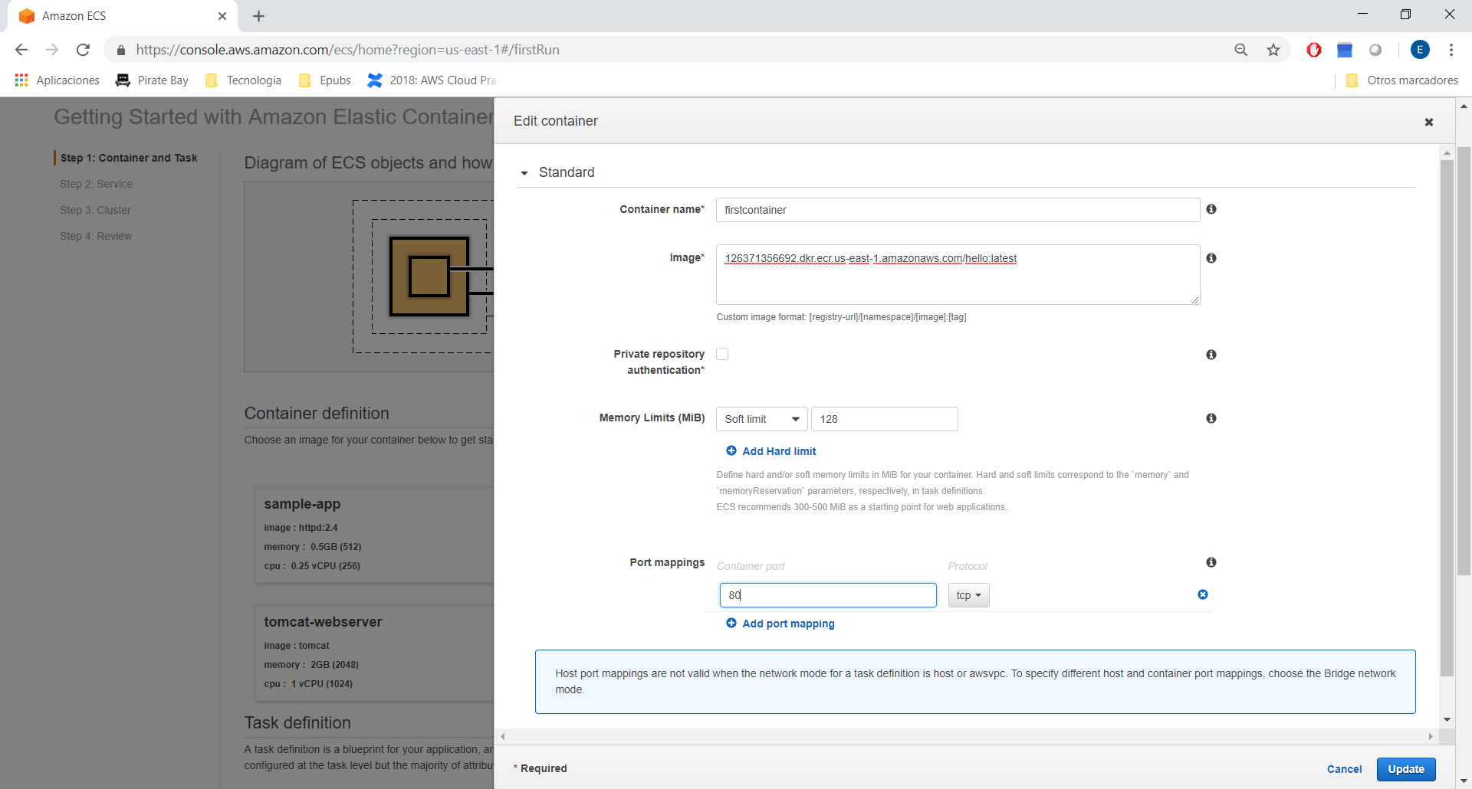
Click in task definition:

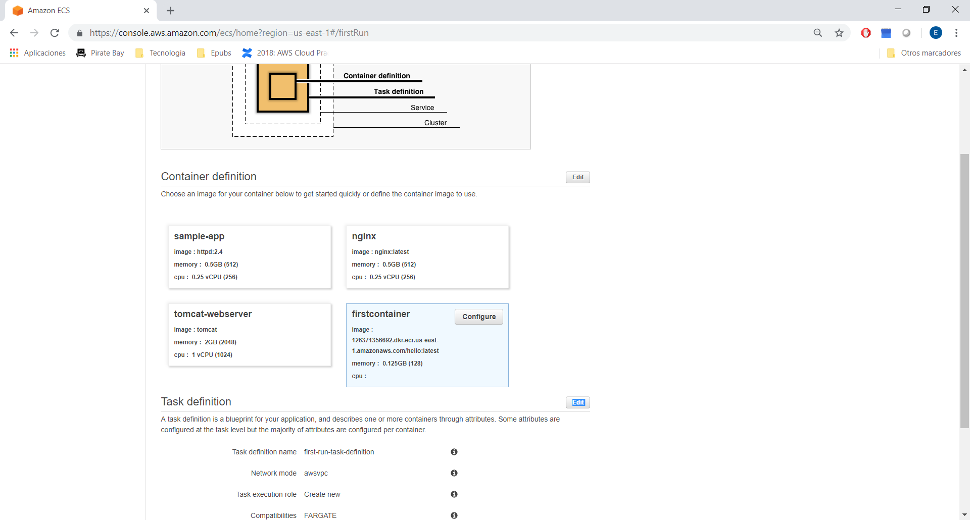
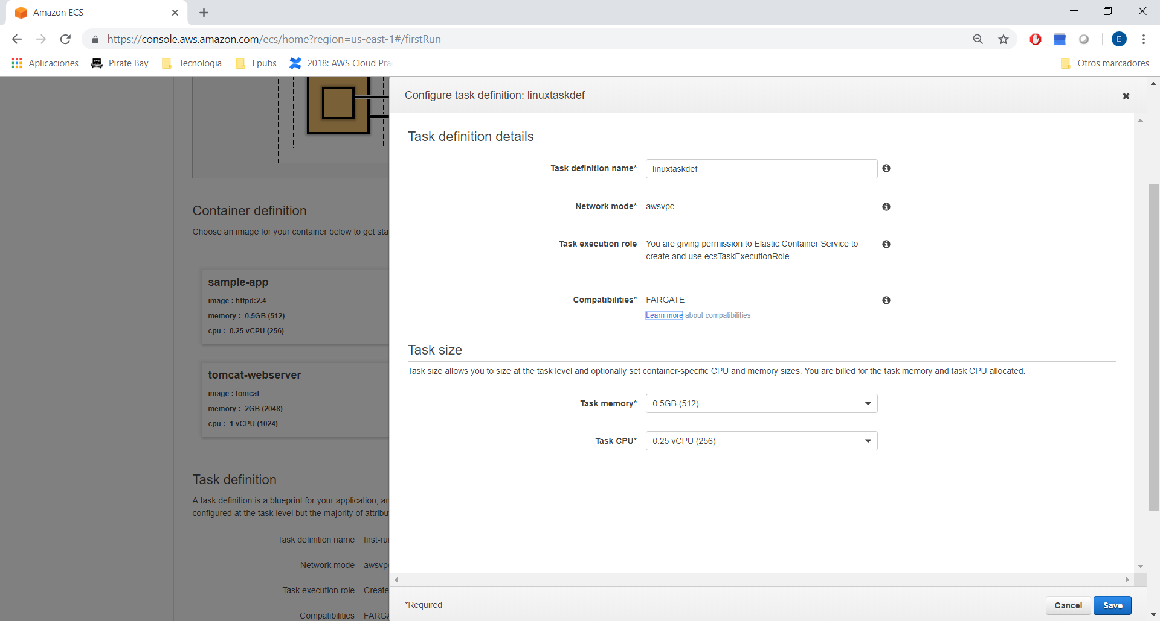
Save
Define a Service:
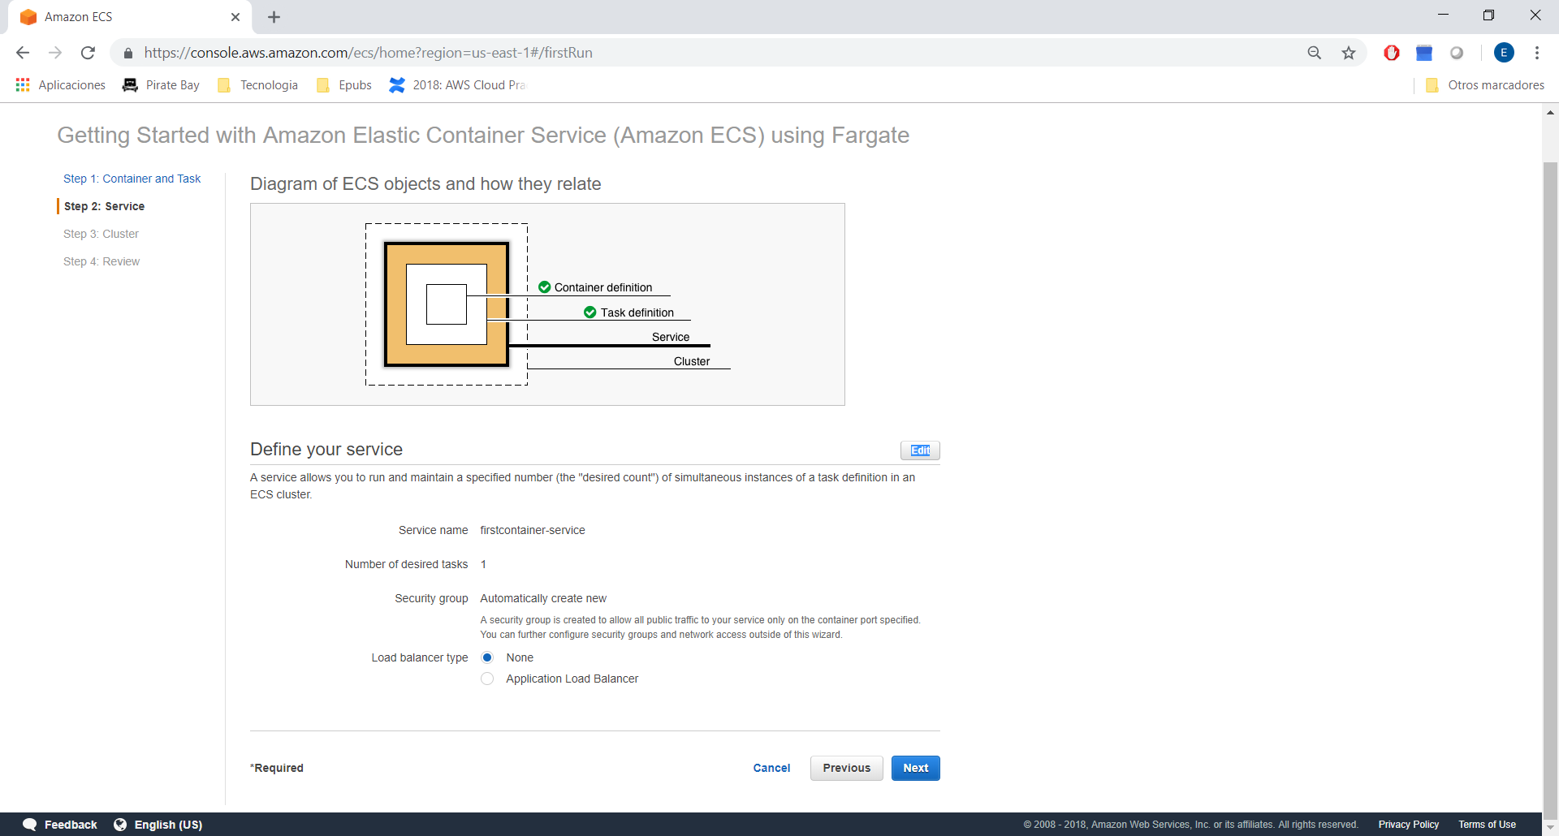
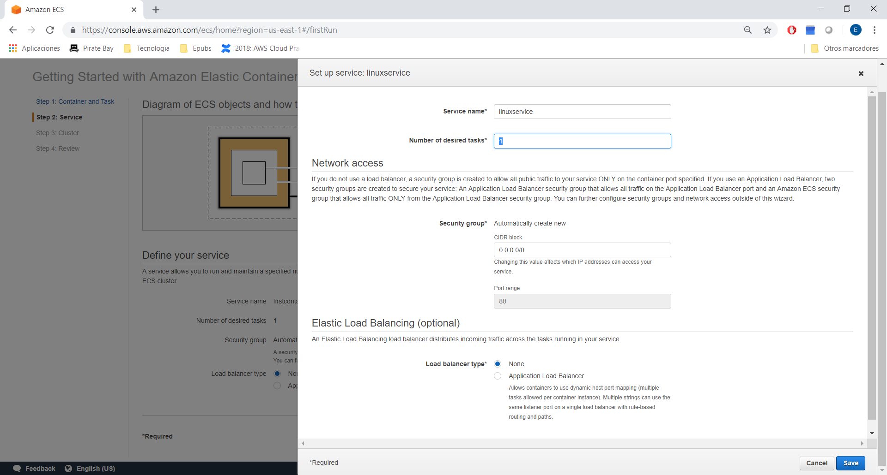
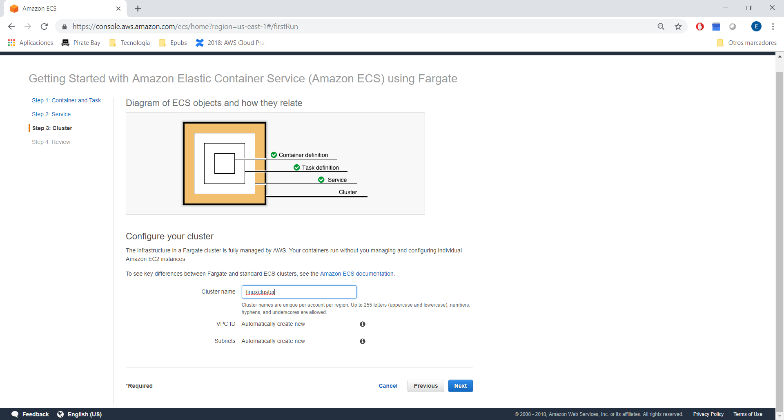
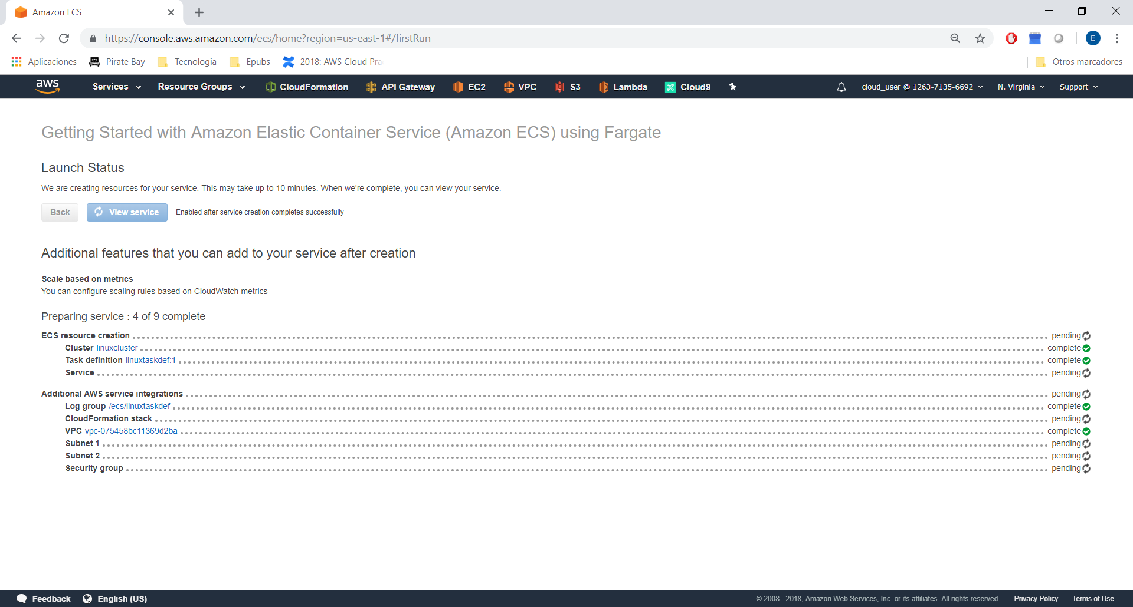
Go to terminal
Download
wget https://raw.githubusercontent.com/linuxacademy/content-lambda-deep-dive/master/section_6/live_activity_12/lambda_function.py
Create a zip from this .py file
and use AWSCLI:
aws lambda create-function \
--function-name ECS \
--handler lambda_function.lambda_handler \
--memory-size 1024 \
--timeout 15 \
--runtime python3.6 \
--zip-file fileb:///home/user/lambda_function.zip \
--role arn:aws:iam::126371356692:role/lambda_exec_role_LA \
--environment Variables="{NAME=secondcontainer,IMAGE=URI,TASK_DEF=linuxtaskdef,CLUSTER=linuxcluster,SERVICE=linuxservice}"
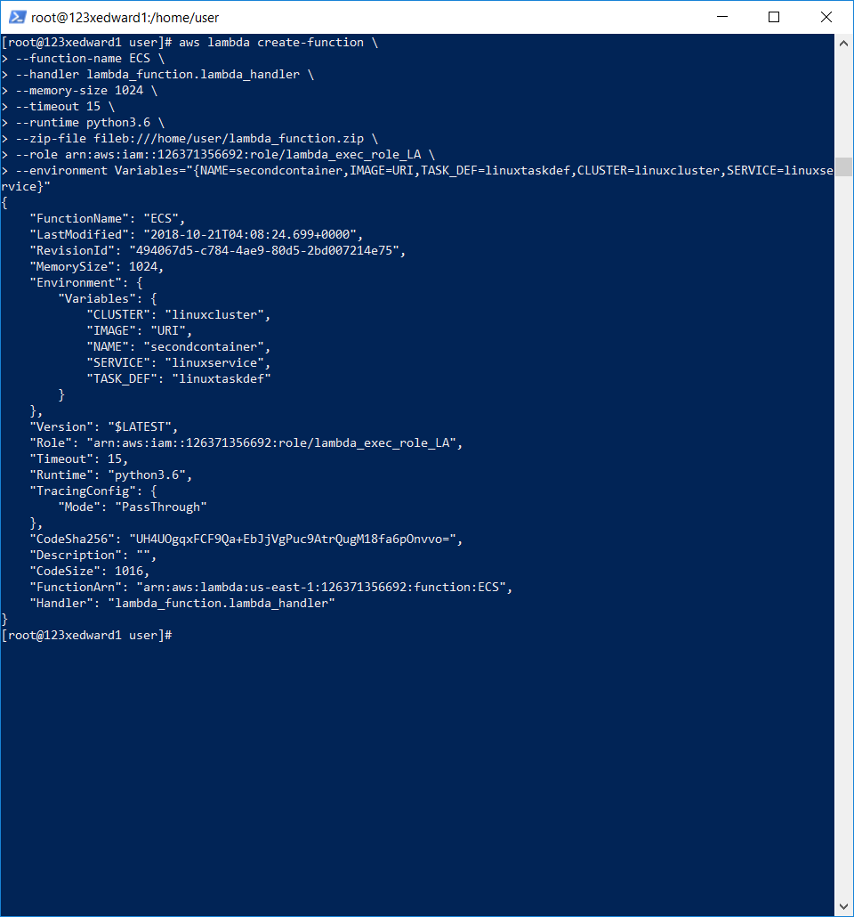
Obtain the URI from image and put in Lambda Parameter:

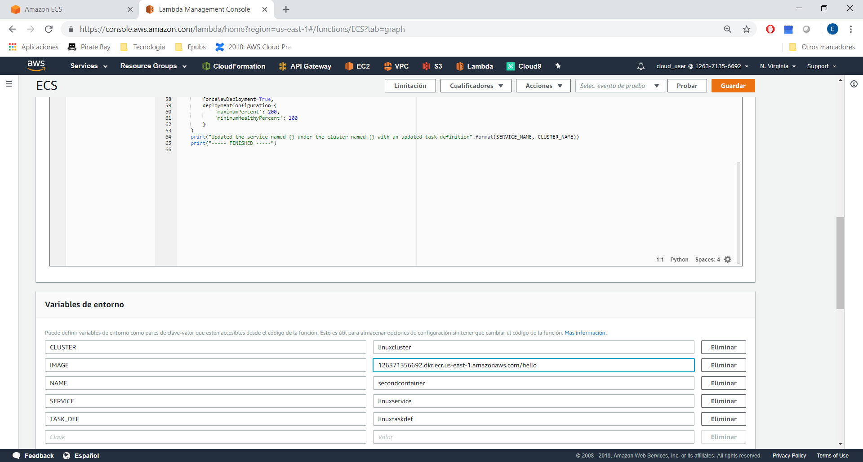
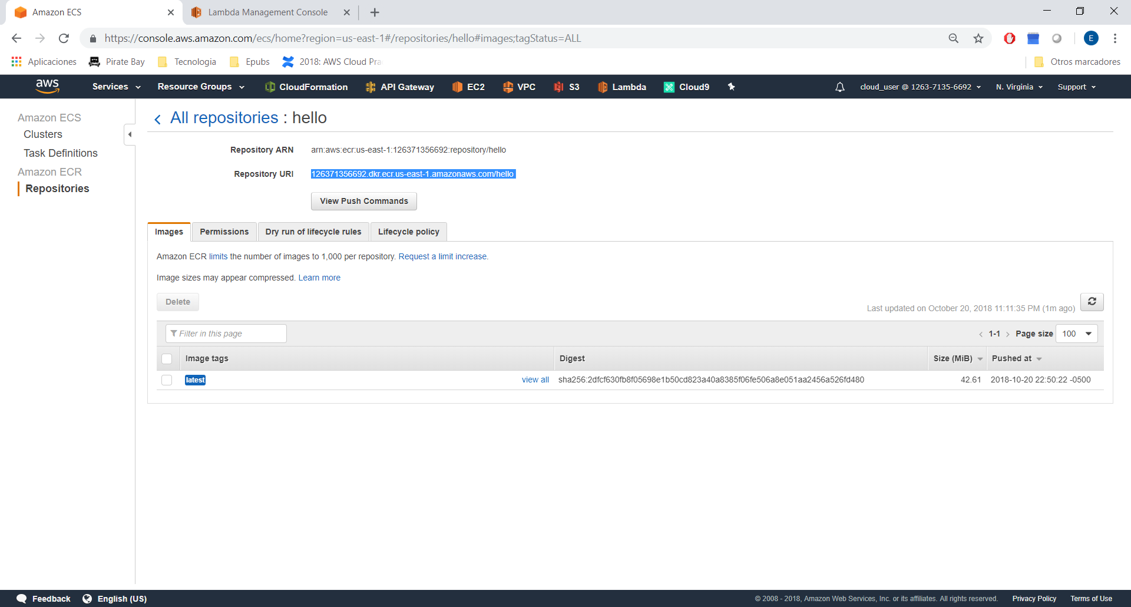
Go to:
ECS-→Cluster-→LinuxCluster-→LinuxService-→task
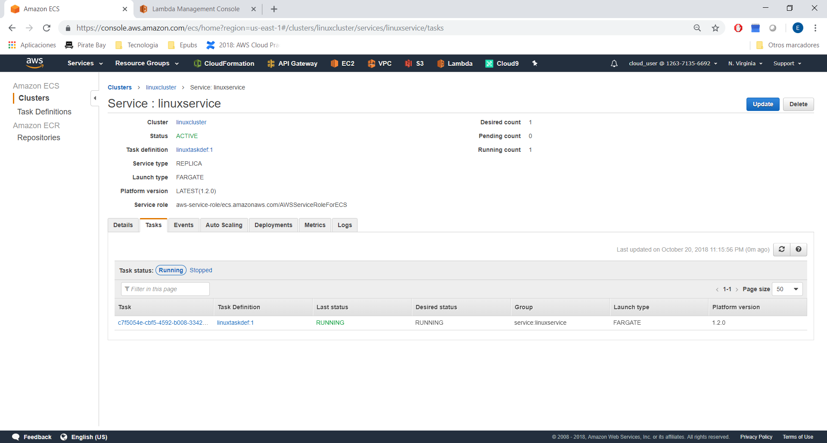
Click in tasks:
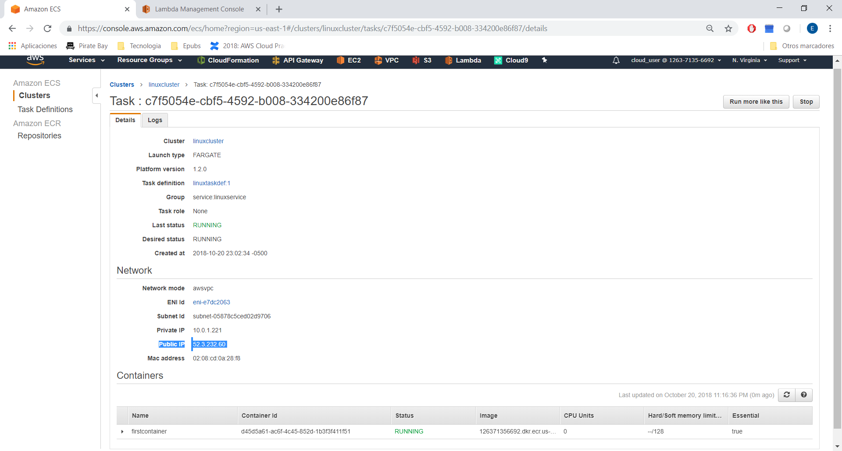
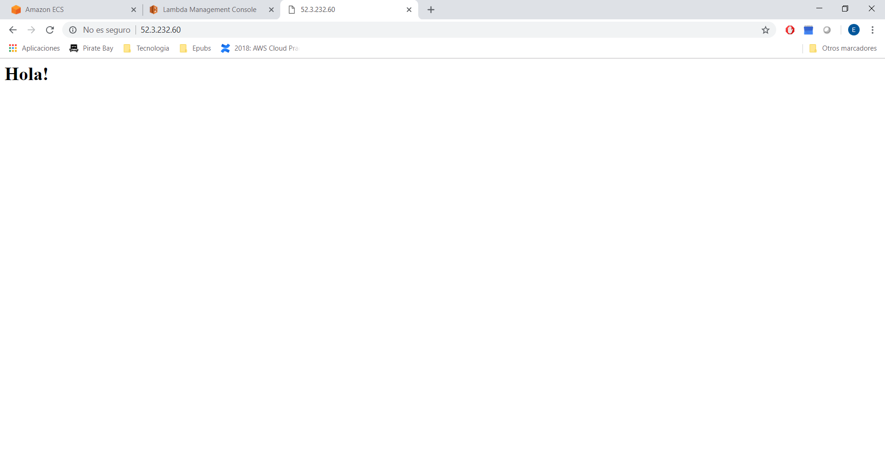
CloudTrail:
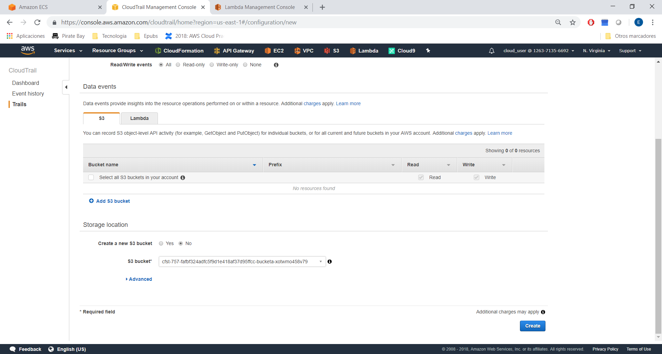
Configure cloudwatch logs:

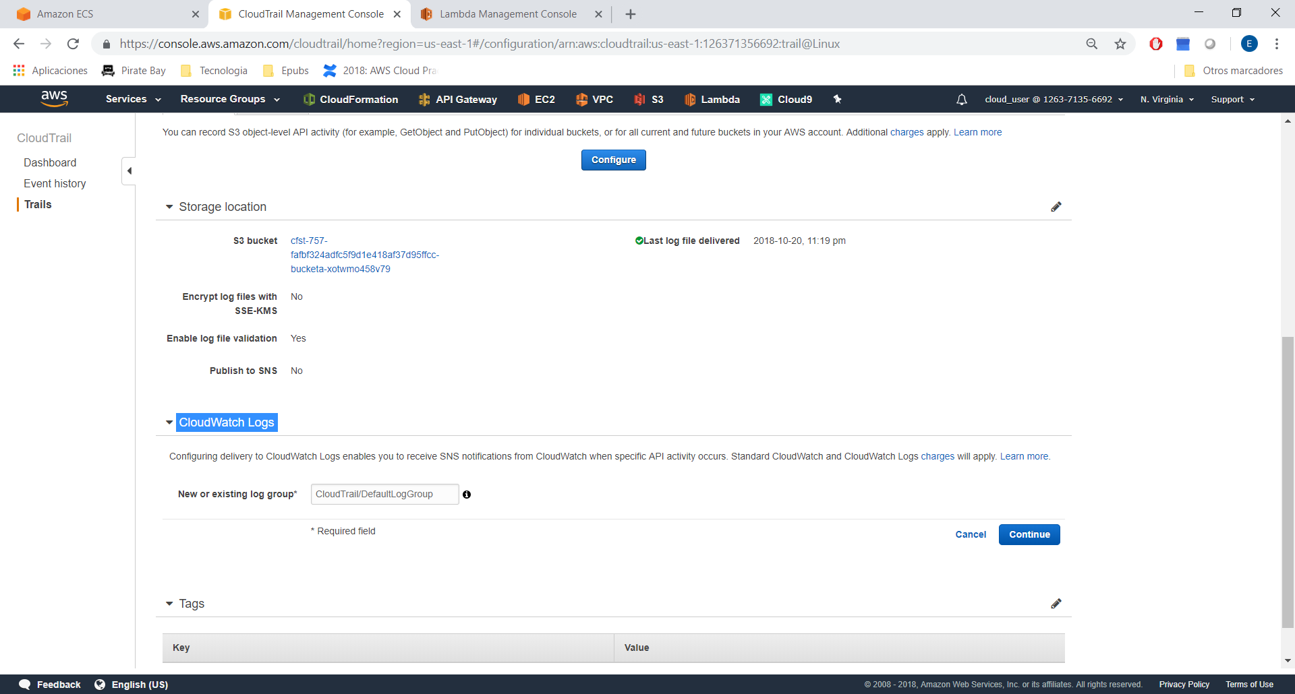
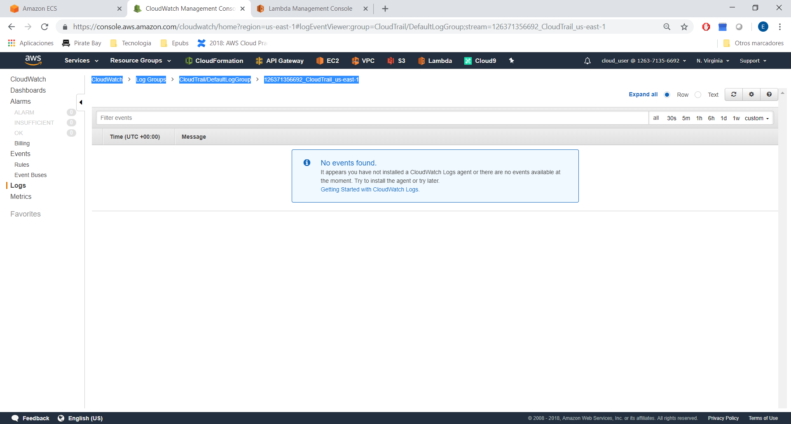
Create Rule:
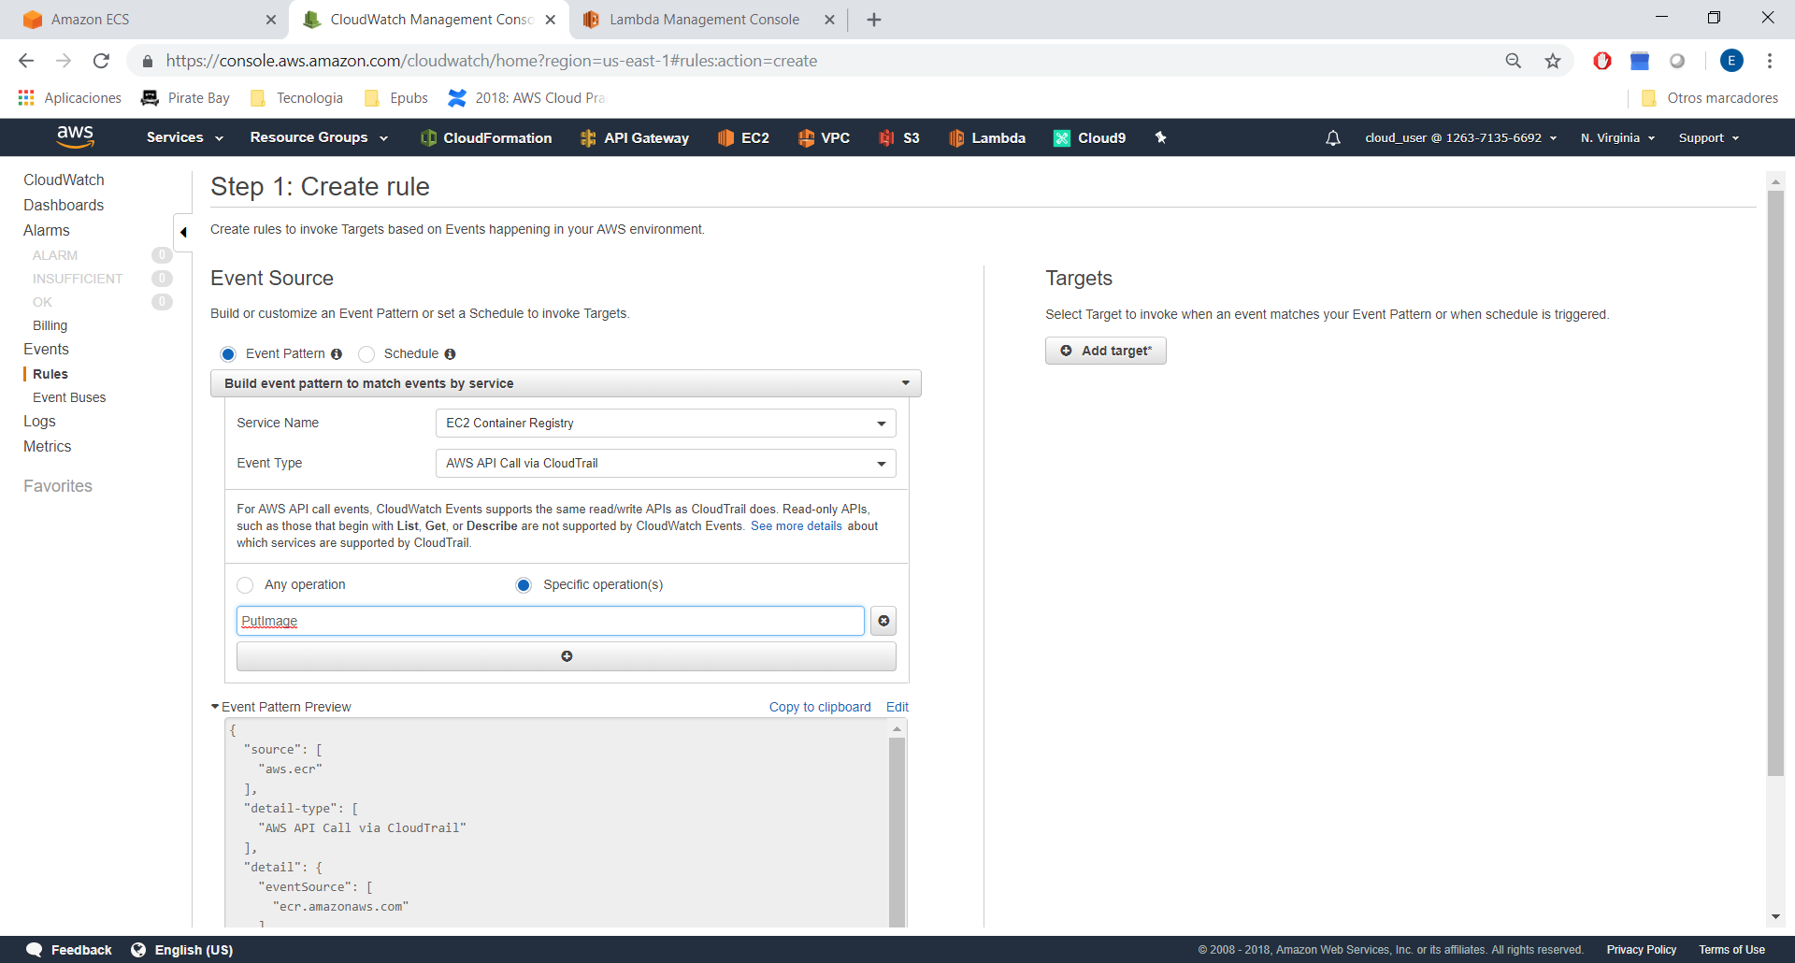
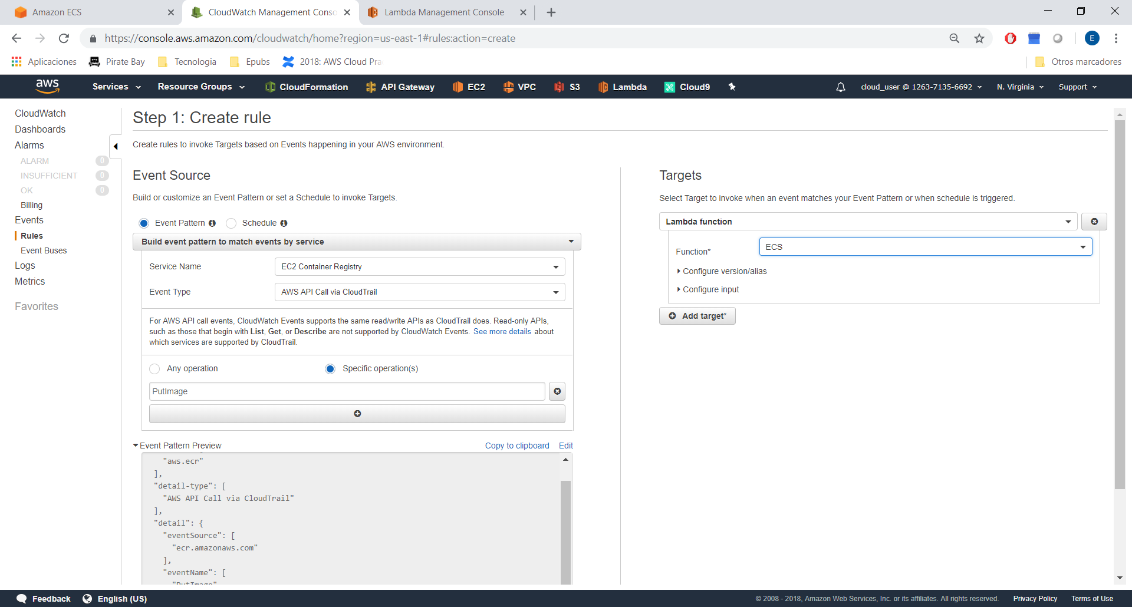
Configure details:

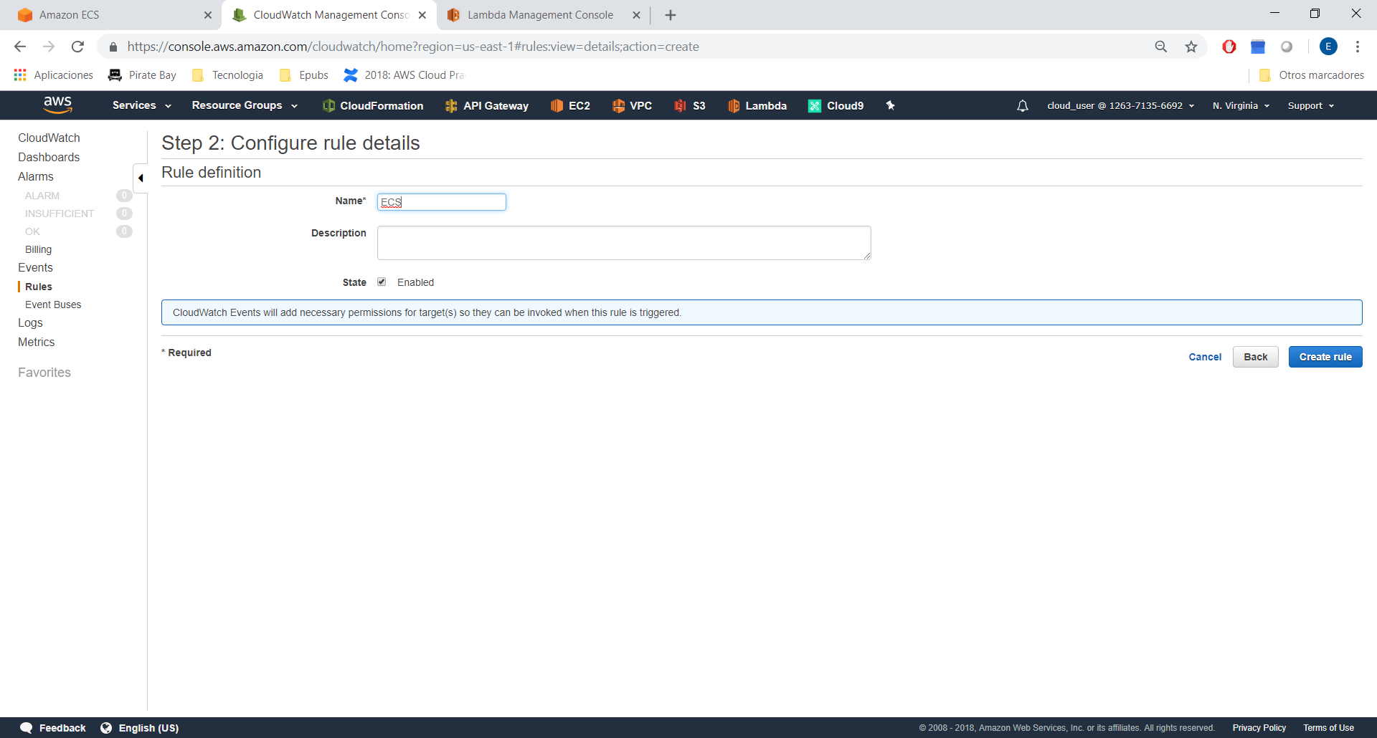
Add some text to index

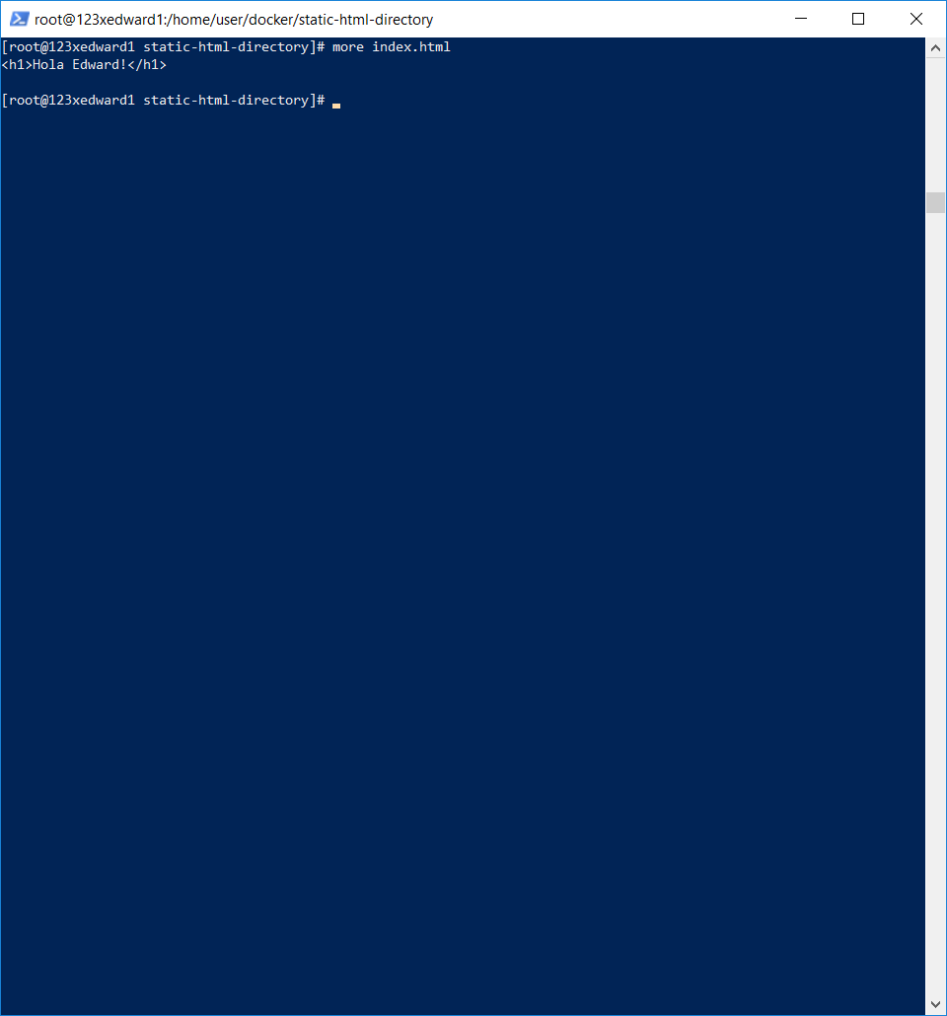
Repeat command
docker tag and docker push:

