Manual:

Check EC2 Instances:

Private:

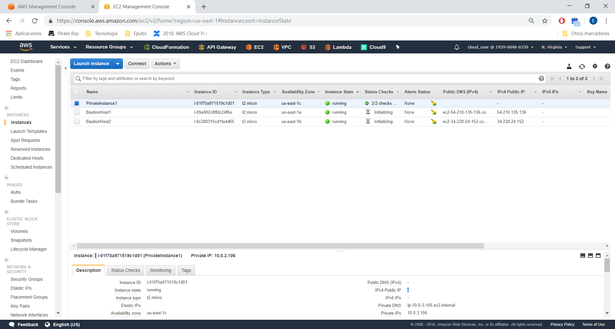

Private:

10.0.3.106

Bastion 1:

54.210.135.136

Bastion 2:

34.228.24.152

Go to Security Groups:

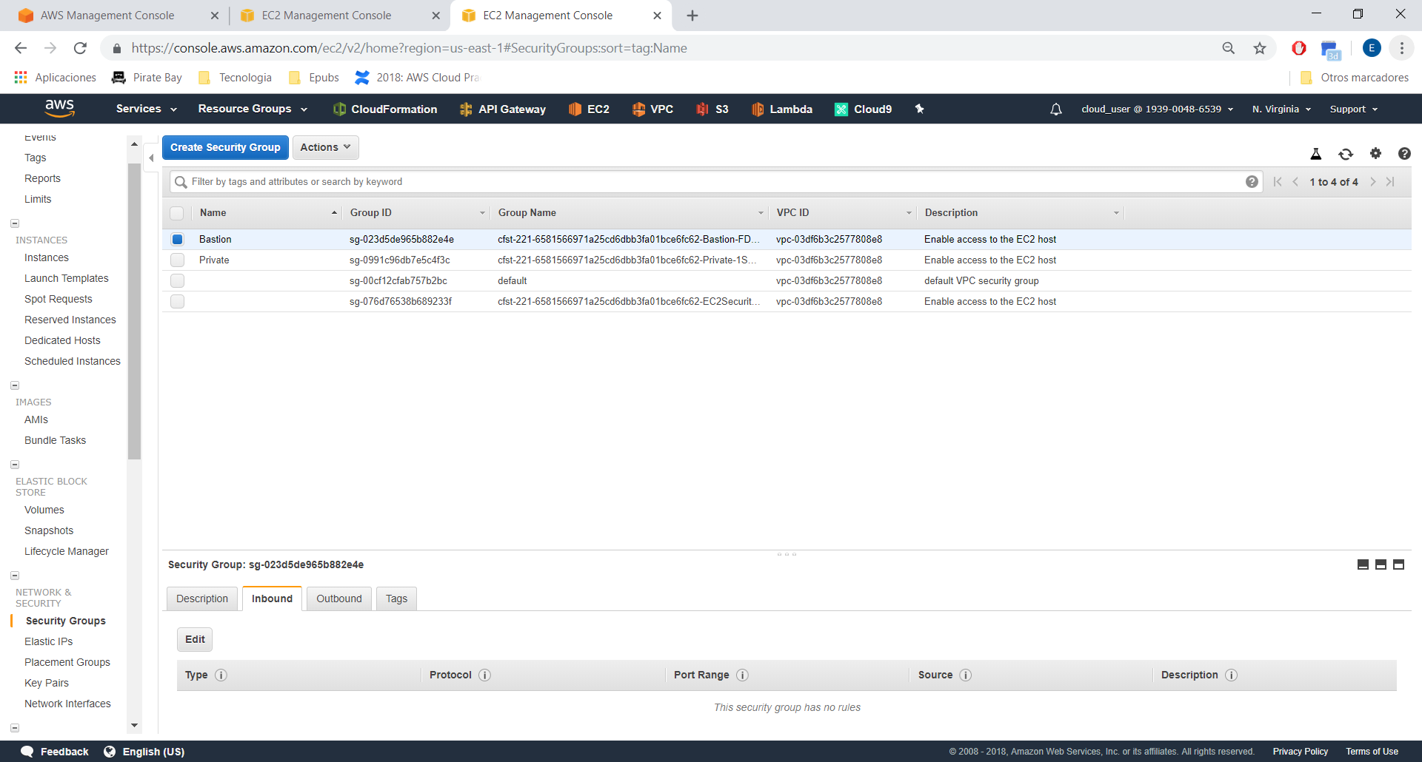

We need to add SSH (Port 22)

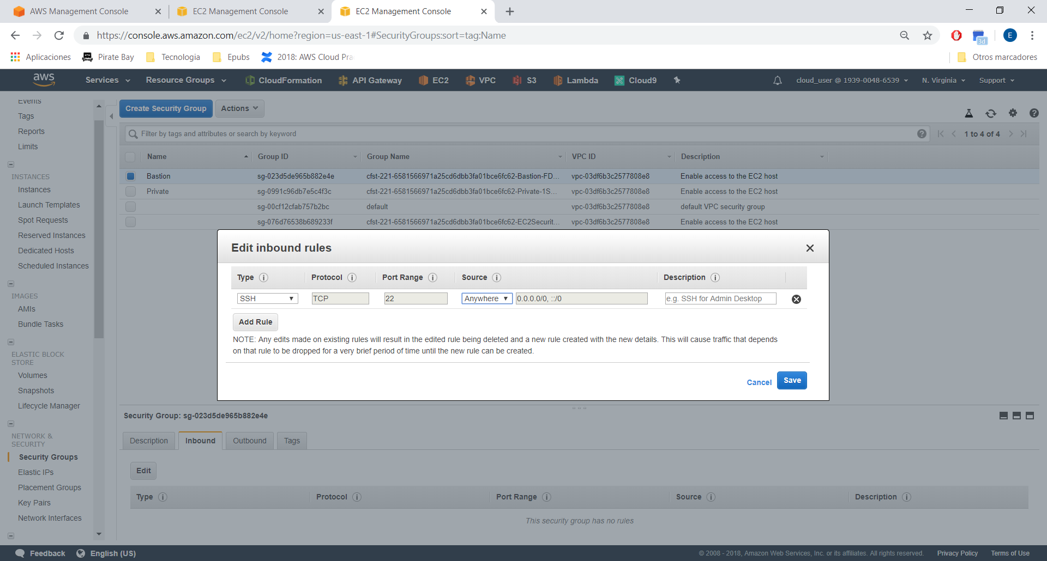

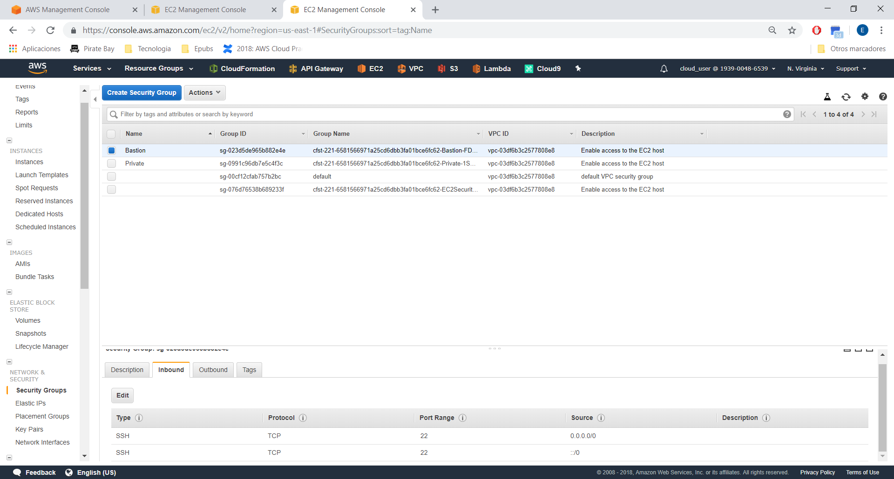

Check Private Security Group:

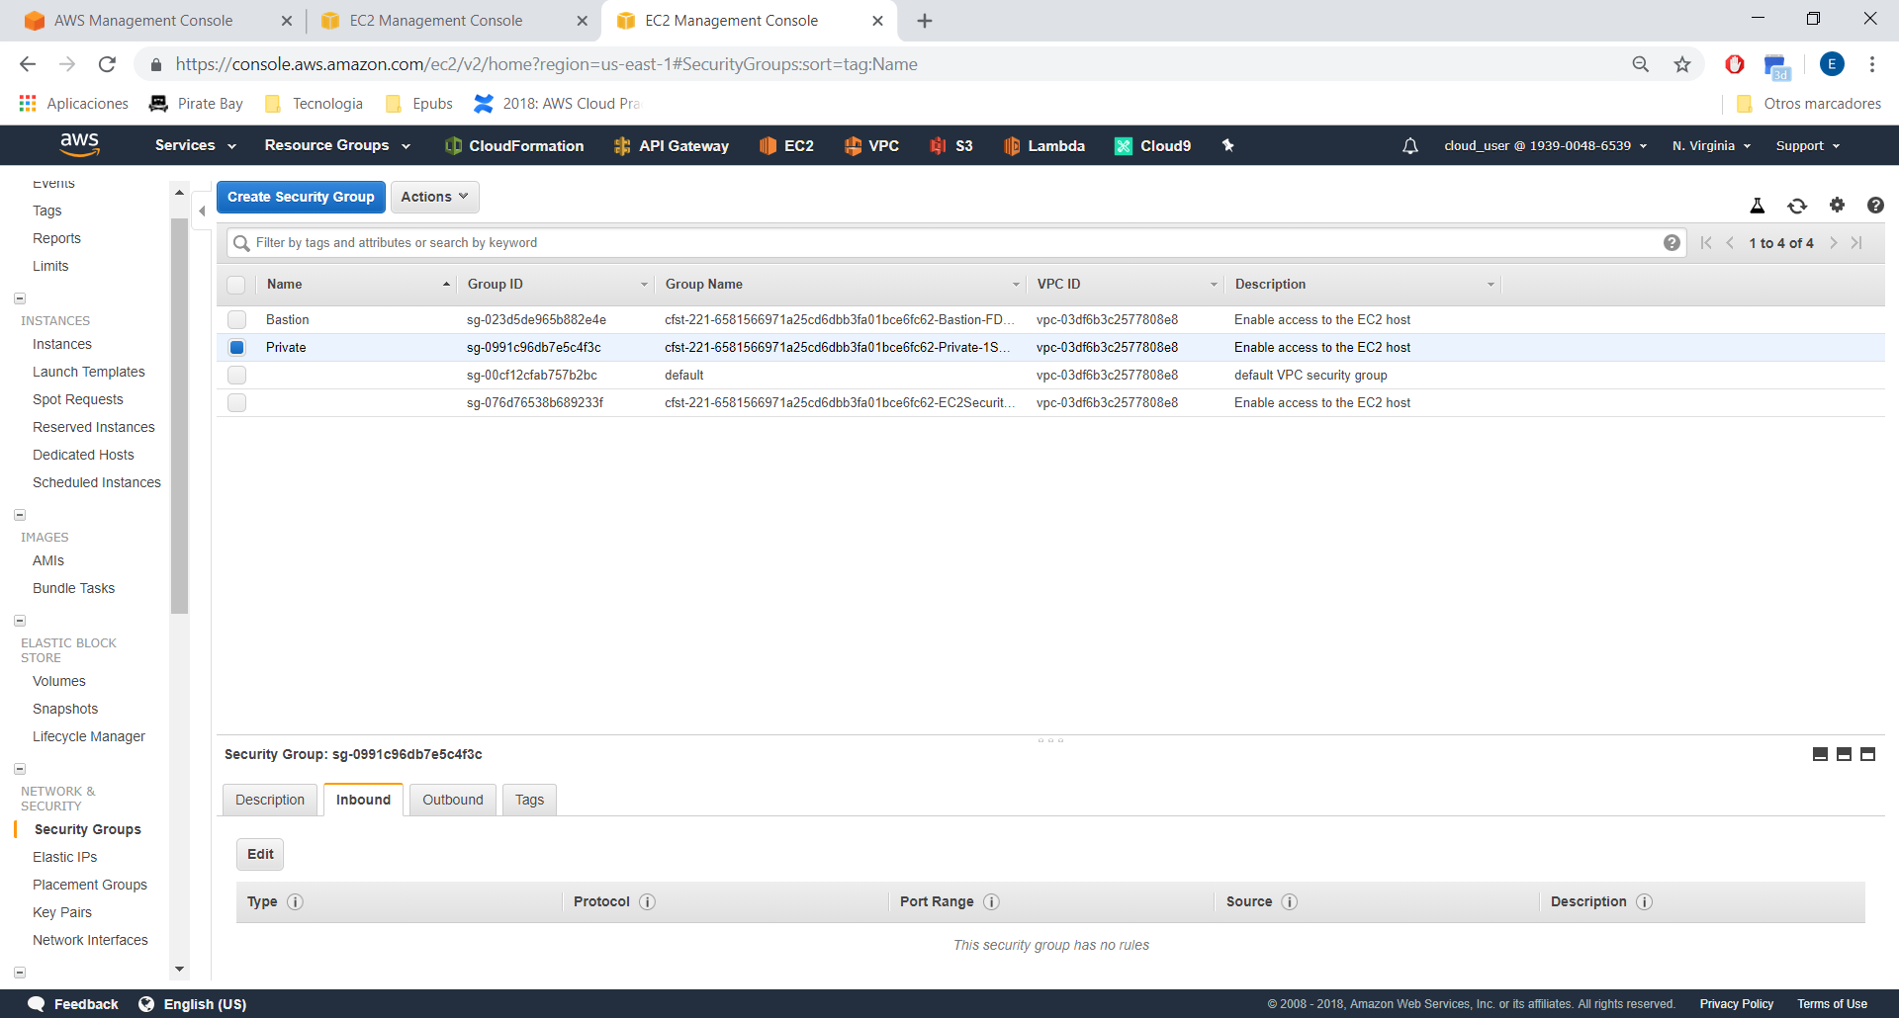

We need to add SSH (port 22), but only from Bastion SG.

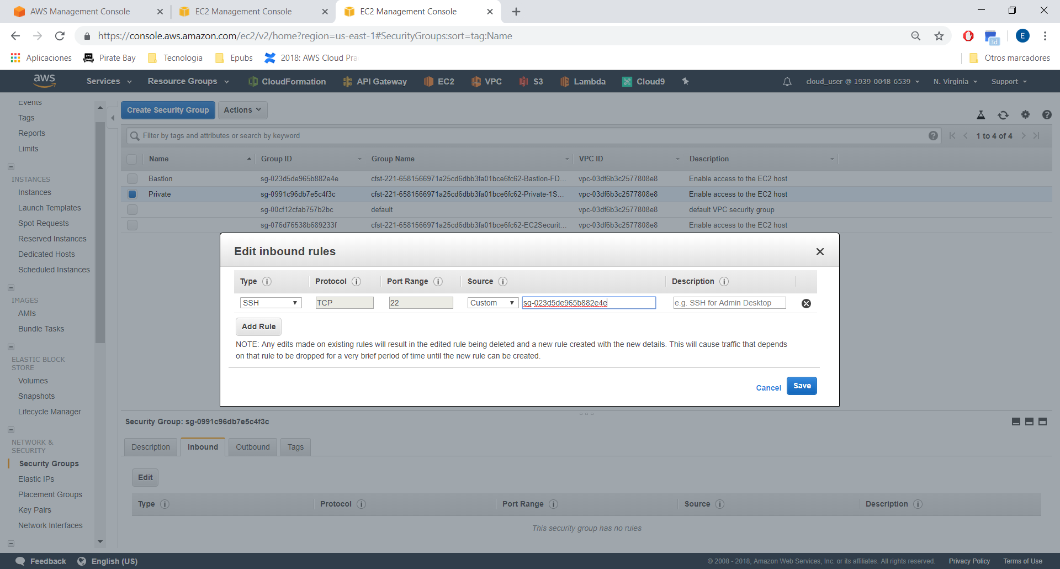

Connecting to the bastion host:

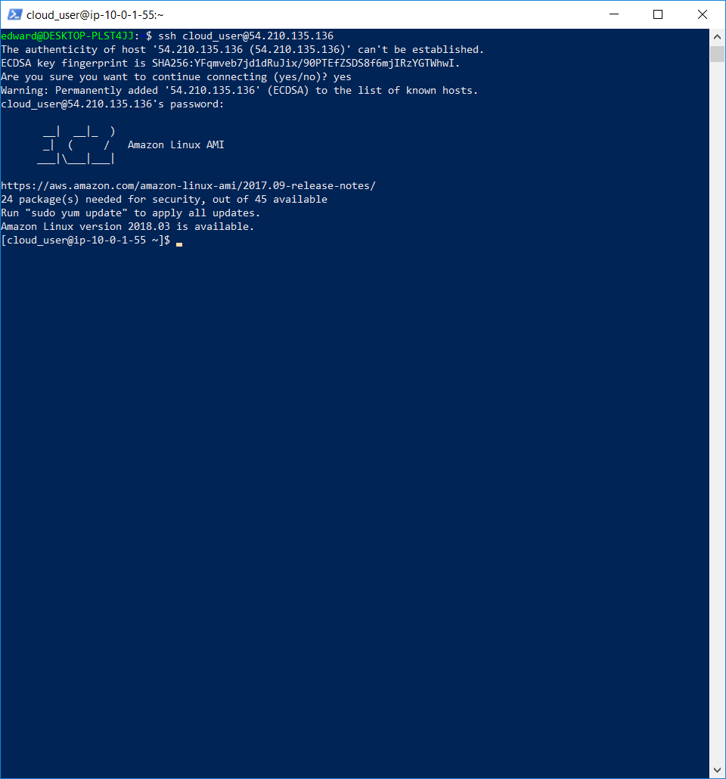

We are in the bastion host, now we need to move to private host:

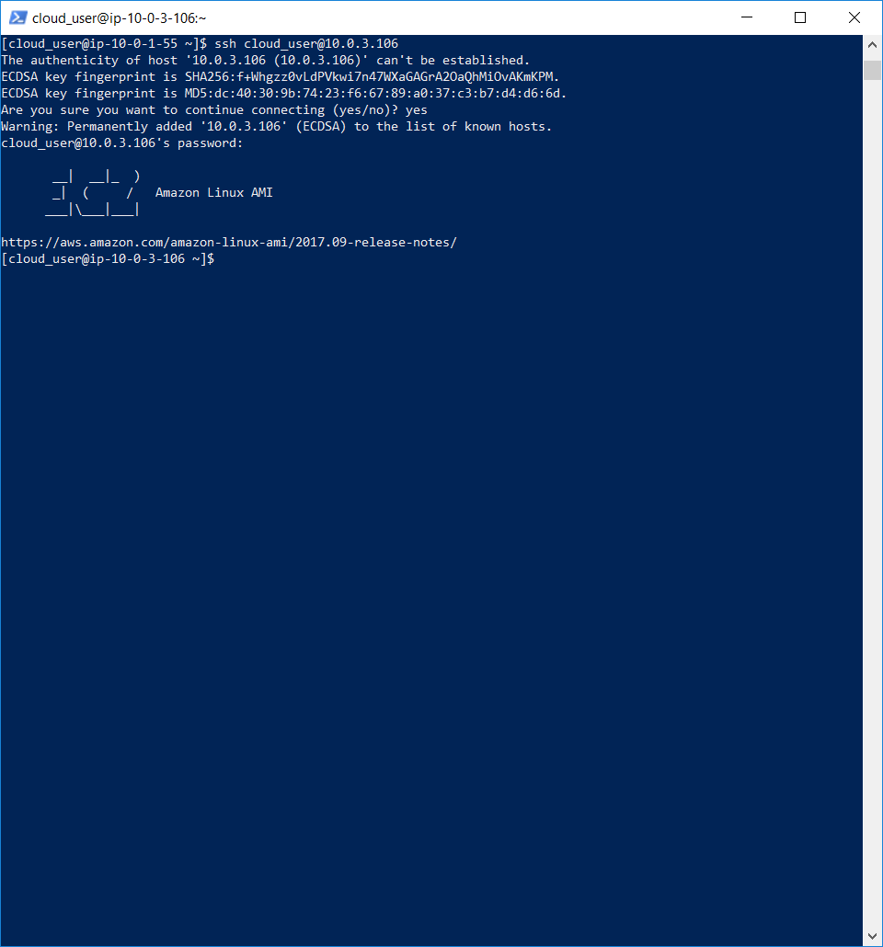

We are in the private host!.