### **Performing a Source Code Security Scan Using git-secrets in AWS**

Connect to an EC2 Instance and update the system.

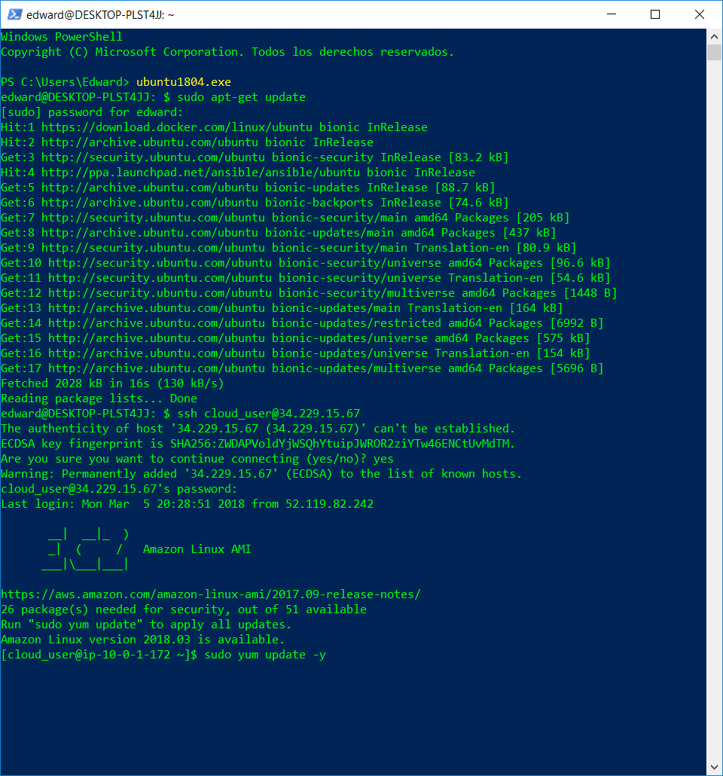

Install git

sudo yum install git -y

Clone next repositories:

<https://github.com/awslabs/git-secrets>

<https://github.com/linuxacademy/la-aws-security_specialty>

Move to git-secrets and:

sudo make install and type git secrets:

Now move to anothere repo:

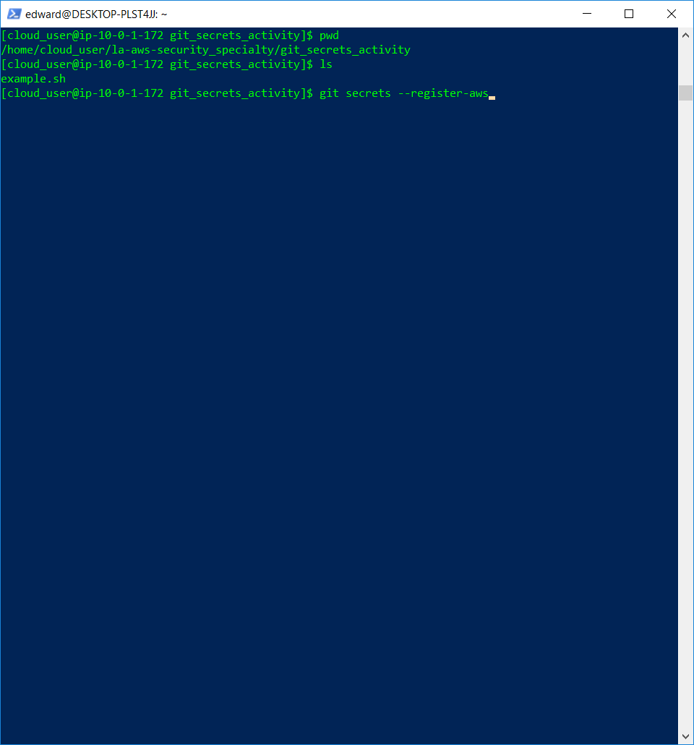

git secrets –register-aws

git secrets –scan :

