AWS Config

Go to Config

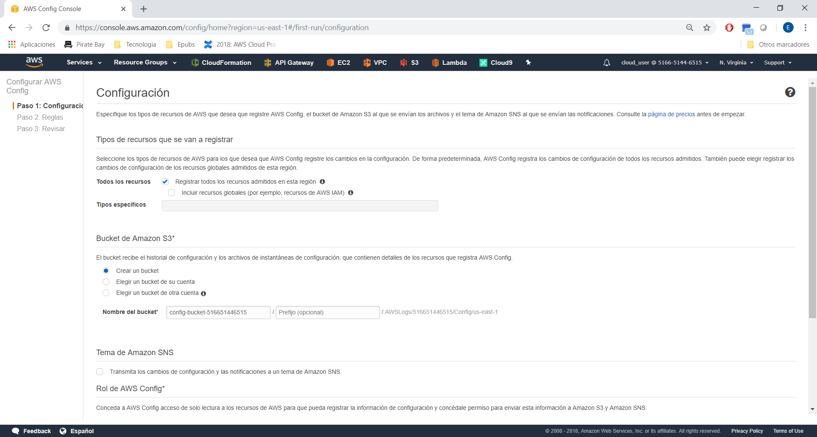
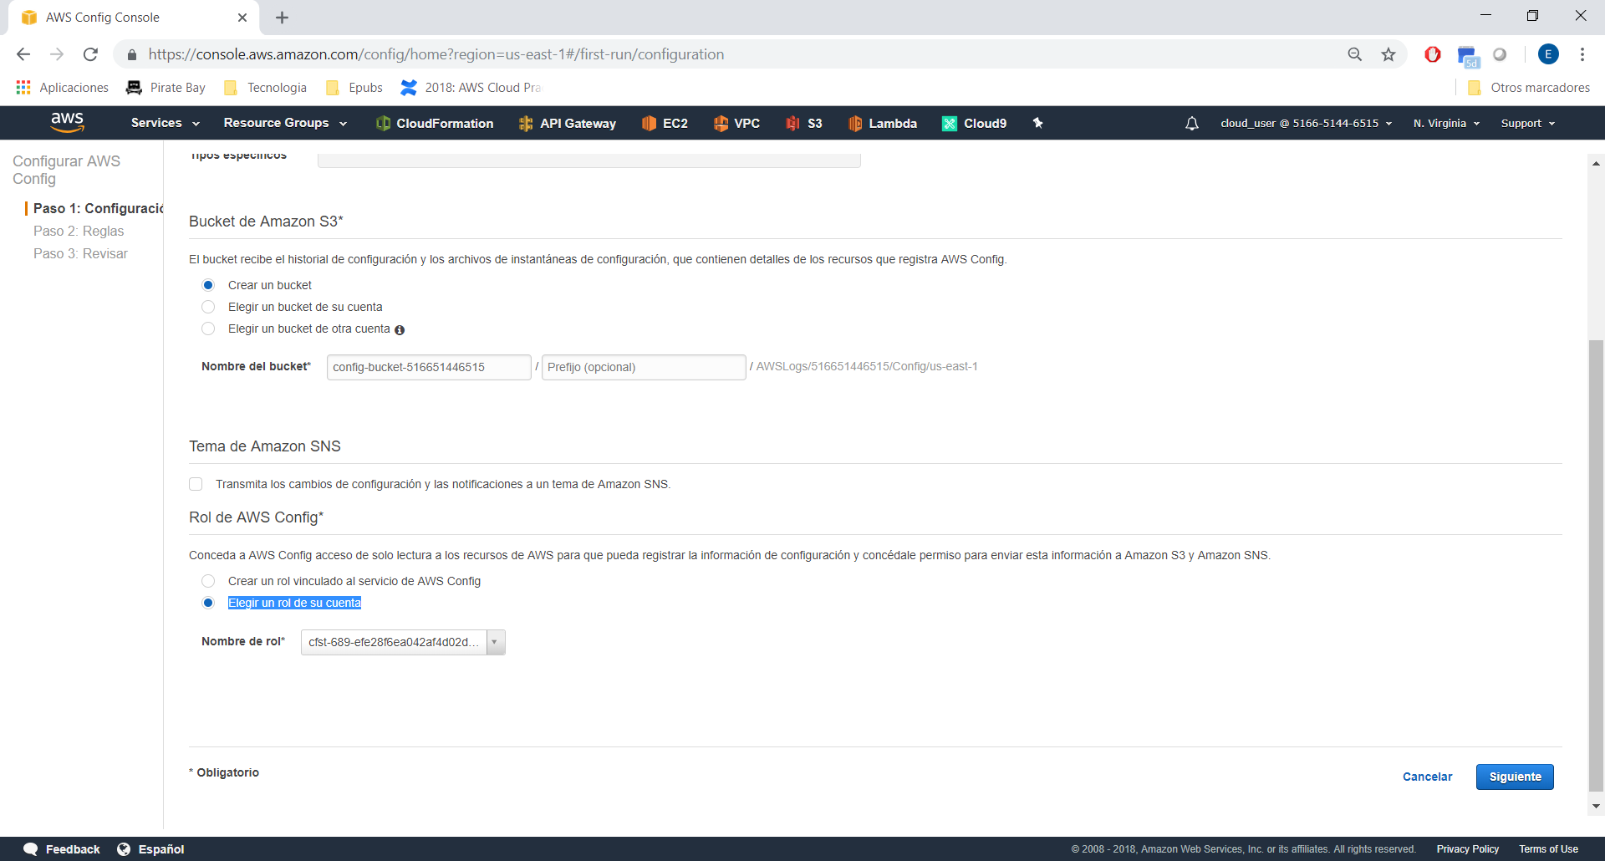
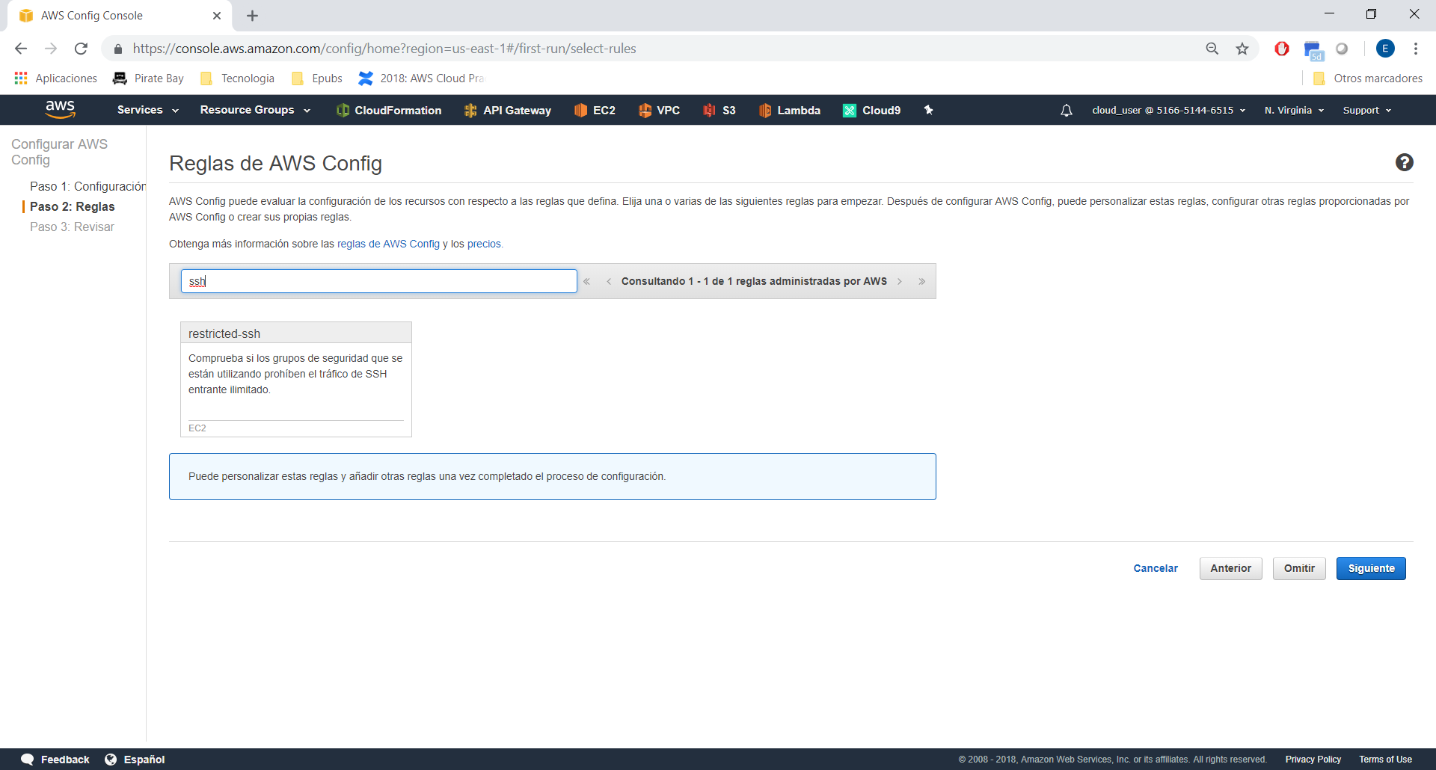
Choose and next:

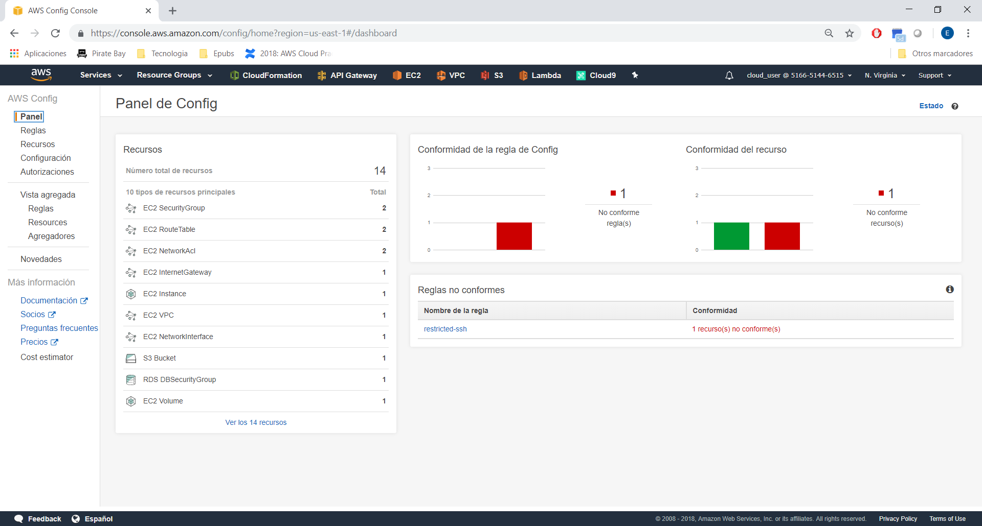
In this example, we have 1 compliant and 1 non compliant ssh rule.

Go to SNS, we need to create a topic:

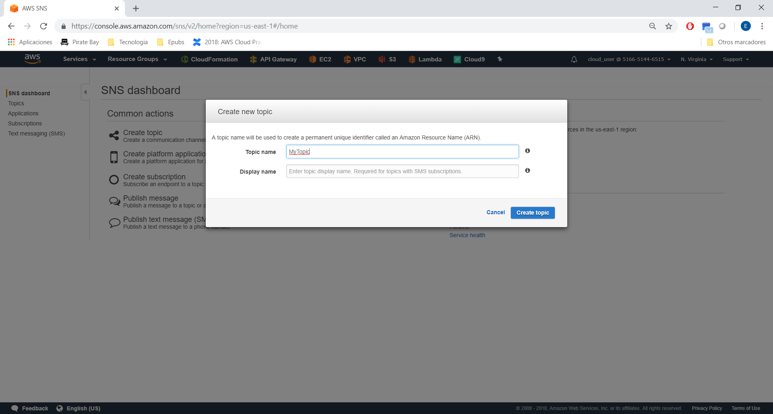

and Create a Suscription:

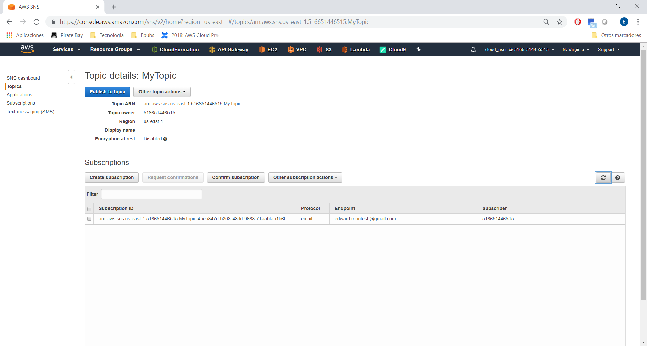
Now, move to Lambda Section:

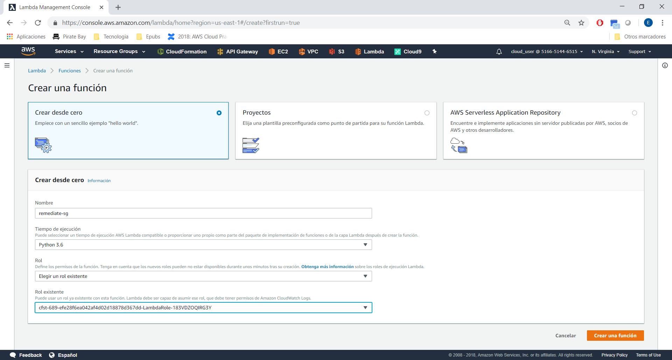
Copy the code in github:

https://github.com/123xedward/AWS_Security/blob/master/AWS_Config/lambda_function.py

Now, move to CloudWatch:

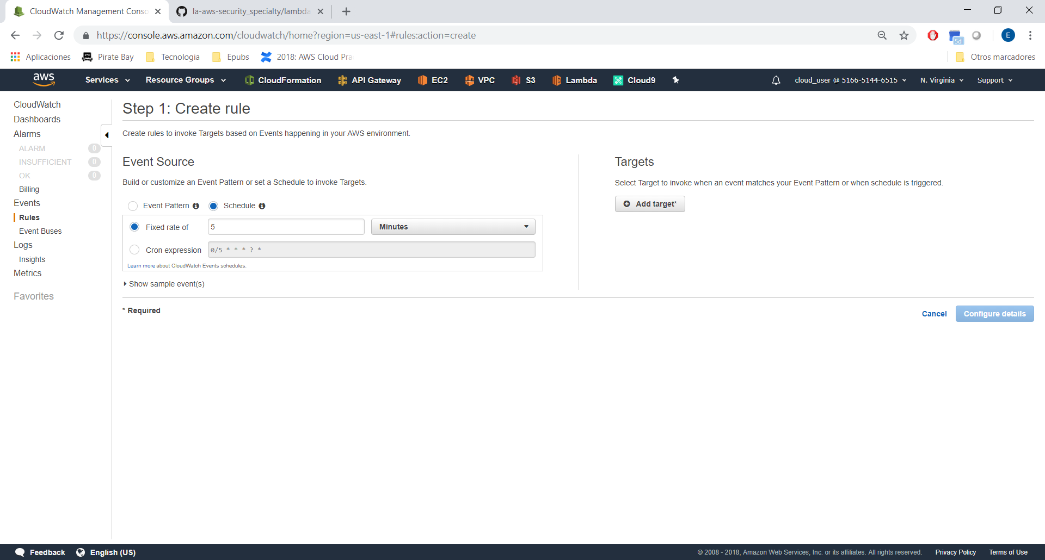
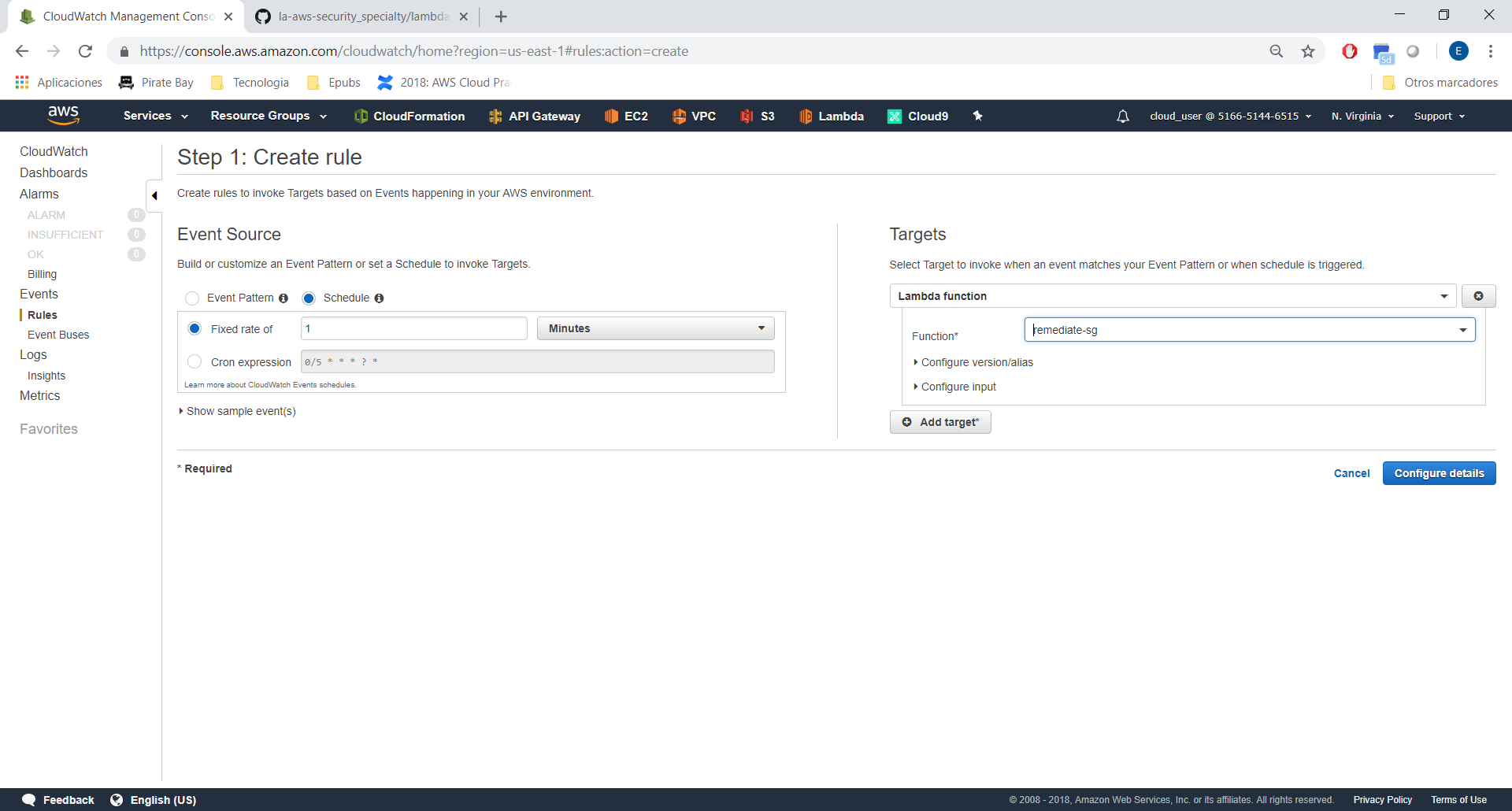

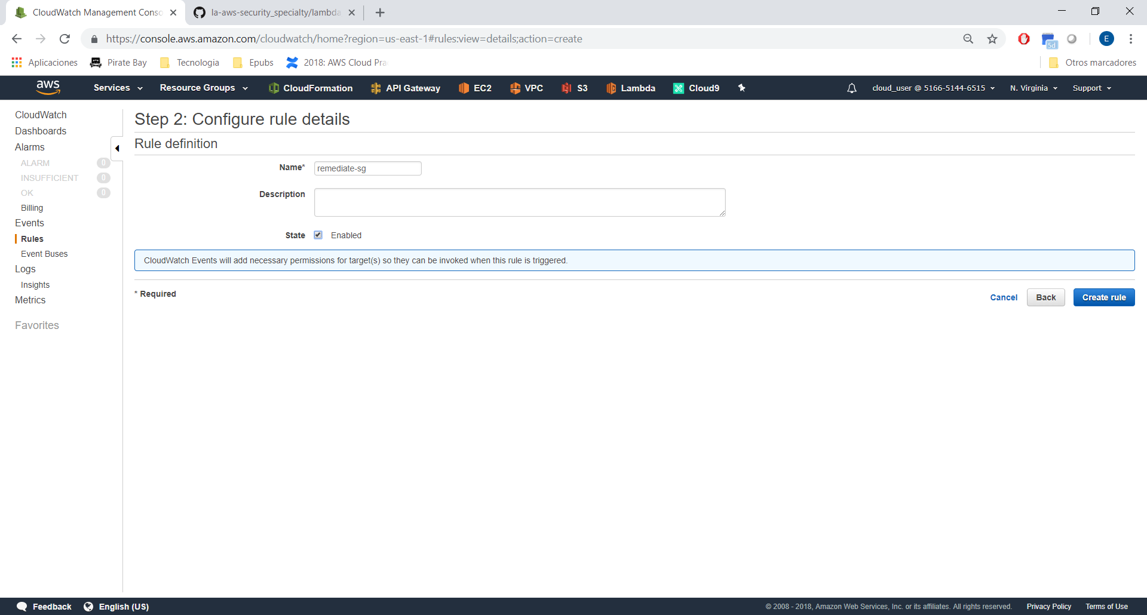
This will sending every 1 minute an SNS message until AWS Config Rule detect the new Compliance.

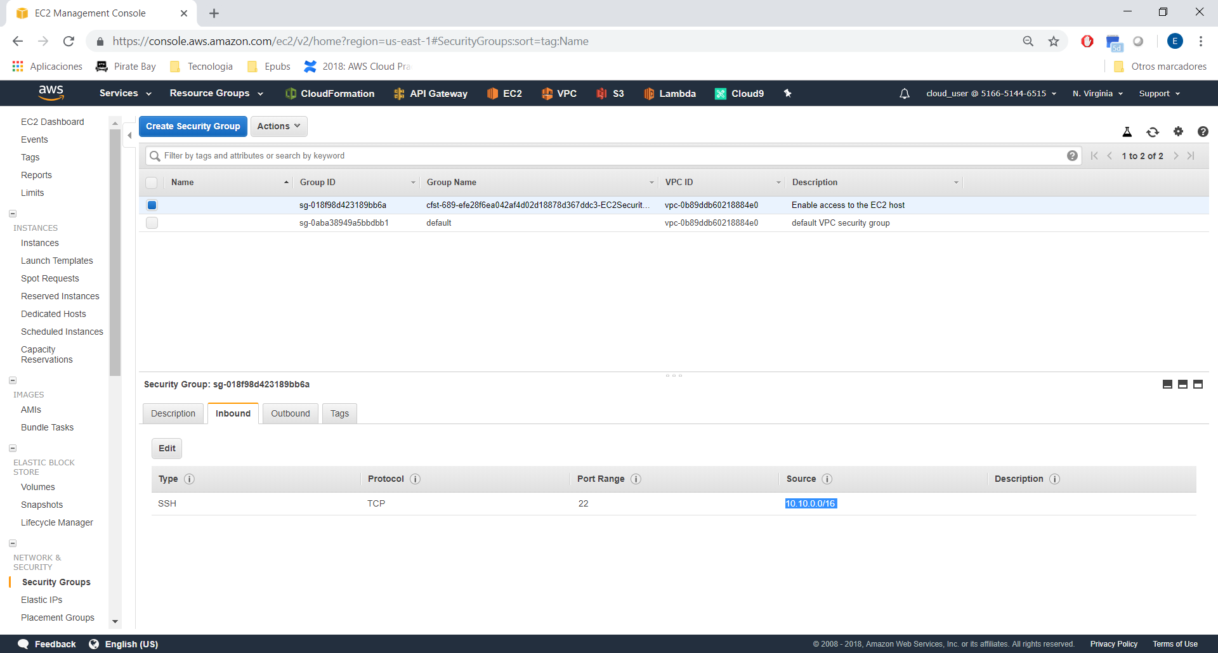
Now, move to S3, and create a new Bucket (Public).

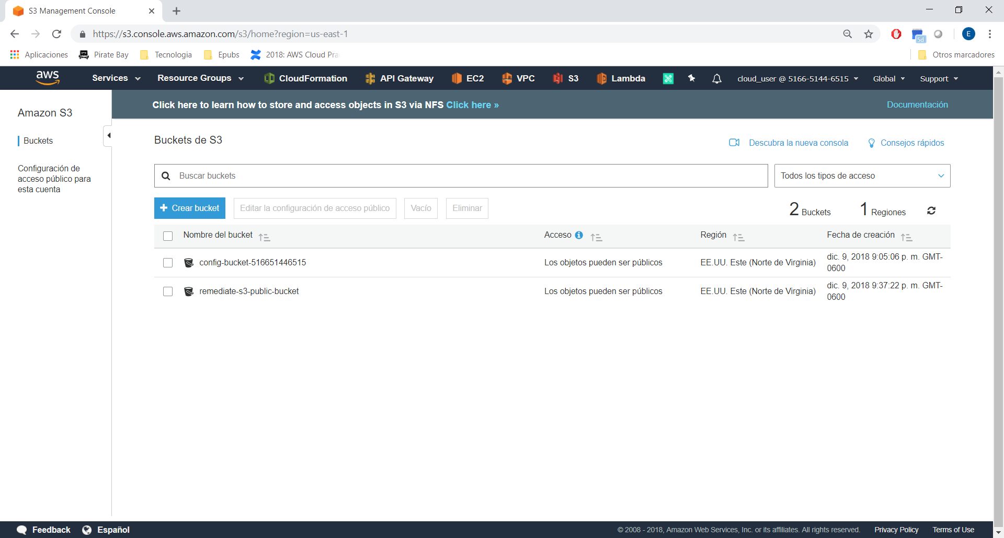

Move to Config → Rule

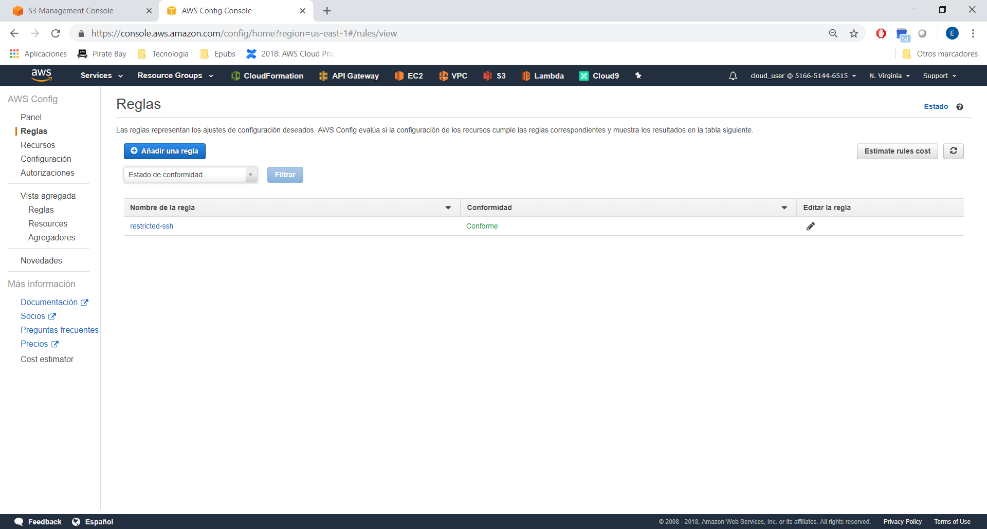
Type S3

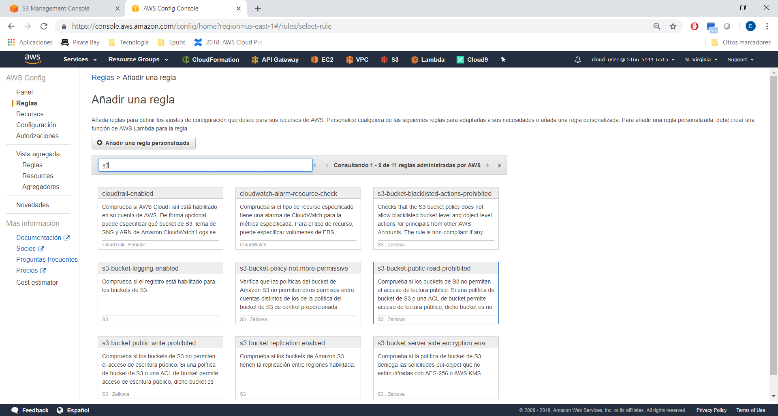
Choose s3-public-read-prohibited:

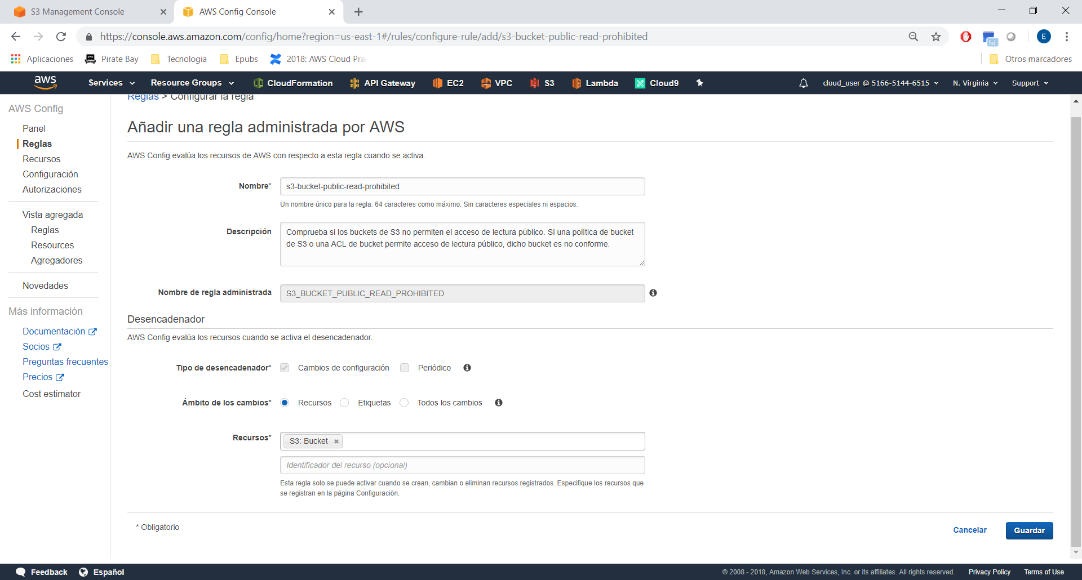

Now, move to lambda and create a new function.

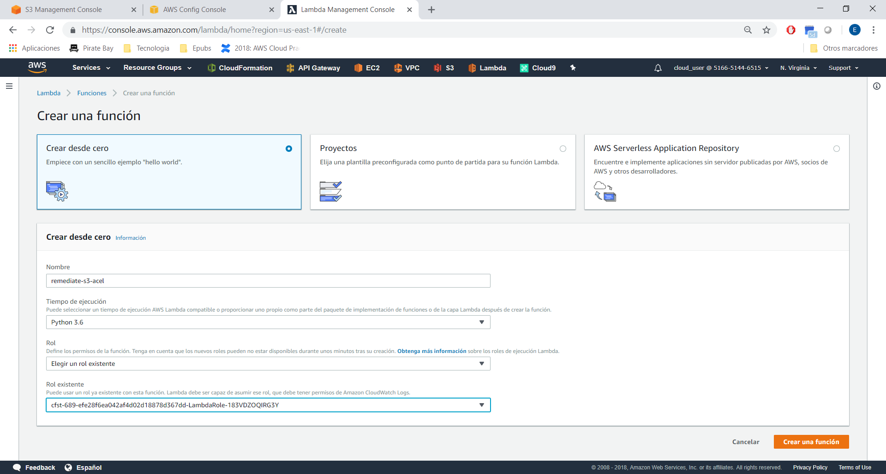

Copy the Lambda Code:

https://github.com/123xedward/AWS_Security/blob/master/AWS_Config/lambda_s3/lambda_function.py

Now move to CloudWatch:

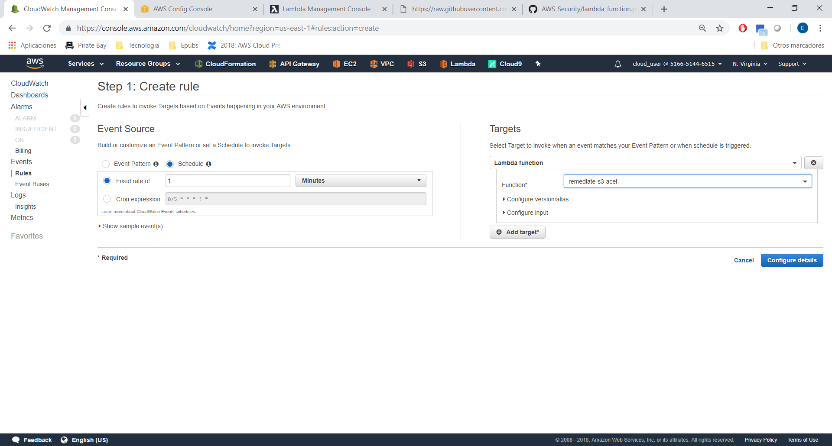
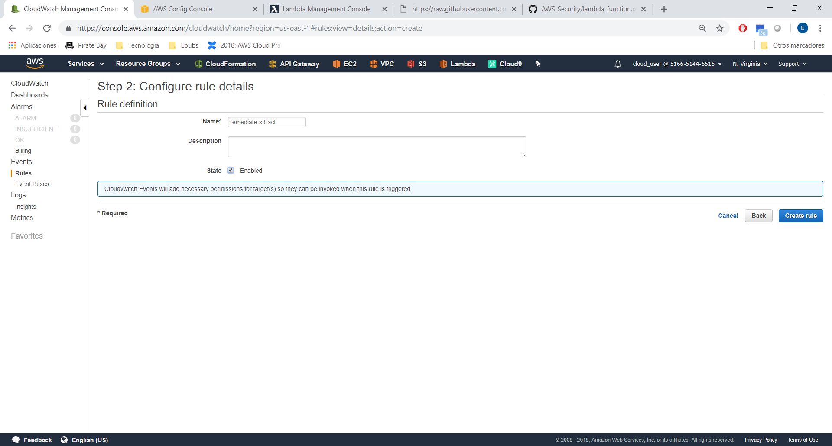

Roles:

