Necromancing Diels: computerising the phonological analysis of early Slavonic texts using existing treebank data and a Late Common Slavonic computerised inflectional morphology

Name Surname
Affiliation

Abstract

This article demonstrates a new way of massively speeding up traditional historical phonological investigations into early Slavonic philological material by furnishing each word of a manuscript-text with its direct Late Common Slavonic (LCS) reconstructed ancestor. Such reconstructions act as a type of "phonological annotation", or index, since they make the reflexes of any LCS phoneme-sequence reliably and predictably searchable, regardless of a manuscript's surface-spellings. To automate the production of this LCS reconstructed layer, a comprehensive computerised LCS inflectional morphology has been developed, which is capable of using existing lemmatisation and morphology-tagging annotation-data from texts in the Tromsø Old Russian and Old Church Slavonic (TOROT) corpus in order to inflect LCS lemmas according to each text-word's morphological shape. A web-interface, ocstexts.co.uk, is provided to showcase some of the benefits of the resulting "phonological annotations", including searchable autoreconstructed versions of OCS texts from the TOROT corpus, with virtually 100% coverage of the Codex Marianus, Codex Zographensis, and Psalterium Sinaiticum.

0. Introduction
Much progress has been made in the last twenty years in early Slavonic corpus linguistics as a result of the Old Church Slavonic part of the PROIEL project (Haug & Jøhndal 2008) and its subsequent expansion as the TOROT treebank (Eckhoff & Berdičevskis 2015), such that currently just over 240,000 words of canonical OCS have been manually lemmatised, part-of-speech and morphologically-tagged, and syntactically parsed. The focus of these projects, however, has been exclusively on the higher-level linguistic domains of syntax, semantics, and pragmatics: surface-morphology has been of only incidental concern, for example in investigations into differential-object marking (Eckhoff 2015, 2022), but the sort of inflection-class-marking which would enable the retrieval of, say, masculine *o-stems vs *i-stems is lacking. The needs of historical phonologists especially are ill-served, since some of the texts contain quite severe typographical inconsistencies and errors that make them impossible to search reliably and dangerous to use without reference to the manuscripts.

That being said, enough information is included in TOROT's lemmatisation and morphology-tagging that, with a few exceptions (e.g. certain comparatives), the morphological shape of the inflected text-forms can be predicted from just the tag-information, provided that inflection-class annotations are added to the lemmas. This means that the immediate Late Common Slavonic ancestors of surface-text forms can be generated by reconstructing and inflection-class-marking the LCS lemmas, and then using a computerised LCS inflectional-morphology to inflect each text-word's lemma according to its morphology-tag. Such LCS reconstructions are an extremely useful form of 'phonological annotation', because theoretically all the information required to give rise to an attested form must by definition be present in any correct reconstructed proto-form, and the complete regularity of the idealised LCS forms makes texts predictably searchable regardless of orthographic variability, abbreviations, or other irregularities in the surface-texts. When applied to whole texts, they make the exhaustive investigation of almost any phonological or orthographic question trivially easy compared to manually reading and extracting relevant forms, or using TOROT's existing lemmatisation and morphology-tagging to try to gather morphological categories which might contain the sound-groups one is interested in.

The goal of this article is to describe just such a computerised LCS inflectional-morphology, and to show how it can be used to "autoreconstruct" different OCS texts from the TOROT corpus, while explaining how difficulties caused by things like morphological innovations, badly-integrated foreign loanwords, or insufficiently-precise tagging-data can be overcome. The resulting ‘phonologically annotated’ texts should allow investigators of the lower-level linguistic domains (phonology, orthography, and morphology) to benefit from the huge amount of manual annotation work that has gone into the OCS part of TOROT, and the computerised LCS inflectional-morphology by itself is valuable in that it allows linguistically-rigorous and comprehensive inflection and conjugation-tables to be generated.

A web-interface for autoreconstructed TOROT OCS texts is being developed at https://ocstexts.co.uk, which aims to demonstrate the benefits of this extra layer of annotation by offering things like LCS phoneme-search of texts, conversion of each autoreconstructed word into canonical "normalised" OCS, for easy comparison with the manuscript-form, and computer-generated inflection and conjugation-tables for every reconstructed lemma. It also includes TOROT's existing morphology, lemmatisation, and (for three of the texts) Greek source-alignment data, plus integration of the recently digitised OCS dictionaries hosted at gorazd.org.

The usefulness of computational methods for diachronic phonology has of course not escaped the notice of previous scholars, and Sims-Williams (2018) offers a useful survey of a field he calls "Mechanising Historical Phonology". Of the three main strands of work considered there, (“automatic cognate-recognition”, “computerised forwards-reconstruction”, and “computerised backwards-reconstruction”), only forwards-reconstruction is of any relevance to the task of holistically investigating the sound-systems of manuscripts, in that one could apply sound-changes and orthographic rules to the LCS reconstructed layer of individual texts to try to “reverse engineer” the manuscript spellings, and in so doing test hypotheses about the phonological features of the underlying dialect[s] that gave rise to them. The forwards-reconstruction work mentioned by Sims-Williams, though, is invariably aimed at producing sets of isolated, regularised forms, either from modern standard languages, or theoretical idealised forms from old languages, e.g. Borin’s (1988) OCSGen system that tried to produce “normalised” OCS from PIE. This type of work is useful for identifying problems with traditional diachronic accounts of ordered sound-rules, but it is of a fundamentally different nature to what I'm doing here, which is about elucidating the concrete philological facts of the manuscripts in order to better understand the synchronic linguistic systems responsible for them.
Most early Slavic texts are from dialect-areas (East Slavic and Bulgaro-Macedonian) whose modern phonological systems show evidence of sharp differentiation along deep structural lines, most importantly in the phonologisation of secondary consonant-palatalisation and the tolerance for bimoraic syllables (i.e. distinctive vowel-length). The seeds of these differences must have been sown around the time of the radical restructuring occasioned by loss of the reduced-vowels *ъ,ь (the so-called "Jer Shift"), i.e. the very time at or shortly after which our manuscripts were written, but the limitations of the original writing-system (which was devised for a language which had not yet undergone the Jer Shift) mean that they do not find clear expression in the texts and can only be dimly groped at through indirect means. Much more thorough investigation of all aspects of the manuscript-spellings are thus required in order to uncover the nature of the linguistic systems they reflect.

Slavonicists are in the fortunate position of having not only a widely and diversely attested set of daughter-dialects from which to reconstruct the proto-language, but also a historical written record which is so close in time to the Common Slavonic period that the far-southeastern Bulgarian dialect of Thessaloniki was considered a suitable vehicle for proselytising the proto-Czech speakers of Moravia. The hypothetical LCS system which I employ for my reconstructions is therefore mostly uncontroversial and widely agreed-upon (except in trivial matters of notation); nevertheless, a corpus-focused project like mine where the aim is to reconstruct all words of a text requires an exhaustiveness and rigour that leaves no room for the dodging of difficult points, so Section 1 of this article is taken up with a comprehensive exposition and justification of my chosen LCS system. Section 2 then looks in more detail at my computerised LCS inflectional-morphology and the structure of the existing TOROT data, and shows that together they can be used to produce the direct phonemic ancestor-forms of text-words, despite various challenges, including the morphological variation and restructuring which is occurring in even the earliest texts. Section 3 highlights some of the benefits gained by having texts indexed with LCS reconstructions and explores some ways this could be used to improve and speed up investigations of manuscripts.

1. My Late Common Slavonic (LCS) phoneme-system

The premise of my chosen form of "phonological annotation" is that the earliest Slavic texts reflect languages which are structurally close enough to the broadly-agreed-upon system of Late Common Slavonic that the forms underlying the manuscript-spellings are more or less trivially derivable (by the application of sound-change rules) from their theoretical LCS ancestors.
By 'structurally' I am referring to structure at the phonological level; structural changes at higher levels of analysis (i.e. inflectional morphology, derivational morphology) are of no concern unless they are made possible only by intervening phonological changes.
My contention is that before about 1100 not enough of these structural changes are in evidence in any Slavic text, and thus texts can be relatively straightforwardly indexed using a well-chosen LCS system. Before giving examples of structural changes that are problematic for such an indexing-system, it's necessary to first lay out my LCS system in full:

In order to account for as much of the subsequently attested Slavic as possible, a point after the monophthongisation of diphthongs, but before the Second and Third Velar Palatalisations (PV2 and PV3) is chosen as the point of departure, because of the difference between the West Slavic /š/ and South/East /ś/ reflex of these two palatalisations of *x (Cz. loc. pl. duších vs Suprasliensis доусѣхъ <*duxěxъ; Polish wszak vs Supr. вь҆сакъ , Ru. всяк[ий] <*vьx-akъ), as well as the probable complete absence of PV2 in northern East Slavic (Old Novgorodian, see Zaliznjak 2004: 42-45 for the evidence), and the blocking of PV2 by an intervening *v in West Slavic (Pol. gwiazda, Cz. květ <*gvězda, *květъ, etc.).
To be explicit, the native phonemes in my LCS system are given in the tables below:

Table 1: LCS Vowels after the monophthongisation of diphthongs
 | Front Back
High | i |  | y u
 | ŕ̥ ь ĺ̥ | y̨ | r̥ ъ l̥
Mid | e ę |  | ǫ o
 | ě ę̌
Low | Ǣ
 |  | a

Table 2: LCS consonants before PV2/PV3 (adapted from Winslow 2022: 304)
Labial | Dental | Palatal | Velar
m | n | ń
b p | t d | ћ ђ | k g
 | s z | š ž | x
 |  | č
 | l | ĺ
 | r | ŕ
v |  | j

1.1 Foreign sounds
In addition, the following symbols are used for phonemes of wholly foreign origin in order to represent badly-integrated foreign borrowings, whose level of integration into the native system we deliberately do not take a position on: /ḱ ǵ x́ f ü/, e.g. in respectively к҄итъ <*ḱitъ, ꙇꙉемонъ <*iǵemonъ, хитонъ <*x́itonъ, иосифъ <*ijosifъ, and мѵро <*müro. Almost none of the words containing these symbols would actually have existed in the language during Common Slavonic times, but they need to be included in the indexing-system because they often contain native Slavic elements (f.ex. inflectional endings). Normally they represent specific sounds in the source-language (usually Greek), so including them is useful for investigating the process of these sounds' integration into the native systems. For instance, the extent to which Greek /ü/ is integrated into either native /i/ or /u/ can be seen in variations in the OCS spellings of the word for 'Egypt' (*eǵüpьtъ): ⰵⰼⱓⱂⱅⰰ {eǵüpta} vs ⰵⰳⰹⱂⱅⰰ {egıpta} vs ⰵⰳⱛⱂⱅⱏ {egϋptŭ}vs е҅гоуптъ vs ⰵ̅ⰼⱛⱂⱅ̅ⰰ {eǵϋpta}, etc.. One might also ask whether a separate <ⰼ> letter for /ǵ/ (and the writing of <к҄ >/<ⰽ҄ > with the palatalisation-diacritic) could be linked to the inadmissibility in the native systems of soft [k^{j}, g^{j}] sounds, and whether their replacement with regular <ⰳ,ⰽ> or <г, к> was more likely in systems with some level of native [k^{j}, g^{j}] (for instance, in Rus' after the so-called Fourth Velar Palatalisation *ky,*gy,*xy > [k^{j}i, g^{j}i, x^{j}i], or in Novgorod due to the retention of native velars before front-vowels because of the non-action of PV2, etc.). In any case, such questions are far easier to investigate if all relevant forms can be reliably retrieved by giving them even a consciously artificial LCS representation.

1.2 Vowels
I have deliberately not included accentual information in my reconstruction of vowels, even though such information is in fact required to explain certain differing manuscript-reflexes, e.g. Russkaja Pravda fem. acc. sg. робу < *orb-ǫ vs Uspenskij Sbornik nt. acc. sg. рало < *ordl-o, because for too large a proportion of the vocabulary this information is not sufficiently securely and uncontroversially reconstructed, and anyway the (often post-LCS) derivational processes which are responsible for most of the actual words in the attested texts (and the inevitable accentual levelling processes likely to have occurred in the course of these derivations) complicate things even further.

The two extra nasal-vowels /y̨/ and /ę̌/ are required to account for the split between North (East and West) and South Slavic forms of certain inflectional-endings:
- *y̨ is used for the nom. sg. masc./nt. pres. act. participle of certain verb-classes whose present-stem ends on a hard-consonant, which in South Slavic remains high and backed, e.g. Supr. ꙁовꙑ <*zovy̨, Psalterium Sinaiticum ⱄⱅⱃⱑⰳⱘⰺ {strěgǫï}<*stergy̨-jь, Codex Marianus ⱑⰴⱕⰻ {ědɴ̨i} <*jǢdy̨-jь (these forms lead Kortlandt (1979:260) to posit that some dialects of early OCS retained some kind of nasal character in this vowel and may even have developed the special "hooked" nasal letter <ⱕ> for it), but which in most of North Slavic lowered to /a/: Old Polish (Kazania Świętokrzyskie) has both reca and recꟁ (with the special Old Polish letter for the merged reflex of *ę and *ǫ) <*reky̨, and in other texts also biorꟁ <*bery̨; Russkaja Pravda река, Uspenskij Sbornik доида <*dojьdy̨, Ru.Ch.Sl. (Vita Methodii) вьсемогаи <*vьxemogy̨-jь. Kortlandt’s positing of a CS *y̨ (which he writes as *aN) is far from universally accepted, and others consider these forms the result of various dialect-specific analogical process; see references and discussion in Olander (2015: 88-92). Whatever the truth of the matter, our *y̨ is a convenient placeholder which allows all the relevant evidence to be retrieved.
- *ę̌ is responsible for the NSl. /ě/ vs SSl. /ę/ shapes of jo-stem masc. acc. pl. and the ja-stem nom./acc. pl. and gen. sg. endings, which are reflected in respectively the post- and pre-revolutionary spellings of the Russian nom./acc. pl. long-adjective endings -ые < *yjě < *yję̌ vs -ыя < *yja < *yję < *yję̌.

The need for the retention of the /Ǣ/ archiphoneme, which represents merged Early Common Slavonic *ē *ā in the position after palatal consonants, up to this point of LCS, is explored in detail in Winslow (2022), but the same archiphoneme (along with its short counterpart /Æ/) was explicitly posited by Kortlandt as far back as 1979 (p.266) as part of his ECS system. In short, a combination of:
1.) the lack of any device in the Glagolitic alphabet to render /ja ńa ŕa ĺa/ sequences (for which Glagolitic texts must use the jat' <ⱑ> letter whose base-value is /ě/);
2.) overwhelming spellings of palatal-letter (<ⱍⱎⰶⱌ>) + jat' in the Kiev Folia (the oldest and therefore least distant ms. from the 'original' OCS, as first codified by Cyrill and Methodius and for which the Glagolitic alphabet was devised) for the reflexes of LCS *č,*š,*ž,*ћ + *Ǣ (e.g. ⱁⰱⱑⱌⱑⰾⱏ {oběcělŭ} <*ob-věћǢlъ, ⰴⱆⱎⱑⰿⰹ {dušěmı}<*dušǢmi), as well as occasional traces of such spellings in later Glagolitic OCS (e.g. Psal. ⱍⱑⱎⱗ {čěšę} <*čǢšę̌); and
3.) the evidence of certain modern Bulgarian dialects, which have reflexes of LCS *ě in words like ж'еба <*žǢba 'toad' (Stojkov 1954: 74–78),

all together point very strongly towards there having occurred a split on the Southeastern periphery of Slavic between LCS dialects which have /ě/ < *Ǣ and the majority of the rest which got /a/, and that original OCS ('Urkirchenslavisch') was an *Ǣ > /ě/ dialect. I posit that *Ǣ remained until the opposition /a/:/ě/ after palatal consonants was reintroduced when PV2 and PV3 brought new soft-consonants /c ś dź/ into the system, which could be followed by both /a/ and /ě/: fem. nom. sg. /stьdźa/ < *stьga (PV3) vs fem. loc. sg. /nodźě/ <*nogě (PV2) (Winslow 2022: 304-305). Thus since my LCS system is based on a point just before PV2 and PV3, I must also retain the *Ǣ archiphoneme.

The syllabic liquids /ŕ̥ ĺ̥ r̥ l̥/ are included as unitary vocalic phonemes, following Schenker (1995: 94), rather than as combinations of /ь ъ/ + /ŕ ĺ r l/, because these groups descend from PIE syllabic liquids and many descendant South Slavic dialects which retain syllabic liquids in this position (including most of those underlying canonical OCS) do not show any evidence of an intervening oral-vowel + liquid stage (such a view is shared by Bethin (1998: 71-72); cf. also Bulgarian dialectal evidence in Stojkov (1954: 130-131), where hard consonants precede reflexes of the LCS /ĺ̥ ŕ̥/ even in dialects with secondarily-palatalised consonants before fallen weak LCS /ь/).
The need for both front and back *ŕ̥ *r̥ is unambiguously shown by the East Slavic reflexes /er/ and /or/ (Ru. смерть, морковь), but *ĺ̥ vs *l̥ is more complicated: PIE *pl̥nos, *wl̥k^{w}os > Lithuanian pilnas 'full', wilkas 'wolf' (LCS *pĺ̥nъ, *vĺ̥kъ) vs Lith. stulpas (LCS *stl̥pъ 'pillar') suggests that Balto-Slavic had differentiated front/back variants of the PIE syllabic *l̥ (Bethin 1998: 69), but the ancestor to East Slavic backed all vowels preceding tautosyllabic /l/ (Ru. молоко < Proto-ESl. *molko < LCS *melko > OCS млѣко), and thus only has /ol/ reflexes here: Ru. волк, столб, полный. It's true that Polish has wilk and milczeć (<*mĺ̥čǢti), but the Polish reflexes are complicated and likely have more to do with the surrounding consonants: *pĺ̥nъ by contrast gives pełny with hardened /l/ and the Polish non-palatalising-/e/ reflex of *ъ, and the differing reflexes in wierzch <*vŕ̥xъ, śmierć <*sъmŕ̥tь and martwy <*mŕ̥tvъjь rule out any explanation based on the nature of the LCS syllabic-liquid alone (for more discussion see Bethin op. cit.: 73-75).
While most OCS shows no sign at all of a front-back distinction in the syllabic-liquids and writes the reflexes of these groups overwhelmingly with <ръ> and <лъ>, the Kiev Folia, which is the only OCS text that reflects a pre-Jer Shift stage and is very nearly flawless in its etymologically correct rendering of the jers, also spells *ŕ̥ *r̥ and *ĺ̥ as one would expect: ⱄⰽⰲⱃⱐⱀ- {skvrĭn-} ⱅⰲⱃⱐⰴ- {tvrĭd-} ⱄⱃⱐⰴⱐⱌ- {srĭdĭc-} ⰴⱃⱐⰶ- {drĭž-} <*ŕ̥, ⱄⰽⱃⱏⰱⱐⱀⰹ {skrŭbĭnı} <*r̥, and ⱀⰰⱂⰾⱐⱀⰵⱀⰺ {naplĭnenï} <*ĺ̥ (Winslow 2022: 313), and even Zographensis spells all 5 occurences of *vĺ̥k- 'wolf' with ⰲⰾⱐⰽ-/ⰲⰾⱐⱌ- {vlĭk-/vlĭc-} and all 15 instances of its *-mĺ̥č- root with -ⰿⰾⱐⱍ- {-mlĭč-}(e.g. ⱆⰿⰾⱐⱍⰰⱎⱔ {umlĭčašɴ}). Therefore, taken as a whole the Slavic evidence pretty securely points to front and back variants of both syllabic liquids, and for searching purposes it's far preferable to denote them with separate symbols rather than as the sequences /ьr ъr ьl ъl/.

1.3 Consonants - Dejotation
Reflexes of the so-called jot-palatalisation are all written either as unitary palatal phonemes, or in the case of jot-palatalised labials as /vĺ mĺ bĺ pĺ/, rather than as sequences of consonant + /j/, hence /ń ĺ ŕ/ for *nj *lj *rj. The ‘dejotated’ reflexes of *tj (and *kt+front-vowel) and *dj are denoted using the modern Serbian Cyrillic letters /ћ/ and /ђ/ respectively, because the commonly used alternatives, i.e. /ť ď/ (as used in e.g. Olander 2015) or /ḱ ǵ/ (as used in Winslow 2022), or variations thereof, are visually too close to symbols used elsewhere in the system. /ḱ, ǵ/ are anyway already used in my system for foreign /k, g/ before front-vowels, and /ť ď/ look too similar to the common denotations of secondarily-palatalised post-Jer Shift /t' d'/, as used in discussions of systems like Russian or Eastern Bulgarian where they arise.
The compelling hypothesis, first proposed by Durnovo (1929: 55-58) but most recently elaborated by Vermeer (2014: 209-214), and accepted by Mathiesen (2014: 197 fn. 22) and Winslow (2022: 310 fn.25), according to which the Urkirchenslavisch reflexes of *ђ,ћ were close enough to foreign /g k/ before front-vowels that the original Glagolitic system used <ⰼ ⱋ> for both sets of sounds (i.e. alongside attested ⰻⰼⰵⰿⱁⱀⱏ {iǵemonŭ}< ἡγεμών would have been **ⱁⱄⱘⰼⰵⱀⰻ {osǫǵeni}<*osǫђeni, and alongside attested ⰴⱏⱋⰵⱃⱐ {dŭćerĭ} <*dъћerъ would have been **ⱋⰻⱀⱏⱄⱏ {ćinŭsŭ} < κῆνσος), does not prevent us from keeping the foreign sounds separate for our LCS stage, since clearly they differed enough in all the dialects underlying actually attested OCS to be written separately.

Pre-dejotation *stj and *zdj are differentiated from the PV1 reflexes of *sk and *zg by writing the former as *šћ and *žђ and the latter as *šč and *žǯ, even though their modern reflexes do not differ from each other anywhere and so must've fallen together in the CS period, because they often alternate with their respective un-palatalised counterparts morphologically and derivationally, e.g. očistiti:očišћenьje vs. jьskati:jьščǫ, jǢzditi:jǢžђǫ vs jьzgъnati:jьžǯenǫ.

There are convincing arguments for PV2/3 having preceded dejotation, at least in more central areas, most recently presented in e.g. Vermeer (2014: 197) and Wandl & Kavitskaya (2023: 244-247), and therefore it could be objected that my system, which contains the dejotation reflexes /ћ ђ ń ĺ ŕ/ but not the PV2/3 reflexes /c ś dź/, is ahistorical. However, it should be reemphasised that the primary goal of my LCS reconstructions is to act as an index which allows reflexes in texts to be found, not to be a historically realistic description of some actually-existing LCS dialect. The absence of PV2 in Novgorodian shows that it can’t have preceded dejotation everywhere in Slavic, and in any case the replacement of the sequences /tj dj nj lj rj/ by articulatorily distinct combined units, no longer associated by speakers with their /t/ and /j/ phonemes, is structurally completely irrelevant unless and until these new units merge with existing phonemes (or new sequences of dental + /j/ are introduced), as e.g. in the KF dialect where /tj/ merged with /c/ from PV2/3, or in ESl. where it merged with /č/ from PV1. A language which had distinct Czech-like palatal [c, ɟ] reflexes of *tj and *dj, and also no new sequences of [tj, dj], could not convicingly be argued to have undergone dejotation at the phonemic level, as these new units would just be phonetic realisations of /tj, dj/. Analysed like that, the symbols /ћ ђ ń ĺ ŕ/ in my system strictly speaking would really just be cover-symbols for the pre-jotation sequences, but such notation is preferable since it prevents searches for groups containing /j/ alone from returning results polluted by all the dejotation-groups. As explored in Winslow (2022), the status of /j/ as a phoneme in the earliest OCS texts is an intricate problem, so the ability to investigate the reflexes of *j in isolation from the dejotation-reflexes is important.

1.4 Issues involving the glide /j/

1.4.1 Word-initial *jǢ-/*a-
The tendency for ECS *ā- to have taken prothetic /j/ by LCS times (in accordance with the drive towards open syllables) can make it difficult to distinguish this group from *jǢ- in the absence of wider Indo-European evidence. Normally I’ve followed Derksen (2008), or the ESSJa (Этимологический словарь славянских языков, Trubačev 1974-), but for certain lexemes, e.g. *ama ‘pit’, which in OCS is spelt overwhelmingly with ⱑⰿ- {ěm-} or ꙗм-, the single Greek cognate ἄμη adduced by ESSJa I p.70 in favour of jot-less *am- is not enough to categorically exclude the alternative *jǢma. In particular the 1sg. nom. pronoun *azъ/*jǢzъ is especially problematic: I follow ESSJa I p.100 which ultimately plumps for *azъ, but Derksen doesn't discuss it at all. (A lengthy discussion of the evidence can be found in Teneva's (2012) article on the subject.)
Forms with insecure etymologies can’t under any methodology be used as good evidence in phonological investigations, so in difficult cases like the above I simply mark the lemma in the database and provide some short discussion, so that eventually the web-interface can flag such forms in some way and inform users of the specific difficulties.

Like Derksen, I assume that roots going back to PIE jot-less long *ē or dipthongal *oi-, e.g. the root for ‘to eat’, PIE *h₁ēd-, all took prothetic *j and merged with *jǢ- from other sources, unlike Durnovo (1929: 54), who seems to think that such a development was limited to Bulgarian and Macedonian dialects, including those underlying OCS (where in the Cyrillic mss. we get regular ꙗсти etc.). Isolated nominal forms like Ru. язва (which Derksen (2008: 155) derives from a Balto-Slavic *oi- based on Lith. aiža and Old Prussian eyswo) suggest that *ě reflexes in the modern forms of verbs like Ru. ехать, Pol. jeść are later generalisations from prefixed forms like OR сънѣсти, where no jot-prothesis could take place (cf. Schenker 1995: 88, Winslow 2022: 302 fn.14).

1.4.2 Jers before *j
As explored more fully in Winslow (2022: 313-315), OCS spellings seem to suggest that free-variation between <ь,ъ> and <и,ъі> was a feature of the pre-Jer Shift Urkirchenslavisch orthographic system for conveying the reflexes of the sound-groups *ьj and *ъj (so-called ‘tense jers’), regardless of whether they were in strong or weak position. The examples given were: Zogr. ⰸⱀⰰⰿⰵⱀⱐⱑ {znamenĭě}vs ⰸⱀⰰⰿⰵⱀⰻⱑ {znameniě} <*znamenьjǢ, ⱆⰴⰰⱃⱐⰺ {udarĭï} <*udaŕь-jь vs ⱁⰿⱁⱍⰻⰹ {omočiı} <*omočь-jь; Mar. ⱁⱄⱘⰴⱔⱅⱏ ⰹ {osǫdɴtŭ ı} vs ⱁⱄⱘⰴⱔⱅⱏⰹ ⰻ {osǫdɴtŭı i} <*osǫdętъ ‿jь; KF ⰿⰻⰾⱁⱄⱅⱐⱙ {milostĭǫ̈} vs ⰿⰻⰾⱁⱄⱅⰻⱙ {milostiǫ̈} <*milostьjǫ, ⰲⱐⱄⰵⰿⱁⰳⱏⰹ {vĭsemogŭı} vs ⰲⱐⱄⰵⰿⱁⰳⱏⰻⰹ {vĭsemogŭiı} <*vьxomogy̨-jь). Of importance here is the fact that the same orthographic system characterises both pre- (i.e. KF) and post-Jer Shift texts; that even in strong position in a text like Zographensis, which shows pretty clear signs of having undergone the Jer Shift, spellings like ⱆⰴⰰⱃⱐⰺ {udarĭï}, ⰱⱁⰾ҄ⱐⰹ {bol҄ĭı}, ⰲⱔⱎⱅⱐⰹ {vɴštĭı} for what in the live dialect underlying Zogr. must surely have been /udaŕij/, /boĺij/, /vęštij/, are not infrequent. The fact that the same alternation occurs in the pre-Jer Shift KF (i-stem gen. plurals ⰸⰰⱂⱁⰲⱑⰴⱐⰹ {zapovědĭı} <*zapovědьjь vs ⰾⱓⰴⰻⰺ {lüdiï} <*ĺudьjь) suggests that it is a common inheritance from the Urkirchenslavisch spelling system, and thus that in pre-Jer Shift Slavic the difference between /ь ъ/ and /i y/ was neutralised before /j/, and we should perhaps posit archiphonemes (which I call /Î/ and /Ŷ/) in this position. These archiphonemes are, in slightly different terms, effectively posited by Trubetzkoy (1954: 70) in his analysis of the Urkirchenslavisch phoneme-system.
However, for simplicity and accessibility’s sake it’s better to avoid overburdening the indexing-system with unfamiliar and controversial archiphoneme-symbols, so I keep *ьj/*ъj as the denotations for these groups.
Difficulties arise though when deciding how to denote foreign sources of /ij/ which may or may not have been integrated into the native system as reflexes of /Îj/: words like мариꙗ < Μαρία, стадии < στάδιον, which are well-integrated into the morphological system as a fem. ja-stem and masc. jo-stem respectively, could either be reconstructed as consciously-foreign *marijǢ, *stadijь, or as nativised *marьjǢ, *stadьjь, but there are no occurrences of jer-spellings in these words in the OCS texts in TOROT. Other similarly-Greek words like диꙗволъ (< διάβολος), however, do show up in OCS with jer-spellings: Supr. дьꙗ҅вола, Zogr. Luke 8 and Psal. Psalm 108 ⰴⱐⱑⰲⱁⰾⱏ {dĭěvolŭ}, which (alongside the modern Macedonian ѓавол with the reflex of *ђ produced by the Macedonian so-called ‘new jotation’ of /d/ after the fallen jer brought it into contact with /j/) clearly suggest an early adaptation of this foreign /ij/-group to native /Îj/. Old Russian texts even show spellings of мариꙗ suggestive of full nativisation: Laurentian Primary Chronicle м҃рья, м҃рьею, Zadonshchina маря, марья, as well as First Novgorod Chronicle gen. sg. васильꙗ (jo-stem василии < Βασίλειος).
Since we can’t ever be sure of the precise timing or route by which these late borrowings entered the various Slavic dialects, or of the extent of their adoption by Slavs beyond a tiny and often Greek-knowing scribal-class, the best solution is to set all such foreign /ij/ groups apart from the native vocabulary by using an *ij reconstruction, even where we can be pretty sure that early nativisation to reflexes of *ьj occurred: *dijǢvolъ, *vasilijь, *marijǢ etc.

1.4.3 Word-initial *jь-/*ji-/*i-
With native Slavic word-initial *ji-/*jь-, I follow Derksen's (2008: 16) practice of writing *jь-, even though Derksen himself (2003) has argued for a split between *ji- and *jь- conditioned partly by accentological factors (which, as stated above, I have chosen not to consider). Most of the modern languages reflect these groups as just /i-/, except for Czech and Ukrainian: forms like Cz. jdou and Ukr. (after vowels) йдyть appear to have dropped the weak-jer in *jьdǫtь just like any other and retained the /j/, and Ukr. ськати <*jьskati (with the restricted meaning ‘look for nits/fleas in someone's hair’ after the base-meaning ‘seek’ was taken over by the Polonism шукати) shows the expected Ukr. softening of the /s/ after fallen weak-jer in *ьsk groups (cf. польський).
I make an exception for certain forms of the personal-pronoun *jь, however, and write *jimь, *jima, *jixъ *jimъ and *jimi for the masc/nt. instr. sg. and dat./instr. dual/pl., because Czech here has jim jich jimi.
In badly-integrated clearly post-LCS foreign words, such as Biblical names like иꙗковъ (borrowed via Gk. Ἰακώβ), or ꙇꙉемонъ (< ἡγεμών), I keep a bare initial *i-, though this is rather an arbitrary choice and done partly as a way of marking such words as non-native (cf. my treatment of foreign initial *e- below). An exception is made for исоусъ < Gk. Ἰησοῦς, which I have as *jisusъ, because of the greater likelihood that Slavs will have heard of Jesus even before the first biblical translations, and because spellings like Zogr. ⰽⱏⰹ ⰻ҃ⱄⱛ {kŭı i҃sϋ} suggest that it causes the same /Ŷ/ archiphoneme reflex of *ъ before *j as you get in e.g. native Mar. ⰲⱏⰹ ⰻⱄⱅⰻⱀⱘ {vŭı istinǫ} < *vъ ‿ jьstinǫ (see above).
Prefixed forms like *do-jьti 'to come, arrive' for morphological reasons have to be distinguished from the class 4 verb *dojiti/dojiši/dojimъ etc. 'to breastfeed' (and its derived noun *dojidlika), a difference which is reflected in the modern Ukrainian дійти (<*dojьti with compensatorily-lengthened /o/ > /i/) vs доїти. Thus /i/ can follow /j/ when the former is part of a morpheme which just happens to be stuck onto a /j/-ending stem: I similarly allow words like *šujika (шюица) and *vojinъ ‘warrior’ (воинъ, as opposed to *vojьnъ, the gen. pl. of *vojьna), or the loc. sg./pl. desinences of any jo-stem noun whose stem ends on /j/, e.g. Psal. ⰶⱃⱑⰱⱐⰹ {žrěbĭı} <*žerbьji.

1.4.4 Word-initial *je-/*e-
No Glagolitic text makes any effort to distinguish /je/ (after vowels or word-initially) from post-consonantal /e/, writing both with <ⰵ>, unlike the situation with the reflexes of *ję vs *ę, where in Zogr. and Mar. and partially in Assem. (Velcheva 1981: 168) the full front-nasal digraph <ⱗ> is reserved for *ję, while just the second 'nasalising component' <ⱔ> is used for post-consontal *ę, e.g. Mar. 3rd pl. aorist ⱗⱄⱔ {ęsɴ} <*jęsę, as opposed to KF ⱂⱃⰹⱗⱅⰻ {prıęti} <*prijęti vs ⰲⱏⰸⱗⰾⰹ {vŭzęlı} <*vъzęli.
Glagolitic evidence alone therefore would suggest that foreign borrowings with word-initial /e-/ were simply adapted to whatever the reflex of native LCS *je was. Suprasliensis, though, which uses the jotated <ѥ> letter, does in fact make an extremely consistent spelling distinction between foreign borrowings and native Slavic words: of the 157 occurrences of the 13 foreign lemmas I have so far reconstructed with word-initial *e/*je- which appear in Supr. (episkupъ, evanǵelьje, eǵüpьtъ, elisavetь, elinъ, evanǵelistъ, eǵüpьtьskъ, elinьskъ, episkupьstvo, evrejьskъ, elisejь, emъmausъ, etijopьskъ), the only spellings with <ѥ> are ѥлисеи, ѥ͞ппъ, ѥ҅лини, and ѥ҅лина, i.e. 4/157 or 2.5%. By contrast, of the 3172 native Slavic words in Suprasliensis which I Autoreconstruct as starting with *je- (not all of whose lemmas start with *je-, e.g. forms of *byti), just 88 are written with initial <е>, vs 3070 with <ѥ>. Thus 97.2% of native word-initial *je- in Suprasliensis is spelt with <ѥ>, while 97.5% of the occurrences of the clearly post-LCS Greek-mediated foreign borrowings listed above instead use plain <е>, suggesting that some sort of difference was felt, at least by the scribes of Suprasliensis, and that we probably shouldn’t index these with the same *je- as used for native forms. I therefore use non-jotated *e- for such foreign borrowings, and the extent to which they take prothetic *j- and fall together with the native vocabularly is left as something for investigators to determine based on the evidence of each manuscript.

1.5 Prefixes and consonant-clusters
The last particularity of my LCS indexing-system worth mentioning relates to the handling of consonant-clusters in prefixes: as exhaustively exemplified by Diels (1963: 121-125),
Common Slavic permitted only a restricted set of consonant-combinations in the syllable onset, generally either combinations of the continuants *s/*z plus obstruent or sonorant (except *r, see below), or of obstruents plus sonorant (with some curiosities such as the seeming dialectal diversity in the tolerance of *bn but not *pn: OCS гъібнѫти <*gyb-nǫti > Ukr. гинути, vs OCS оусънѫти <*usъp-nǫti (cf. 3sg. aor. оусъпе), Ru. тонуть <*top-nǫti, though see Meillet (1965: 142)).
Geminate consonants were banned and either simplified (исѣшти <*jьs-sěkti) or dissimilated (процвисти <*prokvit-ti).
The ban on *sr/*zr is dealt with by insertion of *t and *d respectively, but the commonly-cited examples of *str <*sr (сестра, строуꙗ, остръ) all concern root-internal *sr where insertion of *t is common also to the Germanic and sometimes Baltic cognates. The examples given by Meillet (1965: 136) include: (for строуꙗ) Lith. dial. srauja next to Latvian strauja, then Germanic *straum- (> Eng. stream, Old Norse straumr etc.); (for остръ) Lith. aštrus, Gk. ἄκρος (here the *s is from PIE *ḱ). As Meillet says, “ce n'est pas un developpement germano-balto-slave; d'une part, le developpement d'un -t- dans le groupe sr est chose naturelle et se retrouve ailleurs (fr. pop. castrole de casserole) et, d'autre part, le developpement de t en ces conditions n'est pas general en baltique: str est regulier en lette, mais sr subsiste couramment en lituanien.”, so we can’t really be sure when the Slavic change took place or whether it was still active during our LCS stage. The only indication of its activity in OCS is the single Psal. ⱄⱅⱃⰰⰿⱁⰿⱐ {stramomĭ} <*sorm-omь spelling cited by Diels (1963: 122); otherwise new /sr/ from metathesised *sErC groups is tolerated unchanged.
New occurences of *zr, on the other hand, are regularly generated in the language right up to OCS times, not only in the derivational-morphology because of the verb-prefixes *orz-, *vъz-, *jьz- (e.g. Supr. 3sg. aor. въздроу ‘roared’, from *vъz-ruti), but also because of the clitic prepositions *jьz and *bez, which form one phonological word with whatever follows them and thus cause OCS spellings like Mar. Luke 1 ⰻⰸⰴⱃⱘⰽⱏ {izdrǫkŭ} <*jь.z ‿rǫ.kъ. Meillet (p.136) also cites the Old Polish adverb zdręki <*jьz ‿rǫ.ky, which proves that the phenomenon is not limited to SSl. or OCS. Curiously, though, despite this overwhelming evidence of a synchronic /zr/ > /zdr/ rule in OCS, /zr/ from the metathesised *zork- root is never spelt <здрак> and so seems to be tolerated, even though Diels (p.122) cites prepositional forms like Supr. беꙁдраꙁоума <*bez ‿*orzuma, бездрала <*bez ‿*ordla, which come from metathesised *orT- groups but do show inserted /d/. Such inconsistency is hard to explain unless the addition of /d/ has been partly morphologised as a variant of specifically the prepositions before /r/.
With such a sound-change that appears most often at morpheme or straight-up word-boundaries, there is a strong drive to restore the underlying shape of the constituent parts, hence the modern languages have mostly restored /zr/ groups in e.g. Russian разрешить, and there are traces of this even in Psalterium Sinaiticum: Psalm 48 ⰻⰸⱃⱘⰽⱏⰹ {izrǫkŭı} (Diels 1963: 122). In Old Russian, the Uspenskij Sbornik is pretty consistent in keeping prefixed verb-forms like раздрушить <*orzrušitь, but by the time of the Laurentian Codex we get forms like възрадуем and неизреченное.
Therefore even though *sr > *str and *zr > *zdr appear to be simply voiced and unvoiced variants of the same sound change, the practical effects are very different because the former is, from the LCS perspective, totally ‘opaque’, since it only occurs in roots and thus is not analysable by speakers into constituent morphemes without the inserted stop, in the way that /bez ‿drǫky/ can be identified with separate /bez/ and /rǫky/.
For this reason I don’t include /zdr/ <*zr at prefix or preposition-boundaries in my LCS system, so that investigators can see for themselves the extent of each text’s adherence to the expected phonological development vs restoration of /zr/ under morphological pressure.

Following the same logic I also retain illegal *ss and *sš groups in prefixed-verbs like Psal. ⰻⱄⱗⱍⰵ {isęče} <*jьs-sęče, Mar. ⰺⱎⰵⰴⱏ {ïšedŭ} <*jьs-šьdъ, Assemanianus ⱃⰰⱎⰹⱃⱑⱙⱅ̆ {rašırěǫ̈t} <*ors-šiŕǢjǫtъ, because that same drive towards restoration of the underlying shapes of the prefixes *jьs-/*ors- etc. can be seen in modern Russian spellings иссякнуть, расширять, and Laurentian Codex расшедше. This treatment is also more consistent with my handling of verbs like *jьs-kěliti (> OCS ицѣлити/исцѣлити) where simplification must have occurred posterior to our pre-PV2 LCS stage (since /sk/ is always totally permissible), and where manuscripts show great diversity, e.g. Zogr. and Assem. consistently have ⰻⱌⱑⰾ- {icěl-} while Mar. and Psal. keep ⰻⱄⱌⱑⰾ- {iscěl-} (more discussion of the wider Slavic reflexes of this group, including the OCS <ст> spellings, can be found in Meillet 1965: 133).

1.6 Morphological innovations that scupper LCS reconstruction

The units of the phoneme-system sketched above serve as the building-blocks for all higher-level linguistic systems, most immediately the inflectional-morphology and derivational-morphology systems, whose features are thus constrained by said phoneme-system and the distributional-restrictions of its units (i.e. phonotactics). Changes which occur in the phoneme-system between the time of our theoretical LCS and the time of our texts can therefore trigger (or allow) restructuring of these morphological systems, which in turn can produce forms containing phoneme-sequences with no possible direct LCS ancestor-sequences.

An example of such morphological change contingent upon structural phonological change, leading to forms which preclude any direct LCS-stage reconstruction, is the replacement of i-stem endings with those of the corresponding jo- or jā-stems, in nouns whose stems end on labials or the subset of LCS dental consonants which lack palatal counterparts, viz. /d t s z/. Evidence for such a change is furnished by the Old Russian masc gen./acc. form татѧ from the 1229 Treaty between Smolensk, Riga and Gotland (Version A). LCS *tatь is a masc. i-stem noun with genitive *tati, as it still appears in the Suprasliensis translation of John Chrysostom's Homily for Holy Thursday (...то кажетъ владꙑкꙑ чловѣколюбь҆ѥ҅· ꙗ҅ко прѣданника раꙁбои҅ника тати...), but in the dialect underlying the 1229 Treaty the rise of phonemically palatalised /t'/ after the Jer Shift means that the stem (and the nom. sg. тать /tat'/) of this noun now ends on the same class of "soft" consonants as original jo-stem nouns like *końь > /kon’/, where the original LCS palatal *ń has fallen together with secondarily-palatalised /n'/ from plain LCS *n before LCS front-vowels, in e.g. the original i-stem *bornь > /boron'/. This system thus no longer distinguishes between descendants of the original LCS palatals and the newly secondarily-palatalised consonants like /t'/: both are now together in the set of 'soft' consonants, opposed to their 'plain' or 'hard' counterparts, and so tend towards taking the same set of inflectional endings (in this case those of the original jo-stems). Consequently, a word like тать has begun to take jo-stem endings, including the Old Russian /a/ reflex of LCS *Ǣ in the genitive/accusative singular.
LCS /Ǣ/, though, by definition can only occur after LCS palatal consonants (see above), so a reconstruction *tatǢ is just nonsensical. In the case of the dat. sg. /u/-desinence (which isn't attested in our Treaty but exists in modern Russian татю), we don't even have an LCS archiphoneme available to signal a preceding soft-consonant; there's simply no way of getting from LCS *tatu to Russian /tat'u/, because such a form was only made possible by the rise of phonemic /t'/, so our ability to index it with our LCS system is gone.

Were the same shift from i-stem to jo-stem to occur in a word like *zvěrь, then the structural change would not be so catastrophic, because our LCS system does contain a palatal *ŕ which any allophonically-softened LCS hard *r could easily be subsumed into. Indeed, interestingly Suprasliensis does in fact contain 3X gen. sg. звѣрѣ, with what looks like a jo-stem reflex of *ŕǢ (spelt with jat’ as an overhang of the Glagolitic tradition, cf. 2X морѣ vs 1X морꙗ spellings), suggesting that Russian-style secondary palatalisation of *r > /r’/ may have occured in the Bulgarian dialect underlying it. You don’t, though, get anything like татѧ, so the system-wide development of secondary-palatalisation does not seem to have advanced enough to have caused the sort of fundamental structural reorganising which shifted *tatь into the jo-stems in Old Russian.

Forms like татѧ, then, though they frustrate our goal of reconstructing entire texts, do provide us some objective measure of ‘linguistic distance’ between stages of a language, because their existence presupposes at least one intervening stage where the structure of the phonological system has changed enough from our LCS stage to have caused/allowed restructuring of the morphological system.

2 LCS Morphology and the Autoreconstructor

2.1 The existing TOROT data

The ten-place morphology-tags included as part of the word-level annotations in Eckhoff’s TOROT corpus constitute a veritable goldmine of linguistic data, because, based as they are on the form of a word rather than the function, they bridge the gap between the higher (syntax, semantics etc.) and lower (phonology, orthography, morphology) levels of linguistics analysis. An example TOROT annotation for the word ⰲⱏⰸⰲⱑⱎⱅⱘ {vŭzvěštǫ} is given below:
Figure 1: TOROT annotation for Psal. Sin. Psalm 70 ⰲⱏⰸⰲⱑⱎⱅⱘ in XML format
TOROT token XML-tags include various attributes, but for the Autoreconstructor all that’s needed are form, lemma, part-of-speech, and morphology. The form attribute is used to check for morphological variations/innovations, to ensure that what gets produced is the direct phonological ancestor of the actually-occurring word (see below for more about this deviance-detection). The lemma and part-of-speech attributes, when concatenated, serve as a unique key linking each word to its lemma and thus to its LCS reconstruction and inflection-class information. Finally the morphology attribute consists of a 10-character string to hold values for the 10 morphological-features used by TOROT (and the wider PROIEL corpora). Not all features are relevant for all words, in which case a dash ‘-’ is used as a placeholder.
A detailed explanation of each feature can be found in Section 6 of Eckhoff et al. (2018: 41), but here it suffices to say that in this example the tag “1spia----i” is telling us that ⰲⱏⰸⰲⱑⱎⱅⱘ {vŭzvěštǫ} is 1st person, singular, present-tense, indicative-mood, active-voice, has no gender, case, degree, or strength features, and is inflectable rather than non-inflecting.

Of importance here is the present tense tagging, even though възвѣстити (even in OCS) can be taken as a perfective verb, opposed to its imperfective counterpart възвѣщати, and thus has future-tense meaning in its non-past indicative forms (and the Greek Septuagint here has ἀναγγελῶ τὰ θαυμάσιά σου, with a morphologically future-formed ἀναγγελῶ ‘I will proclaim’ from ἀναγγέλλω). The tagging thus follows the inflectional-morphology of ⰲⱏⰸⰲⱑⱎⱅⱘ {vŭzvěštǫ}, rather than the future-meaning which is carried by the derivational-morphology. This is important because the Autoreconstructor works by inflecting LCS lemmas according to those morphology-tags; the annotation gives no information about its derivational-morphology or derivational relationship to its imperfective (and thus 1sg. present tense) counterpart ⰲⱏⰸⰲⱑⱎⱅⰰⱙ {vŭzvěštaǫ̈}, since that is annotated with a separate lemma.
An even clearer example where this form over function annotation helps us is with the accusatives of animate nouns: it’s well known that a type of so-called differential-object-marking is beginning to take hold in Early Slavic, whereby syntactic accusatives use genitive endings to varying extents as a way of encoding the semantic ensouledness (and possibly definiteness) of the noun (the details aren’t important; for a recent thorough diachronic treatment of the topic see Eckhoff 2022), e.g. Supr. раꙁбои҅ника въ породѫ вь҆веде ‘he brought the robber into paradise’. If these were all tagged as accusatives, the Autoreconstructor would produce the wrong ancestor to the text-form, i.e. *orzbojьnik-ъ, because the semantic information needed to decide whether this differential-object-marking is needed is not available. Happily though all such animate-accusatives are marked as genitive in TOROT: the morphology-tag for раꙁбои҅ника above is “-s---mg--i”, so the Autoreconstructor produces *orzbojьnik-a.

2.2 Computerised LCS inflectional-morphology and the Autoreconstructor

The Autoreconstructor reads the morphology-tag character-by-character and numerifies each field, and from that it computes a number which corresponds to the row of the inflection-table where the endings for that particular word’s inflection-class are stored. For verbs this will be a number between 1 and 44 (9 person/number combinations for each of present, aorist, imperfect, and imperative, plus 8 non-finite forms, 9*4+8), and for nominals between 1 and 63 (7 cases * 3 numbers * 3 genders). A version of the function which actually implements this tag-reading process can be seen in the OcsServer::numerifyMorphTag() function here: https://github.com/12401453/ocs_server/blob/main/OcsServer.cpp#L2714.

Currently each inflection-class has up to three tables associated with it, the first of which is full (i.e. contains 44 or 63 entries) and holds the ‘basic’ or ‘correct’ (from the LCS perspective) endings. The second and third tables are ‘sparse’, in that they only contain entries for those parts of the paradigm where we expect to encounter alternative forms, with those I consider ‘deviant’ or ‘innovated’ held in table 2, and ‘alternative’ but still ‘correct’ endings (i.e. LCS allomorphs) in table 3. An example of some of the endings in the three tables for basic class 1 verbs like *reћi is given below:

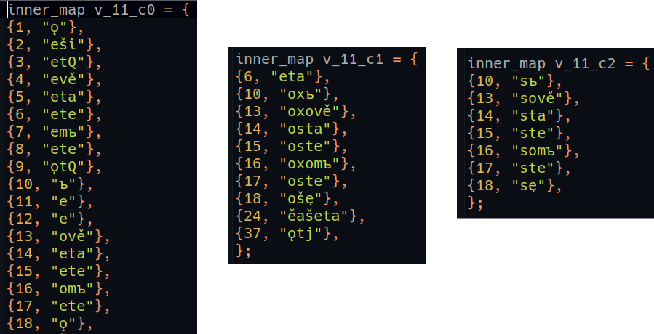Figure 2: Inflection-endings for class 1 verbs like *reћi, *greti stored using C++ std::unordered_map<int, std::string>
Here the ‘deviant’ endings consist mostly of the ‘extended S-’, or *-ox- aorists (e.g. Assem. ⱀⰰⱃⰵⰽⱁⱎⱔ {narekošɴ}), while the third ‘alternative’ table contains the primary S-aorist endings (e.g. Assem. ⱂⱁⰳⱃⱑⱄⱔ {pogrěsɴ} <*pogrěb-sę). Clearly those primary S-aorist endings just being stuck onto a stem like *greb- would not produce the correct LCS form, so for certain inflection-classes there are post-processing functions which do things like replace all “ebsę” with “ěsę”, or (for stems which end on RUKI-consonants like *rek-) all “eks” with “ěx”. The full routines for verbs can be found in https://github.com/12401453/ocs_server/blob/main/autoreconstructor/verb_cleaning.h; to a large extent this is just enforcing the Slavic consonant-cluster restrictions discussed in Section 1.5.

The inflection-tables themselves are indexed by integer-keys associated with each inflection-class, such that the ‘correct’ table’s key always ends on ‘1’, meaning that shifting to the alternative tables is a matter of simply incrementing the key by either 1 or 2, and I can keep track of whether or not a form has required a deviant or alternative ending by inspecting the final value of this key:

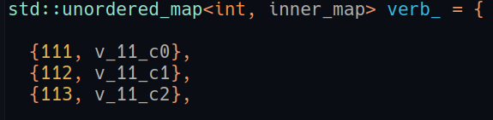Figure 3: Integer-keys of the three inflection-tables in Figure 2

Multiple inflection-classes can share the same tables, for instance the masc_o, nt_o, and fem_a noun-classes all take endings from the adj_hard table, since the same set of 63 endings (21 for each gender) is used in all four paradigms.

Full paradigms for the 4,500-ish OCS lemmas I have so far reconstructed can be dynamically generated here https://ocstexts.co.uk/words; these are constructed from LCS lemmas in the same way the Autoreconstructor reconstructs individual forms, except it produces every form in the paradigm, rather than just the one specified by a text-word’s morphology-tag. The LCS forms are then converted into ‘normalised’ OCS by the browser using the convertToOCS() function here: https://github.com/12401453/ocs_server/blob/main/HTML_DOCS/LCS_to_OCS.js#L197. Forms generated from the "deviant" and "alternative" tables are included, but the former are given less prominent styling to identify them as (probable) post-LCS innovations.

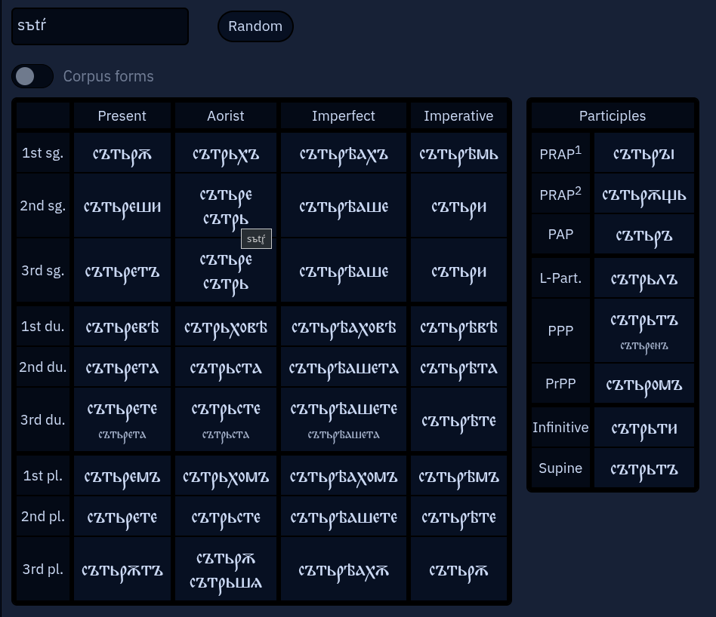Figure 4: Dynamically-generated paradigm for the OCS verb сътрьти, based on the Autoreconstructor's computerised LCS inflectional-morphology

The accuracy of the generated-forms can then be gauged by comparing them to tables populated only by forms which actually occur in Eckhoff’s corpus-texts, using the ‘Corpus-forms’ switch:
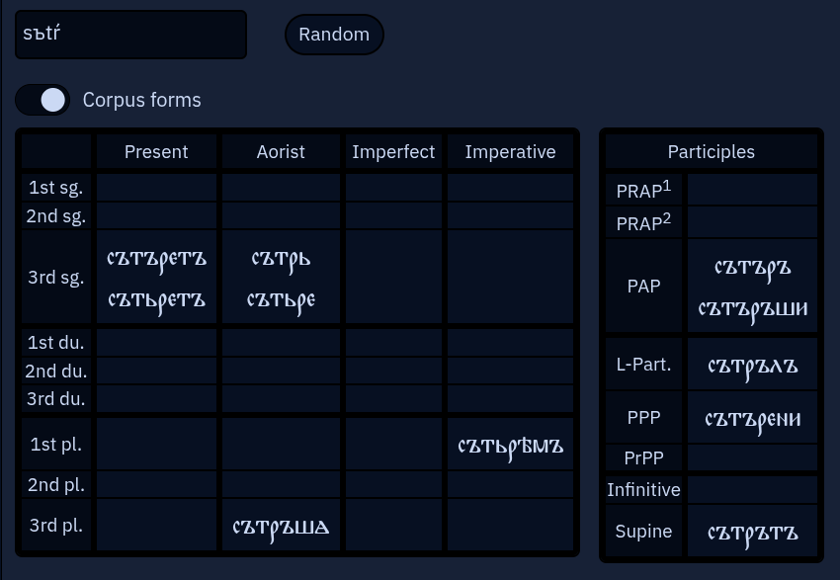Figure 5: Forms of the same сътрьти verb as they actually occur in Eckhoff's (Cyrillicised) TOROT corpus of Church Slavic texts

An advantage of basing computer-generated paradigms on converted LCS (rather than directly on normalised OCS) is that it allows for the possibility of dialect or manuscript-specific conversions: e.g. Kiev Folia-flavoured paradigms that convert *ћ, *ђ to <ц, з> and use <ѣ> for all *Ǣ, or a Marianus-specific conversion that frequently shows vocalised strong-jers, or even an artificial pre-Jer Shift form of Old Russian that shows the denasalisation of *ę and its merger with *Ǣ via stochastic mixing up of <ꙗ, а> and <ѧ>:
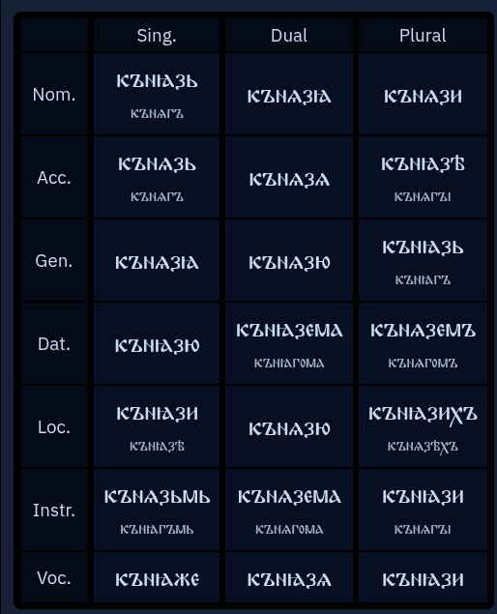Figure 6: Dynamically-generated paradigm of *kъnęgь but with an Old Russian rather than OCS conversion
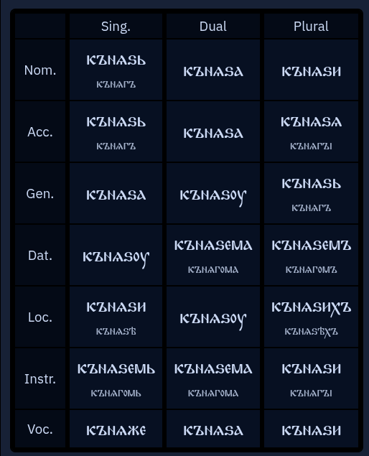Figure 7: *kъnęgь with the canonical OCS conversion for comparison

2.3 Detecting and dealing with morphological innovations
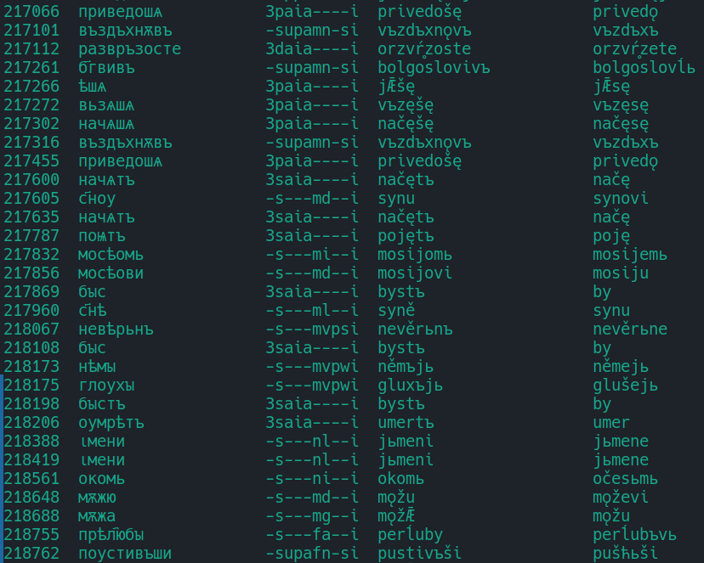Figure 8: Auto-detected and -reconstructed morphological deviances from a small part of the Book of Mark in Codex Zographensis
The screenshot above shows some raw data from my autoreconstructed SQLite database of the TOROT OCS texts; in this case it’s forms from Zographensis (around Mark 7 to Mark 10) where the Autoreconstructor has detected morphological innovations. The fourth column shows what the Autoreconstructor thinks is the direct phonological ancestor to the text-form, but the ancestor of the ‘original’, ‘correct’, or ‘default’ morphological form is also generated and stored in the fifth column, so that such cases of innovation can be easily searched-for and counted (since non-innovated forms have NULL values in this column).
Types of innovation detected here include:
- extended S-aorists of class 1 verbs: 3rd pl. приведошѧ vs. приведѫ, 3rd dual развръзосте vs *разврьзете
- unetymological extension of the RUKI-rule-produced *š in 3rd pl. primary sigmatic aorists: ѣшѧ vs. ѣсѧ <*jǢd-s-ę, вьзѧшѧ vs. възѧсѧ <*vъzьm-s-ę, начѧшѧ vs. начѧсѧ <*načьn-s-ę (neither *d, *m, nor *n have ever been RUKI sounds)
- extension of the *-nǫ- suffix to the past. act. part. of class 2 verbs like въздъхнѫти: въздъхнѫвъ (cf. Mar. ⱆⱄⱏⱈⱏⱎⱘ {usŭxŭšǫ} from оусъхнѫти)
- addition of the *-tQ suffix from the 3rd sg. pres. (where Q stands for NSl. *ь vs SSl. *ъ, see fn. 5 above) to 3rd sg. aorist forms: начѧтъ, поѩтъ, оумрѣтъ
- original u/ju-stem nouns taking o/jo-stem endings: dat. sg. с҃ноу, мѫжю; loc. sg. с҃нѣ, gen. sg. мѫжа
- past act. part. of class 4 verbs using the suffix *-ivъ rather than *-jь: б҃гвивъ, поустивъши (cf. Mar. Mark 10 ⱂⱆⱎⱅⱏⱎⰻ {puštŭši} <*pust-jьši)

Deciding upon the “correct” morphological endings for an unattested language inevitably entails some uncertainty and controversy: for instance, *-ox- aorists occur in both OCS and Old Russian, so why do I consider them LCS deviances? Basically because they never occur in Marianus, which would be quite improbable if they were a discarded archaism (especially given their ubiquity in the closely related Zographensis). Additionally, West Slavic uses *-ex- here (e.g. Old Czech 1sg. nesech <*nes-ex-ъ), suggesting that the extended S-aorists were innovated independently in the post-LCS dialects (Meillet 1965: 256).
In other cases we are dealing with hodge-podge paradigms which are only ever attested with endings from multiple older classes, and sometimes dialectal or orthographic features of the manuscripts can make it difficult to distinguish potential LCS ancestors of certain endings. For instance, I have a masc_tel class used for agent-nouns like OCS дѣлател҄ь (i.e. Diels 1963: 166), which in the sg. and dual. behave exactly like masc jo-stems, but which in the gen. and instr. plural are attested also with basically consonant-stem endings on a hard *-tel- stem, e.g. Zogr. ⱅⱔⰶⰰⱅⰵⰾⱏ {tɴžatelŭ} <*tęžǢtelъ, Supr. свꙙтителꙑ <*svętitely. The nom. pl. appears also to take a consonant-stem *-e ending, but as Diels (op. cit.) points out, the spellings in Zogr. and Supr. (where use of the palatalisation-diacritic < ҄ > to denote LCS *ĺ is consistent enough to suggest a real phonemic /ĺ/ in the underlying dialects) like мѫчител҄е mean we can’t follow Meillet (1965: 426) in setting up *-tele as the ‘correct’ ending, because spellings like ⰶⱔⱅⰵⰾⰵ {žɴtele} in Mar. could just as easily descend from *žęteĺe as from *žętele. Absent a manuscript which both consistently marks *ĺ and doesn’t use such a mark in this nom. pl. desinence, there’s no hard evidence of this *-tele ending ever actually existing. I thus use *-teĺe in the ‘correct’ table, and the jo-stem *-teĺi in the ‘deviances’ table.

2.4 Overcoming poor lemmatisation practice

Sometimes Eckhoff's lemmatisation is too coarse-grained, in that forms which clearly descend from distinct doublets are subsumed under one lemma. To demonstrate just one example of how the Autoreconstructor deals with this sort of problem, take the numeral ѥдинъ <*jedinъ, which in the earliest OCS has straightforward hard pronominal endings and which therefore goes in my pron_hard class alongside demonstratives like *onъ. There is, however, what must be viewed as an LCS doublet *jedьnъ, which gives e.g. Serbian jedan and the modern Russian fem. nt. and oblique-case forms одна, одного etc., and which is used for the majority of non masc. nom./acc. sg. forms of the pronoun in Suprasliensis, e.g. ѥдʼномоу. Notwithstanding Eckhoff’s habit of lemmatising these with ѥдинъ instead of ѥдьнъ, it’s trivial for the Autoreconstructor to check the form (which has in a previous step already been aggressively normalised to get rid of morphologically-irrelevant variation) for a <дін> sequence, which would never occur in the inflectional-ending and so always point to a *jedin-descended stem, and then replace our autoreconstruction with *jedьn- if such isn’t found:
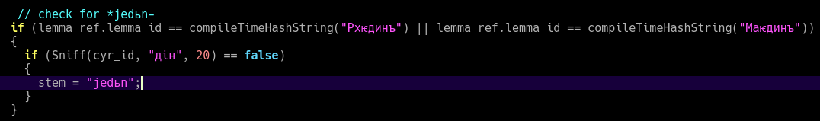Figure 9: Part of the Autoreconstructor's code which checks for reflexes of *jedьn- that TOROT has mistakenly lemmatised under ѥдинъ
In the long-term TOROT itself should fix such lemmatisation problems, but in the meantime checks like the above are computationally extremely cheap and prevent great swathes of the texts from being wrongly autoreconstructed.

3. Benefits and potential for future studies

We have already seen a few examples of minor questions where recourse to an LCS reconstructed layer makes exhaustive investigation of texts trivial; e.g. the reality of a difference between word-intial /je-/ and (foreign) /e-/ in the Codex Suprasliensis was shown by demonstrating statistically significant discrimination in the use of the <ѥ> letter (p.9-10). Another example, as hinted at in fn. 20, concerns the fate of the PV3 reflexes *ś and *ʒ, specifically whether they harden and merge with plain /s z/, or become palatalised counterparts to plain /s z/ (/s’ z’/) as in East Slavic, which is a very important indicator of the extent to which a phonological system is developing Russian-style phonemic secondary palatalisation of consonants.

By far the largest benefit though of the type of annotation proposed here would be felt in questions of a more systematic and holistic nature, where cross-referencing of multiple orthographic (and potentially also morphological) features must be undertaken to corroborate hypotheses. The extremely important issue of the development of phonemic secondary consonant-palatalisation before various LCS front-vowels, for example, which is a critical isogloss in both Bulgaro-Macedonian and East Slavic, is just such a problem, but since there are no separate letters in either Glagolitic or Cyrillic for palatalised consonants, its existence can only be deduced indirectly by combining evidence from a range of other indicators. In addition to changes in nominal morphology mentioned in Section 1.6 (the adoption by *i-stems of *jo/*ja-stem endings), Townsend & Janda (1996: 107-8) bring our attention to a fascinating inverse-relationship in the Slavic dialects between the extent of phonemic tonality-distinctions (hard/soft opposition) in consonants on the one hand, and the longer maintenance of pitch-distinctions and distinctive vowel-length on the other. This is linked to earlier loss of jers in central vs. peripheral areas, with e.g. far southwestern Ukrainian being the most central part of East Slavic and thus most likely to have either lost or not developed secondary consonant palatalisation, and to have longer maintained distinctive vowel-length (on the East Slavic material specifically see also Trubetzkoy 1924).

An LCS index makes testing for such correlations much easier, not only because of the speed and ease with which things like the Jer Shift can be investigated, where there are simply so many data-points that exhaustive manual investigations would be a significant undertaking, but also because relevant changes often involve unpredictable or zero-reflexes, which it is simply not possible to reliably search for via surface-forms. The tolerance of bimoraic syllables and distinctive vowel-length, for instance, may be probeable by looking at things like loss of intervocalic /j/ and subsequent vowel-contractions (in e.g. the 3sg. present ending of class 5.4 verbs *-ajetQ, which in some OCS texts is reflected as <-аатъ>, or long-adjective endings like *o-je, *a-jǢ, which are the source of Ukrainian neuter -е and fem. -а endings, opposed to Russian uncontracted -ое and -ая), but one cannot search the surface-texts for the absence of something. One can however search the LCS index for sequences like *ajǢ or *ějǢ to see whether a certain text has more or fewer spellings indicative of contraction.
Similarly, one way that signs of the development of secondary consonant palatalisation before certain front-vowels can be sought out, at least in the case of /n’ l’ r’/, is by comparing spellings of the original LCS palatals *ĺ *ŕ *ń with those of plain *l *r *n. Shevelov (1956: 490) claims that the “ziemlich deutlich[e Unterscheidung]” of *ĺ,*ń from *l,*n before *e, but not *i, in the Archangel’sk Gospel of 1092 and the Dobrilo Gospel of 1166, is evidence that following *e never caused palatalisation of these consonants in the proto-Ukrainian dialects of the scribes, whereas *i did. Plain *ni,*li thus fell together with palatal *ńi,*ĺi as /n’i l’i/ and were no longer distinguishable. Whether or not this argument has validity, searching texts for relevant instances to compare is only possible with an LCS index that preserves *ŕ *ń *ĺ, because there is no way to search the surface-spellings for the absence of palatalisation-marking on, say, *ŕe *ńe *ĺe without just getting all the reflexes of *re *ne *le as well.
While detailed studies into individual manuscripts’ treatment of the jers were conducted more than a century ago by figures like Jagić (1876, Zogr.) and Leskien (1905, Zogr./Mar.), they contain little attempt to integrate their findings into something we would recognise as a coherent phonological description. Jagić’s study, which is the origin of the so-called ‘Jer Umlaut’ theory (the view that weak jers in Zographensis especially were fronted/backed by the vowel in the following syllable, p.17-18), in particular is full of incorrect etymologies, and although Leskien's is more systematic and free of etymological errors, the fact that he was writing before our concept of the phoneme shows itself everywhere in his reasoning and in the implausibility of his explanations. His ultimate conclusion is that the apparently ‘umlauted’ weak-jer spellings in fact reflect the hardness/softness of the consonant-cluster brought into being by the disappearance of the weak-jer (p.347-8), and therefore that front-vowels in following syllables softened in some way the preceding consonant, i.e. *zъlě > /zl'ě/ > /z'l'ě/ <ⰸⱐⰾⱑ> {zĭlě}. On p.325 though he explicitly denies "dass die Palatalisirung durch folgende weiche Vokale denselben Grad der Stärke besass wie die der altererbten palatalen Consonanten", and so must be envisaging a rather farfetched three-way phonological opposition between e.g. /n/, /n'/, and /ń/. Lunt (1952: 322-5) then looked again at Zographensis, and adduces data he manually gathered from "about half the manuscript" to broadly support Jagić's 'Jer Umlaut' theory, but since he only gives rough percentages and we don't have the exact data he draws them from, we have no way of verifying it ourselves.
Perhaps the best indication of the need for a more holistic approach is the fact that Totomanova (2014: 14-28), drawing on Bulgarian dialect data, recently proposed yet another solution to this jer-question which is mutually incompatible with both Leskien's and Jagić's: a merger of the jers in the earliest Bulgarian after palatal and secondarily-palatalised consonants, and then only a later fronting of this merged /ʌ/ vowel to /e/ in strong-position if the preceding consonant remained soft, parallel to the better-known Middle Bulgarian merger of the nasals in the same environment. Under such a theory no conclusions whatsoever can be drawn about incorrect weak back-jer spellings before LCS hard consonants in OCS, because they could equally easily denote softening and then jer-merging as simple lack of softening and loss of the vowel.

Even very imperfect, wholly automatic autoreconstructions of manucripts not-yet manually morphology-tagged can provide a useful window into a text’s features: included on ocstexts.co.uk is the Codex Assemanianus (Cyrillicised from Jouko Lindstedt's ASCII-encoded version), which I tagged and lemmatised using a (slightly improved version of) the extremely outdated method detailed in Berdičeviskis, Eckhoff & Gavrilova (2016), and as shoddy as the autoreconstructions often are, one can still glean useful insights from searching around in it. For example, the affricate /ʒ/ reflex of the Second and Third Velar Palatalisations of *g, in e.g. OCS ноѕѣ ‘leg’ (fem. dat./loc. sg. of нога) and ѩѕа ‘illness’ (cf. the Polish cognates nodze and jędza ‘witch’), which in all major manuscripts shows clear signs of deaffrication to /z/, looks to be pretty flawlessly preserved: in 100% of the forms with autoreconstructions implying such a PV2 or PV3 reflex of *g (i.e. those matching the regexes /gv?[ěęeiьṝḹ]/ or /[ьięṝḹ]g[auǫ]/ ), the spelling is <ⰷ> {ʒ}, never <ⰸ> {z}, and the only indications of its deaffrication to /z/ are the two spellings of the *-zęb- verb-root in ⱂⱃⱁⱖⱔⰱⰵ {proʒɴbe} and ⱂⱃⱁⱖⱔⰱⱀⰵⱅⱏ {proʒɴbnetŭ}.

LCS reconstructions are also useful for checking uncertain etymologies: if a text consistently spells a certain sound-group in securely-reconstructed words one way, but a different etymon which we less-assuredly reconstruct with that same sound-group is spelt differently, then that’s a strong indication that our candidate-etymology is faulty. For example, the entry for Russian брение in Vasmer’s etymological dictionary (Фасмер 1986) mentions Sobolevskiy’s suggested *bŕ̥nьje reconstruction with syllabic *ŕ̥ instead of the more traditional *brьnьje with a TRЪT-group, based on East Slavic бьрние and берние spellings in a.o. the Izbornik 1073 and the Archangel’sk Gospel 1092. Sobolevskiy’s view is that Russian брение is a written borrowing from Church Slavonic which reflects the OCS <liquid + jer> ordering of the letters for syllabic liquids, viz. брьнье.
If we search for this lexeme in Psalterium Sinaiticum, however, we find three spellings: ⰱⱃⰵⱀⰹⱑ {brenıě}, ⰱⱃⰵⱀⱐⰵ {brenĭe}, and ⰱⱃⱏⱀⱐⱑ {brŭnĭě}, two of which suggest a regular vocalised /e/ reflex of strong *ь in a TRЪТ-group. Searching my autoreconstructed layer for *ŕ̥ turns up zero similar <ⱃⰵ> {re} spellings in the 410 reflexes of *ŕ̥ found: overwhelmingly this group is spelt <ⱃⱏ> {rŭ} in Psal. Conversely, if we use the regex [tŕrpsšdfgћђklĺzžxčvbnńmǯ]rь[tŕrpsšdfgћђklĺzžxčvbnńmǯ]+[ьъ] to search for the strong TrьT-group suggested by the traditional *brьnьje etymology, we find multiple <ⱃⰵ> {re} spellings: ⱂⱁⱄⰽⱃⰵⰶⱐⱋⰵⱅⱏ {poskrežĭćetŭ} <*poskrьžьћetQ, ⰲⱐⱄⰽⱃⰵⱄⱏ {vĭskresŭ} <*vъskrьsъ, ⰴⱐⰱⱃⰵⱈⱏ {dьbrexŭ} <*dьbrьxъ, and ⱂⱁⱄⰽⱃⰵⰶⱐⱎⱅⰵⱅⱏ {poskrežĭštetŭ} <*poskrьžьћetQ.
The evidence of Psal. is therefore unambiguously in favour of the *brьn- reconstruction: other reflexes of strong TrьT-groups show the same distribution of spellings as this etymon, while none of the *ŕ̥ reflexes do. Sobolevskiy is right to suspect a Church Slavonicism in Russian, but it’s more likely to be in the early East Slavic бьрние etc. forms, where East Slavic <ьр> was introduced as a hypercorrection by scribes who mistakenly etymologised unfamiliar Bulgarian брьние as *bŕ̥nьje.

4. Conclusion
The foregoing article has laid out a method for leveraging existing morphosyntactic annotation-data to produce rigorous phonological annotations of Old Church Slavonic texts, and in so doing to make the results of large-scale corpus-building efforts like PROIEL and TOROT directly useful to historical phonologists, morphologists, and textologists, rather than just to the syntacticians, semanticists and pragmaticians these resources were primarily created for.

Both the resulting annotations and the computational apparatus used to produce them have value not only for researchers, but also in their potential for creating innovative pedagogical tools for learners. The work-in-progress ocstexts.co.uk website aims to demonstrate some of these things: for example ‘normalised’ spelling of a text’s words, based on conversions from the regular autoreconstructed LCS forms, can help students learn about and cope with the significant dialectal and orthographic variation characteristic of all OCS texts (Figure 10), and the computerised LCS inflectional morphology which is used to generate the autoreconstructions of single forms can be repurposed to dynamically-generate the whole paradigm of every reconstructed lemma, resulting in comprehensive and high-quality inflection-tables (see p.16). We can even combine this paradigm-generating ability with each text-word’s TOROT morphology-tag to visually locate a specific form in its generated table, which massively helps with the learning of paradigms (Figure 11).

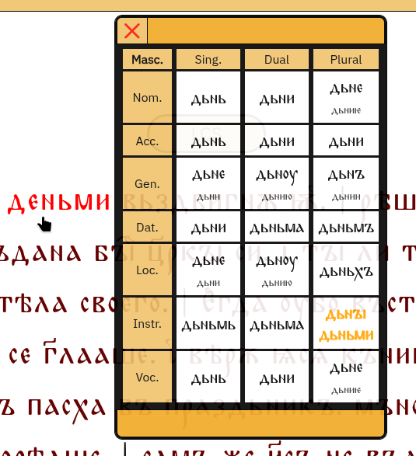Figure 11: Paradigm of the noun дьнь generated after Ctrl+clicking on an instrumental-plural occurrence in the Codex Marianus, with the corresponding table-entry animated
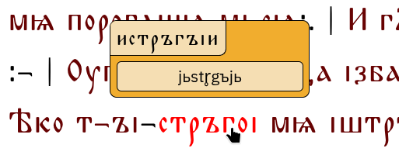Figure 10: Tooltip showing the autoreconstructed LCS ancestor of the past active participle of the verb истръгнѫти in Psalterium Sinaiticum, along with its conversion into 'normalised' OCS

In many ways the point of what I’m proposing with this article is simply to make maximally accessible and applicable for manuscript-investigators the knowledge already accumulated by the nearly two centuries of serious Slavonic scholarship, i.e. the sum of our etymological knowledge (as distilled in etymological dictionaries like Derksen (2008) and the ESSJa) combined with what we know about Common Slavonic phonology and morphology. Furnishing every word of a text with its LCS ancestor simply brings this accumulated knowledge directly ‘on top’ of the philological evidence at a granular, per-word level, so that deviations from this regular theoretical yardstick are visible, retrievable, and quantifiable.

Though important OCS and Old East Slavic texts are still lacking the sort of annotation-data needed for the method of autoreconstruction outlined here, it should be noted that recent advances in neural-network-based tagging and lemmatisation (e.g. Rabus & Besters-Dilger 2021) mean that modern taggers trained on the existing manually-annotated corpus will perform extremely well on the remaining canonical OCS texts, which massively cuts down the time and effort required to do for, say, the Savvina Kniga what has already been done for the Marianus. As the volume and quality of training-data increases, the performance of such automatic taggers can only improve, which will open up more and more of the early Slavic written record to the sort of automatic phonological annotation described here.

References

Berdičevskis, A., Eckhoff, H., & Gavrilova, T. (2016). The beginning of a beautiful friendship:
Rulebased and statistical analysis of Middle Russian. In Computational linguistics and intellectual
technologies. Proceedings of Dialogue 16. Moscow.

Bethin, Christina. 1998. Slavic prosody: Language change and phonological theory. New York.

Borin, Lars. 1988. “A Computer Model of Sound Change; an example from Old Church Slavic”. Literary and Linguistic Computing Vol 3/2. pp.105-8

Derksen, Rick. 2003. Slavic *jь-. In Schaeken, Jos & Houtzagers, Peter & Kalsbeek, Janneke (eds.), Dutch contributions to the Thirteenth International Congress of Slavists, Ljublana: Linguistics, 97-105. Amsterdam.

Derksen, Rick. 2008. Etymological Dictionary of the Slavic Inherited Lexicon. Leiden.

Diels, Paul. 1963. Altkirchenslavische Grammatik. 2. Aufl. Heidelberg.

Durnovo, Nikolaj N. 1929. Mysli i predpoloženija o proisxoždenii staroslavjanskogo jazyka i slavjanskix alfavitov. Byzantoslavica 1. 48-85.

Eckhoff, Hanne Martine & Berdičevskis, Aleksandrs. 2015. Linguistics vs. digitial editions: The Tromsø Old Russian and OCS Treebank. Scripta & e-Scripta 14-15.

Eckhoff, Hanne & Bech, Kristin & Bouma, Gerlof & Eide, Kristine & Haug, Dag & Haugen, Odd Einar & Jøhndal, Marius. 2018. The PROIEL treebank family: a standard for early attestations of Indo-European languages. Language Resources and Evaluation 52. 29-65.

Eckhoff, H.M. 2015. Animacy and differential object marking in Old Church Slavonic. Russian Linguistics 39(2). 233-254.

Eckhoff, Hanne Martine. 2022. A Long-Haul Change: Differential Object Marking in Early Slavonic. Journal of Historical Syntax, Volume 6, Article 8. 1-40.

Haug, Dag T. T. & Jøhndal, Marius L. 2008. Creating a Parallel Treebank of the Old Indo-European Bible Translations. In Caroline Sporleder and Kiril Ribarov (eds.). Proceedings of the Second Workshop on Language Technology for Cultural Heritage Data (LaTeCH 2008). 27-34.
Jagić, Vatroslav. 1876, Studien über das altslovenisch-glagolitische Zographos-Evangelium. Archiv für slavische Philologie 1. 1-55.
Koch, Christoph. 1990. Das Morphologische System des Altkirchenslavischen Verbums. I: Text. München.

Kortlandt, Frederik. 1979. On the history of the Slavic nasal vowels. Indogermanische Forschungen 84. 259-272.

Le Feuvre, Claire. 1993. The Sound Change e > o in the Birchbark Letters of Novgorod and T. Fenne’s “Manual” and the N.sg m. Ending -e. Harvard Ukrainian Studies 17(3/4). 219-250.

Leskien, August. 1905. Die Vocales ъ, ь in den Codices Zographensis und Marianus. Archiv für slavische Philologie 27. 321-349.

Lunt, Horace G. 1952. On Old Church Slavonic Phonemes: The Codex Zographensis. Word 8(4). 311–328.

Mareš, F.V (ed.). 1997. Psalterii Sinaitici pars nova: monasterii s. Catharinae codex slav. 2/N. Wien.

Mathiesen, Robert. 2014. A new reconstruction of the original Glagolitic alphabet. In Flier, Michael S. & Birnbaum, David J. & Vakareliyska, Cynthia M. (eds.), Philology broad and deep: In memoriam Horace G. Lunt, 187–213. Bloomington.

Meillet, Antoine. 1965. Le slave commun. Seconde édition revue et augmentée avec le concours A. Vaillant. Paris

Nakonečnyj, Mykola F. 1962. Do vyvčennja procesu stanovlennja j rozvytku fonetyčnoï systemy ukraïnsʹkoï movy. In Bilodid, Ivan K. (ed.), Pytannja istoryčnoho rozvytku ukraïnsʹkoï movy, 125–165. Kharkiv.

Olander, Thomas. 2015. Proto-Slavic Inflectional Morphology. Leiden.

Schenker, Alexander M. 1995. The dawn of Slavic. New Haven.

Severjanov, Sergey. 1922. Синайская псалтырь. Глаголитический памятникъ ХІ вѣка. Petrograd.

Sims-Williams, P. 2018. “Mechanising Historical Phonology”. Transactions of the Philological Society Vol. 116/3. pp.555-573

Shevelov, George Y. 1956. Konsonanten vor e, i in den protoukrainischen Dialekten. In Bräuer, Herbert & Woltner, Margarete (eds.). Festschrift für Max Vasmer zum 70. Geburtstag, 482–494. Wiesbaden.

Stojkov, Stojko. 1954. Bălgarska dialektologija. Sofija.

Tarnanidēs, Iōannēs Chr. 1988. The Slavonic Manuscripts Discovered in 1975 at St. Catherineʼs Monastery on Mount Sinai. Thessaloniki.

Teneva, Evelina. 2012. Das Personalpronomen 1. p. sg. nom. im Slavischen und das abweichende aksl. azъ: Eine interdiziplinäre Betrachtung und Alternativlösung im Licht der Soziolinguistik und Balkanistik. Linguistique Balkanique LI(1). 61-104.

Totomanova, Anna-Marija. 2014. Iz bălgarskata istoričeska fonetika. Sofija.

Townsend, Charles E. & Janda, Laura A. 1996. Common and comparative Slavic: Phonology and inflection. With special attention to Russian, Polish, Czech, Serbo-Croatian, Bulgarian. Columbus (Ohio).

Trubačev, O.N. (ed.). 1974-. Etimologičeskij slovar’ slavjanskix jazykov. Moskva.

Trubetzkoy, N. 1924. Einiges über die russische Lautentwicklung und die Auflösung der gemeinrussischen Spracheinheit. Zeitschrift für slavische Philologie 1(3–4). 287–319.

Trubetzkoy, Nikolaus S. 1954. Altkirchenslavische Grammatik: Schrift-, Laut- und Formensystem. Wien.

Vaillant André. 1942. L'article en vieux slave. Revue des études slaves, tome 20, fascicule 1-4. 5-12.

Van Wijk, N. 1929. Die aksl. Formen господѣ, господю und die Aussprache der Buchstaben ѣ, ю. Zeitschrift für Slavische Philologie, Vol. 6, No. 3/4. 363-368.

Vermeer, William. 2014. Early Slavic dialect differences involving the consonant system. In Fortuin, Egbert & Houtzagers, Peter & Kalsbeek, Janneke & Dekker, Simeon (eds.), Dutch contributions to the Fifteenth International Congress of Slavists, Minsk, 181-227. Amsterdam.

Wandl, Florian & Kavitskaja, Darya. 2023. On the reconstruction of contrastive secondary palatalization in Common Slavic. Journal of Historical Linguistics 13(2). 220-254

Winslow, Joseph J. 2022. Old Church Slavonic phonemes: The problem of /j/ and /ě, a/ after palatals. Die Welt der Slaven 67(2). 296-323.

Zaliznjak, Andrej A. 2004. Drevnenovgorodskij dialekt. 2-e izdanie, pererabotannoe s učetom materiala nachodok 1995–2003 gg. Moskva.

Велчева, Боряна. 1981. Проблеми на глаголическата писменост: Асеманиево Евангелие. In Константин-Кирил Философ: Материали от научните конференции по случай 1150-годишнината от рождението му, 167-171. София.

Галинская, Елена. 2014. Прогрессивная палатализация и древненовгородское местоимение въхе. Slavistica Vilnensis 59. 7-16.

Поливанова, А.К. 2013. Старославянский язык - Грамматика · Словари. Москва.
Фасмер М. 1986. Этимологический словарь русского языка: В 4 т. / Пер. с нем. и доп. О. Н. Трубачева. — 2-е изд., стер. — М.: Прогресс.

Appendix 1: Glagolitic transliteration table

Glagolitic | Latin |  | Commonly-used Cyrillic
ⰰ | a |  | а
ⰱ | b |  | б
ⰲ | v |  | в
ⰳ | g |  | г
ⰴ | d |  | д
ⰵ | e |  | е
ⰶ | ž |  | ж
ⰷ | ʒ |  | ѕ, ꙃ
ⰸ | z |  | з, ꙁ
ⰺ | ï |  | ї, ꙇ
ⰹ | ı |  | і
ⰻ | i |  | и
ⰼ | ǵ |  | ꙉ, г̑, ђ
ⰽ | k |  | к
ⰾ | l |  | л
ⰿ | m |  | м
ⱀ | n |  | н
ⱁ | o |  | о
ⱂ | p |  | п
ⱃ | r |  | р
ⱄ | s |  | с
ⱅ | t |  | т
ⱛ | ϋ |  | ѵ, y
ⱇ | f |  | ф
ⱈ | x |  | х
ⱉ | ω |  | ѡ
ⱚ | θ |  | ѳ
ⱌ | c |  | ц
ⱍ | č |  | ч
ⱎ | š |  | ш
ⱋ | ć |  | щ
ⱏ | ŭ |  | ъ
ⱐ | ĭ |  | ь
ⱑ | ě |  | ѣ
ⱆ | u |  | оу, ѹ
ⱓ | ü |  | ю
ⱘ | ǫ |  | ѫ
ⱙ | ǫ̈ |  | ѭ
ⱗ | ę |  | ѩ, ѧ
ⱔ | ɴ |  | ѧ
ⱕ | ɴ̨ |  | ꙙ

Morphological innovations and variations are detected by inspecting the text-forms and then applying 'alternative' endings as specified in the inflectional-endings database; see Section 2.3.
The lemma and inflection-class data included as a supplement to Polivanova’s (2013) comprehensive OCS grammar, https://integral.github.io/osd/, would in principle allow similar tables to be generated, but as far as I know Polivanova has not digitised the actual endings, nor written any scripts to generate paradigms. Additionally, because she bases her forms on a normalised OCS, rather than LCS, phonemic system, a massive amount of information has been needlessly destroyed. To give just one obvious example, the syllabic-liquids *ŕ̥ *ĺ̥ *r̥ *l̥ are represented by their OCS reflexes /рь ль ръ лъ/, meaning there’s no distinction between the syllable-rimes of roots like /-срьд-/ <*sŕ̥d and /-крьст-/ <*krьst. An inflectional-morphology based on her data would therefore only be good for generating the (in reality unattested and fictional) “normalised” form of OCS, whereas my LCS forms are trivially convertible into any dialect of OCS, as well as pre-Jer Shift Old East Slavic (see pg. 17 and Figure 6), because they represent the language at a stage before any such dialect-specific phonemic mergers.
For a recent example see Marr & Mortensen (2020), who found many problems with the traditional account of how Latin became French, and were able to improve upon it using their suite of software for performing forwards-reconstruction and "debugging" problematic sets of rules.
The evidence regarding the possible absence of PV3 from Novgorodian is far less convincing: the Birchbark letters abound with examples of the PV3 reflex of *k (e.g. letter №439 from around 1200 has свинеце <*svinьkь and полотенеца <*poltьnьka), and those of *g are not unknown: Zaliznjak (2004: 47) admits that palatalised forms of the Germanic loan кънѧз- <*kъnęg- are the rule, but considers this to be a "supradialectal" word originating outside of the Novgorodian dialect-area; Галинская (2014: 10) is less convinced and adduces the form оусьрѧзи (cf. Russian серьга, commonly assumed to be an Oghur, i.e. Bulgar, Turkic loan, cognate with e.g. Kazakh сырға) 'earrings' from letter №429 as a word of "вполне бытового характера" which thus supposedly shows a native Novgorodian reflex of PV3 of *g. More importantly, as Галинская (op. cit.) points out, in all of the well-known Novgorodian forms of the pronoun *vьxъ 'all' which supposedly show a lack of PV3 by retaining both /x/ and back/hard desinences (e.g. fem. gen. sg. въхоѣ <*vьxoję̌ from letter №850), and which come from letters which otherwise correctly convey the jers (by writing <ь,е> for *ь and <о,ъ> for *ъ), the weak-jer is always written with <ъ,о>, unambiguously suggesting a /ъ/ pronunciation. These forms therefore more likely point to a LCS doublet-form *vъxъ which would never contain the conditioning environment for PV3 anyway, and thus you can't use them as evidence of a lack of PV3 in Novgorodian (on the plausibility of such a doublet see Галинская (2014: 14), though cf. Zaliznjak's (2004: 54) less convincing explanation of the /ъ/ in these words as an assimilation of original /ь/ to the back-vowels of the following syllable).
Of course the sequence /jo/ violates LCS phonotactics as well.
Forms are given as they appear in the manuscripts; modern fonts and Unicode symbols mean that the misleading and unhelpful practice of transcribing Glagolitic into Cyrillic is no longer defensible. Latin-based transliterations of Glagolitic forms are given in {curly braces} according to the table in Appendix 1, but it should be emphasised that no transliteration system can adequately convey the internal logic of the Glagolitic, and those who study OCS through transliterations are hamstringing themselves. Where specific forms from Eckhoff's corpus-texts are cited, they are hyperlinked to the corresponding part of the text as it appears on the ocstexts.co.uk website. The Glagolitic texts there are unfortunately still Cyrillicised and should be used with care, particularly ones like Psalterium Sinaiticum where certain ruesome decisions from the editors Severjanov (1922) and Mareš (1997) have been compounded by further information-destroying simplifications (for instance, Severjanov transliterates <ⰼ> with <г̂>, but Eckhoff then replaces Severjanov's roundy diacritic with a titlo, leading to nonsense transcriptions like Psalm 8 <ан҃г҃лъ> for ms. <ⰰⱀ҃ⰼⰾⱏ>). Cleaned up digitisations, using the Glagolitic originals as the base-text, and a mechanism for displaying manuscript-images, are planned for the near future.
Other troublesome pre-LCS morphological isoglosses reflected in the texts include the masc./nt. instr. sg. *o- and *jo-stem endings *-ъmь/*-ьmь (N.Sl., e.g. KF ⱁⰱⱃⰰⰸⱏⰿⱐ {obrazŭmĭ}, Uspensk. Sbor. кнѧзьмь) and *-omь/*-emь (S.Sl., e.g. Supr. о҅браꙁомъ, кнꙙꙁемь), which are most commonly (e.g. Olander 2015: 168) thought to be analogical replacements of the original instr. sg. ending ECS *-ā which is preserved in the adverb *vьčera ‘yesterday’; and the *-tь (N.Sl.) vs *-tъ (S.Sl.) verbal endings of 3rd sg. and pl. present (plus its extension to 2nd and 3rd sg. aorists like OCS начѧтъ, OR (Uspensk. Sbor.) бꙑсть, начать). Here I have no choice but to index them with dummy-symbols in the database: *-Omь/*-Emь for the instr. sg. ending and *-tQ for the verb-endings.
It's possible to argue that the short *Æ counterpart to *Ǣ persisted in East Slavic until after the Fall of the Jers, and that the ESl. so-called e > o shift before hard-consonants / back-vowelled syllables is actually just the resolution of this archiphoneme as /o/ (where palatalisation of the preceding consonant remained, in e.g. Ukr. бджола <*bьčÆla, or was newly phonemicised, in e.g. Ru. вёсла <*v'Æsla <*vesla), and that there was never a stage when these words had /e/ (based among other things on <о> spellings regardless of stress after palatal-letters in very early texts, and even after the letters for secondarily-soft LCS plain consonants in the Birchbark documents (Le Feuvre 1993, Nakonečnyj 1962), but there isn't space to elaborate on the issue here (see Winslow 2022: 304 fn.16). Unlike the situation with long *Ǣ, OCS shows no sign of anything but an /e/ reflex of short *Æ (and indeed the fact that the East Slavs inherited their writing system ultimately from the Urkirchenslavisch system designed for such a dialect, rather than one which had a clear way of writing /soft consonant/ + /o/, is likely the reason that /o/ reflexes are so rarely detectable in the early texts, since <e> had to be used for both /e/ and /’o/, cf. the spelling є̑вшанъ of the Kipchak word /jovşan/ ‘wormwood’ in the Hypatian Codex, whose modern cognates (Turkmen ýowşan /jowşan/, Kazakh жусан /žuwsan/, Azeri yovşan) unambiguously point to a Kipchak /o/), and the history of the East Slavic /o/ reflexes remains the subject of much disagreement, so it's simpler for everyone if I continue the traditional practice of writing LCS *e after palatals, even if that strictly speaking is inconsistent with my use of *Ǣ.
In the database I will have to use the single Unicode characters <ṛ ṝ ḷ ḹ>, rather than what's shown in Table 1, since the latter cannot actually be rendered without using the letters for /r ŕ l ĺ/ plus the 'combining ring below' U+0325 symbol, which means searches for the consonantal liquids on their own will also return results containing syllabic liquids. A similar problem affects /ę̌ y̨/, which I will have to replace with <ḝ ỹ>.
To my mind the only evidence in support of a genuine jer + liquid stage comes from the paradigms of verbs like OCS сътрьти < *sъtŕ̥ti, where the syllabic /ŕ̥/ in the stem alternates with /ьr/ depending on the vocality of the following morpheme: the e.g. 3sg. pres. *sъtьretъ (Zogr., Supr. сътьретъ) or (one possibility of the) 3rd sg. aorist *sъtьre (Supr. съть҆ре) must have /ьre/, while the 3rd pl. aorist *sъtŕ̥šę (Supr. сътръшꙙ) and the other possibility for the 3rd sg. aorist *sъtŕ̥ (Psal. ⱄⱏⱅⱃⱐ {sŭtrĭ}, or with a different prefix Mar. ⱁⱅⱃⱏ {otrŭ} <*otŕ̥ ), being word-final or pre-consonantal, must be syllabic /ŕ̥/. The same alternation occurs in the zero-grade forms of verbs like *umerti, as is clear from the Polish reflexes umarł <*umŕ̥lъ vs umrę <*umьrǫ. The argument could be that at some stage, before the LCS tendency towards Open Syllables became dominant, the stems in these paradigms were surely unitary /tĭr/, /mĭr/, i.e. 3sg. aor. /sŭ.tĭ.re/ vs 3rd. pl. aor. /sŭ.tĭr.šę/, and that the latter’s closed /tĭr/ syllable was only forced to open itself up by changing to /tŕ̥/ because of the Law of Open Syllables. Thus at least one source of the syllabic-liquids could be shown to have developed from a vowel + liquid stage, but that still doesn’t prove that they all did, or that the change of /ĭr/ to /ŕ̥/ in these verb-forms was not merely a move to an already-existing syllabic-liquid phoneme.
Interestingly, this aspect of the hypothesised Urksl. orthographic system has rearisen in the modern Macedonian standard due to Turkish loanwords: ќемер < Tk. kemer ‘belt’, ќе < *[xъ]ћe[tъ]; ѓон < Tk. gön ‘leather’, меѓу <*meђu.
Marianus and Psalterium Sinaiticum, on the other hand, frequently show a Russian-style /ej/ reflex of strong tense *ьj: Psal. ⰲⱃⰰⰱⰵⰹ {vrabeı} <*vorbьjь, ⱂⰾⱏⱅⰵⰹ {plŭteı} <*plъtьjь, ⰿⱐⱀⰵⰹ {mĭneı} <*mьńьjь; Mar. ⰸⰰⱂⱁⰲⱑⰴⰵⰻ {zapovědei} <*zapovědьjь, ⱆⰴⰰⱃⰵⰻ {udarei} <*udaŕь-jь, ⰳⰲⱁⰸⰴⰵⰻⱀⱏⰹⱗ {gvozdeinŭıę} <*gvozdьjьny-ję̌. Psal. (Psalm 21) even has a past act. part. Nsg. masc. def. form ⱄⱅⱃⱏⰳⱁⰹ {strŭgoı} <*jьstr̥gъ-jь that suggests an /oj/ reflex of *ъjь.
Though Trubetzkoy, like me, believes Urkirchenslavisch to have been based on a /j/-less dialect, so in that particular system the archiphonemes would be conditioned by the position before vowels, rather than before /j/.
The sequence /ij/ is not totally banned from native words, since it appears to be preserved across morpheme-boundaries, such as in prefixed-verbs like приѩти <*prijęti or long-form adjectives like masc. nom. pl. дроуѕии <*drugi-ji, but within roots it does seem restricted to these post-LCS loanwords.
Spellings like Zogr. Mark 13:3 “ⱂⰵⱅⱃⱏ. ⰺ ⱑⰽⱁⰲⱏ. ⰺ ⱁⰰⱀⱀⱏ.” {petrŭ. ï ěkovŭ. ï oannŭ} “Peter and Jacob and John” would suggest that this initial *i- can get dropped after an /i/ of a preceding word, but whether this points to a dropping of the non-native *i-, simple deletion of a double /i i/ (haplology), or a native-like reflex of a weak-jer /*i *jьjǢkovъ/ > /i jakov/, is not really knowable, so indexing such words with a markedly foreign initial *ij- group is again the best way of allowing such difficult cases to be investigated.
Psalterium Sinaiticum contains at least five occurrences of non-digraph <ⱔ> for *ę: Eckhoff’s digitisation suggests ⰱⱃⱑⰿⱔ {brěmɴ}, ⰲⱏⰸⰾⰰⱍⱔ {vŭzlačɴ}, ⱄⱅⱐⰷⱔ {stĭʒɴ}, ⱅⱔ {tɴ}, ⱀⱔ {nɴ}, and ⱂⱃⱁⰽⰾⱔⱅⱏ {proklɴtŭ}, but the last one ⱂⱃⱁⰽⰾⱔⱅⱏ (which is from Psalm 151 in the part discovered in 1975) comes from a mistake in Mareš’s (1997: 50) Cyrillicised edition: the manuscript-photograph in Tarnanidēs (1988: 260) clearly shows ⱂⱃⱁⰽⰾⱗⱅⱏ {proklętŭ}: 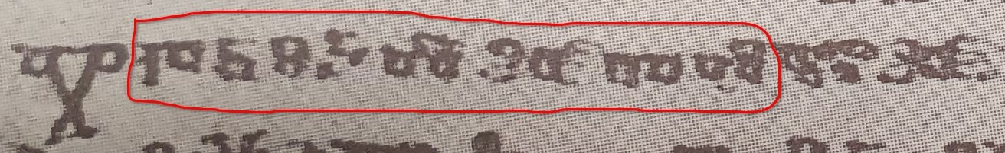
The leftover 14 are things like 1st. pres. dual. и҅мавѣ which Eckhoff’s corpus wrongly lemmatises as имати instead of имѣти, and which thus get reconstructed as *jemĺevě instead of *jьmavě. At the time of writing only 3227/6862 Suprasliensis lemmas have been reconstructed, but those 3227 cover 89713/99194, or 90.4%, of the words.
For some baffling reason this form is missing from Eckhoff's text, so I link instead to the relevant folio of David Birnbaum's online edition.
Conversely, sequences of *sk, *zg at prefix-boundaries which show PV1 reflexes, like Mar., Zogr. ⱃⰰⱎⱅⱐⱅⰵⱅⱏ {raštĭtetŭ} <*orš-čьtetъ (ECS *skĭt- > *ščĭt-), Psal. ⱃⰰⰶⰴⰹⰷⰰⰵⱅⱏ {raždiʒaetŭ} <*orž-ǯigajetъ (ECS *zgīg- > *žǯīg-) are kept as *šč, *žǯ. Such forms may well not go all the way back to the time of PV1, and instead be just the result of a synchronic rule prohibiting /zž/ and /sč/ (> /žǯ/ and /šč/) that remained active until much more recently, especially given prepositional-phrase forms like Psal. ⰹⱎⱅⱃⱑⰲⰰ {ıštrěva} <*jьs ‿*červa, so this is arguably inconsistent with my treatment of *ss, *sš etc. My justification is firstly that *sk, *zg > *šč, *žǯ are conspicuously PV1-changes, which we know originated well before our target LCS point, whereas the precise timing of de-gemination or simplification of *sš is less clear-cut; and secondly that even in languages like Russian which orthographically have restored <сч> and <зж> spellings in compounds like исчезнуть and разжечь, the pronunciations are still arguably direct reflexes of LCS *šč and *žǯ, viz. [ɕː] and [ʐː] (or, in the conservative Moscow-dialect, the palatalised [ʑː] found also in дождь <*dъžђь).
In some dialects (notably East Slavic) the PV3 reflexes *ś and *ʒ became patalised counterparts to plain /s z/, i.e. /s’ z’/, and merged with the /s’ z’/ that developed from LCS *s,z before front-vowels, but in most OCS they seem to have just hardened to /s, z/: searching my database for the sequence *ьxǫ, for example, turns up exclusively <ⱄⱘ> spellings in Marianus, just one <ⱄⱙ> in Zogr., and exclusively <сѫ> in Suprasliensis, with only Assem. and Psal. containing a significant minority of <ⱄⱙ> spellings.
Russian feminine i-stems like весь (<*vьsь, ‘village’) do not fall together with ja-stems in the way the masculines like *zvěrь fall together with jo-stems, but they do all still take the /am, ax, ami/ endings in the dat., loc. and instr. pl., e.g. ве́сям, which contain the same LCS ja-stem *-Ǣ- vocalism which can only occur after LCS palatals, meaning they too end up totally unreconstructable due to an illegal **sǢ sequence.
Numerous spellings in Supr. like боура <*buŕǢ, о҄укараѥ҅тъ <*ukaŕǢjetъ, мороу <*moŕu etc., however, point to a hardening of LCS palatal *ŕ to plain /r/, so it’s difficult to know whether звѣрѣ spellings stem from a genuine /zvěŕa/ form in the history of the language, or if they instead represent synchronic /zvěra/, i.e. with a hard o-stem ending, but with confusion by the scribe between <ра> and <рꙗ>/<рѣ> spellings for what in his/her dialect would’ve all been /ra/.
Except the numerous gen. sg. господа and dat. sg. господоу for the i-stem *gospodь, but this word seems to be an isolated special case, because it bafflingly turns up even in early Glagolitic OCS with endings like ⰳ҃ⰲⰻ {g҃vi} (ju-stem dat. sg. *-evi, cf. Supr. господеви), ⰳ҃ⱓ {g҃ü} (jo-stem dat. sg. *-u), and ⰳ҃ⱑ {g҃ě} (jo-stem gen. sg. *-Ǣ). See Van Wijk (1929).
Identical lemmas with the same part-of-speech tag, such as вести ‘to lead’ <*ved-ti and вести ‘to drive’ <*vez-ti, both of which have ‘V-’ for verb, are differentiated by appending #2 etc. to the extra homomorphs, i.e. вести vs. вести#2.
The spreadsheet containing my reconstructions and inflection-class annotations for the TOROT OCS lemmas can be downloaded from https://github.com/12401453/torot_2023/blob/main/lemma_lists/chu_lemmas_master.xlsx
Extra handling is required for forms of *byti, since that has a separate future-paradigm (and future-participle) which TOROT does actually specify separately with an ‘f’ value for the tense feature, as well as two variant imperfect sets (3sg. *bě vs. *běaše, which aren’t tagged, but which I detect), and a ‘conditional’ *bimь, *bi, *bǫ etc. Participles require an extra step to read their nominal-features and add their adjective-like endings.
This is bad design and prevents me from easily handling more than one type of morphological innovation per class: for the masc_jo class nom. pl. I have the i-stem *-ьje ending in the ‘deviances’ table (as found in e.g. Supr. стражиѥ <*storž-ьje ‘guards’), which leaves no room for forms like Supr. зноѥве <*znoj-eve, Psal. ⰸⰿⰹⰵⰲⰵ {zmıeve} <*zmьj-eve, which have the *-eve ending from the ju-stems.
The long-form adjectives (and participles) are then formed by just sticking the inflected-form of the pronoun *jь onto the end, since this is the origin of such long-forms (Vaillant 1942). I agree with Townsend and Janda (1996: 178) that some simplification of these concatenated endings must have occurred by LCS, especially where the short-form endings contain *m or *x (e.g. the dat. and loc. pl. for all genders), because it’s unreasonable that e.g. Mar. Matt. 24 masc. loc. pl. ⱀⰵⰱⰵⱄⱏⱄⰽⱏⰹⱈⱏ {nebesŭskŭıxŭ} could've developed directly from *nebesьskěxъjixъ (here not least because of the lack of PV2-reflex). I am however relucant to adopt the (undiscussed) simplified LCS forms they present in the tables on p. 182-3 before I've done a more thorough investigation of early manuscript-forms, so for now I've left all such adjectives wholly uncontracted (though the Autoreconstructor does actually mark long-adjectivals that contain such problematic concatenations and this information could be used to exclude them from searches).
Koch (1990: 293) lists only sigmatic aorists as possibilities for the *-verz-/*-vŕ̥z- stem verbs, and it seems that outside of the 3rd sg. (e.g. Psal. ⱃⰰⰸⰲⱃⱏⰸⰵ {razvrŭze}, Zogr. ⱁⱅⰲⱃⱐⰸⰵ {otvrĭze}) no root-aorists are attested in any Slavic text, so maybe I am wrong to set up asigmatic root-aorists like 3rd dual *-vŕ̥zete as a possibility alongisde primary sigmatic *-verste (e.g. Mar. Mark 7 ⱃⰰⰸⰲⱃⱑⱄⱅⰵ {razvrěste}). My justification is that the *-verg-/*-vŕ̥g- stem verbs do attest such root-aorists, e.g. 3rd pl. ⱁⱅⱏⰲⱃⱏⰳⱘ {otŭvrŭgǫ} in Psal. Psalm 77, and I don’t see what, apart from the nature of the final stem-consonant (obstruent vs. continuant), could be grounds for classifying these two verbs differently.
Having autoreconstructed all of Marianus I can verify this (admittedly already well-established) fact far more quickly and easily than was possible just with Eckhoff’s morphology and part-of-speech annotation-information: using TOROT the smallest net you could cast would be one that caught all aorist-tense verbs, whereas I can just search for reflexes of *oxъ, *oxov, *oxom, *ošę, *osta$, and *oste$ (the latter two using ‘regular-expression’ mode and $ to specify end-of-word), which for Mar. turns up nothing except the three occurrences of ⱁⱄⱅⰰ {osta}.
Searching my database for *teĺe$ returns only a single властеле in Supr. without the diacritic; everything in Zogr. has it.
Diels mentions only Psal. Psalm 26 ⱄⱏⰲⱑⰴⱑⱅⰵⰾⰹ {sŭvědětelı}, but the Autoreconstructor is intended for use with other early texts beyond canonical OCS which might also contain this type of assimilation to the jo-stems.
This despite Meillet's (1965: 144) incoherent speculation about the /i/ in *jedinъ resulting from a phonetic development of strong *ь, analogous to what happens in the vicinity of *j, because "or il s'agit d'un composé dont le second élément est *jĭnŭ". While this interpretation of *jedinъ’s derivation could be true (and according to Derksen’s (2008: 212) etymology of the *jьnъ pronoun, its *j is prothetic, meaning it wouldn’t develop if already attached to a stem ending in *d), the idea that a synchronic *-dьnъ by any purely phonological means could become /-din/, let alone early enough to completely displace by analogy the oblique forms in the earliest OCS where ⰵⰴⰻⱀ- {edin-} spellings are overwhelming, is ludicrous and contradicted by all the philological evidence.
According to my database there are 145 reflexes of *jedьn- in this category vs 46 from *jedin-, though all 107 reflexes of the masc. nom./acc. sg. are from *jedinъ. Interestingly the Uspenskij Sbornik (at least the parts included in TOROT), in contrast to later Russian, appears to completely lack *jedьn-, though all except the single одинои are spelt with the OCS <ѥ/е> reflex of intial *je-.
E.g. p.23 “кълати halte ich für richtigere als клати” (<*kolti), and on p.35 he assumes a jer-fronting in зьрѣти based on his (also incorrect) assumption that the jer in бърати is original.
Leskien also missses a few spellings which contradict his argument, which I can trivially find using my LCS index, e.g. p.324-5 he claims that Zogr. *ь is prevented from being backed by a following *ń, despite ⰴⱐⱀⰵⱄⱏⱀ҄ⱑⰰⰳⱁ {dĭnesŭn҄ěago} <*dьnьsьńǢjego and ⱄⱏⰲⱔⰸⱏⱀ҄ⱑ {sŭvɴzŭn҄ě}< *sъvęzьńǢ (here perhaps he is led astray by the jat'-spelling of Zographensis /a/ <*Ǣ).
https://www.kielipankki.fi/download/ccmh-src/www/assemanianus.html
Though note that the modern Macedonian ѕемне <*zębne[tъ] ‘shiver’ also has an unetymological /dz/ in this root, as do many other Macedonian words with LCS *z such as ѕвер <*zvěrь.

