University Name: CVM University
College Name: A. D. Patel Institute of Technology
Course Title: Programming with JAVA
Course Code: 202044502
Assignment No.: Assignment -2
Student Name: Savani Ayushi Jivrajbhai
Enrollment No.: 12402080101014
Semester: 4th semester
Academic year: 2025 – 26
GitHub Link: https://github.com/Ayushi-1410/JAVA-Programming-Assignments/tree/main/Assignment_2

Program – 1
Aim: Find prime numbers using multithreading (Thread, Runnable, Executor Framework)
Objective:
To develop a Java program that finds prime numbers using multithreading techniques such as Thread class, Runnable interface, and Executor Framework to improve performance.

Source Code:
import java.util.concurrent.*;
// Class to check prime numbers
class PrimeTask implements Runnable {
int number;
// Constructor
PrimeTask(int number) {
this.number = number;
}
// Method to check prime
boolean isPrime(int n) {
if (n <= 1)
return false;
for (int i = 2; i <= n / 2; i++) {
if (n % i == 0)
return false;
}
return true;
}
// Run method
public void run() {
if (isPrime(number)) {
System.out.println(number + " is Prime");
}
}
}
public class Program_1 {
public static void main(String[] args) {
ExecutorService executor = Executors.newFixedThreadPool(3);
// Check numbers from 1 to 20
for (int i = 1; i <= 20; i++) {
executor.execute(new PrimeTask(i));
}
executor.shutdown();
}
}

Output:
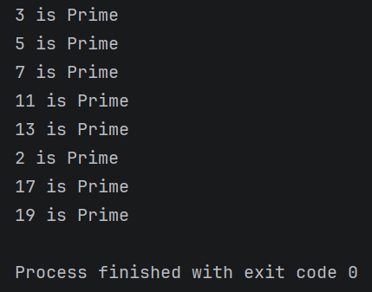

Program – 2
Aim: Producer–Consumer problem using synchronization and inter-thread communication
Objective:
To implement the Producer–Consumer problem using synchronization and inter-thread communication methods like wait() and notify().

Source Code:
class SharedBuffer {
int data;
boolean valueSet = false;
// Produce method
synchronized void produce(int value) {
while (valueSet) {
try {
wait();
} catch (Exception e) {
}
}
data = value;
System.out.println("Produced: " + data);
valueSet = true;
notify();
}
// Consume method
synchronized void consume() {
while (!valueSet) {
try {
wait();
} catch (Exception e) {
}
}
System.out.println("Consumed: " + data);
valueSet = false;
notify();
}
}
// Producer class
class Producer extends Thread {
SharedBuffer buffer;
Producer(SharedBuffer buffer) {
this.buffer = buffer;
}
public void run() {
for (int i = 1; i <= 5; i++) {
buffer.produce(i);
}
}
}
// Consumer class
class Consumer extends Thread {
SharedBuffer buffer;
Consumer(SharedBuffer buffer) {
this.buffer = buffer;
}
public void run() {
for (int i = 1; i <= 5; i++) {
buffer.consume();
}
}
}
public class Program_2 {
public static void main(String[] args) {
SharedBuffer buffer = new SharedBuffer();
Producer p = new Producer(buffer);
Consumer c = new Consumer(buffer);
p.start();
c.start();
}
}

Output:
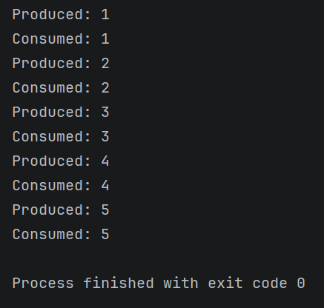

Program – 3
Aim: Implement CRUD operations using Collection API (ArrayList, HashMap, TreeMap)
Objective:
To develop a Java program that performs Create, Read, Update, and Delete (CRUD) operations using Collection API classes such as ArrayList, HashMap, and TreeMap.

Source Code:
import java.util.*;
// Student class
class Student {
int id;
String name;
// Constructor
Student(int id, String name) {
this.id = id;
this.name = name;
}
}
public class Program_3 {
public static void main(String[] args) {
Scanner sc = new Scanner(System.in);
// Using ArrayList
ArrayList<Student> list = new ArrayList<>();
// Using HashMap
HashMap<Integer, Student> hmap = new HashMap<>();
// Using TreeMap
TreeMap<Integer, Student> tmap = new TreeMap<>();
int choice;
do {
System.out.println("\n---- CRUD MENU ----");
System.out.println("1. Add Student");
System.out.println("2. View Students");
System.out.println("3. Update Student");
System.out.println("4. Delete Student");
System.out.println("5. Exit");
System.out.print("Enter your choice: ");
choice = sc.nextInt();
switch (choice) {
// CREATE
case 1:
System.out.print("Enter Student ID: ");
int id = sc.nextInt();
System.out.print("Enter Student Name: ");
String name = sc.next();
Student s = new Student(id, name);
// Add to ArrayList
list.add(s);
// Add to HashMap
hmap.put(id, s);
// Add to TreeMap
tmap.put(id, s);
System.out.println("Student Added Successfully");
break;
// READ
case 2:
System.out.println("\nArrayList Data:");
for (Student st : list) {
System.out.println(st.id + " " + st.name);
}
System.out.println("\nHashMap Data:");
for (Student st : hmap.values()) {
System.out.println(st.id + " " + st.name);
}
System.out.println("\nTreeMap Data (Sorted by ID):");
for (Student st : tmap.values()) {
System.out.println(st.id + " " + st.name);
}
break;
// UPDATE
case 3:
System.out.print("Enter ID to Update: ");
int uid = sc.nextInt();
if (hmap.containsKey(uid)) {
System.out.print("Enter New Name: ");
String newName = sc.next();
Student updatedStudent =
new Student(uid, newName);
// Update HashMap & TreeMap
hmap.put(uid, updatedStudent);
tmap.put(uid, updatedStudent);
// Update ArrayList
for (Student st : list) {
if (st.id == uid) {
st.name = newName;
}
}
System.out.println("Student Updated");
} else {
System.out.println("Student Not Found");
}
break;
// DELETE
case 4:
System.out.print("Enter ID to Delete: ");
int did = sc.nextInt();
hmap.remove(did);
tmap.remove(did);
// Remove from ArrayList
list.removeIf(st -> st.id == did);
System.out.println("Student Deleted");
break;
case 5:
System.out.println("Program Ended");
break;
default:
System.out.println("Invalid Choice");
}
} while (choice != 5);
sc.close();
}
}
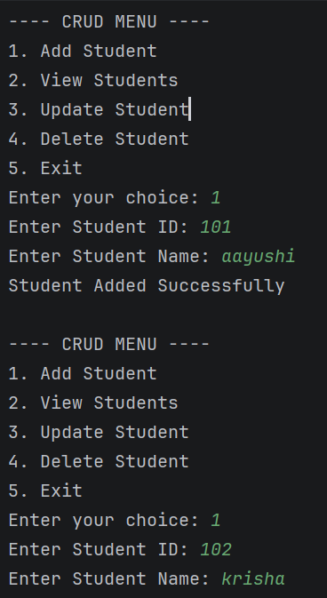
Output:
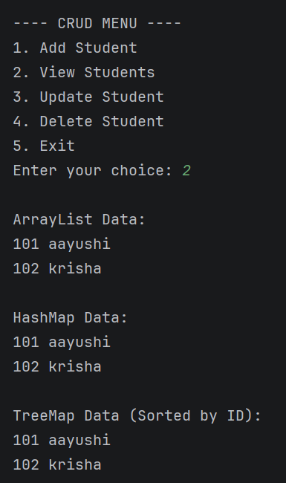

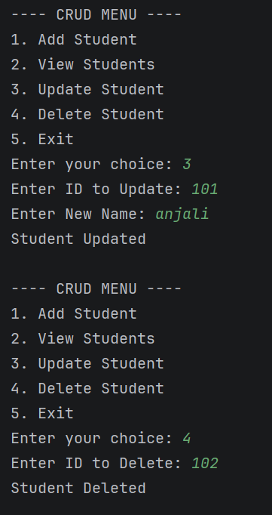
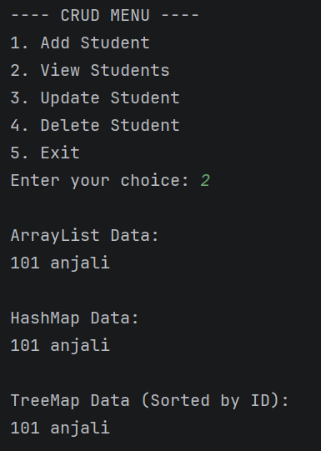

Program -4
Aim: Sort Book objects using Comparable and Comparator interfaces
Objective:
To create a Java program that sorts Book objects using Comparable and Comparator interfaces based on different attributes like title and price.

Source Code:
import java.util.*;
// Book class
class Book implements Comparable<Book> {
int id;
String title;
double price;
// Constructor
Book(int id, String title, double price) {
this.id = id;
this.title = title;
this.price = price;
}
// Comparable: Sort by price
public int compareTo(Book b) {
if (this.price > b.price)
return 1;
else if (this.price < b.price)
return -1;
else
return 0;
}
}
// Comparator class to sort by title
class TitleComparator implements Comparator<Book> {
public int compare(Book b1, Book b2) {
return b1.title.compareTo(b2.title);
}
}
public class Program_4 {
public static void main(String[] args) {
ArrayList<Book> list = new ArrayList<>();
// Adding book objects
list.add(new Book(1, "Java", 500));
list.add(new Book(2, "Python", 400));
list.add(new Book(3, "C++", 300));
// Sort by price
Collections.sort(list);
System.out.println("Sorted by Price:");
for (Book b : list) {
System.out.println(b.id + " " + b.title + " " + b.price);
}
// Sort by title
Collections.sort(list, new TitleComparator());
System.out.println("\nSorted by Title:");
for (Book b : list) {
System.out.println(b.id + " " + b.title + " " + b.price);
}
}
}

Output:
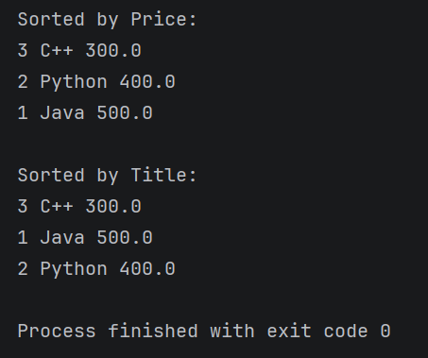

Program – 5
Aim: Count word occurrences from a file using File Handling APIs
Objective:
To develop a Java program that reads data from a file and counts the occurrence of each word using Java File Handling APIs.

Source Code:
import java.io.*;
import java.util.*;
public class Program_5 {
public static void main(String[] args) {
HashMap<String, Integer> map = new HashMap<>();
try {
BufferedReader br =
new BufferedReader(
new FileReader("C:\\Users\\SIS\\Documents\\aayushijava\\src\\Assignment_2\\aayushi.txt"));
String line;
while ((line = br.readLine()) != null) {
String words[] = line.split(" ");
for (String word : words) {
word = word.toLowerCase();
if (map.containsKey(word)) {
map.put(word,
map.get(word) + 1);
} else {
map.put(word, 1);
}
}
}
br.close();
System.out.println("Word Count:");
for (String word : map.keySet()) {
System.out.println(word + " : "
+ map.get(word));
}
} catch (Exception e) {
System.out.println("File not found");
}
}
}
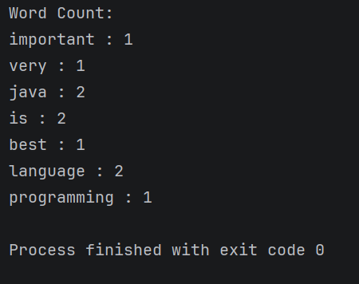
Output:

Program – 6
Aim: Display all files of a given directory using File class
Objective:
To create a Java program that displays all files present in a specified directory using the File class.

Source Code:
import java.io.File;
public class Program_6
{
public static void main(String[] args) {
// Change this path to your folder
File folder = new File("C:\\Users\\SIS\\Documents\\aayushijava\\src\\Assignment_1");
// Check if folder exists
if (folder.exists() && folder.isDirectory()) {
File[] files = folder.listFiles();
System.out.println("Files in Directory:");
for (File file : files) {
// Check only files (not folders)
if (file.isFile()) {
System.out.println(file.getName());
}
}
} else {
System.out.println("Directory not found or invalid path");
}
}
}

Output:
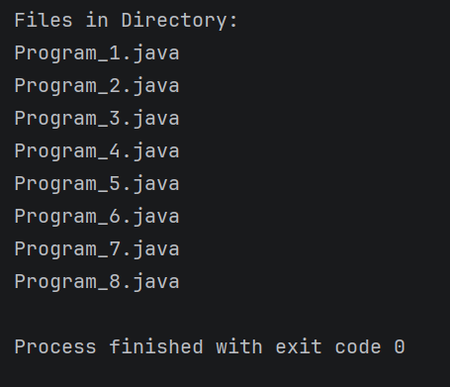

Program – 7
Aim: Implement TCP Echo Client–Server program
Objective:
To develop a TCP Client–Server application in Java where the client sends a message and the server returns the same message (echo) using socket programming.

Source code:
1. Server side:
import java.io.*;
import java.net.*;
public class Program_7_Server
{
public static void main(String[] args) {
try {
ServerSocket server =
new ServerSocket(5000);
System.out.println("Server Started...");
Socket socket = server.accept();
BufferedReader in =
new BufferedReader(
new InputStreamReader(
socket.getInputStream()));
PrintWriter out =
new PrintWriter(
socket.getOutputStream(), true);
String message;
while ((message = in.readLine()) != null) {
System.out.println("Client: " + message);
out.println("Echo: " + message);
}
socket.close();
server.close();
} catch (Exception e) {
System.out.println(e);
}
}
}

2. client side:
import java.io.*;
import java.net.*;
import java.util.Scanner;
public class Program_7_client {
public static void main(String[] args) {
try {
Socket socket =
new Socket("localhost", 5000);
BufferedReader in =
new BufferedReader(
new InputStreamReader(
socket.getInputStream()));
PrintWriter out =
new PrintWriter(
socket.getOutputStream(), true);
Scanner sc = new Scanner(System.in);
System.out.print("Enter message: ");
String message = sc.nextLine();
out.println(message);
String response = in.readLine();
System.out.println(response);
socket.close();
} catch (Exception e) {
System.out.println(e);
}
}
}
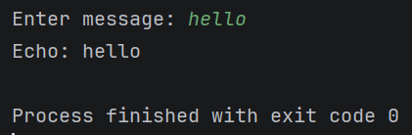
Output:
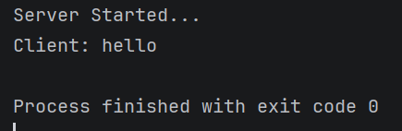

Program – 8
Aim: Develop GUI-based Investment Calculator using Swing
Objective:
To design a GUI-based Investment Calculator using Java Swing that calculates the final investment amount based on principal, rate, and time entered by the user.

Source Code:
import javax.swing.*;
import java.awt.event.*;
public class Program_8 extends JFrame implements ActionListener {
JTextField principalField;
JTextField rateField;
JTextField timeField;
JLabel resultLabel;
JButton calculateButton;
Program_8() {
setTitle("Investment Calculator");
setSize(300, 250);
setLayout(null);
JLabel l1 = new JLabel("Principal:");
l1.setBounds(30, 30, 100, 25);
add(l1);
principalField = new JTextField();
principalField.setBounds(130, 30, 100, 25);
add(principalField);
JLabel l2 = new JLabel("Rate:");
l2.setBounds(30, 70, 100, 25);
add(l2);
rateField = new JTextField();
rateField.setBounds(130, 70, 100, 25);
add(rateField);
JLabel l3 = new JLabel("Time:");
l3.setBounds(30, 110, 100, 25);
add(l3);
timeField = new JTextField();
timeField.setBounds(130, 110, 100, 25);
add(timeField);
calculateButton =
new JButton("Calculate");
calculateButton.setBounds(90, 150, 100, 30);
add(calculateButton);
resultLabel = new JLabel("Result:");
resultLabel.setBounds(30, 190, 200, 25);
add(resultLabel);
calculateButton.addActionListener(this);
setDefaultCloseOperation(JFrame.EXIT_ON_CLOSE);
setVisible(true);
}
public void actionPerformed(ActionEvent e) {
try {
double principal =
Double.parseDouble(
principalField.getText());
double rate =
Double.parseDouble(
rateField.getText());
double time =
Double.parseDouble(
timeField.getText());
double amount =
principal + (principal * rate * time) / 100;
resultLabel.setText("Amount = " + amount);
} catch (Exception ex) {
resultLabel.setText("Enter valid numbers");
}
}
public static void main(String[] args) {
new Program_8();
}
}

Output:
