Synopsis

Solar Panel Efficiency

Prediction System
Submitted in partial fulfilment of the requirements
rd

of the 3 Year of
Bachelor of Technology

In
ENERGY ENGINEERING

by
VENUS JOHN [EU2236003]
Under the Guidance of

(Mr. Kiran Beldar)
AIML & COMPS, SJCEM


DEPARTMENT OF ENERGY ENGINEERING

ST. JOHN COLLEGE OF ENGINEERING & MANAGEMENT

UNIVERSITY OF MUMBAI

2026-2027


Certificate of Approval
This is to certify that Venus John is a bonafide student of B. Tech in AIML, COMPS- Department, St. John College of Engineering and Management, Mumbai. The student has satisfactorily completed the requirements of Synopsis as prescribed by ST. JOHN COLLEGE OF ENGINEERING AND MANAGEMENT (An Autonomous College affiliated to University of Mumbai), while working on “Solar Panel Efficiency Prediction System”.

Signature :  Name : Mr. Kiran Beldar  Designation : Project Guide | Signature :  Name : Mr. Ajay Sirsat  Designation : Head of Department
Signature :
Name : Dr. Kamal Shah
Designation : Principal,
St. John College of Engineering and Management.

Declaration
I declare that this written submission represents my ideas in my own words and where others ideas or words have been included, I have adequately cited and referenced the original sources. I also declare that I have adhered to all principles of academic honesty and integrity and have not misrepresented or fabricated or falsified any idea/data/fact/source in my submission. I understand that any violation of the above will be cause for disciplinary action by the Institute and can also evoke penal action from the sources which have thus not been properly cited or from whom proper permission has not been taken when needed.

______________________

Venus John [EU2236003]

Date: 22-10-2026

ACKNOWLEDGEMENT

I take this opportunity to express my sincere gratitude to all those who have supported and guided me throughout the development of my project, “Solar Panel Efficiency Prediction System”
I am deeply thankful to our Principal, Dr. Kamal Shah, and the Head of the Department of Computer Science, Mr. Ajay Sirsat, for providing me with the facilities and resources necessary for the successful completion of this project.
My heartfelt appreciation goes to our Project Guide, Mrs. Kiran Beldar, for their continuous encouragement, valuable insights, and expert guidance during every stage of this work. Their constructive feedback helped me refine my ideas and overcome various challenges during development.
I would also like to extend my gratitude to all the faculty members of our Department for their constant support and for imparting the knowledge that made this project possible. Lastly, I express my sincere thanks to my friends and family for their patience, cooperation, and encouragement, which motivated me to complete this project successfully.

VENUS JOHN [EU2236003]

ABSTRACT
The increasing demand for electricity and the need for sustainable energy solutions have encouraged the wider adoption of solar energy. Solar panels convert sunlight into electrical energy through photovoltaic (PV) cells; however, their efficiency is not constant and changes with environmental conditions, particularly sunlight intensity and panel temperature. The Solar Panel Efficiency Prediction System is a machine learning-based project designed to predict the efficiency of a solar panel using sunlight intensity and temperature data.
The proposed system collects sunlight intensity, panel temperature, and solar panel efficiency data and prepares it through preprocessing steps such as removing missing values and handling incorrect data. The dataset is then divided into training and testing sets, and regression algorithms including Linear Regression, Decision Tree Regression, and Random Forest Regression are trained using Python and the Scikit-learn library. The trained model accepts new values of sunlight intensity and panel temperature and predicts the expected efficiency as a percentage. For example, for a sunlight intensity of 800 W/m² and a panel temperature of 35°C, the model generates the corresponding predicted efficiency. Pandas, NumPy, Matplotlib, and Seaborn are used for data handling and visualization, and a simple Streamlit-based interface can be used to present the predicted efficiency and performance graphs where implemented.
The primary objective of the project is to study how sunlight intensity and temperature influence solar panel efficiency and to demonstrate the practical application of machine learning in renewable energy monitoring. Traditional systems mainly monitor generated power and do not predict efficiency in advance; the proposed system helps users estimate the expected performance of solar panels under different environmental conditions. The project also provides a foundation for future enhancements, including additional parameters such as humidity, wind speed, and dust accumulation, integration of real-time weather data through APIs, IoT-based live monitoring, a mobile or web application, and prediction of daily and monthly solar energy generation.

C O N T E N T S
Chapter No. | Topic | Page No.
 | • List of Figures | i
 | • List of Tables | ii
 | • Abbreviations and symbols | iii
Chapter 1 | Overview | 1
 | 1.1 Introduction | 1
 | 1.2 Background | 1
 | 1.3 Importance of the Project | 3
 | 1.4 Perspective of Stakeholders and Customers | 4
 | 1.5 Objectives and Scope of the Project | 5
 | 1.6 Summary | 6
Chapter 2 | Literature Survey & Proposed Work | 7
 | 2.1 Introduction | 7
 | 2.2 Literature Survey Table | 7
 | 2.3 Problem Definition | 8
 | 2.4 Feasibility Study | 10
 | 2.5 Methodology Used | 12
 | 2.6 Summary | 17
Chapter 3 | Analysis and Planning | 18
 | 3.1 Introduction | 18
 | 3.2 Project Planning | 18
 | 3.3 Scheduling | 20
 | 3.4 Summary | 21
Chapter 4 | Design & Implementation | 22
 | 4.1 Data Flow Diagram (DFD) | 22
 | 4.2 Block Diagram | 22
 | 4.3 Flowchart | 23
Chapter 5 | Results & Discussion | 24
 | 5.1 Actual Results | 24
 | 5.2 Future Scope | 28
 | 5.3 Testing | 30
 | 5.4 Deployment | 34
Chapter 6 | Conclusion | 37
 | References | 38
List of Figures
Figure No. | Figure Name | Page No.
1 | Data Flow Diagram (DFD) of the Solar Panel Efficiency Prediction System | 22
2 | Block Diagram of the Solar Panel Efficiency Prediction System | 22
3 | Flowchart of the Solar Panel Efficiency Prediction System | 23
List of Tables
Table No. | Table Name | Page No.
1 | Literature Survey Table | 8
2 | Project Planning Table | 18
3 | Functional Test Cases Table | 33
Abbreviations and symbols
▪ AI/ML: Artificial Intelligence and Machine Learning
▪ API: Application Programming Interface
▪ CSV: Comma-Separated Values
▪ DFD: Data Flow Diagram
▪ MAE: Mean Absolute Error
▪ ML: Machine Learning
▪ RMSE: Root Mean Squared Error
▪ PV: Photovoltaic
▪ UI: User Interface
▪ IoT: Internet of Things

CHAPTER 1
OVERVIEW

1.1 Introduction
Solar energy is one of the most important renewable energy sources. Solar panels generate electricity by converting sunlight into electrical energy through photovoltaic (PV) cells, and they are now widely used in residential, commercial, and utility-scale installations. The amount of electricity produced, however, is not constant, because it depends on several environmental factors that change throughout the day and across seasons.
Sunlight intensity directly affects the amount of electricity generated by a solar panel. When the intensity of the sunlight falling on the panel is high, more energy is available for conversion, and when it is low, the output decreases. Temperature also plays an important role. High operating temperatures can reduce the electrical efficiency of a solar panel, so a panel does not necessarily perform best at the hottest time of the day, even though the sunlight may be strongest.
Efficiency is the percentage of sunlight energy that a solar panel converts into electrical energy. Because both sunlight intensity and temperature change continuously, solar panel efficiency is not constant throughout the day. Understanding how these two parameters affect efficiency is therefore important for monitoring and evaluating solar panel performance.
Traditional systems mainly monitor the power that has been generated and may not predict efficiency in advance. Without proper prediction, it becomes difficult to estimate how a solar panel will perform under different environmental conditions. Machine learning techniques provide an alternative by learning the relationship between environmental parameters and efficiency from data and using it to predict efficiency for new input values.
The proposed Solar Panel Efficiency Prediction System applies machine learning to predict solar panel efficiency using sunlight intensity and temperature. The system takes the sunlight intensity and the panel temperature as inputs, processes them using a trained machine learning model, and displays the predicted efficiency as a percentage.
The primary objective is to develop a simple and user-friendly application that helps users understand and monitor solar panel performance. The system is intended to support the study of the relationship between environmental conditions and efficiency, the comparison of different machine learning algorithms, and the estimation of solar panel performance under different conditions.
1.2 Background
The global energy sector is gradually transitioning towards cleaner and more sustainable sources of electricity. Conventional power generation methods based on coal, petroleum, and natural gas contribute to greenhouse gas emissions and environmental degradation. Renewable energy technologies provide an alternative by utilizing resources that are naturally replenished, and solar energy is among the most important of them.
Solar energy has become increasingly accessible because photovoltaic panels can be installed on rooftops, in commercial buildings, and in large solar power plants. A solar panel consists of photovoltaic cells that convert sunlight into electricity. Despite these advantages, the performance of a panel depends on the conditions in which it operates. Sunlight intensity varies with the time of day, season, and weather, whereas the operating temperature of the panel rises as it absorbs sunlight and is also influenced by the surrounding air temperature. Consequently, the efficiency of a solar panel changes over time instead of remaining constant.
The main parameters considered in this project are sunlight intensity, temperature, and efficiency. Sunlight intensity is the amount of sunlight received by the panel and is commonly expressed in watts per square metre (W/m²). Temperature is the operating temperature of the solar panel, and efficiency is the percentage of sunlight energy converted into electrical energy. Higher temperatures generally reduce the electrical efficiency of PV cells, whereas the available sunlight determines the amount of energy that can be converted.
Monitoring systems in use today generally report the power that a panel has already produced. They do not usually indicate how efficiently the panel is expected to perform under a given combination of sunlight and temperature. A prediction-based approach allows users to estimate efficiency in advance and to understand how much performance may be lost under unfavourable conditions.
Advances in data science and machine learning have created opportunities to model such relationships directly from data. Regression algorithms such as Linear Regression, Decision Tree Regression, and Random Forest Regression can learn how efficiency varies with sunlight intensity and temperature. Python libraries such as Pandas, NumPy, and Scikit-learn make it practical to prepare data, train models, and evaluate them, while Matplotlib and Seaborn help to visualize the results. The proposed project applies these tools to build a machine learning-based system that predicts solar panel efficiency and presents the results in a clear and understandable form.

1.3 Importance of the Project
The importance of the Solar Panel Efficiency Prediction System lies in its potential to support solar panel performance monitoring and analysis through data-driven techniques.
1. Understanding efficiency variation: Predicting efficiency helps users understand how solar panel performance changes with sunlight intensity and temperature during the day.
2. Advance estimation of performance: Unlike systems that only monitor generated power, the proposed system predicts the expected efficiency for any chosen set of sunlight and temperature inputs.
3. Impact of temperature: The system helps show how high panel temperatures can reduce electrical efficiency, so that this effect can be considered when evaluating solar panel performance.
4. Relationship between environment and efficiency: Analysing sunlight, temperature, and efficiency data helps identify how each environmental condition influences solar panel performance.
5. Comparison of algorithms: Linear Regression, Decision Tree Regression, and Random Forest Regression can be compared to find the model that predicts efficiency most reliably.
6. Easy-to-use output: A simple and user-friendly interface displays the predicted efficiency as a percentage, supported by graphs and visualizations, so that users do not need to interpret raw data.
7. Support for solar energy adoption: Better understanding and monitoring of panel performance can support the effective utilization of solar energy in homes, businesses, and power plants.
8. Practical application of machine learning: The project demonstrates data collection, preprocessing, model training, prediction, and visualization in a real-world renewable energy problem.
The project is particularly valuable as an academic implementation because it connects machine learning concepts with a practical renewable energy problem. It combines data analysis, regression modelling, and result visualization in a single, easy-to-follow system.

1.4 Perspective of Stakeholders and Customers
The proposed system may be useful to several groups involved in solar energy generation, monitoring, and analysis. Each stakeholder can benefit from the efficiency predictions and visualizations.
1. Residential solar users
Households with rooftop solar panels can use the system to understand how their panels are expected to perform under different sunlight and temperature conditions, and to judge whether the observed performance appears reasonable.
2. Commercial solar installations
Businesses and institutions that operate solar installations can use efficiency predictions to understand the expected performance of their systems and to support the planning of energy use.
3. Solar power plant operators
Operators of solar power plants can use predicted efficiency to understand expected performance under changing environmental conditions and to compare it with the actual performance of the plant. The system supports analysis, but physical inspection and engineering verification remain necessary.
4. Solar energy monitoring service providers
Companies that provide solar energy monitoring solutions can use efficiency prediction to complement the generated-power data that traditional systems report.
5. Researchers and data analysts
Researchers can use the system to study the relationship between environmental conditions and solar panel efficiency, compare machine learning algorithms, and extend the work with additional parameters.
6. Students and educational institutions
The project provides an example of how machine learning, Python libraries, and data visualization can be applied to a renewable energy problem in an academic setting.
7. Energy planners and consumers
Energy planners and consumers interested in renewable energy can use the predictions to build a better understanding of how environmental conditions influence solar energy performance.
The system is primarily intended as a decision-support and learning tool. Its predictions should be interpreted alongside actual measurements and the limitations of the dataset used.

1.5 Objectives and Scope of the Project
The main objective of the project is to develop a machine learning-based system that predicts solar panel efficiency using sunlight intensity and temperature data, helping users understand the expected performance of solar panels under different environmental conditions.
The specific objectives are:
1. To study the relationship between sunlight intensity, temperature, and solar panel efficiency.
2. To collect and analyze environmental and solar panel performance data.
3. To develop a machine learning model for predicting solar panel efficiency.
4. To identify how changes in sunlight and temperature affect efficiency.
5. To display predicted efficiency through a simple and user-friendly interface.
6. To help users estimate solar panel performance under different conditions.
7. To compare the performance of Linear Regression, Decision Tree Regression, and Random Forest Regression models.
Scope
The scope of the project includes the development of a machine learning-based system for predicting solar panel efficiency from sunlight intensity and panel temperature.
The system covers:
• Collection and analysis of sunlight intensity, temperature, and efficiency data.
• Data preprocessing, including removal of missing values and handling of incorrect data.
• Splitting of the dataset into training and testing data.
• Training of Linear Regression, Decision Tree Regression, and Random Forest Regression models.
• Prediction of solar panel efficiency for new sunlight intensity and temperature inputs.
• Comparison of the performance of different machine learning algorithms.
• Visualization of predicted efficiency and performance graphs.
• A simple and user-friendly interface (for example, using Streamlit, if implemented).
• Study of the effect of temperature and sunlight intensity on efficiency.
The project is limited by the quality, completeness, and range of the available dataset. Prediction performance may change under conditions that are not represented in the training data, and the model considers only sunlight intensity and temperature; other factors such as humidity, wind speed, and dust accumulation are not included in the current scope.
The system does not control or physically measure solar panels. It does not identify the cause of low performance in a specific panel, such as dust, shading, or equipment failure, and such conclusions require additional measurements and engineering verification.
Similarly, predictions are estimates rather than guaranteed values. The reliability of the system depends on suitable data, correct preprocessing, and appropriate model training and validation.

1.6 Summary
This chapter introduced the Solar Panel Efficiency Prediction System and explained why predicting solar panel efficiency is important. The efficiency of a solar panel changes with sunlight intensity and temperature, and traditional systems mainly monitor generated power without predicting efficiency in advance.
The chapter discussed the background of solar energy, the importance of machine learning for efficiency prediction, and the potential benefits for residential users, commercial installations, solar power plant operators, and researchers. It also defined the objectives and scope of the project, including data collection, preprocessing, model training, prediction, and visualization.
The proposed system uses machine learning to predict solar panel efficiency and displays the predicted efficiency as a percentage. The next chapter presents the literature survey, problem definition, feasibility study, and proposed methodology.

CHAPTER 2 Literature Survey & Proposed Work

2.1 Introduction
Predicting the performance of solar energy systems has become an important research area due to the increasing use of solar power for electricity generation. Since the output of a solar panel depends on environmental conditions, understanding and predicting its efficiency is essential for effective performance monitoring and analysis.
Several approaches can be used to study solar panel performance. Traditional approaches use mathematical relationships and the monitoring of generated power. Machine learning techniques extend these approaches by learning patterns from historical data and associated environmental variables, and then predicting the output for new conditions.
Regression algorithms such as Linear Regression, Decision Tree Regression, and Random Forest Regression are commonly applied to problems in which a continuous value must be predicted from input variables. Linear Regression identifies the relationship between inputs and the output and is suitable for understanding basic relationships. Decision Tree Regression uses decision-making rules and can capture nonlinear relationships, while Random Forest Regression combines the predictions of multiple decision trees to improve robustness.
Solar panel performance is commonly studied using parameters such as sunlight intensity (solar irradiance), ambient temperature, panel temperature, and generated power. Sunlight intensity directly affects the amount of electricity generated, whereas high temperatures can reduce the electrical efficiency of the panel. Efficiency, defined as the percentage of sunlight energy converted into electrical energy, therefore varies with both parameters.
In this project, efficiency is treated as the target variable, and sunlight intensity and panel temperature are treated as input variables. When a trained model receives new values for these inputs, it predicts the expected efficiency. For example, for a sunlight intensity of 800 W/m² and a panel temperature of 35°C, the trained model generates the predicted efficiency as an output.
The proposed Solar Panel Efficiency Prediction System applies these concepts through a machine learning-based prediction system developed in Python using Pandas, NumPy, Scikit-learn, Matplotlib, and Seaborn. The prediction results are displayed as a percentage and supported by graphs.
The literature survey provides the conceptual foundation for the proposed system by examining the role of sunlight and temperature in solar panel performance, regression-based machine learning approaches, data preprocessing, and visualization. The findings help establish a suitable methodology for implementing and evaluating the project.

2.2 Literature Survey Table
The reviewed research areas indicate that machine learning regression models and clear visualization can work together to support solar panel efficiency prediction. Linear, tree-based, and ensemble regression models are particularly relevant for structured datasets containing sunlight intensity and temperature values.
Table 1: Literature Survey Table
Sr. No. | Research Area | Main Focus | Relevance to the proposed project
1 | Solar energy and photovoltaic conversion | Conversion of sunlight into electrical energy by photovoltaic (PV) cells. | Provides the basic understanding of how solar panels generate electricity.
2 | Effect of sunlight intensity | Relationship between the intensity of sunlight received and the electricity generated. | Identifies sunlight intensity as a key input parameter.
3 | Effect of temperature on PV performance | Reduction of electrical efficiency at high operating temperatures. | Identifies panel temperature as a key input parameter.
4 | Linear Regression | Models the relationship between input variables and a continuous target using a linear equation. | Provides a simple baseline model for predicting efficiency.
5 | Decision Tree Regression | Uses decision-making rules to predict continuous values. | Helps model nonlinear relationships between environmental conditions and efficiency.
6 | Random Forest Regression | Combines predictions from multiple decision trees to improve robustness. | Can capture nonlinear relationships and improve prediction reliability.

2.3 Problem Definition
Solar panels are an important source of renewable energy, but their efficiency is not constant throughout the day. Changes in sunlight intensity and temperature affect the amount of electricity generated and the efficiency with which sunlight is converted into electrical energy. These variations create challenges in estimating the performance of a solar panel.
Traditional systems mainly monitor the power that has been generated, but they may not predict efficiency in advance. Without proper prediction, it becomes difficult to estimate solar panel performance under different environmental conditions, and users cannot easily judge whether a panel is performing as expected.
A further challenge is that the effects of sunlight and temperature act together. High sunlight intensity increases the energy available to the panel, while the accompanying rise in temperature may reduce electrical efficiency. Understanding this combined effect requires a data-driven model that can learn the relationship between these parameters and efficiency, rather than relying on either parameter alone.
The problem addressed by this project is the development of a machine learning-based system that predicts solar panel efficiency using sunlight intensity and temperature data, helping users understand the expected performance of solar panels under different environmental conditions.
The proposed system aims to address the following problems:
1. Variable solar panel efficiency: Efficiency changes with sunlight intensity and temperature, making it difficult to know the expected performance at a given time.
2. Lack of advance prediction: Traditional systems mainly monitor generated power and may not predict efficiency in advance.
3. Combined effect of sunlight and temperature: The effects of sunlight intensity and temperature must be analysed together to understand how they jointly influence efficiency.
4. Need for understandable output: Users require a simple prediction, expressed as an efficiency percentage, rather than raw measurements and complex calculations.
5. Difficulty in estimating performance: Without a prediction model, it is hard to estimate how a solar panel will perform under different environmental conditions.
6. Choice of a suitable model: Different machine learning algorithms may perform differently, so they must be compared to select a suitable model.
To address these problems, the project proposes a system that collects and preprocesses sunlight intensity, temperature, and efficiency data, trains regression models, predicts efficiency for new inputs, and displays the results through graphs and a simple interface.
The intended outcome is a solar panel efficiency prediction system that supports understanding and preliminary performance estimation. Its predictions are estimates, and any suspected equipment issue requires further investigation before a definitive conclusion can be reached.

2.4 Feasibility Study
A feasibility study is conducted to determine whether a proposed project can be developed and implemented using the available technology, resources, time, and budget. It helps identify potential limitations before development begins.
The feasibility of the Solar Panel Efficiency Prediction System is evaluated in terms of technical, economic, operational, and schedule feasibility.
2.4.1 Technical Feasibility
The project is technically feasible because it uses established machine learning algorithms and widely available Python libraries. The system can be developed in Python, using Pandas and NumPy for data processing, Scikit-learn for model development, and Matplotlib and Seaborn for visualization.
The dataset of sunlight intensity, temperature, and efficiency values provides the basis for training, testing, and evaluating the prediction model. Once the model has been trained, it can be used to generate predictions for new input values without retraining it every time a prediction is required.
The following technologies can be used:
• Python: For data processing and machine learning.
• Pandas and NumPy: For data cleaning, transformation, and numerical calculations.
• Scikit-learn: For model development, training, and evaluation.
• Matplotlib and Seaborn: For data visualization and statistical visualization of results.
• Linear, Decision Tree, and Random Forest Regression: For predicting solar panel efficiency.
• Google Colab / Jupyter Notebook: For developing and running the code.
• Python IDE: For writing and managing the project code.
• Streamlit: For building a simple user interface, if implemented.
The exact technologies depend on the implementation, but the proposed architecture can integrate these components in a straightforward manner.
One technical requirement is that the input values and data preparation steps used during prediction must match those used when the model was trained. The system must also check that the entered values are valid before generating a prediction.
Therefore, the project is technically feasible, provided that the dataset is suitable and the trained model is correctly used for prediction.
2.4.2 Economic Feasibility
The project is economically feasible because it can be developed using open-source software and freely available development environments.
Python, Pandas, NumPy, Scikit-learn, Matplotlib, Seaborn, and Streamlit can be used without purchasing commercial software licences. Google Colab and Jupyter Notebook provide convenient environments for developing and running the code at no cost for basic use.
Development can be carried out on a personal computer, since regression models of this type are not computationally demanding. A dedicated GPU is not required for training or using Linear Regression, Decision Tree Regression, or Random Forest Regression models.
Potential expenses may include additional data acquisition, hosting, or sensors if the system is later extended to live monitoring. These costs are not mandatory for an academic implementation.
The use of open-source libraries and reusable software components makes the project suitable for a student-level implementation with a limited budget.
2.4.3 Operational Feasibility
Operational feasibility evaluates whether the proposed system can be used effectively by its intended users.
The system is designed to be simple to use. The user enters the sunlight intensity and the panel temperature, and the system displays the predicted efficiency as a percentage. Graphs and visualizations help users understand how efficiency changes with the input parameters, so extensive machine learning knowledge is not required.
The prediction output can be used to estimate how a solar panel is expected to perform under different environmental conditions, and the visualizations can be used to study the effect of temperature and sunlight on efficiency.
The system is intended as a decision-support and learning application rather than an automated control system. Its outputs can support preliminary analysis, but operational decisions should be made using appropriate engineering procedures and verified measurements.
These characteristics make the application operationally feasible for educational demonstrations, performance estimation, and prototype solar energy monitoring.
2.4.4 Schedule Feasibility
The project is also feasible from a development perspective because its functionality can be divided into independent stages. Data collection, preprocessing, model training, prediction, and visualization can be developed and tested separately before being combined into the complete system.
This modular structure allows development activities to be organized into manageable stages such as data preparation, model development, interface development, and testing.
2.4.5 Feasibility Conclusion
The feasibility study indicates that the Solar Panel Efficiency Prediction System is suitable for development as an academic machine learning project. The availability of suitable data, established regression algorithms, and open-source development tools provides a practical foundation for implementation.
Although the accuracy and usefulness of the final system depend on data quality and model validation, the overall project is technically achievable, economically reasonable, operationally practical, and suitable for staged development.

2.5 Methodology Used
2.5.1 Data Collection
The project uses a dataset containing sunlight intensity, solar panel temperature, and solar panel efficiency values. These are the three main parameters of the system: sunlight intensity is the amount of sunlight received by the panel, temperature is the operating temperature of the panel, and efficiency is the percentage of sunlight energy converted into electrical energy.
The dataset is intended to provide the values needed to learn the relationship between the input parameters and efficiency. The actual column names, units, and value ranges must be verified before processing begins. The main categories of information required include:
• Sunlight intensity (for example, in W/m²).
• Solar panel temperature (for example, in °C).
• Solar panel efficiency (in percent).
• Additional environmental measurements, where available.
• Date and time information, where available.
The dataset is stored in a structured format, such as a CSV file, that can be processed using Python and the Pandas library.
2.5.2 Data Preprocessing
Raw datasets may contain missing values, inconsistent data types, invalid measurements, and other data-quality issues. Preprocessing is performed to improve data consistency before the model is trained.
The main preprocessing operations include:
1. Loading the dataset into a Pandas data frame.
2. Checking the data types of the sunlight intensity, temperature, and efficiency columns.
3. Removing records with missing values.
4. Handling incorrect or physically implausible values.
5. Checking for duplicate records.
6. Verifying measurement units.
7. Selecting sunlight intensity and temperature as input features.
8. Selecting efficiency as the target variable.
9. Preparing the cleaned dataset for splitting into training and testing data.
Missing values should not be filled indiscriminately. The handling strategy must depend on the type of variable and the number of affected records.
For example, a small number of records with missing values may be removed, whereas incorrect values such as negative sunlight intensity or an efficiency above 100% should be corrected or excluded from model training.
The same preprocessing must be applied consistently during both model development and prediction.
2.5.3 Data Splitting and Input Features
After preprocessing, the dataset is prepared for model development. The input features are the variables supplied to the model, and the target variable is the quantity that the model must predict.

The data is organized as follows:
A. Input features
Sunlight intensity and panel temperature are used as the input features. Sunlight intensity represents the amount of sunlight received by the panel, and temperature represents its operating temperature.
If required, the input values can be scaled or normalized so that features with different units do not affect the training of the model unequally. Tree-based models are generally less sensitive to scaling than Linear Regression.
B. Target variable and data splitting
Solar panel efficiency, expressed as a percentage, is the target variable that the model learns to predict.
The dataset is divided into training data and testing data. The training data is used to train the models, whereas the testing data, which the models have not seen during training, is used to evaluate how well they predict efficiency.
2.5.4 Model Development and Integration
The machine learning stage uses the prepared data to predict solar panel efficiency. Regression algorithms are appropriate because efficiency is a continuous numerical quantity. The algorithms used in this project are Linear Regression, Decision Tree Regression, and Random Forest Regression.
The model development process generally involves:
1. Selecting efficiency as the target variable to be predicted.
2. Selecting sunlight intensity and panel temperature as input features.
3. Dividing the dataset into training and testing data.
4. Training the regression models using the training data.
5. Predicting efficiency for the testing data.
6. Comparing the models using suitable regression metrics.
7. Selecting the model intended for prediction.
Linear Regression identifies the relationship between the input parameters and efficiency and is suitable for understanding basic relationships between variables. Decision Tree Regression uses decision-making rules to predict efficiency and can capture nonlinear relationships between the input parameters. Random Forest Regression combines the predictions of multiple decision trees and is generally more robust than a single tree.
For prediction, the trained model receives new values of sunlight intensity and panel temperature. These values must be prepared in the same way as the data that was used for training.
The model does not need to be retrained for every prediction; it is trained once and then used to generate predictions for new inputs unless it is deliberately retrained with new data.
2.5.5 Efficiency Prediction
After the model has been trained, it can be used to predict solar panel efficiency. The user supplies the sunlight intensity and the panel temperature, the input data is processed by the trained machine learning model, and the expected efficiency is predicted.
The predicted efficiency is displayed as a percentage. For example, for a sunlight intensity of 800 W/m² and a panel temperature of 35°C, the trained model generates the predicted efficiency as its output.
The relationship learned by the model can be written in general form as:
Efficiency (%) = f (Sunlight Intensity, Panel Temperature)
Here, f represents the relationship learned by the selected regression model. Its form depends on the algorithm: a linear equation for Linear Regression, a set of decision rules for Decision Tree Regression, and an ensemble of decision trees for Random Forest Regression.
The entered values must be in the same units as those used for training, such as W/m² for sunlight intensity and °C for temperature. Values far outside the range of the training data may produce unreliable predictions.

The predicted value is then passed to the interface for presentation of the result and the related graphs.
2.5.6 Interface Development
The user interface provides a simple way to enter input values and view the predicted efficiency. The system can be run in Google Colab or Jupyter Notebook, and a Streamlit-based interface can be used for a more user-friendly application, if implemented.
The proposed architecture separates data preparation, model training, prediction, and result display, which makes it easier to maintain the system and update individual parts. Python libraries such as Matplotlib and Seaborn are used to display graphs.
The main parts of the interface include:
• Input Section: Allows the user to enter sunlight intensity and panel temperature.
• Prediction Output: Displays the predicted efficiency as a percentage.
• Graphs: Shows how efficiency varies with sunlight intensity and temperature.
• Model Comparison: Presents the performance of the different algorithms.
• Data Summary: Shows basic information about the dataset used.
• About System: Explains the project’s objective, workflow, and intended use.
Entered values are checked before they are used, and a meaningful error message is shown when the input is invalid.
2.5.7 Visualization and Interpretation
Visualization converts the model’s numerical results into information that users can interpret.
The proposed system includes plots showing the relationship between sunlight intensity and efficiency, the relationship between temperature and efficiency, a comparison of actual and predicted efficiency, and a comparison of the algorithms, where the data supports these visualizations. Matplotlib and Seaborn are used to create these graphs.
The graphs should use clear labels, consistent units, and appropriate scales. Actual measurements and model predictions should be visually distinguishable.
Observed efficiency can be compared with the predicted efficiency to understand how well the model represents the data. A difference between them does not identify the cause of low performance, and the system should not claim a specific equipment fault without suitable diagnostic evidence.
2.5.8 Testing and Evaluation
Testing is performed to confirm that the dataset, prediction model, and interface function correctly as a unified application.
The testing process includes:
• Checking whether the dataset loads correctly.
• Verifying the handling of missing and incorrect values.
• Confirming that the trained model receives the expected input columns.
• Testing prediction generation for valid inputs.
• Checking that the predicted efficiency is displayed as a percentage.
• Verifying that the graphs display the results correctly.
• Comparing the predictions of the different algorithms.
• Testing the behaviour of the system for values outside the expected range.
• Confirming that invalid inputs produce clear error messages.
The predictive model is evaluated separately from the user interface using appropriate regression metrics and the unseen testing data. This distinguishes model performance from software functionality.
The completed system is expected to provide a reliable and easy-to-use way of exploring the predicted efficiency supported by the underlying data and model.

2.6 Summary
This chapter presented the literature survey and proposed methodology for the Solar Panel Efficiency Prediction System. The reviewed topics demonstrate the relevance of sunlight intensity, temperature, and regression-based machine learning to solar panel efficiency prediction.
The problem definition highlighted the challenges associated with variable efficiency, the lack of advance prediction in traditional monitoring systems, and the difficulty of estimating performance under different environmental conditions. The feasibility study established that the project can be implemented using open-source tools, machine learning libraries, and freely available development environments.
The methodology described the main stages of the system, including data collection, preprocessing, data splitting, model training, prediction, visualization, and testing.
The proposed architecture separates the machine learning pipeline from the display of results, allowing the application to present the predicted efficiency through a simple interface. The next chapter focuses on the analysis and planning of the project, including project planning and scheduling.

CHAPTER 3
ANALYSIS AND PLANNING

3.1 Introduction
Analysis and planning are essential stages in the development of a software-based machine learning system. They help define the project requirements, identify the resources required, organize development activities, and establish a systematic approach to implementation.
The Solar Panel Efficiency Prediction System involves several interconnected stages, including data collection, data preprocessing, model training, efficiency prediction, and result visualization. Proper planning is necessary to ensure that these stages work together as a unified system.
The analysis phase focuses on understanding the relationship between sunlight intensity, temperature, and solar panel efficiency and identifying the information needed to generate meaningful predictions. It also considers the limitations of the available dataset, the expected output of the prediction model, and the needs of users.
The planning phase divides the project into manageable tasks, establishes their sequence, and identifies the technologies and resources required for each activity. It also considers testing and documentation to ensure that the completed system meets its intended objectives. The proposed system follows a modular development approach, in which data preparation, model training, and result display are handled separately. This separation simplifies development, testing, debugging, and future improvements.
This chapter presents the project plan, major development activities, and proposed schedule for implementing the Solar Panel Efficiency Prediction System.

3.2 Project Planning
Project planning involves identifying the tasks, resources, technologies, dependencies, and deliverables required to complete the system. For the Solar Panel Efficiency Prediction System, the project is divided into distinct phases so that each stage can be developed and evaluated systematically.
The major activities involved in the development of the system are as follows:
Table 2: Project Planning Table
Sr. No. | Development Activity | Major Work
1 | Requirement Analysis | Identification of input parameters, output, users, resources, and system requirements.
2 | Data Collection | Collection of sunlight intensity, temperature, and solar panel efficiency data.
3 | Data Preprocessing | Removal of missing values, handling of incorrect data, and preparation of the dataset.
4 | Data Splitting | Division of the dataset into training and testing data.
5 | Model Training | Training of Linear Regression, Decision Tree Regression, and Random Forest Regression models.
6 | Model Evaluation | Prediction on the testing data and comparison of the algorithms using regression metrics.
7 | Interface Development | Development of the interface for entering inputs and displaying the predicted efficiency (for example, using Streamlit).
8 | Visualization | Creation of graphs showing efficiency, input parameters, and model performance.
9 | Testing | Testing of data handling, prediction, graph display, and error handling.
10 | Deployment | Preparation and configuration of the system for execution in the intended environment.

The development can be organized into the following logical phases:
Phase 1 – Requirement Analysis:
The input parameters (sunlight intensity and panel temperature), the output (predicted efficiency), and the resources required for the project are identified. The expected users and their needs are also defined.
Phase 2 – Data Collection and Preprocessing:
Sunlight intensity, temperature, and efficiency data are collected. Missing values are removed, incorrect data is handled, and the dataset is prepared for model development.
Phase 3 – Model Development:
The dataset is divided into training and testing data. Linear Regression, Decision Tree Regression, and Random Forest Regression models are trained using Python and Scikit-learn.
Phase 4 – Prediction and Evaluation:
The trained models predict efficiency for the testing data, and their performance is compared. The model used for prediction is then selected.
Phase 5 – Interface and Visualization Development:
A simple interface is developed to accept sunlight intensity and panel temperature and to display the predicted efficiency as a percentage. Graphs are created using Matplotlib and Seaborn.
Phase 6 – Integration and Testing:
The individual components are integrated and tested to verify that they operate correctly as part of the overall system.
This planning approach allows the project to be developed incrementally while keeping the major components organized and manageable.

3.3 Scheduling
Project scheduling defines the order and estimated duration of development activities. A structured schedule helps ensure that data preparation, model development, interface development, testing, and documentation are completed within the available project period.
The development activities are arranged according to their dependencies. For example, the dataset must be prepared before the models can be trained, and the models must be trained before predictions can be displayed through the interface.
The activities listed in Table 2 form the proposed development plan.
3.3.1 Project Development Scheduling
The activities are planned largely in sequence, although some tasks may overlap; for example, documentation can be prepared throughout development. The actual calendar duration depends on team size, development progress, and testing outcomes.
A simplified development sequence is:
Requirement Analysis → Data Collection → Data Preprocessing → Data Splitting → Model Training → Model Evaluation → Interface Development → Visualization → Testing → Deployment This sequence allows each major stage to be developed and verified before the final system is assembled.
3.3.2 Task Dependencies
The major task dependencies are as follows:
• Requirement analysis must be completed before finalizing the system design.
• Data collection must precede preprocessing and model training.
• Preprocessing and data splitting must be completed before reliable model training.
• Model training must be completed before efficiency prediction and model comparison.
• Interface development depends on defining the input and output formats.
• Visualization follows the generation of prediction results.
• Final testing follows integration, while documentation can be prepared throughout development and finalized after the implementation stabilizes.
This dependency-based approach reduces the risk of developing components that cannot work together.

3.4 Summary
This chapter presented the analysis and planning activities for the Solar Panel Efficiency Prediction System. The requirements were identified, and the software, data, and development resources required for implementation were discussed.
The development plan divided the project into manageable phases covering data collection, preprocessing, data splitting, model training, prediction, visualization, testing, and documentation. The proposed architecture separates data processing, model development, and result display to improve maintainability.
The chapter also considered potential risks, including missing or incorrect data, incompatible input formats, and integration issues. Careful preprocessing, validation of inputs, and testing can reduce their impact.
Finally, a development schedule was established to organize the project activities and monitor progress. The next chapter focuses on the design and implementation of the system, including the data flow diagram, block diagram, and flowchart.

CHAPTER 4

DESIGN AND IMPLEMENTATION
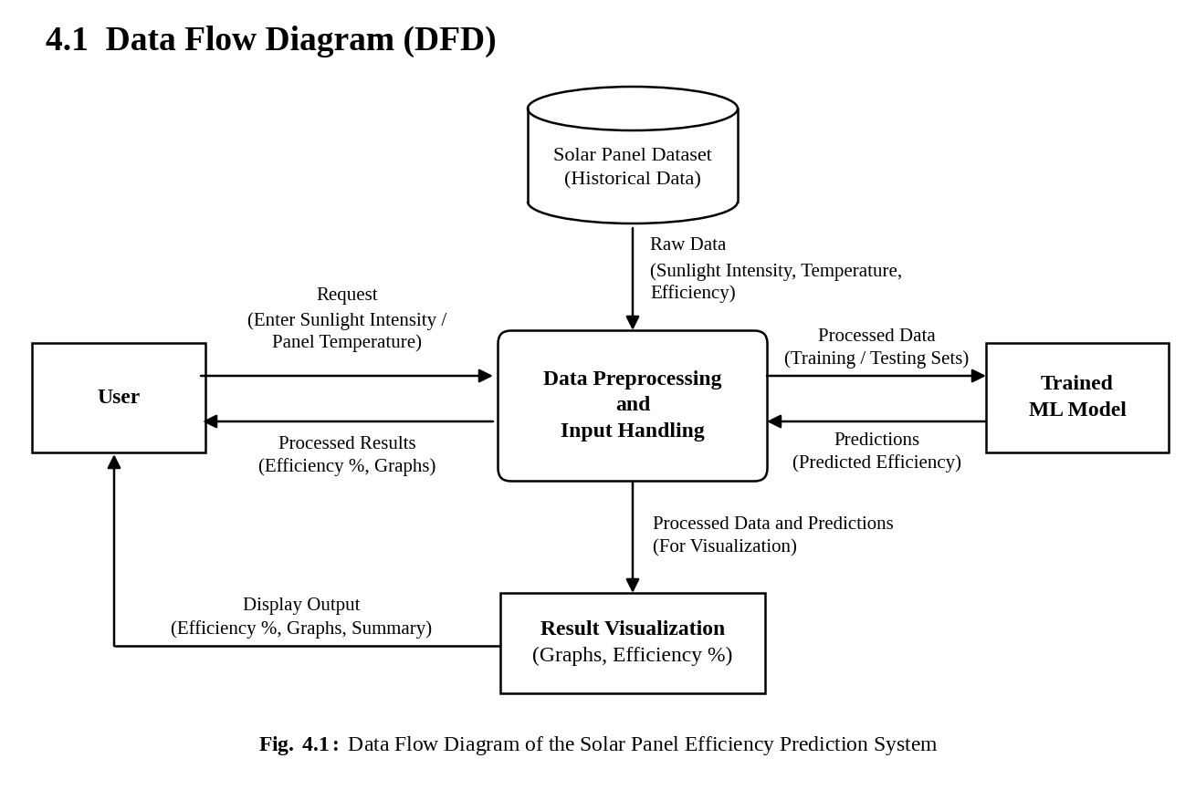
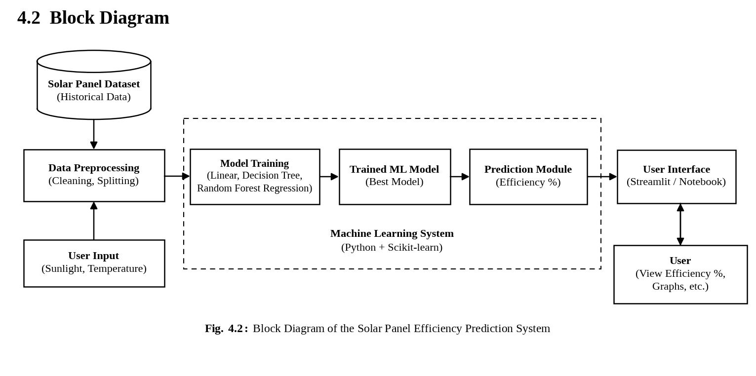
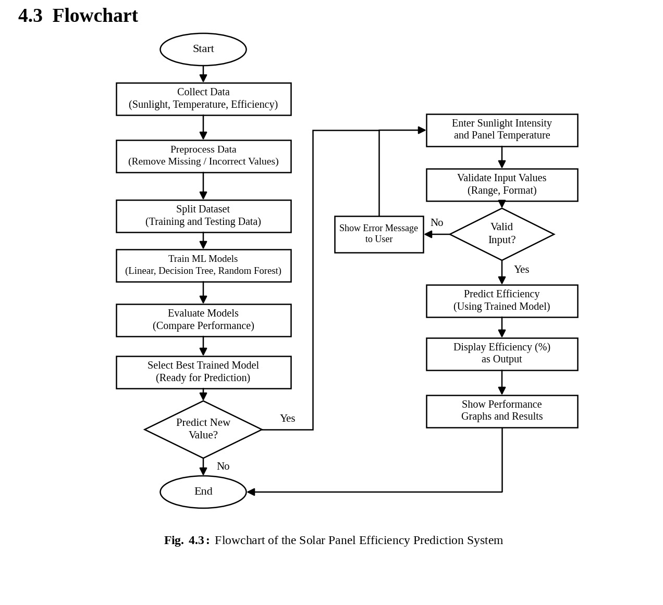

CHAPTER 5
RESULTS & DISCUSSION

5.1 Actual Results
The Solar Panel Efficiency Prediction System is designed to predict solar panel efficiency using machine learning. The system processes sunlight intensity and temperature data, trains regression models, generates predictions for new input values, and presents the predicted efficiency in an understandable format.
The project aims to make the effect of environmental conditions on solar panel performance easier to understand by combining prediction, comparison of algorithms, and visualization within a single system.
5.1.1 Dataset Analysis
The project uses a dataset containing sunlight intensity, solar panel temperature, and solar panel efficiency values. The dataset provides the historical basis for studying the relationship between these parameters.
The dataset provides the basis for analysing how efficiency changes with sunlight intensity and temperature and for preparing the inputs required by the prediction models. Before the data is used, its values, units, and column structure must be verified to ensure that they are suitable for model training.
The range of values in the dataset determines the conditions under which the model can make reliable predictions. The quality and usefulness of the resulting analysis depend on the completeness of the data and the availability of the variables required for prediction.
5.1.2 Machine Learning Prediction
The machine learning component is responsible for generating estimates of solar panel efficiency from the sunlight intensity and temperature values supplied as input.
The system trains Linear Regression, Decision Tree Regression, and Random Forest Regression models using the training dataset. When a prediction request is received, the entered values are prepared and passed to the trained model, and the resulting efficiency is displayed. The prediction workflow consists of the following stages:
1. Load the dataset containing sunlight intensity, temperature, and efficiency.
2. Preprocess the data and split it into training and testing sets.
3. Train the machine learning models using the training data.
4. Receive sunlight intensity and panel temperature as input.
5. Predict the expected solar panel efficiency using the trained model.
6. Display the predicted efficiency as a percentage.
7. Display the related graphs and performance results.
The model’s predictions depend on its training data and configuration. The actual predicted efficiency values and model performance should therefore be taken from the implemented model rather than assumed.
5.1.3 Prediction Results
The prediction interface is intended to present the efficiency of a solar panel for the sunlight intensity and temperature entered by the user.
For example, for a sunlight intensity of 800 W/m² and a panel temperature of 35°C, the trained model produces a predicted efficiency, which is displayed as a percentage. The output depends on the trained model, so the example value is generated by the model rather than fixed in advance.
By trying different combinations of inputs, users can see how the predicted efficiency changes. In particular, increasing the panel temperature while keeping the sunlight intensity constant can show the reduction in efficiency at high temperatures, provided that the dataset reflects this behaviour.
The actual predicted values should be obtained from the implemented model. They should not be represented as measured efficiency or guaranteed performance.
5.1.4 Data Visualization
The system presents numerical data and results as graphs so that they can be interpreted without examining raw data manually.
The planned visualizations include:
• Sunlight intensity versus efficiency: Shows how efficiency changes as sunlight intensity varies.
• Temperature versus efficiency: Illustrates the effect of panel temperature on efficiency.
• Actual versus predicted efficiency: Compares observed values with model predictions.
• Correlation heatmap: Shows the relationship between sunlight intensity, temperature, and efficiency.
• Data distribution plots: Highlight the spread of the input and target variables.
• Algorithm comparison: Compares the performance of Linear, Decision Tree, and Random Forest Regression.
Each visualization should include appropriate labels, units, and legends. The available data determines which observations appear in each graph.
5.1.5 Performance Observations
The predicted efficiency can be compared with the observed efficiency of a solar panel to support preliminary analysis of its performance. Significant and persistent differences may indicate conditions requiring further investigation.
For example, lower-than-expected efficiency may be associated with changing environmental conditions, shading, dust, equipment limitations, or data-quality issues. However, a difference between actual and predicted efficiency does not establish the cause of the deviation.
The application should therefore present such findings as performance observations rather than confirmed equipment faults. A reliable fault diagnosis requires additional operational information and appropriate diagnostic methods.
5.1.6 Model Comparison
The system is designed to compare the Linear Regression, Decision Tree Regression, and Random Forest Regression algorithms so that a suitable model can be selected for predicting solar panel efficiency.
Each model is trained on the same training data and evaluated on the same testing data. Their predictions are compared using suitable regression metrics such as Mean Absolute Error, Root Mean Squared Error, and the coefficient of determination.
The results can be presented in a table or graph, which helps to identify the algorithm that predicts efficiency most reliably for the dataset used. Linear Regression is useful for understanding basic relationships, whereas Decision Tree and Random Forest Regression can capture nonlinear relationships.
The performance of each algorithm depends on the dataset, so conclusions about the best model should be drawn only from the actual evaluation results.
5.1.7 Discussion
The proposed system combines data analysis, machine learning prediction, and visualization in a unified application for solar panel efficiency. Its main contribution is the use of a trained machine learning model to predict efficiency from sunlight intensity and temperature through a simple interface.
The effectiveness of the final implementation depends on the quality of the dataset, suitable preprocessing, and the selection of an appropriate model. The system can support exploratory analysis and preliminary estimation of solar panel performance, but the quality of its predictions must be assessed using an unseen testing dataset.
The final results section should be supported by screenshots of the working system, actual prediction outputs, and relevant plots generated by the implemented system. Quantitative claims should be included only when they are supported by the model evaluation results.

5.2 Future Scope
The Solar Panel Efficiency Prediction System provides a foundation for further development in solar energy performance prediction and monitoring. Several improvements can be introduced to increase its functionality, reliability, and practical usefulness.
5.2.1 Additional Input Parameters
The system can be extended to include additional parameters such as humidity, wind speed, and dust accumulation. These parameters also influence the performance of solar panels, and including them could allow the model to represent the operating conditions more completely. The benefit would depend on the availability and quality of the additional data.
5.2.2 Real-Time Weather Data Integration
A future version of the system could integrate real-time weather data using APIs. This would allow the system to obtain current sunlight and temperature conditions automatically instead of relying on manually entered values.
Real-time integration would require suitable data sources, secure communication, and mechanisms for handling missing or delayed data.
5.2.3 IoT Sensor Integration
IoT sensors could be connected to the solar panel for live monitoring of sunlight intensity, panel temperature, and generated power. The system could then compare the predicted efficiency with the actual performance of the panel.
The usefulness of this extension would depend on the accuracy and calibration of the sensors and on reliable data communication.
5.2.4 Mobile and Web Application
A mobile or web application could be developed so that users can obtain real-time predictions from different devices. Such an application would provide a more accessible interface than a notebook or a local script.
It could include features such as input forms, prediction history, and graphs of efficiency under different conditions.
Such functionality would require additional work on user interface design, hosting, and testing across devices.
5.2.5 Prediction of Daily and Monthly Energy Generation
The system could be extended to predict daily and monthly solar energy generation, in addition to efficiency. This would help users estimate the amount of electricity that a solar installation may produce over a longer period.
Such predictions would require additional information, such as the panel area, the duration of sunlight, and the expected weather conditions over the period.
Historical generation data and seasonal patterns could improve the reliability of the estimates, although predictions would remain estimates rather than guaranteed values.
The system could also present the results as daily and monthly summaries through graphs and tables.
5.2.6 Advanced Machine Learning Models
Additional algorithms, such as Gradient Boosting or neural networks, could be evaluated and compared with the Linear, Decision Tree, and Random Forest Regression models used in this project.
The most suitable model would depend on the dataset size, the available input parameters, and the required prediction accuracy.
5.2.7 Improved Interface and Reporting
The user interface could be enhanced with downloadable reports, additional filtering options, and exportable graphs.
Users could select different panels, date ranges, and operating conditions. Automated reports could summarize efficiency trends and unusual performance observations over a specified period.
5.2.8 Cloud Deployment and Scalability
The application could be deployed to a cloud platform to make it accessible to users from different locations. A future version could include user authentication and secure storage of datasets.
The system could also be optimized to support multiple solar panels and concurrent users, depending on the expected usage.
5.2.9 Uncertainty Estimation
Instead of displaying only a single predicted value, future versions could provide prediction intervals or uncertainty estimates when these are produced by a suitable method.
This would help users understand the range of plausible efficiency values rather than interpreting a prediction as a guaranteed value.
Overall, these extensions could transform the prototype into a more comprehensive solar energy monitoring and analysis platform. Their implementation would require additional data, development, and validation.

5.3 Testing
Testing is an essential part of software development because it verifies whether the system behaves as expected and whether its components work together correctly.
The Solar Panel Efficiency Prediction System includes data processing, machine learning prediction, visualization, and an input interface. Each component must be tested independently and as part of the integrated system.
5.3.1 Objectives of Testing
The main objectives of testing are:
1. To verify that the dataset is loaded and processed correctly.
2. To ensure that the prediction model receives the expected input features.
3. To check that the system returns predictions in the expected format.
4. To verify that the predicted efficiency is displayed correctly as a percentage.
5. To ensure that the graphs display the data and results accurately.
6. To validate the input checking and error-handling mechanisms.
7. To check the behaviour of the interface and its controls.
8. To identify and correct integration errors before deployment.
5.3.2 Types of Testing
A. Unit Testing
Unit testing evaluates individual components independently. Examples include testing data loading, missing-value handling, input preparation, and the functions that generate predictions.
B. Integration Testing
Integration testing verifies communication between the data-processing steps, the prediction model, and the interface. It checks whether the data passed between them uses the correct format and whether the application displays the returned information properly.
C. Functional Testing
Functional testing verifies that the system’s features behave according to the specified requirements. It includes checking input entry, prediction output, graph display, and error messages.
D. Data Validation Testing
Data validation testing checks whether the system can identify missing values, incorrect data types, invalid sunlight or temperature values, duplicate records, and unsuitable input.
E. Model Evaluation
Model evaluation measures the predictive performance of the models using unseen testing data. Suitable metrics may include Mean Absolute Error, Root Mean Squared Error, and the coefficient of determination.
This evaluation is separate from software testing. A working application does not automatically imply that its predictions are accurate.
F. User Interface Testing
User interface testing checks the readability, navigation, input fields, output display, and error messages of the interface.
5.3.3 Testing Results
The proposed test cases in Table 3 provide a framework for checking the correctness and reliability of the system.
Table 3: Functional Test Cases Table
Test ID | Test Case | Input / Action | Expected Result | Result (Pass / Fail)
TC1 | Dataset loading | Load the dataset. | The dataset loads without errors and the required columns are recognized.
TC2 | Missing values | Dataset containing missing values. | Records with missing values are removed or handled.
TC3 | Valid prediction | Sunlight intensity = 800 W/m², panel temperature = 35°C. | The predicted efficiency is generated and displayed as a percentage.
TC4 | Invalid input | Empty or non-numeric input value. | A clear error message is displayed.
TC5 | Out-of-range input | Negative sunlight intensity. | The input is rejected or a warning is displayed.
TC6 | Graph display | Select the efficiency graphs. | The graphs are displayed with labelled axes and units.
TC7 | Model comparison | Run the comparison of the three algorithms. | The performance of each algorithm is displayed.

After execution, each test should be marked as Pass or Fail according to its observed result. Failed tests should be investigated, corrected, and executed again.
The final report should include the actual testing outcomes rather than assuming that all tests have passed. Screenshots of successful operations and relevant error-handling scenarios can be added as supporting evidence.
The testing process should also verify that the system uses the same data preparation and input format as the trained model. This is particularly important because an incorrect input format may cause prediction failures or produce unreliable output.

5.4 Deployment
Deployment is the process of making a software application available for use in its intended environment. The Solar Panel Efficiency Prediction System can initially be run in Google Colab, Jupyter Notebook, or locally for development and demonstration, with the option of deploying it as a web application later.
5.4.1 Deployment Requirements
The deployment environment must provide the software dependencies and resources needed to run the code, dataset, and trained model.
The main requirements include:
• A compatible Python environment.
• The required Python libraries (Pandas, NumPy, Scikit-learn, Matplotlib, and Seaborn).
• The trained model and any associated preprocessing steps.
• Access to the dataset used for training.
• Streamlit, if the web interface is used.
• Configuration of the interface for entering inputs and displaying results.
• Appropriate checks on the values entered by users.
The exact requirements depend on the final implementation and the selected environment.
5.4.2 Local Deployment
During development, the system can run locally on the same computer. The general process is as follows:
1. Install the required Python libraries.
2. Place the dataset in its configured location.
3. Train the models or load the trained model.
4. Run the notebook or the Streamlit application.
5. Open the interface in a web browser, if Streamlit is used.
6. Enter sunlight intensity and panel temperature.
7. Verify that the predicted efficiency and graphs are displayed correctly.
If a Streamlit application is used, it runs on a local port that can be opened in a web browser on the same computer.
Local deployment is suitable for development, debugging, and academic demonstrations.
5.4.3 Cloud Deployment
A future public deployment could host the application on a compatible cloud platform so that it can be accessed by users from different locations. The platform would need to provide the Python environment, the trained model, and the required libraries.
The deployment process would involve installing dependencies, configuring the application, and testing the prediction interface after deployment.
The selected platform must support the application’s runtime requirements and provide sufficient memory and storage for the dataset and model.
5.4.4 Model and Dataset Management
The trained model and the dataset must be managed carefully during deployment. File paths should be configured in a way that remains valid in the target environment.
The model should be trained or loaded once rather than being retrained for every prediction request unless the application requires it.
User inputs should be validated before processing. Appropriate limits should be applied to the accepted range of sunlight intensity and temperature values.
Updates to the model or dataset should be accompanied by compatibility checks and testing.
5.4.5 Deployment Security and Reliability
A deployed application should validate user input and restrict access to any sensitive data.
The application should handle invalid inputs, missing files, unavailable models, and unexpected processing errors without exposing internal details to users.
Logging can be used to record application errors and assist with debugging.
The deployed application should be tested after every significant configuration or model update to confirm that its main functions continue to work correctly.
5.4.6 Deployment Outcome
The intended deployment outcome is a simple application that allows users to enter sunlight intensity and panel temperature and obtain the predicted solar panel efficiency along with supporting graphs.
For an academic demonstration, local or notebook-based execution may be sufficient. A web deployment can be considered when remote access, wider sharing, or integration with live data sources is required.
The final report should identify the actual deployment method used and include screenshots or access details only after the application has been successfully run and verified.

CHAPTER 6
CONCLUSION
The Solar Panel Efficiency Prediction System presents a machine learning-based approach to predicting solar panel efficiency using sunlight intensity and temperature data. The project addresses the need to understand how environmental conditions affect solar panel performance by combining data analysis, predictive modelling, and visualization.
The proposed system uses sunlight intensity, panel temperature, and efficiency data as its primary data source. The data-processing steps prepare the input features, while the trained regression models, including Linear Regression, Decision Tree Regression, and Random Forest Regression, predict the expected solar panel efficiency, which is displayed as a percentage.
An important aspect of the project is that it predicts efficiency in advance, whereas traditional systems mainly monitor the power that has been generated. The system helps users understand how sunlight intensity and temperature influence solar energy generation, and in particular how high temperatures can reduce efficiency.
The project also supports a comparison of different machine learning algorithms and the display of prediction results through graphs and visualizations. Such observations can support the analysis of solar panel performance, although confirming a specific equipment fault requires additional operational information and engineering verification.
The development process demonstrates the application of several important concepts in artificial intelligence and software engineering, including data preprocessing, regression modelling, model evaluation, data visualization, and system testing. The modular design also provides opportunities to extend the system with additional parameters, real-time weather data, IoT sensors, and a mobile or web application.
The usefulness of the completed system depends on the quality of the dataset, the correctness of the preprocessing, and the ability of the model to generalize to unseen observations. Therefore, predictions should be treated as estimates rather than guaranteed values. Proper testing and evaluation are necessary before the system can be considered suitable for practical use.
In conclusion, the Solar Panel Efficiency Prediction System provides a practical foundation for applying machine learning to solar panel performance analysis. By combining data-driven prediction with accessible visualizations, the project makes it easier to understand how environmental conditions influence solar energy generation. With further validation, additional parameters, real-time data integration, and live monitoring, the system could be developed into a more comprehensive solar energy monitoring platform.

REFERENCES
1. Pedregosa, F., Varoquaux, G., Gramfort, A., et al. (2011). Scikit-learn: Machine Learning in Python. Journal of Machine Learning Research, 12, 2825–2830. Available at: https://jmlr.org/papers/v12/pedregosa11a.html

2. Breiman, L. (2001). Random Forests. Machine Learning, 45, 5–32. Available at: https://doi.org/10.1023/A:1010933404324
3. Breiman, L., Friedman, J. H., Olshen, R. A., and Stone, C. J. (1984). Classification and Regression Trees. Chapman and Hall/CRC.

4. McKinney, W. (2010). Data Structures for Statistical Computing in Python. Proceedings of the 9th Python in Science Conference, 56–61. Available at: https://doi.org/10.25080/Majora-92bf1922-00a
5. Harris, C. R., Millman, K. J., van der Walt, S. J., et al. (2020). Array programming with NumPy. Nature, 585, 357–362. Available at: https://doi.org/10.1038/s41586-020-2649-2

6. Hunter, J. D. (2007). Matplotlib: A 2D Graphics Environment. Computing in Science & Engineering, 9(3), 90–95. Available at: https://doi.org/10.1109/MCSE.2007.55

7. Waskom, M. L. (2021). seaborn: statistical data visualization. Journal of Open Source Software, 6(60), 3021. Available at: https://doi.org/10.21105/joss.03021

8. Skoplaki, E., and Palyvos, J. A. (2009). On the temperature dependence of photovoltaic module electrical performance: A review of efficiency/power correlations. Solar Energy, 83(5), 614–624. Available at: https://doi.org/10.1016/j.solener.2008.10.008

9. Streamlit. Streamlit Documentation. Available at: https://docs.streamlit.io/

10. Google. Google Colaboratory. Available at: https://colab.research.google.com/

11. Python Software Foundation. Python Documentation. Available at: https://docs.python.org/3/

