Bài tập lý thuyết Buổi 4
Họ và tên: Nguyễn Trọng Thuận
MSSV: 1250080193 Lớp: 12_ĐH_CNTT4
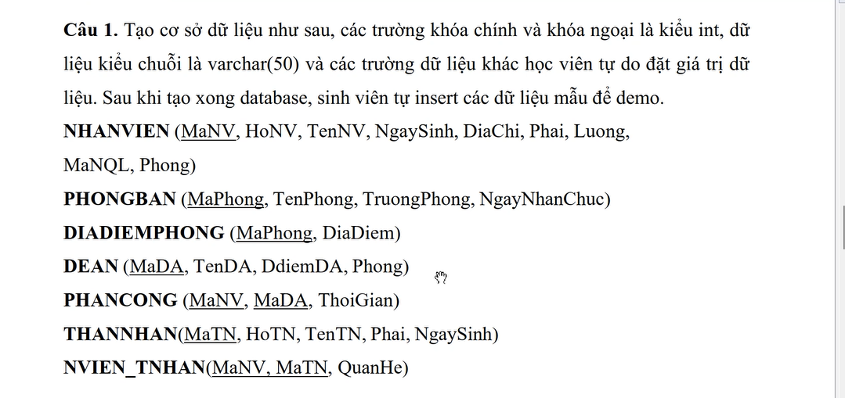
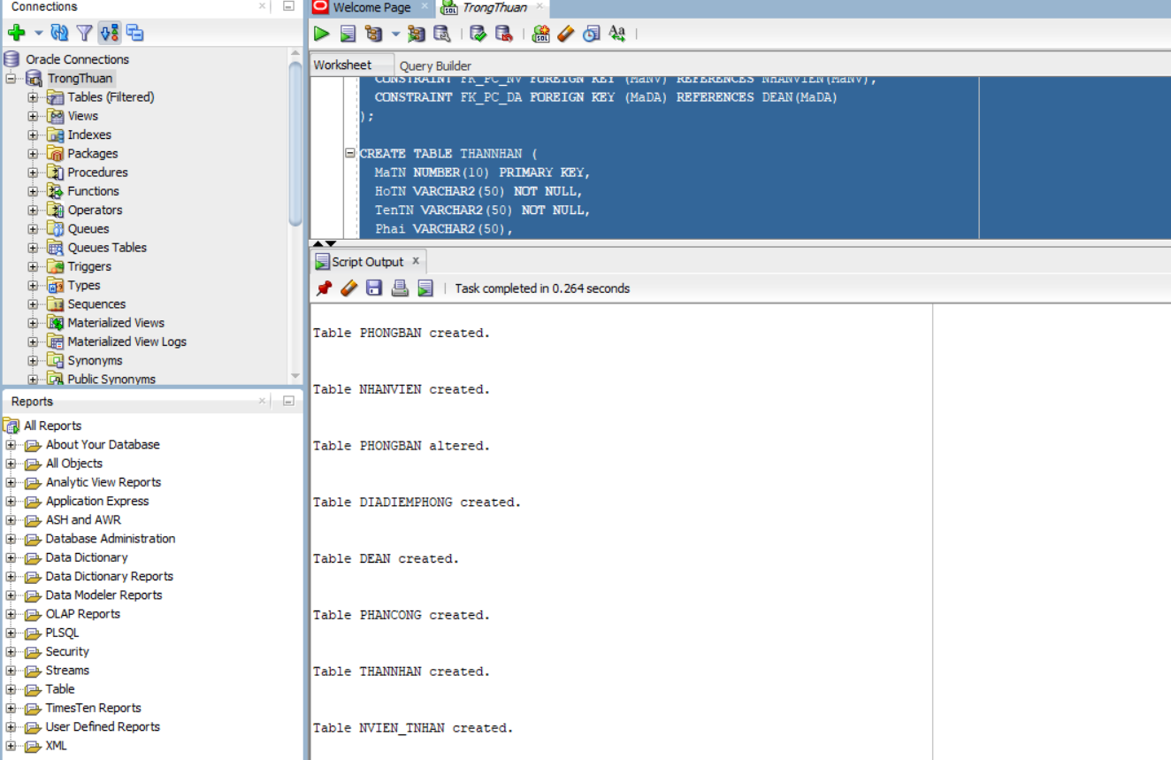
SET SERVEROUTPUT ON;
ALTER SESSION SET NLS_DATE_FORMAT = 'YYYY-MM-DD';

BEGIN EXECUTE IMMEDIATE 'DROP TABLE NVIEN_TNHAN CASCADE CONSTRAINTS'; EXCEPTION WHEN OTHERS THEN NULL; END;
/
BEGIN EXECUTE IMMEDIATE 'DROP TABLE PHANCONG CASCADE CONSTRAINTS'; EXCEPTION WHEN OTHERS THEN NULL; END;
/
BEGIN EXECUTE IMMEDIATE 'DROP TABLE THANNHAN CASCADE CONSTRAINTS'; EXCEPTION WHEN OTHERS THEN NULL; END;
/
BEGIN EXECUTE IMMEDIATE 'DROP TABLE DEAN CASCADE CONSTRAINTS'; EXCEPTION WHEN OTHERS THEN NULL; END;
/
BEGIN EXECUTE IMMEDIATE 'DROP TABLE DIADIEMPHONG CASCADE CONSTRAINTS'; EXCEPTION WHEN OTHERS THEN NULL; END;
/
BEGIN EXECUTE IMMEDIATE 'DROP TABLE NHANVIEN CASCADE CONSTRAINTS'; EXCEPTION WHEN OTHERS THEN NULL; END;
/
BEGIN EXECUTE IMMEDIATE 'DROP TABLE PHONGBAN CASCADE CONSTRAINTS'; EXCEPTION WHEN OTHERS THEN NULL; END;
/

CREATE TABLE PHONGBAN (
MaPhong NUMBER(10) PRIMARY KEY,
TenPhong VARCHAR2(50) UNIQUE NOT NULL,
TruongPhong NUMBER(10),
NgayNhanChuc DATE
);

CREATE TABLE NHANVIEN (
MaNV NUMBER(10) PRIMARY KEY,
HoNV VARCHAR2(50) NOT NULL,
TenNV VARCHAR2(50) NOT NULL,
NgaySinh DATE,
DiaChi VARCHAR2(50),
Phai VARCHAR2(50),
Luong NUMBER,
MaNQL NUMBER(10),
Phong NUMBER(10),
CONSTRAINT FK_NV_PHONG FOREIGN KEY (Phong) REFERENCES PHONGBAN(MaPhong),
CONSTRAINT FK_NV_NQL FOREIGN KEY (MaNQL) REFERENCES NHANVIEN(MaNV)
);

ALTER TABLE PHONGBAN
ADD CONSTRAINT FK_PB_TRUONGPHONG FOREIGN KEY (TruongPhong) REFERENCES NHANVIEN(MaNV);

CREATE TABLE DIADIEMPHONG (
MaPhong NUMBER(10) NOT NULL,
DiaDiem VARCHAR2(50) NOT NULL,
CONSTRAINT PK_DIADIEMPHONG PRIMARY KEY (MaPhong, DiaDiem),
CONSTRAINT FK_DDP_PHONG FOREIGN KEY (MaPhong) REFERENCES PHONGBAN(MaPhong)
);

CREATE TABLE DEAN (
MaDA VARCHAR2(50) PRIMARY KEY,
TenDA VARCHAR2(50) NOT NULL,
DdiemDA VARCHAR2(50),
Phong NUMBER(10),
CONSTRAINT FK_DEAN_PHONG FOREIGN KEY (Phong) REFERENCES PHONGBAN(MaPhong)
);

CREATE TABLE PHANCONG (
MaNV NUMBER(10) NOT NULL,
MaDA VARCHAR2(50) NOT NULL,
ThoiGian NUMBER,
CONSTRAINT PK_PHANCONG PRIMARY KEY (MaNV, MaDA),
CONSTRAINT FK_PC_NV FOREIGN KEY (MaNV) REFERENCES NHANVIEN(MaNV),
CONSTRAINT FK_PC_DA FOREIGN KEY (MaDA) REFERENCES DEAN(MaDA)
);

CREATE TABLE THANNHAN (
MaTN NUMBER(10) PRIMARY KEY,
HoTN VARCHAR2(50) NOT NULL,
TenTN VARCHAR2(50) NOT NULL,
Phai VARCHAR2(50),
NgaySinh DATE
);

CREATE TABLE NVIEN_TNHAN (
MaNV NUMBER(10) NOT NULL,
MaTN NUMBER(10) NOT NULL,
QuanHe VARCHAR2(50),
CONSTRAINT PK_NVIEN_TNHAN PRIMARY KEY (MaNV, MaTN),
CONSTRAINT FK_NVTN_NV FOREIGN KEY (MaNV) REFERENCES NHANVIEN(MaNV),
CONSTRAINT FK_NVTN_TN FOREIGN KEY (MaTN) REFERENCES THANNHAN(MaTN)
);
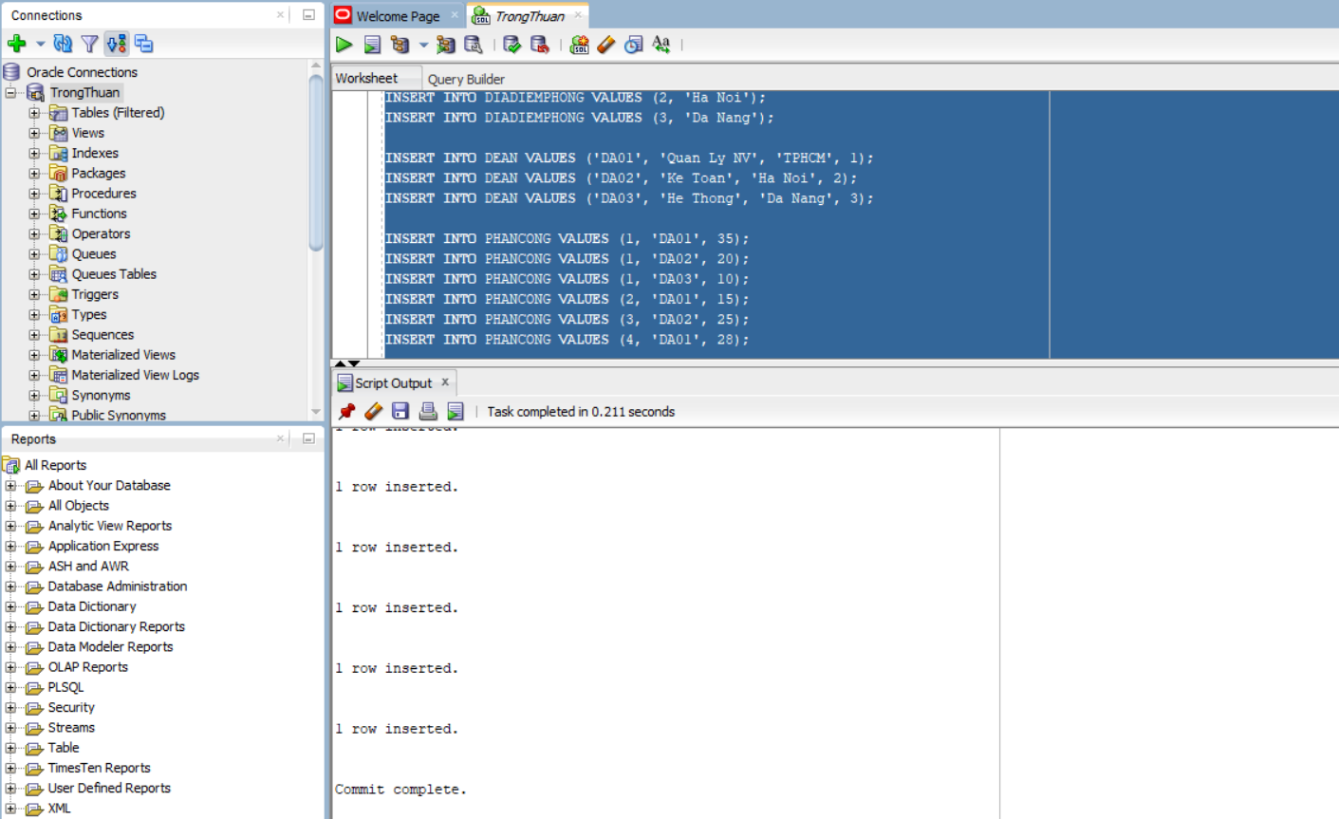
INSERT INTO PHONGBAN VALUES (1, 'Hanh Chinh', NULL, DATE '2024-01-01');
INSERT INTO PHONGBAN VALUES (2, 'Tai Vu', NULL, DATE '2024-01-02');
INSERT INTO PHONGBAN VALUES (3, 'Ky Thuat', NULL, DATE '2024-01-03');

INSERT INTO NHANVIEN VALUES (1, 'Nguyen', 'Trong Thuan', DATE '2003-03-10', 'TPHCM', 'Nam', 1500000, NULL, 1);
INSERT INTO NHANVIEN VALUES (2, 'Tran', 'Minh Anh', DATE '2002-07-21', 'TPHCM', 'Nu', 1200000, 1, 1);
INSERT INTO NHANVIEN VALUES (3, 'Le', 'Quang Huy', DATE '2001-12-05', 'Ha Noi', 'Nam', 900000, 1, 2);
INSERT INTO NHANVIEN VALUES (4, 'Pham', 'Ngoc Mai', DATE '2000-09-09', 'Da Nang', 'Nu', 800000, 1, 2);
INSERT INTO NHANVIEN VALUES (5, 'Do', 'Van A', DATE '1999-01-01', 'Can Tho', 'Nam', 400000, 1, 3);

UPDATE PHONGBAN SET TruongPhong = 1 WHERE MaPhong = 1;
UPDATE PHONGBAN SET TruongPhong = 3 WHERE MaPhong = 2;
UPDATE PHONGBAN SET TruongPhong = 5 WHERE MaPhong = 3;

INSERT INTO DIADIEMPHONG VALUES (1, 'TPHCM');
INSERT INTO DIADIEMPHONG VALUES (2, 'Ha Noi');
INSERT INTO DIADIEMPHONG VALUES (3, 'Da Nang');

INSERT INTO DEAN VALUES ('DA01', 'Quan Ly NV', 'TPHCM', 1);
INSERT INTO DEAN VALUES ('DA02', 'Ke Toan', 'Ha Noi', 2);
INSERT INTO DEAN VALUES ('DA03', 'He Thong', 'Da Nang', 3);

INSERT INTO PHANCONG VALUES (1, 'DA01', 35);
INSERT INTO PHANCONG VALUES (1, 'DA02', 20);
INSERT INTO PHANCONG VALUES (1, 'DA03', 10);
INSERT INTO PHANCONG VALUES (2, 'DA01', 15);
INSERT INTO PHANCONG VALUES (3, 'DA02', 25);
INSERT INTO PHANCONG VALUES (4, 'DA01', 28);

INSERT INTO THANNHAN VALUES (1, 'Nguyen', 'Trong Thuan', 'Nam', DATE '2010-10-10');
INSERT INTO THANNHAN VALUES (2, 'Tran', 'Be Na', 'Nu', DATE '2012-02-02');

INSERT INTO NVIEN_TNHAN VALUES (1, 1, 'Em');
INSERT INTO NVIEN_TNHAN VALUES (2, 2, 'Con');

COMMIT;
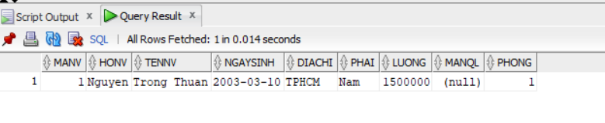
SELECT * FROM NHANVIEN WHERE TenNV = 'Trong Thuan';
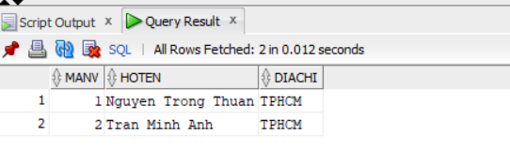
SELECT nv.MaNV, nv.HoNV || ' ' || nv.TenNV AS HoTen, nv.DiaChi
FROM NHANVIEN nv JOIN PHONGBAN pb ON pb.MaPhong = nv.Phong
WHERE pb.TenPhong = 'Hanh Chinh';

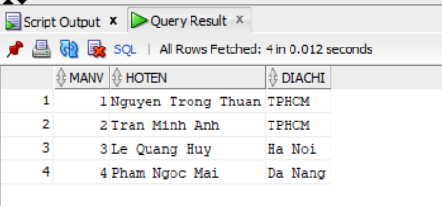
SELECT nv.MaNV, nv.HoNV || ' ' || nv.TenNV AS HoTen, nv.DiaChi
FROM NHANVIEN nv JOIN PHONGBAN pb ON pb.MaPhong = nv.Phong
WHERE pb.TenPhong IN ('Hanh Chinh','Tai Vu');
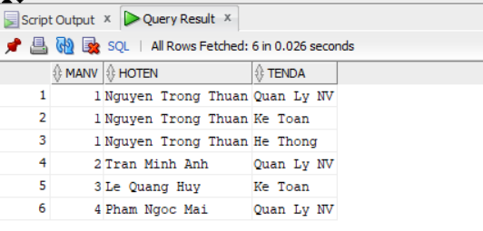
SELECT nv.MaNV, nv.HoNV || ' ' || nv.TenNV AS HoTen, da.TenDA
FROM NHANVIEN nv JOIN PHANCONG pc ON pc.MaNV = nv.MaNV
JOIN DEAN da ON da.MaDA = pc.MaDA
ORDER BY nv.MaNV, da.MaDA;
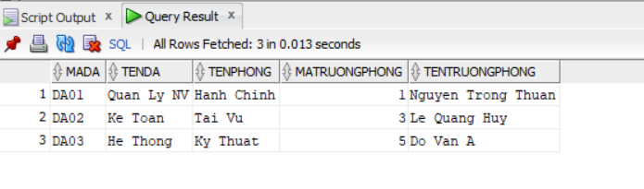
SELECT da.MaDA, da.TenDA, pb.TenPhong,
tp.MaNV AS MaTruongPhong, tp.HoNV || ' ' || tp.TenNV AS TenTruongPhong
FROM DEAN da JOIN PHONGBAN pb ON pb.MaPhong = da.Phong
JOIN NHANVIEN tp ON tp.MaNV = pb.TruongPhong;
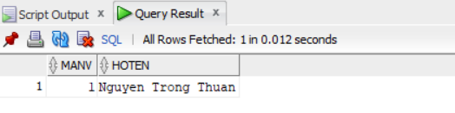
SELECT nv.MaNV, nv.HoNV || ' ' || nv.TenNV AS HoTen
FROM NHANVIEN nv JOIN PHANCONG pc ON pc.MaNV = nv.MaNV
WHERE pc.MaDA='DA01' AND pc.ThoiGian>30;
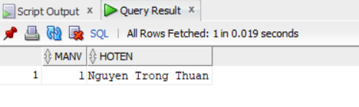
SELECT DISTINCT nv.MaNV, nv.HoNV || ' ' || nv.TenNV AS HoTen
FROM NHANVIEN nv JOIN NVIEN_TNHAN nt ON nt.MaNV = nv.MaNV
JOIN THANNHAN tn ON tn.MaTN = nt.MaTN
WHERE nv.TenNV = tn.TenTN;
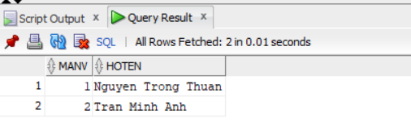
SELECT nv.MaNV, nv.HoNV || ' ' || nv.TenNV AS HoTen
FROM NHANVIEN nv JOIN PHONGBAN pb ON pb.MaPhong = nv.Phong
JOIN NHANVIEN tp ON tp.MaNV = pb.TruongPhong
WHERE tp.HoNV='Nguyen' AND tp.TenNV='Trong Thuan';
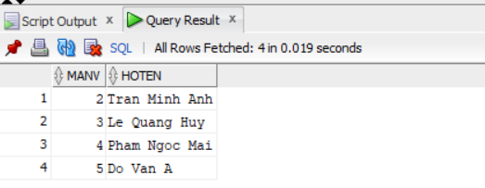
SELECT nv.MaNV, nv.HoNV || ' ' || nv.TenNV AS HoTen
FROM NHANVIEN nv JOIN NHANVIEN ql ON ql.MaNV = nv.MaNQL
WHERE ql.HoNV='Nguyen' AND ql.TenNV='Trong Thuan';

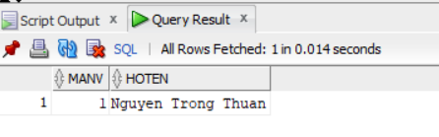
SELECT nv.MaNV, nv.HoNV || ' ' || nv.TenNV AS HoTen
FROM NHANVIEN nv
WHERE NOT EXISTS (
SELECT 1 FROM DEAN da
WHERE NOT EXISTS (
SELECT 1 FROM PHANCONG pc
WHERE pc.MaNV = nv.MaNV AND pc.MaDA = da.MaDA
)
);
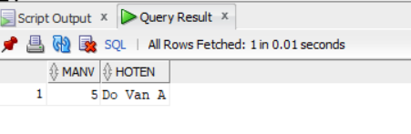
SELECT nv.MaNV, nv.HoNV || ' ' || nv.TenNV AS HoTen
FROM NHANVIEN nv
WHERE NOT EXISTS (SELECT 1 FROM PHANCONG pc WHERE pc.MaNV = nv.MaNV);
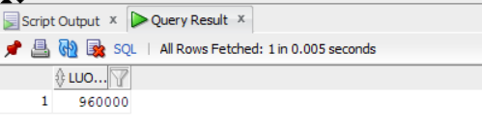
SELECT AVG(Luong) AS LuongTB FROM NHANVIEN;
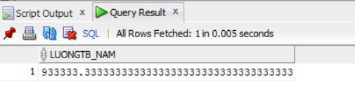
SELECT AVG(Luong) AS LuongTB_Nam FROM NHANVIEN WHERE Phai='Nam';
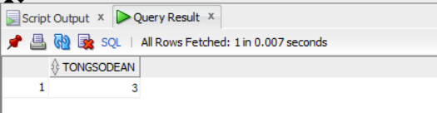

SELECT COUNT(*) AS TongSoDeAn FROM DEAN;
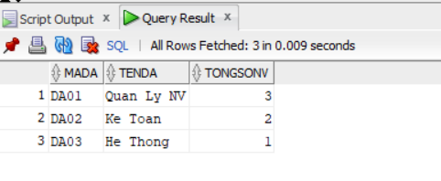
SELECT da.MaDA, da.TenDA, COUNT(DISTINCT pc.MaNV) AS TongSoNV
FROM DEAN da LEFT JOIN PHANCONG pc ON pc.MaDA = da.MaDA
GROUP BY da.MaDA, da.TenDA
ORDER BY da.MaDA;
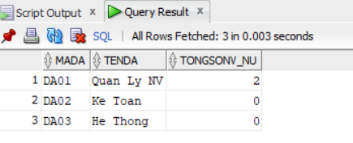
SELECT da.MaDA, da.TenDA, COUNT(DISTINCT nv.MaNV) AS TongSoNV_Nu
FROM DEAN da
LEFT JOIN PHANCONG pc ON pc.MaDA = da.MaDA
LEFT JOIN NHANVIEN nv ON nv.MaNV = pc.MaNV AND nv.Phai='Nu'
GROUP BY da.MaDA, da.TenDA
ORDER BY da.MaDA;

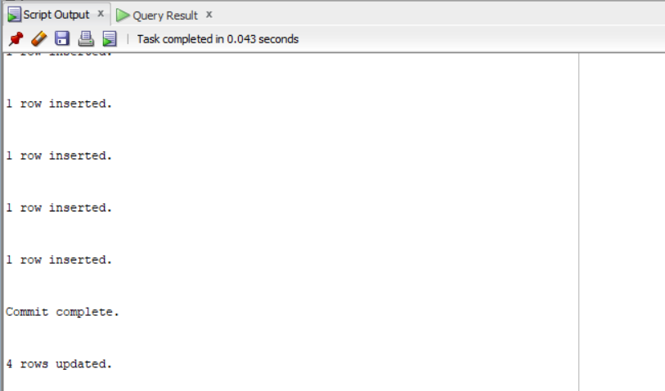
UPDATE PHANCONG
SET ThoiGian = ThoiGian + 4
WHERE MaNV IN (SELECT MaNV FROM NHANVIEN WHERE Phai='Nam');
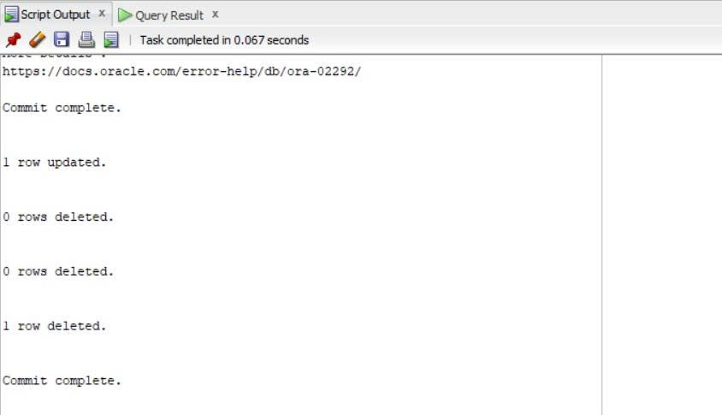
UPDATE PHONGBAN
SET TruongPhong = NULL
WHERE TruongPhong IN (SELECT MaNV FROM NHANVIEN WHERE Luong < 500000);
DELETE FROM PHANCONG
WHERE MaNV IN (SELECT MaNV FROM NHANVIEN WHERE Luong < 500000);
DELETE FROM NVIEN_TNHAN
WHERE MaNV IN (SELECT MaNV FROM NHANVIEN WHERE Luong < 500000);
DELETE FROM NHANVIEN
WHERE Luong < 500000;
COMMIT;

