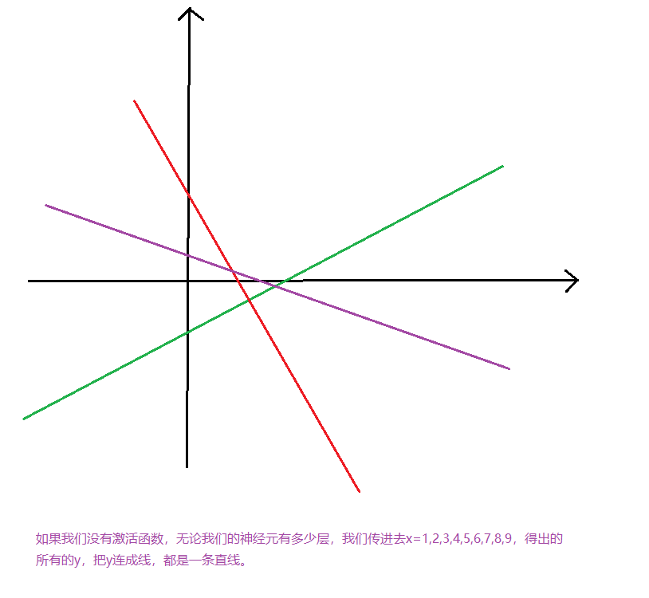

函数作图工具

https://zh.numberempire.com/graphingcalculator.php?functions=log(x)%2Csqrt(x)%2Csin(x)%2C1%2Fx%2Cx%5E2&xmin=0&xmax=3&ymin=-1.0&ymax=1.0&var=x