Triple Port RAM
2015
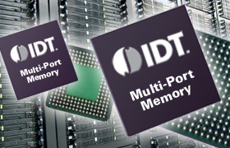

Mohit Sharma [11-ECS-48]
Instructor: Dr. S.A. Loan
Introduction

- What are Multi-Port RAM?

Multi-Port RAM is basically a simple RAM with multiple ports.

These multiple ports are used for the purpose of providing
simultaneous access of a shared memory to multiple devices
such as I/O devices and processor.

Single
Port
RAM

Address

Control

Data

Triple
Port
RAM
Left Address Right Address

Left Control Right Control

Left Data Right Data

Middle Middle Middle
Address Control Data

- Differences:

* A standard RAM consists of a single port which has an address bus,
control logic and data bus.

# Address bus : Used to uniquely identify a memory word.
# Control Logic : Decides whether data is to be read from the
memory word selected or to be written there.
# Data bus : Carries the data to be written or read to and
from the memory respectively

* A multi-port RAM is one having more than one of these ports.
Again each port has an address bus, data data bus and control bus.

Each of these ports have the capability to address any word in the
memory array and write data in or read data out. Some of these
devices are available in asynchronous (all timing controlled by the
CPU) or Synchronous (timing provided by a master clock)
formats.

Multi-port RAM thus provide for a larger bandwidth enabling faster
access time. Hence, accessing memory by the CPU is not a costly
operation in terms of the number of cycles required.

- Why are they required?

Accessing system memory by devices other than a processor like the i/o
devices is always required.

An example of this is running an application stored in a hard disk drive.

For CPU to run such an application, this program must be loaded into system
Memory from the hard drive.

Earlier, this was done using the DMA(Direct Memory Access) process. A DMA
Controller would be connected to the system’s memory bus along with the
CPU and the hard disk controller. When the data needed to be transferred to
or from the hard drive the DMA controller to execute the data transfer. Once
the transfer was complete the DMA controller would inhibit the hard disk
controller and remove the hold from the CPU.

RAM
Hard Disk Conroller

DMA Controller
CPU

Figure shows Hard Disk access by CPU
using DMA Controller

Problems with DMA:

* Input/Output (I/O) devices require the memory bus only a small
percentage of the time.
* Hence, the impact on CPU processing time is minimal.

* However, in today’s systems it is not uncommon to have multiple
CPU’s or GPU’s having multiple ALU’s in the system.

* Even if we have two CPU’s, both of which require access to the
system memory. Using a DMA approach in this case would result
in both CPU’s processing time to be cut in half since each CPU would
spend half the time in a wait state.

* A memory access method is thus needed that wouldn’t slow down
either CPU.

- Solution to the CPU wait problem

Using multiple ports for the RAM enables faster access of system memory
without wait.

For the previous case considered, the problem is with the memory which
allows only one device to access it.

If the memory has multiple ports, multiplexing of memory control by the
DMA won’t be required.
In the following solution, each CPU is connected to each of the ports on a
Dual-Port RAM. The DMA controller has been eliminated as a result.

Now, CPU can access any location in memory whenever it needs to. This
means that both CPU’s can operate with minimal wait states providing
maximum performance.

CPU
CPU
Multi-Port
RAM

Fig 2: Solution to the DMA problem

Multi-port RAM’s thus enable concurrent access of memory by
multiple devices, resulting in better performance.

Applications

- Multi-port RAM’s can be utilised for systems that require multiple devices to access
memory. This can include I/O devices or
devices to access memory.

- GPU’s (Graphical Processing Units) is also an application domain for multi-port RAM’s

- They are also used to address the needs of high-end multimedia handset applications.

Implementation

- The implementation done in this project is of an asynchronous triple-port AM

- These are devices with non-clocked inputs and outputs for data, memory and control functions.

- These RAM’s respond to address and control pin changes without the need for clocks of counter while allowing simultaneous access to a single memory location from three buses.

- The Triple port RAM has been implemented on the Xilinx Spartan 3E kit.

- The block diagram for the RAM is as follows:

wordsize
TRIPLE
PORT
RAM
L_write enable L_data
M_write enable M_data
R_write enable R_data

L_port_addr L_data_read
M_port_addr M_data_read
R_port_addr R_data_read

rst clk
Fig : Triple Port RAM block diagram

Basic memory cell

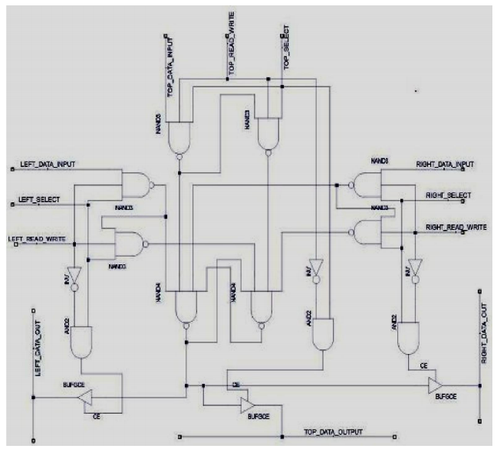

Memory Cell Operation
* The working of Basic Memory Cell can be described in two parts, first one is the
read operation and the second is the write operation, which are described below:

1. Read :
Consider the read operation from left port. When a read operation is desired the read/write signal of left port is kept at low level suggesting read operation. The left_select line is kept at high level to select the left port. Since, these two inputs are “anded” together, hence, the output of and gate is high. The output of this “and gate” is fed to the control input of a buffer. The input of this buffer is connected to output of the storage element, the latch. As active high signal is applied on the control pin of the buffer, the bit stored in latch will be taken as output of buffer onto the read bus.
2. Write:
Write operation of the basic memory cell is more complex as compared to read operation as the signals from other ports also have significance. It should be kept in mind that only one write operation can be carried out by any one of three ports at a given time. If multiple write operation are tried then collision will occur and data will be corrupted. Let’s take example by carrying out write operation using left port. When data ‘1’ is written then output of first nand gate is low while the output of second nand gate will be high and output of other nand gates of top and right port will be zero as their read/write signal will be low and data ‘1’ will be written into latch. Same case will be for writing ‘0’ but in that case output of the nand gated of left port will be inverted form the previous case.

Arbitration
* In most memory access scenarios there is no problem.
* Either CPU can read or write to different memory locations at any time without any problem. They can even read from the same memory location at the same time without any problem. However, if either CPU attempts to write to a memory location at the same time that the other CPU is doing a read or a write, the data could be corrupted. One problem location out of a thousand or more is a small percentage, but it still cannot be ignored. Some form of arbitration is required to insure that simultaneous access to a single location does not include a write operation from either side.
* Certain Multi-Port devices have control logic that helps solve the simultaneous access problem(Busy) and two other common application problems. These additional problems are; signalling between CPU’s (Interrupts) and hardware support for temporary assignment (allocation) of a memory block (Semaphore).

Arbiter Algorithm
If Left and Right and Middle ports require access, give priority to Left port, then Middle and then right port for writing.
Else if left and right ports require access, give priority to left port for writing.

Else if middle and left ports require access for writing, give priority to left port.

Else if right and middle ports require write access, give priority to middle port
Else, put data required in the reading lines

Program

Listing

