Placement Exercise

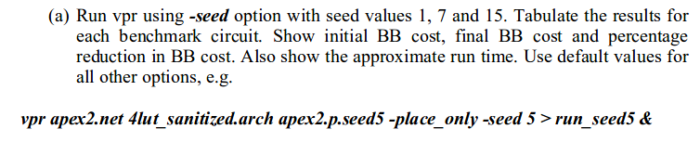
a) -seed <int>: Sets the initial random seed used by the placer. Default: 1.
Using the -seed option with seed values 1, 5, 7 and 15, following results were obtained with vpr:
Benchmark circuit  (No. Of netlist primities) | Seed value | bb_cost |  | Percentage Reduction in bb_cost | Runtime(mm:ss) | Placement cost |  | timing_cost |  | delay_cost
Benchmark circuit  (No. Of netlist primities) | Seed value | Initial | Final | Percentage Reduction in bb_cost | Runtime(mm:ss) | Initial | Final | Initial | Final | Initial | Final
Apex2  (1116) | 1 | 894.188 | 280.12 | 68.67% | 0:42.59 | 0.996 | 0.879 | 1.27e-4 | 6.23e-6 | 1.41e-4 | 7.27e-5
Apex2  (1116) | 5 | 903.734 | 280.641 | 68.94% | 0:42.98 | 0.994 | 0.836 | 1.27e-4 | 3.61e-6 | 1.40e-4 | 7.23e-5
Apex2  (1116) | 7 | 894.452 | 279.275 | 68.78% | 0:43.17 | 0.980 | 0.851 | 1.26e-4 | 6.04e-6 | 1.39e-4 | 7.16e-5
Apex2  (1116) | 15 | 904.57 | 279.799 | 69.07% | 0:43.25 | 1.00682 | 0.893 | 1.27e-4 | 5.19e-6 | 1.40e-4 | 7.28e-5
Frisc  (3291) | 1 | 2271.44 | 587.227 | 74.15% | 1:51.29 | 0.999 | 0.939 | 1.21e-4 | 3.87e-6 | 3.29e-4 | 1.39e-4
Frisc  (3291) | 5 | 2275.88 | 589.02 | 74.12% | 1:54.66 | 1.00763 | 0.941 | 1.21e-4 | 6.37e-6 | 3.29e-4 | 1.36e-4
Frisc  (3291) | 7 | 2252.98 | 587.466 | 73.92% | 1:53.71 | 0.991 | 0.941 | 1.18e-4 | 6.11e-6 | 3.22e-4 | 1.44e-4
Frisc  (3291) | 15 | 2249.87 | 593.212 | 73.63% | 1:53.10 | 0.991 | 0.947 | 1.18e-4 | 7.12e-6 | 3.22e-4 | 1.36e-4
s38417  (4888) | 1 | 5835.43 | 687.198 | 88.22% | 5:18.81 | 0.995 | 0.572 | 4.60e-4 | 6.77e-6 | 6.94e-4 | 1.85e-4
s38417  (4888) | 5 | 5828.23 | 689.025 | 88.18% | 4:49.80 | 1.00278 | 0.577 | 4.65e-4 | 7.98e-6 | 7.05e-4 | 1.83e-4
s38417  (4888) | 7 | 5827.58 | 694.011 | 88.09% | 4:55.78 | 0.986 | 0.604 | 4.51e-4 | 3.79e-6 | 6.83e-4 | 1.79e-4
s38417  (4888) | 15 | 5790.68 | 686.778 | 88.14% | 5:07.13 | 0.987 | 0.567 | 4.53e-4 | 3.68e-6 | 6.84e-4 | 1.87e-4
Table 1
Inferences:
* Since, seed value determines the initial random placement, the initial bb_cost varies with the seed value for each benchmark circuit.
* “Percentage reduction in bb_cost” (highlighted in green) and “final bb_cost” (highlighted in turqoise) seem to be independant of the seed value for the 3 benchmark circuits.
* Final bb_cost achived is very close (Low standard deviation) for the four seed values for each benchmark circuit:

Benchmark Circuit | Average final bb_cost | Standard deviation
apex2 | 279.96 | 0.57
frisc | 589.23 | 2.77
s38417 | 689.25 | 3.32

* Percentage reduction achieved in bb_cost increases with design size i.e number of netlist primitives
* Runtime for the vpr seems to be independant of the seed value but depends on the design size (as expected).

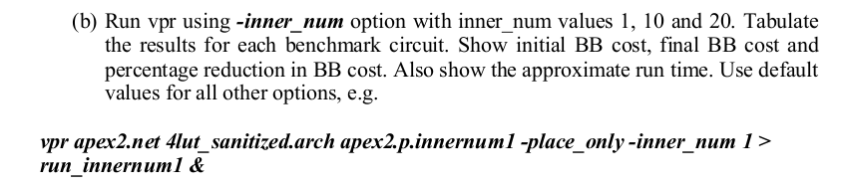

b) -inner_num <float>: The number of moves attempted at each temperature is inner_num times the total number of blocks 4/3 in the circuit. The number of blocks in a circuit is the number of pads plus the number of clbs. Changing inner_num is the best way to change the speed/quality tradeoff of the placer, as it leaves the highly-efficient automatic annealing schedule on and simply changes the number of moves per temperature. Default: 10. Note: specifying -inner_num 1 will speed up the placer by a factor of 10 while typically reducing placement quality only by 10% or less (depends on the architecture). Hence users more concerned with CPU time than quality may find this a more appropriate value of inner_num.

Using the -inner_num option with inner_num values 1, 10, and 20, following results were obtained with vpr:

Table 2

Benchmark circuit  (No. Of netlist primities) | Inner num value | bb_cost |  | Percentage Reduction in bb_cost | Runtime(mm:ss) | Placement cost |  | timing_cost |  | delay_cost
Benchmark circuit  (No. Of netlist primities) | Inner num value | Initial | Final | Percentage Reduction in bb_cost | Runtime(mm:ss) | Initial | Final | Initial | Final | Initial | Final
Apex2  (1116) | 1 | 894.188 | 290.454 | 67.51% | 00:04.90 | 0.996 | 0.993 | 1.27e-4 | 7.05e-6 | 1.41e-4 | 6.88e-5
Apex2  (1116) | 10 | 894.188 | 280.12 | 68.67% | 00:44.05 | 0.996 | 0.879 | 1.27e-4 | 6.23e-6 | 1.41e-4 | 7.27e-5
Apex2  (1116) | 20 | 894.188 | 275.449 | 69.19% | 01:24.26 | 0.996 | 0.897 | 1.27e-4 | 3.28e-6 | 1.41e-4 | 7.26e-5
Frisc  (3291) | 1 | 2271.44 | 681.733 | 69.99% | 00:12.53 | 0.999 | 0.997 | 1.21e-4 | 4.63e-6 | 3.29e-4 | 1.55e-4
Frisc  (3291) | 10 | 2271.44 | 587.227 | 74.15% | 01:54.53 | 0.999 | 0.939 | 1.21e-4 | 3.87e-6 | 3.29e-4 | 1.39e-4
Frisc  (3291) | 20 | 2271.44 | 586.742 | 74.17% | 03:47.84 | 0.999 | 0.959 | 1.21e-4 | 6.14e-6 | 3.29e-4 | 1.38e-4
s38417  (4888) | 1 | 5835.43 | 726.34 | 87.55% | 00:34.60 | 0.995 | 0.960 | 4.60e-4 | 1.29e-5 | 6.94e-4 | 1.70e-4
s38417  (4888) | 10 | 5835.43 | 687.198 | 88.22% | 04:54.88 | 0.995 | 0.572 | 4.60e-4 | 6.77e-6 | 6.94e-4 | 1.85e-4
s38417  (4888) | 20 | 5835.43 | 671.954 | 88.48% | 09:11.89 | 0.995 | 0.549 | 4.60e-4 | 5.31e-6 | 6.94e-4 | 1.86e-4

Inferences:

* Since, number of moves attempted at each temperature is a multiple of inner_num, hence, increasing inner_num value increases the runtime of the simulated annealing algorithm. As can be seen from table 2 above, runtime is maximum for inner_num value of 20 for each benchmark circuit. Similarly, the minimum runtime was seen with inner_num value of 1.
* Also, the quality of results i.e. the bb_cost achieved, improves with higher number for inner_num. This is because the number of moves attempted at each temperature increases with increase in inner_num value. For each benchmark circuit, the best placement was achieved (lowest bb_cost) for inner_num = 20
* As was the case with different seed values, the maximum runtime is seen for design with maximum number of blocks i.e. s38417

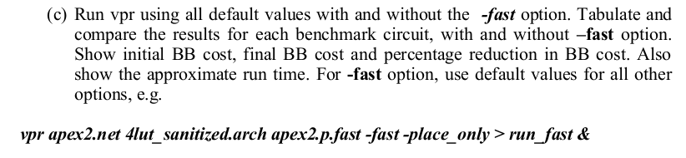
c)
-fast: Sets various placer and router parameters so that a circuit will be placed and routed more quickly, at the cost of some (~10 - 15%) degradation in quality. Note: -fast should probably not be used with the timing-driven router, as it can degrade the circuit speed by over 30%, without significantly speeding the router.

Benchmark circuit  (No. Of netlist primities) | Fast option | bb_cost |  | Percentage Reduction in bb_cost | Runtime(mm:ss) | Placement cost |  | timing_cost |  | delay_cost
Benchmark circuit  (No. Of netlist primities) | Fast option | Initial | Final | Percentage Reduction in bb_cost | Runtime(mm:ss) | Initial | Final | Initial | Final | Initial | Final
Apex2 (1116) | Yes | 894.188 | 290.454 | 67.52% | 0:04.75 | 0.996 | 0.993 | 1.27e-4 | 7.05e-6 | 1.41e-4 | 6.88e-5
Apex2 (1116) | No | 894.188 | 280.12 | 68.67% | 0:42.18 | 0.996 | 0.879 | 1.27e-4 | 6.23e-6 | 1.41e-4 | 7.27e-5
Frisc (3291) | Yes | 2271.44 | 681.733 | 69.98% | 0.12.22 | 0.999 | 0.997 | 1.21e-4 | 4.63e-6 | 3.29e-4 | 1.55e-4
Frisc (3291) | No | 2271.44 | 587.227 | 74.15% | 1:51.60 | 0.999 | 0.939 | 1.21e-4 | 3.87e-6 | 3.29e-4 | 1.39e-4
s38417 (4888) | Yes | 5835.43 | 726.34 | 87.55% | 0:30.34 | 0.995 | 0.960 | 4.60e-4 | 1.29e-5 | 6.94e-4 | 1.70e-4
s38417 (4888) | No | 5835.43 | 687.198 | 88.22% | 4:35.98 | 0.995 | 0.572 | 4.60e-4 | 6.77e-6 | 6.94e-4 | 1.85e-4
Table 3

Inferences:
* Runtime was reduced to 10-15% of the original runtime when the -fast option is used.
* Although, a slight degradation is seen in the bb_cost achieved.
* Initial placement remained unaffected due to the -fast option.

=> The runtime for the various runs was obtained through the “time” command. vpr tool was run as an argument to the time command.

