

**e-Yantra Robotics Competition - 2014**

**Implementation Analysis – Cargo Sorting Robot**

**eYRC#1004**

|  |  |
| --- | --- |
| **Team leader name** | **Vaibhav Pahwa** |
| **College** | **Jamia Millia Islamia** |
| **Email** | **vaibhavpahwa1@gmail.com** |
| **Date** | **26/1/2015** |

**Preparing the Arena (5)**

<Prepare the arena according to the steps given in Section 3: Arena, of the rulebook. Take a photo of the completed arena such that the entire arena is clearly visible in the photo. Insert the image here>

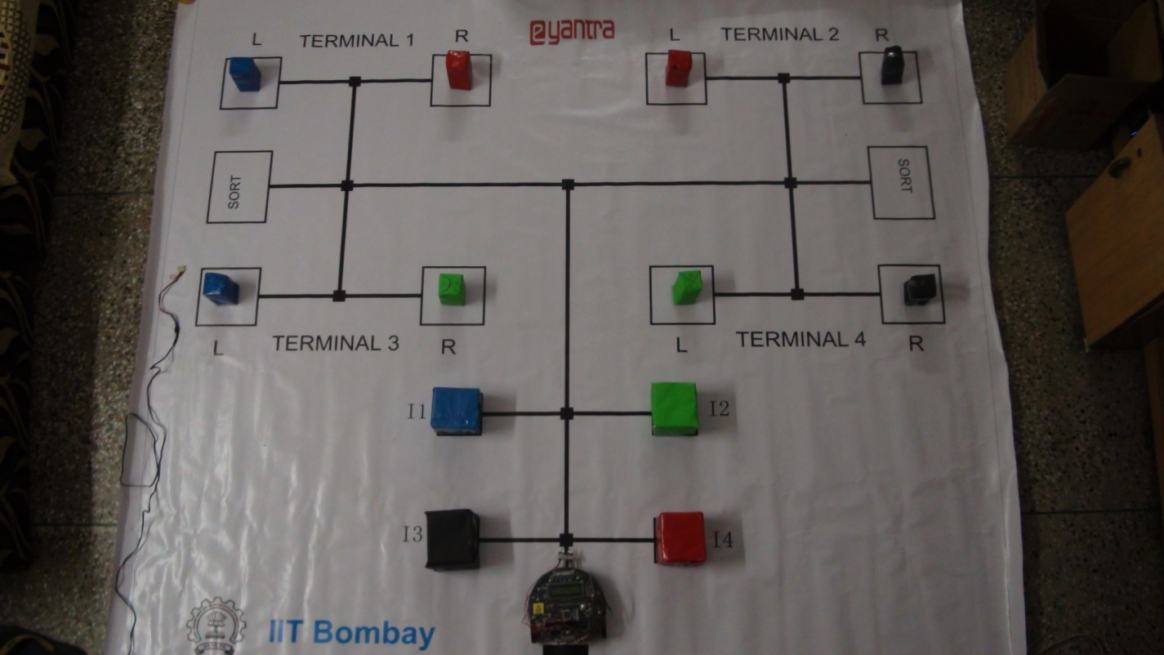

**Design Analysis**

**Q-1. How will you detect the absence/presence of packages and colors of the packages? (10)**

**Answer:**

Two sensors have been used for detection of packages and identifying the color of the packages:

* DETECTION OF PACKAGES (IR SHARP SENSOR):

The Sharp IR range sensors which consists of IR LED and CCD array have been used to identify the absence/presence of the package. The IR LED throws a beam of IR rays continuously. When an object, sufficiently close to the Sharp sensor, blocks the path of the beam, the IR rays get reflected back from its surface. The CCD array then captures the reflected IR rays and is used to compute the angle made by the reflected light. Depending on the distance from the obstacle, this angle varies and is thus used to compute the distance of the sharp IR sensor (and thus the robot from the object).

* The range of this sensor is about 80cm, so if the computed distance according

to the formula :

If distance is greater than 80cm, the package is assumed to be absent and if any value less than 80cm is computed then the package is present.

* + - Sharp sensor is based on measurement of angle rather than the a minimum

intensity of light required for flowing of leakage current through the photo

diode, on which the proximity sensor is based. As a result, sharp sensor is able

to detect black colored package and the proximity sensor is not able to do so.

* IDENTIFYING COLOR OF THE PACKAGES(TCS3200 COLOR SENSOR):

The color sensor TCS3200, which is a programmable light-to-frequency converter, is used for this purpose. It uses Si photodiodes and a current to frequency converter to convert light intensity into a 50% duty cycle square wave whose frequency is directly proportional to the light intensity received by it.

Since, this frequency is high, therefore it is scaled down using two control input pins S0 and S1 attached to port D pin 4 and 5. 20% scaling is done in our case so that S1 = LOW and S0 = HIGH which are applied at the respective port D pins of the microcontroller. Scaling is done by passing the square wave generated through frequency dividers.

The color sensor has 8*8 array of photodiodes of which 16 have red filters, 16 have blue filters, 16 have green filters and 16 have no filter at all. All photodiodes of same color are connected in parallel. Each of red, blue or green filters allows only that type of light to pass through and hence the respective 16 photo diodes receive light intensity of the respective color. By selecting the particular group of 16 photodiodes, pulses of that particular color can be counted. Pins S2 and S3 enable to select one of the four types of the photodiodes.

After selecting one of the four types of photodiodes, the corresponding current is converted to frequency by the current to frequency converter. Since, the leakage current of the photodiode depends on intensity of light received, hence, the corresponding frequency of the square wave produced also depends on the light intensity.

The number of square pulses produced in a particular time interval is measured and reported as a number.

**Q-2. Draw a labeled diagram to explain how you have planned to place the sensors on/around the robot? (10)**

**Fig 1 :**  **Side view of Firebird V(IR sharp sensor not shown)**

Cardboard supporting color sensor through spacers.

Color Sensor

Castor Wheel

Front side of robot

Bottom side of robot

Three white line sensors

**Fig 2 : Front view of Firebird V (White line sensors not shown)**

Sharp IR sensor

Color sensors

Cardboard behind the color sensor supporting it using spacers

Spacers

Castor wheel

Slotted disk

Color sensor

Position encoder

Wheel

Axel of wheel, slotted disk and motor

Optical encoder MOC7811

The color sensor has been placed in the front for easy detection of color of package or identification box. Since, the color sensor is protruding out from the front of the robot, it is easy to identify the color of the package with the help of IR sharp sensor itself. As color sensor is protruding out, the bot does not have to go close enough to the robot to enter blind spot of the IR sharp sensor. This removes the requirement for the proximity sensor. The bot simply needs to stop behind the package using the IR sharp sensor and it can identify package color.

The IR sharp sensor is placed in front because, the bot only needs to detect obstacles in front (for the theme assigned , the bot only needs to detect the packages in front of the bot).

Also, since the color sensor is protruding from the front, detection of package color is made easy as the sharp sensor is also facing to the front. Every time the sharp sensor determines that an obstacle has blocked the passage, the bot simply needs to stop and allow color sensor to take its readings.

The white line sensors are placed at the bottom of the bot behind the castor wheel and face downwards. They are placed so because they are supposed to detect white or black line printed as a track on the floor. Facing downwards enables them to emit light towards the floor and receive reflected light from the bottom.

The position encoder is placed close to the wheel so that it can easily be connected to the optical encoder. The optical encoder mounting forms a 3 side wall across the slotted wheel disk. The optical encoder is placed on the sides of the slotted disk so that one side has the emitter and the other has the receiver to pass IR light through the optical encoder.

**Q-3. Teams have to make the robotic arm for picking up/placing the packages in the arena.**

1. **Choose an option you would like to use to position the robotic arm on the robot and why? (5)**

1. **Front 2. Back 3. Right/Left 4. On both sides**

**Answer:** On both sides

* **Structure**: The arm mechanism on our bot consists of two arms connected to the two servo motors. The servo motors are mounted on top of the bot on either sides towards the front end. The arms are attached to the rotating axel of the respective servo motor on one end and a cup shaped( or a three sided wall shaped) hand on the other side. The hands connected to the arm are tall enough so as to completely enclose the package inside them.
* **Working** : After the robot has stopped at appropriate distance behind the package and has decided to pick the package, it simply closes its arms as if to hug the package. The servo motors rotate toward the package to completely enclose it.
* **Advantages** :

1. Simplicity: It requires only the two servo motors, the extending arm and the 3-sided wall shaped hand to gather the package.
2. Accurate positioning of package : It is easy to pick the package for the first time as the boxes are positioned correctly. But, when the bot picks the package and places it back on another site(for eg sorting area), it may result in improper positioning of the package(the package could fall too). If the bot needs to pick this improperly place package, it might face difficulties or it might be difficult to program to pick the package.

This is especially the case with an arm which lifts the package from overhead. While placing the package, there are chances that it might fall or might be positioned incorrectly.

The tall hand of the arm ensures that the package is enclosed completely. By moving the robot just by the required amount and then stopping, the arm and thus its hand can be made to reach over the appropriate dropping point. To drop the package, the arms just need to be opened up, ensuring that the package keeps standing at its correct location.

* **Problems :**

The main problem with this arm mechanism is that the package rubs along the floor. In real life, it could damage the package. To overcome this, the package should be placed on a trolley (having wheels beneath). This would prevent rubbing of the package and hence, its damage.

1. **Draw a diagram to show the robotic arm and how it is mounted on the robot. Also show the mounting of the color sensor. (10)**

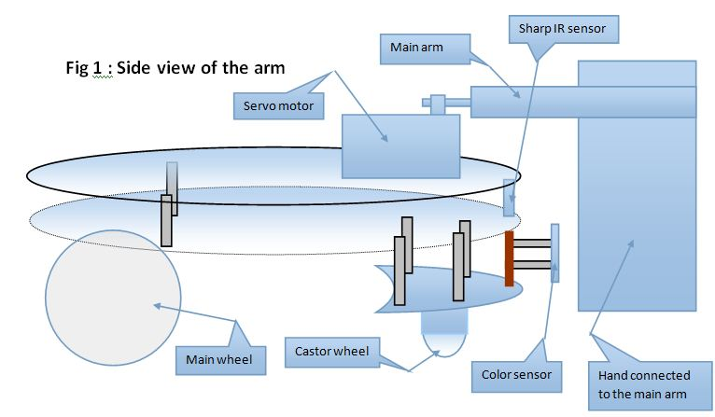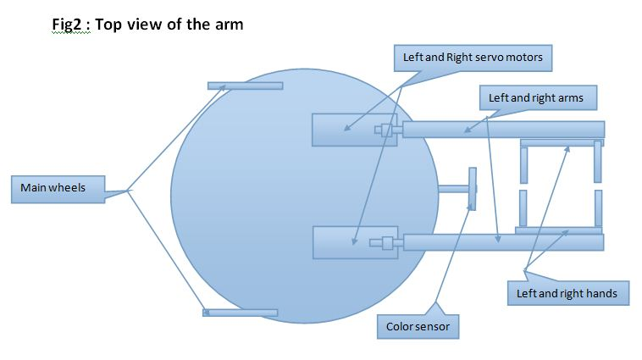

**Q-4. Choose the actuator you will use to design the robotic arm. (5)**

1. **DC-Motor 2. Servo Motor 3. Stepper Motor 4. Others**

**Answer: _________________**

**Justify your answer by stating the advantage of the chosen actuator over others. Also give reasons for not using other actuators.**

**Q-5. How will you identify Red, Blue and Green colors from the values you get from the color sensor? Explain your algorithm to identify the three colors (Red, Blue and Green). (15)**

Step 1: If all color values, i.e. Red, green and blue are less than the threshold value(2000 in our case), then the color is Black.

Step 2: If the color is not black, it would be one of Red, Green or Blue.

Step 3: To decide which one of the three it is, check for the maximum of the three values, i.e.

3.1 : If number of red color pulses is greatest of the three, the color identified is RED.

3.2 : If number of green color pulses is greatest of the three, the color identified is GREEN.

3.3 : If number of blue color pulses is greatest of the three, the color identified is BLUE.

**Q-6. (15)**

**a. How will you determine the threshold value for Black color?**

Step 1: Get an approximate red, blue and green pulse counts for red, blue and green color papers.Among the 9 readings obtained, note down the one which is the least of all these values. Let it be Threshold_plus. Also, let red_max be the maximum of the three readings obtained for red colored paper. Similarly, let blue_max be the maximum pulse count for blue color paper and green_max for the green colored paper.

Step 2 : Now, note the red, blue and green pulse counts for black color paper. Note, down the maximum reading of these three values. Let it be Threshold_minus.

Step3 :

3.1: Now, choose the Threshold such that it is greater than Threshold_minus (Round to nearest thousands value on upper side).

3.2. a) If Threshold_plus is greater than Threshold_minus, take the Threshold in between (approximately the half).

b) If not so, make sure that the threshold you chose in 3.1 should be much smaller than red_max, blue_max and green_max.

**b.** **Upload a video to show the color sensor values for black color.**

Ans : Video URL: <https://www.youtube.com/watch?v=zaIGLKUmqug>  
It is also submitted at the requested place.

**c. Threshold value obtained = 2000**

**Algorithm Analysis**

**Q-1 Draw a flowchart illustrating the algorithm used to complete the entire task. (50)**

