
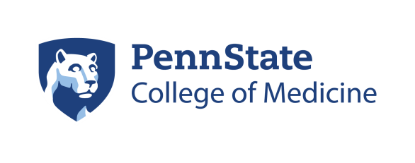

Department of Pathology Penn State Milton S. Hershey Medical Center Tel: (717) 531-8247
Beth Smith, C-TAGME Penn State College of Medicine Fax: (717) 531-0153
esmith31@pennstatehealth.psu.edu Department of Pathology, H083
500 University Drive, P.O. Box 850
Hershey, PA 17033-0850

November 1, 2025

Dear Candidate:

Thank you for your interest in the Penn State Health Milton S. Hershey Medical Pathology and Laboratory Medicine Residency Program. As an invited applicant to our program, we provided you with where the following documentation are located for your information and review:

Sample Resident Contract which includes:

- Salary & Benefits Information
- Institutional Resident Appointment and Promotion Policy

By signing below, you are acknowledging receipt of this information. Emailed copies will be provided at your request.

_______________________________________ _________________
Applicant Signature Date

_______________________________________
Print Name

