TensorFlow 1.x

Installation Instructions

Robert Genis – 2018-07-03

# Summary

This document describes the installation of **TensorFlow 1.x** onto a Windows RTN Secure computer.

These instructions are provided to end users only for self-service installation and launching of the provided software on Raytheon computers. Remote assistance can only be provided in a limited manner with the installation and initial launch of the software. Assistance with tool usage is out of scope, however the Tool PoC will make a limited attempt to resolve such issues.

# Contact

Primary support contact for installation is Robert Genis, [robert.g.genis@raytheon.com](mailto:robert.g.genis@raytheon.com), 520.746.2022

# Requirements

The following conditions are required of the target end user (“EU”) and target computer (“computer”):

* EU must be doing work for RMS that requires use of TensorFlow 1.x
* EU must have COEuser / ERPM privileges on the computer
* computer must be attached to the Raytheon ORION network
* computer must configured with an unclassified RTN Secure Windows OS installed
  + I.e., RTN Secure R3 (Windows 7) or RTN Secure R5 (Windows 10)
  + The tool is not guaranteed to work when included within a “Golden Image”

If any of the above are not satisfied, discuss with the Tool PoC to determine a workable solution.

# Preparation

TensorFlow 1.x is a set of python modules – which means they must be installed into an existing python 3.5 environment. On Windows, we recommend that you install Anaconda. Instructions for obtaining and installing Anaconda onto an RTN Windows machine can be found [here](http://toolquest.app.ray.com/TQ?PRODUCT_SK=11707&SCREEN=SEARCH&SUBSCREEN=PRODUCT_DATA).

Additionally, TensorFlow 1.x is available in two implementations: one that leverages CPU resources and one that leverages GPU resources. This document focuses solely on the CPU implementation, as the GPU implementation requires additional software (CUDA) and configuration that is outside of the scope of this document.

# Installation

1. Ensure that Anaconda has been installed. If not, review the Preparation section above.
2. Open an Anaconda Prompt by searching for it in your start menu:

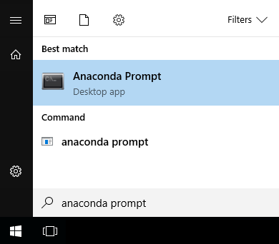

1. Uninstall any existing tensorflow versions using the python package manager (pip) by issuing the following command in the Anaconda Prompt window:  
     
   **pip uninstall tensorflow**  
     
   For example:  
   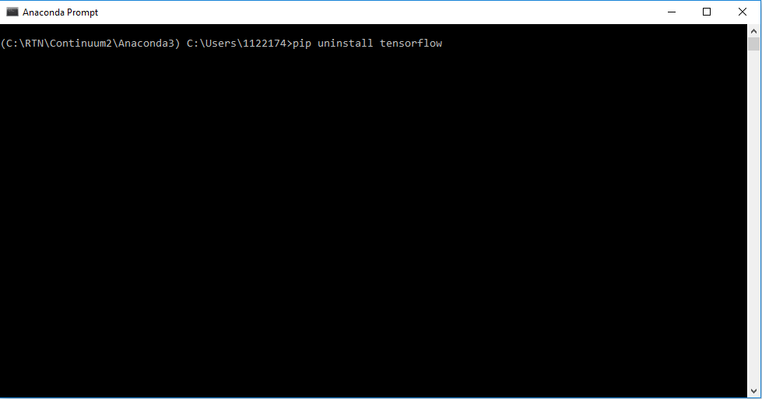
2. Once the uninstall is complete, issue the following command using the python package manager to install tensorflow from the RMS python repository:  
   **pip install --ignore-installed --upgrade --find-links file:\\apfs\apps\sses\Python\pypi_repo\ --no-index tensorflow**

|  |
| --- |
| **TIP: If you need to install a particular approved version of tensorflow, append the version number to the end of the pip install command similar to the following:  pip install --ignore-installed --upgrade --find-links file:\\apfs\apps\sses\Python\pypi_repo\ --no-index tensorflow==1.5.0** |

For example:  
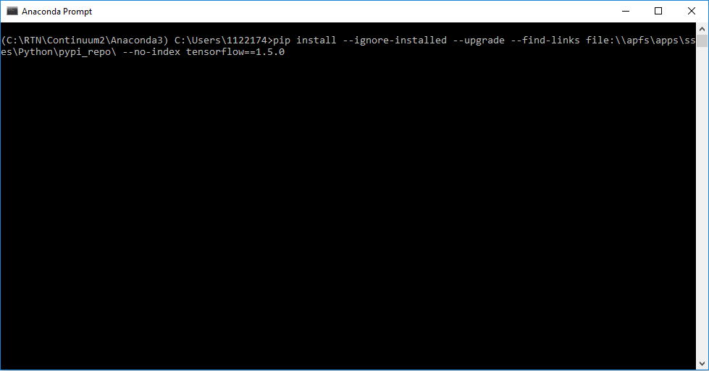

1. The python package manager will begin collecting the prerequisite packages for the tensorflow install. Once that’s done, pip will install the packages into your Anaconda python environment. A successful install looks like the following:  
   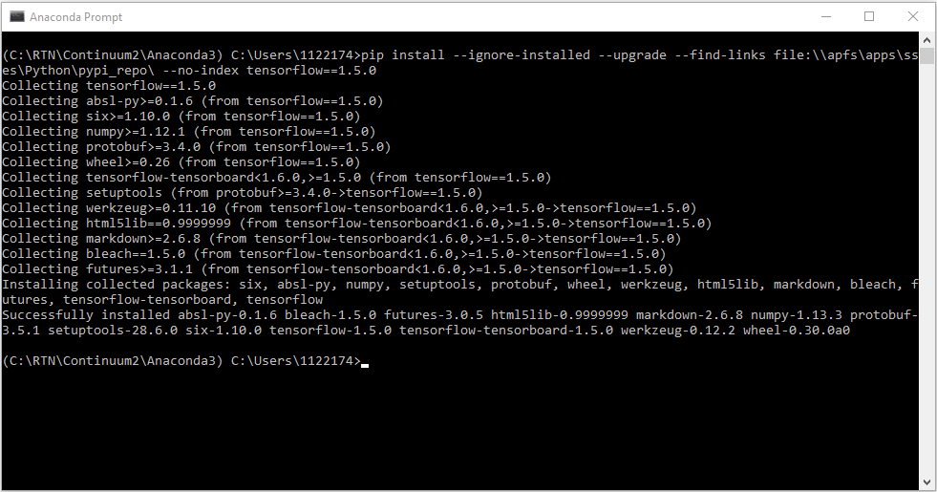
2. To verify that tensorflow is usable, run the following commands in the Anaconda Prompt:  
     
   **python**

**import tensorflow as tf  
import tensorflow as tf**

**hello = tf.constant('Hello, TensorFlow!')**

**sess = tf.Session()**

**print(sess.run(hello))**

If the system outputs the following, then you are ready to begin writing TensorFlow programs:

*b’Hello, TensorFlow!’*

For example:  
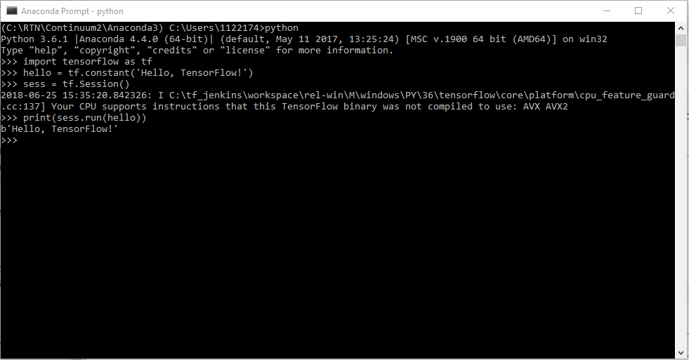

# License setup

Tensorflow is free open-source software and requires no licensing.

This concludes the setup and configuration of TensorFlow 1.x

# Help Desk Assistance

[Create a Help Desk Ticket](mailto:raytheonitservicedesk@raytheon.com&cc=es_systems@rlist.app.ray.com?subject=Route%20to%20RTN%20-%20Internal%20Support/%20RTN%20–%20RMS%20–%20Engineering%20-%20Systems%20&body=--------------------------------------------------%0DThis%20email%20is%20to%20submit%20a%20Remedy%20ticket%20for%20technical%20help%20with%20Systems%0DEngineering%20tools%20supported%20by%20ES_Systems.%20Please%20include%20errors%20received.%20Attach%20screen%20captures%20of%20the%20issue.%0D--------------------------------------------------%0D%0D%0DPLEASE%20DESCRIBE%20THE%20TECHNICAL%20ISSUE%20YOU%20NEED%20HELP%20WITH.%0D)

# Appendix

## Type conventions

|  |  |  |
| --- | --- | --- |
| **Usage** | **Meanings** | **Examples** |
| Heading 1 style  Heading 2 style | Headings  Subheadings | Main section  Supplementary section |
| Sans serif text | Body type | Follow the on-screen prompts. |
| *Italic or oblique text* | Special keystroke | Hit *Enter* to continue. |
| ▸ or 🡪 | Submenu marker | **File ▸ New…** |
| **Bold sans serif font** | Menu  User interface prompt  User interface heading | **File ▸ New…**  **Enter file name:**  **Installation progress…** |
| **Bold monospace font**  **(Consolas 10 Bold)** | Filename  Path  Typed command | **installer.exe**  **C:\RTN\**  **cd C:\RTN** |
| Code block | Literal code, in a contiguous block | 10 PRINT "HELLO, WORLD!"  20 GOTO 10 |
| “Wasp text”  Yellow paragraph background from bucket, not highlighter | Strong warning  Needs user attention | Do not push Esc or the installer will exit without doing anything.  Waiting on vendor for clarification. |

**This concludes the setup and configuration of TensorFlow 1.x**

# Version control

Robert Genis – 2018-06-25 – 0.1 Document Originated

Robert Genis – 2018-06-25 – 1.0 Document Released for Production

* The version after version 1.9 is version 1.10.
* When a new software version is released, the document version restarts at 0.1
  + Exception: Unless it makes sense to continue numbering from the previous version, e.g. if doc version 1.2 was written for product version 2017.1, but it works for a newly-release 2018.1, then add a reference to the new version in the same doc as the existing version, and bump the version to 1.3